A Review on Thermal Energy Storage for Concentrating Solar Power Plants

Junaid Sheikh* *Department of Mechanical engineering, G.H.Raisoni College of Engg, Nagpur.

Abstract
Thermal applications are drawing increasing attention in the solar energy research field, due to their high performance in energy storage density and energy conversion efficiency. This paper focuses to provide a detailed review on solar thermal energy storage especially for concentrating solar power plants. Thermal energy storage systems are reviewed on the basis on their designs, material selection and different thermal storage technologies. Thermal energy storage for concentrating solar thermal power (CSP) plants can help in overcoming the intermittency of the solar resource and also reduce the levelized cost of energy by utilizing the power block for extended periods of time.

- Introduction

Solar thermal energy (STE) is a form of energy and a technology for harnessing solar energy to generate thermal energy or electrical energy for use in industry, and in the residential and commercial sectors. Concentrated solar thermal power (also called concentrating solar power and CSP) systems use mirrors to concentrate sunlight from a large area to a small area where it is absorbed and converted to heat at high temperatures. The high temperature heat is then used to drive a power block (usually a steam turbine connected to an electrical power generator) similar to the power block of a conventional thermal power plant. In a concentrating solar power (CSP) system, the sun's rays are reflected onto a receiver, which creates heat that is used to generate electricity that can be used immediately or stored for later use. This enables CSP systems to be flexible, or dispatchable, options for providing clean, renewable energy. A major advantage of CSP plants over solar photovoltaic (PV) power plants is that CSP plants may be coupled with conventional fuels and can utilize thermal energy storage to overcome the intermittency of solar energy. TES systems can collect energy during sunshine hours and store it in order to shift its delivery to a later time or to smooth out plant output during cloudy weather conditions. Hence, the operation of a solar thermal power plant can be extended beyond periods of no solar radiation without the need to burn fossil fuels. Energy storage not only reduces the mismatch between supply and demand but also improves the performance and reliability of energy systems and plays an important role in conserving energy [1]. By extending the hours of usage of the power block beyond the sunshine hours a thermal energy storage system can reduce the Levelized Cost of Energy for the plant.

- Criteria for design
There are three main aspects that need to be considered in the design of a solar thermal energy storage system: technical properties, cost effectiveness and environmental impact.
Excellent technical properties are the key factors to ensure the technical feasibility of a solar thermal energy storage system. Firstly, a high thermal storage capacity (sensible heat, latent heat or chemical energy) is essential to reduce the system volume and increase the system efficiency. Secondly, a good heat transfer rate must be maintained between the heat storage material and heat transfer fluid, to ensure that thermal energy can be released/absorbed at the required speed. Thirdly, the storage material needs to have good stability to avoid chemical and mechanical degradation after a certain number of thermal cycles.
Criteria | Important factors
- Technical criteria  - Cost effectiveness  3.Environtment | - High thermal energy storage capacity (the most important)  - Good mechanical and chemical stability of storage material  - Low thermal losses and ease of control  - The cost of thermal energy storage materials  - The cost of the space and/or enclosure for the thermal energy storage  - Operation strategy  - Maximum load  - Integration to the power plant

Table.1. Important Factors Regarding Design Criteria

- Thermal energy storage technologies

  - Two-Tank Direct System
Solar thermal energy in this system is stored in the same fluid used to collect it. The fluid is stored in two tanks—one at high temperature and the other at low temperature. Fluid from the low-temperature tank flows through the solar collector or receiver, where solar energy heats it to a high temperature, and it then flows to the high-temperature tank for storage. Fluid from the high-temperature tank flows through a heat exchanger, where it generates steam for electricity production. The fluid exits the heat exchanger at a low temperature and returns to the low-temperature tank.
Two-tank direct storage was used in early parabolic trough power plants (such as Solar Electric Generating Station I) and at the Solar Two power tower in California. The trough plants used mineral oil as the heat-transfer and storage fluid; Solar Two used molten salt.
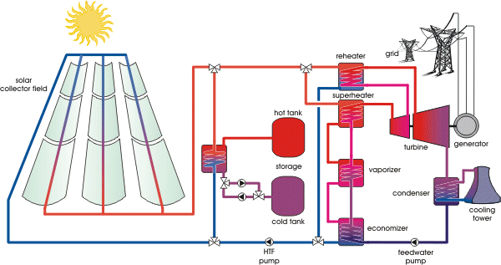
Fig.1.Two-Tank Direct system

3.2. Two-Tank Indirect System
Two-tank indirect systems function in the same way as two-tank direct systems, except different fluids are used as the heat-transfer and storage fluids. This system is used in plants in which the heat-transfer fluid is too expensive or not suited for use as the storage fluid. The storage fluid from the low-temperature tank flows through an extra heat exchanger, where it is heated by the high-temperature heat-transfer fluid. The high-temperature storage fluid then flows back to the high-temperature storage tank. The fluid exits this heat exchanger at a low temperature and returns to the solar collector or receiver, where it is heated back to a high temperature. Storage fluid from the high-temperature tank is used to generate steam in the same manner as the two-tank direct system. The indirect system requires an extra heat exchanger, which adds cost to the system.

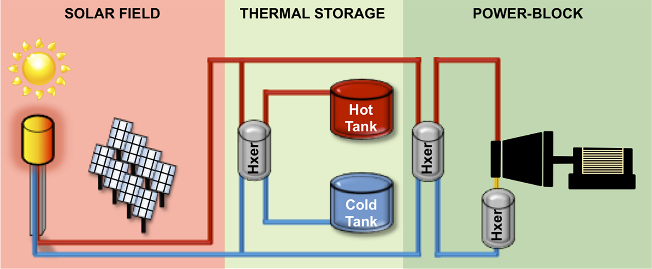
Fig.2.Two-Tank indirect storage system

This system will be used in many of the parabolic power plants in Spain and has also been proposed for several U.S. parabolic plants. The plants will use organic oil as the heat-transfer fluid and molten salt as the storage fluid.

3.3 Single Tank Thermocline System
Single-tank thermocline systems store thermal energy in a solid medium—most commonly, silica sand—located in a single tank. At any time during operation, a portion of the medium is at high temperature, and a portion is at low temperature. The hot- and cold-temperature regions are separated by a temperature gradient or thermocline. High-temperature heat-transfer fluid flows into the top of the thermocline and exits the bottom at low temperature. This process moves the thermocline downward and adds thermal energy to the system for storage. Reversing the flow moves the thermocline upward and removes thermal energy from the system to generate steam and electricity. Buoyancy effects create thermal stratification of the fluid within the tank, which helps to stabilize and maintain the thermocline.
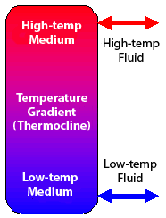
Fig.3.A single-tank thermocline thermal energy
storage system.
Using a solid storage medium and only needing one tank reduces the cost of this system relative to two-tank systems. This system was demonstrated at the Solar One power tower, where steam was used as the heat-transfer fluid and mineral oil was used as the storage fluid.

4. Thermal Energy Storage Materials
The materials used for solar thermal energy storage are classified into three main categories according to different storage mechanisms: sensible heat storage, latent heat storage and chemical heat storage (with their storage capacity in ascending order)

4.1. Sensible heat storage
Sensible heat storage is achieved by raising the temperature of a material - liquids such as water, oil-based liquids, molten salts etc. or solids such as rocks, metals, and others. The amount of heat stored is a function of the medium's heat capacity and is linearly dependent on the temperature increase. The larger the difference between the high temperature and low temperature system, the higher is the heat stored by the material. All of the currently installed thermal energy storage systems in solar thermal electric plants store energy use sensible heat. The current systems use two-tanks with either oil or molten salt. Both oil and molten salt systems were found to be technically feasible. In sensible heat storage, thermal energy is stored during the rising or dropping of temperatures of thermal storage media, which can be either solid state or liquid state.

4.2. Latent heat storage materials
Storage systems based on PCMs can be smaller, more efficient and provide a lower cost alternative to sensible thermal storage systems. There have been many studies on solar TES systems using PCMs of the different forms of phase change processes, the solid-liquid transition is efficient in terms of low volumetric expansion compared to the liquid- gas transition and high latent heat compared to the solid- solid transition. During phase change, heat is stored in the medium without an increase in the temperature. Due to this reason, PCMs can store larger amounts of heat compared to sensible storage media, for the same operating temperatures. Several types of PCMs are available based on the type of application. For example, for melting ranges between 00C and 2000C, PCMs such as paraffins, fatty acids, polymers, salt hydrates and sugar alcohols may be used. For higher melting temperatures, salts, salt eutectics, high performance polymers, metal alloys and carbonates are available.
Several methods employed by researchers to enhance the heat transfer in PCMs include using extended surfaces, employing multiple PCM’s, thermal conductivity enhancement using metallic structures, PCM impregnated foams, dispersion of highly conductive particles and encapsulation of PCM. Figure shows some methods used for enhancing the heat transfer in PCM thermal storage systems.
Other problems with using PCMs include super cooling, large volumetric changes during phase transition and incongruent melting. Moreover, some of the PCMs such as salts are corrosive in nature.

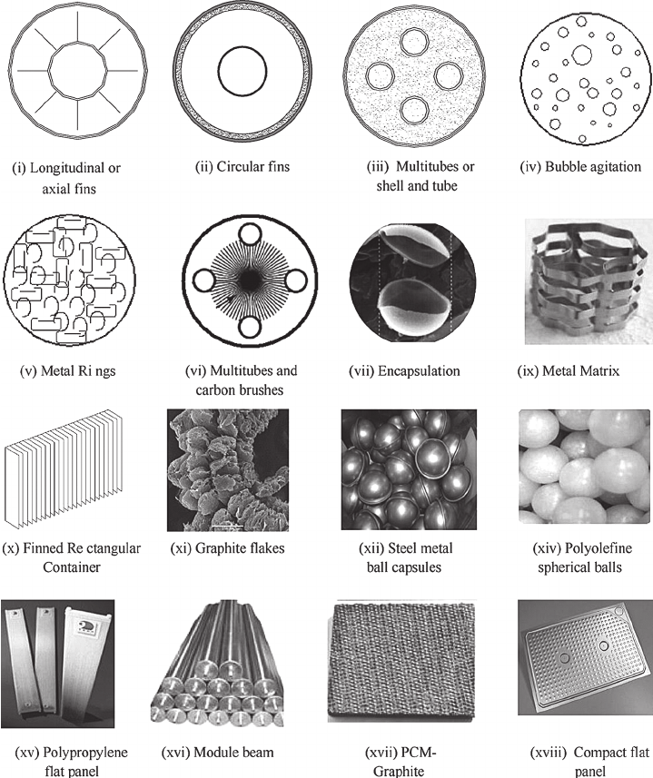

Fig.4.Heat transfer Enhancement procedures employed for various PCMs
4.3 Chemical heat storage materials
Special chemicals can absorb/release a large amount of thermal energy when they break/form certain chemical bonds during endothermal/exothermal reactions. Based on such characteristics, the storage method making use of chemical heat has been invented. Suitable materials for chemical heat storage can be organic or inorganic, as long as their reversible chemical reactions involve absorbing/releasing a large amount of heat. When designing a chemical storage system, three basic criteria need to be considered: excellent chemical reversibility, large chemical enthalpy change and simple reaction conditions (reactions cannot be too complicated to be realised).
However, chemical storage has not yet been extensively researched, and its application is limited due to the following problems: complicated reactors needed for specific chemical reactions, weak long-term durability (reversibility) and chemical stability.

5. Conclusion
The review shows that solar energy can be the best solution in terms of energy generation. Concentrating solar collectors can play a great role in energy generation. Various types of thermal solar collector technology have been reviewed and all types of thermal storage materials have been discussed. Thermal Energy Storage can not only overcome the intermittency of solar energy resource, but it can reduce the LCOE by as much as 20% with the current costs of TES systems and by more than 30% if the costs of TES is reduced to $10/kWhth. Ongoing research at USF is developing a system based on macro-encapsulated PCM, which has the potential to reduce the cost of thermal energy storage to less than $15/kWhth. This development is based on an industrially scalable encapsulation technique. The process is being optimized in order to implement it successfully at a large scale.

6. Reference
- H. P. Garg, S. C. Mullick, and A. K. Bhargava, Solar Thermal Energy Storage: Springer, 1985.
- U. Herrmann, B. Kelly, and H. Price, "Two-tank molten salt storage for parabolic trough solar power plants," Energy, vol. 29, pp. 883-893, 2004.
- U. Hermann and D. Kearney, "Survey of Thermal Storage for Parabolic Trough Power Plants," Journal of Solar Energy Engineering, Transactions of the ASME, vol. 124, p. 8, 2002.
- C. Turchi, M. Mehos, C. Ho, and G. Kolb, "Current and Future Costs for Parabolic Trough and Power Tower Systems in the US Market," NREL/CP-5500-49303, 2010.
- D. Y. Goswami, F. Kreith, and J. F. Kreider, Principles of Solar Engineering: Taylor and Francis, 2000.
- J. A. Duffie and W. A. Beckman, Solar Energy Thermal Processes: John Wiley & Sons, Inc., 1989.
- R.Z. Wang, X.Q. Zhai Development of solar thermal technologies in China Energy, 35 (2012), pp. 4407-4416
- D. Laing, C. Bahl, T. Bauer, M. Fiss, N. Breidenbach, and M. Hempel, "High-Temperature Solid-Media Thermal Energy Storage for Solar Thermal Power Plants," Proceedings of the IEEE, vol. PP, pp. 1-9, 2011.

