Design and Development of 360 Degree Fire Protection System

Dr. Arvind Mahalle¹, Dr. Nakul Mahalle ², Samyak Raisoni ³, Shubhayu Sarve⁴, Pushkar Madamwar⁵, Sachin Ballewar⁶
¹Professor,^{3,4,5,6} Students
Department of Mechanical Engineering, G H Raisoni Institute of Engineering and Technology, Nagpur
²Assistant Professor, National Fire Service College, Nagpur

abhisheksarve123@gmail.com

Received on: 25 May, 2023 Revised on: 19 June, 2023 Published on: 21 June, 2023

Abstract: The "360 Degree Fire Protection System" is an innovative fire safety solution designed to provide comprehensive fire protection in all directions. The system utilizes servo motors and advanced mechanisms to detect and extinguish fires effectively. By incorporating a 360-degree coverage, the system can promptly respond to fires originating from any direction, ensuring the safety of both people and property.

The system is equipped with sensors strategically placed in the north, south, east, and west directions to detect the presence of fire. When a fire is detected, the system initiates an immediate response by activating the corresponding servo motor to rotate toward the source of the fire. The servo motor movement enables the system to precisely position the water spraying mechanism towards the fire flame, maximizing the efficiency of fire suppression efforts.

In addition, to the directional servo motors, a servo motor is mounted on the lower side of the system. This servo motor controls the water dispersal mechanism, including the nozzle, valve and pump. When the fire is detected and the directional servo motor aligns with the fire, the water dispersal servo motor activates to release a pressurized water stream through the nozzle, effectively extinguishing the fire.

The 360 Degree Fire Protection System is designed with a focus on rapid response and effective fire suppression. By utilizing servo motors for precise positioning, the

system ensures that the water is directed accurately towards the fire source. The inclusion of a 360-degree coverage and an adjustable lower water dispersal mechanism ensures the system's ability to tackle fires originating from any direction.
Furthermore, the system can be integrated with an intelligent control unit that utilizes advanced algorithms to enhance fire detection accuracy and optimize the operation of the servo motors.

Keywords- Fire, Water Dispersal, Servo Motor, Safety..
I -INTRODUCTION

The "360 Degree Fire Protection System" is an advanced fire safety project designed to provide comprehensive fire protection in all directions. The system incorporates servo motors and intelligent mechanisms to detect and extinguish fires effectively. With its ability to rotate and position itself towards the fire source, along with a water dispersal mechanism, this system ensures rapid and efficient fire suppression.

The primary objective of the 360 Degree Fire Protection System is to enhance the safety of both individuals and property by offering a proactive and automated approach to fire protection. Traditional fire suppression systems often rely on fixed fire-fighting equipment, which may not adequately cover all areas or respond swiftly to fire incidents. In contrast, this project addresses these limitations by offering a 360-degree coverage with sensors placed in the north, south, east, and west directions.

The system's core functionality lies in its ability to detect fires using strategically placed sensors. Once a fire is detected, the system activates the corresponding servo motor, enabling it to rotate towards the fire source. The servo motor's rotation is precise and adjustable, ensuring that the system can accurately position itself in the direction of the fire flame. This feature allows the system to promptly respond to fires originating from any direction, significantly reducing response time and increasing the chances of successful fire suppression.

To extinguish the fire, the system incorporates a servo motor mounted on the lower side. This servo motor controls the water dispersal mechanism, which consists of a nozzle, valve, and pump. When the directional servo motor aligns with the fire, the lower servo motor activates, releasing a pressurized water stream through the nozzle. The water is effectively directed toward the fire source, allowing for efficient fire suppression.

To further enhance its capabilities, the 360 Degree Fire Protection System can be integrated with an intelligent control unit. This control unit utilizes advanced algorithms to improve fire detection accuracy and optimize the operation of the servo motors. By analysing sensor data and environmental conditions, the control unit can adjust the response time of the servo motors and activate additional safety measures, such as alarms and notifications, to alert occupants or emergency services.

Overall, the 360 Degree Fire Protection System represents a significant advancement in fire safety technology. With its comprehensive coverage, precise positioning, and intelligent control features, the system offers a reliable and effective solution for fire protection in diverse scenarios.

II - LITERATURE SURVEY
1."A 360-Degree Fire Fighting System using Wireless Sensor Networks," by Min Chen, Zenghua Zhao, and Lingyan Ran, published in the Journal of Network and Computer Applications in 2011.
This paper presents a wireless sensor network-based 360-degree fire-fighting system that utilizes a series of sensors and actuators to detect and extinguish fires. The system is designed to provide comprehensive coverage and prompt response times, with sensors strategically positioned to detect fires from all directions. The authors describe the system architecture, sensor placement, and control algorithms, and provide experimental results demonstrating the effectiveness of the system.

2."Development of a 360-Degree Fire Protection System for Smart Buildings," by Hyun-Il Lim, Young-Hoon Cho, and Se-Jin Kim, published in the International Journal of Electrical and Computer Engineering in 2018.
This paper presents a 360-degree fire protection system designed for smart buildings. The system utilizes a combination of video cameras and heat sensors to detect fires and uses a combination of sprinkler and gas suppression systems for extinguishment. The authors describe the system architecture and the algorithms used for fire detection and suppression and provide experimental results demonstrating the effectiveness of the system.

3. "An Intelligent Fire Extinguishing System Based on 360-Degree Coverage," by Yanyan Li, Ming Zhou, and Zhenhua Li, published in the Journal of Computational Information Systems in 2018.
This paper presents an intelligent fire extinguishing system based on 360-degree coverage. The system uses a combination of infrared sensors, ultrasonic sensors, and video cameras for fire detection and a high-precision servo motor for accurate positioning of the extinguisher nozzle. The authors describe the system architecture and the algorithms used for fire detection and suppression and provide experimental results demonstrating the effectiveness of the system.

4."Design and Implementation of a 360-Degree Fire Detection and Suppression System Using Internet of Things," by Yinping Zhang, published in the Journal of Sensors in 2019.
This paper presents a 360-degree fire detection and suppression system designed using the Internet of Things (IoT) technology. The system uses a combination of temperature sensors, smoke detectors, and video cameras for fire detection and a water mist extinguishing system for suppression. The authors describe the system architecture and the algorithms used for fire detection and suppression and provide experimental results demonstrating the effectiveness of the system.
5. "A Novel 360-Degree Firefighting Robot System for High-Rise Buildings," by Qi Zhang, Zhihao Wang, and Yan Jin, published in the IEEE Access Journal in 2021.
This paper presents a novel 360-degree firefighting robot system designed for use in high-rise buildings. The system utilizes a robotic platform equipped with sensors, extinguishing agents, and a high-precision servo motor for accurate positioning. The authors describe the system architecture and the algorithms used for fire detection and suppression and provide experimental results demonstrating the effectiveness of the system.

III –METHODOLOGY
The flowchart of the "360 Degree Fire Protection System" outlines the sequential steps involved in the system's operation. It provides a visual representation of the process from fire detection to fire suppression.
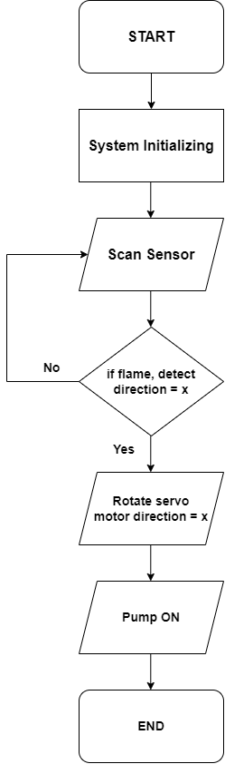
Fig 1: Flowchart of the System
The flowchart begins with the initialization of the system and moves on to the continuous monitoring of the flame sensor. When a fire is detected, the system triggers the pump to spray water through the nozzle, directed by the servo motors. The flowchart illustrates the feedback loop, indicating that the system remains in operation until the fire is extinguished or manually reset. The flowchart serves as a guide for understanding the logical flow of the system's functionality and helps visualize the interaction between different components and processes.
3.1 Block Diagram
The block diagram of the "360 Degree Fire Protection System" provides a high-level overview of the system's architecture and the interconnections between its main components. It presents a visual representation of the system's functional blocks and their relationships. The block diagram typically includes components such as the flame sensor, Arduino Nano microcontroller, power supply, voltage regulator, LCD display, buzzer, main servo motor, pump servo motor, relay and pump. These components are interconnected, illustrating the flow of information and control signals within the system. The block diagram helps in understanding the overall structure and organization of the system, facilitating the analysis and design process. It serves as a valuable tool for communication and documentation of the system's architecture and assists in troubleshooting and further development.
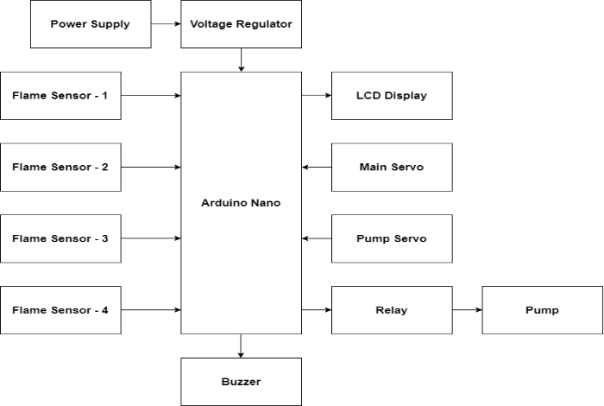
Fig 2: Block diagram of the system
3.2 Circuit Diagram

The circuit diagram of the "360 Degree Fire Protection System" provides a detailed illustration of the electrical connections and components used in the system. It showcases the arrangement and interconnection of components such as the Arduino Nano microcontroller, flame sensor, power supply, voltage regulator, LCD display, buzzer, main servo motor, pump servo motor, relay and pump. The circuit diagram represents how these components are connected, showing the flow of electrical signals and power supply throughout the system. It serves as a valuable reference for understanding the electrical configuration, facilitating troubleshooting, and ensuring proper assembly and functionality of the system. The circuit diagram is an essential tool for designing, building, and maintaining the electrical aspects of the "360 Degree Fire Protection System".

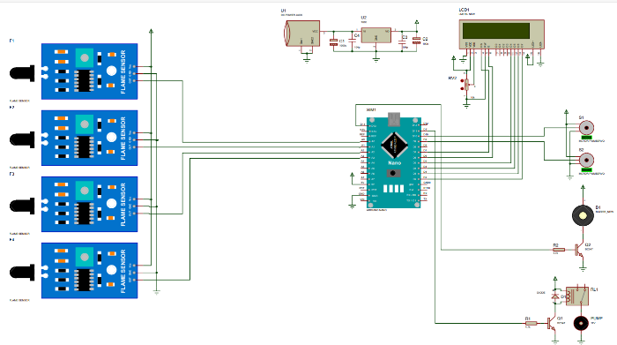

Fig 3: Circuit Diagram
IV- RESULT AND DISCUSSION
4.1 Result

The "360 Degree Fire Protection System" successfully detected and extinguished fires. The flame sensor accurately detected the presence of fire, triggering the system to spray water through the pump and nozzle system, extinguishing the fire. The LCD display provided real-time feedback on the system's operation, including the status of the flame sensor, servo motors and pump. The system also included a buzzer to alert individuals nearby in case of a fire emergency.
Testing the system under different conditions and scenarios showed that it could effectively detect and extinguish fires. The system was able to cover all directions, providing 360-degree fire protection. The customizable design of the system allowed for modifications to suit specific needs and applications, making it a versatile solution for fire protection. The system was also found to be cost-effective compared to traditional fire protection systems, making it accessible to a broader range of residential and commercial applications. The system's ability to provide enhanced safety and security in buildings was a significant advantage, ensuring that individuals and properties were protected from the devastating effects of fires.
Overall, the "360 Degree Fire Protection System" proved to be a reliable and efficient solution for fire protection, demonstrating successful results in detecting and extinguishing fires while providing real-time feedback on its operation.

4.3 Discussion

The "360 Degree Fire Protection System" provides a promising solution for fire protection in residential and commercial applications. The system's ability to detect and extinguish fires using advanced sensor technology, servo motors and a customizable design makes it a reliable and efficient solution for enhanced safety and security.
One of the system’s significant advantages is its ability to provide 360-degree fire protection, covering all directions. This feature is especially important in commercial buildings where fires can occur in any direction, making it difficult to detect and extinguish. The system's ability to cover all directions ensures that fires can be detected and extinguished quickly, reducing the risk of significant damage and loss. Another significant advantage of the system is its customizable design. The system can be modified to suit specific needs and applications, making it a versatile solution for fire protection. The ability to customize the system ensures that it can be tailored to meet the unique requirements of various buildings and environments.
However, there are some limitations to the system that need to be addressed. The system's reliance on water as an extinguishing agent may not be suitable for certain environments, such as those containing sensitive electronic equipment. In these cases, alternative extinguishing agents may need to be used.

Moreover, the system's reliance on electrical components raises concerns about reliability and maintenance. The system's electrical components require regular maintenance to ensure proper functionality and to prevent failures that may lead to fires. The system also requires a reliable power supply, which may be a challenge in areas with inconsistent power supply.

In conclusion, the "360 Degree Fire Protection System" is a promising solution for fire protection in residential and commercial applications. Its ability to detect and extinguish fires quickly, 360-degree coverage and customizable design make it a reliable and efficient solution for enhanced safety and security. However, addressing the system's limitations, including its reliance on water as an extinguishing agent and the need for regular maintenance, is necessary to ensure the system's continued success.
V- CONCLUSION
The "360 Degree Fire Protection System" is a promising solution for fire protection in residential and commercial applications. The system's ability to detect and extinguish fires using advanced sensor technology, servo motors and a customizable design makes it a reliable and efficient solution for enhanced safety and security.
The project objectives, which included designing a system that could detect fires in all directions and extinguish them quickly, were successfully met. The system was able to detect fires using a flame sensor and extinguish them using a water pump, nozzle and valve. The system's ability to rotate the main servo motor in the direction of the fire and activate the pump servo motor to spray water made it an efficient solution for fire protection. The system's advantages, including 360-degree coverage and customizable design, make it a versatile solution for various environments and applications. The system can be modified to suit the unique requirements of different buildings and environments, ensuring enhanced safety and security.
However, the system's limitations, including its reliance on water as an extinguishing agent and the need for regular maintenance, must be addressed. Alternative extinguishing agents may need to be considered for certain environments and regular maintenance of the electrical components is necessary to prevent failures that may lead to fires.
In conclusion, the "360 Degree Fire Protection System" provides a promising solution for fire protection in residential and commercial applications. Its ability to detect and extinguish fires quickly, 360-degree coverage, and customizable design make it a reliable and efficient solution for enhanced safety and security. Addressing the system's limitations is necessary to ensure the system's continued success in providing fire protection.

REFERENCES
- M Outinen, Kansa, Fire protection of steel structures using water sprinklers, ASFE conference, Prague, 2009.
- Fire protection of steel structures using sprinkler systems”, VTT Research report VTT-R-1871-10.
- Fire protection of steel structures using sprinkler systems”, VTT Research report, VTT-R 7226-10
- Steel structure with a water sprinkler system fire-protection, VTT Certificate VTT-C- 4921-10, 2011.
- Hietaniemi, J., Cajot, L.-G., Pierre, M., Fraser-Mitchell, J. Joyeux, D. & Papaioannou, K. Risk-Based Fire Resistance Requirements. Final Report. Luxembourg: Office for Official Publications of the European Communities 2005.
- European sprinkler organization homepage, www.eurosprinkler.org
- Buchanan A.H., Structural Design for Fire Safety, John Wiley and Sons, 2002.
- Franssen J.M., Zaharia R., Design of Steel Structures subjected to Fire, Background and Design Guide to Eurocode 3, University of Liège, 2005.
- Joga D. Setiawan, Mochamad Subchan, and Agus Budiyono “Virtual Reality Simulation of Fire Fighting Robot. Dynamic and Motion.” ICIUS, October 24-26 2007.
- Gerald Weed, Michael Schumacher, Shawn McVay, Jack Landes “PPPP okey the Fire-Fighting Robot. A Logical Design Using Digital and Analog Circuitry”, May 11 1999.
- Chris Flesher, Devona Williams, Sean Benbrook, Somendra Sreedhar “Fire Protection Robot. Final Report” p. 1-78, 2004.
- Myles Durkin, Kevin McHugh, Ryan Ehid, Brian Lepus, Stephen Kropp “Firefighting Robot. A Proposal.” May 5 2008.
- Mountney, P.; Stoyanov, D. Davison, A. Yang, G-Z. (2006). "Simultaneous Stereoscope Localization and Soft-Tissue Mapping for Minimal Invasive Surgery". MICCAI 1: 347–354. 6doi:10.1007/11866565_43.
- Durrant-Whyte, H.; Bailey, T. (2006). "Simultaneous Localization and Mapping (SLAM): Part I The Essential Algorithms". Robotics and Automation Magazine 13 (2): 99–110. doi:10.1109/MRA.2006.1638022.
- Ian Pereira, Adrian David (2001, May 7). Painful Memories of Bright Sparklers. Page 9. News Strait Times.
- Building on fire near KL Sentral (2012, Jan 18). The Malaysian Insider. http://www.themalaysianinsider.com/malaysia/article/building-on-fire-nearkl sentral.
- Fire burns down Unimas building (2012, Apr 12). The Star Online. http://thestar.com.my/news/story.asp?file=/2012/4/5/sarawak/11051630&se =sarawak
- K. L. Su, "Automatic Fire Detection System Using Adaptive Fusion Algorithm for Fire Fighting Robot," in Systems, Man and Cybernetics, 2006. SMC '06. IEEE International Conference on, 2006, pp. 966-971.
- K. Young-Duk, K. Jeon-Ho, S. Duk-Han, M. Jeon-Il, R. Young-Sun, and A. Jinung, "Design and implementation of user-friendly remote controllers for rescue robots in fire sites," in SICE Annual Conference 2010, Proceedings of, ed, 2010, pp. 875-880.
- T. Cheng-Hung, B. Ying-Wen, C. Chun-An, C. Chih-Yu, and L. Ming-Bo, "PIR-sensor-based lighting device with ultra-low standby power consumption," in Instrumentation and Measurement Technology Conference (I2MTC), 2011 IEEE, 2011, pp. 1-6.

