https://doi.org/10.46335/IJIES.2024.x.xx.xxx e-ISSN: 2456-3463

Vol. x , No. xx, 20xx, PP. xx-xx

International Journal of Innovations in Engineering and Science, www.ijies.net

Object detection using AI

Neha Shinde¹, Sandali Tagunde², Saraswati Zerkunte³, Prof.Megha Dhotay⁴
¹Dept. Computer engineering, MIT Polytechnic Kothrud-411038, Pune, India
MIT Polytechnic, Pune, Kothrud 411038

*Corresponding Authors: sandalitagunde@gmail.com, nehashinde8836@gmail.com

Received on: xxxx,20xx, Revised on: xxxx,20xx, Published on: xxxx,20xx

Abstract: Object detection using artificial intelligence (AI) has revolutionized various industries, from surveillance to autonomous vehicles and retail. This paper provides a concise overview of object detection techniques employing AI algorithms. It explores the fundamental concepts behind object detection, including the use of convolutional neural networks (CNNs) and deep learning architectures. The abstract discusses key methodologies such as regionbased convolutional neural networks (RCNN), single shot detectors (SSD), and You Only Look Once (YOLO). Additionally, it highlights recent advancements, challenges, and future directions in AIdriven object detection. Understanding these approaches is critical for researchers and practitioners seeking to harness the power of AI for robust and efficient object detection systems.

Keywords: Object localization, Object recognition, Image Preprocessing, Leaf disease detection.
I. INTRODUCTION
Object detection using AI is a cutting-edge technology that empowers machines to recognize and locate objects within images or video streams. It plays a pivotal role in computer vision, allowing computers to understand the visual world much like humans do. At the heart of this technology are Convolutional Neural Networks (CNNs), which have proven exceptionally effective in image analysis. These networks are trained to identify specific objects within an image and then draw bounding boxes. around them, providing both their position and
class labels, such as "car," "person," or "cat."
Proposing a methodology for object detection using AI involves a systematic approach to tackle this complex task. The process begins with a clear definition of the object detection problem, collection and annotation follow, where a diverse dataset of gathered and labelled. Data preprocessing steps involve images or videos containing the target objects is resizing, normalization.

Camera Based Detection :-
Camera-based object detection using AI involves using a machine learning model to identify objects within images or video frames captured by a camera in real-time. The resources been used for developing this mouse system are these:
• HTML CSS JavaScript Software :-
HTML (Hypertext Markup Language) is the standard markup language used to create and design web pages.
CSS (Cascading Style Sheets) is a style sheet language
used to describe the presentation of HTML elements on a. web page.
JavaScript is a programming language commonly used to create interactive and dynamic elements on web page.

Fig 1. HTML CSS JS Software
Uses In Different Fields:
- Autonomous Driving and Vehicle Detection
- Surveillance and Security
- Healthcare and Medical Imaging
- Object Recognition in Images and Videos

Fig .2.Surveillance and Security

II.LITERATURE SURVEY
[1] In recent years, there has been a growing need to perform object detection at the edge. Since the edge environment has tight physical constraints, the efficient use of AI devices is a key challenge to execute object detection at high throughput.
[2] In this paper, we propose an object detection acceleration method which uses two types of one-stage detectors in combination. After detecting object candidates by a lightweight detector, the method generates aggregated images by combining the candidate images and executes the second more accurate detector on the aggregated images to improve execution efficiency of AI devices.
[3] Our evaluations confirmed that the proposed method can speed up object detection by up to eight times for a license plate detection task with almost no accuracy degradation. We conducted evaluations with a car detection task and a pose estimation task as well and confirmed the broad applicability of the proposed method. For object detection in garbage sorting applications, the YOLOv4 model have been employed in the detection of abnormal objects during waste sorting. YOLO models have been proven as an effective solution with stable performance and accuracy.
[4] In addition, mobile terminals such as smart cameras have limited computing resources, and conventional AI models face difficulty in deployment on mobile terminals. In this case, it is of high practical significance and application value to carry out the research on the lightweight of the recognition model.

III.SYSTEM ARCHITECTURE
- One popular deep learning model for object detection is the Convolutional Neural Network (CNN).CNNs have been extensively used in various object detection frameworks due to their ability to automatically learn hierarchical features from input images.
- It efficiently generates region proposals and then classifies those proposals using a CNN. This approach significantly speeds up the detection process compared to earlier R-CNN models.
- These CNN-based models have been successfully applied in various domains, including object detection in cameras and agriculture, due to their ability to detect objects accurately and efficiently.

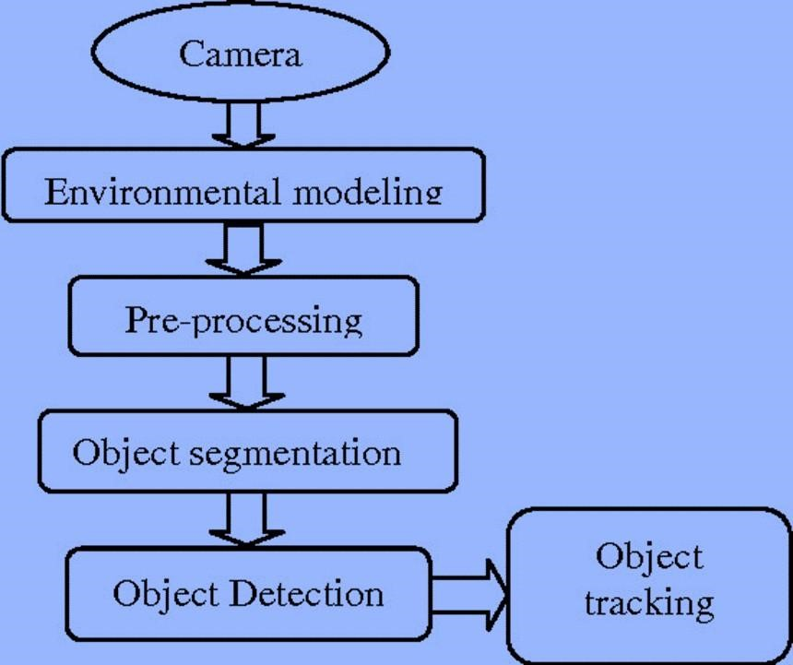
The Basic block diagram of the system:

Fig.3.Block Diagram

PROPOSED METHODOLOGY

Capturing the real time view:

- Model Loading: Load a pre-trained object detection model.
- Initialization: Prepare the model for inference.
- Input Acquisition: Capture input data (e.g., images or video frames).
- Preprocessing: Prepare the input data for the model (e.g., resizing, normalization).
- Inference: Analyse the input data to identify objects present.
- Detection Output: Generate predictions with bounding boxes and labels.
- Postprocessing: Refine the detection results if needed (e.g., filtering, non-maximum suppression).
- Visualization: Display the detected objects on the input data.
- Continuous Operation: Continuously process new input data for real-time detection.
- User Interaction: Allow users to adjust parameters or
enable/disable features for customization.

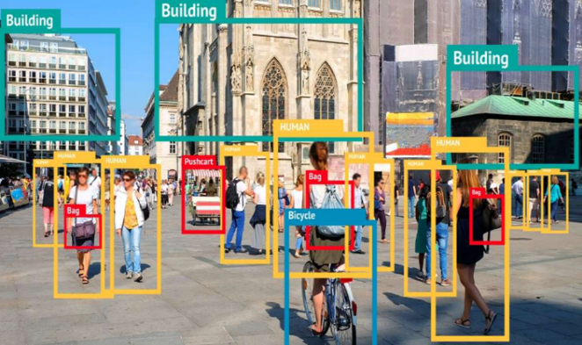
Fig.4.Object Detection using Camera

Working:

In these project it implements an AI object detection system using a pre-trained model called "cocossd" and the ml5.js library. When the webpage loads, it displays a user interface consisting of a video element for live camera feed, input fields for custom object labels and confidence threshold, and a toggle switch to enable/disable AI object detection. The AI model is loaded and initialized, allowing it to process input data from the camera in real-time. Users can enable the AI detection by toggling the switch and adjust parameters like FPS (frames per second) and confidence threshold.

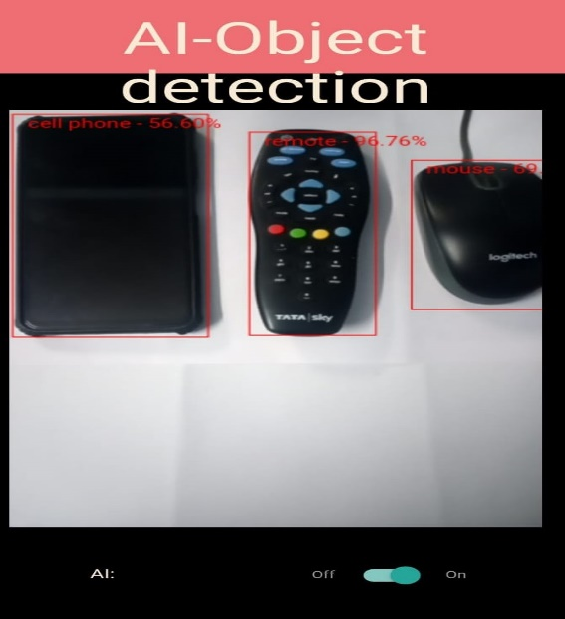
Fig.5.Output

As the camera captures video frames, they are processed by the object detection model, which identifies objects present in the scene. Detected objects are displayed on the video feed with bounding boxes and labels, indicating their positions and classifications. Users can interact with the system by adjusting parameters to customize the detection behaviour. Additionally, the system provides a reset button to clear any settings or detected objects. Overall, the code creates an interactive AI object detection interface, allowing users to observe and analyse their surroundings in real-time using computer vision technology.

Agriculture:

In recent years, AI has been widely adopted in agriculture to improve productivity and efficiency. Object detection is one such technique that has gained immense importance in the field of agriculture.
Object detection is a valuable tool in agriculture because it allows for more efficient and precise farming practices, leading to increased productivity and sustainability while reducing costs and environmental impact.

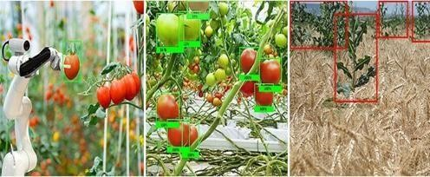

Fig.6.Agriculture

DISEASE DETECTION:

The provided code forms the foundation of a web-based application designed for agricultural purposes, specifically focusing on plant disease detection. The HTML structure defines the user interface, featuring an image upload form where users can submit images of plants for analysis. Upon selecting an image and clicking the "Detect Disease" button, the JavaScript function detectDisease() is invoked. Currently, this function initiates a placeholder simulation of disease detection, presenting mock results within the designated result container. The detected region seems like the following image:

Fig.7.Output

● It includes UI elements for controlling the detection process, such as toggling AI, adjusting FPS, and entering custom object labels.

● JavaScript is used to handle model loading, user interactions, camera feed processing, and object detection.

● CSS is used for styling the layout and appearance of HTML element.

PLANT DISEASE DATASET:

The CSS styling enhances the visual presentation of the webpage, including elements such as the background image, navigation bar, and button. However, the functionality of the application remains limited to the provided simulation, where the actual disease detection process is not implemented. In a real-world scenario, the simulateDetection() function would be replaced with genuine detection logic, potentially leveraging machine learning or image processing algorithms to accurately identify plant diseases based on uploaded images.

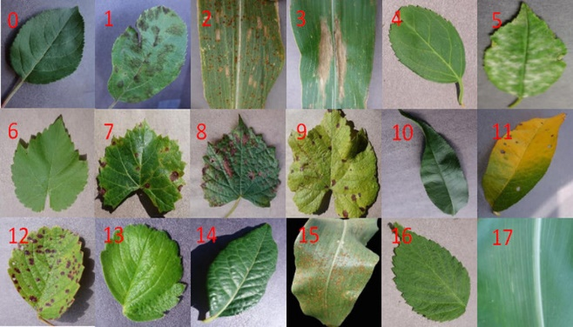

Fig.8. Leaf disease detection

APPLICATION
This technology has wide applications in the fields of Autonomous Driving and Vehicle Detection, Surveillance and Security, Healthcare and Medical Imaging, Object Recognition in Images and Videos.

FUTURE SCOPE
Overall, the future holds promise for object detection AI to revolutionize various sectors and enhance our daily lives with intelligent and reliable detection capabilities.

CONCLUSION
The system demonstrates the potential of AI in practical applications, such as surveillance, inventory management, and augmented reality. As AI technologies continue to evolve, this implementation serves as a foundation for developing more sophisticated object detection solutions across various domains, contributing
to advancements in computer vision.

REFERENCES
[1]Watanabe, Yoshikazu, et al. "Work-in-progress: Object detection acceleration method by improving execution efficiency of ai device." 2022 International Conference on Compilers, Architecture, and Synthesis for Embedded Systems (CASES). IEEE, 2022.
[2] Wei, Zhang, et al. "Efficient object detection of non-perishable in smart garbage sorting booths using the Efficient-Net model." 2022 China Automation Congress (CAC). IEEE, 2022.
[3]Bey-Temsamani, Abdellatif, Agusmian Partogi Ompusunggu, and Florian Hammer. "AI meets Agriculture: A Smart System for Foreign Object Damage Avoidance." 2020 IEEE Conference on Industrial Cyberphysical Systems (ICPS). Vol. 1. IEEE, 2020.
[4]Rani, Ruchi, et al. "Role of Artificial Intelligence in Agriculture: An Analysis and Advancements with Focus on Plant Diseases." IEEE Access (2023).
[5]Guo, Chaoxu, et al. "Augfpn: Improving multi-scale feature learning for object detection." Proceedings of the IEEE/CVF conference on computer vision and pattern recognition. 2020.
[6]Ramachandran, Anitha, and Arun Kumar Sangaiah. "A review on object detection in unmanned aerial vehicle surveillance." International Journal of Cognitive Computing in Engineering 2 (2021): 215-228.

