Power generation by double cylinder engine
Md Tuseef Md Tauheeb Farooqui¹, Junaid Akram Gavali², Shaikh Mohammad DanishAtikurrah³, Shaikh Mohammad Kashif md naeem⁴,Dr.Hemant R.Nehete
^{1,2,3,4}UG- student, Department of Mechanical engineering, Godavari college of engineering, Jalgaon,Maharashtra
⁵Assistant Professor, Department of Mechanical engineering, Godavari college of engineering, Jalgaon,Maharashtra

Received on: xxxx,20xx, Revised on: xxxx,20xx, Published on: xxxx,20xx

Abstract – Power is obviously needed and has advanced, but the problem with the power that is currently available on the market is that it is expensive and difficult for the working class, who makes up the majority of the country's population, to manage. The optimal solution is to develop an invention that can convert the widely used dual chamber motor into electricity. The double chamber motor is a new environmentally friendly invention that emphasizes using a magnet to power the motor. It shows a motor that manages the head of shock of two distinct types of magnets: an electromagnet and an extremely durable magnet
.Keywords- magnet, energy, engine, piston
INTRODUCTION
Double acting cylinders feature ports on both ends, and they move the cylinder forward and backward by switching the port that experiences the most strain.air Vital.When should a load be transferred for both important functions, like opening and closing an aquarium? In contrast to the cylinder's outermost edges, Airpres sureis is applied. Bidirectional and capable of sealing dynamic tension from both sides is a twofold active chamber. One model is an earthmover. By widening the bar, the earthmover's arm is first moved in a single direction while excavating a channel. At that moment, the pole is removed, pulling it down one more course. While searching for a gadget to move load in the two bearings, twofold acting chambers are a helpful application when your machine requires more than one development. Dissimilar to single acting air chambers, twofold acting chambers can broaden and withdraw without the need of aspring. The mechanical energy is changed over into electrical energy by generators, the significant components of the generators are themagnetic field and the movement of the channel in an attractive field. The free energy generator is adevice, which is utilized to create electrical energy in light of the neodymium magnets rule. There are many different types of generators available in different sizes; one type of generator that generates electrical energy is the free energy generator. This article looks at a summary of the free energy generator, including its definition, benefits, limitations, and uses. Introduction: One type of device used to generate electrical energy that works with neodymium magnet standards is the free energy generator. A section of the generator of free energy
II. LITERATURE REVIEW
Nikola Tesla (tenth July 1856-seventh January 1943) designed free energy by utilizing a curl. The mechanical energy is changed over into electrical energy by generators, the significant components of the generators are the attractive field and the movement of the conveyor in an attractive field. The free energy generator is a gadget, which is utilized to produce electrical energy in light of the neodymium magnets standard. There are various kinds of generators in various sizes, in that free energy generator is one sort of generator which produces electrical 2 energy. This article examines an outline of the free energy generator which incorporates its definition,advantages,disadvantages and its applications. Despite the fact that the Tesla Curl should be connected to a power supply, hypothetically, the Tesla Loop could be exceptionally productive and support a lot of energy improvement for little info. In this manner, it has been alluded to as "free energy", despite the fact that it is recognized that it isn't completely free, in light of the fact that a few hardware and a power supply is required. Current endeavors to utilize the Tesla Loop have finished into the helpful development called the "Fix the World Task". Their main goal is to "center around projects managing energy access, financial difficulty, and essential compassionate guide"

III. WORKING
Neodymium magnets are firmly placed on base plates so that their similar shafts face each other. As a result, an enormous power is generated between the posts, which causes the DC engine's shaft to continuously rotate. The electromagnetic field created by this pivot causes the channel's electric flow to be activated. As shown in Figure 1, the entire framework arrangement includes the inverter framework, charge regulator, and free energy generator.Neodymium magnets are used in the free energy generator to provide the energy needed by the result load. The neodymium magnets are decisively put on base plates with their like posts confronting one another. Hence, a loathsome power is produced between the posts, causing the shaft of the DC engine to consistently pivot. This pivot produces electromagnetic field and electric flow is prompted in the conduit. The initiated energy is provided to the heap (a 12-volt battery) by means of the charge regulator. The battery is charged and the charge voltage is directed by the regulator. The inverter framework changes over the info DC voltage into an air conditioner voltage. Figure 1: Block Graph of the Free Energy Generator and Inverter Framework A. Neodymium Magnets Neodymium magnets are the most generally utilized kind of uncommon earth magnets. They are super durable magnets produced using combination of neodymium amalgam, iron and boron to shape the Nd2Fe14B tetragonal glasslike structure. They are the most grounded sort of long-lasting magnet economically accessible and have supplanted different kinds of magnet in the numerous application regions, for example, engines in cordless apparatuses, hard plate drives and attractive clasp. There are two interesting earth magnets: neodymium iron boron and samarium cobalt. Despite the fact that neodymium iron boron is like samarium cobalt, the previous is all the more effectively oxidized and doesn't have a similar temperature opposition. Neodymium iron boron is precisely more grounded than samarium cobalt magnets, and it is additionally weightier than fired or alnico. Notwithstanding, it creates the most noteworthy measure of transition per unit of volume or mass, making it more prudent for various applications. Alnico is the business trademark for a composite used to make high energy super durable magnets; it contains aluminum, iron, nickel with one or the other cobalt, copper or titanium.has an extremely high energy item and an exceptionally high coercive power. The temperature solidness is very moderate. This work used this kind of magnet in view of their solidarity. Their long life expectancy is a benefit to keep the rotor turning ceaselessly over an extremely significant stretch
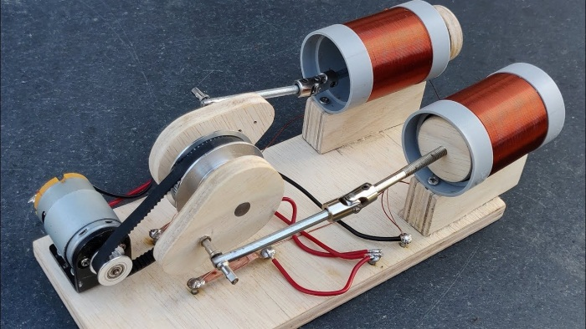
Fig.1 working model

IV. CONSTRUCTION
It consists of cylinder, permanent magnet, neodymium magnet, crank, piston, bearings, crank, piston, bearings, DC motor, clamp, socket, wood, screw, spoke, glow gun, M-seal, wire, gear, electric board, nail, bulb, socket.
V. ADVANTAGES
Decreased ecological effect,
Smaller plan
More straightforward activity component
Strength
Easy to understand in tasks
Low commotion during activities
Low discharge levels • Simple to work • Minimal expense
Accessibility of material
Free power produce
VI.DISADVANTAGES
The high cost of permanent magnets
Magnet corrosion and possible demagnetization
Noise and vibration

VI. CONCLUSION
Overall, even though Tesla's theory of free energy is intriguing, his invention was hardly ever put to use. Now, with concerns about energy conservation, this intriguing idea is particularly noticeable. Magnets and the free power age could upend the field of energy creation by providing a clean, limitless, and sustainable source of energy. Although the Fix the World Task is pushing the use of the Tesla Loop to address global energy issues, many believe that they are a scam and that their efforts are self-serving. In any case, it is critical to take note of that no never-ending movement machine has been effectively made, and the idea stays a hypothetical chance. Numerous analysts and creators keep on chipping away at the thought, and it is conceivable that forward leaps will be made from now on. Up to that point, it is vital to put resources into existing environmentally friendly power advancements, for example, sun based, wind, and hydroelectric ability to diminish our reliance on non-renewable energy sources and relieve the effect of environmental change.
ACKNOWLEDGMENT
We would like to take this opportunity to express our honour, respect, deep gratitude and genuine regards to our guide Dr.Hemant Nehete whose invaluable guidance supported us in completing the project. We would like to thanks to Prof.Tushar Koli (H.O.D. of Mechanical Engineering Department) and Prof.Kishor Mahajan (Project coordinator) for their moral support and able suggestion. Lastly we would like to thanks Dr.Vijaykumar Patil (Principal) for given us such opportunity. We are very thankful to our friends for their suggestion and co-ordination. We also express our indebt thank to our teaching and non-teaching staff of Mechanical Engineering Department, Godavari college of engineering,Jalgaon.
.REFERENCES
- The website "Magnetic Energy Generation" by Magnetic Energy
- The YouTube channel "Magnetic Motors" by Magnetic Motors
- The website"Free Energy Generation" by Free Energy Generation
- It is important to note that some of the claims made by proponents of free power generation using magnets may not be scientifically sound, and it is important to approach the topic with a critical eye.
- EL-PRO-CUS (ELECTRONICSPROJECTFOCUS}
- https://youtu.be/DbLwGc8-u-Q
- https://youtu.be/0RygYcrm7vA [8] Journals &otherbooks: [9] Nikola Tesla free energy and the white dove Journal of

