Design and Analysis of Go-kart Chassis
Sanket Nawade¹, Danishkhan Pathan², Akash Bawane³, Shubham Baitule⁴, Omkar Shende⁵, Rohit Birkurwar⁶, Prof. T. V. Sabnis⁷
Students^{1,2,3,4,5,6}, Assistant Professor⁷
Dept. of Mechanical Engineering, Jagadambha Collage of Engineering & Technology, Yavatmal-455001, India

Abstract- A vehicle with no suspension, low ground clearance, with moderate speed and generally use for motor sport purpose called as Go-kart. Its design and features are generally different from car. The objective of this paper is to design and analyse the most important component of Go-kart that is chassis frame. We called it most important because it hold all different assemblies which help the Go-kart to be in live condition such as Breaking assembly, Steering Assembly and transition assembly. Chassis Frame bears all the loads acting on it and transmit it to ground. In motor sports First priority is given to Driver’s safety. So, we try design the Chassis Frame in such a way that it bears the load of over weighted driver too. In this research we locate most influencing position with suitable load and calculate the deflection using software and numerical basis. We design the frame in CATIA V5R18 software and analysis for optimising the strength is done by using Ansys 14.5 software. We choose the material AISI 4130 which is best suitable to use for Go-kart chassis. It has good weld ability, high tensile strength for better opposition to bending moment acting due to the loads.
Keywords- Keyword should be times new roman size 10 italic, bold.

I. INTRODUCTION
A Go-kart, by definition, has no suspension and no differential. They are usually raced on scaled down tracks, but are sometimes driven as entertainment or as a hobby by non-professionals. Karting is commonly perceived as the stepping stone to the higher and more expensive ranks of motor sports. Kart racing is generally accepted as the most economic form of motor sport available. Art Ingels is generally accepted to be the father of karting. He built the first kart in Southern Cali-fornia in 1956. From them, it is being popular all over America-ca and also Europe.
We designed a CAD model of the chassis on the 3D modelling software. Using this design software allowed the team to visualize the design in 3-D space and reduce errors in fabrication. The main criterion in chassis design was to achieve perfect balance between a spacious and ergonomic driver area with easy ingress and egress, and compact dimensions to achieve the required weight and torsional rigidity criteria. Following this criterion, the required dimensions were roughly set using a virtual template to achieve the necessary clearances in case of a rollover situation. After a series of design changes and subsequent calculations, the final chassis design was decided upon. The design process of the vehicle is iterative and is based on various engineering and reverse engineering processes depending upon the availability, cost and other such factors.
II. DESIGN OBJECTIVE
- First and most important objective is to provide protection to the driver, by arranging the frame member to yield maximum strength and torsional rigidity, while reducing weight by avoiding the redundancy of member.
- Design for manufacturability, as well as cost reduction, to ensure both material and manufacturing costs reduced competitive with other Go-Karts.
- Comfortable driver seating and reduce escape timing while in emergency.
- Maintain ease of serviceability by ensuring that chassis members do not interfere with other subsystems
- Cost effectiveness taken in consideration for large scale manufacturing purpose.
- Calculation of stresses acting on the chassis of the vehicle under different loading conditions.
- Minimum Deflection in chassis in full load condition.
- Sustain impact forces in case of accident.
- Reduction of welding joint by preferring bending.
A. Vehicle Specifications
Vehicle Specification is according to the rule book of ICG organised by LPU SAEINDIA Collegiate Club.
VEHICLE MODLE | MAKE VALUE
Wheel base | 1219.2mm
Wheel track | 1041.1mm
Overall length | 1778.0mm
Overall width | 749.30mm
Overall weight (with driver) | 193 Kg
Material | AISI 4130

Vehicle Specification
III. DESIGN METHODOLOGY
Design of any component is consists of three major principles:
1. Optimization
2. Safety
3. Comfort

The primary objective of the roll cage is to provide a 3-dimensional protected space around the driver that will keep the driver safe. Its secondary objectives are to provide reliable mounting locations for components, be appealing, low in cost, and low in weight. These objectives were met by choosing a roll cage material that has good strength and also weighs less giving us an advantage in weight reduction. A low cost roll cage was provided through material selection and incorporating more continuous members with bends rather than a collection of members welded together to reduce manufacturing costs. The modelling of the roll cage structure is done by using CATIA V-5 software. This design is analyse by Finite Element Analysis. We have focused on every point of roll cage to improve the performance of vehicle without failure of roll cage.
A. Material Used & Its Composition
The chassis material is considered depending upon the various factors such as maximum load capacity, absorption force capacity, strength, rigidity. The material selected for the chassis building is AISI 4130. For go kart the main consideration in design of roll cage is that due to no suspension it should have flexibility which will be act as suspension while in motion. Alloy Steels are designated by AISI four digits number. They are more responsive to mechanical and heat treatments than carbon steel. They comprise different types of steels with compositions which exceeds the limitations of B, C, Mn, Mo, Ni, Si, Cr and Va in the carbon steels. ASIS 4130 Alloy Steel contains Chromium and Molybdenum as strengthening agents. It has low carbon contains and hence it can be welded easily.

B. Mechanical Properties

Sr. No. | Properties | Values
1 | Tensile Strength (ultimate) | 560 MPa
2 | Tensile Strength (yield) | 460 MPa
3 | Modulus of Elasticity | 210 GPa
4 | Bulk Modulus | 140 GPa
5 | Poisson Ratio | 0.30
6 | Percentage of Elongation (in 50 mm) | 21.50%
7 | BHN | 217

Mechanical Properties

IV. ANALYTICAL CALCULATIONS
The impacts are purely elastic collision and the velocities for the impact tests were taken according to The European New Car Assessment Program (ENCAP).
Formula Used:
(Impulse momentum theorem – Newton’s 2nd law)
- F = m × a
Factor of safety (FOS) = Yield stress / Working stress

Where,
F – Impact force applied on the vehicle
m – Mass of the vehicle (118 + 75 = 193 Kg)

Here we assumed our vehicle to experience the impact force at a speed of 60km/hr for a collision time of 1.05secs in the front region of our frame by applying constraints at the rear end.
Therefore,
F = 193 × 4 ×9.81
= 7573.32 N
A. Front Impact
1. Total Deformation
The 7573.32 N force is acting on the frontal member of the chassis and constraint are given in rear side of the chassis. We get the result of following deformation, in Ansys software.

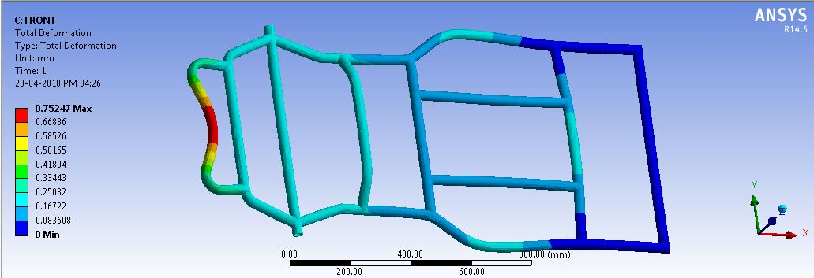

Front Impact Maximum Deflection
Maximum deflection= 0.752 mm.
2. Equivalent Von-Mises Stress
According to the front impact force acting on the chassis the following stresses are generated in Ansys.

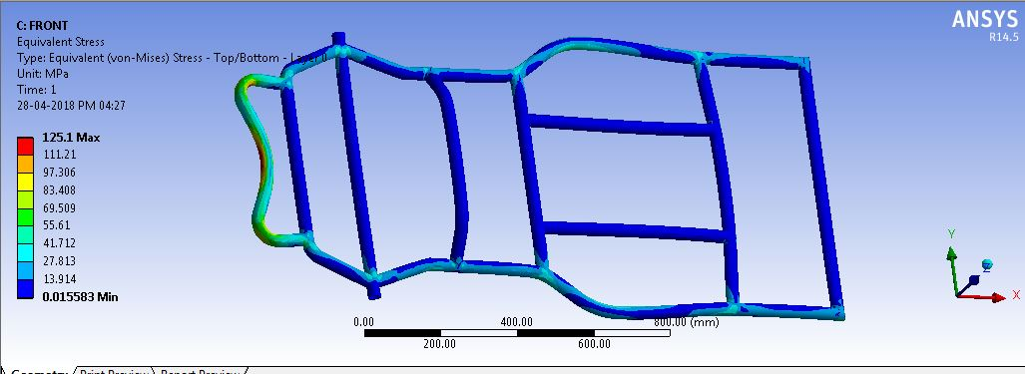
Front Impact Equivalent Stress
Maximum stress value = 125.1 MPa
3. Factor of Safety
The standard formula for finding the factor of safety is given below.
F.O.S. = yield stress / working stress
= 460 / 125.1
F.O.S. = 3.67
B. Rear Impact
1. Total Deformation
The 7573.32 N force is acting on the rear member of the chassis and constraint are given in front side of the chassis. We get the result of following deformation, in Ansys software.

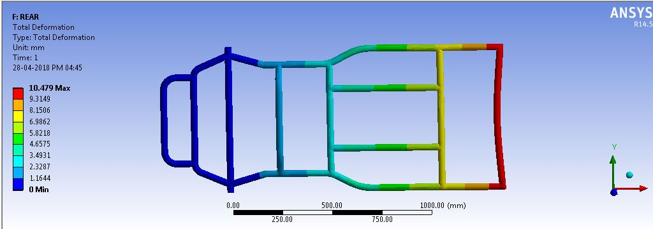

Rear impact maximum deflection

Maximum deflection = 10.47 mm.
2. Equivalent Von-Mises Stress
According to the rear impact force acting on the chassis the following stresses are generated in Ansys.
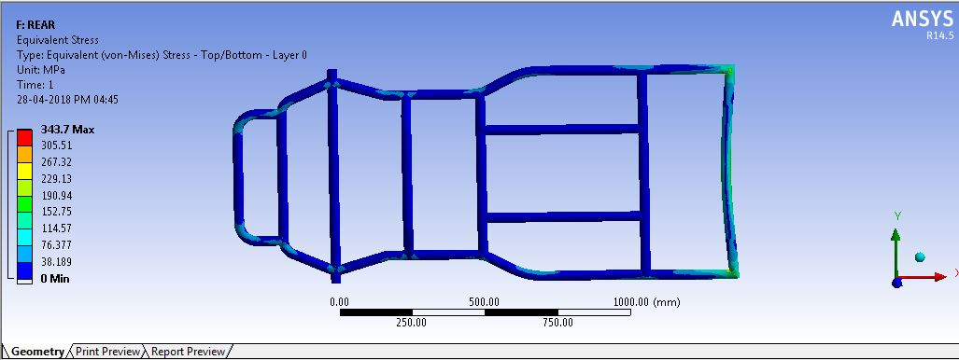

Rear impact equivalent stress

Maximum stress value = 343.7 MPa.
FOS = yield stress / working stress
= 460 / 343.7
FOS = 1.33
C. Side Impact
1. Total Deformation
The 7573.32 N force is acting on the side member of the chassis and constraint are given in opposite side of the chassis. We get the result of following deformation, in Ansys software.

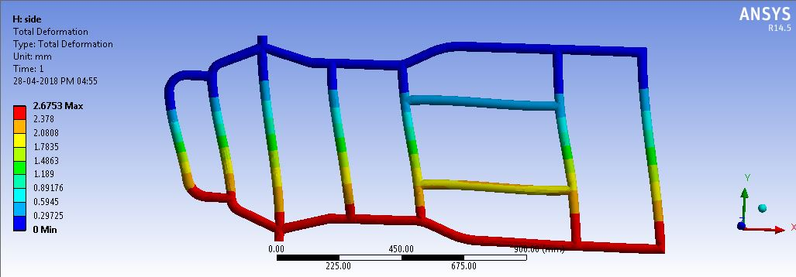

Side Impact Maximum Deflection

Total deformation = 2.67 mm
2. Equivalent Von-Mises Stress
According to the side impact force acting on the chassis the following stresses are generated in Ansys
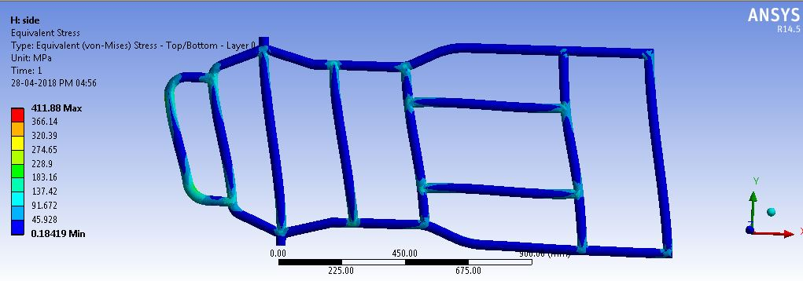

Figure 7.6: Side Impact Maximum Stress

Maximum stress value = 202.37 MPa
F.O.S. = yield stress / working stress
= 460 / 411.88
F.O.S. = 1.11
D. Loading
Figure below shows the forces that have been imposed downward to the structural model. The load is distributed uniformly on member below of driver’s seat and engine compartment.
Load applied on the frame is approximately 1157.58 N.
1. Total Deformation
The 1157.58 N force is acting on the respective member of the chassis and constraint are given on the chassis. We get the result of following deformation, in Ansys software.

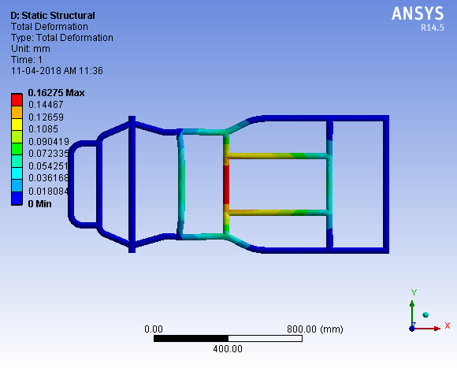

Deformation of vertical load condition

Maximum deformation = 0.162 mm
2. Equivalent Von-Mises Stress
According to the static impact force acting on the chassis the following stresses are generated in Ansys.

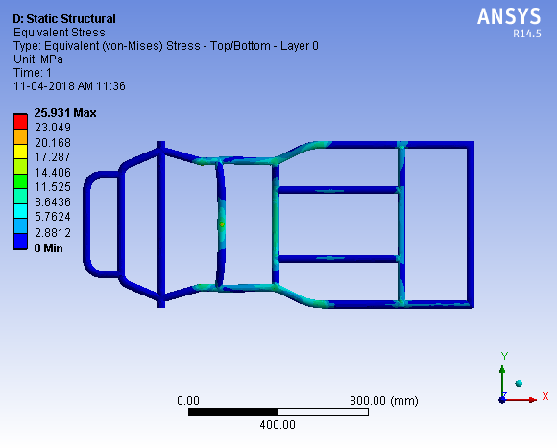

Equivalent stress of vertical load condition

Maximum stress=25.931 MPa
F.O.S. = yield stress / working stress
= 460 / 25.93
F.O.S. = 17.74
V. VALIDATION OF RESULT OF COMPUTATIONAL ANALYSIS BY NUMERICAL CALCULATION:
In this we calculate Shear Forces & Bending Moment, also we calculate the Maximum Deformation occur in chassis as a validation.
Parameters:
1) Front overhang (a) = 508 mm
2) Rear overhang (c) = 254 mm
3) Wheel Base (b) =1219.2 mm
4) Total Length = 1981.2 mm
5) Weight of Front Bumper (F_{FB}) = 3 Kg= 29.43 N
6) Weight of Steering System (F_{S}) = 8 K =78.48 N
7) Weight of Driver (F_{D}) = 60 Kg
If we consider 25% extra then it is equal to 75 Kg = 735.75 N
8) Weight of Firewall (F_{FW}) = 10 Kg = 98.1 N
9) Weight of Engine (F_{E}) = 40 Kg = 392.4 N
10) Weight of Shaft & Power Train (F_{SPT}) =30Kg = 294.3 N
11) Weight of Rear Bumper (F_{RB}) =3 Kg=29.43 N
12) UDL of Frame= (24Kg*9.81)/(1981.2)=0.118 N/mm
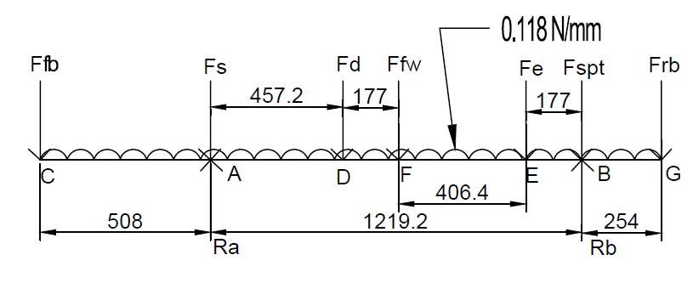
Force Diagram (All Dimensions are in mm)
Calculation of Reaction Force,
Chassis has two beams. So load acting on each beam is half of the Total load acting on the chassis.
- Load acting on Single Beam=1893.33/2=946.665N
- Length of Beam = 1981.2 mm
- Total Weight of Kart with Driver = 193 Kg
A. Calculation for Normal Reaction
∑ All Vertical forces = 0
∴F_{FB}+F_{S}+F_{D} + UDL*length+F_{FW}+F_{E} + F_{SPT} +F_{RB} = R_{A} + R_{B}
∴R_{A}+R_{B =} 193*9.81/2
∴R_{A}+R_{B}= 946.665 N
Now,
∑ M_{A} = 0
∴-F_{FB} * 508 + F_{S} * 0 + R_{A} * 0 + F_{D} * 451.2 + F_{FW} * 635 + UDL * length * 1219.2/2 + F_{E} * 1041.4 + F_{SPT} * 1219.2 - R_{B} * 1219.2 + F_{RB} * 1473.2 = 0
∴-29.43 * 508 + 0 + 0 + 735.75 * 457.2 + 98.1 * 635 + 0.118 * 1981.2 * 609.6 + 392.4 * 1041.4 + 294.3 * 1219.2 - R_{B} * 1219.2 + 29.43 * 1473.2 = 0
∴ RB*1219.2= 413628.84+953325.459
∴ RB= (1366954.299/1219.2) = (1096.66/2)
∴R_{B}= 548.33 N
Now,
∴R_{A}=946.665-548.33
∴ R_{A}=398.33 N
B. Shear Force Analysis
1) S.F. on L.H.S. of C = 0 N
S.F. on R.H.S. of C = -29.43 N/2 = - 14.715 N
2) S.F. on L.H.S. of A = -29.43/2 - 0.118 * 508/2
= - 44.687 N
S.F. on R.H.S. of A = -44.687 - 78.48/2 + 398.335
= 314.408 N
3) S.F. on L.H.S. of D = 314.408 - 0.118 * 457.2/2
= 287.433 N
S.F. on R.H.S. of D = 287.433 - 735.75/2 = - 80.442 N
4) S.F. on L.H.S. of F = -80.442 - 0.118 * 177.8/2
= -90.932 N
S.F. on R.H.S. of F = -90.932 - 98.1/2 = -139.982 N
5) S.F. on L.H.S. of E = -139.982 - 0.118 * 406.4/2
= - 163.95 N
S.F. on R.H.S. of E = -163.95 - 392.4/2= - 360.15 N
6) S.F. on L.H.S of B = -306.15 - 0.118 * 177.8/2
= - 370.64 N
S.F. on R.H.S. of B = -370.64 - 294.3/2 + 548.33
= 30.53N
7) S.F. on L.H.S of G = 30.53 – 0.118 * 254/2 = 15.55 N
S.F. on R.H.S of G = 0 N

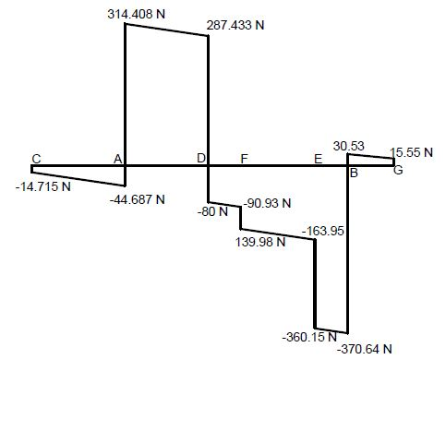
Shearing Force Diagram
Maximum Shear Force at point A which is equal to 314.408 N & Minimum Shear Force is obtained at point B which is equal to -370.64 N.
C. Bending Moment Analysis
∴B.M. at C = 0
∴B.M. at A = - F_{B}*508 - (0.118*508*508/2)
= (29.43/2) * 508 - (0.118*508/2) * (508/2)
= -137.668 Nmm
∴B.M. at D = - F_{B}/2 * 965.2 - F_{s}/2 * 457.2 + R_{A}* 457.2 - (0.118*965.2)/2 *965.2/2
= -29.43/2 * 965.2 - 78.48/2 * 457.2 + 398.335 * 457.2 - (0.118*965.2)/2*965.2/2
=122492.79 Nmm
∴B.M. at F = - F_{B}/2 *1443 – F_{S}/2 *635+ R_{A}*635- F_{D}/2 *117.8 - (0.118*1143)/2 *1143/2
= - 29.43/2*1143 78.48/2*635+398.335*635-735.75/2*117.8-(0.118*1143)/2 *1143/2
= 129330.159 Nmm
∴B.M. at E = - F_{FB}/2 * 1549.4 – F_{S}/2 *1041.4+ R_{A}*1041.4- F_{D}/2*584.2 - F_{FW}/2*406.4 – (0.118*1549.4²)/2²
= - 29.43/2 *1549.4 -78.48 / 2 * 1041.4 + 398.335 *1041.4 - 735.75/2 *584.2-98.1/2 *406.4 – (0.118*1549.4²)/2²
= 45496.732 Nmm
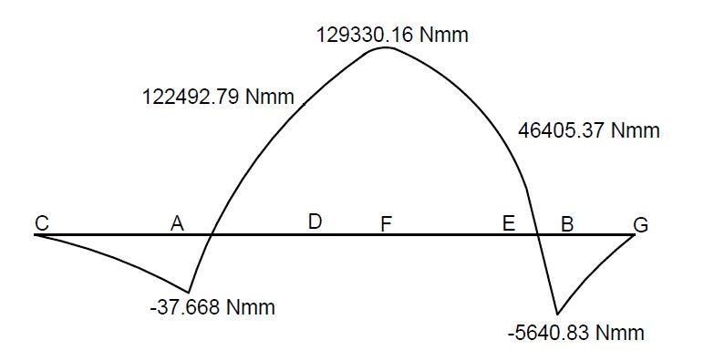
Bending Moment Diagram
D. Pipe thickness calculation
We have,
σ_{yield} =460 N/mm²
We know that,
σ_{b} = M_{max}*y/I
460 = 129330.159 * 15.875 / {π/64[31.75⁴ – D_{i}²]}
∴D_{i} = 31.014
∴Theoretical Thickness of Pipe = D_{o} – D_{i} = 0.736
Available dimensions of Pipe in market are as follows:
Outer Diameter (D_{o}) = 1.25” = 31.75mm
Inner Diameter (D_{i}) = 1.13” = 25.75mm
Thickness (t) = 3mm
Working stress is as follows:
σ_{b} = M_{max}*y/I
= 129330.159 * 15.875 / {π/64[31.75⁴ – 25.75²]}
= 72.54 N/mm²
Working σ_{b <}σ_{yield}
FOS =460/72.54 = 6.34
E. Deformation Analysis
Deformation = W × (b-x) / (24EI) {x (b-x) + b² - 2 (c² + a²) – 2/b [xc² + a² (b-x)]}
=1893.33(1219.21143)/2×24×210×28300×1981.2 {1143(1219.2 – 1143) + (1219.2)² -2 (254² + 508²) – 2/1219.2 [1143×254² + (1219.2 – 1143)]}
= 0.1984 mm

In this we design the model of chassis and analyse it. On Software computational basis, we calculate the deformation of chassis in full load condition. We also calculate the same on Numerical basis and we found approximately same result by both analysis. We found approximately same deformation. From this we can say our design is ergonomically good and safe.

Following table shows the comparison between Software computation and Numerical Analysis.
Sr. No. | Parameters | Computational Analysis | Numerical Analysis
1 | Deformation | 0.162 mm | 0.198mm

Comparison of Computational and Numerical Analysis
VI. CONCLUSION
We concluded that after the Software Computation Analysis and Numerical Analysis, we found the approximate same deformation in chassis which is negligible. Also FEA analysis is successfully carried out on CAD model to determine Equivalent Stresses and Factor of Safety. We found the Factor of Safety greater than 1, that conclude our chassis design is safe and the material used that is AISI 4130 is best material for Go-Kart Chassis.

REFERENCES
1]A.HARI KUMAR, V.DEEPANJALI, “DESIGN & ANALYSIS OF AUTOMOBILE CHASSIS”, International Journal of Engineering Science and Innovative Technology (IJESIT),Volume 5, Issue 1, January 2016, ISSN: 2319-5967
2]HARSHA PATIL, SAURABH BHANGE, ASHISH S. DESHMUKH “DESIGN AND ANALYSIS OF GO-KART USING FINITE ELEMENT” International Journal of Innovative and Emerging Research in Engineering Volume 3, Special Issue 1, ICSTSD 2016.
3]RAVINDRA LAXMAN GAIKWAD, PRATHMESH VISHWAS WAGHMARE, “DESIGN OF GO-KART VEHICLE SYSTEMS”, International Conference on Emerging Trends in Engineering & Management Research ISBN: 978-81-932074-7-5.
4]PRASHANT THAKARE, RISHIKESH MISHRA, KARTIK KANNAV, NIKUNJ VITALKAR, SHREYAS PATIL, “DESIGN AND ANALYSIS OF TUBULAR CHASSIS OF GO-KART”, International Journal of Research in Engineering and Technology-ISSN: 2319-1163.
5]D.RAGHUNANDA, A.PANDIYAN, SHAJIN MAJEED, "DESIGN AND ANALYSIS OF GO-KART CHASSIS" International Journal of Engineering Sciences & Research Technology November, 2016, ISSN: 2277-9655.
6]MR.VIRENDRA.S.PATTANSHETTI, "DESIGN AND ANALYSIS OF GO KART CHASS", International Journal of Mechanical and Industrial Technology, Vol. 4, Issue 1, pp: (150-164), Month: April 2016, ISSN 2348-7593.

