Development and Fabrication of Modified Evaporative Cooler
Pratik Bhake¹, Shrirang Joshi¹, Kunal Kumar Mishra¹, Ataul Haque¹
Prof. (Mrs.) Prachi K. Tawele², Prof (Ms.) Sonam V. Sontakke²
1* UG Students, Department of Mechanical Engineering, Priyadarshini College of Engineering, Nagpur.
2* Assistant Professor, Department of Mechanical Engineering, Priyadarshini College of Engineering, Nagpur.

Abstract – An evaporative cooler also known as swamp cooler or desert cooler, is a device that cools air through the evaporation of water. Evaporative cooling differs from typical air conditioning system which use vapour compression or absorption refrigeration cycle. Evaporative cooling works by using water’s large enthalpy of vaporization. The temperature of dry air can be dropped significantly through the phase transition of liquid water to water vapor which is known as evaporation, which can cool air using much less energy than refrigeration.
In this system we are using this concept for cooling of air. We have designed a air cooler that does not contain water pump , while the other coolers present in the market which are equipped with water pump to wet the cooling material. We have also used air filters at the outer vents of the cooler so that we can able to clean as well as cool the air and also make it more hygienic. By designing the cooler in such a manner we were able to wet the cooling material completely and get good results out of it.
Keywords - Evaporative Cooling, Air Cooler, Water Pump, Air Filters.

1. INTRODUCTION

Evaporative cooling has been in use for many decades in India for cooling water and for providing thermal comfort in hot and dry regions. Evaporative air conditioning systems offer an attractive alternative to the conventional summer air conditioning systems in places, which are hot and dry. Evaporative air conditioning systems also find applications in hot industrial environments where the use of conventional air conditioning systems becomes prohibitively expensive. In addition, evaporative cooling systems are more environmentally friendly as they consume less energy and their performance improves as air temperature increases and humidity decreases. As it is relatively cheap and requires less energy than other forms of cooling thus it has a prime importance in summer season and hot condition.

2. LITERATURE REVIEW

Numerous articles dealing with theory and working of evaporative cooling have been published over last 5 years, but topic is still under considerable development. We have examine the work related to concept of evaporative cooling published in referred journals.
The various researchers have applied different methodologies to get evaporative cooling effect. The literatures are classified on the basis of methodology applied for the particular applications, but following are few research gaps which are found in the literature :

- The methodologies used by different authors are partially difficult to understand.
- There are number of papers available in different field of evaporative cooling but very few papers are available related to reduce the water consumption.
- Very less research work is done related to reduce noise in operation.
- So that the areas for future research can be summarized as water consumption, quality of air, noisiness in operation which are not explored yet with full potential.

The literature survey of evaporative cooling technology applicable in hot & dry area was carried out, which states Evaporative cooling is more economic, effective and energy saving in hot and dry climates. The performance and effectiveness of evaporative cooling depends upon inlet air velocity, air mass flow rates and moisture contents present in the environment and it also depends on thickness of evaporative media and geographical locations. [1]
So more attention and lot of research is required in this area for developing new technologies related to evaporative cooling.

3. COMPONENTS OF THE SYSTEM

The main components of modified evaporative air cooler are outer body, Cylindrical cage, Fan blades (centripetal flow blade, axial flow blade), Motor (cage motor & shaft motor), Air filter and Cooling pad material i.e., wood wool.
3.1 Outer Body :
- The arrangement of the air cooler will be in horizontal form.
- Two air vents are provided on the either side of the cooler to pull the air centripetally into the cooler.
- Air vents are also provided on the back of the cooler to pull the air from the backside of the cooler.
- The side vents are so designed that they can slide upwards for maintenance or for milling the water to wet the wood wool.
- The top portion of the cooler can also be removed for disassembly of the entire cooler and for removing the cylinder cage.
- The front of the cooler consists of the air diverter to change the direction of the air in various directions.
- The switches of the cooler are provided on the right hand side of the air cooler to turn on and off the fan as well as the cylindrical cage.
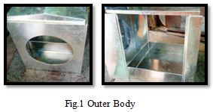

3.2 Cylindrical Cage :

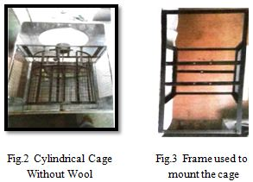

- The air cooler also consists of the cylindrical cage that is placed at the back of the motor.
- The cylindrical cage is rotated by the another motor which rotates the cage at a very slow speed of 6-8 rpm.
- The cage is mounted on the frame of the cooler to rotate at its position.
- Bearings are used here to reduce the friction between the moving parts.
- A shaft is placed in between the cage to rotate the cage. This shaft is connected to the low rpm motor.
- By using cylindrical cage and rotating it were able to avoid using the water pump and saving the cost of the changing the pump again and again.
3.3 Fan Blades :
- In this cooler the blade motor has two blades over it. That two blades are Centripetal Flow Blade and Axial Flow Blade.
- The centripetal flow blade helps in collecting the air in centripetal manner and moves it forward.
- The air which is moved forward is now pulled by the axial flow fans which throw the air at a larger distance so we can obtain better cooling at a larger space.
- By placing both the fan blades on the same shaft which is run by the same motor, we don’t require extra power to run the both the blades. A single motor is doing the work for both of the blades.
- The axial flow blades consists of 6 blades and is of 16 inch and the centripetal flow blades consist of 4 blades and is of 9 inch.
- The size of the centripetal flow blade is taken small so as to reduce the load on the motor.
- Both the blades are so arranged that they throw the air in the same direction and at the same time.

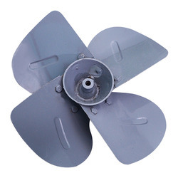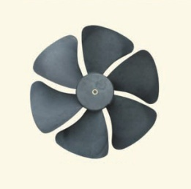
Fig.4 Centripetal Flow Blade Fig.5 Axial Flow Blade
3.4 Motor :
A. Blade Motor :

- The motor used in this project is of clockwise direction.
- The motor has shaft of 1 inch on both sides to mount the blades on either side of it.
- The motor requires 200W and 230V single phase.
- The speed of the motor is of 1400 RPM.
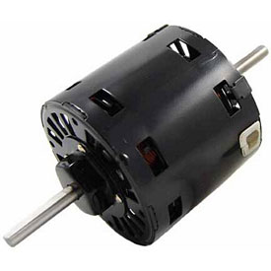
Fig.6 Blade Motor
B. Cage Motor :

- The motor used for the cage is of 10 rpm side shaft.
- The diameter of the motor is of 37mm.
- It has sturdy construction with gear box built to handle small torque produced by the motor.
- The motor has 6mm diameter, 22mm length drive shaft with D-shape for excellent coupling,
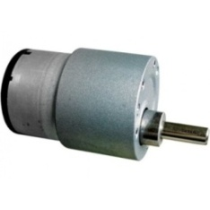
Fig.7 Cage Motor
3.5 Air Filter :
- We have used air filters on both the side vents of the cooler.
- The air filter cleans all the dust particles in the air and provided clean air for further cooling of the air.
- By using air filter we are able to increase the life of the wood wool.
- The air filter is easily removable and washed or changed when required.

4. DESIGN SPECIFICATIONS
The design specifications of evaporative cooler are as follows :

Table.1 Design Specifications

AREA
Length | 36”
Breath | 24”
Height | 30”
GAUGE STEEL SHEET | 60MM
FAN BLADES
Axial Flow Fan | 16 Inch, 6 Blades
Centripetal Flow Fan | 9 Inch, 4 Blades
MOTOR SPECIFICATION
FAN MOTOR SPECIFICATION
Shaft | Two Sided Shaft
Power : | 200W, 230V
Revolution | 1400 Rpm
Diameter | 37MM
CAGE MOTOR SPECIFICATION
Shaft | Side Shaft.
Revolution | 5-10 Rpm
Diameter | 6MM
Length Drive | 22MM
WATER CAPACITY | 100 Litres.
COOLING POD MATERIAL | Wood Wool

5. WORKING METHODOLOGY
- The evaporative cooler works on the principle of evaporation. The working of the cooler is simple. The working can be so explained as the surrounding air pulled in by the cooler, the air gets in contact with the water and the water content of the air increases. Due to this increases in water content the air gets cooled because of the air losses its heat.
- The working of the evaporative cooler and regular cooler is similar to each other. All the evaporative coolers have a cooling medium in it. In our cooler we have used wood wool as it is cheap and readily available everywhere. The surrounding air already consists of dry air and water vapour, but by suing an evaporative cooler we increase in it.
- The working principle of this type of cooler is that it pulls the air inside centripetally manner through the centrifugal flow fan and then this air is forced forward at a long distance with the help of the axial flow fan.
- The air is pulled through the wood wool which is wrapped over the cylindrical cage. As the cylindrical cage rotates inside the cooler with the help of the low rpm motor the wood wool absorbs water from the water tank at the bottom of the cooler and when the air is pulled through the cylindrical cage the wet wool cools the air and gives the cooling effect.

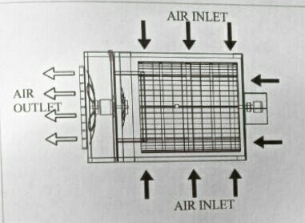

Fig.8 Air flow of the cooler

The speed of motor can be controlled using the regulator if attached to the cooler. The speed of the cylindrical cage is kept slow to allow the wood wool to get enough time to absorb water from the water tank. If the speed of motor is kept high the wood wool would not get enough time to collect water from the tank and the proper cooling will not be achieved. One more problem that can arrive while rotating the cage high speed that the water may splash out of the evaporative cooler which can be dangerous, therefore the speed of the cage is kept slow to absorb good amount of water in it.

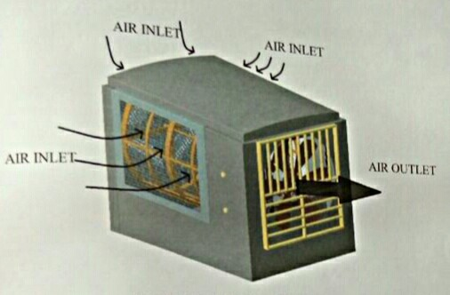

Fig.9 Actual air flow of the cooler

- The motor chosen for the fan blades is a high speed one so as to cool the given area at a faster rate. The centripetal fan is kept slightly inside the cylindrical cage to collect the air more effectively from the wood wool. The air that is pulled by the centripetal fan is now pulled by the axial flow fan.
- The axial flow fans are arranged in front of the motor so that they can throw the air at a larger distance and cool more effectively to the surrounding area.
- The benefit of using the cylindrical cage is that the air drawn is more efficiently from all the places whereas in the normal evaporative coolers the air is not drawn from the corners of the cooler body. Here by using a cylindrical shaped cage we are able to draw the air more effectively and get a very good cooling effect.
5. RESULTS
The experiment is carried out with both conventional air cooler and modified evaporative air cooler to record observations in a 500 Sq.Ft. for five hours in Nagpur. Properties of the room considered for experimentation are :

- The floor is covered by tiles.
- Two sides of the room are covered by concrete walls.

Table.2 Initial Condition
SR. NO. | CONDITION | TEMPERATURE  (○C)
1. | Room Temperature | 36○C

After taking the observations from last 5 hours, we can make the following comparison between both coolers :
Table.3 Comparison of Room Temperature using Conventional Air Cooler and Modified Air Cooler
SR. NO. | TIME IN MINUTES | TEMPERATURE  (○C)
 |  | Conventional Air Cooler | Modified Air Cooler
1. | 0 | 36 | 36
2. | 30 | 34 | 33
3. | 60 | 32 | 31
4. | 90 | 30 | 29
5. | 120 | 30 | 28
6. | 150 | 29 | 27
7. | 180 | 29 | 26
8. | 210 | 28 | 26
9. | 240 | 28 | 25
10. | 270 | 28 | 25
11. | 300 | 28 | 24

It is observed from Table 3 that in five hours, the room temperature decreases from 36 ○C to 28○C by using conventional air cooler, in last two hours the temperature of remains constant at 28○C. While using modified Air Cooler, the room temperature decreases up to 24○C which is 4○C less than conventional air cooler.
Below graph shows the comparison between Conventional Air Cooler and Modified Air Cooler.

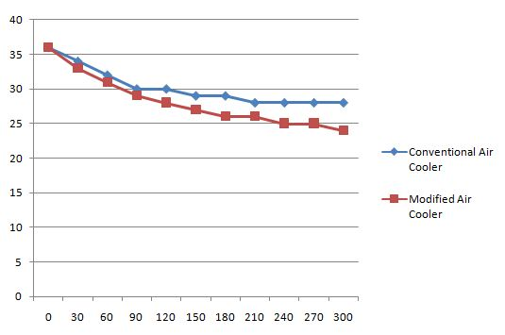
On X-Axis = Time in Minutes
On Y-Axis = Temperature (○C)

Fig. 8.1 Comparison Between CAC & MAC
6. CONCLUSION
- As less number of parts are coming in contact with the water the chances of rust is reduced and life of the cooler is increased.
- Eliminating the use of water pump, so there is no need of change the water pumps yearly which cost around Rs.300-400.
- Water consumption is low as compared to conventional air cooler.
- Because of its simple design, it is easy to change the wood wool.
- More hygienic than the conventional air cooler as there is no water falling outside the cooler, which results no leakage of water.
- By using the air filters on the side vents, the cooler even purifies the coming outlet air so than we can get cleaner air along with cool air.
- Better air cooling capacity than conventional air cooler.

SCOPE FOR FUTURE WORK

- In this project we can make the provision of cold storage box for storing perishable items.
- By making changes in design, it also can be used for the purpose of storage of vegetables, bakery products, medicines, drinking water etc.
- By making changes in design, total cost will also get reduced.

REFERENCES

- Prachi K. Tawele & Pratik Bhake, “Evaporative Cooling Technology – A Literature Review”, International Journal of Science, Research & Development, March-2017.
- D. A. Hindoliya, “Direct Evaporating For Thermal Comfort in a Building in the Summer Months for Four Climatic Zones of India”, 2004.
- Velasco Gomez & Rey Martinez, “The Phenomenon of Evaporative Cooling from a Humid Surface as an Alternative Method for Air Conditioning”, International Journal of Energy & Environment, 2010.
- S. S. Kachhwaha and Suhas Prabhakar, “Heat and mass transfer study in a direct evaporative cooler”, Journal of Scientific and Industrial Research, Vol. 69, September 2010.
- Vivek W. Khond, “Experimental Investigation of Desert Cooler Performance Using Four Different Cooling Pad Materials”, American Journal of Scientific & Industrial Research, 2011.
- Poonia M. P., “Design & Development of Energy Efficient Multi-Utility Desert Cooler”, Universal Journal of Environmental Research & Technology, 2011.
- Seth I. Manuwa, “Evaluation of Pads & Geometrical Shapes For Constructing Evaporative Cooling System”, Journal of Modern Applied Science, 2012.
- M. S. Sodha and A. Somwanshi, “Variation of Water Temperature along the Direction of Flow: Effect on Performance of an Evaporative Cooler”, Journal of Fundamental of Renewable Energy and Applications, Vol. 2 (2012) .
- R. K. Kulkarni, “Comparative Performance Analysis of Evaporative Cooling Pads & Alternative Configurations & Materials”, International Journal of Advanced In Energy & Technology, 2013.
- Ashok Kumar Sharma, Pawan Bishnoi, “Development and testing of natural draught desert cooler”, International Journal of Science and Engineering Applications, Vol. 2, Issue 1, 2013.
- V. S. Shammy Srinivasa, H. S. Lohit, “Design And Development of a Low Cost Air Cooler”, Sastech Journal, Vol. 12, Issue 2, September 2013.
- Krishna Shrivastava, “Modified Air Cooler With Split Cooling Unit”, International Journal Of Science & Research, 2014.
- Dr. Sunil Prayag, “Review of Direct Evaporative Cooling with Its Applications”, International Journal of Engineering Research & General Science, 2014.
- R. Bouknanouf, H. G. Ibrahim, “Investigation of an Evaporative Cooler for Buildings in Hot & Dry Climates”, International Journal of Clean Energy Technology, 2014.
- Amit Kumar Jain, “Thermal Performance Analysis of Pump Less Earthern Pipe Evaporative Air Cooler”, International Journal Of Engineering Research And Applications (IJERA), 2014.
- Kumar Sourav, “Modified Indirect Evaporative Cooling For Desert Cooler”, International Journal Of Science Engineering & Technology, 2015.
- Amit Chandak, “Study of a Pump Less Air Cooler”, IJARIIE, 2016.
- Upendra Parashar, “Performance Enhancement of Evaporative Desert Cooler by Using Cooling Duct”, International Journal of Advance Research In Science Engineering & Technology, 2016.
- S. Rajavel, “Design & Development of Modified Air Cooler & Storage System”, International Research Journal of Energy & Technology, 2016.

Details of all authors :

PROF. PRACHI K. TAWELE

Assistant Professor
Department of Mechanical Engg.
Priyadarshini College of Engg., Nagpur.

p.tawele@gmail.com

PRATIK D. BHAKE

UG Student
Department of Mechanical Engg.
Priyadarshini College of Engg., Nagpur.

pratik.bhake@gmail.com

Kunal Kumar Mishra

UG Student
Department of Mechanical Engg.
Priyadarshini College of Engg., Nagpur.

kmishra853@gmail.com

PROF. SONAL V. SONTAKKE

Assistant Professor
Department of Mechanical Engg.
Priyadarshini College of Engg., Nagpur.

SHRIRANG D. JOSHI

UG Student
Department of Mechanical Engg.
Priyadarshini College of Engg., Nagpur.

shrirangjoshi49@yahoo.com

ATAUL M. HAQUE

UG Student
Department of Mechanical Engg.
Priyadarshini College of Engg., Nagpur.

ataulhaque07@gmail.com

