Analysis of Pile under Lateral Loads Using ALP Module

Gajendra Ahir¹, Sanket S. Sanghai²
M. Tech Scholar¹, Assistant Professor²
Department of Civil Engineering
G. H. Raisoni College of Engineering, Nagpur, India
Corresponding Author’s Email: ahirgajendra8@gmail.com¹, sanket.sanghai@raisoni.net²

Abstract: The main aim of the present study was to analyze the piles under the lateral loads using OASYS ALP software. Further, the effect of variation in soil properties, and diameter of pile on rotation, deflection, and bending moment were evaluated. The Humboldt Bay Middle Channel Bridge was considered as the case study. Three different pile lengths of 500 mm, 1000 mm and 1200 mm were considered for the present study along with the three layers of soil introducing non-linearity. The P-Y model was used for the analysis of lateral load. The results showed that with an increase in the diameter of the pile the deflection and the rotation goes on decreasing till the layer of soft clay. The point of fixity lies at the 2 m from the top of the pile. Moreover, with an increase in diameter from 500 mm to 1000 mm the deflection decreases up to 50 % and from 1000 mm to 1200 mm decreases upto 25 %. Finally, the load-deflection characteristics are studied and were compared with the values obtained from IS code. It was found that the load-deflection relationship was found to be linear for the present case. The output of the present study will be useful for proper analysis and design of the piles subjected to the lateral loads.
Keywords-Pile soil interaction, ALP
INTRODUCTION
Nearly all structures of civil engineering have some structural elements that have direct contact with the soil medium. Therefore, an analysis should also be carried out taking into account soil behavior. The superstructure analysis model should be verified with the correct soil foundation response. The primary idea at the back of the provisions is that the soil-structure gadget may be replaced with an equal constant-base version with a longer length and usually a larger damping ratio. Soil Structure Interaction (SSI) is defined as the effect of soil movement on the structure and the effect of structure on the soil. Whilst a shape is subjected to an earthquake excitation, it interacts with the inspiration and the soil, and hence modifications the movement of the ground. Historically, there have been many case histories in which pile foundations have suffered both total collapses and excessive damage throughout earthquake loading. Some pile foundations finished adequately at the same time as others have suffered damages.
LITERATURE REVIEW
Various studies were carried out in the past on the effect of adjoining soil on the structure in the aspect of lateral loads mostly seismic activities. Some of them are discussed below.
In the study of Kong et al. (2006) Finite Element Model (FEM) was developed for the pile-supported structures in order to analyze the soil structure interaction. The numerical analysis is presented comparing finite element method and simplified method. Earthquake intensity and characteristics of the spectrum were found to most influencing factors for the seismic behaviour of the soil structure interaction. This study has provided the guidelines for the design of the pile-supported elements considering interaction with the corresponding soil. Callisto et al. (2013) illustrated the behaviour of the seismic soil structure interaction developed in the early stage of bridge design at Messina Strait Bridge. Nonlinear dynamic analyses were carried in the time domain for effect of two records which includes two dimensional (2D) plane analyses. The results show that the immersed foundation condition affects the soil condition greatly than the dynamic response of the superstructure in aspect of soil-structure interaction. Mukherjee and Dey (2016) conducted the study on lateral load behavior capacity of single pile having layered soil of clay and sand using P-Y approach. The analysis was carried out by assuming the fixed headed pile using the OASYS ALP software. The results showed that the flexural response of the soil is depending upon the soil and diameter of pile. In the study of Halder and Bandyopadhyay (2016) the lateral load capacity of piles in layered cohesive soil is carried out using OASYS ALP software. The P-Y analysis was carried out using ALP and the results were compared with the IS code values. The results shows that the lateral load carrying capacity of pile is underestimated by the IS code procedure and also the increase in diameter increases the lateral load carrying capacity. According to the study of Das et al. (2016) the effect of intrinsic variability of un-drained shear strength of soft soil was examined in seismic design of structures supported by piled raft foundation. For the analysis purpose the superstructure and piled structure was modelled as the lumped mass stick model and as rigid plate respectively. The results showed that the fundamental period was following the normal distribution and shear force, bending moment and displacement at column and pile head were found to follow lognormal distribution. Inherent variability of soil was found to be one of the reasons for significant increase in shear force at column.
From the above literature it was found that the mostly studies about soil structure interaction were carried out for the buildings. Not much research was carried out on the soil and pile interaction. Hence, the objectives of the present study were oriented for assessment of soil pile interaction using the simulation software. For the present study the software platform Analysis of Laterally Loaded Piles (ALP) developed by OASYS is used.
METHODOLOGY
For determining lateral load capacity for a specific deflection (1% of pile diameter) at its cut off level, analysis as per IS code and ALP software has been used in this present study. The OASYS ALP software is considered in the present study as it is widely used for the analysis of the pile under the lateral loads. The model was developed for the analysis of soil pile interaction using load-deflection (P-Y) model as per the guidelines of ALP module (Oasys 2017). The three different soil layers were taken which being into non-linearity into the soil. Three different diameters of piles were considered for the present study as the 500 mm, 1000 mm and 1200 mm. The lateral load capacity was also evaluated from the IS code method (IS 2911 (Part 1/Sec 2) 2010). The load deflection relationship was thus developed and finally the sensitivity analysis was carried out to check the effect of pile diameter and soil properties on deflection, rotation and bending moment. The model was thus validated with the previous literature and finally conclusions and recommendations were made. The total length of the pile was found to be 25 m. The pile cut off length was assumed to be 2 m from the top of the pile. Also, the grade of concrete was considered as the minimum grade of concrete as M25 as per the guidelines given in IS 2911 (Part 1/Sec 2) (2010). The pile head is assumed to be fixed connection with the pile cap.
WORKING PRINCIPLE OF ALP SOFTWARE
Analysis of Laterally Loaded Piles (ALP) module under the OASYS software is used for the prediction of the effects caused due to the lateral loads on the piles in the form of pressures, ground movement in horizontal direction, induced shear force and bending moments. The premise for the ALP is that the modelling of pile is carried out as beam elements in series connection. Further, the modelling of soil is done as non-interactive and non-linear “Winkler type” springs (finite number of spring on rigid base). In this model only horizontal forces are allowed for the transmission in between soil and node. The P-Y curve for the discrete soil model is independent of shape, size, and stiffness of the pile. Further, the nodal forces are related to the displacements by developing two stiffness matrices; one with pile in bending and other representing the soil. Modeling of pile is done as the series of the elastic beam elements and the required stiffness matrix for the modeling is done on the basis of basic principles of slope-deflection equation. Fig. 1 represents the Soil pile interplay model done in ALP.
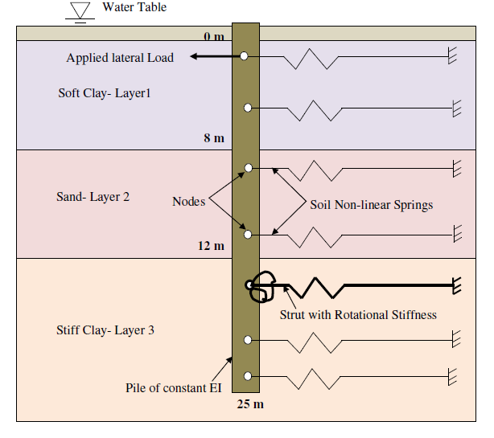
Fig. 1 Schematic model of Soil pile interaction in ALP

CAPACITY OF PILE AS PER INDIAN STANDARD (IS) CODE
The depth of fixity of piles has been calculated as per IS 2911 (Part 1/Sec 2) (2010) Refer Appendix – C
For 500 mm diameter of pile:
Diameter of piles (D) = 500 mm
$E=5000√fck$) = 25000.0 N/mm² = 25000 x10³ KN/m² (IS-456:2000 2000)
Moment of inertia of pile (I) = $\frac{π}{64}{×D}^{4}$ = 306796.16 cm⁴
EI = 25000 x10³ x 3.06796x10⁻³ = 76699.04 KNm²
To Calculate Stiffness factor R,
$R= 4√\frac{EI}{KB}$

K = $\frac{k1}{1.5}×\frac{0.3}{B}$ where, k₁ = modulus of subgrade reaction for cohesive soil in KN/m³ (Table 4 page no.14, IS 2911 Part-I /Sec 2)
B = width of pile shaft
R = stiffness factor
.’. KB = 2118.96 KN/m²
Stiffness factor $R= 4√\frac{EI}{KB}$ = 2.453 m
From fig - 4 of I.S: 2911 (Part-I /Sec 2)
To calculate length of fixity
L_{f} / R = 2.15 (fig.4 page no.15, IS 2911 Part-I /Sec 2)
.’. L_{f} = 2.15 × 2.453
= 5.274 m
Max. Permissible deflection y = 5 mm
To calculate Lateral load capacity for fixed head pile (Hu),
.’. $Hu=\frac{12EIy}{\left(L1+Lf\right)3}$
$Hu=\frac{12 ×76699.04×0.005}{\left(0+5.274\right)3}$ = 31.37 KN

Table 1 Lateral load capacity of Pile obtained from IS code
Dia. (mm) | y_{cut-off} (mm) | Hu (KN) | L_{fix} (m)
500 | 5 | 31.37 | 5.274
1000 | 10 | 125.409 | 10.55
1200 | 12 | 302.756 | 12.657
The obtained values for the different diameters of pile from IS code method is given in Table 1.
EFFECT OF LATERAL LOAD ON DIFFERENT DIAMETER OF PILE
The OAYSS ALP platform was used for the analysis purpose. The lateral load is thus estimated for the present condition using load-deflection method considering the inertial SSI. The total pile depth is divided into 55 numbers of nodes. The output of the OAYSS ALP for case1 is shown in the Fig. 2.
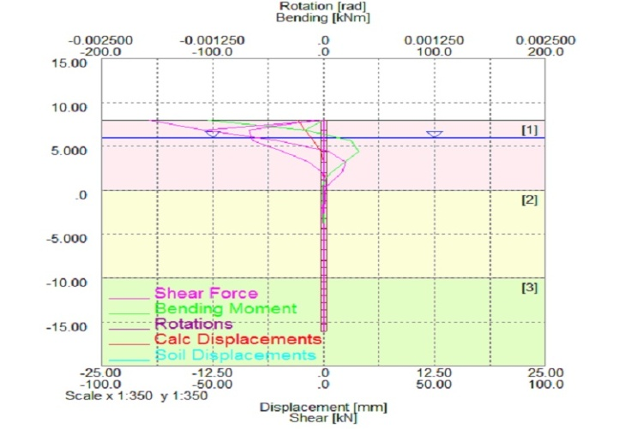
Fig. 2 (a) 500 mm diameter
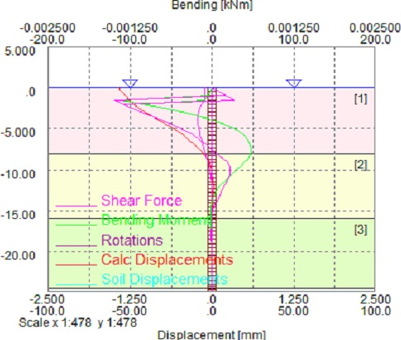
Fig. 2 (b) 1000 mm diameter
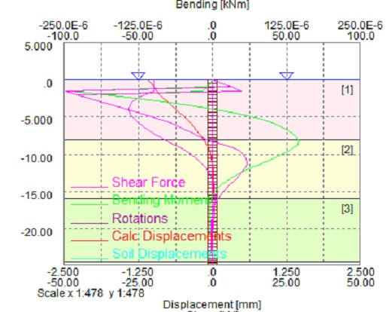
Fig. 2 (c) 1200 mm diameter
Fig. 2 Typical flexural response envelopes as obtained from ALP 19.3-Case 1
Sensitivity Analysis
Present study was carried out to check the effect of diameter on lateral load capacity, rotation of pile, shear force and bending moment induced and displacement occurred. Hence, the diameter is varied from 500 mm to 1200 mm in three steps keeping the other factors constant. The results obtained from the analysis are shown in Fig. 3.
Fig. 3 (a) depicts the effect of diameter on the rotation (in radian) keeping the other soil properties same. The results shows that the rotation shows peak at the 5 m depth for all pile diameter. The maximum rotation was observed for the pile having diameter 500 mm as it is having less width to restrict the lateral loads than the other diameter piles. But with an increase in diameter from 500 mm to 1000 mm the rotation decreases upto 50 % which shows the effect of pile stiffeness against the lateral loads. Further, with increase an pile diameter from 1000 mm to 1200 mm the rotation decreases upto 25%. Thus it is concluded that for stability purpose the diameter should be large enough to resist the lateral loads. Also, the effect of diameter remains constant below the 15 m pile depth.

Fig. 3 (a) Rotation envelope

Fig. 3 (b) Bending Moment envelope

Fig. 3 (c) Deflection envelope
Fig. 3 Envelope Obtained from ALP software for Case 1
Fig. 3 (b) shows the effect of diameter on bending moment (in kNm) keeping the soil properties constant. The results shows that the negative bending moment occured at top depth of pile which further changes to positive from 5 m depth and remains constant (nearly zero) from 15 m onwards (for 1000 mm and 1200 mm diameter) and 10 m onwards (for 500 mm diameter). It is worth noticing that the point of fixity, represented by the position of maximum bending moment, does not reveal significant change with the change in the diameter of the pile. This is attributed to the fact that ALP considers the passive resistance offered by the soil.
Fig. 3 (c) illustrate the variation in deflection occurred due to change in diameter. The results showed that the diameter increases the deflection goes on decreasing. The maximum deflection occurred on the top of the pile that is at 0m. The deflection was found to be highest for 500 mm diameter pile which remains mostly same for 1000 mm diameter and decreases suddenly 25 % with further increase in diameter of 200 mm.
LOAD DEFLECTION CHARACTERISTICS.
One of the main factors of occurrence of deflection is the load. The load variation with respect to diameter was compared with IS code values as shown in Fig. 4.
The results show that as the diameter increases the load carrying capacity increases. Also, it was observed that IS code values were less than the output produced by the ALP software. But as diameter increases the load from IS Code and software show less deviation from each other.
Further, the load-deflection characteristics were evaluated and the results show that as the load increases the deflection goes on increasing. The scatter plot was plotted for the load versus deflection and regression analysis was carried out for finding the relationship in between the load-deflection (Fig. 5).

Fig. 4 Load-diameter Envelope

Fig. 5 Load –Deflection Envelope
It was observed that the load-deflection show the linear relationship for the present study. Load-deflection (P-Y) curves developed reveal that the soil condition in present case show eminence in nonlinear behaviour and reaches the plastic limit under failure load condition.
CONCLUSIONS
The following conclusions were drawn from the present research work.
With an increase in diameter of the pile from 500 mm to 1200 mm the deflection goes on decreasing which shows that the increase in flexural rigidity of pile increases the stability against the lateral loads.
The maximum deflection occurred on the top of the pile that is at 0m. The deflection was found to be maximum for 500 mm diameter pile which remains mostly same for 1000 mm diameter and decreases suddenly 25 % with further increase in diameter of 200 mm.
It is worth noticing that the point of fixity, represented by the position of maximum bending moment, does not reveal significant change with the change in the diameter of the pile
REFERENCES
- Callisto, L., Rampello, S., and Viggiani, G. M. B. (2013). “Soil – Structure Interaction for the Seismic Design of the Messina Strait Bridge.” Soil Dynamics and Earthquake Engineering, Elsevier, 52, 103–115.
- Das, B., Saha, R., and Haldar, S. (2016). “Effect of In-Situ Variability of Soil on Seismic Design of Piled Raft Supported Structure Incorporating Dynamic Soil-Structure-Interaction.” Soil Dynamics and Earthquake Engineering, Elsevier, 84, 251–268.
- Halder, A., and Bandyopadhyay, K. (2016). “Lateral Load Carrying Capacity of Piles in Layered Cohesive Soils.” Indian Geotechnical Conference IGC2016 15-17 December 2016, IIT Madras, Chennai, India, 17–20.
- IS-456:2000. (2000). “Plain and Reinforced Concrete- Code of Practice.” Burea, (July), 1–100.
- IS 2911 (Part 1/Sec 2). (2010). “IS 2911 (Part 1/Sec 2).” Burea of Indian Standards, 1–29.
- Kong, D., Luan, M., and Wang, W. (2006). “Comparative Analysis of Seismic Response Characteristics of Pile-Soil-Structure Interaction System.” Journal of Ocean University of China, 5(l), 1–6.
- Mukherjee, S., and Dey, A. (2016). “Analysis of Laterally Loaded Fixed Headed Single Pile in Multilayered Soil using P-Y Approach.” Indian Geotechnical Conference IGC2016 15-17 December 2016, IIT Madras, Chennai, India ANALYSIS, 1–5.
- Oasys. (2017). “Alp19.3.”

