**Study on Azo-aldehyde Part-X: Synthesis, Characterization, Liquid Chromatography and Biological screening of Azo-salicylaldehyde from Nitro and Methyl-anilines**

**C. J. Patil¹, S. M. Harimkar2 , S. V. Rajput2**

*1Organic Research Lab., Department of Chemistry, MTES's Smt. G. G. Khadse College. Muktainagar-425 306. Dist. Jalgaon, MS. India*

*2Department of Basic Sciences and Humanities, HSM's ShriSantGadge Baba College of Engineering and Technology, Near Z.T.C., Bhusawal-425 203, Dist. Jalgaon. MS, India.*

***drcjpatil@yahoo.com***

***Received on****: 31 March,2023* ***Revised on****: 22 April,2023* ***Published on****: 24 April,2023*

***Abstract –****Azo derivatives of salicylaldehyde (I-II) were prepared by reaction of Salicylaldehyde derivatives (Ic) with diazonium salt of variedly substituted aniline (Ia-b) by diazo couplingsequence (retention of N). These were characterized by Schiff reagent test, analytical (viz. colour, physical constant, TLC and HPLC) and spectral (viz. UV-Vis, FTIR) methods. A simple, fast and accurate method has been developed and reported for the identification and screening of Azo aldehydes by chromatographic method, High-performance liquid chromatography (HPLC) and also the biological potency studywere reported.*

***Keywords-****Aldehydes, Schiff reagent test, Analytical - Spectral method, HPLC and Biological Potency.*

**INTRODUCTION**

The phenolic compounds showed reaction like diazotization and hence, due to variety applications of the azo compounds, it is interesting to study the synthesis of such azo phenolic derivatives. The extensive literature study shows the scope for study on their derivatives in order to explore the newer potentials of similar compounds. In the literature the amino1 and hydroxyl2-5 and ketone6 are the most common functional group of organic compounds used as coupling agents. A review on the azo compounds of aminobenzothiazoles7-8 and salicylic acid9and phenols10with aromatic or heteroaromatic motifs and its biological activities has also been reported therein. Very recently an azo group containing Beta-Lactams11-12were synthesized from azo aldehyde, to Schiff bases13-14 as reported. Recently, from our lab, synthesis of azo-azomethines12,15-21 were synthesized from azo-aldehydes12, 15-23.

While surveying the literature, it is marked that there are many studies on the synthesis but its analytical(limited to spectral and elemental) studies were less attended or very scare studies reported on the advanced analytical methods like HPLC, AAS, GC, electrochemistry and TGA.

As per the literature survey15-22 with respect to azo-aldehyde synthesis we have proposed following work and depicted in **Scheme-I**. Here, we proposed the synthesis as well as their advance analytical method like HPLC thought to undertake this initiative and studied the HPLC method development parameters in detail as per ICH guidelines. Such methodology would help research and developmental activities in exploring further, the estimation of Azo aldehydes by HPLC method. Also, these synthesized compounds were screened for the antifungal potential evaluation against two fungal strains.

Scheme of the Present Work: The following Scheme-I indicates the one step involved for the synthesis of particular Azo-aldehyde in the present work.

**EXPERIMENTAL**

1. **MATERIAL AND METHODS:**

All the reagents and solvents used are of synthesis grade and were purchased from Sigma Aldrich and Merck. Solvents were of synthesis and analytical grade.

1. **SYNTHESIS:**

**Synthesis of Substituted-azo-salicylaldehyde:** The diazonium chloride from substituted aniline(Nitro- and Methyl-) was synthesized and reacted with substituted-salicylaldehyde as per the following procedure12,15-22.

**Aniline to Azo-aldehyde, (E)-5-[(Substituted-phenyl)diazenyl]-2-hydroxy-benzaldehyde**

Where, **I,** R1 = NO2-, R2 = H; **II,** R1 = CH3-, R2 = -OC2H5;

**Scheme-I**: The reaction involved in the synthesis of Azo-aldehydes, **I-II**.

1. **Preparation of diazonium salt:** In 100 ml beaker charged 0.035 mol substituted-aniline, **Ia** further added to it 40 ml concentrated HCl and 15 ml distilled water, and the solution is cooled up to 0°C by keeping it in ice-salt bath (Solution-A). In a 250 ml RB flask, charged 0.045 mol of Sodium nitrite and dissolved 15 ml water and the solution cooled up to 0°C by keeping it in an ice-salt bath (Solution-B). When both the solutions attained 0°C temperature, Solution-B is added drop wise in Solution-A with constant stirring over one hour. During addition temperature is maintained up to 5°C. The diazotize solution was tested using starch iodide paper, which turns to blue color. A pinch of solid urea was added to decompose the excess of Nitrous acid. Filter the solution through cotton to get clear diazonium salt and is used for the next step of synthesis.
2. **Synthesis of Azo-aldehyde (I-II):** In 250 ml capacity beaker prepare a solution of 0.123 mol, Na2CO3 and 0.034 mol NaOH in 125 ml distilled water (if required add excess of Na2CO3 and NaOH). In the clear solution charge Substituted-salicylaldehyde, **Ic** 0.025 mol.The solution is cooled up to 0°C by keeping it in an ice-salt bath. Above filtered diazonium solution is added slowly to this content with vigorous stirring and during addition temperature is maintained up to 5°C. After complete addition, allow the charged mass to stand for 75 minutes in an ice bath. Filtered the dye, washed with cold water with pH check to neutral, dried, recrystallized the crude product, weighed and stored in an airtight container till to get a constant weight. It is assigned as **I**. This synthesis is in accordance with the modification in reported procedure12. The derivative, **II** also prepared using a similar procedure by changing the initial aniline to p-Methyl-aniline and the aldehyde to **II**.
3. **CHARACTERIZATION:**

The characterization of Azo-aldehyde derivatives was done by primary method like TLC and color and instrumental methods viz. UV-Vis, FT-IR and by usual HPLC Characterization.

1. **Primary Characterization:**

Color by visual method; Nature solid or liquid; Physical Constant (m.p.) by instrument recorded on Equiptronics digital m.p/ b.p. apparatus in degree calculus on model EQ-730 and TLC using TLC plates of silica gel coated aluminum plates made by Merck. The progress of the reaction was monitored by the TLC method.

1. **Schiff’s reagent Color Test for the Azo-aldehyde:**Schiff’s reagent is prepared by using 0.2 gm of Rosaniline hydrochloride and 100 ml water is mixed and this solution is decolourized by aqueous SO2 or H2SO3. Take powdered compound, in a test tube and add 2 ml of above prepared Schiff’s reagent, shake well and observe the color on standing.

**II.Secondary Characterization (Instrumental):**

The UV-Vis spectra were recorded on Shimadzu UV 1800 series spectrophotometer in the range of wavelength 800-200 nm. FT-IR spectra were recorded on (KBr pellets) FT-IR spectrophotometer (Shimadzu, 4000-600 cm-1). The instrumental work viz. analytical HPLC work was performed at a public testing laboratory exactly with reagent and the chemicals, preparation of mobile phase, as reported22.

In the present competitive world, the cost and time are very important points in the Good Manufacturing Practices24. The objective of method development25 is user friendly approach quality aspects are not compromised.

1. **PROCEDURE:**

**Sequence of injections**

**Sequence I:** 1) Blank, to check baseline

**Sequence II:** 1) Sample **I** and **II**.

Inject separately equal volumes (20 μl) of the Blank solution (i.e. Diluent) and desired sample solutions **I** and **II** of into the chromatograph. Record the chromatograms & measure the responses for the major peaks. Record and print the output result.

1. **EVALUATION OF BIOLOGICAL ACTIVITY:**

These synthesized Azo-aldehydes were screened22 for the antifungal potential evaluation against two fungal strains viz. *A. flavus (Aspergillus flavus) and C. albicans (Candida albicans).*

**RESULTS AND DISCUSSION:**

In the present work, Substituted-phenyldiazonium chloride reacted with Salicylaldehyde or Substituted Salicylaldehyde to obtain Azo-salicylaldehyde, as per the **Scheme-I**.

**Schiff’s Colour Test for the Azo-aldehyde:** Schiff’s reagent test, indicated, development of pink colour solution on standing. This confirms the presence of –CHO group in the newly synthesized compound **I** (**Fig. 1**).Similar reports were made in our earlier investigations20-22.

**I II**

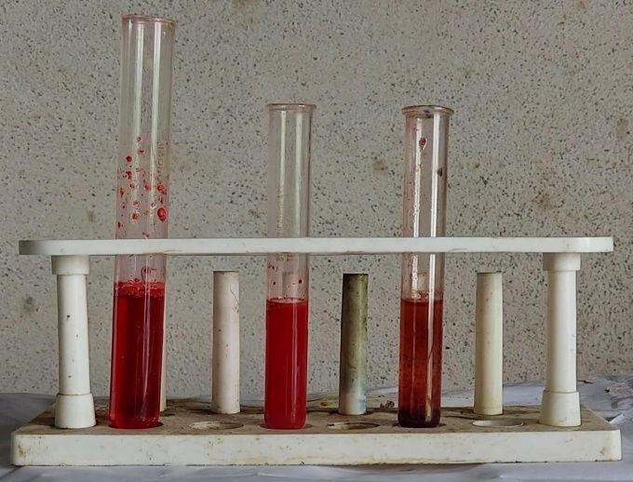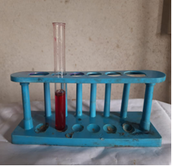

***Fig. 1:*** *Colour test – Schiff’s Reagent test for the synthesized azo-aldehyde respectively (****I*** *and* ***II)****.*

The physical and analytical data such as physical constant viz. m.p. range, colour and yield, for the synthesized Azo Salicylaldehyde and Azo substituted Salicylaldehyde.

The C, H and N data for azo-aldehyde, **I- II** is depicted in **Table 1**.

***Table 1:*** *The elemental micro-analysis data for varied Azo-aldehyde (****I-II) (Scheme-I).***

|  |  |  |  |  |  |
| --- | --- | --- | --- | --- | --- |
| **Code** | **R1-** | **R2-** | **Calc.(Obs.)** | | |
| % C | % H | % N |
| **I** | NO2- | H- | 57.17 (57.01) | 3.34 (3.32) | 15.49 (15.42) |
| **II** | CH3- | C2H5O- | 67.59 (67.55) | 5.67 (5.65) | 9.58 (9.61) |

The results in **Table 1**, indicated satisfactory C, H and N analysis.

The Physical and Analytical data of azo-aldehyde, I - II is given in **Table 2**.

The UV-Vis and FTIR spectral data for azo-aldehyde, **I-II**, is given in **Table 3**, the typical UV spectra of **I-II** is shown in **Fig. 2**.

***Table 2:*** *The Physical and Analytical data for Substituted-azo-aldehyde,* ***I-II (Scheme-I).***

|  |  |  |  |  |  |  |
| --- | --- | --- | --- | --- | --- | --- |
| **Code** | **Compound**  **M.F.** | **Mol. Wt. (g/mol)** | **Color** | **m.p.**  **oC** | **\*Rf**  **value** | **%**  **Yield** |
| **I** | C13H9O4N3 | 271.23 | Black brown | 181-184 | 0.72 | 84.60 |
| **II** | C16H16O3N2 | 284.31 | Brown | 190-191 | 0.68 | 74.02 |

* Pet ether: Ethylacetate 2.6: 0.4

**I II**

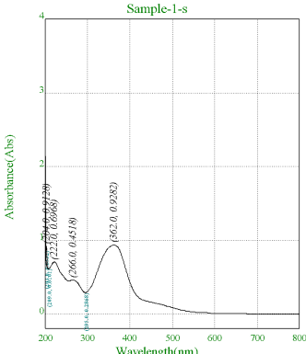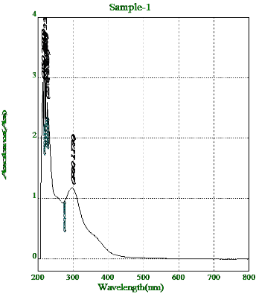

***Fig. 2****: UV-Vis spectrum of the Substituted-azo-aldehyde,* ***I-II****.*

The UV-Vis spectra of Azo-aldehyde, **I-II,** in ethanol shows 3 bands at about 362.0, 266.0 nm and 222.0 nm. The excitation at 362.0 nm shows n —> π* transition which may be due to –N=N– group and 266.0 nm and 222.0 nm arising due to π —> π* transition attributed to aromatic ring and, as shown in Fig.**2** and the data is depicted in **Table 2.** These UV-Vis observations are coinciding with the observations with earlier reports15-18,21.

**Table 3:** The UV-Vis and FT-IR spectral data for Substituted Azo-aldehyde, **I-II.**

|  |  |  |
| --- | --- | --- |
| **Code** | **UV-Vis, λmax, (nm)** | **FT-IR data (cm-1)** |
| **I** | 362. 0  266.0  222.0 | 3220, 3430 ν-OH-;2740,2876 νH>C=O ;  1657, 1710 ν>C=O ; 1600 ν->C=C<(ar);  1581, 1475 ν-N=N-;1248 ν-C-O-C;  1511, 1377 ν>C-NO2 |
| **II** | 298.0  227.0  216.5 | 3400 ν-OH-;2876 νH>C=O ;  1645 ν-C=O;1515, 1611ν->C=C<(ar) ;  1461 ν-N=N-;1248 ν-C-O-C;  1338, 1388 ν-C-CH3;874, 729 ν-meta; |

The FTIR spectra of Azo-aldehyde, **I-II,** are depicted in **Fig. 3** and **Fig. 4,** respectively.

**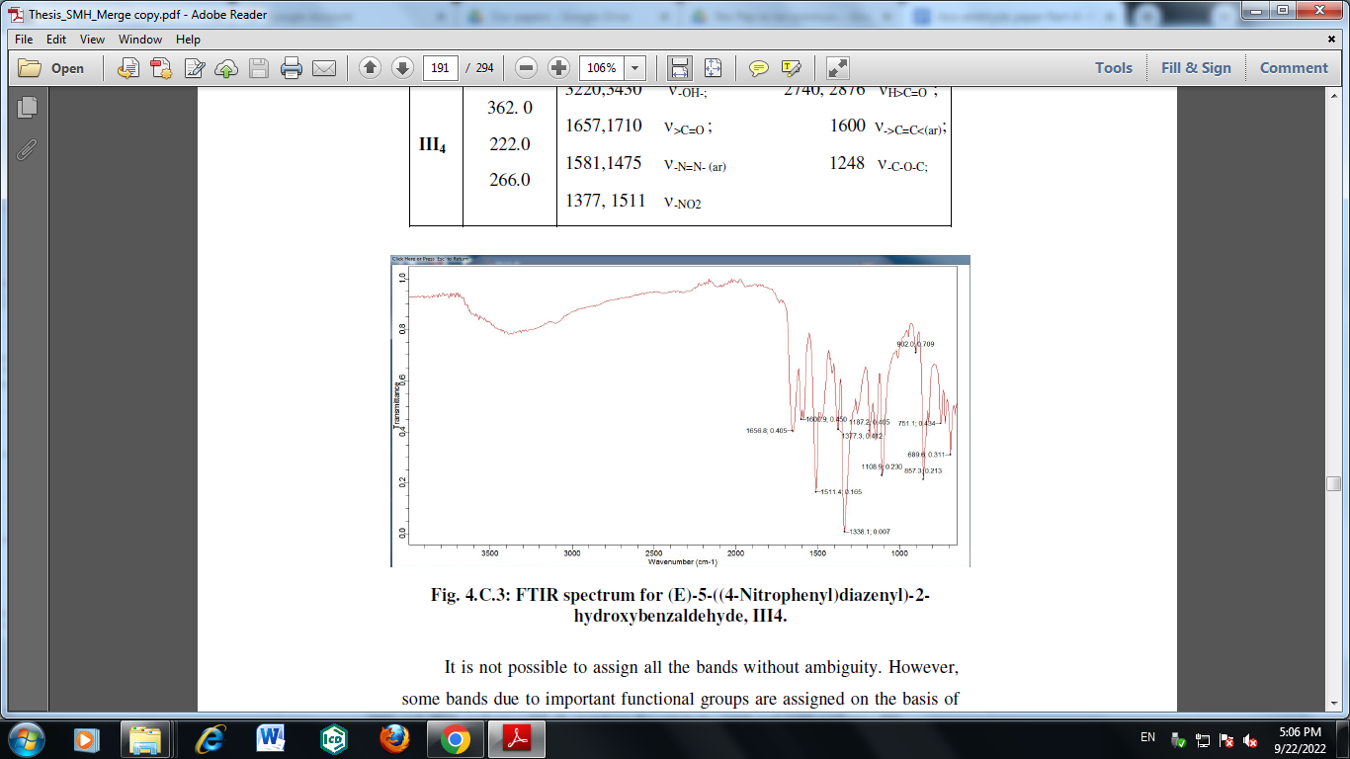*Fig. 3:*** *FTIR spectrum for Substituted-azo-aldehyde,****I****.*

*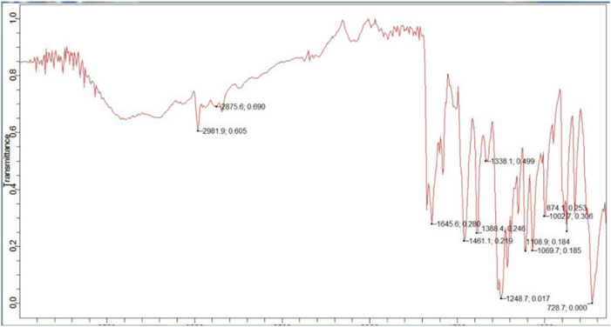****Fig. 4:*** *FTIR spectrum for Substituted-azo-aldehyde,****II****.*

The FTIR spectra of Azo-aldehyde, **I-II,** showed the observations as 1600 and 1515, 1611 cm-1 are ν>C=C< in aromatic ring, 1657, 1710 and 1645 cm-1 are ν>C=O stretching for respective aldehyde, 2740, 2876 and 2876 cm-1 are ν>CH=O stretching for aldehyde, 3220 and 3430 and 3400 cm-1 respectively for the ν–OH stretching, 1248 cm-1 for ν-C-O-C stretching in case of both, whereas1511, 1377 cm-1  for ν-NO2for azo-aldehyde **I**, and 1338, 1388 cm-1ν-C-CH3for azo-aldehyde **II**. Also, absorption at 1581, 1475 and 1461 are attributed to ν-N=N- in respective azo-aldehydes. Similar band frequencies were reported previously11,14-18,21.

From the results of primary observations, based on the reactants and method used in the reaction and the spectral data of UV-Vis and FTIR one arrives at the following structures of the compounds.

**HPLC Characterization:** The results of the HPLC analysis are depicted in **Table3**. The results are explained on the basis of the spectral purity of the peak.The method of analysis used for Azo-aldehyde, **I-II** (in % w/w) on as is basis by using High performance liquid chromatography method is developed here in this work.The representative HPLC chromatogram indicating purity of amines used for the synthesis of azo-aldehyde are depicted in the HPLC **Fig. 5**(blank), **Fig. 6**(HPLC Graph - Azo aldehyde, **I**), respectively.





***Table 3:*** *The observed Peak Purity (% assay) determined by HPLC*

|  |  |  |  |
| --- | --- | --- | --- |
| **Code** | **HPLC Peak Purity for Anilines used for synthesis of Azo-aldehyde** | **HPLC Peak Purity for Azo-aldehyde** | **Remark** |
| **I** | 99.02 | 97.38 | Peak spectrally pure |
| **II** | 100.00 | 94.70 | Peak spectrally pure |

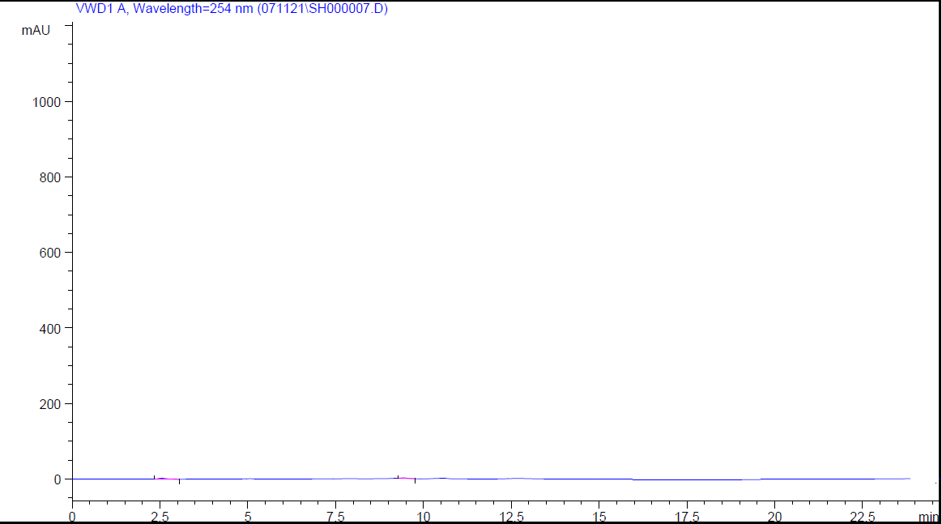

***Fig. 5:*** *Chromatogram for Blank*

**Fig. 5**, depicts the blank HPLC graph as obtained on running the blank mobile phase without the sample.

**Fig. 6**, indicates the representative chromatogram of the Azo-aldehyde derivatives (e.g. I). Thus, the peaks are spectrally pure(97.38 %).



***Fig. 6:*** *Representative Liquid Chromatogram for Azo aldehyde,* ***I****.*

**Antifungal Activity:**

The synthesized Azo-aldehyde compounds were screened for the antifungal potential evaluation against two fungal strains viz. *A. flavus* and *C. albicans* and compaired with standard drug, Fluconazole, after 48 hrs.

***Table 4****: The Antifungal Activity data for Azo aldehyde (****I - II****) (****Scheme-I****).*

|  |  |  |
| --- | --- | --- |
| **Antifungal Activity** | | |
| **Compound Code and Concentration** | ***A. flavus*** | ***C. albicans*** |
| Zone of Inhibition After 48 hrs. of Incubation | |
| **I** (1000 µg/ml) | 19 | 17 |
| **II** (1000 µg/ml) | 21 | 22 |
| **Fluconazole**  (1000 µg/ml) | 22 | 19 |
|
| **+ ve control** | + ve | + ve |
| (**Distilled water**) |

**Glimpses of the Antifungal Activity of Azo aldehyde:**

* All the azo-aldehydes showed positive activity at 1000 µg/ml against *A. flavus and C. albicans.*
* All the azo-aldehyde **I**, showed higher activity against *A. flavus* than *C. albicans* at 1000 µg/ml.
* In this study highest activity is depicted by **I** against *A. flavus* and **II**against *C. albicans* at (1000 µg/ml).
* The azo-aldehyde **II**, showed higher activity than the standard drug Fluconazole at studied concentration (1000 mg/ml).

These antifungal activities are represented in the histogram form as in **Fig. 7.**

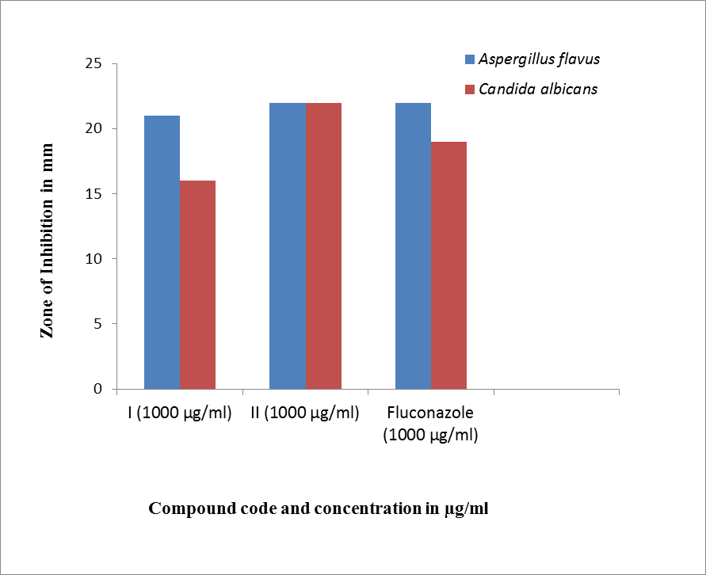

***Fig. 7.*** *The antifungal activities of the azo-aldehyde, (****I*** *to* ***II****) against A. flavus and C. albicans in the graphical form.*

**ABBREVIATIONS:**

UV-Vis: Ultra Violet Visible

FTIR :Furirer Transform InfraRed

HPLC : High performance liquidchromatography

**CONCLUSION**

The present scientific article gives an overview or detailed account of synthesis of azo-aldehyde and its usefulness in reaction forming organic compounds. The compounds synthesized from the azo-aldehyde are useful for many applications such as colours of azo-dyes include different shades of yellow, red, orange, brown, and blue used for textile, dying industry, for the chelation ion-exchanging properties of the polymers. These types of compounds have been used as a building block for many intermediates. Few compounds **I** against *A. flavus* and **II**against *C. albicans* also which is respectively similar and more than the standard drug used (at 1000 µg/ml).

The analytical method used for analysis of Azo-aldehyde (**I, II**), HPLC analysis data is useful for the estimation of metals in the solution of say waste samples using HPLC analysis of ligands as seen in the scientific literature.

**FUTURE SCOPE**

Thus, this scientific output may be useful to many researchers for further developments of varied compounds in particular Azo-aldehyde and Azo-schiff bases and their varied reactions to form different applied derivatives in near future. HPLC analysis method and data made available will be useful to the analytical as well as organic chemist to identify the molecule, for the estimation of various metals. Further, these compounds can be screened for the antibacterial activity.

**ACKNOWLEDGEMENT**

Authors are thankful to their respective Management and Principal, MTES's Smt. G. G. Khadse College, Muktainagar and HSM's S. S. G. B. College of Engineering and Technology, Bhusawal, for their kind permission and providing the internet facility, for the present work.

**1) Personal Identity : Dr. C. J. Patil**

Google Scholar : C. J. Patil;

ORCID : orcid.org/0000-0002-7535-698X;

Researcher ID : G-6274-2015;

Scopus ID : 56810689600

**2) Personal Identity : Sachin M. Harimkar**

Google Scholar : Sachin M. Harimkar

ORCID : orcid.org/0000-0001-9320-4122

Publons : Sachin M. Harimkar

Semantic scholar :SachinHarimkar

**3) Personal Identity : Sujay V. Rajput**

Google Scholar : Sujay Rajput

ORCID : orcid.org/0000-0003-1685-8645

Researcher ID : ACH-1144-2022

**DECLARATIONS:** The work done without any kind of Funding. No any Conflict of interest.

**REFERENCES**

1. *Nehete, C. A.&Patil, C. J. (2017).Coupling Reactions Involving Reactions of Aryldiazonium Salt: Part-IV. Synthesis of Novel Azo-Aniline from Different Substituted Anilines and study of their Biological Activity, Int. J. Pharma Biol. Arch., 8(1), pp. 20-26.*
2. *Patil, C. J.; Patil, M. C.; Rane, V.; Mahajan, K.&Nehete, C. A.(2015). Coupling Reactions Involving Reactions of Aryldiazonium Salt: Part-III. Chemoselective Condensation with Beta-Naphthol to Synthesize Sudan-1, its Nitro Derivatives and Antibacterial Potential, Int. J. Chem. Biol. Phy. Sci., 5(4), pp. 3860-3867.*
3. *Patil, C. J.;Talele, D. S.; Talele, S. P.;Pohekar, P. R. &Kolhe, D. S. (2019). Coupling Reactions Involving Reactions of Aryldiazonium Salt: Part-VII. Products of Chemoselective Reactions of Aryldiazonium chloride with Active methylene group containing Moiety; J. Pharm. Sci. Res.; 11(6), pp. 2213-2219.*
4. *Patil, C. J.;Waghulade, G. P.; Patil, M. C. &Patil, M. C. (2017). Coupling Reactions Involving Reactions of Aryldiazonium Salt: Part-VIII. Chemoselective Synthesis of 1-Substituted phenyl-azo-naphthalene-2-ol; Int. J. Pharm. Res. Rev., 45(2), pp. 21-28.*
5. *Patil, C. J.; Waghulade, G. P. &Patil, M. C. (2017). Coupling Reactions Involving Reactions of Aryldiazonium Salt: Part-VI. Chemoselective Condensation with Resorcinol, Int. J. Green Herbal Chem., 6(2), pp. 5-14, doi:10.24214/JGHC/GC/6/2/0514.*
6. *Patil, C. J.;Talele, D. S.;Talele, S. P.; Pohekar, P. R. & Patil,A. S. (2017). Coupling Reactions Involving Reactions of Aryldiazonium Salt: Part IV. Chemoselective Synthesize and Antibacterial Activity of 3-(Substituted-phenylazo pentane-2,4-dione, Int. J. Pharm. Sci. Rev. Res., 45(1), Article No 13, pp.64-73.*
7. *Dhake, A. N.; Patil, C. J.& Chaudhari,G. R. (2021). Coupling Reactions of Aryldiazonium Salt. Part-XI: Review on Coupling of Aryldiazonium Salts of Aminobenzothiazoles with Aromatic and Heterocyclic Components, Int. J. Pharma. Sci. Rev. Res., 70(2), pp. 75-99.*
8. *Dhake, A. N.; Patil, C. J.& Chaudhari,G. R. (2022). Coupling Reactions of Aryldiazonium Salt. Part-XII: Review on Coupling of Aryldiazonium Salt of Aminobenzothiazoles With Aromatic or HeteroaromaticMofits, Heterocyc. Lett., 12(2), pp. 415-443.*
9. *Nehete, C. A. &Patil, C. J. (2015). Review on the azo derivatives of Salicylic acid, Int. J. Pharm. Sci. Rev. Res, 33(2), pp. 248-256.*
10. *Patil, C. J. & Rajput, S. V. (2019). Coupling Reactions Involving Reactions of Aryldiazonium Salt: Part IX. Review on Synthesis of Azo phenolic derivative, their Applications and Biological Activities, Int. J. Rec. Sci. Res., 10(4-G), pp. 32144-32156, doi: 10.24327/ijrsr.2019.1004.3405.*
11. *Shinde, A. H. &Patil, C. J. (2020). Synthesis and characterization of azo Schiff bases and their beta lactam derivatives, Asian J. Chem, 32(6), pp. 1520-1524, doi: 10.14233/ajchem.2020.22657.*
12. *Shinde, A. H. &Patil, C. J. (2019). Synthesis, Characterization and Evaluation of Pharmacological Activity of Beta Lactam derivatives from Azo-aldehyde: Study on Beta Lactams. Part-IV.Two Day National Conference on "Need based Res. and Develop. in Pharma” at R. C. Patel Institute of Pharmaceutical Education and Research, Shirpur, 2019.*
13. *Shinde, A. H. &Patil, C. J. (2020). Study on Azo-Aldehyde. Part-VIII. Synthesis of Azo-Aldehyde of 5-Bromo-Salicylaldehyde and Azo-Schiff Bases with 2-Aminobenzothiazole Derivatives.National Conference at DNCVP, Jalgaon, 2020.*
14. *Shinde, A. H. &Patil, C. J. (2022).Study on Azo-Aldehyde. Part-VII: Synthesis and Characterization of Azonapthaldehyde, Relevant Schiff Bases and their Beta Lactam Derivatives, ‘research Journey’, Int. E-Res. J., 2022, 291b.*
15. *Rajput, S. V. &Patil, C. J. (2018). Study on Azo-aldehyde. Part-III: Synthesis, Characterization, Liquid Chromatography and Bio-evaluation of Azo-aldehyde Schiff Bases.Int. J. Res. Anal. Rev., 5(4), pp. 964-981.*
16. *Harimkar, S. M.& Patil, C. J. (2019).* [*Study on Azo-aldehyde. Part-IV:*](https://scholar.google.com/citations?view_op=view_citation&hl=en&user=hBupHSgAAAAJ&citation_for_view=hBupHSgAAAAJ:9yKSN-GCB0IC)*Synthesis, Characterization, Chromatographic Behaviour and Anti-bacterial Evaluation of Azo-aldehyde Schiff Bases, Int. J. Res. Anal. Rev., 2019, 6(1), pp. 278-297.*
17. *Rajput, S. V. &Patil, C. J. (2019).Study on Azo-aldehyde. Part-V: Synthesis, Characterization, Liquid Chromatography and Bio-evaluation of Azo-aldehyde Schiff Bases, Int. J. Res. Anal. Rev., 2019, 6(1), pp. 521-533.*
18. *Harimkar, S. M.& Patil, C. J. (2019).*[*Study on Azo-aldehyde. Part-VI:*](https://scholar.google.com/citations?view_op=view_citation&hl=en&user=hBupHSgAAAAJ&citation_for_view=hBupHSgAAAAJ:9yKSN-GCB0IC) [*Synthesis, Characterization, Chromatographic behaviour and Antimicrobial Screening of Schiff Bases*](https://scholar.google.com/citations?view_op=view_citation&hl=en&user=YbhhO_gAAAAJ&cstart=20&pagesize=80&citation_for_view=YbhhO_gAAAAJ:PR6Y55bgFSsC) *from* [*Azo-salicylaldehyde*](https://scholar.google.com/citations?view_op=view_citation&hl=en&user=YbhhO_gAAAAJ&cstart=20&pagesize=80&citation_for_view=YbhhO_gAAAAJ:PR6Y55bgFSsC)*, Int. J. Res. Anal. Rev., 2019, 6(2), pp. 159-174.*
19. *Odabasoglu, M.; Albayrak, C.; Ozkanca, R.; Aykan, F.Z.&Lonecke, P. (2007). Some polyhydroxy azo–azomethine derivatives of salicylaldehyde: Synthesis, characterization, spectroscopic, molecular structure and antimicrobial activity studies. J. Mol. Stru., 840, pp. 71–89, doi:10.1016/j.molstruc.2006.11.025.*
20. *Harimkar, S. M., Ph.D. Thesis, submitted to KBCNMU, October 2022.*
21. *Rajput, S. V., Ph.D. Thesis, submitted to KBCNMU, October 2022.*
22. *Harimkar, S. M.; Rajput, S. V. & Patil, C. J. (2022). Study on Azo-aldehyde. Part-IX:Synthesis, Characterization, Liquid Chromatography and Biological Screening of Azo-salicylaldehyde from Bromo and Chloro-anilines, World J. Pharm. Res., 11(12), pp. 1388-1402, doi: 10.20959/wjpr202212-25277.*
23. *Harimkar, S. M.; Rajput, S. V. & Patil, C. J. (2022).*[*Study on Azo-aldehyde. Part-XI:*](https://scholar.google.com/citations?view_op=view_citation&hl=en&user=hBupHSgAAAAJ&citation_for_view=hBupHSgAAAAJ:9yKSN-GCB0IC)*Synthesis, Characterization, Liquid Chromatography and Biological Screening of Azo-salicylaldehyde from Methoxy and Ethoxy-anilines, Int. J. Pharm. Sci. Rev. Res,(commun. 2022).*
24. *ICH Harmonised Tripartite Guideline: Good Manufacturing Practice Guide for Active Pharmaceutical Ingredients Q7. Current Step 4 Version Dated 10 November 2000, 12.8 Validation of Analytical Methods.*
25. *Snyder, L. R.; Kirkland, J. J. &*[*Glajch*](https://www.wiley.com/en-us/search?pq=%7Crelevance%7Cauthor%3AJoseph+L.+Glajch)*, J. L. (1997). Practical HPLC method development, ISBN: 978-0-471-00703-6, 1997.*