**Smart System for College Regular Operational Management**

**Rutuja Satish Mandlik1, Nilesh Bhika Chaudhari2, Kajal Sandip Awari3, Shital Ramesh Sangale4**

*1,2,3,4 Electronics Engg.Dept, Amrutvahini college of Engineering, Sangamner, India, ,422608*

***mandlikrutuja133@gmail.com***

***Received on****: 31 March, 2023* ***Revised on****: 22 April, 2023* ***Published on****: 24 April, 2023*

***Abstract –****The smart system for college Regular operational management is used to maintain college activities like to maintain the student attendance provide information of student to their parents through message. In this paper with the help a GSM module we operate the opening closing door smartly*

*.*

***Keywords-****Microcontroller, Relay Module, Resistor, Capacitor, DC motor, Diode, PIR Sensor, GSM module, Led Transformer,Connectors*

**INTRODUCTION**

**I**n Practical Lab automation system different system technologies are employed for conservation of electricity. In most of our institutions, candidates in college must present their photo cards to invigilators before they are granted access to classroom. Theses photo cards serve as entry permits into the classroom. Student attendance system helps teachers to mark online attendance of students during class and reduce manual work. It is use to track students’ attendance, absent record and attendance history and inform to parent through massage. It helps to parents for record the attendance information of his child. In our project the student can access door lock from inside lab & class or outside also at anytime from anywhere with using atmega-32 Microcontroller, Bluetooth application.

**LITERATURE REVIEW**

*Table 1 : Literature Review*

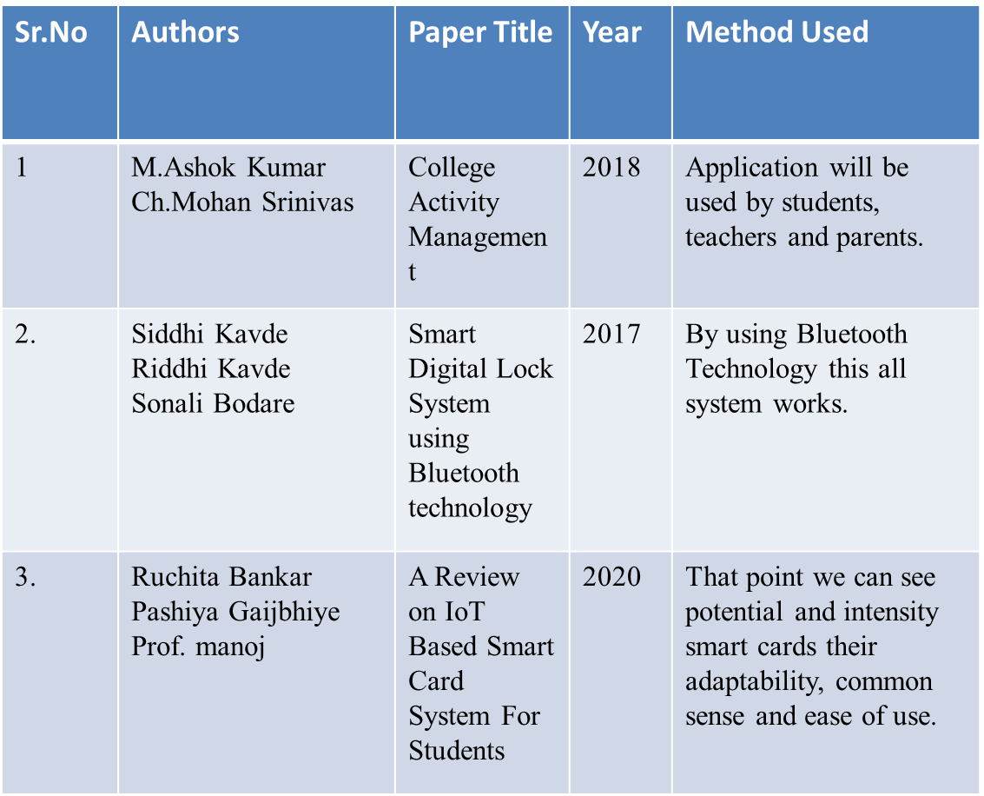

**METHOLOGY**

**Block diagram**

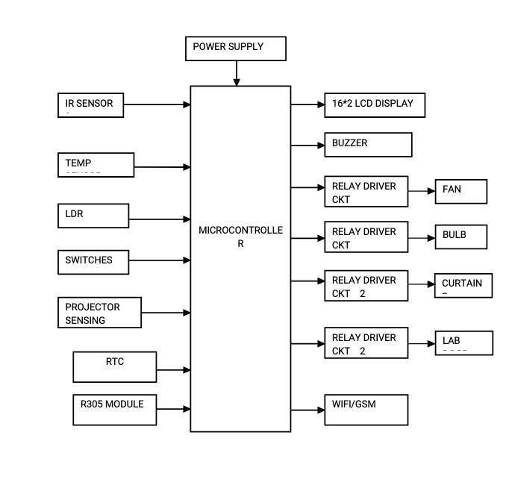

*Fig 1: Block Diagram*

* **Algorithm**
* Start
* Collect all information of students /lab
* Mange attendance and lab details
* Then inform parents to their child details
* lab will be automatically closed and opening with the help of detecting the human
* End.
* **Flowchart**



*Fig 2: Flowchart*

**System flow diagram**

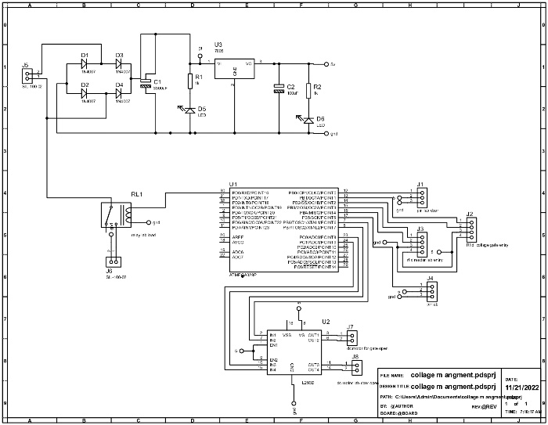

*Fig 3:System Flow Diagram*

**Hardware Details**

**1**.**Arduino Mega 2560:**

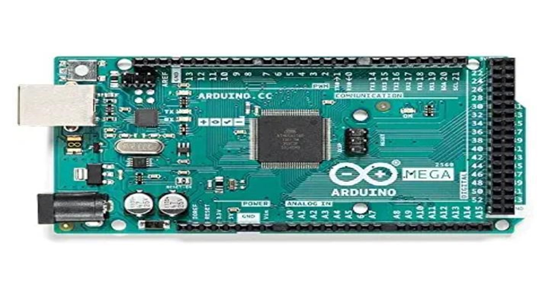*Fig 4: Arduino Mega 2560*

ArduinoMega 2560 is basically acts as a microcontroller. It having the many GPIO pins having their different functions**.**Arduino Mega is basically having 16 Analog pins, 54 digital Input Output pins. Mainly 15 pins use in the working. Arduino Mega is having operating voltage range is 5V, and 8KB SRAM cell,4KB EEPROM cell 256 KB flash memory cell.

**2.GSM Module (SIM800):**

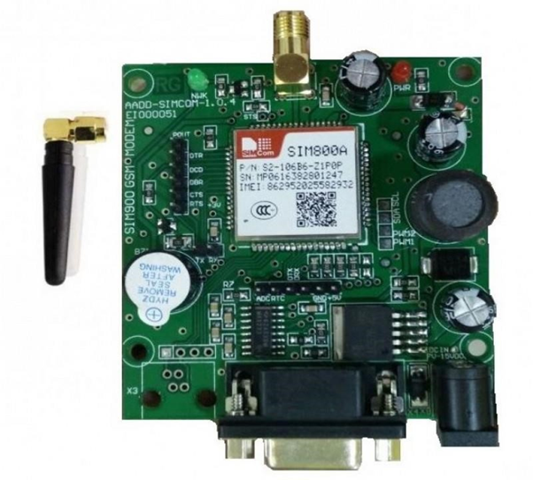

*Fig 5:GSM Module(SIM800)*

In this with the help of TTL converter GSM module works as a chip having range SIM800 and RS232.It uses the easy connections related to the computer or laptop with the help of USB to the serial connector or to the microcontroller.

**3.Ultrasonic Sensor:**

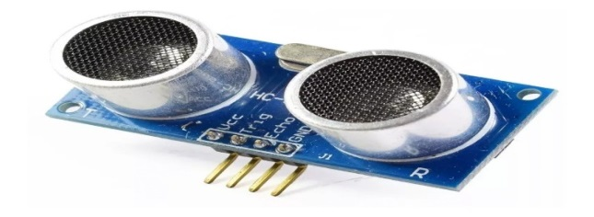

*Fig 6:Ultrasonic Sensor*

Ultrasonic sensor is basically used to detect object in specific range and give signal after detecting object.it has range up to 5m. it has two parts transmitter and receiver.

**4.DC Motor:**

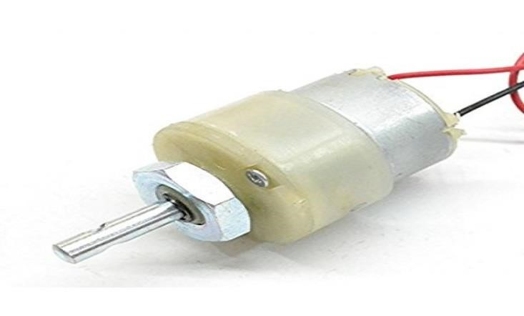

*Fig 7:DC Motor*

DC Motor is an electric component which is used in the conversion of electric energy into mechanical energy. basically, DC motor works on the mechanical force DC motor having the output having the 100 rpm. The range of the input voltage in between 6 -12V resp. For this motor we required the 500-600 mA stall current and length of the shaft near about the 2.4 cm and internal diameter of shaft is 6mm

**IV. RESULT & DISCUSSION**

The application will increase the speed of the process and increases the proper management system.

This application helps to increase the automation of process mention in the project and help to reduce the manual work system.

Students and parents do not require to visit the college every day.

This application also consumes the less power supply then it also helps to energy conservation.

This various application increases the accuracy of the result.

**CONCLUSION**

These applications provide to appropriate information to user according to the project service. The project helps to keeping in view the day-to-day problem faced by a college. This paper we have use to record the attendances of the students is very difficult job in a college information and is also useful for student’s parents to get their child information easily. A students track easily in a college campus. And also, this paper is useful to lab opening and closing operation it will helps to save the electricity

**REFERENCES**

1. *E. Varadaraja n, R. Dharani, B. Kavinmathi, S. Hemalatha “Automatic attendance management system using face detection”, 2016 By using face detection, Online International Conference on Green Engineering and Technologies (IC-GET).*
2. *Adnan Ibrahim, Afhal Paravath, Aswin P. K., Shijin Mohammed Iqbal, and Shaeez Usman Abdulla “GSM Based Digital Door Lock Security System” 2015 IEEE International Conference on Power,*
3. *Siddhi Kavde, Riddhi Kavde, Sonali Bodare, “Smart Digital Lock System using Bluetooth technology”, 2017 By using Bluetooth Technology this all system works, INTERNATIONAL CONFERENCE ON INFORMATION, COMMUNICATION & EMBEDDED SYSTEMS (ICICES 2017).*
4. *Ruchita Bankar, Pashiya Gaijbhiye, Prof. manoj A Nove, “Intelligent Curtain Control System Based on ZigBee” 2020 Is all based on embedded platform and ZigBee technology, International Conference on Mechanical, Control and Computer Engineering (ICMCCE)*
5. *Tomas Larrain,John Bernhard, Domingo mery published a paper Face Recognition Using Sparse Fingerprint classification Algorithm in June 2017.*