Development of Multi-Sensory system for Evaluation of Horizontal curve Super-elevation.

Karan D Jaiswal
PG Scholar
Department of Civil Engineering,
G.H Raisoni College of Engineering, Nagpur.
Karanjaiswal6977@gmail.com

Abstract-
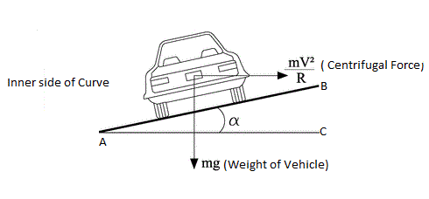
The Purpose of this research is to control the behavior of driver while driving especially on Horizontal Curve. Super-elevation play important role by providing riding comfort and safety through horizontal curves on roadways. During construction and maintenance, laying the various layers of road pavement (i.e. subgrade, sub base, base course, wearing course, etc.) could change the super-elevation; thus, evaluating a road cross-slope along curves is of great importance. In this research, a Multi-sensory system is developed to evaluate super-elevation of newly constructed MIHAN Flyover. It was chosen because of the availability of curve parameters such as start/end points, radius super-elevation, and design speed. A good agreement was found between super-elevation measured by Multi-sensory system and Curve design. Horizontal curve of MIHAN flyover were evaluated and analyzed based upon curve design. Results shown that curve have super-elevation shortage of 1%. In this case, the temporary solution is to install a new “Posted-Speed” sign based on existing curve super-elevation.
Proposed paper focuses on introducing an innovation way to measure existing pavement geometric parameters, especially cross-slope, Super-elevation, etc.
Keywords- Horizontal curve, super-elevation, riding comfort, road pavement, road cross-slope, Multi-sensory system, evaluate etc.

I. INTRODUCTION-
Providing comfort and safety are important parameters in horizontal curves. The balance of vehicle while passing through a horizontal curve is secured by super-elevation by counteracting centrifugal force. Various manual methods for collecting data of cross-slope, road cross-section etc. are extremely accurate but time consuming. As time required for data collection through manual methods is more and interruption to traffic also takes place thus, this methods are infeasible for large-scale project database. Survey techniques using Total Station and Hand held GPS equipment can provide accurate results, but have disadvantage similar to those of the manual method. Now-a-days various researchers have developed Road-Surface Profiler (RSP), Road surface sensor, Low-cost mobile device to find out various parameters of road cross-section.

Er. S V Bhalerao
Asst. Professor
Department of Electronics Engineering,
G.H Raisoni College of Engineering, Nagpur.
Shailesh.bhalerao@raisoni.net

Horizontal Curves-
The curve provided at the turning points in the alignment (in the horizontal plane) of a road are known as Horizontal curves.
These curves are provided to achieve gradual change in the direction of alignment of a road in the horizontal plane.

Super-elevation-
The inward transverse inclination provided to the cross-section of the carriageway at the horizontal curved portion of a road is called super-elevation. Thus, providing a transverse slope to counter-act the effect of centrifugal force and to reduce the tendency of vehicle to overturn and to skid laterally outwards super-elevation is provided.
It is expressed as the ratio of elevation of outer edge above inner edge to the horizontal width of the carriageway or as the tangent of the angle of slope of the road surface. Ti is generally denoted by ‘e’ or ‘S.E’.
Super-elevation, e = BC/AC = tan α

Fig I. Super-elevation on curved portion of road

Now,
Weight of Vehicle (W) = mg
Centrifugal force (P) = mV² /R
So,
P/W = mV² /R
mg
I.e, P/W = V²
gR
If the Speed of the vehicle is in kmph

Then, e = (0.278V) ² = V²
9.81*R 127R

Indian Road Congress (IRC) has recommended the following formula for calculating the design value of super-elevation required on horizontal curve in India-
S. E = (0.75) V² /127R

S. E = V² /225R
This is assumes that centrifugal force corresponding to three-fourth the design speed is balanced by super-elevation and rest counteracted by side friction.
Super-elevation obtained from the above formula should however be kept limited to the following values-
- In plain and Rolling area-7%
- In snow bound areas-7%
- In hilly area not bound by snow-10%

When the design value of super-elevation is less than the road camber, the normal cambered section should be continued on the curved portion without providing any super-elevation.
As per I.R.C recommendations, the radii of horizontal curves for different camber rates, beyond which super-elevation will not be required, are given below-

Design Speed kmph | Radius in meters for camber of
 | 4% | 3% | 2.5% | 2% | 1.7%
20 | 50 | 60 | 70 | 90 | 100
25 | 70 | 90 | 110 | 140 | 150
30 | 100 | 130 | 160 | 200 | 240
35 | 140 | 180 | 220 | 270 | 320
40 | 180 | 240 | 280 | 350 | 420
50 | 280 | 370 | 450 | 550 | 650
65 | 470 | 620 | 750 | 950 | 1100
80 | 700 | 950 | 1100 | 1400 | 1700
100 | 1100 | 1500 | 1800 | 2200 | 2600

Table I. Radii beyond which no super-elevation is required

II. MULTI-SENSORY SYSTEM APPROACH-
It involves inter-connection and interface of Accelerometer sensor, Rotation sensor, GPS, GPRS (GSM), Arduino Mega UNO, Graphic display, battery (if required), Speedometer of car or separate, circuit wiring etc. with some fixture and fastening.
In this system, Accelerometer sensors are used to determine level difference between levels of front wheel of car. To determine the speed with which vehicle is negotiating the particular section of road, speedometer is used. All instruments used in this research are compatible with Ardino which is essential condition for interfacing all instruments with each other.

Hardware Design-
The components of Hardware are shown below-

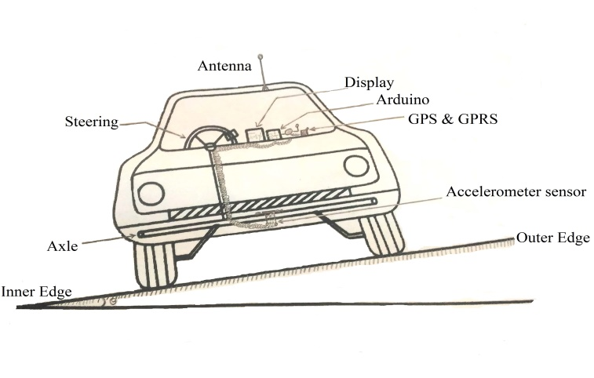Fig II. Components Parts of Multi-sensory system.

Above Figure shows the Inter-connection and interface of various sensors and equipment’s which are used for designing Sensory system. Accelerometer is mounted on the front axle of car, which will give the exact value of inclination when vehicle will negotiate a particular curve and also, it will measure the level difference (with reference to horizontal plane) between the outer and inner wheel with reference to datum.. Rotation sensor will give the angle of inclination depending upon which radius of curve will be computed. Antenna mounted on top of roof panel programmed with GPS and GPRS (GSM). Antenna will give the current location of vehicle and will give signal to following vehicle on type and real time condition of road and its surrounding. If Vehicle is travelling on Horizontal curve then it will also inform following vehicle regarding maintaining safe speed on horizontal curve on the basis of super-elevation evaluation.
All the instruments are inter-connected to each other through controlling circuit with the help of Ardino UNO and the will give their output on graphic display. The values recorded by sensory system will be compared to standard values inputted in standard database. Result obtained by comparing standard values with actual obtained values will be studied and the remedied and precaution on speed will be stated by sensory system which will be displayed on display.

III. DATA COLLECTION-
Following is the systematic view of selected site-

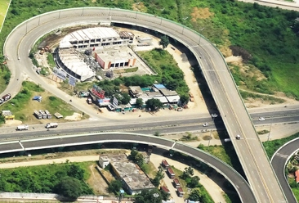

Fig. III Top view of selected site

The geometric design parameters of MIHAN Flyover (Horizontal curve) taken from Maharashtra Airport Development Corporation (MADC) –

Chainage (m) | Point | Super-elevation (%) | Radius (m) | Design Speed (kmph) | Lane Width (m)
0 | Start of UP Ramp | 0 | 80 | 40 | 7
20 | Start of Transition curve | 2 | 80 | 40 | 7
100 | Mid-point of curve | 8 | 80 | 40 | 7
200 | End of Transition Curve | 3 | 80 | 40 | 7

Table. II MIHAN flyover data from MADC

IV. DATA ANALYSIS
The analysis of Multi-sensory system is done by programming the inputs by script writing in Arduino UNO software and then taking multi- sensory system mounted on vehicle to selected site. The accelerometer sensor and rotation sensor are mounted on front axle of the car and they are connected to arduino by means of cable by compiling and uploading the necessary data and codes.
GPS and GSM (GPRS) are inter-connected and coded with arduino which shows the Current location of vehicle and also simultaneously store the readings and upload it to standard database.
Following figure shows the display of sensory system which shows the reading of MIHAN flyover-

Chain-age (m) | Speed (kmph) | Radius (m) | Base-width/lane (B) | Height (h) (m) | Super-elevation (h/B) | Super-elevation (Required)  %
0 | 0 | 80 | 3.5 | - | - | -
20 | 20 | 80 | 3.5 | 0.09 | 2.5 | 2.2
40 | 25 | 80 | 3.5 | 0.11 | 3.14 | 3.47
60 | 32 | 80 | 3.5 | 0.13 | 3.71 | 5.6
80 | 35 | 80 | 3.5 | 0.19 | 5.42 | 6.8
100 | 40 | 80 | 3.5 | 0.24 | 6.85 | 8.8
120 | 45 | 80 | 3.5 | 0.21 | 6.0 | 11.25
140 | 40 | 80 | 3.5 | 0.19 | 5.42 | 8.8
160 | 42 | 80 | 3.5 | 0.178 | 5.0 | 9.8
180 | 30 | 80 | 3.5 | 0.17 | 4.86 | 5
200 | 25 | 80 | 3.5 | 0.115 | 3.28 | 3.47

Table. III Analysis of data obtained from sensory system.

V. PROFILE LEVELLING
Profile leveling is a method of surveying that has been carried out along the central line of a track of land on which a linear engineering work is to be constructed/ laid. The operations involved in determining the elevation of ground surface at small spatial interval along a line is called profile leveling. The route along which a profile is run may be single straight line, as in case of a short sidewalk; a broken line, as in the case of a transmission line or sewer; or a series of straight lines connected by curves, as in case of a railroad, highway or canal.
Profile leveling was carried out to determine the level difference between inner and outer edge of curve through its length.
Temporary Bench-mark was set-up and the R.L of bench mark was taken as 100 meters. After that, Fly leveling was carried out by taking Back sight reading at Bench-mark. Leveling was carried out from starting of UP Ramp to end point of transition curve at the interval of 20 meters.
Following table shows the readings taken by Profile Leveling on MIHAN flyover-

Chainage  (m) | Width of Road (m) | R.L of inner edge (m) | R.L of outer edge (m) | Super-elevation (%)
0 | 7.0 | 100 | 100 | -
20 | 7.0 | 100.25 | 100.58 | 3.14
40 | 7.0 | 100.45 | 100.82 | 3.5
60 | 7.0 | 100.85 | 101.29 | 4.4
80 | 7.0 | 100.97 | 101.46 | 5.2
100 | 7.0 | 101.15 | 101.67 | 7.2
120 | 7.0 | 101.18 | 101.64 | 6.57
140 | 7.0 | 101.22 | 101.63 | 5.85
160 | 7.0 | 101.265 | 101.645 | 5.42
180 | 7.0 | 101.29 | 101.61 | 4.57
200 | 7.0 | 101.31 | 101.51 | 2.85

Table. IV Profile leveling reading of MIHAN flyover

Fig. III Graph showing level difference between R.L of outer and inner edge of curve.

As from the graph we can see the elevation of outer edge above inner edge, it means super-elevation is provided on selected curve throughout its alignment. Satisfactory result were found my doing profile leveling on selected curve as compared to design values of super-elevation.

VI. COMPARISON OF MEASURED & DSIGN SUPER-ELEVATION-
Following graph shows the comparison of measured super-elevation by sensory system and design super elevation-

Fig. IV Design super-elevation versus measured super-elevation

As we can see from the graph that design super-elevation is 8% but at present i.e. real time value of super-elevation measured by multi-sensory system is 6.85%. So, it indicate that there is lack of super-elevation by nearly equal to 1%.
In this situation the temporary solution is to reduce the speed of vehicle or to install ‘Posted-Speed’ sign based on measured Super-elevation.

VII. COMPARISON OF DESIGN SUPER-ELEVATION AND SUPER-ELEVATION CALCULATED BY PROFILE LEVELING-

Following graph shows the comparison of design super-elevation and super-elevation calculated by profile leveling-

Fig. V Design super-elevation versus super-elevation calculated by profile leveling.

In these comparative study we can see that at the start and end point of transition curve the values of design super-elevation are grater that the values calculated by profile leveling. So, it indicates that there is no harm to vehicles while driving on curve. But, the value of design super-elevation at mid-point of transition curve iis less that the value evaluated by profile leveling. So the temporary solution at mid-point of transition curve is to reduce the design speed and install real time speed limit sign posts.

VIII. RESULT AND DISCUSSION-

As the comparative study of values obtained by followed three methods are varying to some extent with each other so it can be stated that all the three methods of evaluation are unique on their principals. Also, the design super-elevation is not varying too much to measured value by sensory system and profile leveling.

Chainage/ Distance (Meters) | Design Super-elevation (%) | Measured Super-elevation by sensory system (%) | Super-elevation calculated by Profile leveling (%)
0 | 0 | 0 | 0
20 | 2 | 2.5 | 3.14
100 | 8 | 6.85 | 7.2
200 | 3 | 3.28 | 2.85

IX. CONCLUSION-
In this research, Multi-sensory system was used to evaluate super-elevation of MIHAN Flyover which was constructed by Maharashtra Airport Development Co-Operation (MADC). Curve design super-elevation and radius was provided by MADC. Also, the start and the end point of the curve were identified based upon alignment and profile of curve from obtained data.
Horizontal curve of MIHAN flyover were then evaluated according to findings from MADC.
Following conclusion are drawn-
- Providing comfort and safety are important parameters in horizontal curves. The balance of vehicle while passing through a curve is secured by super-elevation for horizontal curve. Lack of attention to road construction or inappropriate implementation of asphalt overlay during the maintenance period results in reduced comfort and safety of the curves. Thus, there is an urgent need to evaluate the curves with efficient & accurate devices. Proposed multi-sensory system is capable to measure super-elevation on simple circular curves as well as on transition curves.
- A good agreement was found between the measured super-elevation and design super-elevation. Also, the nearly equal result was found by evaluating super-elevation by profile leveling.
- There is no urgent need to carry out necessary maintenance on MIHAN curve just by installing ‘Posted-Speed’ sign boards the comfort to the passengers and accident prevention can be secured.
- It is found that 35 kmph speed is safe speed to travel on selected curve as indicated by proposed sensory system.
- Also there is no need to do extra widening as the radius of curve is 80 meters and paved shoulder are 0.5 m on both side of curve.
- The accuracy of super-elevation relies on the accuracy of curve radius, vehicle speed and acceleration rate from Sensors. Improving their accuracy can achieve more accurate super-elevation measurement.

X. REFERENCES-
- Evaluation of Horizontal Curve Super-elevation using Road Surface Profiler (RSP)-Mojtaba Abbasghorbain1, Armin Bamdad Ziksari , Ebrahim Shoormeij and Sina Brazvan.

- A Sensor fusion Approach to Assess Pavement Condition and Maintenance Effectiveness- Dr. Raj Bridgelall, Dr. Ying Huang, Zhiming Zhang.

- Inernational Journal on Smart Sensing and Intelligent System Vol 1, No 2, June 2008. – Evolution Process of Pavement Roughness Evaluation Benefits from Sensor Technology.

- Identification, Calculation and warning of Horizontal Curves for low-volume Two-lane Roadways Using Smartphone Sensors- Shaohu Zhang.

- United State Patent by Keishin Tanaka; Toichiro Hikichi; Chiaki Kumagai.

- An automated Super-elevation measurement method for horizontal curve safety assessment using a low-cost mobile device.

- Road Surface condition Sensor for Controlling Brakes-Keishin Tanaka, Toichiro Hikichi, Chiaki Kumagai, all of Wako, Japan.

- Identification, Calculation and Warning of Horizontal Curves for Low-volume Two-lane Roadways Using Smartphones Sensors- Shaohu Zhang.

- Analysis of relationship between road safety and road Design parameters of four lane National Highway in India- Ravi Shenkar, Arti Chowksey and Amrit Sandhu.

- Takeshi IKEDA, Nozomu MORI. Analysis of Correlation between Roadway Alignment and Traffic Accidents. 3rd International Symposium on Highway Geometric Design. Chicago, June 2005.

- Tang-Hsien Chang, Effect of Vehicles’Suspension on Highway Horizontal Curve Design. Journal of Transportation Engineering, Vol. 127, No. 1, January/February 2001, pp. 89-91.

- Polus A.,“The Relationship of Overall Geometric Characteristics to the Safety Level of Rural Highways”.

Traffic Quarterly, Vol.34, 1980, PP.575-585.

- PEI Yulong, MA Ji. Research on countermeasures for road condition causes of traffic accidents. China Journal of Highway and Transport, 2003,16(4):77-82.

14.Ministry of Communications of Peoples Republic of China. Technical

- Standard of Highway Engineering (TJG B01 2003), Beijing: Peoples Communications Publishing House, 2003.

