Contribution to Primary Frequency Control from Smart Load using Reactive Compensation
Rohit R. Shende¹, Manisha V. Jape ²
¹Student
Government College of Engineering, Amravati, India,444601
²Assistant Professor
Government College of Engineering, Amravati, India,444601

Abstract – By the growing infiltration of asynchronous inverter interfaced generation (solar, wind etc.), the actual inertia of upcoming power systems is expected to scale back drastically. These would make the primary frequency management far more difficult than what it is presently. Frequency-dependent loads inherently contribute to primary frequency response. Primary frequency control based on voltage dependent non-critical (NC) loads that may tolerate a large variation of voltage is analyzed. A smart load (SL) includes of a voltage compensator connected in series between the mains and a voltage-dependent load, which may tolerate a wider variation in supply voltage. Such a load is henceforth referred to as non-critical load. By using a series of reactive compensators to decouple the non-critical load from the mains to create a smart load, the voltage and hence the active power of the non-critical load can be controlled to control the mains frequency. The effectiveness of Smart Load is presented by incorporating it in an IEEE 37 node test feeder.
Keywords— Smart Load (SL), non-critical(NC) ) Electric Spring (ES), demand side management (DSM), Smart Load with Reactive Compensation(SLQ)
INTRODUCTION

Frequency-dependent loads essentially subsidize for primary frequency response. Here describes supplementary contribution to primary frequency control depend on the noncritical (NC) loads which are voltage dependent so that it can tolerate a large variation of supply voltage. Using reactive compensators which is in series to separate the non critical loads from mains so that we get a smart load (SL). Here smart load control voltage which control the active power and finally by controlling active power we can control frequency. Here we primarily focus on reactive compensation which then control voltge using quadrature relationship of injected voltages . This control scheme of controlling active power for controlling frequency has been demonstrated on IEEE 37 bus test feeder. In this paper primary frequency has been in consideration where system unbalance should be overcome from 0 to 30 sec. Frequency control can be categorized in three type which are primary, secondary and tertiary. In primary control response of system in between 0 to 30 sec. In secondry control response of system is up to 15 min and in tertiary control it is more than 15 min. This primary frequency control on demand side. In demand side there are many method like switch on/off load or provide reactive compensation using STATCOM or other devices. For controlling active power we require load which are voltage dependent for type of loads we have lighting, electric heating, small motors with no stalling problems (e.g. Fans, dishwashers, ovens, and dryers). Without making these load off we can control frequency by implementing smart load (SL) configuration.
CONCEPT OF SMART LOAD
Generally the frequency management with relation to demand is finished by dynamical speed governor, that is thought as secondary management that takes thirty seconds to fifteen minutes to revive the frequency. Primary frequency management offers fast restoration of the frequency that takes zero to 30seconds when disturbance of balance between generation and demand. So that, a smart load configuration is used to get rapid control of frequency restoration. A smart load consists of a voltage compensator, critical load, non-critical (NC) load and controller as shown in Fig. 1. This technique are often connected at the distribution level that's low voltage (LV)/medium voltage (MV) feeders. There are varieties of classes ought to be in load could: 1) critical; or 2) sensitive masses, that need a tightly regulated offer voltage and critical load which may tolerate a wider fluctuation in offer voltage while not inflicting perceivable disruption to the critical load. a number of these non critical load , e.g., air-conditioners draw a relentless power from the provision over a large vary of voltage. As shown in Fig. 1 a SL is formed by inserting a electric spring in series between the mains and the load . By using electric springs the concept of smart load was proposed in as a mean of exercising continuous control of both voltage and frequency in an unified framework. Smart Load can be control by controller for both under frequency and over frequency events.

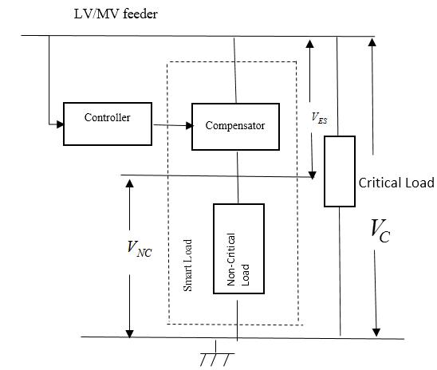

Fig.1 Smart load configuration
Compenstor used here is a Electric Spring. Electric spring will maintain critical load voltage constant by changing voltage across noncritical load. It will operate for two condition like under voltage and over voltage by using reactive compensation. Electric Spring in series th non critical load is combine called as smart load. 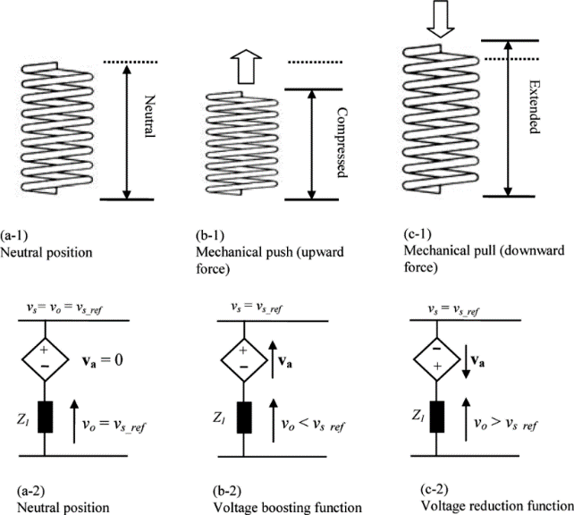
Fig.2 Analogy of a mechanical spring and an electric spring
MODELLING OF SMART LOAD
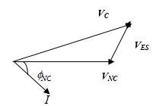
In this paper we restricted to smart load with reactive compensation only. Depending on the type of compensation used, there could be two types of SLs. For a SLQ, the compensator has been injected the voltage to be in phase quadrature with the current. This implies only the magnitude of the injected voltage can be controlled while maintaining the phase angle at ±90Hence, both the magnitude and phase angle of the voltage injected by the compensator can be controlled. This allows control of both active and reactive power of the SL, enabling voltage, and frequency regulation at the same time. However, energy storage (e.g., battery or super-capacitor) or a back-to-back converter arrangement is required by the compensator to support the active power exchanged. By controlling the compensator injected voltage (VES) and the voltage across the non-critical load (VNC), power consumption of total load at the point of connection, is controlled. In this paper, the type of loads used is of resistive-inductive (R-L) nature. The compensator used here is a STATCOM which has two compensating modes i.e. capacitive and inductive compensations where the phase angle is 900. The phasor diagrams for the smart load with the compensations are shown in Fig. 3
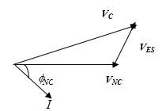
- Inductive compensation mode
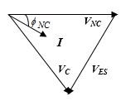
- Capacitive compensation mode

Fig.3 Phasor diagram of Smart Load with reactive compensation

The relation between non critical and critical load with electric spring is shown by equation 1.
$\begin{matrix}V_{C}^{2}=V_{NC}^{2}+V_{ES}^{2}±2V_{NC}V_{ES}sin⁡ϕ_{NC}.\end{matrix}$ (1)
Here we have two modes one is inductive compensation mode and other is capacitive compensation mode. Following equation 2 and 3 shows inductive and capacitive compensation respectively.
$\begin{matrix}V_{ES}= & -IZ_{NC}sin⁡ϕ_{NC}±\sqrt{V_{C}^{2}-(IZ_{NC}cos⁡ϕ_{NC})^{2}} \\ = & -F(I,V_{C}).\end{matrix}$ (2)

$\begin{matrix}V_{ES}= & +IZ_{NC}sin⁡ϕ_{NC}±\sqrt{V_{C}^{2}-(IZ_{NC}cos⁡ϕ_{NC})^{2}} \\ = & +F(I,V_{C}).\end{matrix}$ (3)

Compensation modes used depending upon the change in frequency. Frequency is directly related with active power consumption. The capacitive compensation reduces active power consumption of smart load P_{SL} while inductive compensation increases P_{SL}.

CONTROL OF SMART LOAD
The control architecture of compensator connected in smart load is as shown in Fig. 4.
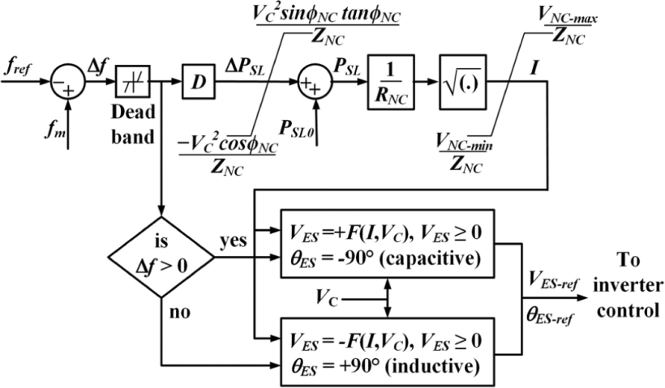
Fig.4 Control loop of Smart load with reactive compensation
An phase-lock-loop (PLL) was assumed for measurement of frequency. The difference (Δf ) between the measured (f_{m} ) and reference (f_{ref} ) frequency is filtered through a dead band (±0.01 Hz) and multiplied by a droop gain D=(0.215/PSL0 ) to calculate the required change in active power (ΔP_{SL} ) consumed by the SL about its nominal value (P_{SL0} ). The value of ΔP_{SL} is limited based on the maximum and minimum possible values calculated from the supply voltage (V_{C} ), and the NC load impedance (Z_{NC} ∠ϕ_{NC} ). The active power to be consumed by the SL at a given instant (PSL ) is obtained by adding up the nominal power (PSL0 ) and the desired change (ΔPSL).As the compensator exchanges only reactive power, the current (I ) through the SL is obtained by calculating square root of PSL divided by RNC . The current magnitude is limited based on the acceptable limits (VNCmax−VNCmin ) on the voltage across the NC load using its impedance (ZNC ).From I , the magnitude of the injected voltage (VES ) can be derived using (2) and (3). The phase angle of the injected voltage (θES ) would be set according to the sign of Δf as shown in Fig. 4. Capacitive compensation (θES=−90∘ ) reduces PSL while an inductive compensation (θES=+90∘ ) is more effective in increasing PSL as explained earlier in this paper. An additional benefit is that inductive (capacitive) compensation decreases (increases) the supply/mains voltage slightly which would result in decrease (increase) in power consumption of other voltage-dependent loads connected to the mains which helps the frequency regulation further.To determine the magnitude of VES , the corresponding positive and real solution(s) of (2) and (3) are considered. If there are multiple positive real solutions, the minimum value of VES is selected to ensure minimum reactive capacity (QES=VES×I ) of the compensator/ES. The reference values of the voltage magnitude (VES ) and the phase angle (θES ) are provided to the standard control system of the inverter. An ideal tracking response is assumed for the inverters so that the reference values of the compensator voltage (VES−ref, θES−ref ) are the same as their actual (VES,θES ) values. For a practical inverter, we will have to consider the nonideal behavior of the PLL, the time delay for the inverter control, and dynamics of the dc link which might cause the phase angle to change a little from the reference angle (+90°) in transient state to account for the losses in the inverter.
CASE STUDY
The supply frequency is a global variable which is influenced by the combined action of several generators and loads connected at the bulk power transmission and distribution networks, respectively A case study is set up based on the following considerations:. It is not straight forward to conduct simulation studies with detailed representation of both bulk power transmission network and low- or medium-voltage (LV/MV) distribution network. Hence, aggregated representation of the LV/MV networks as lumped loads is commonly used for frequency control studies. Therefore, the Fig. 5 shows a two-part bottom-up and top-down approach has been adopted for this research. Hence, aggregated representation of the LV/MV networks as lumped loads is commonly used for frequency control studies. As the SLs would be deployed at the LV/MV level within the distribution network, aggregated representation of LV/MV networks as loads would not be adequate. Therefore, a two-part bottom-up and top-down approach. as shown in Fig. 5 has been adopted for this research. In this paper, results of the simulation studies with detailed representation of a distribution network is presented with an equivalent model of the upstream system (bottom-up approach) with same capacity as the load capacity

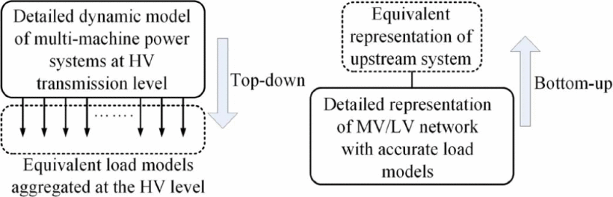
Fig.5 Top-down and bottom-up approaches for system modelling
As a standard distribution system, the IEEE 37-bus test system, shown in Fig. 6 is considered for this paper. It is a three-phase medium voltage radial distribution system with both single phase and unbalanced three phase loads. There are 32 static loads with a mix of constant impedance (Z), constant current (I), and constant power (P) i.e., ZIP characteristics. About 50% of these loads are considered as noncritical and assumed to be of purely impedance type while the other loads (connected to the supply/mains) are represented by the ZIP model. The location of SLs is the same as the location of original loads in the standard system. The actual percentage of the voltage dependent NC load is the key to the effectiveness of SLs. Also, the limits of voltage variations allowable across different loads would differ widely which affects the above percentage.
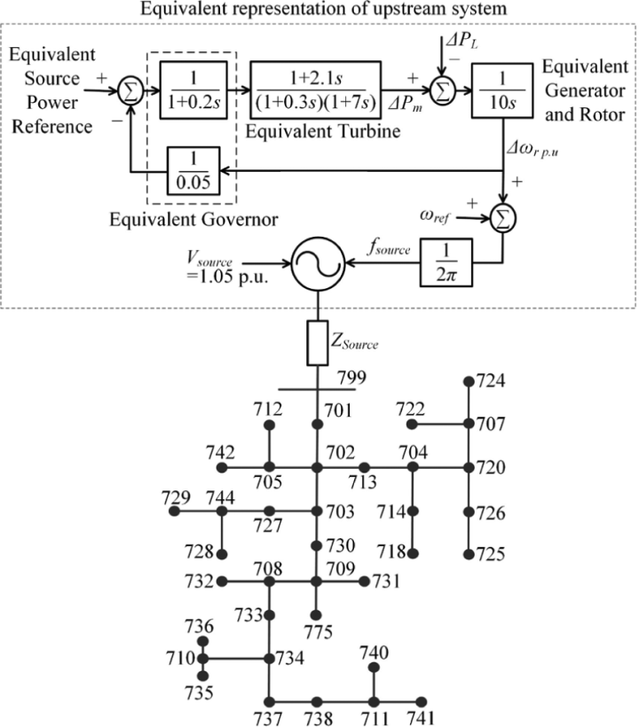
Fig.6 Single line diagram of IEEE 37 node test feeder
Simulation Results
Time domain simulations have been carried out in MATLAB SIMULINK using a time step of 20 μs. Frequency disturbances were created by applying 15% step changes in the equivalent source power reference. Simulation results at bus 738 are shown here for under-frequency (Figs. 7) events. It is a bus close to the far end of the distribution system. So the voltage regulation at this bus is relatively poor compared to the buses close to the upstream system. A small increase in voltage is observed for a reduction in the supply frequency. This is due to decrease in network reactance with a decrease in the frequency. Similarly, an increase in frequency results in a slight decrease in voltage due to an increase in network reactance. There are no frequency dependant loads in the standard IEEE 37 test feeder.
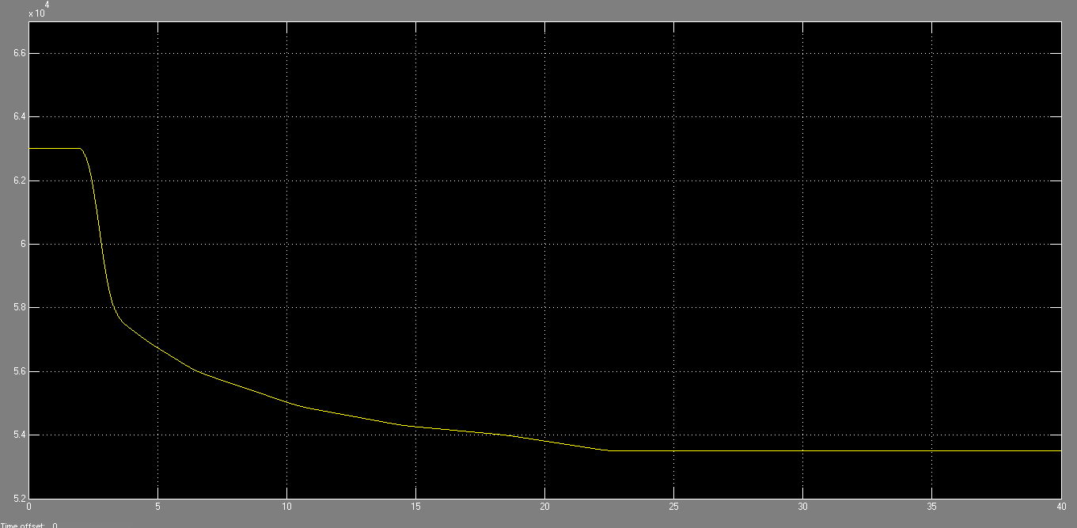
^{(a)}
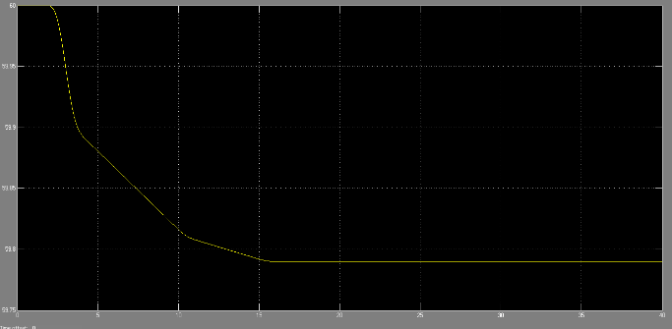
(b)
Fig. 7: Frequency (a) Smart Load (b) Normal Load
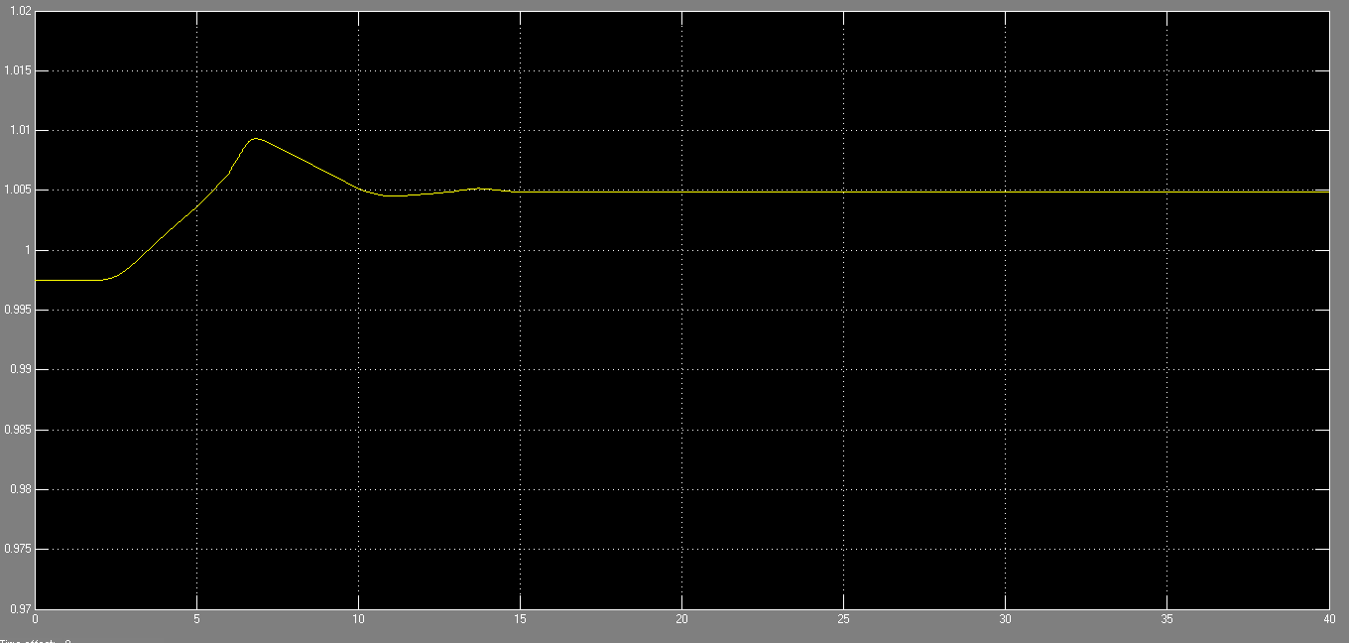
(a)
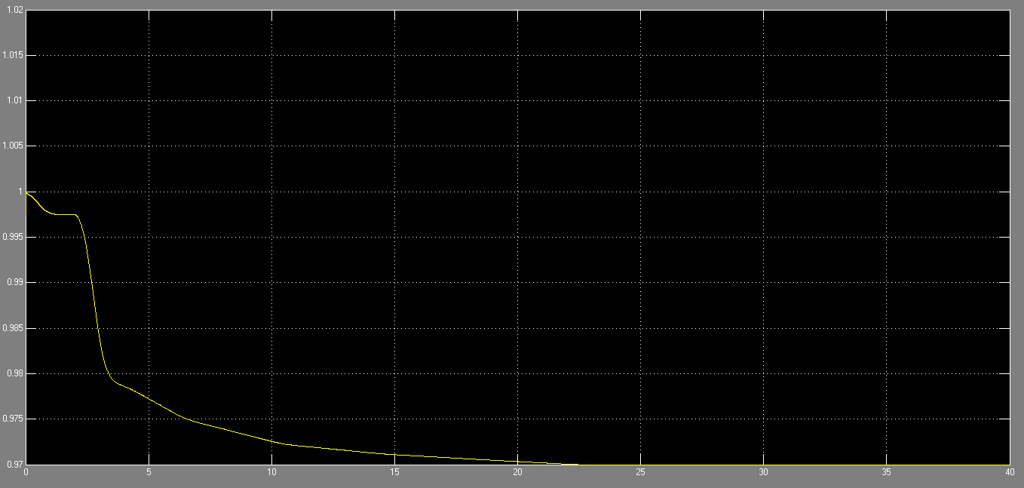
(b)
Fig. 8: Critical load voltage (a) Normal Load
(b) Smart Load
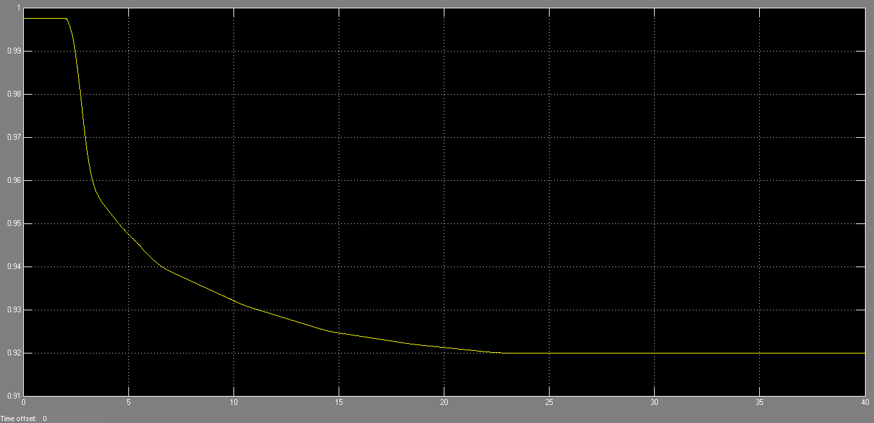
Fig. 9: Non Critical load voltage
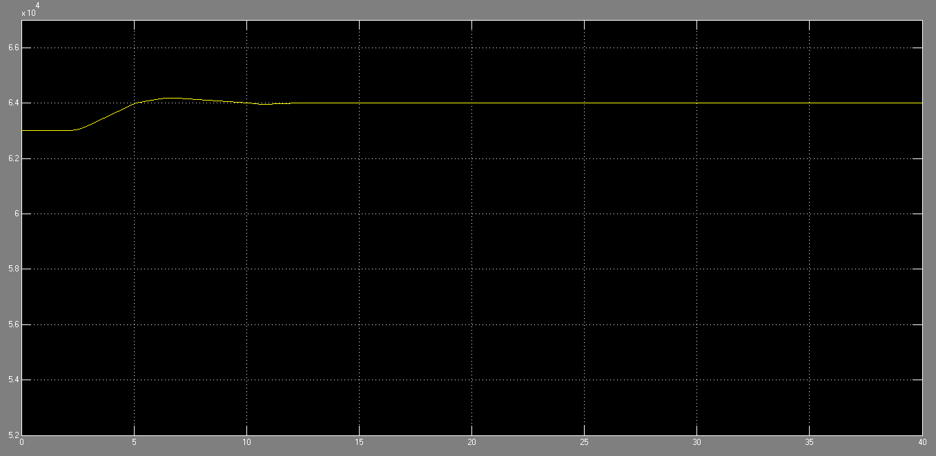
(a)
Fig. 10: Critical load voltage (a) Normal Load
(b) Smart Load
Fig.8 shows critical load voltage for smart load and normal load. SL ensures much improved frequency regulation compared to a normal load (i.e.,a NC load without a series compensator). The mains voltage regulation turns out to be slightly worse but still staying well within the acceptable (5%) limits. Fig.9 shows non critical load voltage and Fig.10 shows the real power of smart load and normal load. In this case, the ompensator is required to inject about 10% of the rated voltage while the variation in voltage across the NC load is limited to ±10%. This transient voltage variation will not cause perceivable change in the performance of NC loads like heating, lighting (especially, LED lighting), and small motors with no stalling problems (e.g., fans, ovens, dish washers, dryers) . With normal loads (red traces), the mains voltage would increase (decrease) in the under- (over-) frequency case which aggravates the situation resulting in the poor frequency regulation.
REFERENCES

[1] G. Stein. (2011). Frequency Response Technical Sub-Group Report, National Grid. [Online]. Available: http://www.nationalgrid.com/NR/rdonlyres/2AFD4C05-E169-4636-BF02-EDC67F80F9C2/50090/ FRTSGGroupReportFinal.pdf
[2] I. Erlich and M. Wilch, “Primary frequency control by wind turbines,” in Proc. IEEE Power Energy Soc. Gen. Meeting, Minneapolis, MN, USA, Jul. 2010, pp. 1–8.
[3] Y. G. Rebours, D. S. Kirschen, M. Trotignon, and S. Rossignol, “A survey of frequency and voltage control ancillary services part I: Technical features,” IEEE Trans. Power Syst., vol. 22, no. 1, pp. 350–357, Feb. 2007.
[4] H. T. Ma and B. H. Chowdhury, “Working towards frequency regulation with wind plants: Combined control approaches,” IET Renew. Power Gener., vol. 4, no. 4, pp. 308–316, Jul. 2010.
[5] A. H. Mohsenian-Rad, V. W. S. Wong, J. Jatskevich, R. Schober, and A. Leon-Garcia, “Autonomous demand-side management based on game-theoretic energy consumption scheduling for the future smart grid,” IEEE Trans. Smart Grid, vol. 1, no. 3, pp. 320–331, Dec. 2010.
[6] J. A. Short, D. G. Infield, and L. L. Freris, “Stabilization of grid frequency through dynamic demand control,” IEEE Trans. Power Syst., vol. 22, no. 3, pp. 1284–1293, Aug. 2007.
[7] P. Palensky and D. Dietrich, “Demand side management: Demand response, intelligent energy systems, and smart loads,” IEEE Trans. Ind. Informat., vol. 7, no. 3, pp. 381–388, Aug. 2011.
[8] M. Parvania and M. Fotuhi-Firuzabad, “Demand response scheduling by stochastic SCUC,” IEEE Trans. Smart Grid, vol. 1, no. 1, pp. 89–98, Jun. 2010.
[9] M. A. A. Pedrasa, T. D. Spooner, and I. F. MacGill, “Scheduling of demand side resources using binary particle swarm optimization,” IEEE Trans. Power Syst., vol. 24, no. 3, pp. 1173–1181, Aug. 2009.
[10] K. Samarakoon, J. Ekanayake, and N. Jenkins, “Investigation of domestic load control to provide primary frequency response using smart meters,” IEEE Trans. Smart Grid, vol. 3, no. 1, pp. 282–292, Mar. 2012.
[11] W. Gu et al., “Adaptive decentralized under-frequency load shedding for islanded smart distribution networks,” IEEE Trans. Sustain. Energy, vol. 5, no. 3, pp. 886–895, Jul. 2 [12] K. Tomiyama, J. P. Daniel, and S. Ihara, “Modeling air conditioner load for power system studies,” IEEE Trans. Power Syst., vol. 13, no. 2,pp. 414–421, May 1998.
[13] K. Christakou, D.-C. Tomozei, J.-Y. Le Boudec, and M. Paolone, “GECN: Primary voltage control for active distribution networks via real-time demand-response,” IEEE Trans. Smart Grid, vol. 5, no. 2,pp. 622–631, Mar. 2014.
[14] L. Liu, H. Li, Y. Xue, and W. Liu, “Reactive power compensation and optimization strategy for grid-interactive cascaded photovoltaic systems,” IEEE Trans. Power Electron., vol. 30, no. 1, pp. 188–202, Jan. 2015.
[15] C.-H. Liu and Y.-Y. Hsu, “Design of a self-tuning PI controller for a STATCOM using particle swarm optimization,” IEEE Trans. Ind. Electron., vol. 57, no. 2, pp. 702–715, Feb. 2010.
[16] S. Wong and S. Pelland, “Demand response potential of water heaters to mitigate minimum generation conditions,” in Proc. IEEE Power Energy Soc. Gen. Meeting (PES), Vancouver, BC, Canada, Jul. 2013, pp. 1–5.
[17] C. K. Lee, S. Li, and S. Y. R. Hui, “A design methodology for smart LED lighting systems powered by weakly regulated renewable power grids,” IEEE Trans. Smart Grid, vol. 2, no. 3, pp. 548–554, Sep. 2011.
[18] N. Lu, Y. Xie, Z. Huang, F. Puyleart, and S. Yang, “Load component database of household appliances and small office equipment,” in Proc. IEEE Power Energy Soc. Gen. Meeting, Pittsburgh, PA, USA, Jul. 2008, pp. 1–5.
[19] C. K. Lee, K. L. Cheng, and W. M. Ng, “Load characterisation of electric spring,” in Proc. IEEE Energy Conv. Cong. Expo. (ECCE), Denver, CO, USA, Sep. 2013, pp. 4665–4670.
[20] S. Y. R. Hui, C. K. Lee, and F. F. Wu, “Electric springs—A new smart grid technology,” IEEE Trans. Smart Grid, vol. 3, no. 3, pp. 1552–1561, Sep. 2012.
[21] N. R. Chaudhuri, C. K. Lee, B. Chaudhuri, and S. Y. R. Hui, “Dynamic modeling of electric springs,” IEEE Trans. Smart Grid, vol. 5, no. 5, pp. 2450–2458, Sep. 2014.
[22] S. C. Tan, C. K. Lee, and S. Y. R. Hui, “General steady-state analysis and control principle of electric springs with active and reactivepower compensations,” IEEE Trans. Power Electron., vol. 28, no. 8,pp. 3958–3969, Aug. 2013.
[23] C. K. Lee and S. Y. R. Hui, “Reduction of energy storage requirements in future smart grid using electric springs,” IEEE Trans. Smart Grid,vol. 4, no. 3, pp. 1282–1288, Sep. 2013.

