Mathematical Modelling of Fuzzy Logic assisted Load Frequency Control of a Two Area Power System
Ajinkya Ashok Wankhede
PG Scholar, Department of Electrical Engineering,
Government college of Engineering, Amravati, India, 444604
Ajinkyawankhede4@gmail.com

Abstract – This paper provides mathematical modelling of load frequency control problem for a Two-area power system taking into consideration system parameter variations. This paper proposes an intelligent control scheme for load frequency control (LFC) of interconnected power systems. A fuzzy logic based controller is proposed for two area power system interconnected via parallel ac/dc transmission link. The simulation studies shall be carried out in future for a two area interconnected power system with reheat steam turbine for simplicity and without loss of generality. Suitable solution for load frequency control problem of two areas electrical power system shall be obtained by means of improving dynamic performance of power system under study.

Keywords- Two area power system, load frequency control, fuzzy logic controller

INTRODUCTION
The load frequency control is a technical requirement for the proper operation of an interconnected power system. For large scale electrical power systems that normally consist of interconnected control areas representing coherent groups of generators, load frequency control is very important in power system operation and control for supplying sufficient and reliable electric power with good quality. In cases of area load changes and abnormal conditions, such as outages of generation and varying system parameters, mismatches in frequency and scheduled tie-line power flows between areas can be caused. These mismatches are corrected by controlling the frequency, which is defined as the regulation of the power output of generators within a prescribed area. The objective

of the LFC is to satisfy the requirements such as zero steady state errors in tie-line exchanges and frequency deviations, optimal transient behaviors and in steady state, the power generation levels should satisfy the optimal dispatch conditions. Some intelligent controllers have been proposed to solve these problems but considering area interconnection with ac line. A little attention has been paid to use of HVDC transmission link as system interconnection. A favorable effect on system dynamic performance has been achieved considering such system interconnection. These studies are carried out considering the nominal system parameter values after linearization of the system about an operating condition. In practical cases, system parameters do not remain constant and continuously vary with changing operating conditions. Therefore, a serious concerned should be given to these parameter variation. The present paper is devoted to analyze the dynamic performance of two interconnected thermal units when equipped with HVDC transmission link parallel to AC tie line taking parameter uncertainties into account. A fuzzy logic based intelligent controller is designed to facilitate the operation smooth and less oscillatory when system is subjected to a sudden load change. The simulation results are presented and compared with other techniques.

MODELING OF SINGLE-AREA SYSTEM

Nomenclatures
R₁, R₂ represents the speed regulation.
D₁, D₂ represents the frequency-sensitive load coefficient.
H₁, H₂ represents inertia constant.
T_{g1}, T_{g2} represents the governor time constant.
T_{t1}, T_{t2} represents the turbine time constant.
B₁, B₂ represents the frequency bias factors.
The main parts of the system consist of Governor, prime mover load and inertia model. These are described as following:

Governor model: The command ΔPg is transformed by hydraulic amplifier to the steam valve position ΔPv. The Tg is governor time constant, the transfer function of governor is given in Eqn. 2.1.

$\frac{ΔPv\left(s\right)}{ΔPg(s)}$=$\frac{1}{1+TgS}$ (2.1)

Prime mover model: The prime mover is used for producing mechanical power; it may be steam for steam turbine, water wall for hydraulic turbine. The model of prime mover ΔPm relates the mechanical power output to change in steam valve ΔPv value the transfer function is given in Eqn. 2.2.

$\frac{ΔPm(s)}{ΔPv(s)}$= $\frac{1}{1+Tts}$ (2.2)

Load and inertia model: The motor load is sensitive to the frequency change and can be analysed by speed load characteristic as given in Eqn. 2.3.

$\frac{Δw(s)}{ΔPm-ΔPl}$=$\frac{1}{2H+D}$ (2.3)

requency bias factor: The frequency biased factor is sum of frequency sensitive load change (D) and speed regulation as given in Eqn. 2.4.

B = $\frac{1}{R}$+ D (2.4)

The block diagram of the system can be presented using Eqn. 2.1 to Eqn. 2.4 and is shown in Fig. 1.

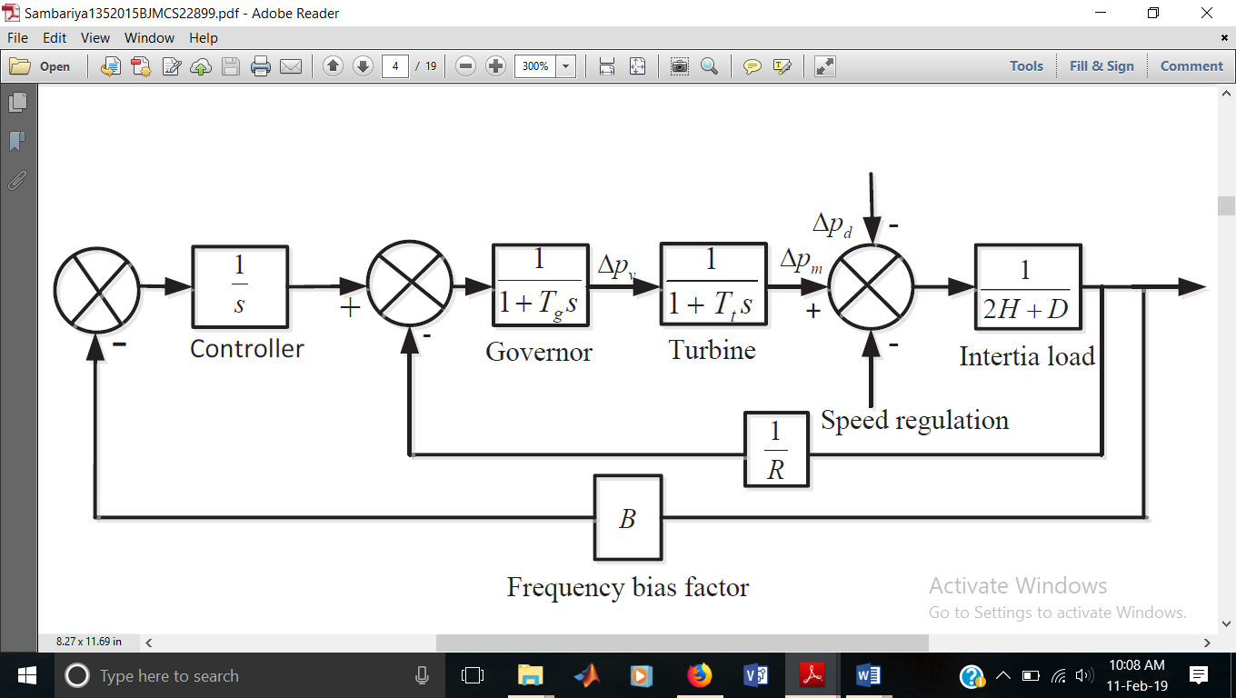
Fig. 1. Block diagram of load frequency control for single area system

MODELING OF TWO-AREA SYSTEM

A two-area system is represented by an equivalent generating unit interconnected by a lossless tie line with reactance of X_{tie} in Fig. 2.

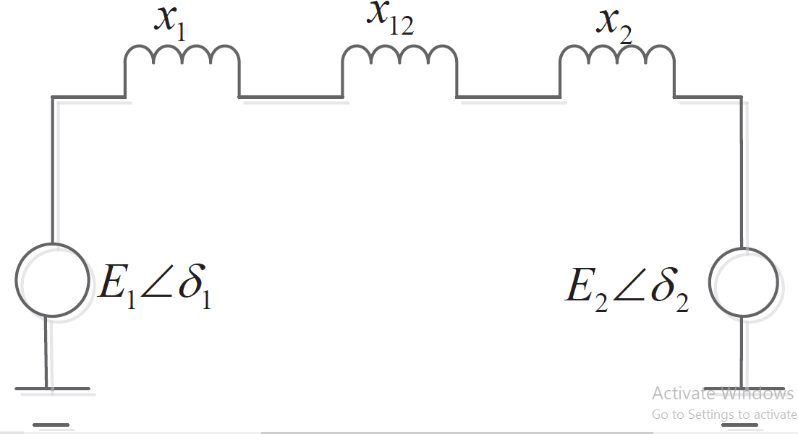
Fig. 2. Representation of two-area system

The real power transferred over the tie-line during normal operating conditions is given by Eqn. 2.5.

P₁₂ = $\frac{\left|E1\right||E2|}{X12}$ sinΔδ₁₂ (2.5)

Consider a small deviation of rotor angle δ₀ the resulting tie line power ΔP12 is given by Eqn. 2.6.

ΔP₁₂ =$\frac{ծP12}{ծδ12 }$ (2.6)

The synchronous power coefficient is given by Eqn. 2.7.

PS = $\frac{\left|E1\right||E2|}{X12}$ cosΔδ₁₂ (2.7)

Considering a load change ΔPL1 in area-1 at the time of steady state in frequency. It results as Δw = Δw1 = Δw2.

ΔP_{m1} - ΔPm2 –ΔP_{l1} = ΔɷD1
ΔP_{m2} + ΔP₁₂ = ΔɷD2 (2.8)

The change in mechanical power is determined by using the governor speed characteristic and is
given as
Δɷ = $\frac{-ΔPl1}{B1+B2}$ (2.9)

ΔP₁₂ =$\frac{B2}{ B1+B2 }$ (-ΔP_{l1}) (2.10)

TIE-LINE BIAS CONTROL

The tie-line bias control is used to maintain frequency and power at a pre-specified value where in each area manages its own load. The conventional LFC is based on the tie line bias control; in which each area is trying to reduce error to zero. The area control error is given by (ACE).
ACE1 = ΔP12 + B1Δɷ1
ACE2 = ΔP21 + B2Δɷ2 (2.11)

By using the above Eqn. 2.11, the block diagram can be made as given below of a two area interconnected power system is shown in Fig. 3.

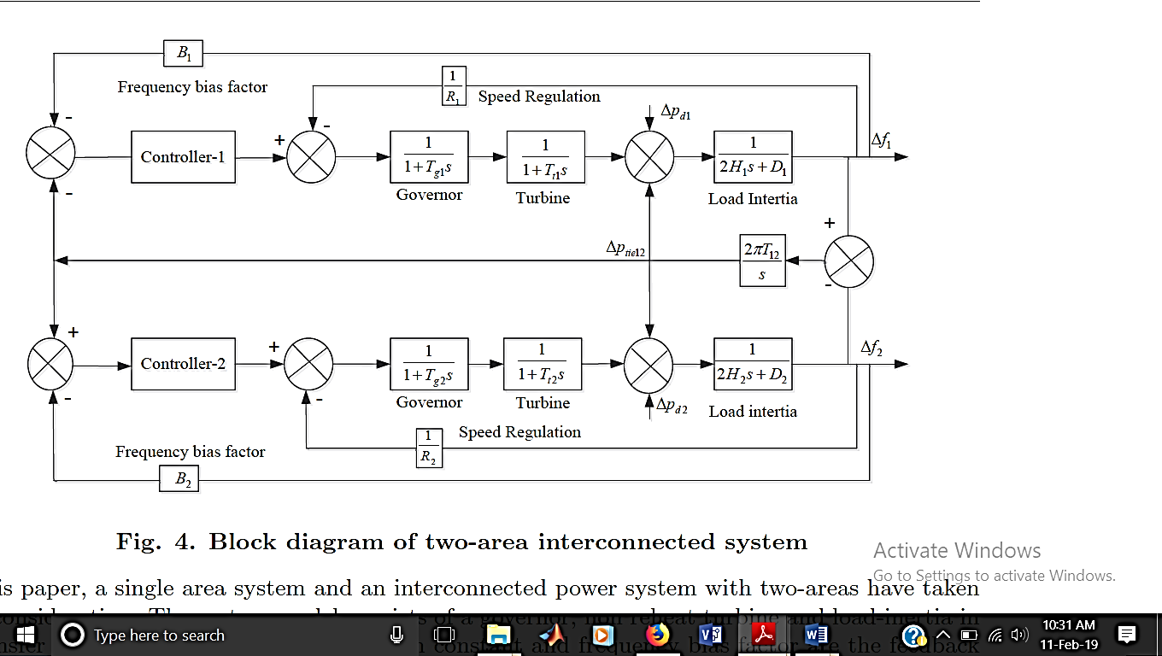
Fig. 3. Block diagram of two-area interconnected system

In this paper, a single area system and an interconnected power system with two-areas have taken into consideration. The system model consists of a governor, non reheat turbine and load-inertia in a transfer function form and speed regulation constant and frequency bias factor are the feedback to the frequency output, there is a frequency deviation in isolated system given as Δf, in two area system are two frequency deviation Δf1 for area-1 and Δf2 for area-2. The power demand
increment for area-1 is ΔPl1 and for area-2 is ΔPl2, this power demand is given in step load form. The area control error (ACE) for the two area is given two the controller. The fuzzy logic controller is used for controlling the frequency and power deviation in single and two are system. Designed fuzzy logic controller has forty nine rules and seven membership functions are used for each input and output. The triangular membership function is used for the controller and centroid method is used for defuzzification

FUZZY LOGIC CONTROLLER

Fuzzy set theory and fuzzy logic establish the rules of a nonlinear mapping. The use of fuzzy sets provides a basis for a systematic ways for the application of uncertain and indefinite models. Fuzzy control is based on a logical system called fuzzy logic which is much closer in spirit to human thinking and natural language than classical logical systems. Nowadays fuzzy logic is used in almost all sectors of industry and science. One of them is load frequency control. The main goal of LFC in interconnected power systems is to protect the balance between production and consumption. Because of the complexity and multi-variable conditions of the power system, conventional control methods may not give satisfactory solutions. On the other hand, their robustness and reliability make fuzzy controllers useful in solving a wide range of control problems. By complex control technique it is difficult to analysis complex problem. Fuzzy logic controller are mainly useful, whenever the source of information is uncertain or not exact. It consist of four components, different part of fuzzy control is given in Fig. 5. Table 1 is presenting the rules for fuzzy logic controller under study

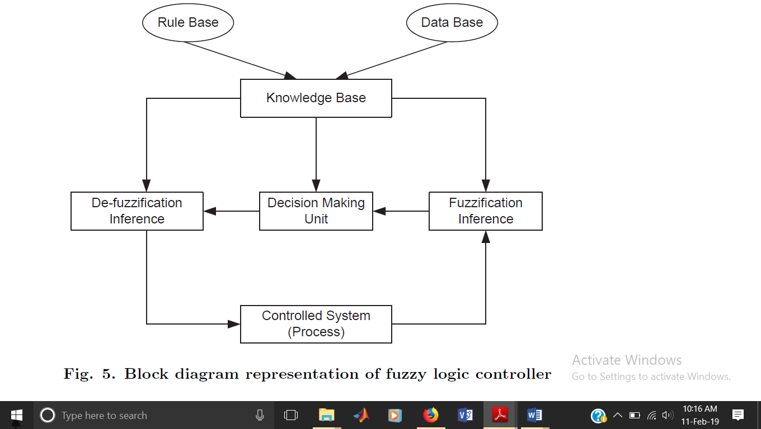
Fig. 4. Block diagram representation of fuzzy logic controller

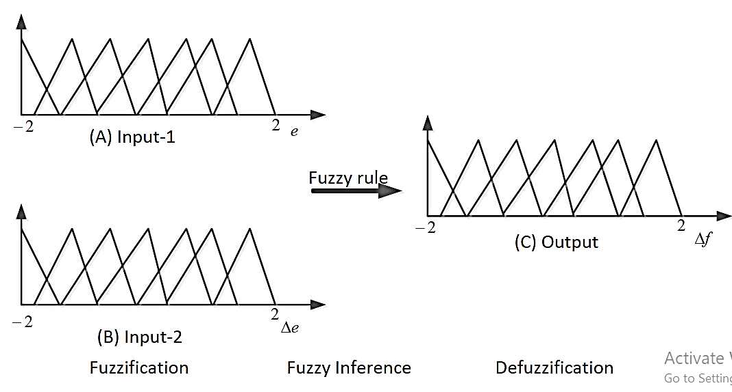
Fig. 5. Membership function for load frequency control

Table 1. Rule base for Load Frequency Control

ACE | LN | MN | SN | Z | SP | MP | LP
ΔACE
LN | LP | LP | LP | MP | MP | SP | Z
MN | LP | MP | MP | MP | SP | ZE | SN
SN | LP | MP | SP | SP | Z | SN | MN
Z | MP | MP | SP | Z | SN | MN | MN
SP | MP | SP | Z | SN | SN | MN | LN
MP | SP | Z | SN | MN | MN | MN | LN
LP | Z | SN | MN | MN | LN | LN | LN

LN: large negative, MN: medium negative, SN: small negative, Z: zero, SP: small positive, MP: medium positive and LP: large positive

CONCLUSION
In this paper, a new power system model is proposed to improve the dynamic performance of interconnected system. New model consists of a fuzzy logic controller
along with a AC/DC link connected parallel to ac tie-line. There are 7 triangular membership functions considered for inputs and one output. In all 49 rules are designed. Power system model with identical thermal units with reheat turbines are considered for the study. A new intelligent control strategy is designed and its feasibility will be studied in future by varying system parameters

REFERENCES
[1] Elgerd O.I., “Electric energy system theory: An Introduction”, Tata Mc-Graw hill, 1982

[2] Fosha C.E. and Elgead O.I., ”The megawatt frequency control problem: A new approach via optimal control theory”, IEEE Transactions on Power Systems, Vol. PAS-89, pp. 563-577, 1970.

[3] Saadat H, “Power system analysis”, Tata Mc-Graw hill Publishing Company Limited, New Delhi (India)

[4] Kundur P.” Power System Stability and Control”, New York McGraw-Hill, 1994.

