“IMPACT OF RICE HUSK ASH ON CEMENT CONCRETE”
(Deepak kumar, Deepak Kumar Sahu, Prashant Janghel, Shashikant Deshmukh, Nageshwar Kumar, Tushar chandel ,Yugalkishor)
Civil Engineering Department, RSR Rungta College of Engineering & Technology Bhilai C.G

- ABSTRACT
The country like india which is agriculture dominated produces a byproduct known as husk.In India rice milling produces a by product which is known as Husk. This husk is used as fuel in rice mills to produced steam for boiling process .This husk contain near about 75 % organic matter and the remaining 25% of this husk is modified into Ash during the firing process which known as rice husk ash (RHA).In India the chhattisgarh which is known as “Dhan ka katora” and west Bengal produces the highest amount of rice husk. The rice husk ash (RHA) contain near about 85 % to 90 % amorphous silica. The current study and experimental investigation were taken to study the properties of concrete made with Rice husk ash. the replacement is done partially in the proportion of 0% ,20% and its effect on workability of concrete made with rice husk ash were investigated for the 20% rice husk ash replacement ,the hardened properties. The compressive strength test was conducted at 0 % and 20 % rice husk ash replacement and the highest compressive strength at 20 % RHA replacement as compared to 0% RHA replacement at 14 ,21 and 28 days.
- KEYWORDS

- Rice husk ash, compressive strength etc.
- Rice husk, Silica, Refectory industry, absorbent.

- INTRODUCTION
Rice husk is a deposit that represents 20% of the 649.7 million a lot of rice created each year round the world. The artificial arrangement of rice husk is found to vary beginning with one specimen then onto successive attributable to the distinctions within the reasonably paddy, harvest year, atmosphere and geologic conditions. Smoldering the husk beneath controlled temperature beneath 800°C will deliver fiery remains with silica primarily in shapeless structure. As of late, Nair et al. reportable an examination on the pozzolanic movement of RHA by utilizing completely different systems as an area of request to examine the impact of combustion temperature and smoldering length. He expressed that the specimens blazed 500°C or 700°C and smoldered for over 12 hours delivered fiery junk with high reactivity with no noteworthy measure of crystalline material. The short blazing spans (15 - 360 minutes) caused high carbon content for the created RHA even with high burning temperatures of 500°C to 700°C. A best in class report on rice husk fiery debris (RHA) was distributed by Mehta in 1992, and contains a survey of physical and compound properties of RHA, the impact of combustion conditions on the pozzolanic qualities of the clinker, and a rundown of the exploration discoveries from a number of nations on the use of RHA as a supplementary establishing pozzolanic material.

- What is RHA?
Rice husk may be smoldered into fiery remains that satisfies the physical qualities and compound piece of mineral admixtures. Pozzolanic action of rice husk cinder (RHA) depends on upon
(i)silica-content , (ii) silica crystallization stage
(iii) size and surface region of fiery remains particles.
Likewise, cinder r should contain simply a little measure of carbon. The upgraded RHA, by controlled blaze and/or pounding, has been used as a pozzolanic material as a part of bond and cement. Utilizing it provides a number of focal points, as an example, natural benefits known with the transfer of waste materials and to lessened carbon dioxide emanations.
RHA created within the wake of smoldering of Rice husks (RH) has high reactivity and pozzolanic property. Concoction structures of RHA are influenced because of blazing procedure and temperature. silica contents within the powder increments with higher the blazing temperature. MATERIALS AND METHODS
Materials: RHA: The temperature was within the scope of 400-600 degree C .The powder collected was sieved through bs standard sieve size 75µm and its shading was dim. Cement: Ordinary Portland concrete (OPC) of 43 evaluation was utilized as a section of that the structure and properties is in consistence with the Indian standard association. Concrete will be defined as the holding material having strong and glue properties that create it capable to join the various development materials and structure the compacted get together. Standard/Normal Portland concrete is a standout amongst the most broadly utilised kind of Portland cement. The name Portland bond was given by Joseph Aspdin in 1824 due to its similarity in shading and its Quality when it solidifies like Portland stone.
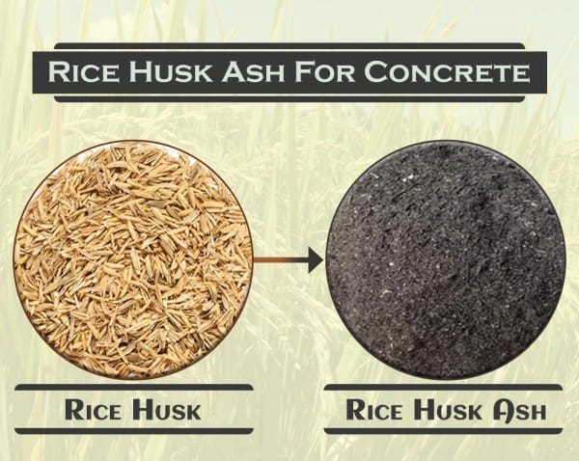
Aggregate - Total is a granular material, as an example, sand, rock, squashed stone, smashed hydraulic-bond cement, or iron impact heater slag, utilized with water powered establishing medium to make either concrete or mortar. Those particles that are dominatingly which held on the 4.75 mm (No. 4) strainer are known as coarse total. Those particles passing the 9.5 mm (3/8 in.) strainer, all passing the 4.75 mm (No. 4) strainer,

PHYSICAL PROPERTY
Sr. No. | Particulars | Proportion
1 | Colour | Gray-black
2 | Shape texture | Inregular
3 | Mineralogy | Noncrystalline
4 | Particle size | Less than 45micron
5 | Odour | Odourless
6 | Specific gravity | 2.3
7 | Appearance | Very fine

CHEMICAL PROPERTY -
Sr. No. | Particulars | Proportion
1 | Silicon dioxide | 87%
2 | Aluminium oxide | .2%
3 | Iron oxide | .1%
4 | Calcium oxide | .3-2.2%
5 | Magnesium oxide | .2-.6%
6 | Sodium oxide | .1-.8%
7 | Potassium oxide | 2.15-2.30%

- METHODOLOGY
It is that last results of the venture can have a general helpful impact on the utility of rice husk powder concrete within the field of structural building development work. Taking when parameters impacts conduct of the rice husk fiery debris solid, thus these parameters are kept consistent for the exploratory work.
1. Percentage substitution of concrete by rice husk powder Fineness of rice husk ash.
2. Chemical structure of rice husk fiery debris.
3. type of curing Additionally from the writing study it's watched that the parameters suggested by varied analysts and their outcomes aren't coordinative with one another. it absolutely was due to variety in properties of various materials thought of within the work. along these lines the rate substitution of bond by rice husk slag and strat
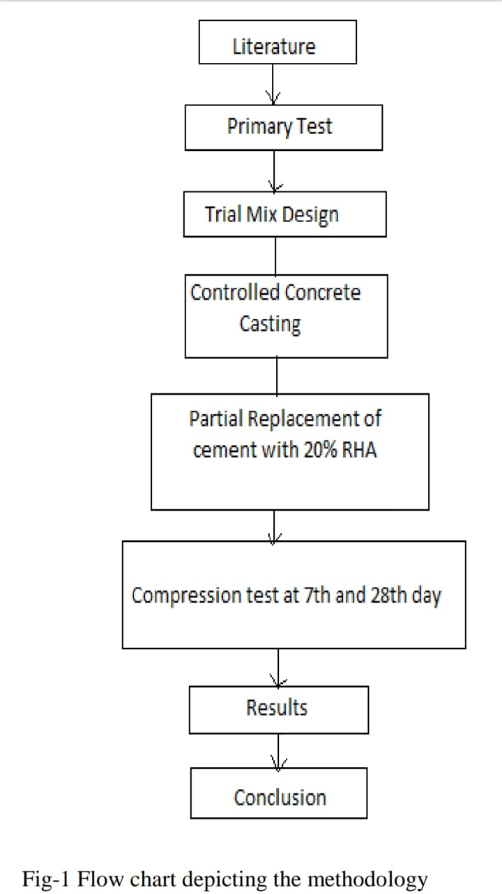

- COMPRESSIVE STRENGTH TEST
Due to the dependence of the mechanical behaviour of concrete on its curing process, for every mechanical characterization test, the following points (proposed by RILEM [20]) have to be stated as a minimum:
Type and dimensions of the specimen;
Composition of concrete;
How to implement concrete;
How to obtain specimens;
curing conditions;
Conservation conditions;
Number of identical tests performed or experimental scattering of the results.
According to investigations, it is thought that the type and size of the specimen could affect considerably on compressive strength test result. Cube specimen of dimension 100 mm × 100mm × 100 mm experienced water curing to evaluate unit weight and short term water absorption, and then placed under hydraulic jack to calculate the compressive strength at 7 and 28 d of curing.
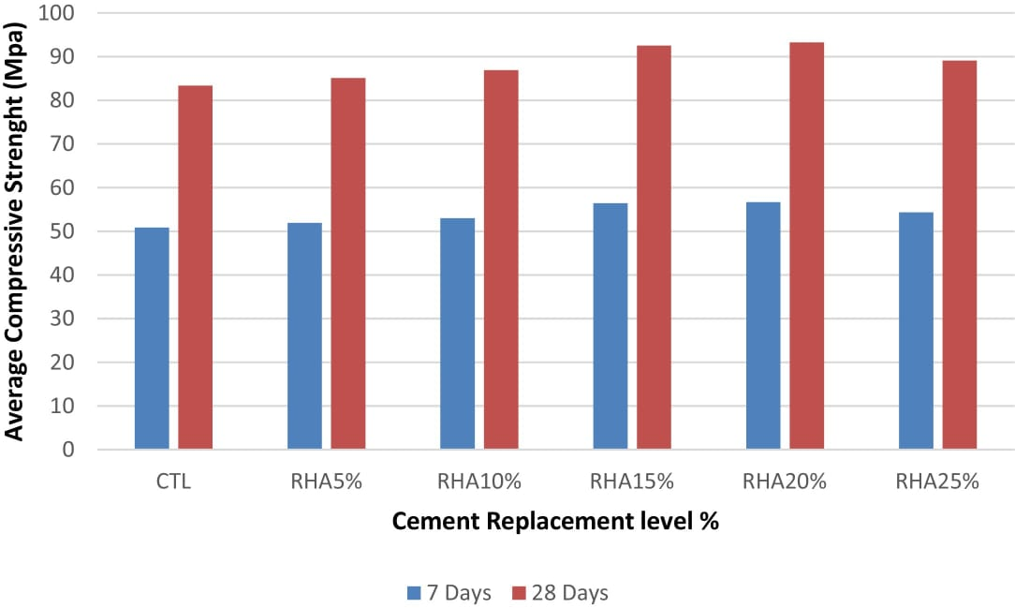
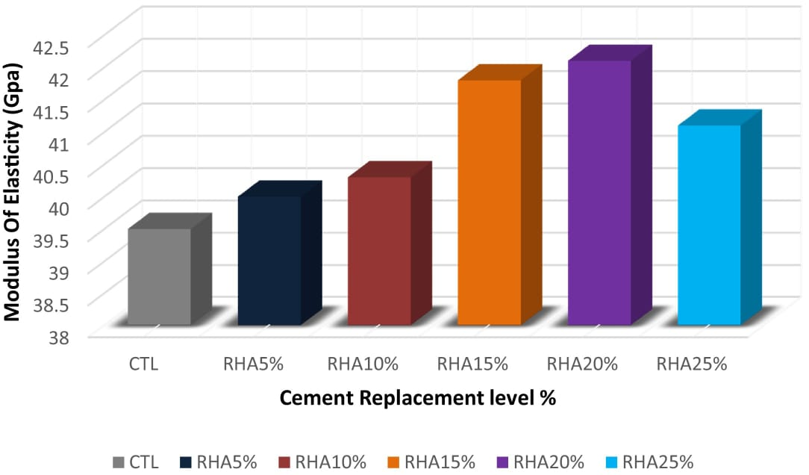

- ADVANTAGES

- Rice husk ashesh provide good compressive strength to the concrete.
- It is a by-product; hence, it helps in cutting down the environmental pollution.
- The high silica content makes it a good supplementary cementitious material or pozzolanic admixture.
- The density of concrete containing rice husk ash is similar to the normal weight. concrete; hence, it can also be used for the general-purpose application too.
- The impervious microstructure of rice husk ash concrete provides better resistance to the sulphate attack, chloride in
- Rice hull concrete has good shrinkage property and increases the durability of concrete.

- DISADVANTAGES

- By the use of rise husk ash, concrete progressively becomes unworkable. Hence water-reducing admixtures should be used to obtain workable concrete for the ease of placement and compaction of concrete.

- APPLICATION OF RESEARCH
RHA is a carbon neutral green product. Lots of modes are being thought of for disposing them by making of
commercial use of this RHA. RHA is a good pozzolanic material and can be used in a big way to make special.
concrete mixes. There is a growing demand for fine amorphous silica in the production of special cement and
concrete mixes, high performance concrete, high strength, low permeability concrete, for use in bridges, marine.
environment, nuclear power plant etc.

This product can be used in a variety of applications like:
- high performance concrete.
- In making green concrete.
- Ceramic glaze.
- oil spill absorbent.
- Water proofing chemicals.

- CONCLUSION
In view of the restricted study did on the quality conduct of Rice Husk cinder, the accompanying conclusions are drawn.
- 1. At all the bond substitution levels of Rice husk fiery debris; there is slow increment in compressive quality from 3 days to 7 days. However there is huge expansion in compressive quality from 7 days to 28 days took after by slow increment from 28 days.

- 2. By utilizing this Rice husk fiery debris as a part of concrete as substitution the discharge of nursery gasses can be diminished to be a more noteworthy degree. Therefore there is more prominent plausibility to acquire number of carbon credits.

- 3. The specialized and monetary focal points of fusing Rice Husk Ash in cement ought to be misused by the development and rice commercial enterprises, all the more so for the rice developing countries of Asia.

- 4. RHA based sand concrete piece can essentially decrease room temperature. Henceforth ventilation system operation is diminishing bringing about electric vitality sparing.

- 5. Also with the utilization of rice husk powder, the heaviness of cement lessens, along these lines making the solid lighter which can be utilized as light weight development material.

- 6. To The pozzolonic action of rice husk fiery remains is viable in upgrade the solid quality, as well as in enhancing the impermeability attributes of cement .

- 7. As the Rice Husk Ash is waste material, it lessens the expense of development.

- REFERENCE-

- 1. Sankar jegadesh J. S & S. Jayalekshmi., “Study on properties of concrete with color adsorbed fly ash, rice husk ash, steel slag and polypropylene fibers”, International Journal of Civil Engineering (IJCE) ISSN(P): 2278-9987; ISSN(E):,2278-9995 Vol. 3, Issue 3, May 2014, 9-18

- 2. Tanvir Hussein, Shuronjit Kumar Sarker, B.C. Basak.,“ Utilization potential of rice husk ash as a construction material in rural areas” ,Journal of Civil Engineering (IEB), 39 (2), November 2011, 175-188

- 3. Tomas U. Ganiron Jr., “ Effects of Rice Hush as Substitute for Fine Aggregate in Concrete Mixture International Journal of Advanced Science and Technology Vol.58, 2013, 29-40

- 4. Zalak Shah., “Experimental Study on the Strength of Concrete by Using Corrugated Steel Fibers with Rice Husk Ash”, Indian journal of applied research Volume : 3 , Issue : 5, May 2013 , ISSN - 2249-555X, 311-315

- 5. Rajendra Singh Dangi, Dr. Y.P Joshi., “Experimental study on Fly Ash, Wheat Straw Ash, Rice Husk Ash ,Saw Dust Ash and Glass powder as a partial replacement of cement in Concrete and their Cost Analysis”, International Journal for Scientific Research & Development Vol. 2, Issue 05, 2014 ISSN (online): 2321 0613

- 6. S. I. Khassaf, A. T. Jasim, F.K. Mahdi., “Investigation The Properties Of Concrete International Journal of Trend in Scientific Research and Development (IJTSRD) ISSN: 2456-6470 @ IJTSRD | Available Online @ www.ijtsrd.com | Volume – 2 | Issue – 3 | Mar-Apr 2018 Page: 1790 Containing Rice Husk Ash To Reduction The Seepage In Canals.”, international journal of scientific & technology research VOLUME 3, ISSUE 4, ISSN 2277-8616, April 2014, 348-355

- 7. P. Padma Rao, A .Pradhan Kumar, B .Bhaskar Singh, “A Study on Use of Rice Husk Ash in Concrete”, IJEAR Vol. 4, Issue Spl-2, ISSN: 2348-0033, Jan - June 2014.

- 8. R. S. Deotale, S. H. Sathawane, A.R. Narde., “Effect of Partial Replacement of Cement by Fly Ash, Rice Husk Ash with Using Steel Fiber in Concrete International Journal of Scientific & Engineering Research, Volume 3, Issue 6, June2012 ISSN 2229-5518, 1-9

- 9. R.N. Krishna, “Rice husk ash – an ideal admixture for concrete in aggressive environments”, 37th Conference on our world in concrete & structures: 29 - 31 August 2012,Singapore Article Online Id: 100037026

- 10. Naveen, Sumit Bansal and Yogender Antil., “Effect of Rice Husk on Compressive Strength of Concrete”, International Journal on Emerging Technologies, ISSN No. (Online): 2249-3255, June, 2015,144-150

