A Review on
“Failure Analysis of Forming Tool Breaking in Pneumatic Machine”
Aishwarya .V.Bisne¹, Dr. A.K.Mahalle²

¹Student, M TECH CAD/CAM, Mechanical Engineering Department,
GHRCE, Nagpur, Maharashtra, India
²Assistant Professor, Mechanical Engineering Department,
GHRCE, Nagpur, Maharashtra, India

ABSTRACT: -In this paper, the pneumatic machine the forming tool is used to mold the powder in the die. The forming tool used in machine breaks down, due to the stroke coming from the feeder that strikes the tool at high speed. If the small bushes are molded in the die the speed of the feeder is high due to which the tool breaks down easily, while in the case of large bush the speed is bearable by the tool. This research aims to the analysis of the tool material and the force striking the tool by the feeder. The objective is to improve the fracture toughness and wear resistance of forming tool and analysis and testing of the new improved tool.
Keywords: pneumatic machine, forming tool, die, powder, etc.
- Introduction:
In this industry based project related to forming tool breaking in the pneumatic machine for MM sintered products PVT LTD. MIDC Nagpur. MM sintered is Assigned a work for designing the bush bearing by the molding process in the pneumatic machine and hydraulic machine which is used for pressing or molding and forming the powder used to make the bush bearing. During the visit, the problem was discussed The forming tool used for pressing the powder in the die breaks down, due to the stroke coming from the feeder that strikes the tool at high speed.

The upper die of forming tool is exposed to shock like compressive and bending loads. The life of tool is less than one month.
During this project, various causes of tool failure will be identified and rectified by using data collected from the industry. The objective is to rectify the design of tool after studying the failure parameters.

- Data Collection:

- RAW MATERIAL USED
- Bronze Powder
- Iron Powder
- MANUFACTURER OF RAW MATERIAL
- Bronze Powder- PP PATEL AND COMPANY SOLAPUR
- Iron Powder- HOGNAS LIMITED AHMEDNAGAR
- MACHINE USED FOR PROCESSING
- Pneumatic machine- 20 Ton and 30 Ton

- Methods used in processing of parts
- The standard methods of shaping metal powder for parts production includes.
- Mechanical pressing
- Injection molding
- Isostatic molding
- Most of the parts are made my mechanical pressing and sintering. Parts can be small to moderate in size and simple or complexed.
- Parts produced by mechanical pressing have close tolerances.
- Failure Data Collection
- Reasons for Breaking of Tool
- The forming tool used for pressing the powder in the die breaks down, due to the stroke coming from the feeder that strikes the tool at high speed.
- If the small bushes are formed in the die the speed of the feeder or frequency is high due to which the tool breaks down easily.
- While in the case of large bush the speed is bearable by the tool.
- The upper die of forming tool is exposed to shock like compressive and bending loads. The cutting and the lateral area is affected by wear strain as a result of friction between the workpiece and the tool.
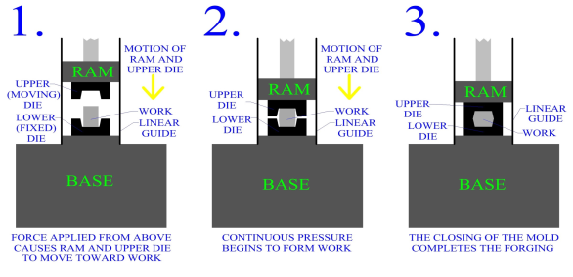 Fig (a)- FORGING PRESS

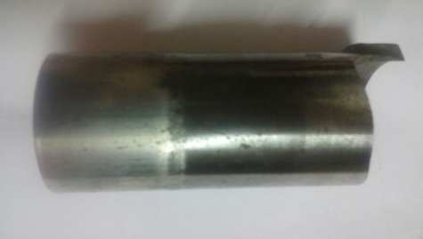
Fig(b)- BROKEN TOOL

- Objective

- To increase the strength of material.
- To design a tool by using the different material.
- To analyze and redesign a tool which is subjected to frequent breakage and heavy impact force.

- Assembly of The Entire System

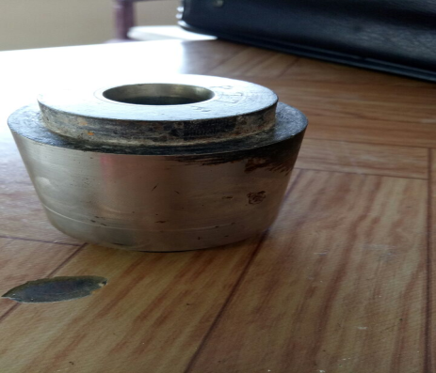
Fig(c)- DIE

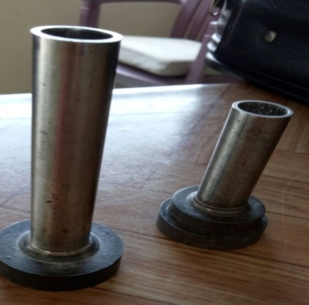
Fig(d)-UPPER AND LOWER TOOL

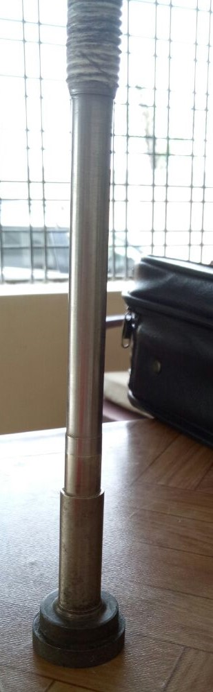
Fig(E)-ROD USED FOR INNER DIAMETER OF BUSHES

- Literature Review

Prof. Dr.-Ing.E.h.F.Klocke
Methods of modifying the subsurface layer selectively
Subsurface hardness
In this process, only one subsurface with a certain thickness (up to a maximum of 5 mm) is hardened selectively. Hardness values of up to 66 HRC are achieved.
Depending on the carbon content of the material and on the depth of the hardening process. The material can be heated by induction, conduction, flame, electron beam or laser.

Associate Professor Mechanical Engineering, MGM’S JNEC Aurangabad
The objective of this paper is to improve the availability of forging press. For this work, different quality tools are used to analyze the cause of failure, and corrective actions are taken as required.

K. Nagendra’s, S. Sathisha and J. David
Rathnaraja
HCHCR punch die and the Tungsten Carbide punch die are the same due to the application. The results shows the Stress level in the HCHCR is comparatively low then the Tungsten Carbide die, means the Tungsten carbide can withstand more stress load for the Blanking Operation in industry

SANAP ASHOK B1, DOLAS .D.R2 1M.E. Manufacturing, MGM’S JNEC Aurangabad Associate Professor Mechanical Engineering, MGM’S JNEC Aurangabad
This paper has been carried out on 1000 ton Pneumatic Forging press performance analysis. The critical system & critical parts are identifying by using Pareto chart, which has been under breakdown condition is also identified and analyzed.

Cassio Barbosa . Ibrahim de Cerqueira Abud . Tatiana Silva Barros . Sheyla Santana de Carvalho.
In general tool, steels are high carbon and high alloyed steels designed for reaching elevated levels of mechanical strength, sufficient for the type of loading. Defects on the surface of this material can lead to stress concentration

J.Arun1S.PravinKumar2,M. Venkatesh3, A.S.Giridharan4 1UG Graduate, Department of Mechanical Engineering, Government College of Technology, Coimbatore.
Failure Mode and Effect Analysis is done in the process of Punching. A punching operation is done on various workpieces, and the defects are found. These steels are classiﬁed in different groups, according to their chemical composition and mechanical properties.
Ullash Joshi1 Dr. Balasaheb D. Biranale2 Antriksh Bhatt3 1P.G.Student 2Principal 3Assistant Professor
Punching or piercing is the oldest and most frequently used sheet metal forming process. Piercing process is used for the finite element method to reduce the failure of punch for a sheet material.
- .Problem Definition
The forming tool of the pneumatic system breaks down prematurely due to the stroke coming from the feeder 8the life of the tool is less than one month because of this the redesign of the tool causes high cost and the ideal time increases.

- Research Methodology
In the present study, we create the CAD model of tool. Then analysis of design will be performed. Then the modifications and analysis of modified design and the stress analysis will be performed.
- Conclusion
The aim is to investigate various reasons for the failure of forming tool. A brief review of forming tool analysis different conventional and recent techniques was discussed for various types of tool.
• Failure types in the most of the forming tool break down, due to the stroke coming from the feeder that strikes the tool at high speed.
• The upper die of forming tool is exposed to shock like compressive and bending loads.

References
- Finite Element Simulation of Punching Process Using in Process Characterization of Mild Steel Ullash Joshi1 Dr. Balasaheb D. Biranale2 Antriksh Bhatt
- Analysis of Breakdowns and Improvement of Preventive Maintenance on 1000 Ton Pneumatic Press Praveen Kumar R1, Rudramurthy2
- Causes & Preventation of Defects (Burr) In Sheet Metal Component Pawan Kumar Rai1, Dr. Aas Mohammad2, Hasan Zakir Jafri3
- A DETAILED STUDY ON PROCESS FAILURE MODE AND EFFECT ANALYSIS OF PUNCHING PROCESS J. Arun1, S. Pravin Kumar2, M. Venkatesh3, A.S. Giridharan4
- AVAILABILITY ANALYSIS OF FORGING PRESS USING QUALITY TOOLS SANAP ASHOK B1, DOLAS .D.R2
- Comparison of HCHCr Steel and Carbide Punch and Die Increase its Strength and Life by Tin & Ceramics coating K. NagendranȦ*, S. SathishȦ and J. David Rathnaraj
- Failure Analysis of Die Block 1Pramila S. Chine, 2Vishnu S. Aher

