Design and Development of Automatic Walker

1st Himanshu Lute
Dept. of Mechanical Engineering
Yeshwantrao Chavan College of Engineering
Nagpur, India
lutehimanshu@gmail.com

2nd Manthan Diwate
Dept. of Mechanical Engineering
Yeshwantrao Chavan College of Engineering
Nagpur, India
manthandiwate1@gmail.com

4th Tanmay Moon
Dept. of Mechanical Engineering
Yeshwantrao Chavan College of Engineering
Nagpur, India
moon.tanmay030@gmail.com
3rd Mohit Fuke
Dept. of Mechanical Engineering
Yeshwantrao Chavan College of Engineering
Nagpur, India
mfuke123@gmail.com

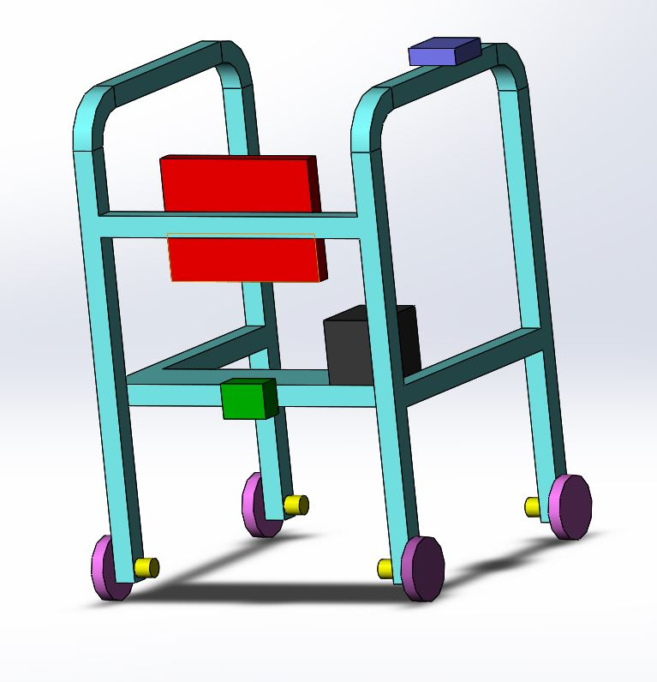

Abstract— Elderly, blind or visually impaired people recur to a cane as a traditional ambulation aid. Although useful for maintaining balance, and for pivoting around obstacles, this tool limits the autonomy of individuals. In some extreme cases, using a cane leads to potential hazards, which can be detrimental to the health of the person relying on it. The aim of this project is to introduce a novel automated ambulation tool, entitled “Design and Development of automatic Walker”, which overcomes the aforementioned disadvantages. The Walker is equipped with sensors and various drives that detects position of obstacles, location of the person intelligently by GPS system etc. and analyzes them. The processing is done in real-time via a pre-programmed Arduino board; accordingly, the user adjusts his plan of action. The encouraging results set path for extending this work to be implemented in more aid-systems; a fact that is apt to improve the well-being of old and impaired people.

Keywords— Arduino, sensors, walker

Introduction
In the 21st century, life has become more complex and more complicated with so little time left to watch and take care of old people or those who have certain physical disabilities. The key is to merge various technological branches and advancements in order to obtain an effective system to maximize its efficiency and render our system useful not only for the present but for the near and long future. Nowadays, the advancements in biology and technology are improving the quality of life of the elderly and the blind by creating and optimizing different solutions that not only will help with their daily life activities but also will make the targeted population useful members in the society instead of a burden by constructing a new life design, thus, probably saving their lives or at least improving it. The time spent with families is in gradual decrease; elder care institutions have been always criticized due to their money consumption and unpleasant treatment with elders and was noticeable on a psychological level were elders feel abandoned or imagine the idea that they have no reason to live anymore and for what purpose. The blind however, face bigger challenges. In a world where human beings designed and developed the basic core of their daily life activities depending on the sense of vision, blind people have managed a limited but realistic success to merge and make their lives active and connected with the society.

why choosing a walker
Walkers assume an important role due to its simplicity and rehabilitation potential. These devices are interesting once they work as a supporting device during biped station and, in addition, use the person’s own remaining locomotion capability in order to move [7] avoiding the early and deteriorative use of wheelchairs. Walkers are prescribed to improve patients’ mobility and help them maintain balance. These devices can increase confidence and sense of safety, which can raise a patient’s level of activity and independence. There may be physiological benefits of limiting osteoporosis, reducing cardiopulmonary reconditioning and improving peripheral circulation Static equilibrium is maintained when the body’s center of mass is positioned over the base of support. Loss of balance can result when the center of mass is positioned over the base of support. Loss of balance can result when the center of mass is displaced in relation to the base of support because of voluntary movements or external perturbations, such as slips, trips or pushes. Use

of a walker increases the base of support, thereby allowing a greater tolerated range for center of mass positions They can also prevent instability by allowing stabilizing reaction forces such as holding on or pushing against the ground. There are many types of walkers, considering their constitutive materials, accessories, sizes and structural configurations. These are classified in two types: conventional and smart walkers. Smart walkers have emerged with the same structure as the conventional ones but they include additional robotic and electronic components, that promote a better assistance to gait, especially considering navigation, gait monitoring, and partial body weight support

III. LITERATURE REVIEW

A. obstacle detection

An infrared sensor (HCSR-04) is an electronic instrument that emits and/or detects infrared radiation that helps in collecting relevant data about the surrounding environment. Infrared sensors are used for the purpose of detecting obstacles. The used sensors have a range of detection that amounts to up to 80 cm. The Smart Walker is equipped with four Infrared sensors, which detect the presence of objects in the vicinity; one sensor for the right direction, one for the left, one for the front right, and one for the front left The function of these sensors is shown in “Fig. 1”.

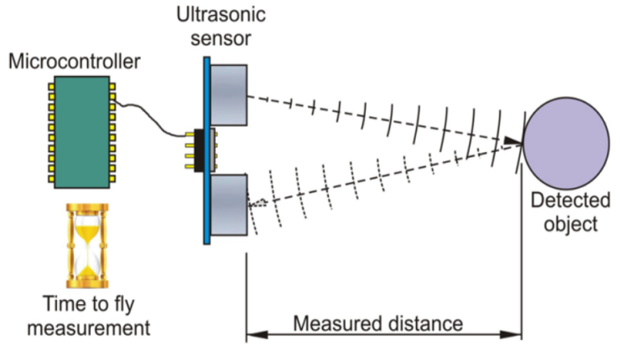

B. system control

In order to control the system’s inputs and outputs, programming codes are used to facilitate the process through the use of an Arduino board. Arduino is an open-source electronics prototype platform based on flexible easy-to-use hardware and software, and that can be connected to a computer via a USB cable which acts as a port to upload the program. An important feature of using Arduino for this project is that it communicates with the motor driver and GPS GSM module. The infrared sensors will be connected to the inputs of the Arduino Board. The four outputs needed will be dedicated to output 5V in order for the GPS module to be activated

at the real time. The geared motors having the basic characteristics such as low speed and high torque are driven by motor driver L293D which in the connection with lead acid rechargeable battery which is also shown in the above circuit diagram. The whole circuit is been driven by regulator chip 7805 which is connected in series with LCD display and microcontroller which is self-actuated by the means of Arduino UNO hardware system.

C. GPS and GSM module

Along with following attachments as mentioned the system is equipped with the GPS based module which will detect the real time location of the person when in such condition
Where the person feels some kind panic or any hazardous activity being detected. The operation will include the pressing of panic button which will be located near the fingers of the person on pressing the Arduino UNO according to programmed condition will automatically send the real time location of the person to the numbers which are being programmed accordingly.

D. Drive system

The drive system of joystick controlled Automatic walker is shown in the following fig. which shows that the input power from battery is supplied to the Arduino board which excites the motor driver IC which is further responsible for the movement of the DC geared motor which further rotates the wheels as the motors are adhered to wheels of the walker however the wheels rotates at the certain low speed and high torque characteristics which enables them to match the speed of impaired, elderly people.

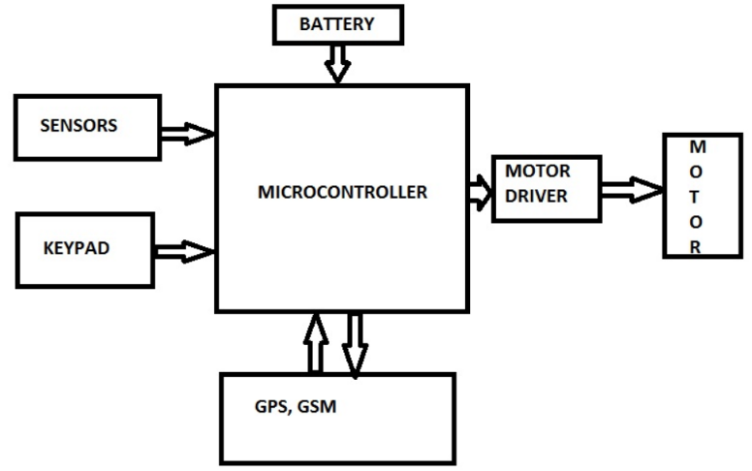

IV. PROPOSED SOLUTION

The Automatic Walker presents an effective ambulation aid for the elderly and vision impaired people. Using simple electronics circuitry, along with profiting from the proliferation of smart phone applications, a smart mobility system which acts also as a health monitor is recommended. One of the main attractions of the Automatic Walker is offering relative independence to people in need, which would reflect on their morale and productivity. The system had undergone extensive testing, and proved to be pretty reliable. Arduino launched a revolution in the ease to assemble and program numerous projects, performing calculations and measurement and even hosting web servers
Arduino can be used to develop interactive objects, taking inputs from a variety of switches or sensors, and controlling a variety of lights, motors, and other physical outputs. Projects can be stand-alone, or they can communicate with software running on your computer Similar to Arduino usage, by using these advancements in technology that are present today, simple yet effective inventions can aid the people who are in most need for it. The ultimate solution that been provided by this automatic walker configure the various aspects as discussed above and also it will to elaborate the behavior normal walker.

V.MATERIALS AND METHODS

This project fundamentally consists of two parts: the local system and the remotely controlled system. The local system is responsible for detecting existing obstacles and notifying the blind, while the remotely controlled system will monitor the GPS and GSM module. The two parts with all their constituents are implemented on the Walker. In order to work in an organized fashion, it is necessary to envision the project as a whole block diagram.to distinguish the different components and phases present, and to engage work efficiently between members.
Early obstacle detection is extremely important for people who use walkers. Due to the effects of impaired balance, sudden changes in terrain can sometimes present serious challenges to balance, even when one is using an ambulatory aid.
Normally, the navigation and obstacles detection employ ultrasonic, vision or infrared sensors capable of detecting static and dynamic obstacles. The control system assists the user in obstacle avoidance by sound or vibration alerts or operating directly on the device’s actuators, momentarily changing the path introduced by the user. This function is usually designed to help users with visual problems or to help navigation on environments with multiple obstacles.
The data gathered is sufficient for obstacle avoidance and is simple enough to allow rapid processing and notification. Another specification is that the device can detect descending stairs, not dragging the user after it. This is done by installing an ultrasonic sensor at the lower front size that calculates the distance between the walker’s lower part and the ground in a tilted front way. If the distance increases suddenly, then this will give a notification that a descending stair is in front.
VI. RESULTS AND DISCUSSIONS

A. Results

The results of the project after testing are the
following:
1.The infrared sensors function properly; their output is analyzed by the Arduino board, which sends a stable 5V output and inform the user of the direction of the present obstacles.
2.The weight of the Smart Walker is an issue, but is solved by installing wheels that are capable of handling weight and reducing unnecessary wiring and adjusting with a smaller but more effective power supply (Lithium Powered).
3.The basic aim of the automatic walker to reduce the efforts behind the moving of the walker which is being considerably reduced by placing the DC geared motored which operates the walker without picking it up and placing on the above position.

B. Discussions

During the course of this project a lot has been learned. When it comes to programming the Arduino, the team has learned how to program and test a lot of examples provided by Arduino website, leading to understanding of how to write the code needed for the infrared sensors. Circuits only needs a little focus and a lot of wiring. It has taken a while before the circuits functioned properly. What is really significant in using the sound recording chip is that whenever an infrared sensor detects an obstacle that is about 80cm far from the walker it will send a prerecorded sound notification telling the elder or the blind to change their direction while walking. In addition to that a LED will light when the sensor is active adding a visual way of notification. The application, though has well-functioned, but still has some imperfections. . The Panic button on the walker adds an effective way of notifying the monitoring person with a sound notification on his mobile phone in case of emergency. of being monitored remotely and can feel safe since someone is constantly there to answer to his/her need. Evaluating the works that were presented in this article, one can infer that, in general, almost all the smart walkers have an assistive navigation system with sensors that detect obstacles, as well as, a design that has been studied to provide and improve a stable gait. This factor is possible with different designs of the guide platform that can have, for example, a forearm support. Another aspect that increases stability is the fact that electronics and other heavy components are put on the center upper part of the walkers, giving a greater balance and stability to the device. Thus, rollators can be easily augmented with simple and relatively low cost instrumentation technologies to provide a wide range of functionality and gait characteristics as Smart walkers, and avoid to inadequately resort to alternative devices thus contributing to the maintenance or to the improvement of the physical and cognitive capabilities of the user.

B. Future Work

The Smart Walker has a bright future ahead. The part that has been accomplished is considered by our team a pillar to what will become in the future. Artificial Intelligence and Video Processing can help the blind to use the Walker, not only in a controlled environment, but also across streets, to work, etc. More accurate pulse sensors will manage to measure and send better results with less noise interfering with the original message. Using smaller electronic parts will reduce the overall weight of the Walker, making it easier to use. Another interesting aspect is to provide a Global Positioning System (GPS) for the Smart Walker in order to detect the presence of the elderly and the blind at all times in case assistance is required. The emergency push-button can also be set to relay its call to a nearby hospital to provide fast medical assistance, or to send an ambulance. This would ultimately lead to a decrease in the rate of accidents and morality. Future researches should improve the safety and stability of walkers, and avoid to inadequately resort to alternative devices such as wheelchairs, that have disabling effects, thus contributing and reinforcing to the maintenance or to the improvement of the physical and cognitive capabilities of the user. A necessary step is the improvement of a smart walker capable of supporting the weight of the user but that can be used to stably and safely drive him with a high maneuverability. For this purpose, different handle bar designs must be addressed and it must be verified the best way to dispose the base support of the upper limbs of the user, in order to improve the maneuverability of the walker and to improve the ergonomics. Additionally, it is important to understand and study the dynamic model of the walker, to quantify and ameliorate the stability of the walker, while the user is guiding it through unknown territory.
Additionally, it is necessary to find components that are low consumption and the battery system has to be improved. For safety the electrical system has to be isolated from the environment in an enclosure to prevent damage from liquid-spills, . On the one hand, the re-charge time of the batteries should not be longer than eight hours to achieve full charge thus allowing re-charge overnight. On the other hand, the runtime of the system should be of the order of six hours. Further, the re-charge system should be simple to connect and monitor.

VII. REFRENCES

- Anonymous.“Arduino.”Internet: http://arduino.cc/

- Alex Swanson. “Opening Up IP Security Solutions.” Internet: http://www.indigovision.com/documents/public/

articles/ON VIF%20Article-UK.pdf, [Jan. 10, 2014].

- Tom Swanton. “Guide to Android Video Streaming.” Internet: http://ezinearticles.com/?Guide-to-Android-Video-Streaming&id=6570341, [Jan. 10, 2014].

- Lacey G, Dawson-Howe K: Evaluation of Robot Mobility Aid for the Elderly Blind. Proceedings of the Fifth International Symposium on Intelligent Robotic Systems, 1997
- Constantinescu R, Leonard C, Deeley C, Kurlan R.: Assistive devices for gait in Parkinson’s disease. Parkinsonism and Related Disorders 2007, 13:133–138.

- Bateni H, Maki B: Assistive Devices for Balance and Mobility: Benefits, Demands, and Tagawa Y, Shiba N, Matsuo S, Yamashta T: Analysis of human abnormal walking using a multi-body model joint models for abnormal walking and walking aids to reduce compensatory action. Journal Balance and Mobility: Benefits, Demands, and Adverse Consequences. Arch Phys Med Rehabil 2005, 86.

