PERFORMANCE AND EXPERIMENTAL STUDIES ON VORTEX CIRCULATING DOUBLE TUBE SOLAR PASSIVE-BED DRYER

Pratik Gondane¹, N. N. Wadaskar ², Avinash R Mankar ³,Kishor Wagh ⁴
^{1, 2, 3,4}Department of Mechanical Engineering, RTMNU University, Nagpur,

Abstract: Solar is one of the renewable and sustainable source of energy. It is abundant in both direct and indirect form. In many tropical countries, agricultural products dried under the open sun. This is the oldest technique used by mankind. Various topics in sun and solar drying are discussed in many scientific reports, research manuscripts and books. This review paper focused on fabricating and testing for drying chillies by using flat plate collector and vortex- circulating bed solar dryer. The advantage of the vortex circulating bed is to provide constant movement of the chillies over the bed in order to enhance the resident time with hot air. Vortex circular motion technique provides efficient agitation. The model can predict the change in the temperature of air, relative humidity, the moisture content and the dryer thermal efficiency. Food scientists have found that by reducing the moisture content of food to between 10 and 20%, bacteria, yeast, mould and enzymes are prevented from spoiling it. The flavour and most of the nutritional value is preserved and concentrated. Wherever possible, it is traditional to harvest most grain crops during a dry period or season and simple drying methods such as sun drying are adequate. However, maturity of the crop does not always coincide with a suitably dry period. Furthermore, the introduction of high-yielding varieties, irrigation, and improved farming practices have led to the need for alternative drying practices to cope with the increased production and grain harvested during the wet season as a result of multi-cropping. Drying and preservation of agricultural products have been one of the oldest uses of solar energy
The traditional method, still widely used throughout the world, is open sun drying where diverse crops, such as fruits, vegetables, cereals, grains, tobacco, etc. are spread on the ground and turned regularly until sufficiently dried so that they can be stored safely Food crops are usually for immediate consumption needs, resulting in wastage of food surpluses during the short harvest periods and scarcity during postharvest periods. Drying is one of the methods used to preserve food products for longer periods. It has been established as the most efficient preservation technique for most tropical crops. This project presents the construction and performance of a vortex-circulating bed solar dryer for food preservation. The solar dryer consists of flat plate collector, a blower with pipe connections, and vortex circulating bed.
The results obtained during the test period revealed that the temperatures inside the dryer and solar collector were much higher than the ambient temperature during most hours of the day-light. The dryer exhibited sufficient ability to dry food items reasonably rapidly to a safe moisture level and simultaneously it ensures a superior quality of the dried product.
Keyword-Solar flat plat collector, Blower, Vortex-circulating double bed, Relative humidity and Absorber plate attached with baffles,
- INTRODUCTION

Drying using solar radiation i.e. drying direct sunlight is one of the oldest techniques used by mankind to preserve agriculture based food and non-food products. This form of energy is free, renewable and abundant in any part of the world specially in tropical countries. However, in order to maximize its advantages and optimize the efficiency of drying using solar radiation, appropriate technology need to be applied order to keep this technique a sustainable one. Such technology is known as solar drying and is becoming a popular option to replace mechanical thermal dryers owing to the high cost of fossil fuels which is growing in demand but dwindling in supply.
Various topics in sun and solar drying are discussed in many scientific reports, research manuscripts and books. This project will

be fabricating and testing for drying agriculture produce by using flat plate collector and vortex circulating bed. The model can

predict the change in absolute humidity of air across the bed, the temperature of air, the moisture content and the dryer thermal

efficiency. By using vortex circulating bed, efficiency is increase and reduces the time for drying. The major two categories of

the dryers are natural convection solar dryers and forced convection solar dryers. In the natural convection solar dryers the

airflow is established by buoyancy induced airflow while in forced convection solar dryers the airflow is provided by using fan

operated either by electricity/solar module or fossil fuel. . It is estimated that 20% of the world‘s grain production is lost after

harvest because of inefficient handling and poor implementation of post-harvest technology, says Hartman‘s (1991). Grains and

seeds are normally harvested at a moisture level between 18% and 40% depending on the nature of crop.

These must be dried to a level of 7% to 11% depending on application and market need. Once a cereal crop is harvested, it may

have to be stored for a period of time before it can be marketed or used as feed. Drying materials at optimum temperatures and in

a shorter amount of time enables them to retain more of their nutritional value such as vitamin C. An added bonus is that

products will look better, which enhances their marketability and hence provides better financial returns for the farmers. It is

cheap. Using freely available solar energy instead of conventional fuels to dry products or using a cheap supplementary supply

of solar heat, so reducing conventional fuel demand can result in significant cost savings

- LITERATURE REVIEW

- R. VidyaSagarRaju, [03] had worked on that, the section comprises of literature review on studies in the past in relation to solar dryer and present. It also discuss the different types of solar dryers, its advantages and disadvantages, comparison of using open sun drying and solar drying technology. He also mentioned that drying may be an interesting method in order to prevent fresh fruit deterioration. There is spoilage of fruits and other fresh foods that could be preserved using drying techniques in India and other developing countries. Seasonal fruits like mangoes are not presently dried for export, or for local consumption during period of scarcity.
- Seini ‘ElaUatekiniVaipulu, [04] had worked on different drying techniques for drying agricultural products were reviewed in the study to develop a suitable dryer for drying sea cucumber as it is a high export value product gaining importance in the international markets now a days. A conceptual prototype solar dryer for drying sea cucumber was designed which has its advantages over the traditional open sun drying methods such as reducing the loss due to damage caused by insects, birds, rodents and adverse climatic conditions. The drying period using the conceptual solar dryer is 1 -2 days whereas it takes 4 -14 days in the traditional open sun drying methods.
- Benjamin TernengeAbur, [05] in this paper, solar drying technologies for drying fruits, vegetables, spices, cereals, grains, legumes, medicinal plants and fish for global food security are reviewed. For nutrient preservation of dried products and superior drying speed, the indirect forced convection type solar dryers are preferred but power requirement increase the cost of drying as well as limit their use in the rural areas. Natural-circulation type solar tunnel dryers, wind ventilated type solar dryers with heat storage units and greenhouse dryers are more suitable for rural applications. Solar-biomass hybrid dryers overcome the limitations of solar drying during cloudy conditions and night hours, operational procedure and effectiveness in promoting better product quality should be consider in the design and production of solar drying systems.
- Chandrakumar B Pardhi, [06]. Based on preliminary investigations under controlled condition of drying experiments, a mixed-mode solar dryer with forced convection using smooth and rough plate solar collector was constructed. This paper describes the development of dryer considerations followed by the results of experiments to compare the performance of the smooth and the roughed plate collector.
- Shanmugamle, KumarAR. Veerappan, [01] had worked on a mathematical model for drying agricultural produce using a solar dryer capable of oscillating its bed while kept at an inclined position with respect to vertical. A model of the solar dryer with double-pass flat plate collector and an oscillating-bed has been fabricated and tested for drying agricultural produce. ⁹³⁷

- METHODOLOGY

The flat plate collector is the heart of any solar energy collection system designed for operation in the low temperature range (ambient-60°C)or in the medium temperature range (ambient-100°C). It is used to absorb solar energy, convert it into heat and then to transfer the heat to a stream of liquid or gas. It absorbs both direct and diffuse radiation, and is usually mounted on the top of a building or other structures. It does not require tracking of the sun and requires little maintenance. Essentially the majority of flat plate collectors consist of several basic elements. These are as follows:
(i) Absorber plate which may be flat corrugated or fins or baffles attached to it, which is normally metallic, upon which the short wave solar radiation falls and is absorbed.
(ii) Glazing, this may be one or more sheets of glass or some other diathermanous (radiation transmitting) material.
(iii) Thermal insulation provided at the back and sides of the absorber plate to minimize the heat losses.

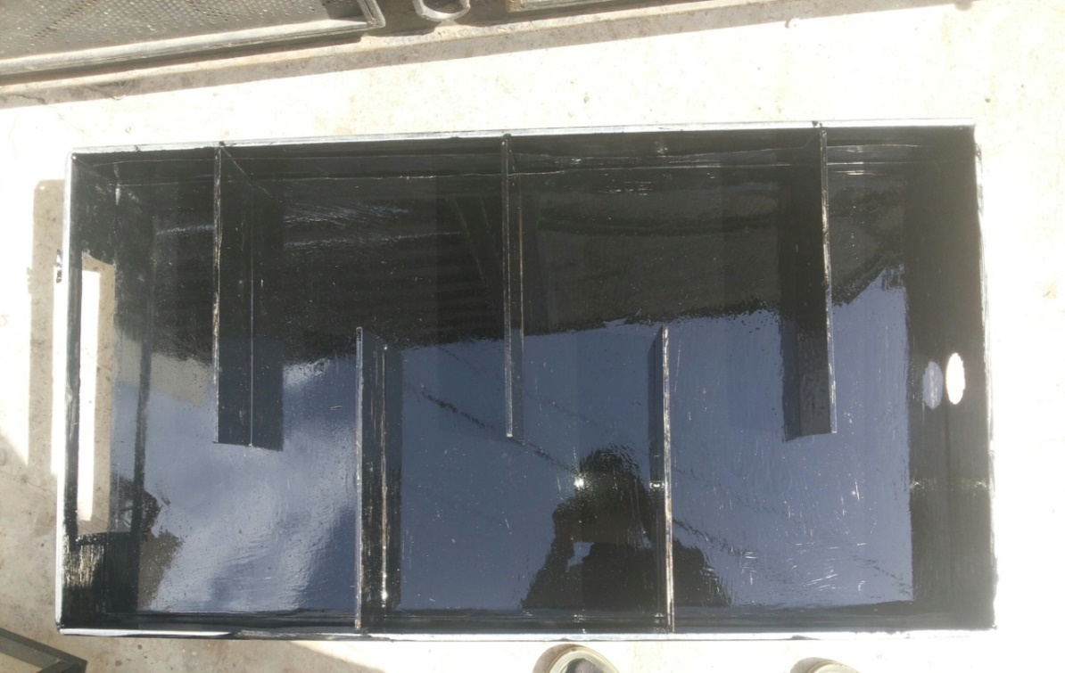
Fig.3.1 Flat plate collector painted black with absorber plate attached with baffles.

The flat plate collector consists of collector plate, absorber plate with baffles and box with insulation. The heat absorber plate with baffles of the solar air heater was constructed using 3 mm thick aluminium plate and the baffles of aluminium are attached to the plate having 8 mm thickness, 300 mm long and 100 mm wide, painted black, is mounted in the box built from galvanized iron sheet. The space between absorber plate and bottom of box is filled with glass wool which is used as insulated material. The solar collector assembly consists of air flow channel enclosed by transparent cover (glass
plate. Baffles provide some time to heat the ambient air. The glazing is a single layer of 4 mm thick transparent glass sheet; it has a surface area of 500 mm by 1000 mm. One end of the solar collector has a rectangular air inlet vent from where ambient air is come inside flat plate collector and on other end blower pipe connection is attached that can suck ambient air from surrounding.
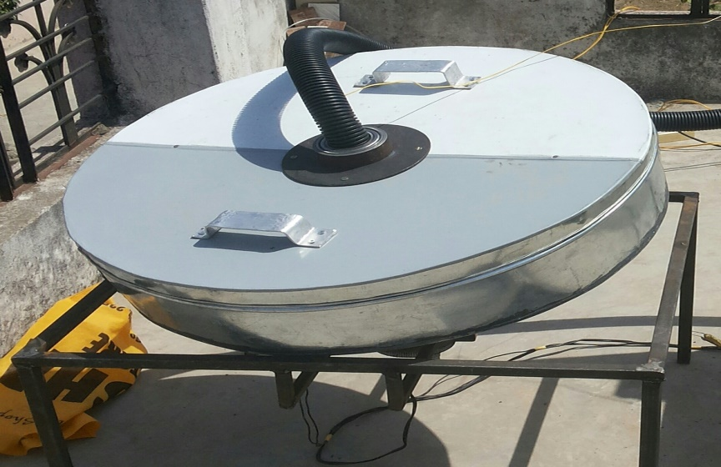

Fig.3.2Vortex-circulating bed with pipe connection

IV. PIPE CONNECTIONS
In this solar dryer the flexible pipe connections are use having diameter of 50mm. The hot air can circulate through this pipe from flat plate collector to vortex-circulating bed. The inlet of the pipe is connected to flat plate collector while outlet is connected to vortex-circulating bed. It has high capacity of sustain high temperature.
V. CONCLUSION

The solar dryer can raise the ambient air temperature to a considerable high value for increasing the drying rate of agricultural crops. The product inside the dryer requires less attentions, like attack of the product by rain or pest (both human and animals), compared with those in the open sun drying. Although the dryer was used to dry chillies, it can be used to dry other crops like yams, cassava, maize, potato and plantain etc. There is ease in monitoring when compared to the natural sun drying technique. The capital cost involved in the construction of a solar dryer is much lower to that of a mechanical dryer. Also from the performance carried out, the simple and inexpensive vortex-circulating bed solar dryer was constructed using locally sourced materials. In this project the experiment is performed on 6m/s, 5m/s and 4m/s of velocity of air. On that particular velocity of air the moisture removal from chillies of solar dryer is observed that 42.85%, 39.35% and 38.15% respectively. As compared to open sun drying it is much higher. The average efficiencies are obtained for mentioned air velocities are 19.92%, 18.018% and 20.38% respectively. The quality of the product obtained after solar drying is much better than open sun drying. The dryer exhibited sufficient ability to dry food items reasonably rapidly to a safe moisture level and simultaneously it ensures a superior quality of the dried product.

VI. REFERENCES

[1] R VidyaSagarRaju et al Int. Design and Fabrication of Efficient Solar Dryer, Journal of Engineering Research and Applications www.ijera.com ISSN: 2248-9622, Vol. 3, Issue 6, Nov-Dec 2013, pp.1445-1458
[2] UmeshToshniwal, S.R Karale / A review paper on Solar Dryer International Journal of Engineering Research and Applications (IJERA) ISSN: 2248-9622 www.ijera.com Vol. 3, Issue 2, March -April 2013, pp.896-902
[3] S. Shanmugam1P. KumarAR.Veerappan,Modeling and Experimental Studies on Oscillating Inclined-Bed Solar Dryer Department of Mechanical Engineering, National Institute of Technology, Tiruchirappalli 620015, India [DOI: 10.1115/1.4023592]
[4] Figueiredo Ramos1, António Cardoso2, and Adérito Alcaso11 Hybrid Photovoltaic-Thermal Collectors: Polytechnic Institute of Guarda, School of Technology and Management, Portugal University of Coimbra, FCTUC/IT, Department of Electrical and Computer Engineering, Portugal Nº SFRH/BSAB/950/2009.
[5] Brokker, O. B., Bakker-Arkema, F. W., and Hall, C. W., 1992, Drying and Storage of Grains and Oil Seed, AVI, New York, p. 405.
[6] Mumba, J,1996, “Design and Development of a Solar Grain Dryer Incorporating Photovoltaic Powered Air Circulation,” Energy Convers. Manage. 37(5),pp. 615–621.]
[7] Forson, F. K., Nazha, M. A. A., and Rajakaruna, H., 2007, “Modelling and Experimental Studies on a Mixed-Mode Natural Convection Solar Crop Dryer, ”Sol. Energy, 81(3), pp. 346–357.
[8] Benjamin TernengeAbur, “Food Security: Solar Dryers And Effective Food Preservation” Mechanical/Production Engineering Programme, School of Engineering and Engineering Technology, Abubakar Tafawa Balewa University, P.M.B 0248 Bauchi-Nigeria E-ISSN2249–8974,

[9] Chandrakumar B Pardhi,(2013), “Development and performance evaluation of mixed-mode solar dryer with forced convection” content/4/1/23,
[10] Seini ‘ElaUatekiniVaipulu, “ Design A Prototype Solar Dryer For Drying Sea Cucumber” University of Southern Queensland Faculty of Engineering and Surveying, ENG4111/4112,
[11] Mahmoud Mohamed El-Ghobashy El-Hagar, Design, Implementation And Testing Of An Indirect Solar Potato Dryer, Mechanical Engineering Department Industrial Education College, Beni-Suef University Egypt ISBN: 978-1-61804-314-6
[12]Vinay Narayan Hegde*, VirajShrikanthHosur, Samyukth Kumar K Rathod, Puneet A Harsoor and K Badari Narayana Design, fabrication and performance evaluation of solar dryer for banana Hedge et al. Energy, Sustainability and Society (2015) 5:23
DOI 10.1186/s13705-015-0052-x
[13] Ljiljana T. Kosti´c, Zoran T. Pavlovi´c, “Optimal position of flat plate reflectors of solar thermal collector”, Energy and Buildings 45 (2012) 161–168.

