Inventory control and Logistic Data Compilation for Outsources at Legrand Pvt. Ltd. Jalgaon
Dr. V. G. Arajpure¹ Rajesh A. Ubale², Shubham K. Sonune³, Dinesh S. WAgh⁴, Kunal S. Hole⁵, Yogendra A. kotwal⁶
¹ Principal & Professor ² Student(BE), ³ Student(BE), ⁴ Student(BE), ⁵ Student(BE), ⁶ Student(BE)
^{1,2,3,4,5,6} Department of Mechanical Engineering, Godavari Foundation Godavari College of Engineering, Jalgaon- 425003
vgarajpure07@rediffgmail.Com¹, rajeshubale1996@gmail.com ², shubhamsonune1997@gmail.com 3, dineshwaghdh1996@gmail.com 4, kunalhole143@gmail.com 5, yakotwal@gmail.com 6

Abstract – This paper study of inventory control management of Legrand Pvt. Ltd. Jalgaon. They are generally maintaining the inventory for 1. Finish goods, 2. Work in progress, 3. Row material. And various techniques are used in company like ABC Analysis, FSN Analysis, KANBAN, and Just in Time (JIT). And also uses of 5S methodology in warehouse for maintaining the raw material. 5S is one of the most widely adopted techniques from the lean manufacturing toolbox. Along with Standard Work and Total Productive Maintenance, 5S is considered a "foundational" lean concept, as it establishes the operational stability required for making and sustaining continuous improvements.
Keywords-logistic, supply chain management, inventory control, kanban, 5s
- INTRODUCTION

Logistics is generally the detailed organization & implementation of a complex operation. In military science, logistics is concerned with maintaining army supply lines while disrupting those of the enemy, since an armed force without resources and transportation is defenseless.
Logistics management is the part of supply chain management that plans, implements,and controls the efficient, effective forward, and reverse flow and storage of goods, services, and related information between the point of origin and the point of consumption in order to meet customer's requirements. A supply chain is an integrated manufacturing process in this process raw materials are converted into final products, and then delivered to customers.
Inventory is the blood of any manufacturing company. Because just like a man, if a man without blood then he will be dead. So, there for the same phenomenon is concerned for a company point of view. Inventory management defined as some total of those activities those are necessary for the control storage, sales, and use of material.
In Legrand Pvt. Ltd. Jalgaon they are generally maintaining the inventory for 1. Finish goods, 2. Work in progress, 3. Row material. The company uses six inventory control techniques i.e. ABC Analysis, FSN Analysis, KANBAN, Maximum-Minimum level, Material requirement Planning (MRP), Just in Time (JIT). The company has maintained 33 days inventory for row material and 14 days inventory for work in progress.
- LITERATURE SURVEY
Kostas-Platon Aronis [5] In this paper the author is presented a case study of applying the Bayesian approach method is not much more complicated than the one currently in use by the company manufacturing and providing the spare parts. Using the same form of inventory control policy, i.e., the ( S-1,S) system, the Bayesian method results in lower total stock for the same level of service. The proposed method has been received very well by the company. As we also advised them to use a METRIC like method for their multi-echelon inventory system, the implementation of the Bayesian method was delayed to a later stage.
Swapnil S. Dange [7] In this paper authors are identified that value mapping activity is an ideal tool to find out wastages. Just in Time (JIT) manufacturing makes outstanding improvement in area of cost and productivity through best use of human resources by focusing on simplicity, waste elimination and time reduction. It helps the companies to reach their ultimate goal of sustainability and profitable growth in the future.
Dinesh B. Shinde [3] By using “5s”technique improved visibility of problem conditions, improved safety, reduced waste, improved morale, an increased sense of ownership of the workspace, improved productivity, improved quality, improved maintenance, shorter lead times, and a better impression on customers. More fundamentally, a wellimplemented 5S program helps the culture develop a new sense of discipline and order that carries over into all activities.
- METHODOLOGY
3.1 Inventory Control
Maintain and control inventory through easy-touse screens for updating item inventory quantities and details, inventory valuation and planning, and the setting of item policies like lead-time and replenishment planning. Includes Purchase Requisition Maintenance for Direct Material Items and Supply Demand Review (an output of Replenishment Planning), to show demand, supply and projected on-hand balances by time period.
3.2 Warehouse Management
Detailed areas (Location IDs and Location Numbers) provide the basis for advanced picking and put away techniques. Easy integration with automated warehouse systems is provided. Combined with features of Inventory Control, Sales Order Management and Purchasing, complete control of the warehouse is available.
3.3 Automated Data Collection
In Legrand Pvt. Ltd they are use mapix software for control the inventory management. Reduce distribution and supply chain costs and increase accuracy and efficiency. Whether using dedicated item code and barcode of cartons can be reported, verified and committed via this software. Standard item code and barcoded forms and reports support this automated data collection solution. By using this software they can see all information in other branches of Legrand Pvt. Ltd.
3.4 Lot & Serial Control
An item’s lot or serial number can be registered through Purchasing Receipts, Inventory and Sales Order Management. As Lot and Serial Number controlled items are consumed, a full traceability tree is constructed and maintained. Supports Lot Expiration dates and product recalls if ever required. A comprehensive history of a serialized device of “as shipped”, “as installed” and “as maintained” is provided.
3.5 5S Methodology
The 5S Method is a standardized process that when properly implemented creates and maintains an organized, safe, clean and efficient workplace. 5S is a workplace organization method that uses a list of five Japanese words as sseiton, seiri, seiso, seiketsu, shitsuke. These Japanese words are translated as Sort, Set In order, Shine, Standardize and Sustain.
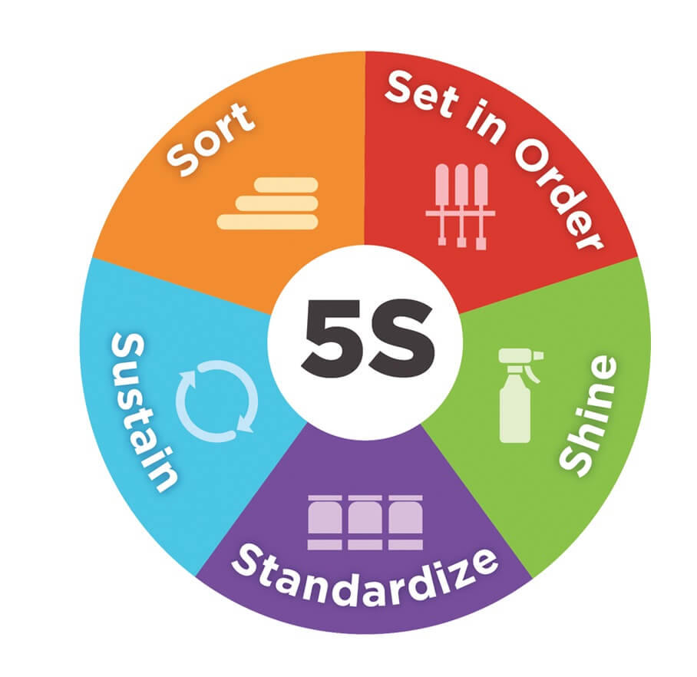
Fig; 5s methods
3.5.1 Sort
The first S, Sort, all collected data is to be sorted first. This is the effective visual method of identifying unneeded
3.5.2 Set in order
Now that your workplace has been sorted, it is time to implement a more pervasive system of organization. Set in Order focuses on effective storage and organization methods, with the end goal of developing an environment that resists clutter and aids long-term productivity.
3.5.3 Shine
Once you have eliminated the clutter in your work area, it is important to thoroughly clean that area and the equipment in it. Clean workplace conditions are also important to employee health, morale, and safety.
3.5.4 Standardize
Cleaning and organization systems implemented without established standards tend to lose effectiveness with time. Allow your employees to participate in the development of standards that improve workplace conditions.
3.5.5 Sustain
This is by far the most difficult S to implement and achieve. People tend to resist change and even the most well-structured 5S plan will fail if not constantly reinforced. Fortunately, there are effective methods of sustaining positive growth.
3.6 FIFO Technique
First in, first out (FIFO) is an asset management and valuation method in which produced or acquired first are sold, used or disposed of first and may be used by an individual or a corporation. Inventory is assigned costs as items are prepared for sale. This may occur through the purchase of the inventory through the purchase of materials and utilization of labor. These assigned costs are based on the order in which the product was used, and for FIFO, it is based on what arrived first. Proposed FIFO system in raw material store.
3.6.1 FIFO Process
1. Pike specific lot from incoming gangway.
2. Check month indicator sticker.
3. Find dedicated space for material.
4. Check available lot in store and put serial lot number on lot as given.
All lots are of JAN-19 but there are two different lots hence they are marked as 4 boxes from frist lot i.e. 1/1, 1/2, 1/3, 1/4, and one box from second lot i.e. 2/1.
Material always moves from left to right.

3.7 Inventory control techniques
3.7.1 ABC Analysis
ABC analysis is a basic analytical material management technique which enables top management to gear the efforts so that output will be maximize. The meaning of ABC is “Always Better Control”.
In Legrand ABC is based on the value based technique. The components and raw material are categorizes as ABC based on its annual Consumption and its value.
3.7.2 FSN Analysis
FSN analysis is based on a consumption figure of items. The items under this analysis are classified into tree group F (Fast Moving), S (Slow Moving), N (Non-Moving).
In Legrang the items are divided as per rating and based on the ratings orders are booked in system. Hence it is clear that due to rating based we cannot say that specific component or row material is fast/slow moving item.
3.7.3 KAN-BAN
KAN-BAN is Japanese technique for maintain the inventory of row material. It is newly developed technique in the modern companies. It is also called as “Two-Bin System”.
In Legrand the KAN-BAN is done on the basis of criticality of components. For example: Biconnect Terminal plate ID4 Dolly Bridge LX, etc.
3.7.4 Just-In-Time (JIT)
The just in time is a newly developed technique for inventory management. The inventory is the dead money of the every company. So therefore they are today used just in time technique for to minimize their dead money. The major benefit of the JIT is, that company can purchased the row material in the few hours. In JIT three parties are involved i.e.
Company Logistics Vendors
- RESULT AND SUGGESTIONS
By using “5s”technique improved visibility of problem conditions, improved safety, reduced waste, improved morale, improved productivity, quality, maintenance, shorter lead times, and a better impression on customers. Develop a new sense of discipline and order that carries over into all activities. On this way we suggest them to applying the FIFO technique for raw material handling. And they are apply the newly FIFO for raw material handling.
- CONCLUSION
In Legrand the inventory management system is in run good way. The company held the minimum stock of raw material for avoiding the wastage.
The company uses Just-In-Time (JIT), ABC Analysis, FSN Analysis, And KAN-BAN techniques for inventory management.
The company has been maintained the 18 day inventory and it has tries to increase sales and reduced the storage cost. In Legrand they generally maintain the inventory for raw material, work in progress and finished goods.
REFERENCES
- Mihail Aurel Titu, Constantin Oprean and Daniel Grecu, Applying the Kaizen Method and the 5S Technique in the Activity of Post-Sale Services in the Knowledge-Based Organization
- Youhua (Frank) Chen, Saibal Ray, Yuyue Song, (2005). Optimal Pricing and Inventory Control Policy in Periodic-Review Systems with Fixed Ordering Cost and Lost Sales, 12 December 2005 in Wiley InterScience, pp. 117-136.
- Benita M. Beamon; “Supply Chain Design and Analysis: Models and Methods” International Journal of Production Economics (1998) Vol. 55, No. 3, pp. 281-294.
- M. L. Spearman et al. (1990) “CONWIP: a pull alternative to kanban”, Vol. 28, No. 5, pp. 879-894.
- Kostas-Platon Aronis, Ioulia Magou, Rommert Dekker, “ Inventory control of spare parts using a bayesian approach: a case study” Correspondence: Prof. R. Dekker, Econometric Institute, Erasmus University Rotterdam, TheNetherlands
- Swapnil S. Dange, Prof. Prashant N. Shende, Chetan S. Sethia; “A Systematic Review on Just in Time (JIT)” International Journal of Scientific Development and Research (IJSDR), (2016) Volume 1, Issue 3. pp. 77-88.
- Dinesh B. Shinde, Prashant N. Shende; “Improvement of Plant Layout by using 5S technique-An industrial case study” International Journal Of Modern Engineering Research (IJMER), (2014) Volume 4, Issue 2, pp. 141-146.

