One Pot Multicomponent Synthesis of Amido Alkyl Naphthol Drugs Derivative using Ortho Phosphoric Acid at Solvent Free Condition
Nikita Vijay Agrawal¹, Borole Harshal Tukaram², Prof . Mrs. Mayuri . J. Deshmukh³
Nikita Vijay Agrawal¹, Borole Harshal Tukaram², Prof . Mrs. Mayuri . J. Deshmukh³
¹²PG students, ³Assistanct Professor
¹²³Department of Chemistry, Moolji jaitha College, Jalgaon, Maharashtra, India,425002
agrawalnikita177@gmail.com ¹, harshucb123@gmail.com ², mayurideshmukh841@gmail.com³

Abstract- amidoalkyl 2- naphthols can be converted to useful and important biological building blocks and to 1- aminoalkyl 2- naphthols by an amide hydrolysis reaction, since compound exhibit depressor and bradycardia effects in humans . Moreover this 1- aminoalkyl alcohol type ligand has been used for asymmertic synthesis and also as a catalyst.
Keywords- orthophosphoric acid, β-naphthol, acetamide, benzaldehyde
- INTRODUCTION
Multi - component reactions (MCRs) ,are one pot processes in which three or four easily accessible components react to form a single product , which incorporates essentially all the carbon atoms of the starting material (Tietze, 1996 ; Ramon and Yus , 2005 ; Zhu ,2003 ) MCRs are a promising and vital field of chemistry because the synthesis of complicated molecules can be achieved in a very first , efficient and time saving manner without the isolation of any intermediate .
There has been tremendous development in three or four component reactions specially the Bigenilli (prajapati and sandhu ,2004 shimokawa et al .,2001) passerini (Bos- sio et al., 1996) and Mannich reaction which have further led to renaissance of MCRs . Nevertheless ,development and discovery of new MCRs is still in demand.

2. EXPERIMENTAL METHODS
(1) Material- Aldehyde , β – Naphthols , Acetamide , using Orthophosphoric acid as a catalyst.
(2) Experimental Method- General procedure for the synthesis of 1-amidoalkyl-2- naphtols
A mixture of aldehyde (1 mmol), β-naphthol (1 mmol), acetamide (2mmol), Orthophosphoric acid (10 mol%) was heated in an oil bath at 120ᵒC under solvent free conditions for the appropriate time according toThe progress of reaction was monitored by TLC. After completion of the reaction, the mixture was washed with water to remove the catalyst. The resulting precipitate was recrystalyzed from Ethanol:Water (1:3) to afford pure 1-amidoalkyl 2-naphthol .
General reaction-
Where R¹= 4-Cl Benzaldehyde , Benzaldehyde, 2-Cl Benzaldehyde, 2-OHBenzaldehyde , 4-NO₂ Benzaldehyde, Acetaldehyde.
Mechanism-
3. FTIR SPECTRA OF SYNTHESIZED COMPOUNDS
Product 1-
Benzaldehyde-
Moleuclar structure-
IR spectra-
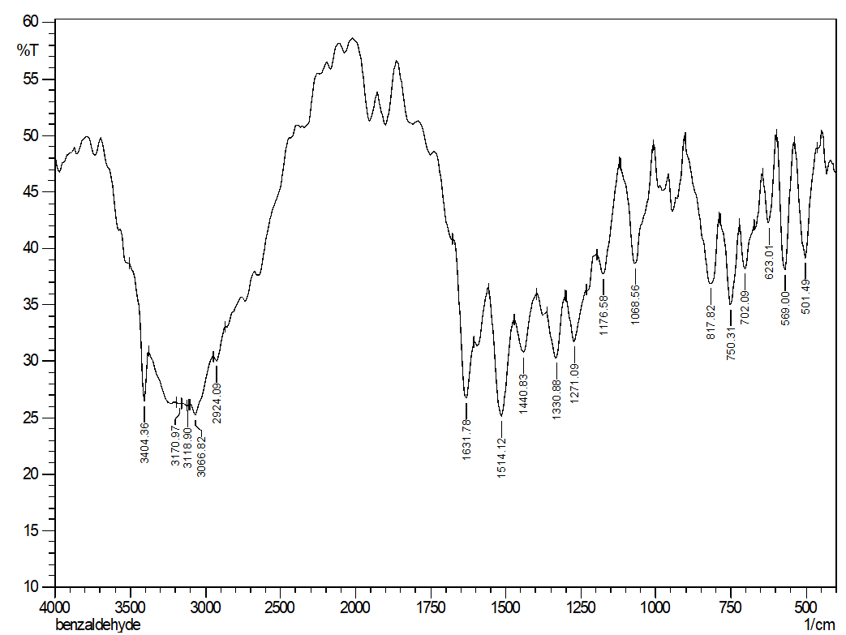
IR frequency-
3404cm⁻¹ – OH
3066-3118-3170cm⁻¹ – C-H stretch (aromatic)
1631cm⁻¹ – N-H
1330cm⁻¹ – C-N
1271cm⁻¹ – C-O
750cm⁻¹ - C-X

Product:-2
2-Chlorobenzaldehyde-
Molecular structure-
IR spectra-
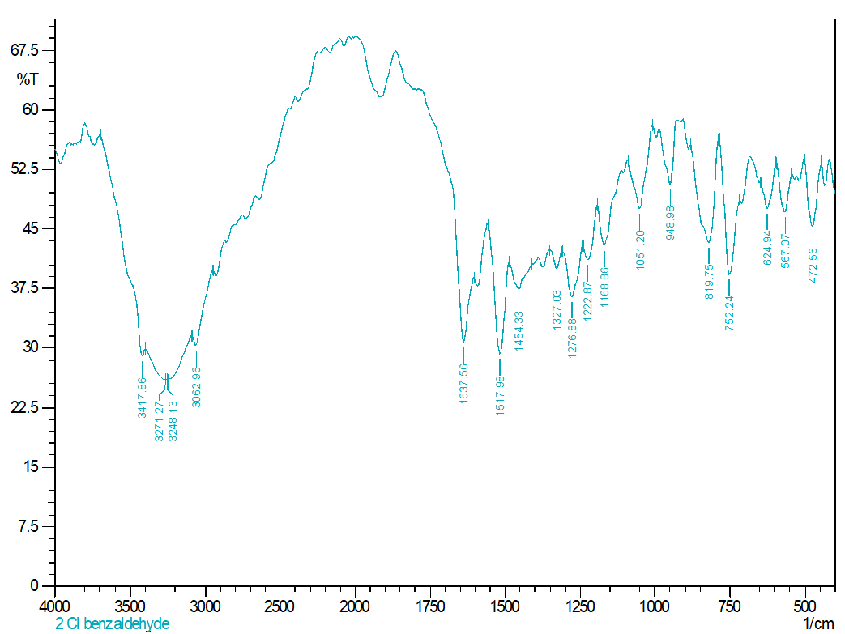
IR frequency-
3271cm⁻¹ – OH group
1622cm⁻¹ – N-H
1273cm⁻¹ – C-O
1336cm⁻¹ – C-N
752cm⁻¹ – C-X (C-C¹)

Product 3-
4-nitrobenzaldehyde-
Molecular structure-
IR spectra-
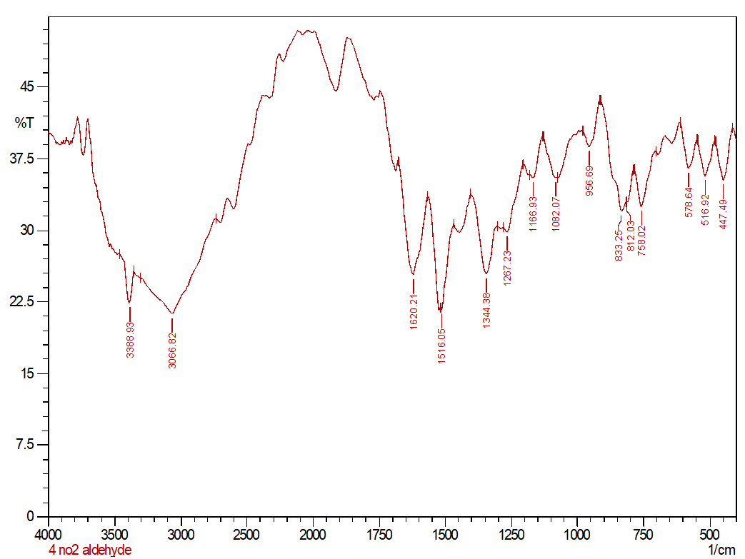
IR frequency-
3388cm⁻¹ – OH
3066cm⁻¹ – C-H (aromatic)stretching
1620cm⁻¹ – N-H
1516cm⁻¹ – N=O (NO₂)
1344cm⁻¹ – C-N
1267cm⁻¹ – C-O

Product 4-
2-hydroxybenzaldehyde-
Molecular structure-
IR spectra:-
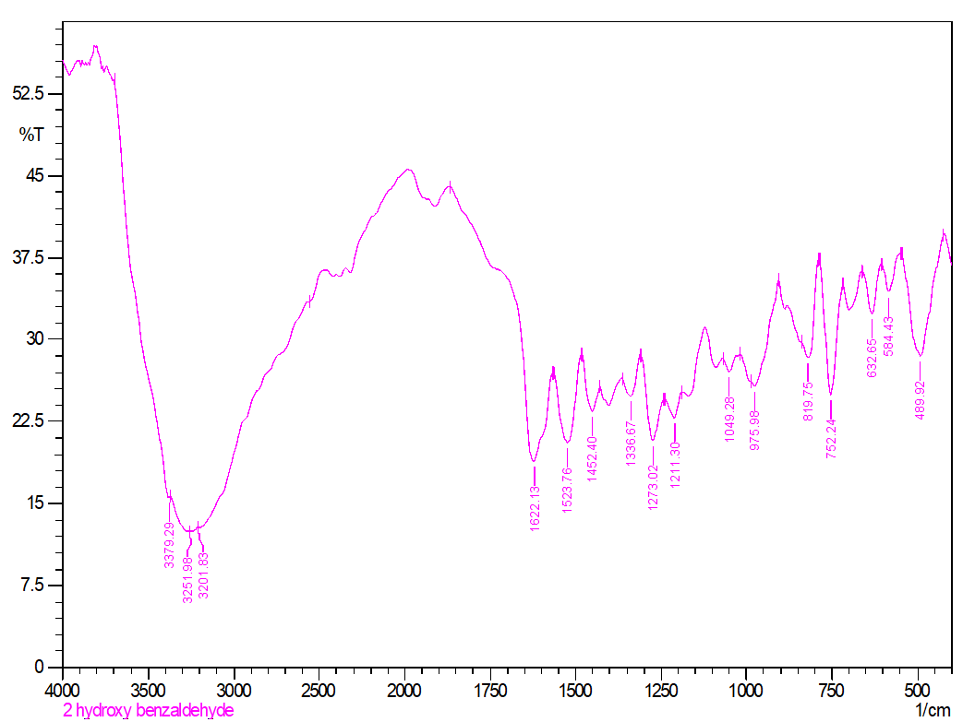
IR frequency-
3250cm⁻¹ – OH
1622cm⁻¹ – N-H
1273cm⁻¹ – C-O
1336cm⁻¹ – C-N
752cm⁻¹ – C-X (C-C¹)

Product 5-
Acetaldehyde-
Molecular structure-
IR spectra-
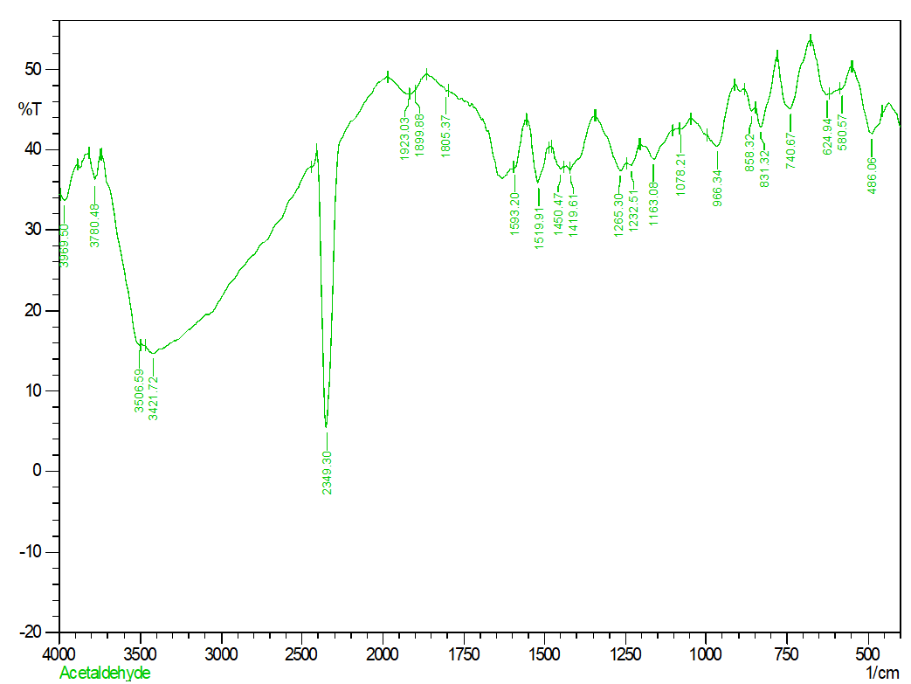
IR frequency-
2349cm⁻¹ – C-O (stretching)
5. RESULT AND DISCUSSION
In order to carry out the synthesis of amidoalkyl naphthols under environmentally benign condition , first we chose benzaldehyde and acetamide as a model for the reaction with 2- naphthol and influence of PPE as a reaction mediator on the yield of corresponding amidoalkyl naphthol discovered by simple optimization study .
The result obtained with benzaldehyde , acetamide and 2- naphthol under the optimized conditions were compared with the best ones published so far for this reaction using inorganic or organic catalyst .
6. CONCLUSION
In summary we have developed a new, general & efficient procedure for one pot synthesis of amidoalkyl naphthols by coupling various aromatic aldehydes with a acetamide & β- naphthol using polyphosperic acid as a reaction mediator under solvent free conditions. The advanges of this enviornmentally safe and benign protocol include a simple reaction set-up high product yields , short reaction times & elimination of solvent and toxic catalyst .
1-amidoalkyl 2-naphthols can be coverted to useful important biological building blocks and to 1-aminoalkyl 2-naphthols by an amide hydrogens reactions since compound exhibits depression and bradicordia effect in humans moreever this 1-aminoalkyl alcohol type ligand has been used for asymmetric synthesis and also as a catalyst.

7. REFERANCES
[1] Akiyama, T.,Itoh, J., Yokata ,K., Fuchibe ,K ., (2004)
[2] Bossio, R., Marcaccini ,S., Pepino,R., Torroba, T., (1996)
[3] 3)M. Anary – A bbasinejad ,A. Hassanabadi ,M.Kamali-Gharamaleki , A, Saidipoor, H. Anaraki – Ardakani, Three –Component reaction between 2- naphthol ,aromatic aldehyddes and acetonitrile in the presence of chlorosulphonic acid yields 1-(acetylamino(aryl)methyl)-2-naphthols ,J chem Res ., 2007 (11) ,2007 ,644-646
[4] M.J. Climent ,A. Corma, S. Iborra
[5] L.Nagarapu, M. Basseruddin, S .Apuri, S. Kantevari, catal.commun.,8(2007)1729

