**Design of Onion Grading Machine: A Review**

**Prof. Rahul A. Lekurwale, Pratik S. Gaurkar, Manoj R. Chimote**

*Department of Mechanical Engineering, DMIETR Wardha, Maharashtra, India,442001.*

***Abstract-****In the economic development of India, agriculture sector plays a key role. For the proper price of any agriculture product, grading according to size is necessary. And it is also value adding technique to the product. To makes the product more attractive and improve its processing qualities uniformity in size is important. Grading according to the sizes is an important value adding technique for most agricultural products. At present, size grading of most agricultural products including lemon, garlic, onion, tomato, Orange, mandarin, apple are carried out manually by farmers, agents, whole sellers, retail sellers and customers also. Most of farmers market their products without any grading. Persons engaging in postharvest crop handling such as collectors, whole sellers, retail sellers, and farmers cannot use high technical and costly grading technique. And also by the local market survey it is found that retail market price of the fruits is significantly varied according to its size. Fruit grading by human is inefficient, labor intensive and error prone. The automated grading system not only time saving but also minimizes error. Improvement of quality and value addition of agricultural produces has gained higher concern in recent times. There is a great demand for fruits in both local and foreign markets. The study is carried out for the design of a machine which can be used to grade multiple fruits by making adjustments. Machine should be simple to use so it can be operated by any illiterate person also so that farmers can also use it.*

***Keywords-******size grading, sorting, onion..***

**INTRODUCTION**

**T**he research on this field is also very much necessary in the future to develop new mechanism that will aid the farmers to be capable manage their crops themselves.

The other area is the creation of awareness among farmers about this type of innovation to proper implementation of advanced technology in the farmland to increase the productivity of farms. Onion is one of the important crops cultivated in India is the second largest producer of onion in the world. Improvement of quality and value addition of agriculture produces has gained higher concern in recent times in India due to creation of new opportunities for sale of agriculture, commodities in open market at competitive prizes .Until now almost everywhere in India, the onion grading is the manually. This manually grading is increase the cost of onion tremendously to customers and producers. The manual grading is also needs more labor .There is also lot of human errors will be in the grading so we cannot clearly guarantee the highest fool proof grading with the present way of grading. Now the need of automation arrives in the agriculture sector also due to the higher competition across the world. So we have to increase the quality and efficiency of the grading machine. This type of new ideas will surely help a lot of people, to focus back to agriculture and this will lead to new innovations in agriculture sectors.

**METHOLOGY**

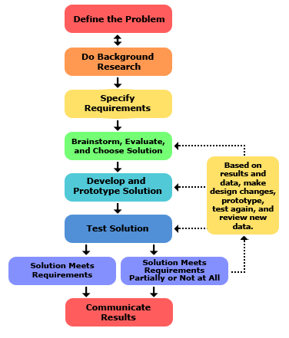

**COMPONENTS-**

a. **Motor**

An AC motor is an electric motor driven by an alternating current. It commonly consists of two basic parts, an outside stationary stator having coils supplied with alternating current to produce a rotating magnetic field, and an inside rotor attached to the output shaft that is given a torque by the rotating field. There are two main types of AC motors, depending on the type of rotor used. The first type is the induction motor or asynchronous motor; this type relies on a small difference in speed between the rotating magnetic field and the rotor to induce rotor current. The second type is the synchronous motor, which does not rely on induction and as a result can rotate exactly at the supply frequency or a submultiples of the supply frequency. The magnetic field on the rotor is either generated by current delivered through slip rings or by a permanent magnet.

b. **Hopper**

A hopper can be used as a container, as a crafting ingredient.. A hopper has an "output" tube at its bottom that can face down or sideways and provides visual feedback of which direction the hopper will output items to if a container is present.

c. **Conveyor Belt**

A conveyor belt is the carrying medium of a belt conveyor system (often shortened to belt conveyor). A belt conveyor system is one of many types of [conveyor systems](https://en.wikipedia.org/wiki/Conveyor_systems). A belt conveyor system consists of two or more [pulleys](https://en.wikipedia.org/wiki/Conveyor_pulley) (sometimes referred to as drums), with an endless loop of carrying medium the conveyor belt that rotates about them. One or both of the pulleys are powered, moving the belt and the material on the belt forward. The powered [pulley](https://en.wikipedia.org/wiki/Conveyor_pulley) is called the drive pulley while the unpowered pulley is called the idler pulley. There are two main industrial classes of belt conveyors; Those in general [material handling](https://en.wikipedia.org/wiki/Material_handling) such as those moving boxes along inside a factory and [bulk material handling](https://en.wikipedia.org/wiki/Bulk_material_handling) such as those used to transport large volumes of resources and agricultural materials, such as [grain](https://en.wikipedia.org/wiki/Grain), [salt](https://en.wikipedia.org/wiki/Salt), [coal](https://en.wikipedia.org/wiki/Coal), [ore](https://en.wikipedia.org/wiki/Ore), [sand](https://en.wikipedia.org/wiki/Sand), [overburden](https://en.wikipedia.org/wiki/Overburden) and more.

d. **PVC Pipes**

Plastic pipe is a tubular section, or hollow cylinder, made of [plastic](https://en.wikipedia.org/wiki/Plastic). It is usually, but not necessarily, of circular cross-section, used mainly to convey substances which can flow liquids and gases (fluids), slurries, powders and masses of small solids. It can also be used for structural applications; hollow [pipes](https://en.wikipedia.org/wiki/Pipe_(fluid_conveyance)) are far stiffer per unit weight than solid members.

e. **Grading Tray**

Onion grading is the important task in this machine. Grading tray is made up of stainless Steel. It has arranged according to the size of onion which has fall on tray.

Table 1. Grades of Onion

|  |  |  |
| --- | --- | --- |
| Grades in Onion Bulb grade | Bulb diameter (mm) | %Proportion in a good crop |
| A | >60 | 40-50 |
| B | 50-60 | 30-40 |
| C | 5-50 | 10-20 |

f. **Belt Drive**

A belt is a loop of flexible material used to link two or more rotating [shafts](https://en.wikipedia.org/wiki/Drive_shaft) mechanically, most often parallel. Belts may be used as a source of motion, to [transmit power](https://en.wikipedia.org/wiki/Transmission_(mechanics)) efficiently or to track relative movement. Belts are looped over [pulley s](https://en.wikipedia.org/wiki/Pulley)and may have a twist between the pulleys, and the shafts need not be parallel. In a two pulley system, the belt can either drive the pulleys normally in one direction (the same if on parallel shafts), or the belt may be crossed, so that the direction of the driven shaft is reversed (the opposite direction to the driver if on parallel shafts).

Belts are the cheapest utility for power transmission between shafts that may not be axially aligned. Power transmission is achieved by specially designed belts and pulleys. The demands on a belt-drive transmission system are huge, and this has led to many variations on the theme. They run smoothly and with little noise, and cushion motor and bearings against load changes, albeit with less strength than gears or chains.

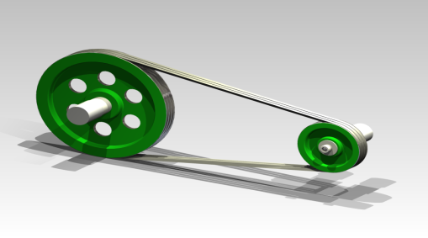

Fig 1. Belt Drive

**WORKING MODEL SETUP-**

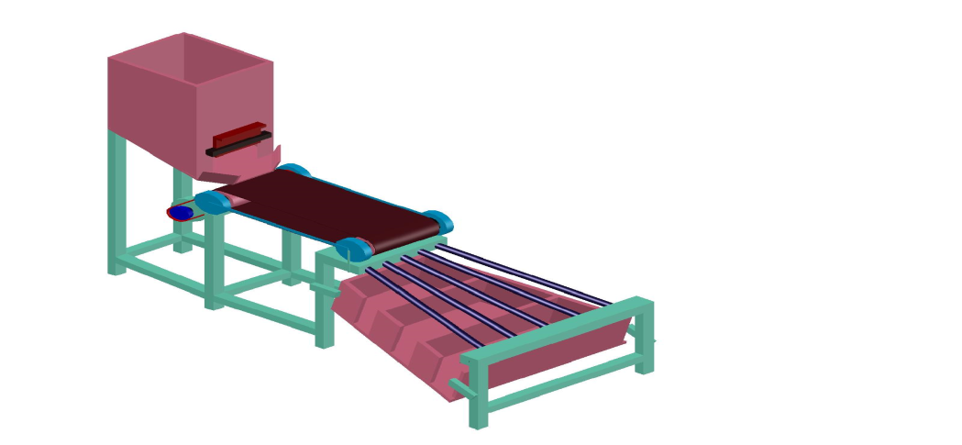Fig 2. 3-D Model of Onion Grading Machine

**Working:**

As compare to other machine in which easy operation will occur. In 1st step onion is fill in the hopper manually. A adjuster is use to adjust the flow of onion on belt. Adjuster can release the flow slowly. With the help of conveyor belt onion transfer from lower end of hopper to next position of conveyor belt. At pipe arranged section of machine onion from conveyer belt fall on upper end of PVC pipe. As the pipes have slope and enlarging area as shown in figure.)small sizes of onion fall in 1st section, medium sizes onion fall in 2nd section and large sizes onion fall in 3rd section. After all these sections collector are placed which can collect different sizes of onion. Grading arrangement with sheets has done below the pipes for sorting purpose.

**DESIGN**

**Design of Hopper:**



By design calculation hopper capacity is 34.5 kg, but as per our project requirement we need 25 kg. So our design is safe.

**Conveyor Belt Consideration:**



**Pipe Consideration:**



**CONCLUSION**

Fast, automatic and precise system for grading of different types of onion. The system can replace the conventional methods with better efficiency. We have successfully developed a model of onion grading machine with better efficiency. From the existing prototype we have studied all the mechanical process which comes under the project.

**REFERENCES**

1. *G.P. Moreda, J. Ortiz-Canavate, F.J. García-Ramos, M. Ruiz-Altisent, (2009) ‘Non-destructive technologies for fruit and vegetable size determination – a review’, Science direct, 92, 119–136.*
2. *Smita Shelke, A.P Phatale, (2013), International Journal of Innovative Research in Electrical, Electronics, Instrumentation and Control Engineering An automatic grading system based on machine vision. vol. 1, issue 4[4].*
3. *G. Gayatri. K.V.Harshanjali, K. Rupavati, D.Vijay Kumar,G.Senthil Kumaran.,International Journal of Agricultural* *Engg.Vol.9 (2)(2016).,College of agricultural Engg. (ANGRU) Madakasira,Anantpur,INDIA.*
4. *Karthik, S.K., Satishkumar, and Palanimuttu V., 2016, Engineering Properties of Some Indian Onion Cultivars.Internat. J. of Agri. Sci., 29(8), 1613-1617Mechanical Engg.,UCOER,Pune.*
5. *Nikhil V. Kamathe, Akshay M.Kapare,Rupesh S. Kamble,Prof. S. G. Khomane,IJGSER VOL. 3 (2)(2017)Department of Mechanical Engg.,UCOER,Pune.*