Improving Efficiency of IC Engine by Using HHO As An Alternative Fuel

Aniket Umare¹, Avinash Thakre², Satish Mandawe³, Mukesh Ale⁴
¹Ass. Prof. Vishwjeet Ambade
Tulsiramji Gaikwad-Patil College Of Engineering and Technology, Nagpur, India,441108

Abstract – Now a days we all know that crude oils are degrading at faster rate from the earth. one of the crude oil like a petrol is also degrading at faster rate so that it is required to save it. Therefore, we are trying to mix petrol fuel with another fuel which meet from resources like water. The water resources that can be used as fuel (HHO) since we are converting water as a fuel by using up by the electrolysis process. after electrolysis process the water will be converted into oxyhydrogen gas (HHO). in the electrolysis process the water will get mix with the potassium hydro oxide (KOH) which is used for accelerating the rate of generation of oxy hydrogen gas which act as a catalyst we observed that the engine performance can be improved by the introduction of the oxy hydrogen gas.
Keywords- fuel, electrolysis, oxyhydrogen, potassium hydro oxide, catalyst
INTRODUCTION
Hydrogen powered engines are those in which “Hydrogen gas” is used to produce a fraction of power for running the engine. This reduces petrol consumption and increases the performance of engine. Hydrogen gas kit is the latest device used to increase the performance of engine. Combustion of fossil fuel causes serious problem to environment because of emission of NOx, CO, CO2, and unburned hydrocarbons. But the use of hydrogen in IC engine helps increasing its performance and also reduces pollution, because on combustion water vapour is the only product
METHOLOGY
Working principle
This works on the principle of electrolysis process. Electrolysis is the process that converts water to gas. The electrical supply for the process is used from your Vehicles battery and alternator. An electrical power source is connected to the two electrode materials which are placed in the water. Hydrogen will appear at the cathode (the negatively charged electrode, where electrons enter the water), and oxygen will appear at the anode material (the positively charged electrode).ie reduction at cathode and oxidation at anode occurs According to ideal faradaic efficiency. The amount of hydrogen generated is twice the number of moles of oxygen and both are proportional to the total electrical charge conducted by the electrodes solution.

Electrolysis process :

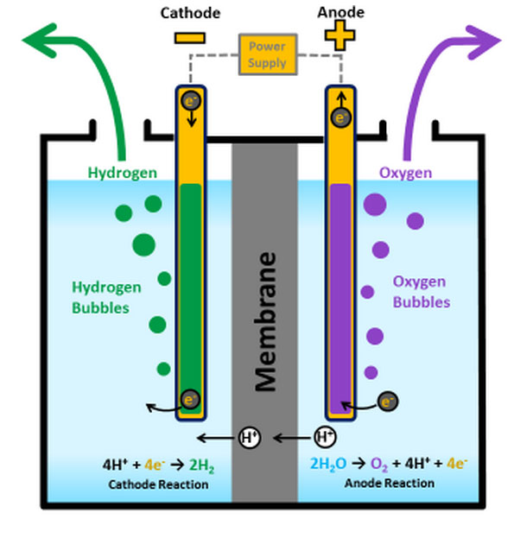

Working process

The hydrogen generated at cathode is fed to the inlet manifold that is in air hose pipe of the carburettor, then this gas mix with the coming air from the air filter when the vacuum is created by the piston movement from TDC to BDC. As the HO gas mixed with air then it goes to engine cylinder with gasoline during suction stroke of the engine. At the end of compression stroke the spark is generated from the cold rated spark plug the combustion of gasoline and HO gas occurs. HHO itself contains 1/3 oxygen by volume and 2/3 hydrogen. The hydrogen explosion is so fast that it fills the combustion cylinder at least 3 times faster then the gasoline explosion and subsequent ignites the gasoline from all directions.
Hence more power is generated consequently the performance of engine gets increased.

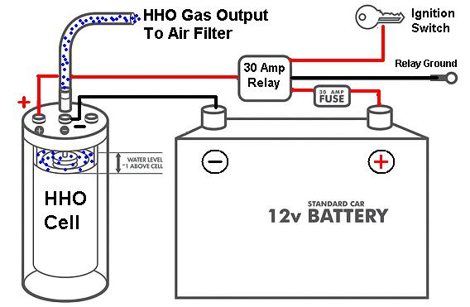
Advantages of adding hydrogen
Its clean exhaust is the most attractive feature of all. As it does not produce co2 there is no green house effect
Hydrogen has high self ignition temperature but very little energy (1/50th of gasoline) is required to ignite it
Zero to near-zero level of harmful emission.
Reduce knocking of engine.
Very less noise generated.
Increase in life of engine oil more than 2 to 3 times.

DESIGN
Cold rated spark plug is used to avoid spark plug electrode temperatures exceeding the auto-ignition limit and causing backfire.
Use of RTD (resistance temperature detector) provide safety because when the temperature of the engine exceed a particular limit then it cuts off the gas supply consequently the engine will only on gasoline. Therefore chances of blasting are reduced to zero.
Avoid uncontrolled ignition, the spark plug gap can be decreased to lower the ignition voltage; this is no problem for hydrogen engines as there will be almost no deposit formation. Spark plug gap is as small as 0.25mm has been used.
After having installed the Cell and electrical connections made properly, we set the carburettor correctly to achieve better performance.

CONCLUSION
Use of hydrogen gas as an additional fuel will reduce the petrol consumption and increase the performance of the engine. The serious problems occurring in the environment because of emission of NOx, CO, CO2 and unburned hydrocarbon will reduce gradually because ,if we use hydrogen gas as an additional fuel then on combustion water vapour is the only product, which will help in reducing the pollution.

REFERENCES
- Internal combustion engine by V.M Domkundwar,” future fuel for IC engine “( chapter 22, pp 22.25 to 22.34 )
- Ogur,E.O.’ and kariuki, S.M.’ (2014).”Effect of Car Emissions on Human Health and the Environment “
- International journal of emerging technology and advanced engineering” Hydrogen operated internal combustion engine – A new generation fuel “ (vol 2,issue 4 April 2012)
- Mathur H.B., Das L.M. (1991)."Performance characteristics of a Hydrogen Fuel SI Engine using Timed Manifold Injection" . Int. J. Hydrogen Energy (vol 16, pp.115–117, 1991)
- Yougen Kong, Sam Crane, Palak Patel and Bill Taylor(January 2004). "NOx Trap Regeneration with an On-Board Hydrogen Generation Device" .SAE Technical Paper Series (2004–01–0582): 6–7.
- Hydrogen internal combustion engine vehicles Idaho national laboratory
- Barton, P.J. 2004. Study of Heavy Duty Vehicle Exhaust Emissions and Fuel Consumption with the use of a JetStar™ Hydrogen Gas Generator. Environment Canada, ERMD Report No
- US Environmental Protection Agency, "Devices and Additives to Improve Fuel Economy and Reduce Pollution Do They Really Work?"

Details of All Authors
Sr. No | Photo | Details
1 |  | Avinash Thakre pursuing Bachelor of Engineering final year (2016-19) Mechanical Engineering from Tulsiramji Gaikwad-Patil College of Engineering & Technology, Nagpur, India,441108.
2 |  | Aniket Umare pursuing Bachelor of Engineering final year (2016-19) Mechanical Engineering from Tulsiramji Gaikwad-Patil College of Engineering & Technology, Nagpur, India,441108.
3 |  | Mukesh Ale  pursuing Bachelor of Engineering final year (2016-19) Mechanical Engineering from Tulsiramji Gaikwad-Patil College of Engineering & Technology, Nagpur, India,441108.
4 |  | Satish Mandwe pursuing Bachelor of Engineering final year (2016-19) Mechanical Engineering from Tulsiramji Gaikwad-Patil College of Engineering & Technology, Nagpur, India,441108

