Techniques & Methods for pesticide spraying: A review

SANKET DAWARE ¹ YASH LOKHANDE ².
Assistant professor Mr S. D. THAKRE.
Professor Dr C. C. HANDA.
Department of Mechanical Engineering, KDK college of engineering, Nagpur, India, 440009.

ABSTRACT:
This research paper gives us brief idea about different techniques for application of pesticide spraying. This paper also gives some information about types of nozzle commonly used in low pressure agriculture sprayer. The main purpose of writing this paper is to explain electrostatic pesticide sprayer. How negative charge is developed in nozzle and the principle behind the induction of negative potential. After generation of potential, it also explain the transfer of charge to mass ratio from nozzle. It also informs us about atomization required to create charge to mass ratio.
INTRODUCTION:
India is the land of agriculture. In 21st century also about 60% of our population depends on agriculture. Indian farmers are comprises of marginal, small, medium and large land owners. It is very important to protect crops from pests to meet the increase in demand of food. So, it is very important to have reliable sprayer for spraying chemicals around the

farm. Hence different method of application of pesticide sprayer such as high, low, ultralow volume sprayer are explain in this paper. But this methods apply pesticides only on upper top portion of the leaves. What about bottom side of leaf? This remains unconsidered over period of time. But now new technique called electrostatic pesticide sprayer are developed which overcome the difficulty of application of spray under the leaves. This technique uses negatively charge spray for covering of entire plant.
METHODS OF PESTICIDE SPRAYER
Sprayer is a machine used for the application of liquid chemicals on plants to control pest and diseases. It can also be used to apply herbicides to control weeds and to spray micro-nutrients to enhance plant growth. Following are the methods used for application of spray depending upon volume:
- High volume spraying.
- Low volume spraying.
- Ultra Low volume spraying

TYPES OF SPRAYERS:
- MANUALLY OPERATED 2. POWER OPERATED 3.NON CONVENTIONAL METHOD
- Hand syringe or sprayer. a. Traction sprayer. a. Electrostatic pesticide spraying
- Knapsack sprayer. b. Moist blower and sprayer.
- Bucket sprayer. c. Foot sprayer or pedal pump.
- Rocker sprayer. d. Stretcher sprayer.
These different types of sprayer with their functional diagram and working are explain as fallows.

TYPES OF SPRAYER:
In this type of sprayer side arm is used to pressurized the fluid in the reservoir tank.
- Hand syringe or sprayer.
“Trigger type device for spray pump for use on hand held containers by piero Battegazzore, Guala S.P.A. Alessandria, Italy, United State Patent.”[1]
Hand sprayer is one of the simplest sprayer. It consist of non-return valve which is placed inside the piston. The spring is then inserted between the top and the piston this subassembly is included in casing. The trigger is then inserted into the casing through two holes. When the trigger is squeezed it lifts up on the piston until the spring is compressed against the top within the cylinder. This feed smaller volume within the main cylinder which forces the liquid up through the nozzle. When triggers release it forces the piston back down into the bottle non-return valve within the piston cylinder assembly prevents any liquid going back into the bottle once it drawn up from cylinder.

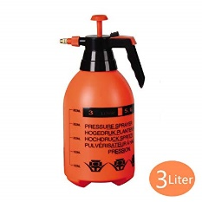
Hand syringe or sprayer

B Knapsack sprayer
“Knapsack sprayer Henry E. Brandt and Clifford Zwickey, St. Paul, Minn, assignors to Dobbins Manufacturing Company, St. Paul, Minn., a corporation of Minnesota, United State Patent Office.”[2]

It is consist of simple cylinder and piston assembly, liquid tank, hydraulic pump, operating lever, pressure chamber, agitator, delivery hose, spray lance and nozzle. The hydraulic pressure for forcing the chemical mixture is generated by direct action of piston and cylinder. The arm or handle on the side of the sprayer is provided for upward and downward movement of piston. The downward action of piston compresses the fluid inside the cylinder. Which forces the fluid through the nozzle. Agitator is small in size and used for proper mixing of liquid. This pump consist of pair of mounting straps for holding the pump on back of operator. The operator have continuously operates the hand lever at rate of 15-25 strokes per minute.
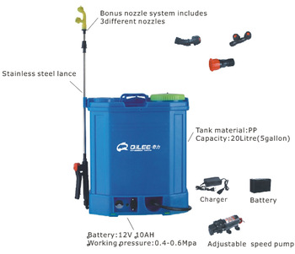

Knapsack sprayer
- Compressor sprayer
“A compressed air direct injection pesticide sprayer S. R. Ghate, S.C. phatak member ASAE"[3]
It contains of a cylindrical metal tank for holding the spray liquid, a hand operated piston kind pump, a filler hole within the tank out let with delivery pipe, cut-off, lance and hydraulic nozzle. There is metal or plastic skirit as the base of the tank. A combine of adjustable shoulder straps is provided for mounting the sprayer on the rear of the operator. The sprayers with tanks of various capacities square measure factory-made, but 18 litre capacity sprayers are commonly used for field spraying. The filtered spray resolution is crammed to 2/3 of the tank capability. Then the pump is operated by hand and atmospheric pressure (50-60 psi) is made up. The compressed gas exerts pressure to manoeuvre spray liquid to the nozzle via delivery pipe, cut-off device & lance system. The spray design is strong and sturdy. It is also easy to operate. The operator need not pump continuously so that he can divert his attention to better coverage. However, because the pressure cannot stay constant because of gradual decrease of pressure, the nozzle discharge rate changes so also angle of spray and droplet size. This sprayer isn't counselled for chemical spraying because of high initial pressure. The field capacity is 0.75 - 1.0 acre/day.
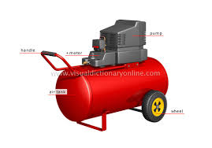
Compressor sprayer
- Rocker sprayer
It is greatly almost like the foot sprayer. The main difference is the operation of pump. The pump feat is completed by hand of the operator. The sprayer pump mounted on picket platform is unbroken on ground and also the spray answer is unbroken in an exceedingly separate tank or instrumentation. It can develop high pressure 10 kg/cm2. For spraying tall trees, associate degree extension bamboo lance are often fitted. The adjustable sort hydraulic nozzle (Triple Action Nozzle) is generally used
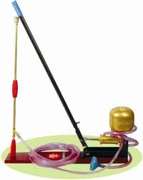

Rocker sprayer
E. Foot sprayer or pedal pump
The pump of the sprayer is worked by operating a pedal lever by foot of the operator. It requires two persons to work. The spray liquid is kept in bucket or container and it is sucked by a suction hose through a filter (strainer) due to piston movement. A suitable valve is provided within the piston assembly to function suction valve. The liquid from the pump cylinder is then delivered into a pressure chamber wherever from the pressurised liquid reaches hydraulic nozzle. Minimum 2 person team is needed to figure on this machine. Hydraulic pressure of 10 kg/cm2 can be achieved which is necessary to project the jet of spray to tall trees simultaneously from two spray nozzles The foot operated sprayer is largely for garden and tree spraying. The design is strong and strudy. Hydraulic pressure of 10 kg/cm2 can be achieved which is necessary to project the jet of spray to tall trees simultaneously from two spray nozzles. An adjustable type hydraulic nozzle (Tripple Action Nozzle) is generally used which can generate different types of spray patterns viz., fine spray (hollow cone), medium spray and coarse spray (jet). The fine and medium spray square measure fitted to low height orchards, jet spray are necessary for tree spraying. The spray jet will reach height of fifteen - twenty feet. For spraying taller trees further} extension like bamboo lance could also be wont togain additional height by eight - ten feet. It is diffcult to treat field crops by foot sprayers because the sprayer is kept on ground and pesticide solution tank is also kept on ground separately and so movement of the long delivery hose becomes very diffcult.

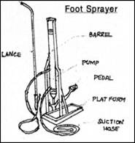

Foot sprayer or pedal pump

ELECTROSTATIC PESTICIDE SPRAYER:
“Embedded- Electrode Electrostatic-Induction Spray-Charging Nozzle: Theoretical and Engineering Design S. Edward Law MEMBER ASAE”[4]
Electrostatic pesticide sprayer is a special type of application technique in which nozzle is negatively charged. The negative charge is created by an electronic circuit.
The three following physical principles were considered in selecting the underlying basis of operation of the developed spray charger:
- ionized-field particle charging:
When conductors L1 and L2 are grounded and a sufficiently high d.c. potential is applied to conductor L3, dielectric breakdown of the air immediately surrounding the metal point P will result. For the cylindrical geometry shown, a self-sustaining gaseous-discharge current will, thus, flow between P and C.
- contact charging:
Charge transfer by conduction to the spray-liquid jet, and subsequently to the generated droplets at their instant of formation, can be effected if an excess supply of free charge is maintained on the metal nozzle itself by connection of conductor Lx to a voltage source. For conductive liquids, maintenance of the fluid nozzle at an elevated voltage also necessitates having the entire bulk of the liquid and the liquid handling system at that elevated voltage. While technically possible in certain industrial processes, system insulation and isolation and associated personnal hazard generally prelude contact charging from agricultural applications for field use.
(C) electrostatic-induction charging:
If a positive potential is applied to the cylindrical electrode C as shown in fig. by connection of a voltage source between conductors Lx and L2, then theoretically for any liquid having non-zero electrical conductivity an excess negative charge will accumulate on the grounded liquid jet J. This charge transfer results from the electrostatic induction of electrons onto the axial jet in order to maintain it at ground potential in the presence of the nearby charged cylindrical electrode. Individual droplets formed from this negatively charged continuous jet will depart with a net negative charge provided that the droplet-formation zone Z is subject to the inducing electric field acting between the cylinder and the jet. Gauss' law indicates that maximum droplet charging should occur for the droplet-production zone located at the region which provides maximum field strength at the terminal surface of the jet.

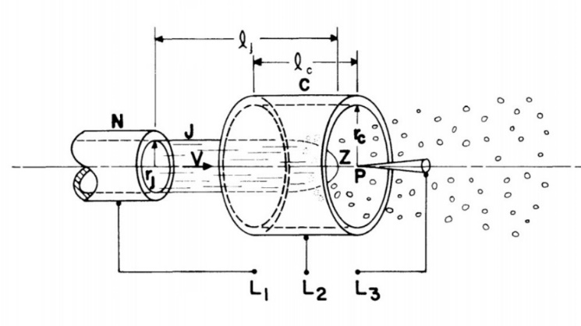
ATOMIZATION:
Atomization is done in simple way by mixing high pressure air and water pesticide mixture in chamber which is fixed between inlet pipe and nozzle. High pressure air is delivered by compressor to atomization chamber. A pneumatic-atomizing spray nozzle was chosen on which to interface a droplet-charging system design since it provided a number of beneficial features as discussed below. Small-Droplet Diameters—Both electrostatic considerations and efficient liquid-use for adequate target coverage at LV and ULV flow rates dictate using droplets with diameters generally under 50 microns. This requirement was satisfied by the selected nozzle.
Turbulent Transport—the turbulent transport feature offered by the pneumatic-atomizing type nozzle strongly dictated its selection for charged-spray application to agricultural targets such as plant canopies. Such biological targets have much internal fruit, leaf and stem surface within the canopy which must be adequately coated for insect and disease control.
NOZZLE:
A nozzle is a device designed to control the direction or characteristics of a fluid flow. The proper choice of a nozzle kind and size is important for correct chemical application. The nozzle may be a major think about decisive the quantity of spray applied to a section, the uniformity of application, the coverage obtained on the target surface, and the amount of potential drift. Nozzle types commonly used in low-pressure agricultural sprayers.
- Flat-fan
“Flat fan spray nozzle by James Slavas, Wendell; matthew Betsold; United State Patent.”[5]
Flat-fan nozzles are used for application of pesticide to a broad area spraying of herbicides. The nozzles spray shape is of tapered-edge, flat-fan spray pattern. The different types of nozzle are such
- standard flat-fan,
- even flat-fan,
- low pressure flat-fan
- extended-range flat-fan
some special types are off - center flat-fans and twin-orifice flat-fans. The operating capacity of standard flat-fan varies between 30 and 60 (psi), and ideal range between 30 and 40 psi.
- Raindrop
“Effect of wind on size and energy of small simulated raindrops: a wind tunnel study G Erpul, Donald Gabriels, D Janssen.”[6]
Raindrop nozzles manufacture massive drops during a hollow-cone pattern at pressures from twenty to fifty psi. The Raindrop nozzles are used for herbicide incorporation and are usually mounted on tillage implements. When used for broadcast application, nozzles ought to be headed thirty degrees from the horizontal. The spray patterns ought to be overlapped one hundred pc to get uniform distribution. These nozzles aren't satisfactory for post emergence or non-incorporated herbicides as a result of the drop size is just too massive.
- Hollow-cone
“Hollow cone nozzle for atomization of liquids Wolfgang Nieuwkamp.” [7]
Hollow-cone nozzles usually area unit wont to apply pesticides or fungicides to field crops once foliage penetration and complete coverage of the leaf surface is needed. These nozzles operate during a pressure vary from forty to one hundred psi. Spray drift potential is higher from hollow-cone nozzles than from different nozzles because of the little droplets made. Generally, this kind of nozzle mustn't be used to apply herbicides.
- Full-cone
“Full cone spray nozzle with external air atomization Daniel A Vidusek” [8]
The wide angle, full-cone nozzles are a good choice if drift is a concern because they produce larger droplets than flood nozzles. Full-cone nozzles (Figure 2G) sometimes area unit counselled over flood nozzles for soil-incorporated herbicides. Full-cone nozzles operate between a pressure vary of fifteen to forty psi and area unit ideal for sprayers equipped with flow controllers.
CONCLUSION:
Theoretical analysis of different types of pesticide spraying is explained. In this paper the different types of nozzle for covering of upper portion of leaves as well as it gives a brief idea about new and modern electrostatic pesticide sprayer. This would help the researchers and authors to developed electrostatic pesticide sprayer.
REFERANCES:
- Trigger type device for spray pump for use on hand held containers by piero Battegazzore, Guala S.P.A. Alessandria, Italy, United State Patent.
- Knapsack sprayer Henry E. Brandt and Clifford Zwickey, St. Paul, Minn, assignors to Dobbins Manufacturing Company, St. Paul, Minn., a corporation of Minnesota, United State Patent Office.
- A compressed air direct injection pesticide sprayer S. R. Ghate, S.C. phatak member ASAE.
- Embedded- Electrode Electrostatic-Induction Spray-Charging Nozzle: Theoretical and Engineering Design S. Edward Law MEMBER ASAE.
- Flat fan spray nozzle by James Slavas, Wendell; matthew Betsold; United State Patent.
- Effect of wind on size and energy of small simulated raindrops: a wind tunnel study G Erpul, Donald Gabriels, D Janssen.
- Hollow cone nozzle for atomization of liquids Wolfgang Nieuwkamp.
- Full cone spray nozzle with external air atomization Daniel A Vidusek.

