An Analysis of the Automatic Attendance System's Face Recognition Technology

Aishwarya M. Zade¹, Tejas K. Kawle², Pranjali R. Surjagade³, Milind V. Lande⁴

^{1,2,3} Students , ⁴I/C HOD, Government Polytechnic, Gadchiroli, Maharashtra, India
Email -aishwaryazade2002@gmail.com ²tejaskawle21@gmail.com , ³pranjalisurjagade5566@gmail.com ⁴milind.jdiet@gmail.com

Received on: 20 January, 2023 Revised on: 15 February,2023 Published on: 17 February,2023

Abstract – In schools, colleges, and universities, an attendance system was put in place to maintain discipline and allow students to learn everything possible. In a particular class, students' attendance can be recorded using one of two traditional methods. One of them involves calling a roll number, and the second involves having students sign a piece of paper next to their roll number. In order to make this system more user-friendly, time-saving, and effective, it had to be developed. The faculty can take class attendance without interruption or wasting time thanks to this automated system. The concept has a wide range of applications, one of which is face identification, which will help save time and effectively identify and reduce the likelihood of proxy attendance. The primary goal of this project is to develop an automated attendance system using a Raspberry Pi 3B+, Open CV/Python libraries, and a recognizer algorithm. Any industry with an existing attendance system that is essential to that industry can use the proposed system. The project is best described as an engineering solution for all universities and colleges to track and manage attendance because the project objectives and design criteria were all met.
Keywords- Recognizer, OpenCV, Raspberry Pi3B+, Attendance, Face identification, Detection.
- INTRODUCTION
We continue to use the same outdated methods of classroom management in this age of technology and automation. Attendance is the most crucial factor in the classroom because it directly affects students' academic performance. Recently, some students have found that they concentrate better during lectures when there is strict classroom management (Research Gate, 2018). More students participate in class and learn more when the attendance system is effective. In the past, we would call and sign against a specific roll number using techniques like roll numbering. These time-consuming methods have a high chance of proxy. We discovered the concept of automating this procedure using contemporary technologies to obtain a well maintained and disciplined classroom. The objectives of this project will be met with the aid of a facial recognition system and the appropriate hardware and software. A facial recognition system is a developed innovation of image processing. In the development of technology, image processing plays a unique role in the extraction of necessary data that can be related to digital images. Receiving digital images and using software and algorithms to extract information that is useful will be our primary focus. As the pictorial information is fed, image processing processes it and makes it suitable for human interpretation. The knowledge gained from image processing will be very beneficial and play a significant role in many different fields where it may be used. The uses for image processing are numerous and can be found in nearly every situation where imaging data can be connected to pre-established algorithms. It was a sophisticated application of image processing and serves as the foundation of our project. We needed some recognition from sophisticated computational analysis because our facial structure was a typical example of a multidimensional structure.
- LITERATURE SURVEY
There has been a lot of research done on the various methods available for implementing an effective attendance monitoring system. These methods differ in terms of the input methods used, the data processing methods used, and the controllers used to implement the systems In this section, look for the various available solutions, along with the benefits and drawbacks of each system.
According to B. Nethravathi et al[1], The main goal of this paper is to develop and put in place a reliable home security system. Controlling and automating the front door of the house using IoT is possible, and the cloud can be used as a database for the data gathered. The proposed work includes home security with realtime mobile phone access and control, using an Arduino as the control unit. At the front door of the house, a webcam-equipped security system is installed. The Arduino is attached to this. Alert messages are sent using a GSM module. Through the use of MATLAB and the EHD algorithm, faces are recognized. The suggested approach to development is less expensive, quick, effective, and trustworthy. Arduino uses less energy and provides adequate efficiency to meet the demands. Following are the steps to be considered: 1. The webcam records and sends to the computer any attempts to unlock the door. The person can unlock the door and enter if the image captured matches the one in the database. The system sends a warning message to the authorized owner if someone tries to open the door but is not authorized to. which is done using GSM module.
According to Venkata Sasank Pamulapat [3], The suggested approach explains how the real-time face tracking Viola-Jones algorithm functions. Face recognition in a live setting is essential for advanced robotics, video coding, and security surveillance. Due to the incorporation of MATLAB and Arduino, it has the potential for a wide range of applications. The main goal of the project is to identify human faces in every frame of video captured by a web camera. The image is processed using the viola-Jones algorithm in MATLAB to identify faces and send signals to an Arduino board, which in turn controls two servo motors to move the camera. Face must be actively tracked and maintained in the frame, with one servo for rotation in the horizontal direction and another in the vertical direction. Some of the built-in functions for reliable real-time tracking and effective face recognition may also be included in the MATLAB code. environment. This idea has many different applications, ranging from advanced robotics to video coding.
By the S.V. Viraktamath[9], this paper discusses an application for automatic face detection and tracking on video streams from security cameras in public or commercial locations. Finding out where people are looking can be helpful in a variety of circumstances, such as in exhibits, shopping centres, and common areas of buildings. Prototype is built to work with web cameras for a face tracking and detection system based on the open source Arduino and OpenCV software. The system abstracts faces' Haar-Like features using the AdaBoost algorithm. The visitor's face can be recorded, as well as faces can be detected and tracked, using this system for security purposes. Using OpenCV, a programme is created that can track from the web camera and identify faces. The paper's detection method can precisely identify and track human faces in real time. The intersection of image processing and embedded systems is demonstrated in this paper. Real-time implementation is made possible by the use of OpenCV and an Arduino board.
According to Lecturer Dr. Abbas Hssien Miry [10], Real-time face recognition is implemented in this work utilizing an Arduino microcontroller as the output device and a webcam as the input device. The software part is programmed using Matlab, broad area and flexible algorithms are provided. Principal component analysis and the wavelet transform are combined to offer data redundancy. Real photos captured via a camera are used to test the system, and promising results are produced.
In a different study by Sajid and Hussain [11], GF was used to identify a facial fiducial point on each student's face. Following the GF approach, For face recognition, the PCA, LDA, and LBP algorithms were employed. The results led to the recommendation to capture three photographs to ensure that every student was present because it is possible that some students would arrive late for class or that certain faces won't be easily identified. The issues with women who wear veils and men who have beards, which may alter the size and contour of the face, were not resolved by this study. human faces in real time. The intersection of image processing and embedded systems is demonstrated in this paper. Real-time implementation is made possible by the use of OpenCV and an Arduino board.
According to Sowmya Kucherlapati, Srihari Varma Mantena[5] Face recognition technology can be used to eliminate the timeconsuming problem of manually counting attendees before seminars, leaving less time for the presenter. All eligible members must register themselves in the proposed activity system whenever a seminar is to be held, providing any necessary information, including their facial image and all applicable credentials. The administrator takes pictures of the participants when the seminar begins, and these pictures are used to track attendance using facial recognition software. The K- Nearest Neighbors technique, which has demonstrated the highest accuracy, is employed in this case for face identification. Face detection is performed using the Histogram of Oriented Gradients. In this project, the algorithm's accuracy was determined to be 97%.
According to Thitinan, Apichat [6] a smart attendance system using face recognition algorithms with deep learning is proposed and used in the university's classroom. Instead of calling names to confirm the identity of students, our system does it automatically. The system was tested in 3 scenarios, namely, in online classes, in on-site classes, and in problematic cases using a standard dataset. The performances of the 3 scenarios were compared in the experiment in terms of precision, recall, F1 score, and percentage accuracy. In this paper, they have used high-definition camera, and video captured by camera is being used by our model to detect and recognize human faces. With this approach, they were able to recognize students in the class, and their attendance is being marked in a database. In this paper, they were providing a user interface which will help the faculty to mark the student’s attendance from their computer screen. They used LBPH algorithm, OpenCV and Eigenface for face recognition [7].
The orthodox process of checking attendance such as current fingerprint or card scanning systems are susceptible to proxies. To tackle these issues, this paper has been proposed. The proposed system makes the utilization of various algorithms such as histogram of oriented Gradient (HOG), convolutional neural network (CNN) and support vector machine (SVM). After the face is recognized, the reports of attendance are going to be created, maintained and stored in excel format. The system is examined in various situations like illumination, head movements, and the variation of distance between the face and cameras. The proposed system was found to be efficient and reliable for marking attendance during a classroom with negligible time consumption and no manual work. This system is inexpensive as less installation is required[8].
According to Nithya [12] in a different study, Mail Transfer Protocol (SMTP) is used to notify parents and faculty members of a student's attendance. The research also face recognition method that utilised PCA. Using the student's image as a starting point, a facial recognition algorithm was used to identify facial features. The class representative and the professor both had access to the login feature thanks to the study. However, the findings did not address issues with ageing, pose variance, partial occlusion, or illumination. They also recommended using mobile-based face recognition.
In a different study by Mehta and Tomar [4], face detection was accomplished using VJM, and face recognition was accomplished using LBP and HOG algorithms. To recognise the students' faces, the study used a feature-based approach. The extraction of features made use of six features. Image quality was poor because the system used video frames as input. A good RAM capacity is necessary for frame selection from the video; otherwise, the face recognition process will take longer. In this study, 92 percent of faces could be recognised. However, the ageing, partial occlusion, and illumination issues were not addressed in this study.
In the Sunaryono, Siswantoro [2] study, face recognition was accomplished using LDA and the k-nearest neighbour (k-NN) algorithm while face detection was accomplished using VJM. The images from this study were discarded because they had poor lighting and were not clear. Students' faces were recognised for attendance purposes in the study using a singleface recognition approach. The ageing, partial occlusion, pose variance, and illumination issues with face recognition were also not addressed in this study.
For face detection, Patil and Shukla [13] used the Voila Jones method, and for face recognition, a hybrid PCA/LDA approach was used. This research revealed that numerous Although it takes a lot of time and effort, work has been done on an automated attendance system that uses biometric techniques. However, the system is unable to address issues with human face variation. The issue of ageing was not covered in this study. Additionally, this study does not address the pose variance, partial occlusion, or illumination issue.

III- METHODOLOGY

We are going to develop a potential solution to our problem based on the literature review because we have carefully examined a number of subjects that are pertinent to our project. In this section, we'll outline a technique that will provide a high- level view of how to approach our project and how it ought to be carried out. Because the previous work was insufficient, we developed this project in the most practical and effective manner we could.
The Viola Jones algorithm is the suggested face detection module for this project. Additionally, a neural network architecture with LBPH is suggested for the project's face recognition modules.
The following figure shows the project system circuit design.

- PROPOSED SYSTEM CIRCUIT DIAGRAM
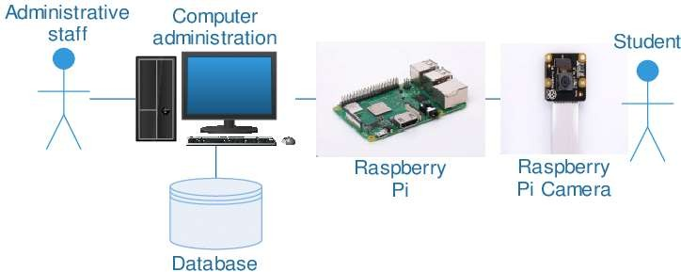

Fig1-Raspberry pi system set up for attendance system

- PROPOSED SYSTEM STRUCTURE

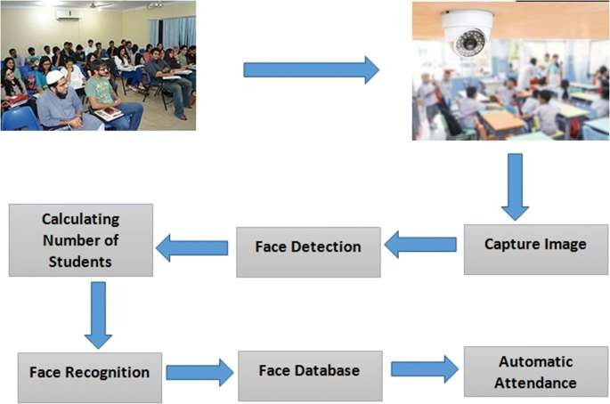

Fig 2. The proposed system

The attendance monitoring system model and its implementation in a specific class are shown in figure 2 above. As we can see, there is also a teacher's desk, and since he is facing the students, he is not going to be regarded as a student. A camera is set up in the centre of the classroom at an appropriate height to capture the entire class, down to the last bench. The camera will take an image after the students have taken their seats and begin the face detection process using the methods and techniques covered in the methodology section.
c. PROPOSED SYSTEM FLOWCHART
The following figure shows the project system flow- chart:
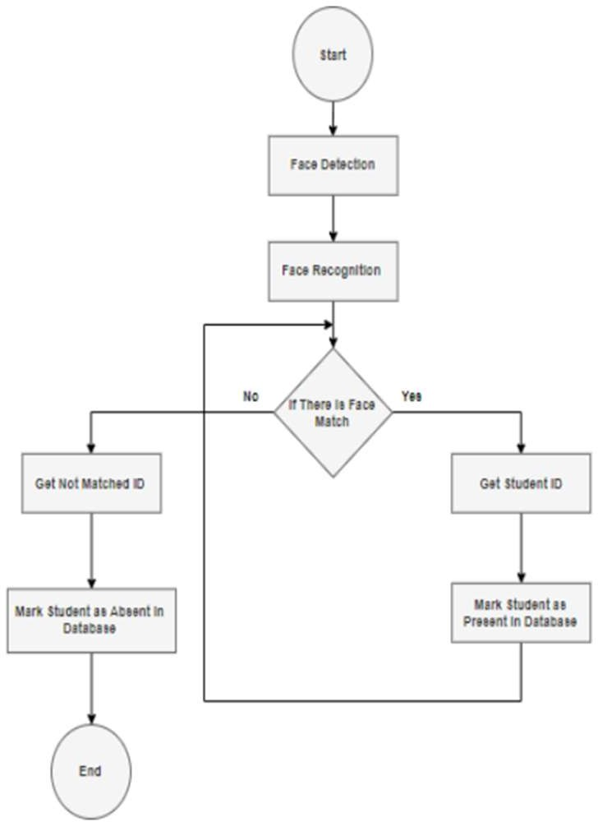
Fig.3 Flow chart for attendance system

HARDWARE REQUIREMENT
The Raspberry Pi set up needs:
The hardware used in this project consists of only 7 components which are:
- Raspberry Pi 3B+
- Logitech Webcam 8Mp Camera Module C270
- Power Supply Cable
- 16 Gb Micro SD Card SanDisk
- Screen
- Mouse & Keyboard
- HDMI Cable

SOFTWARE REQUIREMENT

OpenCV-Python software
OpenCV is a software that deals with programming languages such as Java, Python, and C++, which are all readable and usable on various platforms such as IOS, Android, and Windows OS , Linux, and Windows are all supported. Interfaces for fast GPU tasks based on CUDA and OpenCL are also being developed dynamically. OpenCV-Python is a Python library designed to address PC vision issues. OpenCV (2018).

Visual studio code software
Windows Visual studio code is a code manager created by Microsoft and Linux. Essentially, this method aids Windows in troubleshooting by incorporating Git control and GitHub, language structure, insightful code finishing, scraps, and code refactoring are all features. Which I used in my project to run Python code. GitHub, language structure, insightful code finishing, scraps, and code refactoring are all features. Which I used in my project to run Python code.
3.Qt Creator Software
The cross-platform development environment Qt Creator, which is a component of the SDK for the Qt GUI application development framework, integrates C++, JavaScript, and QML. It features a visual debugger as well as a coordinated GUI designer and formatter. Highlights for the editorial manager include automatic finishing of realistic UI and sentence structure highlighting.
- CONCLUSION
The development of technology encourages us to think creatively and generate ideas that might change the world. Education is the most crucial thing that every person should obtain because it is the cornerstone of a better lifestyle and undoubtedly raise the standard of living in community. The participation of students in our educational system is lacking. Students should skip classes and stay with friends and their devices rather than listening lectures and studying. This helps to attend the classes for students regularly.
REFERENCES
- B. Nethravathi, S. S. Sinchana, H. N. Pavan Kumar. (2020) Advanced Face Recognition Based Door Unlock System Using Arduino & MATLAB. International Journal of Internet of Things and Web Services, 5, 1-6
- Sunaryono D, Siswantoro J, and Anggoro R, 2019. An android based course attendance system using face recognition. Journal of King Saud University Computer and Information Sciences
- Venkata Sasank Pamulapati1, Yekula Sumith Rohan2 Real-time Face Tracking using MATLAB and Arduino FEB 2018 | IRE Journals | Volume 1 Issue 8 | ISSN: 2456-8880.
- Mehta Preeti, Pankaj Tomar (2016), “An efficient attendance management system based on face recognition using MATLAB and Raspberry Pi 2”, Internat. J. of Eng. Tech. Sci. and Res., Volume 3, Issue 5, pp. 71-78..
- Sowmya Kucherlapati, Srihari Varma Mantena, "A Face Recognition and Sentiment Analysis Activity System using Machine Learning Algorithm", 2022 International Conference on Edge Computing and Applications (ICECAA), pp.1346-1351, 2022.
- Thitinan Kliangsuwan, Apichat Heednacram, Kittasil Silanon, "Face Recognition Algorithms for Online and On-Site Classes", 2022 19th International Joint Conference on Computer Science and Software Engineering (JCSSE), pp.1-6, 2022.
- Vivek Mishra, Rashmi Mishra, Rupa Rani, Irfan Khan, "Attendance Management System Using Face Recognition", Advances in Computational Intelligence and Communication Technology, vol.399, pp.47, 2022.
- Aditya Kapse, Tejas Kamble, Ashutosh Lohar, Shubham Chaudhari, Digambar Puri, "Face recognition Attendance system using HOG and CNN algorithm", ITM Web of Conferences, vol.44, pp.03028, 2022.
- S.V, Viraktamath, Mukund Katti, Aditya Khatawkar and Pavan Kulkarni. “Face Detection and Tracking using OpenCV.” (2016).
- Dr. Abbas Hssien Miry (2018). Real Time Face Recognition of Human Faces by using LBPH and Viola Jones Algorithm. International Journal of Scientific Research in Computer Science and Engineering, 6(5), 6-10.
- S. A. Khan, S. Hussain, S. Xiaoming and S. Yang, "An Effective Framework for Driver Fatigue Recognition Based on Intelligent Facial Expressions Analysis," in IEEE Access, vol. 6, pp. 67459-67468, 2018, doi: 10.1109/ACCESS.2018.2878601.
- Nithya, D.. “Automated Class Attendance System based on Face Recognition using PCA Algorithm.” International journal of engineering research and technology 4 (2015): n. page.
- Shukla, Subhasini et al. “A Step Towards Smart Ration Card System Using RFID & IoT.” 2018 International Conference on Smart City and Emerging Technology (ICSCET) (2018): 1-5.

