Retinal Vessel Segmentation by Pixel Optimization using the BAT Algorithm calculations and A Deep Neural Network

Prof. Shubhangi Chaware¹, Dr.Mohd. Zuber²

¹Assistant Professor, ² Associate Professor
Department of Computer Science & Engineering, Madhyanchal Professional University, Bhopal, India.

s.chaware.chunne@gmail.com, mzmkhanugc@gmail.com

Received on: 11 February, 2024, Revised on: 11 March, 2024, Published on: 13 March, 2024

Abstract – Non-uniform illumination and low contrast of blood vessels are challenging tasks in retinal segmentation. Non-accurate blood vessel segmentation degrades the efficacy of automatic blood vessel segmentation. Recently, several authors proposed deep learning and optimization-based blood vessel segmentation. This paper proposes optimized pixel-based segmentation using deep neural networks. For the extraction of pixel features, the LoG feature extractor is employed. The lower content of noise affects the segmentation process, which now applies the BAT optimization algorithm. The BAT optimization algorithm reduces the lower content of noise and improves the training process of deep neural networks. The optimized pixel features improve segmentation accuracy and sensitivity. The proposed algorithm is implemented in MATLAB 2014. For the analysis of the proposed algorithm, it employs two reputed datasets, DRIVE and STARE. The suggested approach has been shown to be successful and effective in increasing the sensitivity of blood vessel segmentation, outperforming other innovative methods.
SVPC561
Keywords- Retinal, Blood Vessels, Segmentation, Deep Learning, Machine Learning, BAT Algorithm
- INTRODUCTION
Retinal blood vessel segmentation is an important application of medical science for the detection of several diseases related to diabetic retinopathy, hypertension, and arteriosclerosis. The complex structure of retinal blood vessels causes difficulties in segmentation [1]. The manual segmentation compromised accuracy and sensitivity. The accuracy and sensitivity of retinal blood vessel segmentation affect the detection of diabetic retinopathy. Recently, several authors proposed deep learning and machine learning-based blood vessel segmentation [2, 3, and 4]. The deep learning algorithm overcomes the limitations of machine learning algorithms and increases the accuracy of segmentation. The incremental development of deep learning Convolutional neural network-based methods improves segmentation performance due to their end-to-end feature learning [5, 6, 7, and 8]. The major and significant work of convolutional neural networks (CNN) is to become familiar with the highlights of images. In many computer activities, including, object detection, image classification and semantic segmentation, CNN-based methods may perform better than conventional methods. Various specialists have proposed CNN-based techniques for retinal vessel division based on the transfer learning methodology. It is important to note that U-Net has delivered prevalent outcomes in biomedical picture division as an encoder-decoder architecture [9.10]. Unsupervised methods are quick to run and do not require prior segmentation knowledge, but it requires time to accurately interpret the results. To precisely segment the blood vessels, supervised methods need a lot of tools and knowledge. Deep convolutional neural network (CNN)-based supervised learning algorithms exhibit the highest levels of robustness and efficiency when segmenting blood vessels. The deep neural network (DNN) is having ability of learning the features by itself with the aid of convolutional layers, unlike any supervised approach that depends on fabricated artificial handcrafted features. In the training phase of a DNN, the network either learns entirely from basics or applies the idea of transfer learning to reaarange and optimize the current CNN models for additional helpful applications. By offering predictions at each pixel in the patch, a five-stage DNN with auto encoder was capable to convert an input RGB retinal patch into a vein map. It divides even tiny vessels and performs flawlessly when pathologies are present. The fundus picture patches that have undergone zero-phase whitening, global contrast normalisation, and gamma corrections were used by Laskowski and Krawiec to train a CNN[11,12]. Despite several approaches to deep learning and machine learning algorithms, blood vessel segmentation still faces several issues, such as a lower content of noise and artefacts. The artefacts of blood vessel images degraded the performance of segmentation. Pixel based optimization approaches boost segmentation approaches for automatic retinal vessel segmentation. Several authors employ swarm-based algorithms such as ant colony optimization, particle swarm optimization. The employed optimization algorithm reduces the lower content of noise and improves segmentation. This paper proposes a pixel optimization-based segmentation approach using the BAT optimization algorithm. The employed BAT optimization algorithm reduces very accurately the lower content of noise. After pixel optimization, the CNN algorithm was used. The proposed algorithm is a combination of the BAT algorithm and the CNN algorithm. For accurate blood vessel segmentation, this paper uses the BAT optimization algorithm along with CNN's following contribution.
- Enhance the pre-handling approach that focuses on the blood vessels.
- The encapsulate BAT optimization algorithm and CNN were proposed and improved segmentation execution with regards to accuracy and sensitivity.
- The proposed algorithm was tested on reputed datasets DRIVE and STARE.
- The proposed algorithm compares with existing algorithms such as CNN, MF, and MU-NET.
The rest of the article is organised as follows: section II describes recently proposed algorithms for retinal blood segmentation, section III describes proposed algorithms for blood vessel segmentation, section IV describes proposed methodology for segmentation, and section V concludes.
II. Related Work

The continuous efforts of algorithm development based on machine learning and deep learning enhance the performance of blood vessel segmentation. The analysis of blood vessel segmentation plays a important role in the detection of several critical diseases, such as diabetes, hypertension, and cardiovascular diseases. Recently, many authors proposed deep learning-based algorithms for vessel segmentation. The contribution of the authors is described here. According to the author [1], the fully convolutional networks (FCNs) and Gaussian process (GP)-based regression used in the proposed automated approach to segment images increase the accuracy of the estimates. In [2], the authors proposed an RC-network-based segmentation approach. The employed approach outperforms the accuracy of segmentation instead of CNN. In [3], the authors study several segmentation approaches, such as IRF, SRF, and PED. The results of the segmentation methods are mean F1 scores of 0.762, 0.796, and 0.805. Additionally, the RFS-Net offers a critical expansion in efficiency over the tedious manual division process . In [5], the authors proposed a lightweight segmentation method and trained and tested it using the most well-known retinal datasets, Drive and Chase. The results of the model are lightweight and have delivered comparable performance, with accuracy of 96.3% and 78.45% with respect to the DRIVE dataset and accuracy of 97.14% and 82.79% with respect to the CHASE dataset. In [6], the authors proposed the most accurate TDCN model for blood vessel segmentation. The results of the proposed TDCN models perform better when compared to the existing methods of segmentation. In [7], the authors proposed a segmentation model for the detection of vessels. The estimated results are positive; ResNet-50 achieved a testing accuracy of 96.21%, which is highly helpful for physicians in the diagnosis of retinal illnesses. The author [8] uses four pre-trained Convolutional Neural Network (CNN) models, including Alex Net, GoogLeNet, ResNet18, and ResNet50, to study this strategy. A better network based on the fusion of ResNet18 and GoogleNet is also suggested. Evaluation of the proposed network using 1174 retinal image patches revealed that it could obtain, respectively, accuracy, sensitivity, specificity, and precision values of 91.57%, 85.69%, 97.44%, and 97.10%. In [9], the authors study several segmentation models for a more accurate outcome. The suggested system segments the optical Disc (OD) and Cup (OC) using two separate CNN architectures. The author's [10] proposed model tries to categorise the coloured fundus images into various classifications, including pathologic Myopia, Glaucoma, Hypertensive Retinopathy, Glaucoma, AMD, and DR. With a maximum accuracy of 0.963, the results indicated a superior result to the methods already in use. The authors [11] proposed model had a training accuracy of 98.82% and a testing accuracy of 96.90%. Overall, all analyses show that the proposed systems performance is increased than existing methods of segmentation. The authors [12] focus on transfer learning, ensemble learning, regularisation methods, pooling operations, activation functions, and optimisation algorithms. The calculations utilized upgrade blood vessel segmentation. In their examination of the effects of four loss functions with four metrics on the segmentation of the vessels in the retina using the U-Net, SA-UNet, Attention U-Net, and Nested U-Net architectures, the authors [14] explore a deep learning-based system for glaucoma detection utilising retinal fundus images. The authors [15] proposed method increases sensitivity in retinal fundus images with lesions. It has been demonstrated that deep learning algorithms, particularly U-Net, 22 and U-shaped enhanced network algorithms, are an efficient technique to segment medical images. The authors [16] proposed model also has a very good execution time to aid with performance. The model takes 0.3632 seconds to execute on average for each image. In order to improve the variety of data available for model training and prevent overfitting, the authors [17] enrich the training data by flipping, rotating, and scaling the original image. According to the authors [18] objective and quantitative evaluation of disease activity in posterior segment uveitis, automated segmentation of ischemic neuronal leakage in UWF FA images may be helpful. The authors [19] argue that convolutional neural networks (CNN), fully convolutional networks (FCN), U-shape networks (U-Net), and other hybrid computational techniques make up the core of deep learning architectures. The authors [20] proposed network structure surpasses certain state-of-the-art methods, including N4-fields, U-Net, and DRIU. Particularly in the DRIVE, STARE, and CHASE datasets, D-Net outperforms U-Net by 1.04%, 1.23%, and 2.79%, respectively. According to the authors [21], a comparison of the findings of the two approaches was done, and it was found that their results were comparable, with a promising average accuracy of 92.31 percent. The author [22] In comparison to other classifiers like k-NN, linear discriminant, quadratic discriminant, and decision tree classifiers, the performance of the suggested strategy employing the SVM classifier is 77.3%. The author's [23] suggested method learns multiple-space features using octave convolutions and octave transposed convolutions, which can better represent retinal vasculatures with a range of sizes and forms. According to the author [24], within the datasets, the overall accuracy and specificity were 95.66% and 96.45% and 98.13% and 98.71%, respectively. When compared to the performance of the matching intra dataset, the accuracy and area under the curve of the inter dataset only differed by 1 and 2. The author [25] For accurate segmentation of retinal blood vessels, the proposed Deep Neural Network (DNN) incorporates multilevel and multistate deep supervision (DS) layers and a superior pre-processing method. In the DRIVE, Stare, and HRF datasets, this suggested model yields better sensitivity values of 0.8282, 0.8979, and 0.8655 with respectable specificity and accuracy performance metrics. The author [26] The extensively used public databases for this study field, Drive and Stare, are used to test the suggested strategy. High accuracy, sensitivity, and specificity are attained by the suggested work, coming in at 96.37%, 87.53%, and 98.18%, respectively. By putting a DRIVE-trained model to the test on anomalous stare pictures, data independence is also demonstrated. The author [27] uses three open datasets, DRIVE, USER_DYNO_PARK, and CHASE_DB1, to assess the suggested technique. On DRIVE, STRAE, and CHASE_DB1 individually, experimental findings show that our suggested technique surpasses the majority of the existing methods with a sensitivity of 0.8342/0.8412/0.8132 and an accuracy of 0.9555/0.9658/0.9644. The author [28] In order to provide helping guidelines to ophthalmologist, diagnose retinopathy of prematurity, it is concluded through observations and mathematical investigation of Experimental data that the current solutions for retinal blood vessel segmentation needs improvement oriented towards using more definite datasets or more profound models. The author [29] The suggested method consists of three phases: segmentation based on Pixel-level Sobel operators in saliency, feature extraction by convolutional neural networks in Salient maps, and edge Salient maps in retinal vascular pictures. Using the DRIVE dataset and the Jaccard index value, we compare the proposed method's findings with those from the other approaches. The author [30] developed a new technique to increase the visual assessment of vascular complexity in cine-angiography images from PAOD patients. In particular, we use computer vision to transform cine-angiographies into single static picture with a higher FOV and a deep learning approach to accomplish the automatic segmentation of the vascular trees in order to extract the vascular tree. The author [31] the approach had a 98.7 accuracy rate, a 97.4 sensitivity rate, and a 99.5 specificity rate. Comparing our idea to some recent prior research in the literature has revealed considerable advancements.

III- PROPOSED METHODOLOGY

This section describes proposed algorithm of blood vessels segmentation. The proposed algorithm has three phases, in 1st phase describes pixel extraction approach, in 2nd phase describes pixel optimization using BAT optimization algorithm, and in 3rd section describes deep neural network for segmentation of blood vessels.
1st phase
Pixel feature extraction is primary phase of blood vessel segmentation. For the extraction of pixel several edge detection and energy entropy-based method employed. The edge detection methods, such as cany edge detector, Sobel edge detector, Robert’s edge detector, LOG detector, root sum of squared level (RSS), gradient based features, and mathematical morphology.
LoG: The Gaussian low pass filter is used by the LoG edge detection algorithm. As a result, it can constrain the image at various cut frequencies. In LoG, the Laplacian is computed after the image has been convolved with the Gaussian function. Direct Laplacian calculations have the potential to produce a large number of artificial edge points, which is undesirable. This situation was avoided by applying Gaussian to the image first. Eq. (1) contains the 2-D Gauss function that will be applied for this.
here, x and y operators focuses on the image coordinates, sigma operator represent the Gauss function standard derivation.
2nd phase
After the pixel extraction process, optimization process is applied, the employed optimization algorithm is dynamic meta-heuristic function is BAT optimization algorithm. Bat optimization algorithm is bio-inspired meta-heuristic function for global optimal solution [32]. The methodology of bat algorithm is population-based for enthralling actions of bat group such as deciding the area of food source and classes various kinds of bugs in entire dull climate. The researchers are motivated to analyses the bat algorithm because of its unique echolocation capability. The entire bat group uses sonar, also known as echolocation, to find the area of the food source and to keep away from snags. The bat group can find a food source by sending low-and high-recurrence frequency pulse, which hit and bounce back to the bat. The processing of bat algorithm based on three rules as
- All bats use echolocation to recognize distance and know difference between food and progressive obstacles
- Bats fly randomly at velocity Vi, at position xi, with constant frequency of freqi and different wavelength λ and loudness of Ao for hunting prey. Likewise they can automatically set emitted waves and sent pulse rates (r ϵ[0.1]) according to proximity to their hunts.
- Given the loudness fluctuate in various ways, consider that loudness varies form Ro(maximum value) to Rmin(minimum value).
By the rule the position with velocity for each artificial bat I in iteration t and frequency frqi is estimated as
Here ϵ [o,1] is a random vector with uniform distribution, is the est current place that is chosen in every cycle and after examination with the place of the artificial bats. Now freqi is selected between freqmin=0 and freqmax=100. In every cycle of local search, one arrangement is chosen as the best solution (BS), and new place of each bat is refreshed with a random step as follows
Here ϵ ϵ[-1,1] is a random number and =< > is the average loudness of bats in iteration t. loudness and pulse rate r are updated as
Here and Y are constants and for each 0< <1 and r>0 when t∞, we have
∞………………………………… (7)
3rd phase
This section proposed deep neural network (DNN) for the segmentation of blood vessels. . The proposed CNN model encompasses M=4. The design of class vessel and non-vessels. The activation function of algorithm is RLU and their basic value is 1. The processing of algorithm describes here. The network define relationship between two non-linear variables X and Xi+1 through network function as
Where activation function and matrix W and b is is called model parameters. The variable X and xi+1 is from of layers. The multilayer neural network argumenta with advance learning called deep neural network. The classification of network defines as y=f(u). The process of network function defines as
X1=(w1u+b1)
X2=(w2p1+b2)
….
………
Y=(wLpL-1+bL)
Where L is number of layers
Process of training of CNN.
The relation of neurons defines the process of data
where
Be the set of data in neurons for the processing.
Hypothesis of error estimated by E
where is the relation of multilayer input?
estimate trained pattern
define learning factor as
Algorithm
Define
whiledo
process the data and M is vector of convergence
Vote the class of classifier
Class with
Measure for next step
End

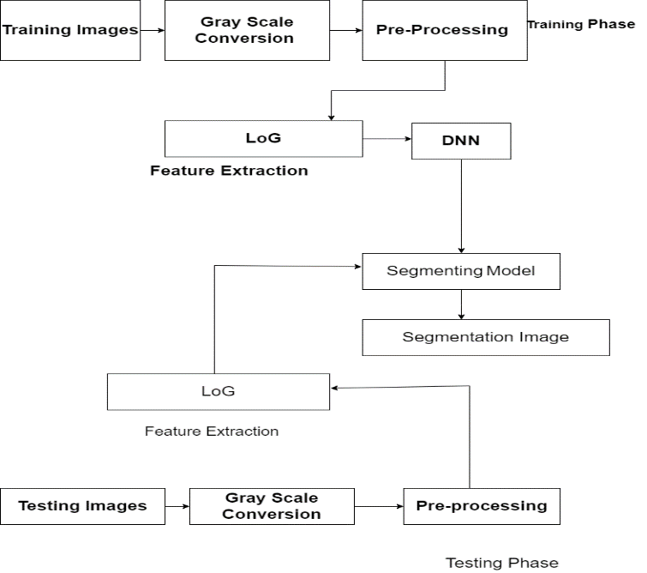
Figure 1 proposed model of deep neural network-based blood vessel segmentation

IV- EXPERIMENTAL ANALYSIS

To exhibition the performance of proposed algorithm for blood vessels segmentation utilizes MATLAB2014R software. The proposed algorithmic method evaluates on two reputed open-access datasets such as, DRIVE, and STARE. The DRIVE dataset which consists of 40 fundus images having a resolution of 565 X584 pixels obtained for the DR screening program. The set of 40 pictures has been isolated into two sets a preparation set and a test sets, each with 20 images. 20 fundus images with a resolution of 605–700 pixels make up the STARE dataset. The STARE dataset lacks separate training and test data, in contrast to the DRIVE dataset. The result of our proposed calculation probability prediction map which indicates the likelihood that a given pixel is either a vessel or not. For each of the three datasets, we threshold a probability map with a value of 0.4 to produce the binary segmentation of retinal vessels. A blood vessel pixel is one whose anticipated value on the probability map exceeds the threshold; otherwise, it is regarded as a background pixel. We applied the well-known, standard evaluation metrics for deep learning models in the segmentation and analysis of medical pictures. By comparing our developed algorithm for the segmentation of retinal vessels to the publicly available ground truth from experts, we hope to assess its performance. The abbreviations TP, FP, TN, and FN stand for true positive, false positive, true negative, and false negative, respectively. The metrics for evaluation are SN, specificity (SP), and ACC.
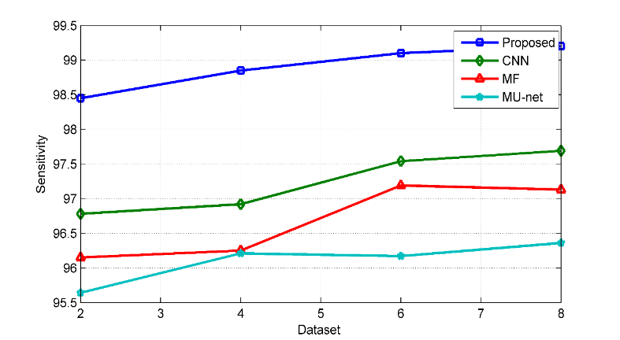
Figure: 2 Comparative result analysis of sensitivity of DRIVE dataset employed proposed method, CNN, MF, and MU-net.
Figure (2) depicts that the value of proposed is better than the other three methods, in which the value of proposed is displayed as 99.2 which is a better performance, while the value of CNN is 97.69. And the MF value is 97.13, which is better, and the MU- net value is also performing better, which is 96.36.
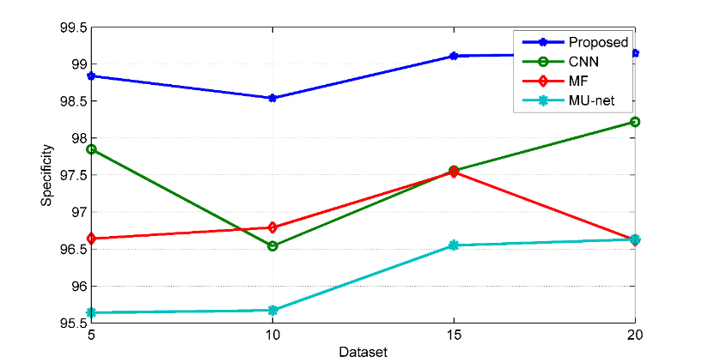
Figure: 3 Comparative result analysis of specificity of DRIVE dataset employed proposed method, CNN, MF, and MU-net.
Figure (3) depicts that the value of proposed is superior than the net other three methods, in which the value of proposed is performed as follows: 99.15 which is a better performance, while the value of CNN is 98.22. And the value of MF is 97.54, which is better, and the value of MU- net is also performing better, which is 96.63.
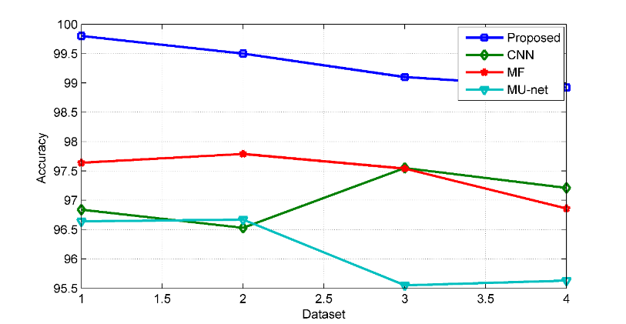
Figure: 4 Comparative result analysis of accuracy of DRIVE dataset employed proposed method, CNN, MF, and MU-net.

Figure (4) depicts that the value of proposed is better than the other three methods, in which the value of proposed is performed as follows: 99.8 which is a better performance, while the value of CNN is 97.55 And the value of MF is 97.79, which is better, and the value of MU-net is also performing better, which is 96.67.
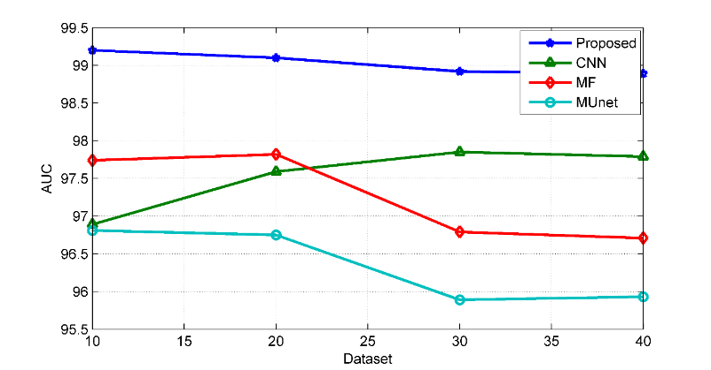
Figure: 5 Comparative result analysis of AUC of DRIVE dataset employed proposed method, CNN, MF, and MU-net.

Figure (5) depicts that the value of proposed is better than the other three methods, in which the value of proposed is performed as follows: 99.2 which is a better performance, while the value of CNN is 97.85 And the value of MF is 97.82, which is better, and the value of MU-net is also performing better, which is 96.81.
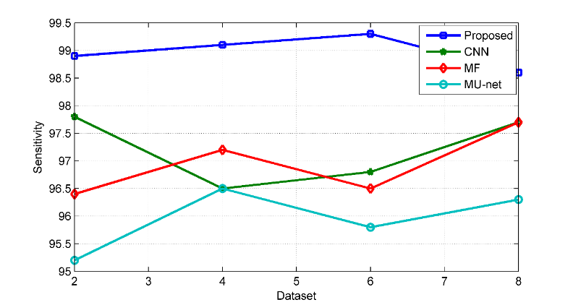

Figure: 6 Comparative result analysis of sensitivity of STARE dataset employed proposed method, CNN, MF, and MU-net.
Figure (6) depicts that the value of proposed is better than the other three methods, in which the value of proposed is displayed as 99.3 which is a better performance, while the value of CNN is 97.8. And the value of MU-net is 96. 5, which is better, and the MF value, which is 97.2, also performs better.
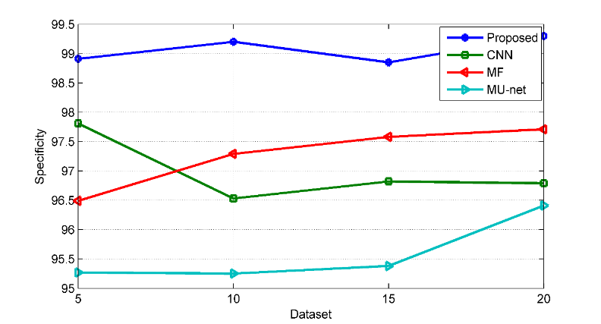
Figure: 7 Comparative result analysis of specificity of STARE dataset employed proposed method, CNN, MF, and MU-net.
Figure (7) depicts that the value of proposed is better than the other three methods, in which the value of proposed is displayed as 99.3 which is a better performance, while the value of CNN is 97.81, and the value of MU-net is 96.41, which is better, and the MF value, which is 97.71, also performs better.
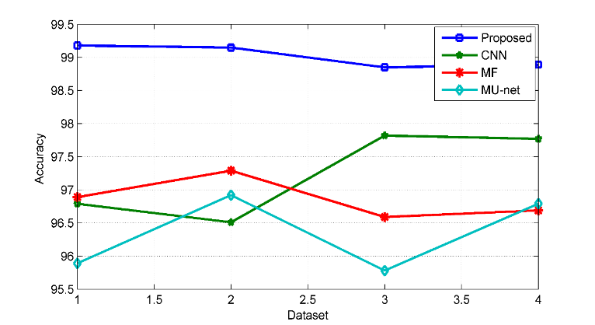

Figure: 8 Comparative result analysis of accuracy of STARE dataset employed proposed method, CNN, MF, and MU-net.
Figure (8) depicts that the value of proposed is better than the other three methods, in which the value of proposed is displayed as 99.18 which is a better performance, while the value of CNN is 97.82, and the value of MU-net is 96.92, which is better, and the MF value, which is 97.29, also performs better.
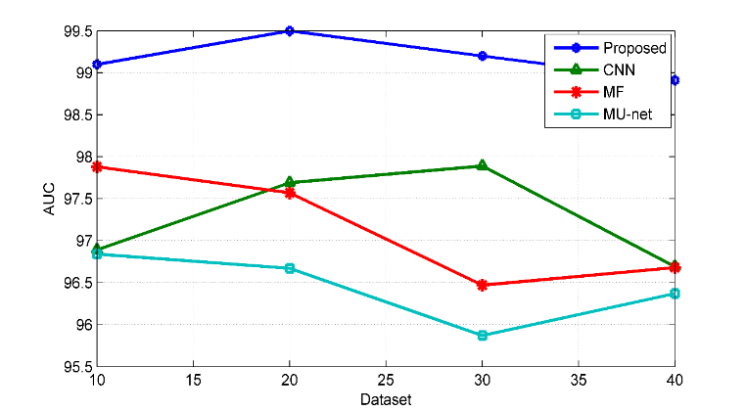
Figure: 9 Comparative result analysis of AUC of STARE dataset employed proposed method, CNN, MF, and MU-net.
Figure (9) depicts that the value of proposed is better than the other three methods, in which the value of proposed is displayed as 99.5 which is a better performance, while the value of CNN is 97.89, and the value of MU-net is 96.84, which is better, and the MF value, which is 97.88, also performs better.

V- CONCLUSION & FUTURE SCOPE

This paper proposes a method of blood vessel segmentation. The proposed algorithm is based on a pixel optimization process that employs the BAT optimization algorithm. The process of Pixel extraction employed LoG feature Extraction. The BAT optimisation algorithm reduces the content of noise and improves the training process of deep neural networks. The DNN classifier is introduced using these features. Utilising DNN training images, it completes the training phase. On the test images, segmentation is done after building the training network. The proposed method is more effective than other state-of-the-art methods, according to experimental results. The suggested approach was developed independently of the dataset. However, all data has undergone preprocessing. The preprocessing helped to lower the noise and get rid of the light reflex. This circumstance has a direct impact on the performance's outcome. The proposed method performs reasonably well, according to experimental results, both in terms of quantitative performance and visual results. The performance of the proposed algorithm compares with existing algorithms such as CNN, MF, and MU-Net. The performance of the proposed algorithm suggests that it is better than existing algorithms. In the future, employ multiple feature extraction processes and apply advanced deep neural network algorithms.

REFERENCES
- Pekala, Mike, Neil Joshi, TY Alvin Liu, Neil M. Bressler, D. Cabrera DeBuc, and Philippe Burlina. "Deep learning based retinal OCT segmentation." Computers in biology and medicine 114 (2019): 103445.
- Khan, Tariq M., Antonio Robles–Kelly, and Syed S. Naqvi. "Rc-net: A convolutional neural network for retinal vessel segmentation." In 2021 Digital Image Computing: Techniques and Applications (DICTA), pp. 01-07. IEEE, 2021.
- Hassan, Bilal, Shiyin Qin, Ramsha Ahmed, Taimur Hassan, Abdel Hakeem Taguri, Shahrukh Hashmi, and Naoufel Werghi. "Deep learning based joint segmentation and characterization of multi-class retinal fluid lesions on OCT scans for clinical use in anti-VEGF therapy." Computers in Biology and Medicine 136 (2021): 104727.
- Haider, Syed Irtaza, Khursheed Aurangzeb, and Musaed Alhussein. "Modified Anam-Net Based Lightweight Deep Learning Model for Retinal Vessel Segmentation." Computers, Materials & Continua 73, no. 1 (2022).
- Bhuiya, Srinjoy, Soumik Roy Choudhury, Geetanjali Aich, Muskaan Maurya, and Anindya Sen. "Retinal Blood Vessel Segmentation and Analysis using Lightweight Spatial Attention based CNN and Data Augmentation." In 2022 IEEE Calcutta Conference (CALCON), pp. 122-127. IEEE, 2022.
- Bhardwaj, Pranjal, Prajjwal Gupta, Thejineaswar Guhan, and Kathiravan Srinivasan. "Early Diagnosis of Retinal Blood Vessel Damage via Deep Learning-Powered Collective Intelligence Models." Computational and Mathematical Methods in Medicine 2022 (2022).
- Elsharif, Abeer Abed ElKareem Fawzi, and Samy S. Abu-Naser. "Retina Diseases Diagnosis Using Deep Learning." (2022).
- Tang, Michael Chi Seng, Soo Siang Teoh, Haidi Ibrahim, and Zunaina Embong. "A deep learning approach for the detection of neovascularization in fundus images using transfer learning." IEEE Access 10 (2022): 20247-20258.
- Veena, H. N., A. Muruganandham, and T. Senthil Kumaran. "A novel optic disc and optic cup segmentation technique to diagnose glaucoma using deep learning convolutional neural network over retinal fundus images." Journal of King Saud University-Computer and Information Sciences 34, no. 8 (2022): 6187-6198.
- Vaiyapuri, Thavavel, S. Srinivasan, Mohamed Yacin Sikkandar, T. S. Balaji, Seifedine Kadry, Maytham N. Meqdad, and Yunyoung Nam. "Intelligent Deep Learning Based Multi-Retinal Disease Diagnosis and Classification Framework." Computers, Materials & Continua 73, no. 3 (2022).
- Sudhan, M. B., M. Sinthuja, S. Pravinth Raja, J. Amutharaj, G. Charlyn Pushpa Latha, S. Sheeba Rachel, T. Anitha, T. Rajendran, and Yosef Asrat Waji. "Segmentation and classification of glaucoma using U-net with deep learning model." Journal of Healthcare Engineering 2022 (2022).
- Sule, Olubunmi Omobola. "A Survey of Deep Learning for Retinal Blood Vessel Segmentation Methods: Taxonomy, Trends, Challenges and Future Directions." IEEE Access 10 (2022): 38202-38236.
- Herrera, Daniela, Gilberto Ochoa-Ruiz, Miguel Gonzalez-Mendoza, Christian Stephan-Otto, and Christian Mata. "Impact of loss function in Deep Learning methods for accurate retinal vessel segmentation." In Advances in Computational Intelligence: 21st Mexican International Conference on Artificial Intelligence, MICAI 2022, Monterrey, Mexico, October 24–29, 2022, Proceedings, Part I, pp. 26-37. Cham: Springer Nature Switzerland, 2022.
- Maurya, Tanya, Lalitha Kala, Kaveti Manasa, Kanimozhi Gunasekaran, and C. Umayal. "Retinal Glaucoma Detection Using Deep Learning Algorithm." International Journal of Intelligent Systems and Applications in Engineering 10, no. 1 (2022): 52-59.
- Zhang, Ting, Lifang Wei, Nan Chen, and Jun Li. "Learning based multi-scale feature fusion for retinal blood vessels segmentation." Journal of Algorithms & Computational Technology 16 (2022): 17483026211065369.
- Sethuraman, Srivaradharajan, and V. A. R. U. N. PALAKUZHIYIL GOPI. "Staircase-Net: a deep learning based architecture for retinal blood vessel segmentation." Sādhanā 47, no. 4 (2022): 191.
- Zhang, Qian, Konstantina Sampani, Mengjia Xu, Shengze Cai, Yixiang Deng, He Li, Jennifer K. Sun, and George Em Karniadakis. "AOSLO-net: a deep learning-based method for automatic segmentation of retinal microaneurysms from adaptive optics scanning laser ophthalmoscopy images." Translational Vision Science & Technology 11, no. 8 (2022): 7-7.
- Keino, Hiroshi, Tomoki Wakitani, Wataru Sunayama, and Yuji Hatanaka. "Quantitative Analysis of Retinal Vascular Leakage in Retinal Vasculitis Using Machine Learning." Applied Sciences 12, no. 24 (2022): 12751.
- Lin, Mengchen, Guidong Bao, Xiaoqian Sang, and Yunfeng Wu. "Recent advanced deep learning architectures for retinal fluid segmentation on optical coherence tomography images." Sensors 22, no. 8 (2022): 3055.
- Jiang, Yun, Ning Tan, Tingting Peng, and Hai Zhang. "Retinal vessels segmentation based on dilated multi-scale convolutional neural network." IEEE Access 7 (2019): 76342-76352.
- Rani, N. Shobha, Nair BJ Bipin, and C. R. Yadhu. "Hemorrhage segmentation and detection in retinal images using object detection techniques and machine learning perspectives." In 2019 Global Conference for Advancement in Technology (GCAT), pp. 1-5. IEEE, 2019.
- Yadav, Pratima, and Nagendra Pratap Singh. "Classification of normal and abnormal retinal images by using feature-based machine learning approach." In Recent Trends in Communication, Computing, and Electronics: Select Proceedings of IC3E 2018, pp. 387-396. Springer Singapore, 2019.
- Fan, Zhun, Jiajie Mo, Benzhang Qiu, Wenji Li, Guijie Zhu, Chong Li, Jianye Hu, Yibiao Rong, and Xinjian Chen. "Accurate retinal vessel segmentation via octave convolution neural network." arXiv preprint arXiv:1906.12193 (2019).
- Ma, Yuliang, Xue Li, Xiaopeng Duan, Yun Peng, and Yingchun Zhang. "Retinal vessel segmentation by deep residual learning with wide activation." Computational Intelligence and Neuroscience 2020 (2020).
- Samuel, Pearl Mary, and Thanikaiselvan Veeramalai. "Multilevel and multiscale deep neural network for retinal blood vessel segmentation." Symmetry 11, no. 7 (2019): 946.
- Sathananthavathi, Vallikutti, G. Indumathi, and A. Swetha Ranjani. "Parallel architecture of fully convolved neural network for retinal vessel segmentation." Journal of digital imaging 33, no. 1 (2020): 168-180.
- Fu, Qilong, Shuqiu Li, and Xin Wang. "MSCNN-AM: A multi-scale convolutional neural network with attention mechanisms for retinal vessel segmentation." IEEE Access 8 (2020): 163926-163936.
- Gojić, Gorana, Veljko Petrović, Radovan Turović, Dinu Dragan, Ana Oros, Dušan Gajić, and Nebojša Horvat. "Deep learning methods for retinal blood vessel segmentation: Evaluation on images with retinopathy of prematurity." In 2020 IEEE 18th International Symposium on Intelligent Systems and Informatics (SISY), pp. 131-136. IEEE, 2020.
- Tuyet, Vo Thi Hong, and Nguyen Thanh Binh. "Improving retinal vessels segmentation via deep learning in salient region." SN Computer Science 1, no. 5 (2020): 248.
- Bruno, Pierangela, Maria Francesca Spadea, Salvatore Scaramuzzino, Salvatore De Rosa, Ciro Indolfi, Giuseppe Gargiulo, Giuseppe Giugliano, Giovanni Esposito, Francesco Calimeri, and Paolo Zaffino. "Assessing vascular complexity of PAOD patients by deep learning-based segmentation and fractal dimension." Neural Computing and Applications (2022): 1-8.
- Skouta, Ayoub, Abdelali Elmoufidi, Said Jai-Andaloussi, and Ouail Ouchetto. "Semantic Segmentation of Retinal Blood Vessels from Fundus Images by using CNN and the Random Forest Algorithm." In SENSORNETS, pp. 163-170. 2022.
- Sathananthavathi, Vallikutti, and Ganesan Indumathi. "BAT algorithm inspired retinal blood vessel segmentation." IET Image Processing 12, no. 11 (2018): 2075-2083.Borenstein, J.; Everett, H.R. & Feng, L. (1996). Navigating Mobile Robots: Sensors and Omni directional Mobile Robot – Design and Implementation Ioan Doroftei, Victor Grosu and Veaceslav Spinu “Gh. Asachi” Technical University of Iasi Romania Techniques. A K Peters, Ltd, MA, USA.

