Review Paper ( TO PREVENT WATER LEAKAGE BY USING OF COPPER RING IN DIESEL ENGINE IN CONNECTION OF CYLINDER LINER AND ENGINE BLOCK.)

Abhilash Sontakke
sonttake_abhilash.ghrceme@raisoni.net
Final Year Student of Mechanical Engg.
G. H. Raisoni Collage of Engineering, Nagpur,India-440016

Abhijeet Raut
abhijeet.raut@raisoni.net
Professor(Mechanical Engineering)
G. H. Raisoni Collage of Engineering, Nagpur, India-440016

Nilesh Awate
nilesh.awate@raisoni.net
Assistant Professor , Dept of Mechanical Engineering
G.H.Raisoni college of Engineering,Nagpur, India-440016.

Vishal Singh
avs.technoservices@gmail.com
Director (A.V.S)
A.V.S Techno Services Private Limited, Bikaner, Rajasthan, India –334001.

Abstract:- This paper presents a review to prevent water leakage in diesel engine. Such type of technique is used to stop water entering in head of engine. Most of the time engine run in 2100 rpm the particle present in the water cut the rubber o rings which takes the pressure to the joining part or joining place of cylinder liner block and head. It is to prevent water leakage from combustion process. The proper prevention of water leakage can be used.

CONTENTS
[1] Introduction of diesel engine.

[2] Operating principle

[3] Major advantages
[4] Problems in Engine

[5] Cylinder liner

[6] working
[7] Conclusions
[8] References

INTRODUCTION OF DIESEL ENGINE
The diesel engine (also known as a compression-ignition or CI engine) is an internal combustion engine in which ignition of the fuel which is injected into the combustion chamber is caused by the elevated temperature of the air in the cylinder due to mechanical compression (adiabatic compression). Diesel engines work by compressing only the air. This increases the air temperature inside the cylinder to such a high degree that atomised diesel fuel that is injected into the combustion chamber ignites spontaneously. In diesel engines, glow plugs (combustion chamber pre-warmers) may be used to aid starting in cold weather, or when the engine uses a lower compression-ratio, or both. The original diesel engine operates on the "constant pressure" cycle of gradual combustion and produces no audible knock.
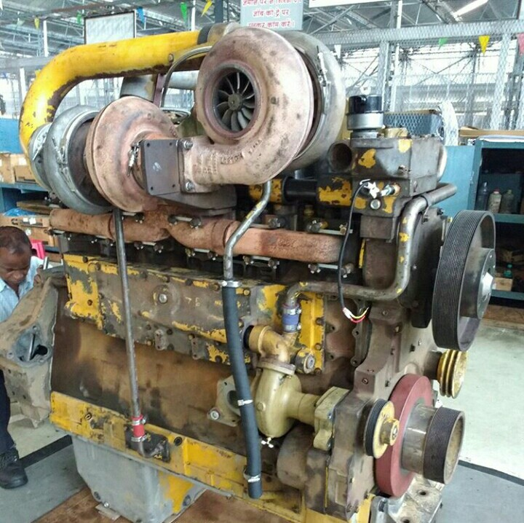

CUMMINS KTTA-19 C
The diesel engine has the highest thermal efficiency (engine efficiency) of any practical internal or external combustion engine due to its very high expansion ratio and inherent lean burn which enables heat dissipation by the excess air. A small efficiency loss is also avoided compared to two-stroke non-direct-injection gasoline engines since unburned fuel is not present at valve overlap and therefore no fuel goes directly from the intake/injection to the exhaust. Low-speed diesel engines (as used in ships and other applications where overall engine weight is relatively
unimportant) can have a thermal efficiency that exceeds 50%.
Diesel engines may be designed as either two-stroke or four-stroke cycles. They were originally used as a more efficient replacement for stationary steam engines. Since the 1910s they have been used in submarines and ships. Use in locomotives, trucks, heavy equipment and electricity generation plants followed later. In the 1930s, they slowly began to be used in a few automobiles. Since the 1970s, the use of diesel engines in larger on-road and off-road vehicles in the US increased. According to the British Society of Motor Manufacturing and Traders, the EU average for diesel cars accounts for 50% of the total sold, including 70% in France and 38% in the UK.
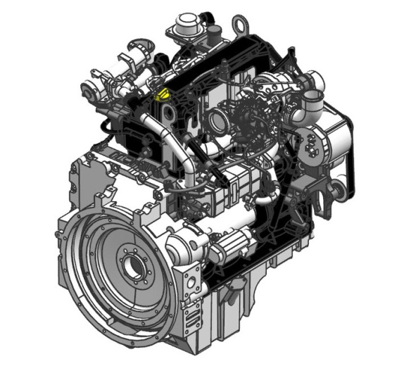
Engine 3D Model

OPERATING PRINCIPLE
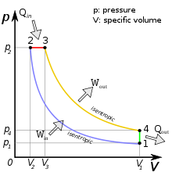
p-V Diagram for the Ideal Diesel cycle.
The cycle follows the numbers 1–4 in clockwise direction. The horizontal axis is Volume of the cylinder. In the diesel cycle the combustion occurs at almost constant pressure. On this diagram the work that is generated for each cycle corresponds to the area within the loop.

MAJOR ADVANTAGES
Diesel engines have several advantages over other internal combustion engines:
Diesel fuel has higher energy density and a smaller volume of fuel is required to perform a specific amount of work.
Diesel engines inject the fuel directly into the combustion chamber, have no intake air restrictions apart from air filters and intake plumbing and have no intake manifold vacuum to add parasitic load and pumping losses resulting from the pistons being pulled downward against intake system vacuum. Cylinder filling with atmospheric air is aided and volumetric efficiency is increased for the same reason.
Heavier fuels like diesel fuel have higher cetane ratings and lower octane ratings, resulting in increased tendency to ignite spontaneously and burn completely in the cylinders when injected. Increased compression ratios create higher combustion chamber temperatures to ignite the injected fuel. Higher compression ratios increase pumping losses as more work is required to compress intake air to a smaller volume, but pumping loss increases are offset by increased power and efficiency. Increasing compression ratios in spark-ignition engines requires higher octane fuels that are harder to ignite and burn completely and/or advanced spark timing to avoid pre-ignition, knocking and resulting performance losses and engine damage. Power gains from increased compression ratios are reduced in spark-ignition engines while the pumping losses remain comparable to similar compression ratio increases in diesel engines.
Because of the above differences in diesel fuels vs. gasoline and other spark-ignition fuels, diesel engines have higher thermodynamic efficiency, with heat efficiency of 45% being possible compared to approximately 30% for spark-ignition engines. Gasoline engines are typically 30% efficient while diesel engines can convert over 45% of the fuel energy into mechanical energy (see Carnot cycle for further explanation).
They have no high voltage electrical ignition system, resulting in high reliability and easy adaptation to damp environments. The absence of coils, spark plug wires, etc., also eliminates a source of radio frequency emissions which can interfere with navigation and communication equipment, which is especially important in marine and aircraft applications, and for preventing interference with radio telescopes.

PROBLEMS IN DIESEL ENGINE
[1]Excessive vibration of engine
[2]Oil throw from turbocharger
[3]Engine not taking rated load
[4]Low lube oil pressure
[5]Mixing of coolant in oil
[6]High fuel consumption
[7]Mixing of diesel in coolant oil throws back from discharge line of air compressor
[8]Engine cranks does not starts
[9]Excessive heating of engine
[10]Over racing of engine
[11]Late stopping of engine
[12]Hunting in engine
[13]Dilution of fuel with oil
[14]Engine emoting white smoke
[15]Abnormal sound from engine

This is the problem which is usually seemed in engine. There are many ways that problem can course for example the mixing or water and oil can be caused from the oil cooler and damages of o rings of cylinder liner. So as this type the problem is one but the reason can be many , that’s why there are many ways to course the problem in engine and almost all the ways has the solution for the problem in engine.
Now from the above mentioned problem i have got an alternative solution which can stop coolant entering in cylinder liner which is the mixing or coolant in oil.

CYLINDER LINER

Basically the cylinder liner is a hollow cylindrical shell which acts as the enclosure in which the combustion takes place.
Of course the word hollow does not imply that it is weak in strength for it is under the fluid pressure due to combustion and hence must withstand the high level of hoop stress induced in it.
A cylinder liner is a removable component, cylindrical in shape, inserted into the engine block. It provides the surface for the piston to slide and carry out its compression task. It can be replaced when worn out.
Cylinder liners are made from close grained cast iron.
The lower end is fitted with rubber rings so as to form a seal for the bottom of the water space. These rubber rings may be arranged also to prevent oil from the crankcase entering the water jackets.

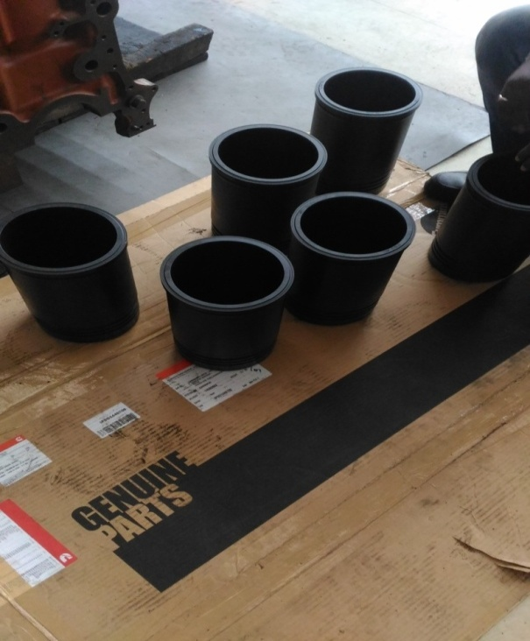
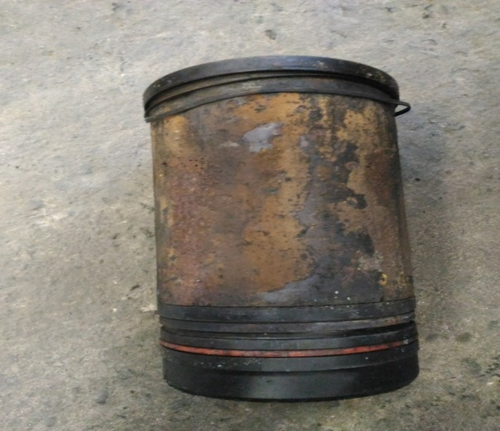

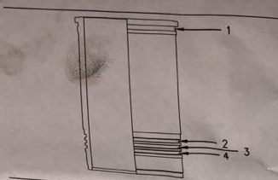
[1]Filler Band
[2]Liner Seal (Coolant)
[3]Liner Seal (MID)
[4]O-Ring seal (OIL)

WORKING
In many of times due to pressure fluctuation the pressure increase or decrease. In this increase and decrease may part of engine are under load. Coolant enters the water jackets from the oil cooler. As the piston reciprocate vibration occur in the liner, due to the vibration the filler band o ring under load gets cut. Due to this the coolant from the jacket comes under the cylinder head. Hence through these phenomena corrosion occur on the cylinder head and also enter the combustion chamber through intake valves. This may lead to hydraulic lock or engine seize. In order to overcome this copper Sims are placed on the joining part of cylinder liner and block. This copper Sims may help to counter seal the cylinder block. Through this action we can overcome the problem of the engine seizing. The copper is a soft metal so that when it get compressed between the linear and the block, it over laps the gap and it block all the leakages passages. It also reduces the vibration created by the reciprocating of piston which also help us to reduce the vibration and life’s of o rings will increase. so by this process we can overcome the problem of coolant entering block and cylinder head.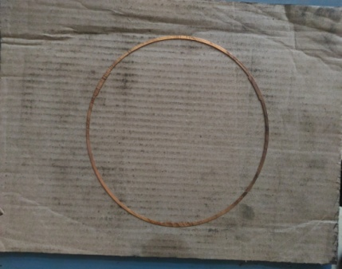
FIG. COPPER SIMS
Hence due to this installation the ovality limit is also get reduced which leads to the low problem of blow by.

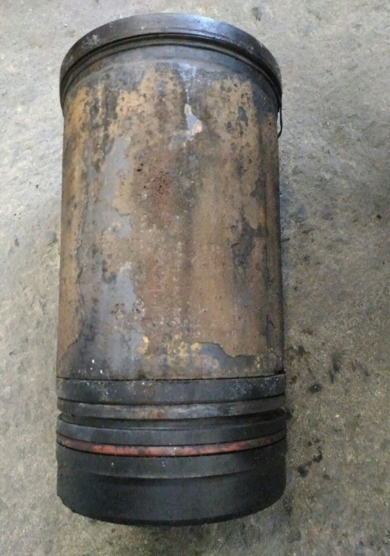
FIG. CYLINDER LINER

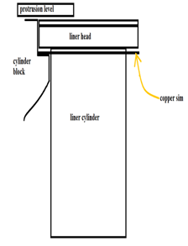
DIG. CYLINDER LINER WITH INSTALLATION OF COPPER SIMS

CONCLUSIONS

[1] Due to this the engine get Counter sealed.
[2] The seizing problem will not occur.
[3] It will also reduce the vibration of cylinder liner.

REFERENCES:-
[1] Piston Ring Handbook. Federal-Mogul Burscheid GmbH. August 2008..
[2] VDi-richtlinie 2840 Kohlenstoffschichten, Grundlagen, Schichttypen, Eigenschafte
[3] "Piston Ring Coating Reduces Gasoline Engine Friction"(PDF). Federal-Mogul.
[4] DimitriosDardalis, PhD (February 2004). "Rotating Liner Engine: A New Approach to Reduce Engine Friction and Increase Fuel Economy in Heavy Duty Engines"(PDF). Austin, TX: RLE Technologies, Inc.
[5] "Wear-Resistant Peripheral Coatings". Federalmogul.com. Retrieved 2010-07-04.
[6] "Wear-Resistant Peripheral Coatings". Federalmogul.com. Retrieved 2010-07-04.
[7] "Wear-Resistant Peripheral Coatings". Federalmogul.com. Retrieved 2010-07-04.

