ITS FOR ASSESMENT OF SUSTAINABILITY CONSIDERING VEHICULAR EMISSION IN METROPOLITIAN CITIES
Nabeel khan Nazim khan Inamdar¹, Sujesh Ghodmare² , Dr. B. V. Khode³
¹PG Student, Department of civil engineering, G. H. Raisoni college of engineering, Nagpur.
²Assistant Professor, Department of Civil Engineering, G. H. Raisoni College of Engineering, Nagpur.
³Professor, Department of Civil Engineering, G. H. Raisoni College of Engineering, Nagpur.

Abstract: : Intelligent transportation system (ITS) is one of the emerging technologies contributing towards the rapid growth of a country. The problem of growing traffic congestion, growing pollution and increasing fuel consumption and limited land access for the widening of roads can be countered effectively by this technology. But it important to evaluate the efficiency of a technology to find its sustainability. The harmful gases from vehicular emission such as CO, NO_{x} which causes global warming, acidification, acid rain and many other health problems. it important to reduce such harmful gas emission. ITS is found to be an effective measure in reducing emission of such gases. Thus this technology should be evaluated for its sustainability for better results and acceptance by the society. In this paper, a thorough study is done on various emissions through vehicles in a metropolitan city Nagpur considering a definite corridor.
Keywords: Intelligent transportation system(ITS), Fuel Consumption, Gases Emission.

Introduction: Intelligent Transportation Systems (ITS) have produced impressive excitement in the transportation group as a potential intends to enhance roadway safety, decrease blockage, and upgrade the mobility of people. In addition, ITS has proved beneficial in increasing vehicle's energy efficiency and reducing gases emissions. On account of expanded worries about energy and natural issues, the goal of this paper is to feature particular ITS projects that are beneficial to environment. Current transportation related energy and environmental problems will not be solved with a single solution; a multitude of solutions will be necessary. Most studies indicate that the application of these systems reduced travel time and frequency. The use of ITS, which was developed from the past 20 years, has had a significant role in reducing environmental pollutants by providing greater flexibility in traffic. “ITS helps to optimize trips, eliminate unnecessary travel miles and decrease time spent caught in traffic. Altogether ITS contains fuel consumption and toxic discharges, decrease reliance on outside vitality supplies and defend the nature of the air. It was found that the application of ITS in some countries such as Advanced traffic management systems(ATMS), traveler information systems(ATIS), public transport systems, commercial vehicle management systems(CVO) helped in reducing energy utilization and emission of harmful gases.
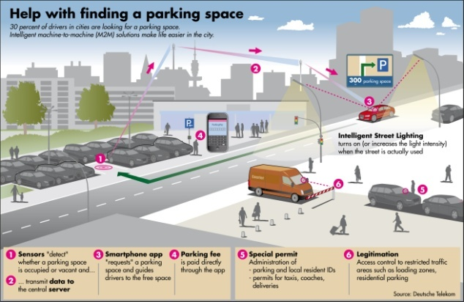

Fig 1: System to provide parking space to drivers with ease which reduce the time required for finding parking space and ultimately reduce Fuel consumption. (Source: Dutsche Telekom)
Literature Review:

Firas Alrawi explained the role of intelligent Intelligent Transportation Systems ITS to take care of natural issues, caused predominantly by traffic congestion, inside Baghdad City. His research studied the contamination rates caused by congestion in the roads associated with the crossing point of Jadriya, which is situated close to the Baghdad University. The extent of gases discharged by vehicles was figured utilizing regression equation and this estimation has relied upon the traffic volume. The results indicate a critical abetment in emissions if ITS applied.

Matthew Barth attempts to show the significance of ITS in diminishing fuel utilization and harmful gases emission. He reviewed on a few ITS exploration ventures being done in southern California that are specifically targeting reduction in energy utilization and GHG emission.

C. Silva, at.al. Demonstrated that the use of public transport helps in reducing the energy consumption and harmful gases emission. Four types of vehicles were selected Gasoline LDV, Diesel LDV, Mini Bus, Regular Bus & two traffic situations were considered for 1 km & the emission of the gases were calculated based on the driver's behavior of accelerating and de-accelerating. The results shows that Each person in Gasoline LDV is equivalent to 11 to 12 passenger in regular bus, Co₂ & Co emission. The No. falls to 6 to 7 for HC emission. Each passenger in Diesel LDV is equivalent to 10 passengers in bus. That No. goes to 17 to 18 for remaining emission.
Maurizio Bruglieri, at.al. used MOTUS travel planner which create a system available for mobility managers and operations. It comprehended, characterize, analyze and monitor urban mobility both in citizens and tourists. It integrates data collected by heterogeneous sources.

Felipe Jimenez. at.al used advanced observation techniques, vehicle automation and communication Realtime time detection and grouping of obstacles and identification of potential risks. Autonomous vehicle performance in case of problems/errors. Combination of vehicle positioning, computerized maps and advanced map matching algorithm to establish decision algorithm of different ADAS system. It shows an in-built collision control system including obstacles identification system using artificial vision and 3D-lesser scanner and wireless communication Module. This system suggest more efficient behavior in normal driving conditions, and provides warning to the drivers if it detects any danger. The system is able to take control of the vehicle for performing evasive manure or stops automatically.

Zissis Samaras, at.al. created a Combination of Traffic and emission modeling at smallest as well as largest scales. The data was collected by moving observer method the result shows that Intelligent transportation system proved their ability to reduce CO₂ emission.

Methodology:

From the Literature Survey various ITS deployments is studied and based on the that a tree diagram is created having all ITS deployments and its Sub-deployments.

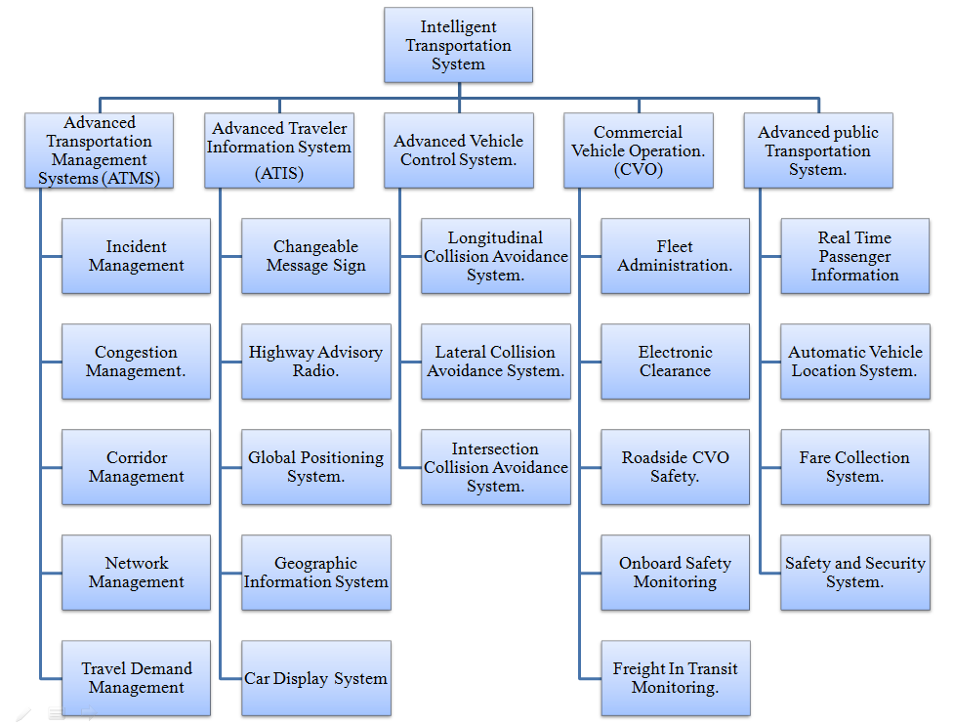
Fig No. 2: Intelligent transportation system deployments(Source:Author)

For the study purpose ITS deployments of congestion management by Signal Synchronization and electronic toll collection system(ETC) is used. For signal Synchronization a corridor in Nagpur city is selected from Reserve bank of India square to Automotive square on Nagpur-Kamptee Road and for Electronic toll collection Kondali toll booth is selected on Nagpur-Amravati NH-6 Highway.
The data required for both the studies is collected by manual data collection method.
Based on the collected the data the reduction in delay, travel time, fuel utilization and emission of gases is calculated.
Signal Synchronization.
Traffic Signal Synchronization is an activity designing strategy of coordinating the green light circumstances for a progression of crossing points to empower the most extreme number of vehicles to go through, consequently lessening stops and delays experienced by drivers. Synchronizing traffic signals guarantees a superior stream of activity and limits gas utilization and emission.

Drivers frequently get disappointed when they need to stop at progressive traffic lights, or when they need to wait a while for a green light, particularly when there is no activity in alternate ways. Traffic signals are designed to disseminate the green time to conflicting traffic streams, based on volumes. If the traffic on a fundamental road is impressively higher than the side road, more green time might be given to the primary road which could bring about a more extended wait for drivers on secondary road. In any case, synchronizing signals along a fundamental road can profit all drivers based on the fact that once a vehicle enters the primary road, it might proceed with minimal stoppages. Subsequently, it is helpful for both the primary road and secondary road movement. The objective of synchronization is to get the highest number of vehicles through the squares with the least delay due to stoppage.

The way traffic signal synchronization works is by calculating the entry time for a gathering of vehicles at every crossing point going at a predetermined speed, and afterward the traffic signals are deliberately planned to turn green just as the vehicle group arrive at the intersection. All together for the traffic signals to be synchronized, a group of signals should all be set to keep running on a similar cycle length (the measure of time it takes to go from green to yellow to red; and back to green once more) after the cross road has been served.
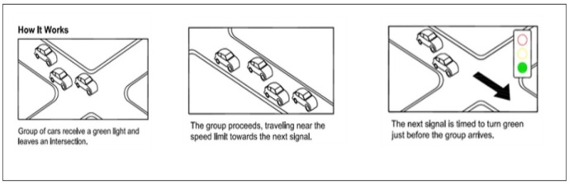
Fig No. 3: Diagram showing traffic signal synchronization (Source: Internet).

Electronic toll Collection.
Electronic Toll Collection (ETC)— a framework for computerized gathering of tolls from moving or ceased vehicles through remote advancements, for example, radio-frequency correspondence or optical scanning. ETC systems are classified as following: (1) system that expect clients to have enlisted toll accounts, with the utilization of hardware inside or on the outside of vehicles, for example, a transponder or standardized tag decal, that is identified by roadside or overhead reader, or with the utilization of tag optical checking, to consequently deduct the toll from the enrolled client record, or (2) system that don't expect clients to have enrolled toll accounts since vehicle number plates are scanned and the invoices of the amount are directly sent through postal mail to the owner.
As the ETC decreases the stoppage time it helps in reducing the fuel utilization and gases emission. The ETC also increases the serviceability of the toll booth as now more number of vehicles can be passed through the toll in less amount of time. The man power required for the traditional toll both is quite high as it requires people for cash transactions, cash handling, and many more tasks. The cash handling has been a big issue for toll booth as the amount of cash is quite large but in case of Electronic toll collection the amount is directly transferred to the account thus reducing the ruckus for cash handling.
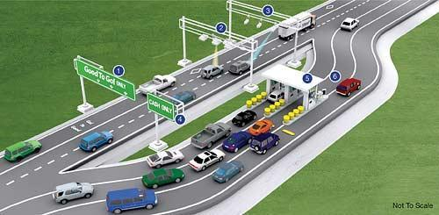
Fig No. 4: Schematic diagram of ETC (Source: Internet).

Result and Discussion

From the collected data the reduction in delay is calculated and from that the difference between the travel Time, Emission and Fuel Consumption is calculated. The results are shown in following graphs.
Graph No. 1 :- Reduction in travel Time (Sec)
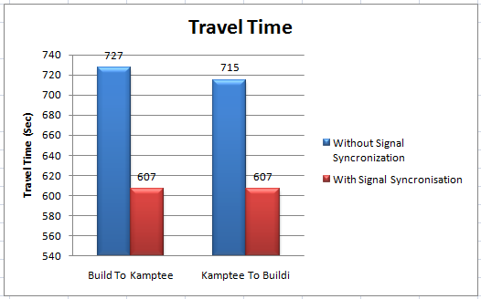
Graph No.1 Shows the reduction in travel time when Signal Synchronization is used and when it is not used.
Graph No. 2 :- Reduction in fuel consumption in one year (Litre)
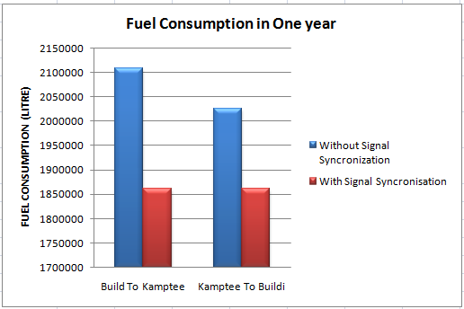
Graph No.2 Shows the reduction in Fuel consumption in one year when Signal Synchronization is used and when it is not used.
Graph No. 3 :- Reduction in emission in one year (Kg)
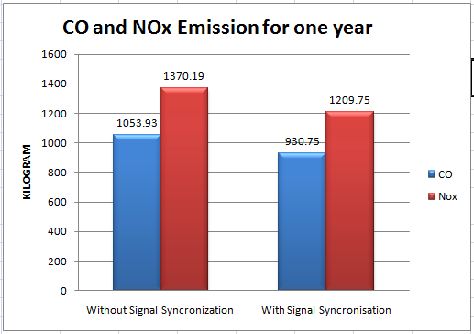
Graph No.3 Shows the reduction in Emission in one year when Signal Synchronization is used and when it is not used.
The above graph shows the reduction in travel time, emission and fuel consumption when signal Synchronization is used.
Graph No. 4 :- Reduction in fuel consumption in one year (Litre)
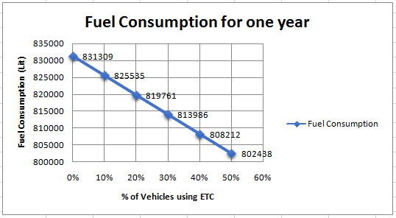
Graph No.4 Shows the decrease in Fuel consumption in one year if Electronic Toll collection is used by a variation of 10% of current traffic flow.
Graph No. 5 :- Reduction in Emission in one year (Kg)
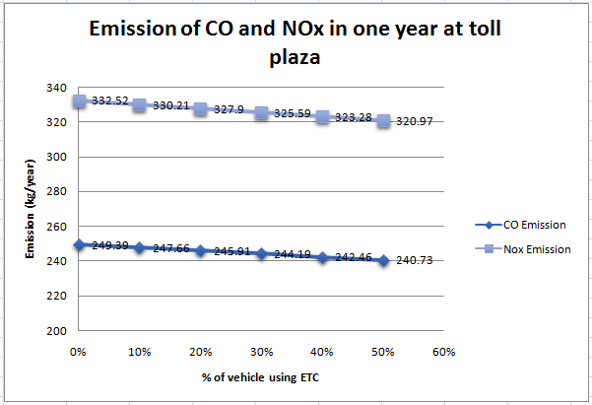

Graph No.5 Shows the reduction in Emission in one year if Electronic Toll collection is used by a variation of 10% of current traffic flow.

Conclusion
From the above discussion it can be concluded that Intelligent transportation system helps in reducing fuel consumption and harmful gases emission.
- The use of Signal synchronization can reduce fuel consumption by nearly 10%-15% in one year.
- Signal Synchronization also reduces the emission of CO and NO_{x} by nearly 11%-12% and also by 11%-12% respectively.
- From the graphs of electronic toll collection it can be concluded that the Emission and energy utilization reduces with the increase in use of electronic toll collection.

References
[1] Firas Alrawi, “The Importance of intelligent transportation system in the prevention of the environment and reduction of harmful gases.”, 3rd conference on sustainable urban mobility, 3rd CSUM 2016,26-27 May 2016, Volos, Greece.
[2] Matthew Barth, et.al., “Environmentally Beneficial Intelligent Transportation systems.”, Proceeding of the 12th IFAC Symposium on transportation systems Redondo Beach, CA, USA , September 2-4 2009.
[3] C. Silva et.ai.,” Bus Public Transport Consumption and emission versus Individual Transportation.” Transportation land use planning and air quality congress 2007.
[4] Maurizio Bruglieri et.al.,” A real-time information system for public transport in case of delays and service disruptions.” 18th Euro Working Group on Transportation, EWGT 2015, 14-16 July 2015, Delft, The Netherlands.
[5] Felipe Jiménez et.al.,” Advanced Driver Assistance System for road environments to improve safety and efficiency” 6th Transport Research Arena April 18-21, 2016
[6] Zissis Samaras et.al.” Quantification of the effect of ITS on CO2 emissions from road transportation .“. 6th Transport Research Arena April 18-21, 2016.

