CNN Approach for Prediction of Covid-19 From X-Ray Images
Poonam Patil, Rujul Modi, Harshita Jagtap, Damini Jadhav
¹Assistant Professor Poonam Patil
K.K Wagh Institute of Engineering Education and Research, Nashik, India,422001
²UG- student, Rujul Modi
K.K Wagh Institute of Engineering Education and Research, Nashik, India,422001
³UG student, Harshita Jagtap
K.K Wagh Institute of Engineering Education and Research, Nashik, India,422001
⁴UG student, Damini Jadhav
K.K Wagh Institute of Engineering Education and Research, Nashik, India,422001
Email of Corresponding Author:mrujul22@gmail.com

Received on: xxxx,20xx, Revised on: xxxx,20xx, Published on: xxxx,20xx

Abstract – COVID-19 also referred to as Severe Acute Respiratory Syndrome Corona virus-2 (SARS-CoV-2) is a very contagious virus infection and has huge effect on global health. The virus is spread from infected person who talks, sneeze, or cough. The most standard method for diagnosing COVID-19 is RT-PCR, performing RT-PCR to detect COVID might be risky, but the X-rays are easiest way available used for detecting infections in the lungs. Using Artificial Intelligence (AI) techniques and convolutional neural networks (CNNs) have achieved fruitful results in medical image analysis and classification. This study suggests a CNN model using TensorFlow for analysing chest X-rays to predict COVID-19 pictures. The study follows a flexible method of deep learning utilizing the CNN model for detection and prediction if a patient is impacted or not with the disease employing image of a chest X-ray. The trained model produced using TensorFlow achieved anaccuracy rate of 97% during the performance training.
Keywords-Prediction, COVID-19, TensorFlow, Convolution Neural Networks (CNN).

I. INTRODUCTION
In December 2019, the COVID-19 outbreak began in Wuhan, China, The Coronavirus disease (COVID-19) is a communicable disease caused by Severe Acute Respiratory Syndrome Coronavirus 2(SARS-CoV-2). The disease rapidly spread all around the world. In August 2020, COVID-19 had caused 27 million cases and 873,000 deaths globally[1]. The only preventive measures to avoid the infection from spreading were social distancing, self-isolation, and shielding oneself by washing hands and avoiding touching the mouth, eyes, nose, and face. The disease's signs and symptoms include cold, high fever, cough, and mild respiratory issues. Many people with low immunity, aged individuals, and medical conditions like diabetes and respiratory illness have been more prone to COVID-19 sickness. Many people were confirmed as Corona-positive, and the number of deaths was growing each day. The need for widespread access to diagnostic testing to identify the cause and stop the spread of this disease grew as the number of cases grew exponentially. Chest Tomography imaging like Computed Tomography (CT) scans and X-rays are some of the common tests used for COVID-19 identification. Polymerase Chain Reaction (PCR) test is a method for locating a particular coronavirus gene sequence. It creates multiple copies, which can be easily used for detection. Also, the reverse transcription-polymerase chain reaction (RT-PCR) test can be used for the diagnosis of COVID-19 disease. Samples of nasal secretions are collected for this test. Early detection from X-rays can help decide whether to keep a patient in isolation until laboratory test results come.
Artificial Intelligence played a vital role in addition to these medical tests. Artificial intelligence was widely used in COVID-19, including diagnosis, clinical decision-making, social control, vaccine development, and the management of patients with COVID-19. AI was widely employed by researchers to find new treatments and medications. Researchers in computer science have even used artificial intelligence to detect infectious individuals using processing of healthcare images such as X-rays and CT scans[2]. Chest X-rays can reveal signs of the disease, but manual analysis can be time-consuming and prone to error.By training a CNN on X-ray images, we built a system that automates Covid-19 detection with high accuracy.
In this paper we used Convolutional Neural Network which is a deep learning model for processing the X-rays images.This technique uses a set of images that includes chest X-ray scans of Covid-19 patients and normal people. Deep Learning uses CNN for recognizing objects in images.Deep Learning is a method of machine learning that trains computers through learning features.
II. LITERATURE REVIEW
The New Indian Express report quotes Dr. Rao, a member of the COVID consulting group, as claiming that X-rays can be a preferable way for quickly and cost-effectively detecting COVID-19 patients [3].This research recommends a CNN model that might predict COVID-19 more accurately based on this theory. A network with three or more layers is a neural network, and deep learning is a subset of machine learning. In their research to use the Convolutional Neural Network technique for predicting COVID-19 and pneumonia from X-ray scan pictures, Sammy V. Militante suggested a VGG-16 model [4]. The accuracy they attained with this model was 95%. With the use of CT scans, Wu et al. suggested a poorly supervised CNN model that has achieved 96.2% accuracy in the detection and classification of COVID-19 [5].
ConvNet is a feed-forward convolutional neural network that examines images by processing data in a grid-like topology. To find and categorize items in a picture, a CNN is employed. Convolution layer, ReLU layer, pooling layer, and a completely connected layer are the four key layers of the CNN model. Typically, a conventional convolutional layer builds a feature map using the kernel and an input picture [6]. A reliable chest x-ray image collection with precise data on healthy and verified COVID patients is also crucial. There are several data repositories with x-ray pictures as well as CSV files of the data available in Kaggle [7]. Convolutional Neural Networks were utilized by Khan Maseeh Shuaib et al. to diagnose pneumonia from X-ray images [9] with an accuracy of 84%. This study suggests using deep learning to categorize chest conditions like COVID-19 using image processing. The paper enables displaying CNN's extensive capabilities.
III. METHODOLOGY
A deep learning technique called Keras and TensorFlow is used as the methodology. Artificial neural networks with several layers are utilized in deep learning models. The highest-level building unit in DL is a layer. A layer is a container that typically accepts weighted input, transforms it via a variety of primarily non-linear functions, and then outputs these values to the subsequent layer. A subset of machine learning is a convolutional neural network (CNN or convnet). For tasks like image identification and pixel data preparation, a CNN is a specific kind of network created for deep learning techniques. A convolutional layer, a pooling layer, and a fully connected (FC) layer form a deep learning system [10]. In image 1.1, the flow of model is displayed.
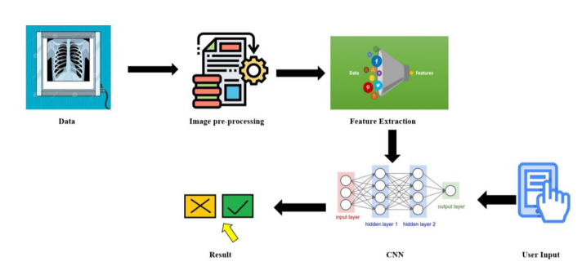
Fig. 1.1- Flow Diagram
Using the Keras toolkit to construct a convolutional neural network is an excellent approach to using deep learning to identify images. And the TensorFlow framework enables the development of extremely flexible CNN structures. TensorFlow is an open-sourced platform and library for numerous machine learning applications, whereas On top of TensorFlow, Keras is an advanced neural network framework. The following are the modules utilized in this paper:
A. Data Gathering:
The initial and most important stage in deep learning is data collection. To apply the suggested model, the dataset used is Covid19-dataset from Kaggle. The dataset consists of training and testing data which is further divided into Covid and normal and viral pneumonia X-ray images.
The dataset contains around 251 images for training and 66 images for testing [7]. Another dataset which contains 1281 COVID-19 affected images and 3270 Normal person chest X-ray images [8]. The viral pneumonia photos were removed from the dataset for training purposes, resulting in the images being classified as covid and normal.
B. Data Preprocessing:
We divided datasets into positive and negative categories before rescaling and standardizing the size of each image. The images have different sizes, so we scale them to 200 x 200 pixels. When compared to other formats, grayscale photos allow for absolute feature extraction; hence, this format was initially used. We alter the data and then save it as np in a NumPy array. The NumPy array is used for training as well as for reducing the storage size.
C. Training the CNN model:
The deep learning methods are applied during the training stage. The suggested model is trained using the training set after data preparation using a convolutional neural network, or CNN model. We utilise the NumPy array information from the data preparation to train the model. We processed images using computer vision, then we utilized ImageDatagenerator to convert them to a machine-readable format. With the parallel convolutional layer, a sequential mode is trained. We added a parallel 2D convolutional layer with 128 filters to the input layer. Then, a convolutional layer with 16, 32, and 64 filters is applied to a 3x3 kernel. Based on whether the input for the activation parameter is negative or not, Relu has been used to generate either 0 or 1. Then use maximum pooling to decrease the spatial dimensions. A one-dimensional array is created from the convolutional layers' output. This is linked to the dense layer of the 128 neurons, also referred as a fully-connected layer. For the purpose of evaluating performance, the softmax function is used in output layer as it uses binary cross entropy and binary classification. The dataset was separated into groups by using the batch size=32 parameter. For training process, a total of 30 epochs have been provided. The output layer for both the positive and negative outcomes of COVID-19 will consist of two neurons. Once a model has been fully trained, the one with the minimum loss and maximum accuracy has been achieved. The filename of the model that has been trained will end in ".h5". The COVID-19 prediction will be made using this preserved model [11].
IV. RESULT & DISCUSSION
The complete model is created using Python 3.9 is the programming language for software development on a 64-bit Windows 11 machine. The model was created and trained for the entire experiment using the backend being Keras and utilizing the TensorFlow framework. The model is put into action on a computer with an AMD Ryzen 5 4600H with Radeon Graphics 3.00 GHz with 7.37 GB RAM.
The key objective of the suggested model is to construct an efficient deep learning model with greater accuracy for COVID-19 illness prediction. We have gathered a total of 317 chest X-ray images, both COVID and non-COVID, for this proposed model. Images have been collected from the Kaggle.com site. A couple of X-rays of COVID-19 and normal people are shown in the figures 2.1(a) and 2.1(b) below. The layers include the convolution layer, flatten layer, activation layer, dense layer, and pooling layer employed inside our suggested model, are shown in the model summary Table.1.1. The optimum model with minimal loss and maximum accuracy is
Layer(type) | Output Shape | Param #
conv2d (Conv2D) | (None, 198, 198, 16) | 448
max_pooling2d (MaxPooling2D) | (None, 99, 99, 16) | 0
conv2d_1 (Conv2D) | (None, 97, 97, 32) | 4640
max_pooling2d_1(MaxPooling2D) | (None, 48, 48, 32) | 0
conv2d_2 (Conv2D) | (None, 46, 46, 64) | 18496
max_pooling2d_2(MaxPooling2D) | (None, 23, 23, 64) | 0
conv2d_3 (Conv2D) | (None, 21, 21, 64) | 36928
max_pooling2d_3(MaxPooling2D) | (None, 10, 10, 64) | 0
conv2d_4 (Conv2D) | (None, 8, 8, 64) | 36928
max_pooling2d_4(MaxPooling2D) | (None, 4, 4, 64) | 0
flatten (Flatten) | (None, 1024) | 0
dense (Dense) | (None, 128) | 131200
dense_1 (Dense) | (None, 2) | 258
Table.1.1: Model Summary
saved when the model has been fully trained. The best model had the .h5 file extension and load this saved model to predict Covid-19.
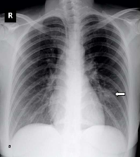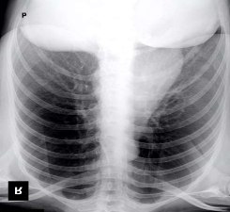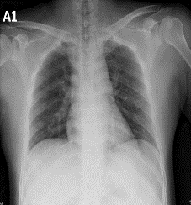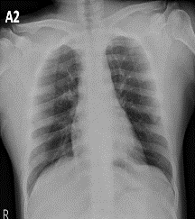
Fig. 2.1(a). X-ray images of covid affected patient.
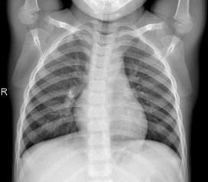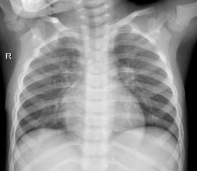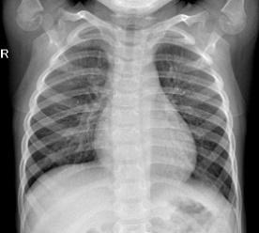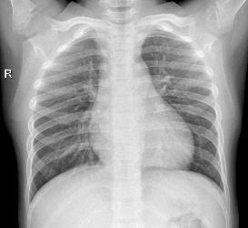
Fig. 2.1(b). X-ray images of a normal people.
The optimizer function accepts learning rate as an argument. We chose ‘RMSprop’ as the optimizer function and ‘categorical_crossentropy’ as the loss function throughout the model because testing various optimizer and loss functions had minor to no impact on the model's effectiveness. Epochs represent the frequency with which the model is applied to training data, and the quantity of specimens being transferred over the network is referred to as the batch size. A high performing model is obtained by tuning the hyperparameters. Following that, training on the entire dataset with parameter values as epochs 30, batch size 32, obtained accuracy results of 99.49% for two classes and 98% for multi-class with five classes. During the training phase, we took note of a few hyperparameter variables that are beneficial to the model's improved performance.
Epochs | Loss | Accuracy
5/30 | 0.4866 | 84.38%
10/30 | 0.3399 | 93.28%
15/30 | 0.2728 | 88.13%
20/30 | 0.0334 | 99.33%
25/30 | 0.0573 | 97.99%
30/30 | 0.0482 | 97.99%
Table.1.2: Hyperparameter values
The outcome generates a 97% accuracy as stated in Table 1.2. Figures 3 to 4 depict the evaluation of chest X-rays. In figure 3, the example chest X-ray result is shown as being covid infected, and in figure 4, the result is a normal chest X-ray.
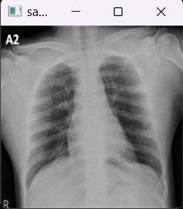
Fig 3- A sample of a chest X-ray result that indicates a COVID-19 infection.

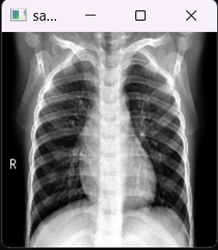
Fig 4- A sample of a chest X-ray result that indicates a normal person.

V.CONCLUSION
In this paper deep learning using CNN method is used to demonstrate how to detect COVID-19 infection cases from patient X-ray images of the chest.This model can be utilized to diagnose COVID-19 quickly and accurately patient’s chest X-rays. This model can be used by local health-care providers where medical professionals were not available. More data is used during machine learning training to improve the model's performance on untrained data. By expanding the Covid X-ray collection and adding a CT scan of other lung conditions, this suggested approach can be enhanced. It can also be expanded to include Internet of Things-related tasks, such as tying them to an X-ray machine to forecast the COVID-19 in real-time.
VI. ACKNOWLEDGMENT
We would like to extend our sincere appreciation to Prof. Poonam Patil who helped us finish our conference paper on COVID 19 prediction using CNN. Your assistance, knowledge, and commitment have been crucial to the accomplishment of this conference paper. We really appreciate the conference organizers for giving us the opportunity to share our findings on their stage. We would like to express our appreciation to our institution for providing us with the necessary resources and support to conduct this research.
VII.REFERENCES
- D. Haritha, N. Swaroop and M. Mounika, "Prediction of COVID-19 Cases Using CNN with X-rays," 2020 5th International Conference on Computing, Communication and Security (ICCCS), Patna, India, 2020, pp. 1-6, doi: 10.1109/ICCCS49678.2020.9276753.
- D. Haritha, C. Praneeth and M. K. Pranathi, "Covid Prediction from X-ray Images," 2020 5th International Conference on Computing, Communication and Security (ICCCS), Patna, India, 2020, pp. 1-5, doi: 10.1109/ICCCS49678.2020.9276795.
- “Chest X-rays can give COVID-19 test results in just 10 minutes: Expert”, The New Indian Express.
- Sammy V. Militante, Nanette V. Dionisio, Brandon G. Sibbaluca, “Pneumonia and COVID-19 Detection using Convolutional Neural Networks”, IEEE Xplore(2020).
- S. Hu, Z. Niu, Y. Gao, Y. Jiang, M. Wang, L. Li, X. Xiao, E. F. Fang, J. Xia, H. Ye, W. Menpes-Smith, ad G. Yang, “Weakly supervised deep learning for COVID-19 infection detection and classification from CT images”, IEEE Access, vol. 8, pp. 118869-118883, 2020. , doi: 10.1109/ACCESS.2020.3005510.
- S. V. Militante, B. D. Gerardo and N. V. Dionisio, "Plant Leaf Detection and Disease Recognition using Deep Learning," 2019 IEEE Eurasia Conference on IOT, Communication and Engineering (ECICE), Yunlin, Taiwan, 2019, pp. 579-582, doi: 10.1109/ECICE47484.2019.8942686.
- https://www.kaggle.com/datasets/pranavraikokte/covid19-image-dataset?resource=download
- https://www.kaggle.com/datasets/unaissait/curated-chest-xray-image-dataset-for-covid19
- Khan Maseeh Shuaib, Solkar Ahmed Shahid, Ansari Almas Javed, Mohammed Zaid., “Pneumonia Detection through X-Ray Using Deep Learning “, IOSR Journal of Computer Engineering (IOSR-JCE) e-ISSN: 2278-0661,pISSN: 2278-8727, Volume 22, Issue 1, PP 08-11.
- S. V. Militante, N. V. Dionisio and B. G. Sibbaluca, "Pneumonia and COVID-19 Detection using Convolutional Neural Networks," 2020 Third International Conference on Vocational Education and Electrical Engineering (ICVEE), Surabaya, Indonesia, 2020, pp. 1-6, doi: 10.1109/ICVEE50212.2020.9243290.
- G. Aparna, S. Gowri, R. Bharathi, V. J. S, J. J and A. P, "COVID-19 Prediction using X-Ray Images," 2021 5th International Conference on Trends in Electronics and Informatics (ICOEI), Tirunelveli, India, 2021, pp. 903-908, doi: 10.1109/ICOEI51242.2021.9452740.

