Delay analysis of Vehicles at Signalized Intersection for Assessing The Need and Utility of Signal Redesigning
Pranit U. Nage¹, Dr. B. V. Khode²
¹PG Student, Department of civil engineering, G. H. Raisoni college of engineering, Nagpur.
²Professor, Department of Civil Engineering, G. H. Raisoni College of Engineering, Nagpur.

Abstract: : The study is to assess the effect of increasing traffic Burdon on present road structures and Traffic management system. For study purpose, Amravati-Nagpur urban Highway passing through Wadi Area of Nagpur, Maharashtra is selected with corridor length of 604.4m. This study will include collection of data from site by means of manual observations, previously available survey/video/photo records. Data collected would be analysed by suitable delay models which suits heterogeneous traffic conditions in spite of choosing traditional models for Delay analysis. The study would use VISSIM simulation software model to compare delays in forms personal delays, overall delays at each individual intersection in the corridor. Along with delays, queue lengths forming would also be studied under this study. If needed, signalized intersection's geometrical restructuring and/or signal cycle redesigning would be suggested.

Introduction: Nagpur is 3rd largest city of Maharashtra with current population of 35 lakhs with probable population of 50 lakhs at the end of 2021. At the end of 2005, total vehicles running on road in Nagpur were 7,23,283 and 12,86,088 at the end of 2016. As the density of vehicles is rapidly increasing in Nagpur, need of restructuring current modes, facilities of transportation occurs. Delay at signalized intersections is one of the major problems causing personal, social economical and environmental loss as well.
New methods, modes should be adopted to overcome these problems before it reaches total restructuring of existing provisions. thus the study includes observations of present scenario, in all possible formats like video recordings, photo images, graphical representations etc. further, collected data would be analyzed with the help of HCM and other models. changes, if any, would be suggested to reduce delays at signalized intersections. VISSIM software would be used for simulation purpose and with the help of VISSIM, proposed signal cycles and/or geometrical structure and of selected signal/corridor would be submitted.
Arpita Saha et.al. proposed an improved delay model for signalized intersections for heterogeneous traffic conditions. They used Simpson's one third rule in spite of opting traditional delay analysis by Highway Capacity Manual. In their study, they measured the queue lengths directly from the field. In their study, they found that their proposed Model yielded best results and is more useful for Indian heterogeneous traffic conditions.
For calibrating the model, they assumed that not traffic rule was violated in their study which is not possible practically. This may be the major drawback of the study.

Bruce Hellinga et.al. used the collected data as a input to a Monte Carlo simulation to determine associated distribution of intersection delay.
Researchers suggested use of empirical data to quantify the distribution of day to day peak hour traffic volumes and the degree of statistical correlation. They studied the requirement of day's count of turning movement counts in order to estimate intersection performance. they found that degree of day to day variability exists in peak hour traffic volume.

S. P. Anusha et.al. Researchers opted to use model based approach in this paper. They calculated Queue & delay at intersections using advanced detectors. They choose Input-output method & queue accumulation polygon methods for accumulation. They also Analyze the characteristics of errors occurred in the model during their model calibration/accumulation.
Researchers used statistical parameters of the estimation scheme for a wide range of operating conditions, such as different weather or traffic conditions , for queue and delay estimation at signalized intersection.

Ch.Ravi Sekhar et.al. selected study area in Ahmadabad city. Further they collected Traffic data which includes vehicle volume counts, speed and delay data, queue length measurements. They considered idling delay also in their study. further they estimated idling delays and fuel consumption at signalized intersections and modelled the data and simulated it into VISSIM simulation. They choose Comparative evaluation between base case and proposed scenario. in which mitigation measures were implemented in VISSIM model.They suggested minor geometric improvements &stabilization of signal timings for corridor in their study.

OBJECTIVES
- To observe Real time scenario of traffic at selected intersection/corridor.
- To find out causes of delays at signalized intersection/corridor.
- To analyze delays with appropriate Delay model.
- To redesign Intersection with signal cycle and/or geometry so as to enhance the utility of corridor and reduce delay.

METHODOLOGY
a) Site Selection:
Urban Highway located at outer cordon of the city and carrying almost half of its vehicular composition as a heavy vehicular traffic is chosen with corridor length 604.4m having three intersections (each of T point ) with one signalized and two non signalized intersections
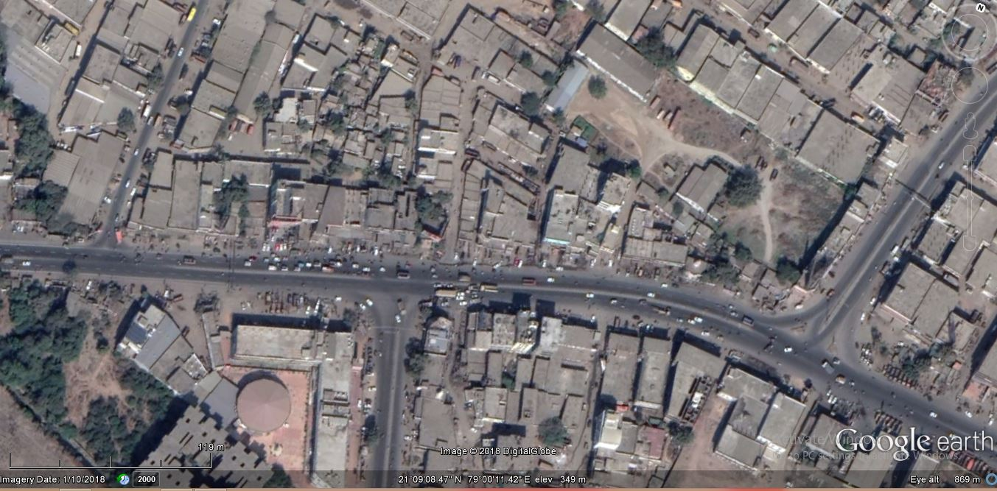
Bypass
Int.
Wadi Int.
T point Int
Fig. Corridor image (courtesy: google earth)

b) Data Collection :
data collection includes volume counts of the vehicles travelling through the corridor. Traffic volume data was collected from selected corridor by manual Data collection method. corridor has two peak hour phases a day. morning peak hour has more traffic in Nagpur - Amravati direction and evening peak hour has more traffic in Amravati-Nagpur direction. National highway in Amravati- Nagpur direction acts as a major/busy route of the corridor. majority of traffic from the links Hingna road, T-Point road and By-pass road merges into Amravati- Nagpur highway. It was observed that the traffic flow is major in one direction and comparatively lesser in other.

Graph: Total volume count at selected corridor

c)Data Analysis:
Collected data is verified and distinguished accordingly. It was then converted to PCU and vehicular compositions of different category of vehicles in obtained vehicular count is calculated. PCUs are classified as two wheelers, cars, three wheelers/LCVs, HGVs and cycles etc. and converted into PCU factor. vehicle compositions and static vehicle routes in the corridor are analyzed from the collected data.
all the necessary measurements of corridor required for the study such as lane width of each lane at intersections and lane width of midway, number of lanes, signal phase and cycles at signalized intersection in the corridor etc are noted for further calculations.

Pie chart: vehicular compositions

d) Use of VISSIM software:
ptv VISSSIM is a German based software used widely for micro simulation. pilot model of actual scenario of corridor and proposed corridor with respective signal cycles, cycle phases, lane distribution are generated in VISSIM and results are drawn from nodal analysis of respective cases.
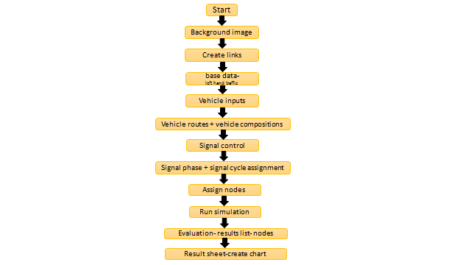
Flow chart: Vissim simulation and analysis steps.

e) Redesigning signal cycles and phases of present signalized Intersection: afteranalyzing the present scenario of corridor in VISSIM. it was observed that conjetion at approches and overall delay, queuelengts generating in the corridor with present signal system can be reduced by changing the signal phase and cycle time at present signalized intersection of the corridor. current signal system has three phases where traffic from one direction moves when the signal is in green cycle of that particular phase.
the signal system at a wadi intersection is redesigned and By-pass, Tpoint intersections are alloted with signal system in the proposed scenario of corridor by means of websters method of signal designing

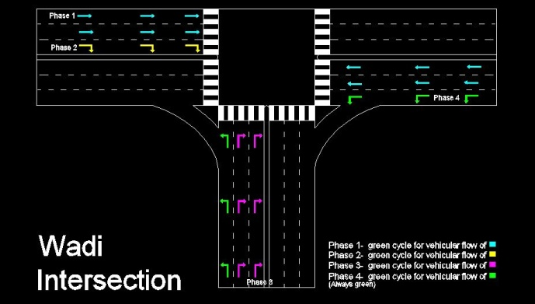
Fig. Redesigned signal phase system at wadi Intersection.

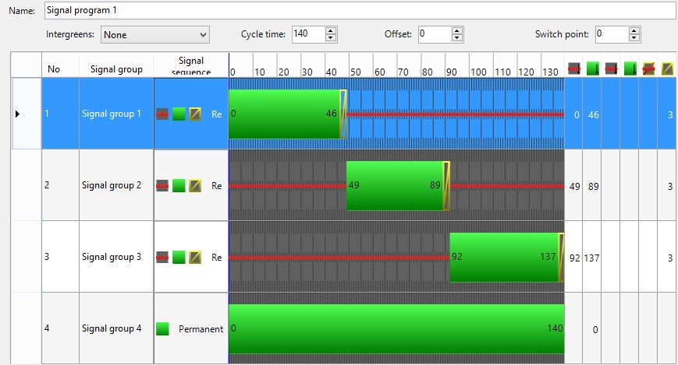

Fig. Assessment of signal phase and signal cycle in VISSIM simulation.

- Intersection redesigning using VISSIM simulation.
- Comparison of present scenario and proposed design of selected corridor.

Results
- Delays and queue lengths formed at the signalized intersection of corridor with present scenario are reduced significantly with the change in signal cycle and phase.
- Assigning the signal system at non signalized intersection reduced the delays at T-point and Bypass intersection of Nagpur.

Conclusion
It is well known fact that Intelligent transportation system helps in reducing fuel consumption and harmful gases emission.
- With the results occurred after Delay analysis through VISSIM simulation, it is cleared that there is a need of several changes in present Traffic management system.
- HGV traffic running on urban Highways is causing more delay to other vehicles.
- Selected corridor needs a restructuring of signal cycles, phases at a present Signalized Intersection and a provision of Signal system at remaining two Intersections.
- Amravati-Nagpur road carries majority of traffic travelling through the corridor, suggested Signal phase would bring down the Delays and queue lengths to a satisfactory results, without major changes in the geometry of Intersections.
- this research paper suggests that change in signal phase of signalized intersection and assigning signal controls at non signalized intersections reduces the occurring delays to a promising level but it is not a permanent solution for ever growing traffic scenario in India. Geometric redesigning with approach width broadening and using ITS parameters along with phase changing would be more effective option or provision of Grade separator at corridor would be the ultimate solution for this problem at a corridor but it will need large amount economical investment.

References

- (2) Arpita Saha, Satish Chandra and Indrajit Ghosh, "Delay at signalized intersections under mixed traffic conditions", DOI: 10.1061/JTEPBS.0000070

- Ch.Ravi Sekhar, Pranoy Raj, Purnima Parida, S.Gangopadhyay,"Estimation of Delay and Fuel Loss during Idling of Vehicles at Signalised Intersection in Ahmadabad",
DOI: 104 ( 2013 ) 1178 – 1187
- Bruce Hellinga, and Zeeshan Abdy,"Signalized Intersection Analysis and Design: Implications of Day-to-Day Variability in Peak-Hour Volumes on Delay"
DOI: 10.1061/_ASCE_0733-947X_2008_134-7_307

- S. P. Anusha, A. Sharma, L. Vanajakshi, S. C. Subramanian and L. R. Rilett, ,"Model-Based Approach for Queue and Delay Estimation at Signalized Intersections with Erroneous Automated Data", DOI: 10.1061/JTEPBS.0000009

