Deep Learning Approach For the Prediction of Cardiac Arrest Using Sleep Apnea

Mrs. Archana. P. ¹, R. Deeksha. ², C.M. Gowda³, Rachana H. C. ⁴, Shreya Girish⁵

¹Assistant Professor, ²Assistant Professor, ³Assistant Professor, ⁴Assistant Professor, ⁵Assistant Professor
Dept. of Computer Science & Engineering, Adichunchanagiri Institute of Technology Chikkamagaluru, Karnataka

archana.havish@gmail.com

Received on: 20 May ,2022 Revised on: 26 July ,2022, Published on: 01 August ,2022

Abstract – Sleep is essential for sustaining good health and high quality of life. Obstructive Sleep Apnea (OSA) is a sleep disorder that has been linked to a higher risk of heart disease and arrhythmia. The most prevalent and deadly event is Sudden Cardiac Arrest. The link between OSA and Sudden Cardiac Death has been further explored in a small but growing body of studies. Despite being one of the most underdiagnosed disorders, OSA is one of the most frequent kinds of sleep apnea, affecting about 9-38 percent adult population worldwide. Bodyweight, age, and being a man are all factors that influence OSA. The impact of OSA on CVD has received a lot of attention. Outside of hospitals, SCD will account for the bulk of deaths due to cardiac illness, which is the leading cause of death worldwide. Sudden Cardiac Death can be defined as unplanned natural death from cardiac pathology that occurs within one hour of the onset of symptoms in a person who has no prior condition that would appear lethal. Because it is not known if OSA raises the risk of SCD on its own, a physiological dataset, as well as the Apnea-Hypopnea Index (AHI), was used in this study to determine the likelihood of Cardiac Arrest in the form of a percentage.
Keywords- Obstructive Sleep Apnea, Sudden Cardiac Death, Physiological data, Apnea-Hypopnea Index.
- INTRODUCTION
Sudden Cardiac Death (SCD) is invariably preceded by Sudden Cardiac Arrest (SCA), which is caused by the heart's inability to adequately pump blood to various organs, resulting in oxygen deprivation and loss of consciousness within one minute. SCA patients are resuscitated with an implantable cardioverter-defibrillator (ICD), which delivers an electrical shock to the heart to reset its electrical activity. Furthermore, cardiopulmonary resuscitation (CPR) can help SCA patients survive until medical help arrives. When SCA happens outside of the hospital, patients have only a 1-2 percent chance of survival compared to those in the hospital.
The goal of research on this serious health issue has been to establish an effective means of forecasting the risk of SCA utilizing aggressive and noninvasive methods.
The deep learning approach is proposed in this suggested work for the prediction of cardiac arrest from obstructive sleep apnea using prior knowledge such as the apnea-hypopnea index and some features. There are currently no widely approved methodologies; hence a deep learning strategy for cardiac arrest prediction is in high demand. The use of CNN in the prediction of cardiac arrest using various variables, including OSA as a major attribute, has not yet been widely used. These included missing value detection and classification algorithms, which were particularly useful for the given collection of heart-related characteristics problems, which involved a large amount of data and required a lot of time and energy if done manually. As a result, a thorough understanding of recognition and classification procedures is critical for the development of Neural Network systems, particularly in the field of medicine.
The World Health Organization (WHO) has announced that cardiovascular illnesses are the leading cause of death worldwide. An irregular diet and lack of physical activity are the most common but effective causes. A large number of people die each year as a result of these diseases, with estimates ranging from 40 to 50 percent of heart disease Patients dying from Sudden Cardiac Deaths, characterized by a sudden irregular heart rhythm, and only about 1% of people worldwide surviving it; however, it is closer to 5% in the United States and other developed countries due to increased excessive alcohol intake, poor diet, and lack of physical activity. This study forecasts the likelihood of a person experiencing cardiac arrest shortly.
A. Related Work
A few research have used computerized detection techniques to hit upon the chance of cardiac arrest utilizing sleep apnea. In one look, CSA detected for the duration of hospitalization was determined to be a critical unbiased predictor of 6-month cardiac readmission, with a chance forty-three-50 percent better than the no SDB manipulate organization. OSA turned into also proved to be an unbiased predictor of 6-month cardiac readmissions whilst AHI become >30 events/hour. Adjusting for all regarded predictors of cardiac readmissions resulted in just a small (less than10%) reduction in effect sizes. Another study found that the presence of OSA predicted incident SCD in a population of 10,000 plus adults mentioned for sleep studies, and the amplitude of risk was predicted by different parameters that influence OSA severity, including the AHI and oxygen desaturation. Remarkably, even when other well-known risk factors were controlled for, the severity of nocturnal hypoxemia, a key pathophysiological hallmark of OSA, strongly predicted SCD. The best discriminating threshold predicts an 81 percent increase in the risk of SCD for the lowest oxygen saturation, according to our findings.
According to a previous study, no sustained supraventricular occurred during sleep in 5.3 percent of patients with insomnia breathing, including OSA and central sleep apnea, and complex myocardial accident/incident occurred in 25percent of patients with insomnia breathing, including OSA and centralized sleep apnea. Patients with insomnia breathing had a 3.4-fold incidence of non-sustained ventricular tachycardia and a 1.7-fold risk of complex ventricular action when comorbidities were taken into account.
People with OSA had a raise in risk of SCD from 10 p.m. to 6 a.m., whereas those without OSA had a diurnal pattern of sudden death that was consistent with the general population, spiking between 6 a.m. and noon. From that study, people with OSA had a 2.6-fold increased risk of SCD, and the severity of OSA was related to the extent of this risk. The current findings suggest that the increase in SCD at the night may be due to "additional" mortality rather than a change in SCD from some of the other times of the day.

II – METHOD

The thesis procedure will be discussed in detail. A convolutional neural network and a collection of pre-processing subsystems are utilized in the algorithm to detect the possibilities of cardiac arrest in terms of percentage. The suggested system's system architecture diagram is shown in Figure 1. The primary goal of the pre-processing subcomponents is to reduce the amount of data that the convolutional neural network, which is the classification subsystem, must use as input. The background of the systems before the CNN will be reviewed, as well as the basic theory behind the use of CNNs. The candidates are classified using the final layer, a Sigmoid classifier. The system receives patient medical reports as input. The initial phase of the system is to eliminate attributes with less than 70% data. The data must then be imputed in the position of the missing value. The mean or median technique will be used to impute the dataset. The selection of features
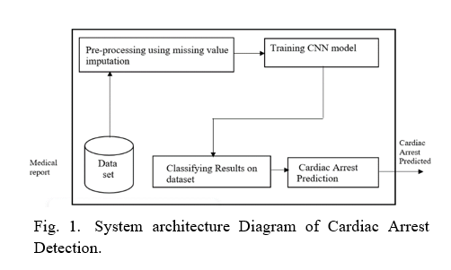
The feature selection will be done using the PCA technique. PCA is a high dimensional method that reduces by translating a large number of variables into a smaller set that still contains the majority of the information in the original set, one can reduce the dimensionality of huge data sets. For feature extraction, CNN is utilized.
A. Input data
A set of patient medical reports serves as the system's input data. To train the system 10,269 medical reports have been used and to test 304 medical reports have been used. Bodyweight, Apnea-Hypopnea Index, blood pressure, and other factors are all included in the report.
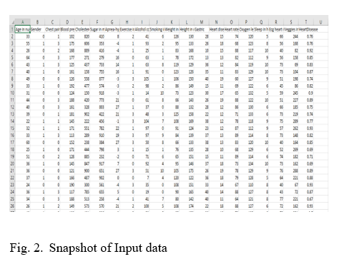
A. Data Cleaning
Data filtering is the process of removing faulty data, structuring raw data, and filling in blanks to prepare raw data for analysis. At last, data cleaning gears up the data for data mining, the process of extracting the most important information from a dataset. Before the analysis, data cleaning in data mining allows the user to detect erroneous or incomplete data. Missing values are replaced using a mean or median strategy in this case. In addition, if a row has additional null values, the entire row is excluded. However, data cleansing takes time, but it is a necessary step to ensure accuracy or risk reaching an erroneous result.
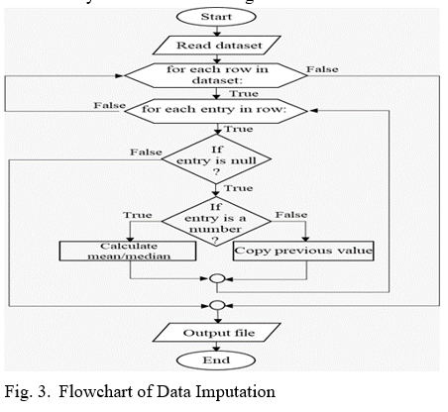
A. Data Transformation
The data has been altered in such a way that it is ideal for data mining. Data conversion is the process of changing data from one form or structure to another. Data transformation is required for the majority of data integration and data management operations, such as data wrangling and data warehousing. The following are the steps involved in data transformation:(1)Aggregation(2)Discretization(3)Attribute Construction (4)Attribute Construction (5)Generalization (6)Normalization.
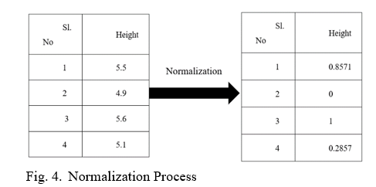
A. Feature Extraction
Feature extraction is critical for extracting information from a given situation. The feature selection will be done using the PCA a high dimensional method that reduces the size of large data sets by changing a large set of variables into a smaller set that still contains the majority of the information in the large set. CNN is being used for feature extraction. For feature extraction, we're utilizing CNN.
Out of 20 features 14 features have been selected which include- age, gender, weight, blood pressure, apnea-hypopnea index, cholesterol, sugar, ECG heart rhythm, gastric, oxygen level, heart rate, chest pain, sleep in an hour, and heart disease.
B. Training
The training dataset will be used to train the model. Typically, a neural network is trained throughout two stages. During this phase, the input is completely routed through the network. Nonlinearities are backpropagated (backdrop) at this point, and weights are adjusted.
C. Classification
A Convolutional Neural Network (CNN) is a Deep Learning approach for assigning significance to the topic (learnable weights and biases) to distinct objects in an image, as well as differences between them. When compared to other classification algorithms, a CNN requires substantially less pre-processing. Traditional approaches need hand-engineering of filters; but, given enough training, CNN can learn these filters.

III- EXPERIMENTAL RESULTS
To acquire the optimal configuration, the first step will be to choose the best combination of parameters in the CNN. To acquire the optimal configuration, the first step will be to choose the best combination of parameters in the CNN. After that, the classification results will be analyzed and compared to various types of ANNs that use previously derived data from the medical report.
- Design of the CNN
A neural network is a group of connected input and output units with a weight assigned to the connection. During the learning phase, the network modifies the weights to anticipate the correct class label of the input tuples. During the learning phase, the network modifies the weights so that it can predict the correct label of the input tuples. Filters are applied to the hidden layer, which is a 3* 1 matrix, and the resulting 1d Array is then passed on to be normalized once more. To keep the range between 0 and1, the Z-Score transform is utilized. Later, the ReLu Activation function is used, which aids in initializing negative integers with 0 and returning the same to inputs with positive values.
The weights are assigned to the convolved result in the fully connected layer, which aids in achieving improved accuracy by lowering the error rate. The weights are adjusted to achieve this. Using the sigmoid activation function, the output from the fully connected layer is sent into the output layer. Later on, the sigmoid formula is used to predict a person's cardiac arrest.
The diagram shown depicts the CNN architecture and how it functions. The filter is applied in the hidden layer, and the features are retrieved thanks to PCA, resulting in a convolved result, which is known as the convolved result layer.
The same thing applies in the subsequent layers, which use the input from the prior layers.
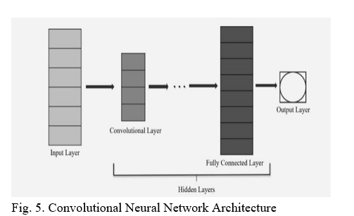
I. Performance
The best CNN configurations will be given training with a larger dataset in this phase to evaluate their efficiency and pick the best. The various setups' accuracy, sensitivity, and training time will be evaluated, but the finest setup will be chosen based on the F1 score. The F1 score is a measurable statistic that takes both acuity and precision into account. It is employed since acuity is an important factor in this job, but a high number of false-positive rates is problematic because it is impossible to tell which ones are true positives, and they must be inspected manually or by another method. To carry out the validation and comparison with other systems, the optimum configuration will be chosen.
This thesis uses a total of 10,573 patient medical records. Eighty percent of them were utilized for training, while the remaining twenty percent were used for testing.
II. Validation
The method's validation described in the thesis is the final step in the process. The validation is done by putting the CNN through its paces using the configuration chosen (input medical report), which was previously trained using the training set. The procedure entails gathering medical records from various patients and calculating the likelihood of cardiac arrest in percentage form. The preprocessing methods described earlier were used to detect the possibility of cardiac arrest. The accuracy was 98.1 percent. The below figure shows how different CNN layer works, the input layer provides all those features required and then undergoes matrix multiplication using a filter so that the resulted output is within the range of 0 to 1. Later on, the output of the first hidden layer undergoes ReLU activation to remove negative terms and consider it as 0. After passing through the hidden layer the output of the layer is then fed into a fully connected layer where the sigmoid activation function has been used to obtain the required output. The likelihood of the patient being attacked by cardiac arrest is displayed.
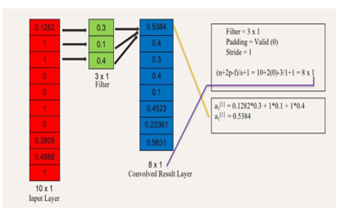
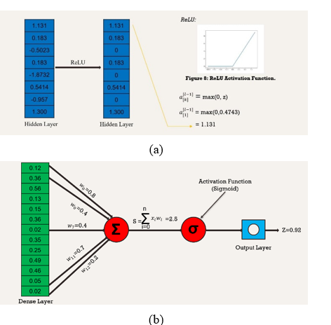
Fig. 6.-Convolutional Layers Activities, (b) Fully Connected layer with Output Layer
IV- DISCUSSION AND CONCLUSION
The proposed work’s outcomes were positive, with good accuracy and sensitivity in the prediction of cardiac arrest in terms of percentage. Because the information contained in a medical report is too long, the preprocessing methods utilized to limit the quantity of data supplied have proven to be there for the classification effective. The construction of these subsystems achieved the goal of utilizing just the most important data. The data augmentation procedure has proven to be beneficial and effective. The CNN had the best performance of all the classification methods used in this study, despite two major drawbacks: the quantity of time it takes to train it and the amount of memory it requires.
The system's considerably high false positives, which means that precision is extremely low, are the most serious flaw in the project's outcomes.
In conclusion, the method created is beneficial for analyzing data from medical reports to determine the chance of cardiac arrest. After the CNN has been trained, it takes about seven minutes to examine a medical report, including preprocessing processes, which saves time for the expert cardiologist.
A. Future Work
Future research in cardiac arrest prediction should focus on identifying additional CNN compositions that outshine the one employed in this study. Modifying its architecture, which comprises numerous convolutional and pooling layers, as well as the activation and error functions employed, even though they were determined by its properties, are examples of this. Because the search procedure was thorough and thorough, future work should not be limited to adjusting hyperparameters using the same structure.
The proposed model should be made available to the common users who can install and check whether the person’s health condition is at risk to consult doctors.
ACKNOWLEDGMENT
Dr. Pushpa Ravikumar, Head of the Department, and Mrs. Archana. P, Assistant Professor, Dept. of Computer Science & Engineering, Adichunchanagiri Institute of Technology, Chikkamagaluru, was instrumental in making this publication and the research underlying it possible. Her enthusiasm, competence, and we were influenced by her meticulous attention to detail, and it assisted us to remain on track with our work. We'd want to express our gratitude to our loving parents for their unwavering good wishes, motivation, and assistance.
REFERENCES
[1] Utsav Chauhan, Vipul Kumar, Vikas Kumar, Vipul Chauhan, Sumith Tiwari, Amith Kumar “Cardiac-Arrest Prediction Using Machine Learning Algorithm”, 2019 2nd International Conference on ICICICIT.
[2] J.M. Kwon, Y. Lee, S. Lee, J. Park, “An Algorithm Based on Deep Learning for Predicting In-Hospital Cardiac-Arrest.
[3] Hsiao-Ko Chang, Cheng-Tse Wu, Ji-Han Lui, Wee Shin Lim, “Early Detection In-Hospital Cardiac-Arrest Based on Machine Learning on Imbalanced Data.
[4] Reeta Devi, Hitendar Kumar Tyagi, Dinesh Kumar “Early-stage prediction of Sudden Cardiac Death”, IEEE-2017.
[5] Sean Pereira, Deepak Karia, “Prediction of Sudden Cardiac Death using Classification and Regression Tree Model with Coalesced based ECG and Clinical Data”, IEEE-2018.
[6] Dakun Lai, Yifei Zhang, Xinshu Zhang, Ye Su, Md Belal Bin Heyat, “An Automated Strategy for early Risk Identification of Sudden Cardiac Death by using Machine Learning Approach on Measurable Arrhythmic Risk Markers”, IEEE-2019.
[7] Ji-Han Lui, Hsiao-Ko Chang, Cheng-Tse Wu, Wee Shin Lim, Hui-Chih Wang, Jyh-Shing Roger Jang, “Machine Learning-based Early Detection System of Cardiac Arrest”, IEEE-2019.

