Electro-Mechanical Smart Switch system using IoT
Jayesh Sonar¹, Aarzoo Sayyed A. Mehdi², Roshani Patil³, Gaurav Sonar⁴
¹UG student, GF’s Godavari College of Engineering, Jalgaon India, 45001, sonarjayesh9881@gmail.com
²UG student, GF’s Godavari College of Engineering, Jalgaon India, 45001, sayyedaarzoo110@gmail.com
³UG student, GF’s Godavari College of Engineering, Jalgaon India, 45001, riyadode143@gmail.com
⁴UG student, GF’s Godavari College of Engineering, Jalgaon India, 45001, sonarg900@gmail.com

Received on: xxxx,20xx, Revised on: xxxx,20xx, Published on: xxxx,20xx

Abstract – The development of electric vehicles (EVs) has been a major focus of the automotive industry for many years. As technology continues to progress, more and more use cases are popping up that require intelligent control over how an EV interacts with its environment. [1] This research paper investigates how Arduino shows potential as a technology platform to enable smart Switching of electric vehicles. It investigates the current solutions and their limitation and discusses how integration of microcontroller’s intelligence with sensing, communication and actuation capabilities can enable more efficient and secure car ignition. The combination of Electrical and mechanical technologies allows for increased levels of convenience and security. Furthermore, this research will propose an optimal approach for using an IoT powered system on cars to enhance the security of their locks and provide enhanced protection from unauthorized access. Finally, future research directions are suggested which could lead to a more integrated approach when implementing such systems.
KEYWORDS: Mechanical, Electronics, IoT, Sensors, Actuators, Aurdino.
INTRODUCTION
In recent years, there has been an increasing demand for more intelligent personal transport solutions due to increasing environmental concerns as well as population growth in urban areas. One way to further enhance the efficiency of these vehicles is through the use of a smart switch connected to the electric vehicle battery. This paper will discuss how a smart switch connected to an electric vehicle's battery using Arduino can improve the safety and performance of electric vehicles. Electro-Mechanical smart switch can provide a secure and convenient way for owners to control the access to their vehicles remotely with the help of IoT. The process detailed in this paper outlines the development, prototyping and testing stages necessary for successful implementation of the system. [2]
II. LITERATURE REVIEW
Hampton. C. Gabler and William. T. Hollowell [2014] studied the compatibility of passenger cars, light trucks, and vans (LTVs) involved in traffic accidents. This resulted in the necessary parameters and requirements that can be compatibly installed in a vehicle to reduce such accidents.
Othman M.K. Alsmadi, Anas A. Al Jallad researched on Arduino-Based Automatic Safety Vehicle Control "California Vehicle Code section 22517" - California Legislative Information, retrieved on February 13, 2018 states that no person shall open the door while driving unless it is for reasonable or for safety precautions during traffic.
Mehmet Akif found that Arduino-based robotic projects spread quickly and effectively - that was the first result of this study. Due to the contribution of Arduino technology to the design and development process of educational robotics systems, this study found that recent studies have mainly focused on efforts to integrate and implement Arduino board’s educational activities and curriculum. This study also determined the research methods and technological tools used in previous research and reported the difficulties and problems associated with the use of Arduino boards.
Bruce Rauner, governor of Chicago, signed into law House Bill 5143, which adds the Dutch Reach strategy to the Illinois" Highway Code manual and adds bicycle safety questions to the state driver’s license exam [Aug 2018]
Hence, from previous works, there has been no attempt to employ the electrical and mechanical technologies together to enhance the security of vehicles using Arduino Uno. This is a fresh concept, hence, making the setup unique.

III. METHODOLOGY
1. Design and Develop Circuit: The first step is to design the electrical circuit for our smart switch using Internet of Things. Consideration should be given to factors such as power rating, input voltage, output voltage and current requirements.
2. Determine the Mechanical Components: The next step is to determine the mechanical components required for the switch. These might include a housing, mounting holes, levers, actuators, buttons, etc.
3. Link IoT Platform with Electrical Circuit: After completion of designing and manufacturing of all the parts and components, it’s time to link up the IoT platform with our circuit in order to make it a ‘smart’ device with remote controls via the internet or mobile app.
4. Program Switch Functionality: Now that we have established an electrical connection between our circuit and the IoT platform, we can start programming for stand-alone switch functionality on-board (manual mode) and enable remote control/monitoring operations from a cloud-hosted application via internet or mobile app (autonomous mode).
5. Test Performance: Once programming is complete, we will perform rigorous testing of our electro-mechanical smart switch by simulating actual operating conditions in order to ensure safe operations at all times - during manual use as well as while operated remotely over internet/mobile app interface.
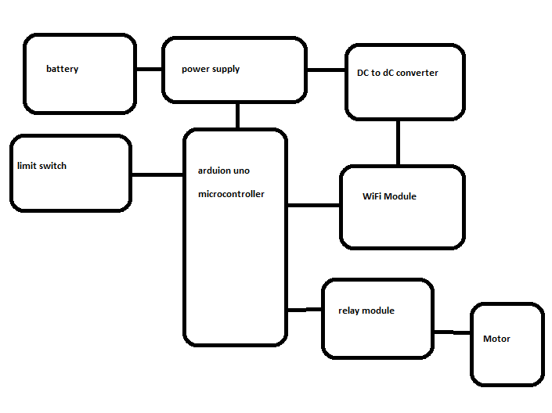
Fig. 1 Block-Diagram of Proposed system

IV. COMPONENTS USED
Arduino UNO
The Arduino UNO is a microcontroller board based on the ATmega328 (datasheet). It contains 14 digital input/output pins (6 of which can be used as PWM outputs), 6 analog inputs, USB port, power connector, 16 MHz ceramic resonator, an ICSP header, and a reset button. It includes everything needed to support the microcontroller; just connect it to a computer with a USB cable or power it with an AC -to- DC adapter or battery to get started. [3]
The Arduino UNO is the "standard" Arduino board currently on the market, and is probably the best choice for beginners just getting started with the platform. Arduino simplifies working with microcontrollers and offers students, teachers, and interested amateurs several advantages over other systems. The Arduino/Genuino UNO has a number of ways to communicate with a computer, another Arduino/Genuino board, or even other microcontrollers. [4]
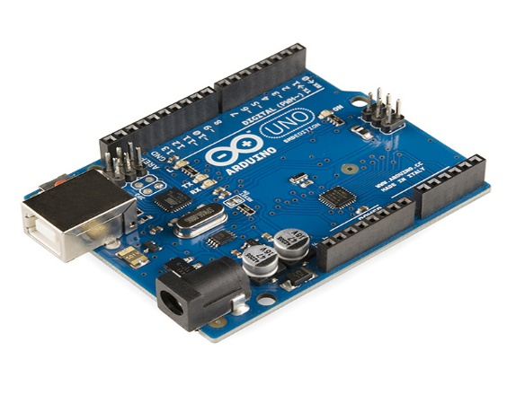
Fig. 2 Arduino UNO
Limit Switch
A limit switch is an electromechanical unit consisting of an actuating element mechanically connected to a set of contacts. When the object moves toward and contacts the actuator, the limit switch operates the contacts to make or break an electrical connection. Automatic operation of a machine requires the use of limit switches that can be activated by the movement of the machine. A limit switch is used to convert this mechanical movement of the machine into an electrical signal for switching circuits. [15]
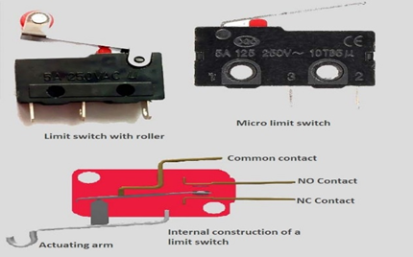
Fig. 3 Limit Switch
WI-FI Module
The ESP8266 Wi-Fi module is a low-cost, standalone wireless transceiver that can be used for endpoint IoT developments. The ESP8266 Wi-Fi module provides Internet connectivity to embedded applications. It uses TCP/UDP communication protocol to connect to the server/client [6]
To communicate with the ESP8266 Wi-Fi module, the microcontroller must use a series of AT commands. The microcontroller communicates with the ESP8266-01 Wi-Fi module using a UART with a specific baud rate (default115200). [6]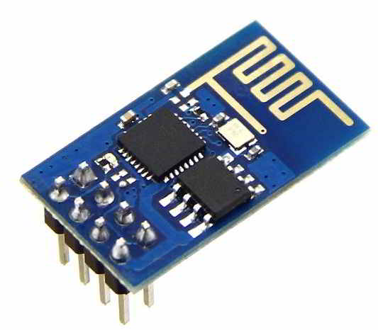
Fig. 4 WIFI-Module
Relay Module
Arduino Relay Shield uses high quality relay worth eight channels input and eight channels output. It can be connected to 250V/I0A AC element or 24V/i 0A DC element maximum, therefore it can be used to control fights, motors and etc. [7]
The modular structure allows easy connection to the Arduino expansion board. The output state of the relay is indicated by a light emitting diode to ensure the actual application. [8]
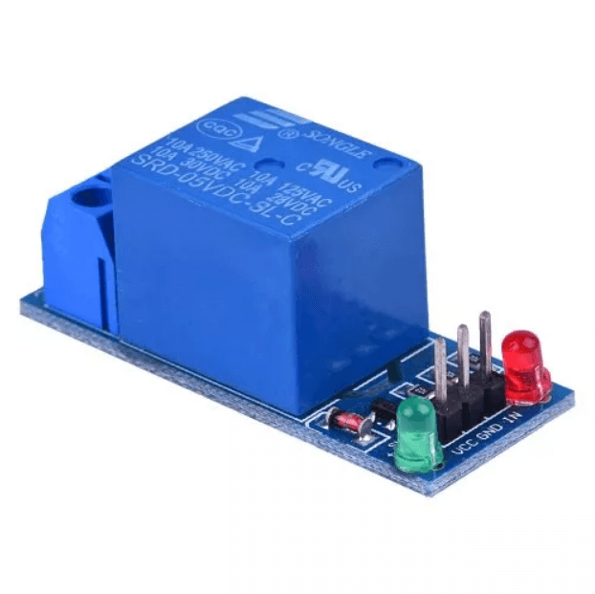
Fig.5 Relay Module
Voltage converter
A dc to dc converter is a circuit used to converts a constant input voltage into a regulated output voltage that can be used for powering wireless modules. DC to DC converters are commonly found in embedded systems, especially those involving wireless communication, such as Wi-Fi module used in this case. They are important component in ensuring that the module operates at the required voltage level without over- or under-volting it. Many wireless communication devices use 3.3V or 5V which are popular voltage used by many integrated circuits and microcontrollers. DC to DC converters helps regulate this voltage so that the device can draw power consistently and reliably. [9]
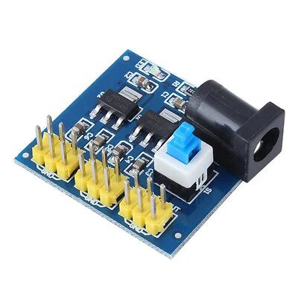
Fig. 6ss Voltage Converter
Arduino IDE
​Arduino Integrated Development Environment (IDE) is a cross-platform application (for Windows, Mac OS, Linux) written in Java programming language. It is used to write programs and load them onto the Arduino board. The source code of IDE is released under the GNU General Public License, version 2. [10]
The Arduino IDE supports C and C++ languages using special code structuring rules. The Arduino IDE provides a software library from the Wiring project that provides many common input and output procedures. The user-written code requires only two basic functions, to start the sketch and the main program loop, which are compiled and linked with a program stub main ( ) to an executable cyclic execution program with the GNU tool chain, which is also included in the IDE distribution. The Arduino IDE uses the argued program to convert the executable code to a text file in hexadecimal encoding, which is loaded into the Arduino board by a loader program in the board's firmware. [10]
V. RESULT & DISCUSSION
This research paper was aimed at exploring the feasibility of developing a smart switch for electric vehicle (EVs) using arduino. The test result showed that, while a basic prototype design can be made with relative ease, achieving reliable and performant operation difficult due to limited resources of current hardware components. In addition, additional complexities arise from different communication protocols and interfaces used by different energy storage systems. Moreover the total cost estimated for developing such an ignition switch was found to exceed most budgetary requirements, indication that either development need to be done in-house.
Nevertheless, it appears that given sufficient time and resources, it is possible to develop a functional and low-cost smart switch for electric vehicle using Arduino as its base platform. Such a solution could prove especially beneficial for civilian applications enhancing the security and safety feature with user friendly interface and easy to use module.

VI. CONCLUSION
This research paper has provided detailed information and analysis regarding the development of a smart switch for use in electric vehicles (EVs). It highlighted the need for this type of device as it can help to optimize the use of energy and make EVs more efficient. The paper describes the design and implementation of a prototype Arduino-based smart switch, as well as its structure, control measures, functions and application in modern vehicle systems.
Overall, it was concluded that an, connecting a smart switch controlled by Arduino board into electric vehicle batteries offers many advantages in terms of improved safety measured enhanced performance efficiency by providing detailed data about vehicle condition and control extra components necessary for smooth functioning of vehicle. A full implementation of this system in a vehicle is feasible, simple and cost-effective.

ACKNOWLEDGMENT
We would like to express our sincere gratitude and appreciation to our supervisor research paper guide, Prof. K. M. Mahajan, for her unfailing support, guidance, and encouragement during the writing of this research paper. Without their expertise and timely feedback, we could not have achieved the success we have now. We are grateful for their patience and valuable advice during this project.

REFERENCES
- Hamid, Umar Zakir Abdul (2022). "Autonomous, Connected, Electric and Shared Vehicles: Disrupting the Automotive and Mobility Sectors". Retrieved 11 November 2022
- Macmillan, Thomas (August 5, 2013). "Danger: Drivers Dooring Cyclists". New Haven, CT: New Haven Independent. Retrieved June 28, 2018. 6. S. Peter Olsen "7th International Cycling Safety Conference 2018". ICSC 2018. International Cycling Safety Community. October 10, 2018. Retrieved July 10, 2018.
- "Introduction to Arduino" (PDF). princeton.edu. Archived from the original (PDF) on 3 April 2018. Retrieved 4 February 2018.
- Brain.W. Evans, Digital I/O, Arduino Programming Notebook
- Brian Benchoff (September 6, 2014). "The Current State of ESP8266 Development". Hackaday. Retrieved 2015-06-24.
- "ESP8266 Non-OS SDK API Reference, Chapter 2.5. System Memory" (PDF). espressif.com. Espressif Systems.
- "The electromechanical relay of Joseph Henry". Georgi Dalakov. Archived from the original on 2012-06-18. Retrieved 2012-06-21
- "Understanding Relays & Wiring Diagrams". Swe-Check. Swe-Check. Retrieved 16 December 2020.
- "How to convert from AC to DC?". GeeksforGeeks. 12 March 2022. Retrieved 16 February 2023.
- "Using AVR Studio for Arduino development". Engblaze.com. Archived from the original on 2012-08-28. Retrieved 2013-01-18.
- Alan. G. Smith, Sensors Galore, Introduction to Arduino, 2011 Edition
- Amit Verma, “A Multi-layer security system” 2013 International Conference on Green Computing, Communication and Conservation of Energy (ICGCE), December 2013
- Divya R.S, “Super secure door lock system for critical zone”. International conference on network &advance in computational technology, 2017.
- K. Suganithi, “Survey of integrating Face and Iris biometrics for security motive using change detection mechanism”, International conference on science technology, June 2018.
- Stephen Herman, Industrial Motor Control Cengage Learning, 2009 chapter 11 "Limit Switches" ISBN 1435442393

