DESIGN AND DYNAMIC ANALYSIS OF STEEL CHIMNEY IN STAAD PRO
Sushmita Tandan¹ Prahallad Choudhari²
Research Scholar, Assistant Professor
MATS School of Information and Technology, Raipur, India, 492001
ssonwani3028@gmail.com
Abstract – Chimneys must transport exhaust gases, gaseous products of combustion,ney is neces sary so that it creates an independent structure capable of withstanding wind loads, seis mic loads, dead loads and other forces acting on it. Industrial chimneys are tall, slender structures with a circular section. Different types of steel chimney models are made by v arying their height, diameter and geometry. Steel chimneys are generally cylindrical. Loads acting on steel chimneys are easily transferred to the foundation by widened or fl ared sections, chimneys built today are often susceptible to wind due to their size, shap e, flexibility, slenderness and of their lightness. Therefore, special attention should be p aid to the safety and economy of the structure when designing the steel chimney.
Keywords-R.C. Steel Chimney, WIND Analysis, STAAD-Pro
- INTRODUCTION
Their flexibility, finesse, shape, size and lightness. Do Not Build These Chimneys Unless Considered 1 the large number of steel chimneys built today is susceptible to wind due to the e-structure. Chimneys are tall, thin structures with a uniform or tapering circular diameter used to release hot combustion gases or fumes from any furnace, boiler, or industrial hearth into upper atmosphere. Chimneys are designed as tall vertical structures that gently release unwanted noxious gases by drawing in air for combustion, known as the “chimney effect”. Steel chimneys are classified according to their support and shape. Based on the support, they are divided into cable-stayed or built-in chimneys and free-Standing chimneys. Freestanding chimneys are widely used in industrial fields. The shape of a freestanding steel flue plays an important role in its organizational performance in sidewise dynamics. However, the basic geometric parameters of steel chimneys.
Height, outlet diameter, are related to the corresponding environ mental conditions.
Steel chimneys to ensure desired failure modes.
1.1) The minimum outside diameter of an unlined top chimneys must be one- twentieth of the height above the chimney.
1.2) The minimum outer diameter of unlined bottom extension chimneys is greater than
1.6 times the outer diameter of the chimney.
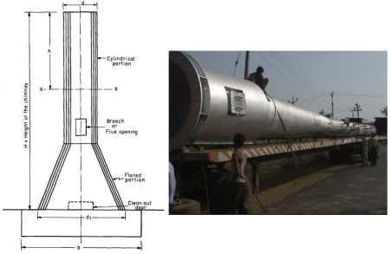
Type Steel fireplace Structure
The type of steel fireplace structure is divided into two main types, namely:
1. Freestanding steel chimney
2. Stamped steel chimney.

1 Freestanding
Steel Chimney When the lateral force (wind force or seismic force) is transmitted to the foundation is the cantilever action of the chimney; this chimney is called a freestanding chimney. The freestanding chimney
Remains stable with the foundation in all operating conditions without any additional sup
Port. The freestanding chimney
Has a diameter of up to 10 meters ht of 50-100 meters.
2.2 Stamped Steel
Chimneys In tall steel chimneys, low carbon steel cords or heads are attached to Trans it lateral forces. This type of steel chimney is called an inclined chimney.
3 structural steel chimney design
3.1 Steel Chimneys options
3.2 chimney steel plates
3.3 bushings
3.4 steel chimney base

4. The force acting on the steel chimney
4.11 Dead weight of the steel chimney
The deadweight of the steel chimney Ws vertical expression behavior by
Where: d: diameter of the chimney, m t: thickness of the steel sheet, m h: height of the t op of the steel chimney in meters XX section 79 kN/m2 is the shearing stress in the cost
-iron per unit weight of steel
4.2 Wind pressure
The horizontal effect of wind pressure is related to the shape, width, height, location and climatic conditions of buildings. Increase in wind pressure per unit area with the height of the building At ground level, to simplify the design, the steel chimney is divided into se viral sections of aligned. Each section can exist leveled up to 10 m.
It can be assumed that strength of the air pressure is uniform over an entire
Surface segment. Wind pressure.

4.3 Seismic pressure
Tectonic pressure acting level alight the construction. To calculate the stress at any point in a steel chimney, consider the following load combinations:
1. Constant load + wind load + temperature
2. Dead load + seismic load (earthquake) + temperature influence
Consider only a best combination of seismic force (earthquake) and wind influence.

- Mathematical Analysis
5.1 A self-supporting steel stack of height of 40m above the ground the diameter of cylindrical part of chimney is 2m the foundation has to rest on medium type of soil having capacity 150kn/m 2 the topography at the is flat ant location is terrain category 2
Design chimney along with foundation Type equation here.
1 Basic dimension of chimney
2 computation / calculation of wind load
3 stress calculation on chimney
5 holding down bolts of Height of chimney = 40m
Topography is almost flat
Diameter of chimney =2 m

Step 1: Basic dimension of chimney
Height of flare = $\frac{1}{4}×40=10m$
Diameter of flax = 1.6 × 2 =3.2m

Step 2: computation / calculation of wind load
The design wind speed at any height “ z “ is given by ,
( V_{z})= V _{b} k₁ k₂
Wind velocity, (v _{z}) = v _{b} k₁ k₂ k₃
Wind pressure, (p z) =0.6 v 2
Wind force, (f z) =0.7. p z. (area)
Segment 1
H = 40m, d =2m
Class of structure = 6
Risk factory, (k₁) =1
(k2) =1.10 + $\frac{0.05}{20}×$10 = 1.125
Topography factory, (k₃) =1
Wind velocity, (v₂) =k₁ k₂ k₃ v_{b} = 1× 1.125 × 1 × 47 =52.875 m/sec
Wind pressure, (p₂) = 0.6 × (52.875)² = 1.677kn/m²
Wind force, (f₂) = 0.7 × 20 × 1.677 =23.478kn
Segment 2
H =30m, d = 2m
Class of structure = B
K₁ = k₃ = 1
K₂ = 1.10
Wind pressure, (p₂) =0.6 × (1.10 × 47)² =1.603kn/m²
Wind force, (f₂) = 0.7 × 20 × 1.603 =22.442kn
H = 20m, d =2m
Class of structure = B
K₁ = k₃ = 1
K₂ = 1.05
Wind force, (F_{Z}) = 0.7 × 1.4161 × 20 = 20.454kn
H = 10m, d = $\frac{2+3.2}{2}$ = 2.6
Wind pressure, (p₂) = 0.6 × (1.00 × 47)² = 1.3254kn/m²
Wind force, (f₂) =0.7 × 1.3254 × 20 = 24.115kn

Step 3: stress calculation on chimney
Stress due to wind moment,$\left(σ_{m}\right)=\frac{4m}{πd2t}$
Stress due to chimney weight, $\left(σ_{m}\right)$ = 0.079h
Stress due to lining (brick lining), $\left(σ_{L}\right)$ = 0.002 $\frac{h}{t}$
Now, the minimum thickness of steel from stability point of view
$$\frac{d}{500}=\frac{2000}{500}=4mn (p4)$$
Let the design of steel 20 year and coal is used to fuel for builder add 4mm to account for corrosion taking 85% efficiency of riveted joint in (p5)
Tension $σ_{t max}$ = 0.85 × (0.6 f_{y} )
127.5n/mm²

Section x₁ – x₁:
He =10m and d =2m
Assuming thickness =6mm
$\frac{he}{d}=\frac{10}{20}=5$ and $\frac{d}{t}=\frac{2000}{6}$
From the table, the compressive stress ($σ$) = 78n/mm²
Moment of section (x₁-x₁), m_{wx} : 117.39knm
$$σ_{m}=\frac{4mw}{πdt}=\frac{4×117.39}{π×2×6}=6.23n/{mm}^{2}$$
$$σ_{s}= 0.079h = 0.079 × 10 = 079n/{mm}^{2}$$
$$σ_{l}= 0.002\frac{h }{t}= 0.002 × \frac{10}{6} = 3.33n/{mm}^{2}$$

Checking all stress:
$σ_{c,cal}$ = 6.23 + 0.79 + 3.33 = 10.35n/mm² < 78n/mm²
$σ_{t,cal}$ = 6.23 – 0.79 = 5.44$<\frac{127.5n}{mn}$

Section x₂- x₂:
He = 20m and d = 2m
Assuming thickness =6mm
$\frac{h}{D}=\frac{20}{2}$ and $\frac{D}{t}=\frac{200}{6}$
From the table compressive stress ($σ_{c}$) = 78n/mm²
Moment of section (x₂-x₁), m_{wx2} : 464.38knm
$σ_{m}$ =24.63n/mm²
$σ_{s}$ = 1.58n/mm²
$σ=$ 6.67n/mm²
$σ_{c,cal}$ = 24.63 + 1.58 + 6.67 = 32.88n/mm² < 78n/mm²
$σ_{c,cal}$ = 24.63 – 1.58 $\frac{23.05n}{mn} <127.5n/mn$

Section x₃-x₃;
H_{e} = 30m and d = 2m
Assuming thickness = 8m
$\frac{he}{D}=\frac{30}{2}$ and $\frac{d}{t}=\frac{2000}{8}$
X₁ = 23.478 × 5 = 117.39 knm
X₂ = 23.478 ×15+22.442 ×5 = 464.38 knm
X₄ = 23.478 × 25 + 22.442 × 20.454 × 15 + 24.115 ×$\frac{3.2+2×2}{3.2+2}×\frac{10}{3}$= 1800.89 knm
From the table, the maximum compressive stress $σ_{c}$ = 70n/mm²

Bending moment, (mw base): 1800.89kn/m
$$σ_{m}=22.39n/{mm}^{2}$$
$$σ_{s}= 3.16n/{mm}^{2}$$
$$σ_{l}= 8n/{mm}^{2}$$

Checking all stress:
$σ_{c,cal}$ = 33.55 < 70n/mm²
$σ_{t,cal}$ = 19.23$<127.5n/m$

Step4: design of base plate
Maximum compressive stress at base plate
C = 31.55n/mm²
Maximum compressive strength per unit f = 𝜎 × 12 = 31.55 × 12 = 315.5kn/m
Width of base =$\frac{f}{σ}=\frac{315.5×10}{4×10}=78.87m$
Leys provide 100m base width
Pressure under base = $\frac{315.5}{100}=3.155n/{mm}^{2}$
Thickness of base plate
$$T=\frac{c\sqrt{3×p}}{185}$$
$$T=\frac{150\sqrt{3×3.155}}{185}$$
$$T=33.92 mm$$
Effective base plate thickness 33.92 – 10 = 23.92mm
Step5: holding down bolts
Try 45m ∅ high tensile bolts = 340n/mm²
Allowable tensile stress at bolts, (t_{f}) = 0.6 × fy = 0.6 × 340 = 204n/mm²
Strength of bolts
(r₁) = 260kn
Weight = π × 2 × 10 × 40 × 78.5
D = 3200+100 = 3300mm
Spacing of anchor bolts = 600mm
Use 45mm ∅ bolts at a spacing of 600 mm c/c

Step6: design of foundation
Diameter of cement concrete foundation, p₂ = 6.51mm
Depth of foundation = 2.64m
Provide foundation of diameter and depth 6.6m and depth = 2.64m

- Experimental validation
Introduction to analysis with STAAD Pro

The following are key considerations for using STAAD Pro (i.e. Structural Analysis & Design program software) effectively for structural analysis. However, since STAAD is a computer program, you should not blindly trust STAAD or any other engineering program. Therefore, prior to the experience of continuously using STAAD for at least one year, analyze and design structure by performing parallel calculation on important structures.

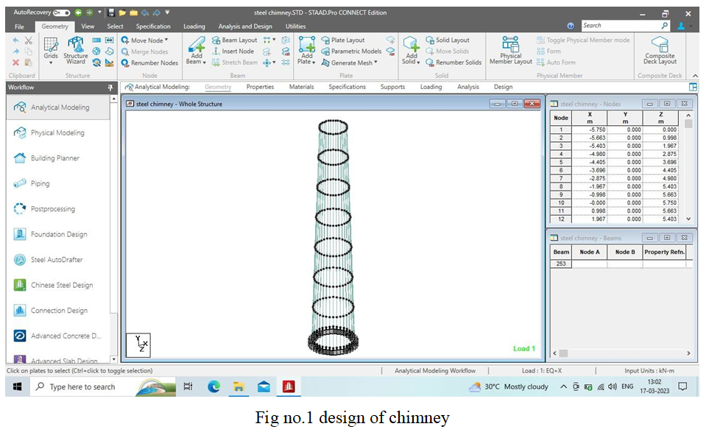

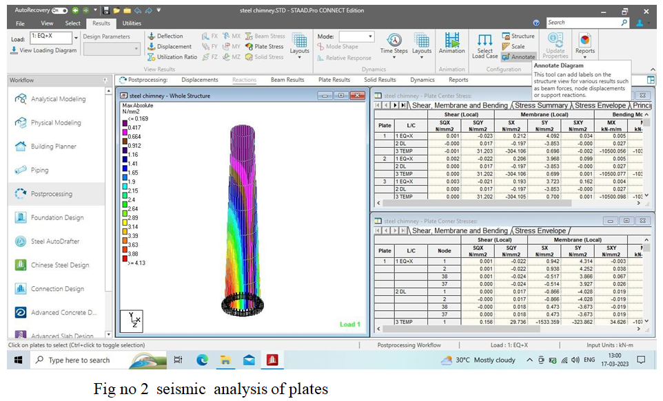

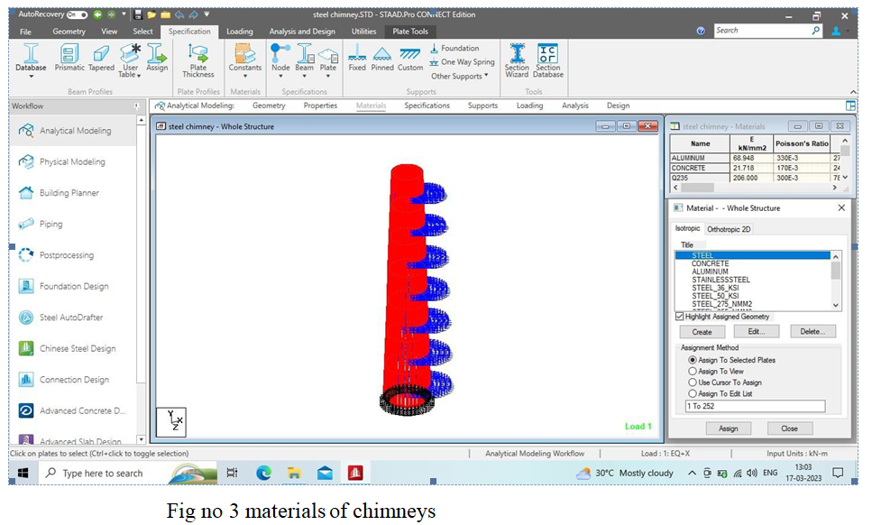

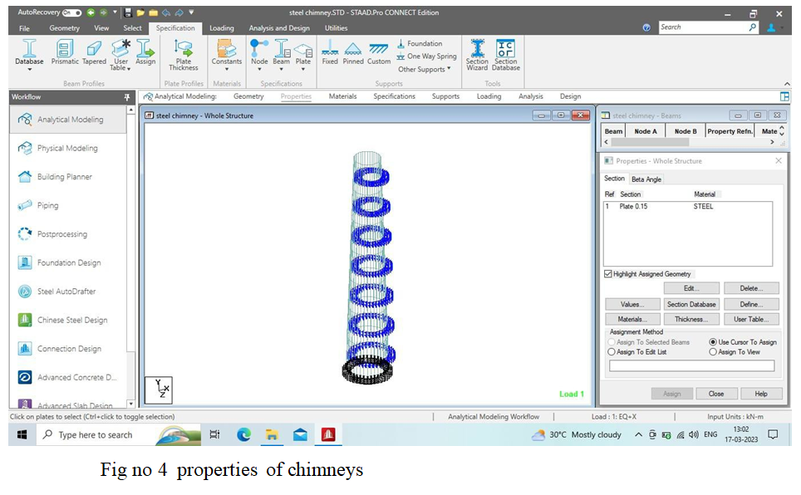
- RESULT

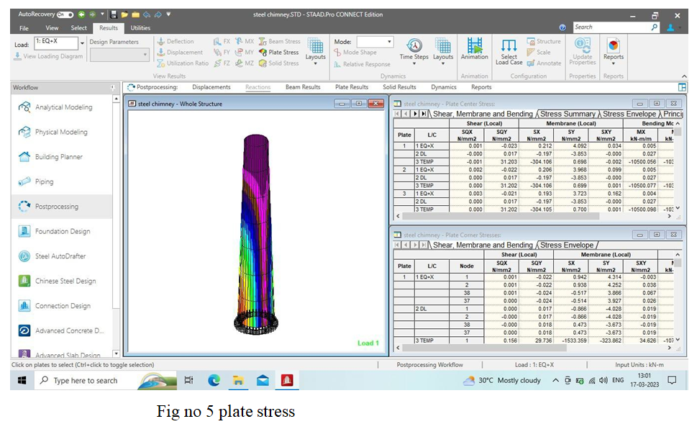

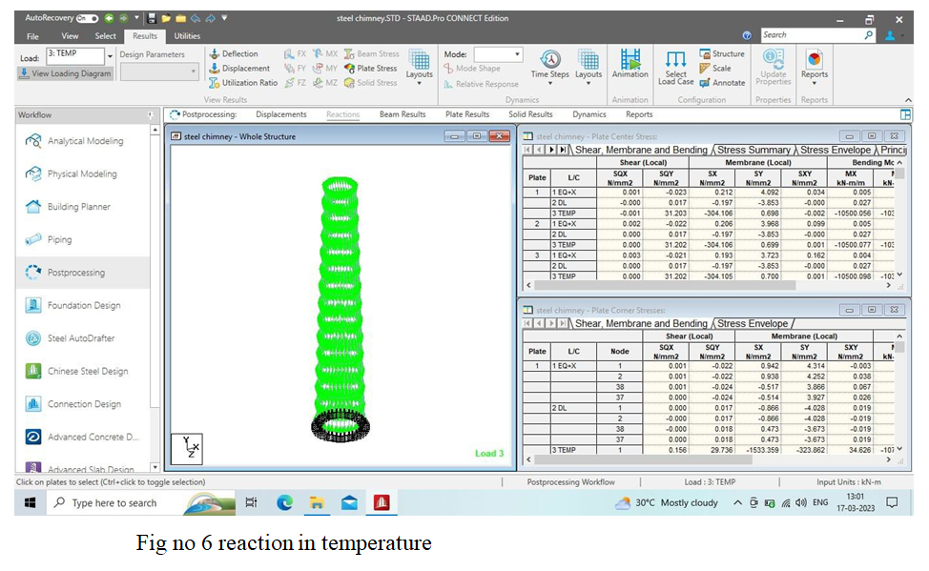

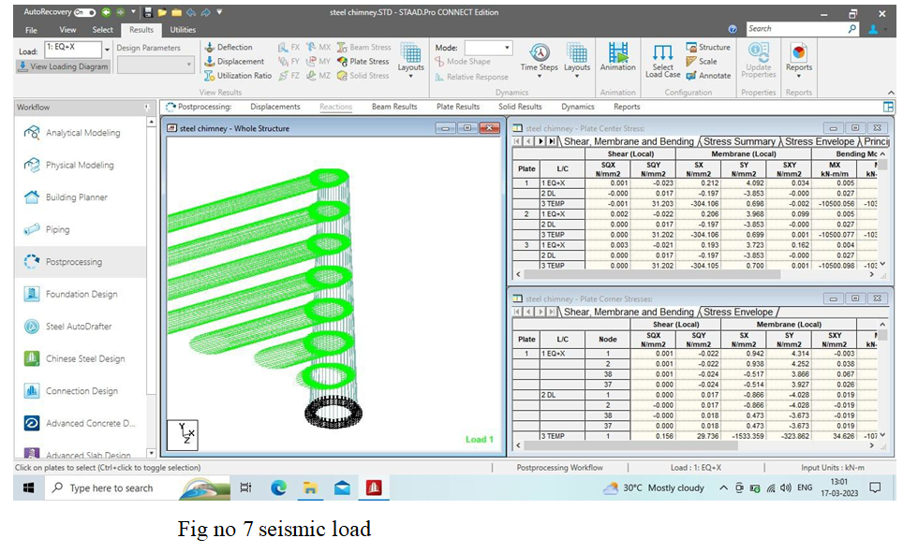

- CONCLUSION
- For high wind intensity and low risk earthquake zone, wind loads were more prominent. Hence, chimney must be analyzed for wind forces.
- It was observed from the result obtained from manual calculation and software developed in
- STAAD PRO, for maximum moment are similar.
- the maximum bending stress due to wind load in a self-supporting steel chimney are continuous function of the geometry height to base diameter ratio as it is observed that at the ratio increase the stress in the steel chimney also increases.
- when the chimney is analysed by the three effects (flexion, shear and rotational inertia), the number of elements to be discrete no longer influence the estimated responses because the height
- of the elements is controlled by the shear if h/D < 2, and by flexion if $\frac{h}{D}$ > 2 ,the height of the element.
- from the research we understand about the contribution of different research in the field of the tall cylindrical structure system (chimneys), a gap in the research and objective of the research to be conducted. These contribution help to visualize the problem faced by Rc & steel chimney from a new perspective. By evaluating the performance of both type of chimney with different height to base diameter its enhanced economic aspect may be achieved, which shall lead to the direction of the design of safe stronger and more economical chimney.
- References
[1] Shiau, “Theoretical and Experimental studies of earthquake response of a chimney “Book on
Aeronautics and astronautics, purdue university, Indiana USA, 1241-1244, 1974.
[2] Anand S. Arya And D. K. paul, “Earthquake Response Of tall chimneys,” School of
Research And Training in Earthquake Engineering, University of Roorkee, 1247-1259, 1999.
[3] Elias, said Vasant Matsagar, and T. K. Datta. 2016.”Effectiveness of Distributed Tuned
Mass Dampers for multi-mode control of chimney under Earthquake .”Engineering Structure 124:
[4] FJ Pallare’s ,A Aguero and M Martrn (2006) Seismic behavior of industrial masonry chimney International Journal of solids and Structures.43, pp.2076 -2090.
[5] D Menon and PS Rao (1997), “Uncertainties in codal recommendation for across-wind load analysis of R/C chimneys”, Journal of wind Engineering and Industrial Aerodynamics. 72, pp. 455-468.
[6] Devi, B. and Singh, S.S, Static and Dynamic Wind force Analysis of Self Supporting Flare
Base Circular Steel Stack with Variable Height.
[7] IS 1893 (part4):2005 “Criteria for earthquake resistant design of structure,”

[8] IS 6533 (part1):1989,” Indian standard code for design and constructional of steel chimney”, [9] IS 65333(part2):1989,” Indian standard code for design and construction of steel chimney”.
[10] V. Rohini Padmavathi, B. Siva Konda Reddy and Srikant “ Study of wind load effects on tall RC chimney “, International Journal of Advanced Engineering Technology, Vol. Issue , April-june 2012pp. 92-97
[11] T Subramani, P.Shanmugam,”Seismic Analysisand Design of industrial Chimneys by Using Staad Pro “,International journal of Engineering Research and Applications (IJERA),ISSN; 2248-9622,Vol.2.Issue 4,july –August 2012,pp,154-161.
[12] Davenport A G 1984 Proc.5th Industrial Chimney Congress, CICIND ,Essen GERMANY, pp.77-84
[13] PN-93/B-03201 1993 Steel structures, Chimneys. Design rules (in polish)
[14] Arya A.S.y Paul,D.K.(1997), “Earthquake Response of Tall Chimneys” . Proceedings world
conference on Earthquake Engineering . New Delhi.

