Experimental Strength Analysis of Membrane Curing Methods Using Polythene Sheets of Different Colors

Amit Kumar Dewangan ¹, K. Divya Kotecha², Harishankar Patel³
Department of Civil Engineering

R. S. R. Rungta college of engineering and technology, Kohka, Bhilai, Durg, Chhattisgarh, India 490020

A b s t r a c t –

Curing plays an important role on strength development and durability of concrete. Curing takes place immediately after concrete placing and finishing, and involves maintenance of desired moisture and temperature conditions, both at depth and near the surface, for extended periods of time. Properly cured concrete has an adequate amount of moisture for continued hydration and development of strength, volume stability, resistance to freezing and abrasion and scaling resistance. A process of controlling the curing of concrete by sealing the moisture that would be lost to evaporation, the process is accomplished by using polythene membranes as sealing agent.
K e y w o r d s –

Concrete, Curing, Water curing, Membrane curing, Immersion, Membrane curing, Plastic Sheeting method.

INTRODUCTION
Concrete:
Concrete is a composite material composed of coarse aggregate bonded together with fluid cement that hardens over time. When aggregate is mixed together with dry Portland cement and water, the mixture forms a fluid mass that is easily molded into shape. The cement reacts chemically with the water and other ingredients to form a hard matrix that binds the materials together into a durable stone-like material that has many uses.

Strength of Concrete by Membrane Curing:
Water is most commonly and frequently used raw material in construction field for aspects such as mixing and curing. This natural resource is also one of the important commodities used in many industries as well as in day to day needs in human life. As a result of this, water is about to become scarce. If this situation prevails, then the cost construction will reach to a point where common man cannot afford to build a home. Hence to mitigate this water problem in construction field, self-curing concrete came into existence. According to the ACI Code-308 “the internal curing is the procedure which involves in the hydration of cement which takes place due to the availability of excessive internal water (which is not part of the mixing water)”. Internal curing is also known as “Self Curing”. The Self curing concrete means that no labour work is required to provide water for concrete or even no external curing is required after placing, where the properties of this concrete are at least comparable to and even better than those of concrete with traditional curing. In other words membrane curing is defined as the process of controlling the curing of concrete by sealing in the moisture that would be lost to evaporation. The process is accomplished either by spraying a sealer on the surface or by covering the surface with a sheet film.

OBJECTIVES OF THE PROJECT
- The main objective of our project is to reduce the water utilization used in mixing of concrete.
- Generally water required for curing is 100 times more than water required for mixing of concrete.
- To compare the compressive strength of 3day, 7day & 28days by two curing method:
- water curing
- concrete cure by the application of polythene sheets
- To find the variation on compressive strength of concrete by membranes curing using three different colour polythene sheets that is light colour (white / transparent), dark (black) and yellow.
CURING:
Curing is the process of controlling the rate and extent of moisture loss from concrete during cement hydration. It may be either after it has been placed in position (or during the manufacture of concrete products), thereby providing time for the hydration of the cement to occur. Since the hydration of cement does take time – days, and even weeks rather than hours – curing must be undertaken for a reasonable period of time if the concrete is to achieve its potential strength and durability. Curing plays an important role on strength development and durability of concrete. It takes place immediately after concrete placing and finishing, and involves maintenance of desired moisture and temperature conditions, both at depth and near the surface, for extended periods of time. Properly cured concrete has an adequate amount of moisture for continued hydration and development of strength, volume stability, resistance to freezing and thawing, and abrasion and scaling resistance. The length of adequate curing time is dependent on the following factors:
- Mixture proportions
- Specified strength
- Size and shape of concrete member
- Ambient weather conditions
- Future exposure conditions.

CASTING STEPS:
(1) First all the moulds are cleaning by dry cloths so that the clean surface created. Than nut & bolts of moulds were tightly fitted and the inner sides of the moulds were thoroughly lubricated by burned engine oil which is easily available in any mortar garage.
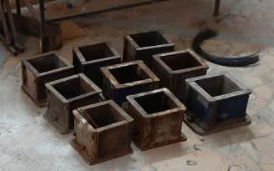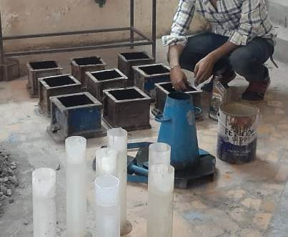
Fig.-1Preparation of mould for casting
(2) Than batching of all the material was done. Required quantities of cement, fine aggregate, coarse aggregate was taken. During the preparation, first coarse aggregate and fine aggregate were poured and mixed thoroughly for some time then cement was added and mix properly than water was add and thoroughly mixed so that uniform paste was prepared.
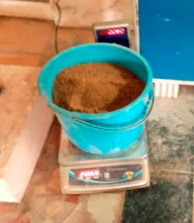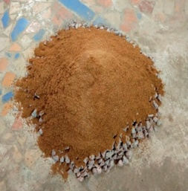
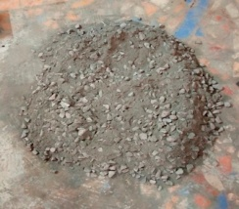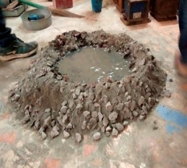
Fig.-2 Weight batching and mix of concrete
(3) Then the prepared concrete was filled in the slump cone whose dimension are (length 30cm, upper cone diameter is 10cm and lower cone diameter is 20cm) moulds in three layers. Each layer was thoroughly compacted by a tamping rod by giving 25 blows after that cone was removed by pooling upside and after that slump was measured by temping road and tape. The process was continued for all the specimens.
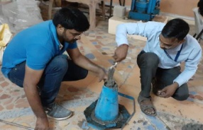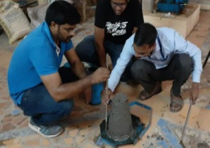
Fig.-3 Slump test of concrete
(4) Then all the concrete which is used for slump test was mix with rest of concrete and then prepared concrete was filled in the moulds of dimension (150mmx150mmx150mm) in three layers. Each layer was thoroughly compacted by a tamping rod by giving 25 blows. After 3 layer filling concrete in the mould top surface is making plain and smooth by using trawler and all the extra concrete was removed to make a uniform size of 150mmx150mmx150mm. The process was continued for all the specimens.
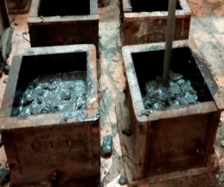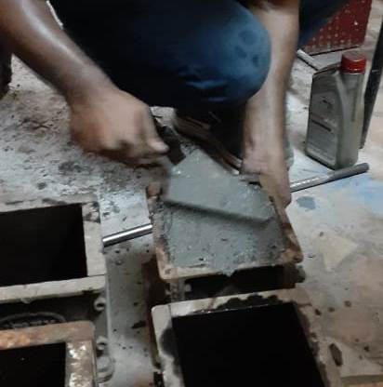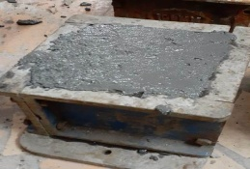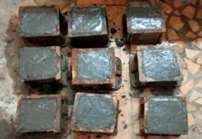
Fig.-4 Slump test of concrete
(5) After 30 minutes all the cube are covered by wet jute bag for fulfill the moisture losses and leave it for one day i.e. 24+2 hours.
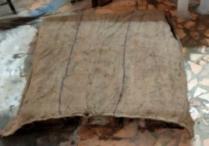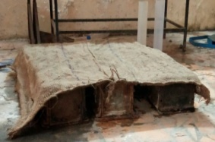
Fig.-5 Concrete cube cover by wet jute bag for retard moisture loss

4.6 CURING PROCESS
The cubes were removed from the mould after 24+2 hrs. Then all the specimens were covered by wet jute bag form 30 minutes for regaining its moisture losses.
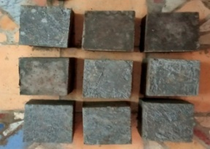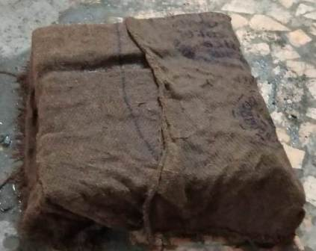Fig.-6 Concrete cube are cure by wet jute bag for 30 minutes before cover by polythene
After that 3 cube are immersed in water tank of college lab, 3 concrete cube are packed/cover by Dark (black) polythene bag/sheet, 3 concrete cube are packed/cover by Transparent (white) polythene bag/sheet, 3 concrete cube are packed/cover by Yellow polythene bag/sheet and create vacuum under the bag and seal it by using cable tie of size 100mm and after that place in area were moderate sun light are coming in the college lab and after that leave the concrete cube for 28 days curing.
All the procedure is repeated for 3 days and 7 days curing process.
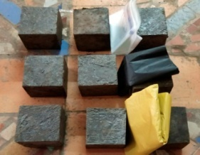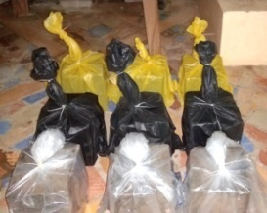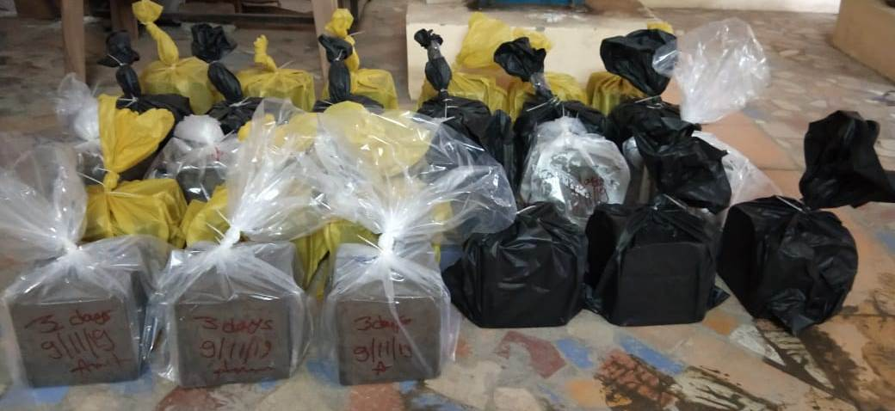
Fig.-7 Concrete cube are cover by 3 different colour polythene for curing

TESTING OF SPECIMENS

Compressive Strength:
The cube specimens were removed by polythene bag after 3, 7 and 28 days after packing the cube and tested on compression testing machine of capacity 1000 kN. The bottom surface of the compression testing machine was cleaned and loose fine particles removed from the surface of the cubes. The mould was placed on the bottom surface of machine in such a way that the load was applied to opposite sides of the cubes as cast that is not top and bottom. The axis of the specimen was aligned in the centre of the loading frame. The load was applied on the specimen and it was increased continuously at a constant rate until the resistance of the specimen to the increasing load breaks down and no longer cubes can sustain. Then, the maximum load applied on the specimen was recorded.
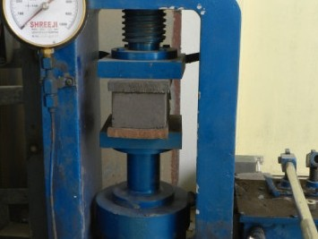
Figure-8 Testing of cubes for compressive strength

RESULTS AND DISCUSSIONS

INTRODUCTION
In this chapter, the experimental results are presented and discussed. The effects of various important parameters on compressive strength of concrete by using two curing method of concrete water curing (immersion curing) and curing by using polythene sheets are discussed below. The parameters considered are as follows:
- Curing types,
- Curing Time,
- Water/cement ratio by mass,
- Colour of polythene

WORKABILITY OF CONCRETE

Table -1 Slump Value of M20 grade of concrete of different mixes
S. No | Slump Value (mm)
Mix1 | 56
Mix2 | 49
Mix3 | 52
Mix4 | 64

Chart -1 Slump Value of M20 grade of concrete of different mixes
The test was carried out on slump cone to find the workability of the concrete and the average slump was found to be 57 mm.
Table - 2 Compressive strength of concrete cubes of different curing method of sample No-1

S. No | Curing type | Compressive Strength (MPa) of sample No.-1
 |  | 3 days | 7 days | 28days
1 | Immersion | 10.46 | 17.32 | 26.16
2 | Black polythene | 9.74 | 16.12 | 24.35
3 | Yellow polythene | 9.78 | 16.43 | 24.46
4 | White polythene | 9.94 | 16.76 | 24.86

Chart-2 Compressive strength of cube of sample-1

Table-3 Compressive strength of concrete cubes of different curing method of sample No-2

S. No |  | Curing type | Compressive Strength (MPa) of sample No.-2
 |  |  | 3 days | 7 days | 28 days
1 | Immersion |  | 10.57 | 16.93 | 25.92
2 | Black polythene |  | 9.62 | 15.98 | 24.23
3 | Yellow polythene |  | 9.64 | 16.22 | 24.35
4 | White polythene |  | 9.86 | 16.56 | 24.53

Chart-3 Compressive strength of cube of sample-2
Table-‎4 Compressive strength of concrete cubes of different curing method of sample No-3

S. No | Curing type | Compressive Strength (MPa) of sample No.-3
 |  | 3 days | 7 days | 28days
1 | Immersion | 10.62 | 17.79 | 26.56
2 | Black polythene | 9.78 | 16.38 | 24.45
3 | Yellow polythene | 9.81 | 16.44 | 24.54
4 | White polythene | 10.06 | 16.85 | 25.15

Chart-4 Compressive strength of cube of sample-3

Table-5 Average Compressive strength of concrete cubes of different curing method

S. No | Curing type | Compressive Strength (MPa) of Sample Average
 |  | 3 days | 7 days | 28days
1 | Immersion | 10.53 | 17.34 | 26.21
2 | Black polythene | 9.71 | 16.16 | 24.30
3 | Yellow polythene | 9.74 | 16.36 | 24.44
4 | White polythene | 9.95 | 16.72 | 24.84

Chart-5 Average Compressive strength of concrete cube
From Table 2,3,4 and 5 it can be seen that the compressive strength of cubes which are cured by polythene sheets are showing less strength compared to immersion curing but the difference of strength is not so big they showing approximately same strength.
CONCLUSIONS: From the experiments conducted on the Curing of concrete, developed in the concrete laboratory of RSR RCET, the following conclusions have been made.
- Black sheets are found to have least value of compressive strength; because it absorbs all the incident solar radiation, and hence can be used during cool climatic conditions and interior locations.
- Curing through yellow polythene sheets produce moderate compressive strength.
- While, curing White polythene sheets produce higher compressive strength in higher values of solar radiations, as they reflect higher proportion of solar radiations.
- Membrane curing through polythene sheets are show less compressive strength compared to immersion curing but the difference of strength is not so big it is approximately equal.
- This curing method will help to save water which is using in curing because curing need fresh water.
- In traditional method of curing concrete need curing daily but in this method it is not required, membrane curing is one time curing and do not need to regular or daily supervision and curing.
- In some times labor does not understand the importance of curing and they ignore it but in the membrane curing it is not necessary of daily supervision.

FURTHER SCOPE OF WORK:
From the literature, it has been seen that membrane curing using polythene sheets are have approximately same compressive strength so that it can be used as area where fresh water is not available or water is expensive. There are many area and country who facing water problems, water table has been continuously going down so that we need solutions for consume less water. It is a alternate solution for area where fresh water is not available. This method is most suitable for precast work where all the environment condition are good. This method has also advantage that the polythene sheets are reusable in many times.

REFERENCES

- Ankita V.Kalbande, Anand G.Chavan, Feroz H. Khan- Membrane Curing Of Concrete
- Er. Rajesh Sharma, Dr. Hemant Sood- Effect of Curing Methods on Various Concrete Grades
- Akinwumi, I.I., Gbadamosi, Z.O. - Effects of Curing Condition and Curing Period on the Compressive Strength Development of Plain Concrete
- Manish A. Kewalramani- Environmentally Sustainable Concrete Curing with Coloure Polythene Sheets
- J. Wang, R. K. Dhir, M. Levitt- Membrane curing of concrete: moisture loss
- R. L'Hermite- Polyethylene film as concrete curing material in a tropical climate
- O. James ,P.N.Ndoke and S.S.Kolo - Effect of different curing methods on the compressive strength of concrete
- Md. Safiuddin, S.N. Raman and M.F.M. Zain - Effect of Different Curing Methods on the Properties of Microsilica Concrete
- D.Gowsika, P.Balamurugan, R.Kamalambigai- Experimental Study on Curing Methods of Concrete
- Dr. K.V.Krishna Reddy - A Comparative Study on Methods of Curing Concrete –Influence of Humidity
- M. Ibrahim, M. Shameem, M. Al-Mehthel, M. Maslehuddin- Effect of curing methods on strength and durability of concrete under hot weather conditions
- By Jerzy Z. Zemajtis, Ph.D., PE (WA)- Role of Concrete Curing
- M.S. SHETTY– Concrete technology theory and practice
- R. W. Nurse- Steam curing of concrete
- Pratik Deogekar, Ashwini Jain, Sudhanshu Mishra, Prakash Nanthagopalan- Influence of Steam Curing Cycle on Compressive strength of Concrete
- A.S. Al-Gahtani- Effect of curing methods on the properties of plain and blended cement concretes
- Tayfun Uygunog˘lu, Ismail Hocaog˘lu- Effect of electrical curing application on setting time of concrete with different stress intensity
- Magda I. Mousa a, Mohamed G. Mahdy a, Ahmed H. Abdel-Reheem a, Akram Z. Yehia- Self-curing concrete types; water retention and durability
- A. Arafah, R. Al-Zaid and M. Al-Haddad- Influence of non-standard curing on the strength of concrete in arid areas
- Ajay Goel, Jyoti Narwal, Vivek Verma, Devender Sharma, Bhupinder Singh- A Comparative Study on the Effect of Curing on The Strength of Concrete
- Shaikh A.S., Lahare P.S., Nagpure V.B, Ghorpde S.S- Curing of Concret
- T. James, A. Malachi, E.W. Gadzama, V. Anametemfioka- Effect of curing methods on the compressive strength of concrete
- Emmanuel Nana Jackson1 , Benjamin Boahene Akomah- Comparative Analysis of The Strength of Concrete With Different Curing Methods In Ghana
- Prerna Tighare, Mr. R. C. Singh- Study of Different Methods of Curing of Concrete & Curing Periods
- P. Kiran kumar, N V Raghvendra, B K Sridhara- Development of infrared radiation curing system for fiber reinforced polymer composites: An experimental investigation
- Nirav R Kholia, Prof. Binita A Vyas, Prof. T. G. Tank- Effect on concrete by different curing method and efficiency of curing compounds.
- B Lokeswar Reddy, K Ravi: Experimental Strength Analysis of Different Membrane Curing Methods

