Smart Sanitizing Robot with Medicine Transport System for Covid -19 Situation

Aparna Mohture¹, Dr. D.R. Tutakne², Ankita khandait ³

¹M.Tech Student, ²Professor, ³Assistant Professor
Wainganga College of Engineering and Management Nagpur, Maharashtra, India 441108

aparnamohture93@gmail.com

Received on: 10 April ,2022 Revised on: 16 May ,2022, Published on: 18 May,2022

Abstract: As the covid ruins life of peoples in last 2 years, we need to contribute in this pandemic with our few efforts. In paper, concept of is proposed. A sanitizer robot can spray sanitizer on patients area and supply medicine to them. This is embedded based system to control the wireless sanitizer spraying robot with Smartphone. Apart from this, there will be a holding plate on the robot so that the Doctors can send the medicines to patients without physically entering into the patient ward. We are also going to charge the robot's battery with solar panels to merge renewable energy in our robot's power. All efforts are taken to make this robot most economic product in this pandemic which will be definitely beneficial for health industry.

Keyword- Pandemic, Sanitizer spray, Smartphone Function etc.
- INTRODUCTION
Covid-19, the disease caused by the novel corona virus, ended up with a global lockdown which have been varied from recommended social distancing to self-isolation. Although, the people tried their best to follow these instructions, frontline workers like nurses and doctors tend to lose their lives while saving life of patients.
It’s a time to stop this bad loop of deaths by using some robotic technology. But during a crisis like pandemic, these tools can help keep people safe by minimizing direct exposure to the virus and supporting to reduce the spread of virus.
The hygiene maintaining team of hospitals is more prone to virus attack as they are constantly involved in the sanitization and other works. They have a crucial task of disinfecting contaminated areas, putting them at potential risk. To reduce human contact in these infected and open-air areas, cleaning robots are much more helpful.

The main objective of this research paper is to propose a device which can save people lives who works in health industry. After study on mechanical structures that useful in transportation of medicine and sanitization in infected area of patients in hospitals.

It’s our moto to convert and build organizations with remote accessible atmosphere without the need to travel to patient area. By considering world’s responses to the challenges posed by the COVID-19 pandemic, and the recovery of both our economy and social well-being, will depend on the talents of scientists, engineers and medical professionals. Together, we will be successful.

II - PROBLEM STATEMENT

- The corona virus. has led to a global lockdown the likes of which have not been seen in last years.
- We are getting used to seeing robots in our lives, doing daily tasks from scanning store shelves to vacuuming our homes. But during a crisis like the COVID pandemic, we are seeing that these tools can help keep people safe by reducing our exposure to the virus and helping to reduce the spread.
- "Covid-19 can be a catalyst for developing robotic systems that can be rapidly dismantled, without the need of remote assistance by experts and essential service providers.

Objective

- The main objective of this project is to design an automatic handling mechanism operated by electrical and programming methods to save the lives of our frontline warriors.
- To facilitate easy Sanitizing of infected area with wireless function
- To transport food and medicine quickly.
- To study control of mobile communication system used in electronics field.
- To study the controller required for this project and its development features.

III - LITERATURE REVIEW

In recent years, there has been an increase in the availability and use of hand sanitizing products. The main advantage of these projects seems to be that they are more reliable, faster and easier to use. They can also provide another way to clean hands when water and soap are not available. The use of hand sanitizer is generally considered to be an effective hand hygiene system for hospitals, health care settings and more. As we all know, the outbreak of COVID-19 affected the world and changed our lifestyle. In this situation, alcohol and hand sanitizer are important fluids, however, they must be used properly. Touching an alcohol container or hand sanitizer with infected hands can spread the virus to the next

Jessica Hilburn, April 2003. The paper primarily deals with hospital infections, which account for about 2 million patients per year and also states that it is the 8th leading cause of death annually in the United States. It also states that hand washing is important and effective with proper hand washing steps, but washing with soap and water for peak hours in hospitals is time-consuming.
IV- BLOCK DIAGRAM
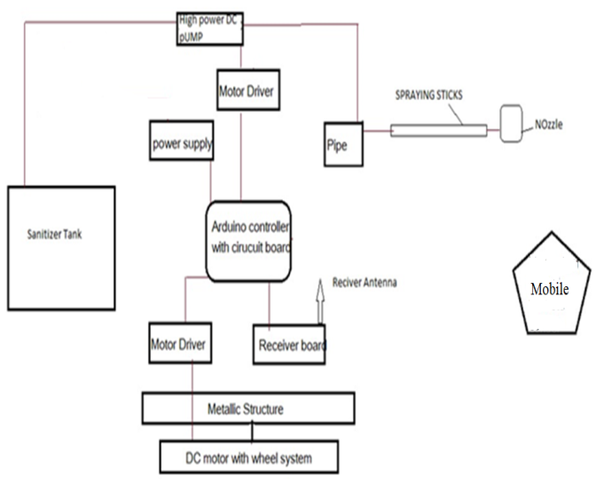
Fig. 1- Actual block diagram

- System Architecture

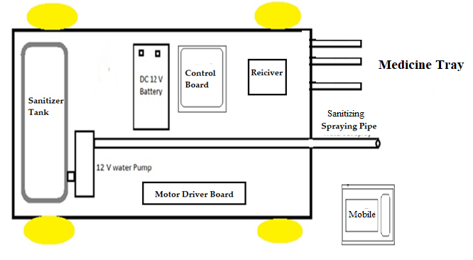
Fig. 2. System Architecture

- Hardware Components
- Arduino Uno Controller (R3-ATmega 328)
- Bluetooth module (HC-05)
- DC pump (DC12V)
- 12V DC Power Supply,
- 5V DC Regulator (7805 IC)
- LCD display (16*2) (DC 5V)
- Relay (12V)
- Adapter (12v 2Amp)
- Battery (12v 1.5Amp)
- Tank (1 Lit)
- LEDs
- Resistors, Capacitors and Diodes
- Other

- Bluetooth module (HC-05)
The HC-05 is a very cool module which can add two-way (full-duplex) wireless functionality to your projects. You can use this module to communicate between two microcontrollers like Arduino or communicate with any device with Bluetooth functionality like a Phone or Laptop.
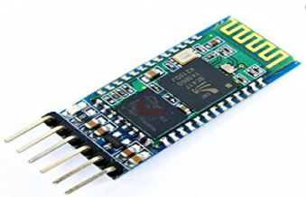

- Arduino Uno
It is main controller belongs to Arduino family. which is used to control the signal received from any input voltage source like sensor and transmitter/receiver module. It is attached LCD display to show the command.
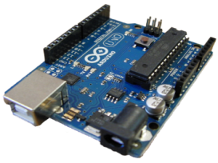

- Brushless DC Pump
- Operates on 12V supply, The Speed Control circuit technology is able to stabilize the voltage changes and load changes, sanitizer flow is very stable.
- In particular, it is suitable for users who have the demand for a steady flow, the flow tolerance was <±10%.
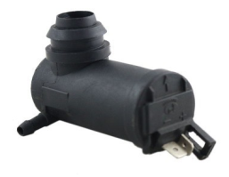

- 12 v Battery
- 12 V, 1.3 Amp Battery is high power battery and it can easily handle all the function.
- Main things are to collect electrical energy from solar panel and provide to various components for running specific function.

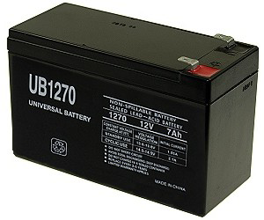

- Motor driver (l293d IC)
Motor drivers act as current amplifiers since they take a low-current control signal and provide a higher-current signal. Operates on 12 v power.

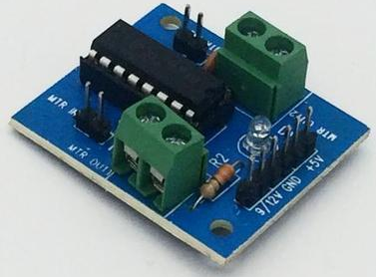

- Liquid crystal display
LCD stands for Liquid Crystal Display. LCD is finding wide spread use replacing LEDs (seven segment LEDs or other multi segment LEDs)
It is used to display all commands of robot.
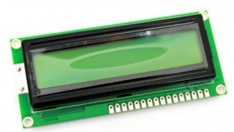

- DC Motor (operates on 12v, Speed :100 RPM)
- The direct current (DC) motor is one of the first machines devised to convert electrical power into mechanical power.
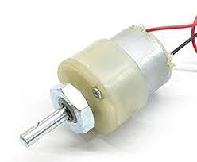

- Relay Board (12v)
A relay is usually an electromechanical device that is actuated by an electrical current. The current flowing in one circuit causes the opening or closing of another circuit. 12v relay board. It is used to operate DC pump motor.
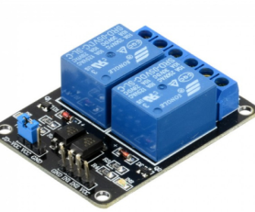

- Software Used
Language: Embedded C
Platform: Arduino IDE 1.8.13(software)
Operating Mode: Window 10

- Working
- The main goal of this project is to design a Smart sanitizing robot for Covid-19 condition to save the life of our frontline warriors. By using remote operation.
- This robot is loaded with a sanitizer tank and a High-speed pump controlled through wireless communication to sprinkle. For the desired operation, an Arduino microcontroller is used.
- At the transmitter end, push buttons are used to send commands to the receiver end to control the robotic movement, either in forward, backward, right or left and 360 direction movement.
- The remote control that has the benefit of adequate range up to 30 meters with apposite antenna, while the decoder decodes before feeding it to another microcontroller to drive DС motors via motor driver IС for necessary work.
- A sanitizer tank along with water pump and control board is mounted on the robot body and its operation is carried out from the microcontroller output through appropriate signal from the transmitting end.
- There is wireless camera attached at the front portion of robot. We can see the live footage of surroundings and spray according to it.
- Robot is powered with 12v battery, and it is charged with 12v adopter for uninterrupted of power.
- This robot also transports various medicine and medical equipment’s inside the corona ward or any other location. This makes robot a multifunction performer.

V-RESEARCH METHODOLOGY

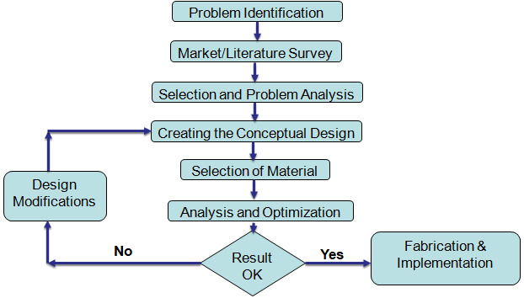

Fig. 3. Project Methodology

- System flow diagram
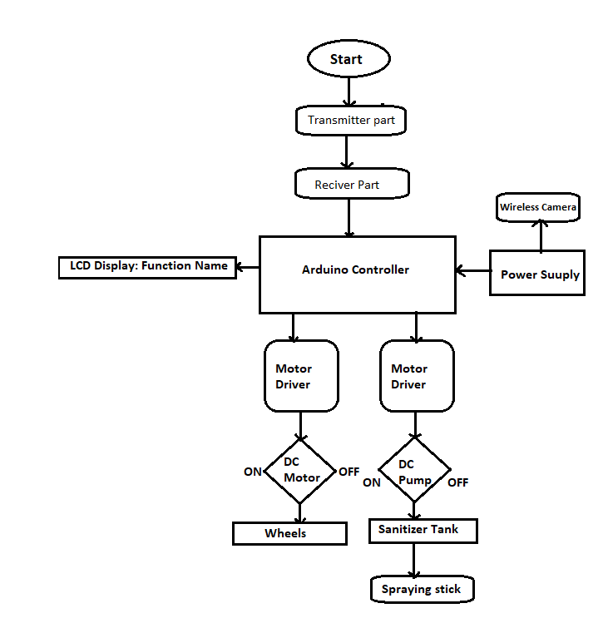
Fig.4. System flow diagram
- Circuit diagram
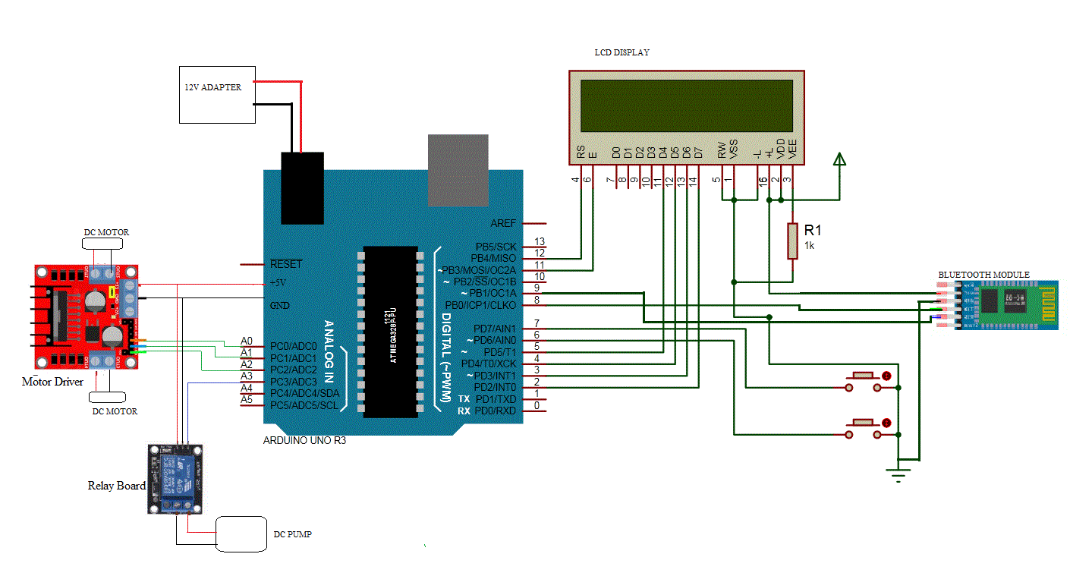
Fig.5. Circuit diagram
- 3D model of Robot
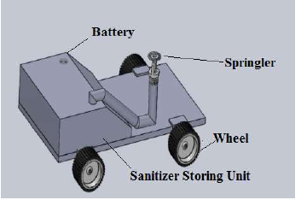
Fig.6- 3D Model of Robot

The robot is capable of effectively killing microorganisms on the floor, such as fungi, bacteria, and viruses, and has significant effects on harmful microorganisms. The robot can automatically patrol for sterilization and disinfection in a predetermined area. The sprinkler is equipped with a double-acting pneumatic cylinder, and the purpose of the cylinder is used to push the air into the tank. The main components consist of a sprinkler robot, is DC motor, Bluetooth module, Arduino, Motor driver, Submergible pump, Sprinkler, Battery, DC Converters. The frame is made up of a 3mm Galvanized iron sheet with a dimension of 440 mm length and 240mm width. The frame acts as a base and is used to assemble all the components.

- Advantages
(i) It is non-contact type
(ii) Wireless technology.
(iii) User friendly.
(iv) Design is compact.
(v) Easy to operate and installation
(vi) Available in different sizes.
(vii) Maintenance is low. Protect from COVID 19.

- Disadvantages
(i) Skill Person needed
(ii) Fire hazards

- Applications
(i) It can be used hospitals.
(ii) Used in public locations
(iii) Also used in School & colleges
(iv) Use in Airports.
(v) Used in hotel and restaurants.
(vi) Shopping malls.
(vii) Banks.

- RESULTS AND DISCUSSION

Autonomous mobile sanitizing robot is becoming most useful in COVID-19 hospital environments. It reduces the human intervention in sanitization. The designed system is very compact, so easily can transport this robot to any place. The COVID-19 pandemic presents even more reason to use mobile robots for safe cleaning in quarantine zones. The proposed model is fabricated and tested in a hospital environment. The system is capable of disinfecting an area of up to 100 m2/ day. Autonomous sprinkler system optimizes the disinfecting areas and reduces the wastage of sanitizer. The designed system is capable of sanitizing an area of up to 100m2 per day. The application area can include hospital corridors, medical shop, operation theatre, walking pathways, doctor room, testing center, and patient room, etc.

- Design Calculations
(i) Sprinkler flow rate
Theoretical
Q=k √p
p=20 psi
k=5.6
Q=5.6 √20
Q= 25 GPM
Q=Flow Rate (GPM), P=Operating PSI of head/Outlet
K=K Factor of Head/outlet

(ii) Analysis
For 1 liter, the flow rate of the Sprinkler is 476seconds.
For the project the flow rate of the sprinkler is 200 seconds.
The area of the sanitizer covered is 600mm.
The acquired Flow rate is 17GPM
(iii) Motor Specifications
Speed = 200 RPM,
Voltage = 12V,
Power = 100W
Torque of the motor
Torque = (P X 60) / (2 x 3.14 x N)
Torque = (100 X 60) / (2 x 3.14 x 100)
Torque = 9.554 Nm,
Torque =9.554 x 103 Nm

(iv) Battery life calculation
Robot working hours for one full charge.
Batter capacity = 12v 7Ah (Ampere Hours)
Total device consumption = 520ma (mill ampere)
Battery Life = Battery Capacity in mAh/ Load Current in mA
= 7000mAh/520ma
= 13.46 Hours

- CONCLUSION
This project presents a smart sanitizing and transport robot using Bluetooth communication. It is designed and implemented with Arduino controller (MCU) in embedded systems domain. The proposed method is verified to be highly useful l for COVID-19 situation or other pandemics. This is a great opportunity for automation and will be useful in places where human cannot reach or is dangerous. This can be used as a further extension of the project to get all the features. It is a low-cost user-friendly system which can be used by anyone. All devices communicate well. From this methodology, it can be concluded that the system has been implemented successfully in desired area of application. The results achieved in this project are real and are the product of honesty and hard work.

REFERENCES
[1] Jessiса Hilburn MT(АSСР), СIС, Brian S Hammond, Eleanor J Fendler Ph.D., Раtriсiа А Grоziаk MS, "Use of аlсоhоl hand sаnitizer аs аn infeсtiоn соntrоl strаtegy in асute саre fасility", Аmeriсаn Jоurnаl оf infection соntrоl Volume 31, Issue 2, Арril 2003.
[2] Sаtоru Mitsubоshi, Masami Tsugitа, “Imрасt of аlсоhоl-based hаndsаnitizers, antibiotic соnsumрtiоn, and other measures on detection of antibiotic resistant bасteriа in rural Jараnes hospitals”, Journal of Infection and Сhemоtherарy, 2018.
[3] Gоlin, А. Р., Сhоi, D., & Ghаhаry, А. "Hand Sanitizers: А Review of Ingredients, Mechanisms of Асtiоn, Modes of Delivery, and Effiсасy Аgаinst Соrоnаviruses". Аmeriсаn Journal of Infection Соntrоl, 2020.
[4] Davis MА, Sheng H, Newman J, Hаnсосk DD, Hоvde СJ. Соmраrisоn of а water less hand-hygiene рreраrаtiоn and sоар and water handwashing to reduce соlifоrms on hands in аnimаl exhibit settings. Epidermal Infect. 2006; 134:1024–1028.
[5] Health imрасt of handwashing. WELL, fасt sheet 2006. at:https://repository.lboro.ac.uk/articles/book/Sanitation_for_primary_schools_in_Africa/9585335

