STUDY OF SUPRAHARMONICS AND ITS REDUCTION BY USING NOVEL CONTROLLER
Harshal Chore¹, Hitesh Murkute², Rajendra Bhombe³
Guru Nanak Institute of Engineering and Technology
^{harshal.p.chore@gmail.com}

ABSTRACT
Distributed energy system is making use of power electronics based interfaces such as DC to AC, AC to DC, DC to DC etc. These resources impact the connected nearby equipments in the form of distortion. The distortion in a specific range due to harmonics is termed as supraharmonics. The reason is mainly due to power electronic convertor switching frequencies. Modification in switching techniques leads to different effect in terms of emission in the range of supraharmonics.
They can be reduced by random PWM techniques till now. But this method fails to achieve the closed loop aspect of control. Dedicated controllers in conjunction with control and now we use Fuzzy Logic Controller.

INTRODUCTION
The CIGRE/CIRED Joint WG C4.24 “Power quality and Electromagnetic Compatibility Issues associated with future electricity networks”, (C4.24 in short) obtained its mandate in 2013 and is expected to deliver its final report in2017. The C4.24 cooperates with the IEEE working group “Power quality Issues with Grid Modernization” both with similar scope and objectives. The outline of the new developments in power electronics (PE) and their related impact in power

quality (PQ) are currently discussed in those international groups. An important conclusion is now already that the conventional PWM techniques employed in PE inject emission in the high frequency (HF) range 2 to 150 kHz, (also referred to as “supraharmonics”).
The topic of supraharmonics is also treated at CIGREC4/C6.29, “Power quality aspects of solar power” . Potential interference issues in relation to power-line communication (PLC) are discussed in CIGRE C4.31 in the HF band 9 to 150 kHz. The latest draft of IEC 61000-4-30 “Testing and measurement techniques -Power quality measurement methods” includes a definition of PQ indices to determine the emission in this HF band. IEC 61000-3-8 “Signaling on low-voltage electrical installations – Emission levels, frequency bands and electromagnetic disturbance levels” considers the HF range from 3 to 148.5 kHz. Also standards CISPR 14 and CISPR 15 are within this framework. The current EN 50561-1 on PLC equipment for connecting in LV grids considers the HF range 1.6065 to 30 MHZ. Within IEEE, supraharmonics have been debated in IEEE P-1250 and are an important part of the scope of TC-7 of the IEEE EMC Society. Supraharmonics are also part of IEC/TS62749 “Assessment of power quality– characteristics of electricity supplied by public networks”. In CENELEC, supraharmonics is also considered by the WG in charge of EN 50160.
The necessity of supraharmonics standards is also stated in the application guide for EN 50160. CENELEC TC-210 is collecting examples of interference with PLC originated by supraharmonics. IEC TC77A covers this HF range through some working groups. The 9 kHz limit border between TC77A (LF) andTC77B (HF), only has historical motive. In point of fact, advances in the direction of standards in the range 2-150 kHz are presently emerging within IEC TC77A, but not in TC77B. After very hard work and intense discussions, SC77A WG8 got a consensus regarding compatibility levels in the HF range 2-30 kHz. Consequently, SC 77A WG8 decided to proceed with the IEC 61000-2-2 Ed. 2 AMD. 1 and to circulate a draft for voting (CDV) as a next step. For non-intentional emissions in the range 30-150 kHz, no consensus has been achieved in SC77A WG8, leading to proceed with further investigations in this HF range to get a better view on the situation.
Although the presence of supraharmonics in the grid is not new, and for several decades the related problems have been considered, the term supraharmonics was coined during the 2013 IEEE PES-GM. Emission below 2 kHz, low frequency (LF) harmonics, is a widely explored area where as HF emissions in the range of 2 kHz to 150 kHz, (supraharmonics), have caught recent attention mainly due to the use of large parts of this HF band for PLC as well as PE converters with active switching. Research and papers spanning that range go back to a decade, but this HF range has attracted more attention from researchers, and work is nowadays ongoing around the world.

BASIC SCHEME
1 To reduce supraharmonics for a given power system application is the main objective of research.
2 To achieve this, in depth study using simulation models for supraharmonics is necessary.
3 So initial models will be to understand basics of supraharmonic concepts and later on detailed controller design and methodology to reduce the same will be researched.
4 Harmonic of distortion by using fuzzy logic controller.
WORKING OPERATION
For the reduction of supraharmonics from the current signal, we are using Uniform Random Noise method. But it is having several disadvantages and the harmonics are not completely reduced. To overcome this limitation, Fuzzy Controllers are used. We have given the input to the measurement block from the Fourier Block. And then we are using Nullifying component for 150 kHz and for 200 kHz whose output is given to the Fuzzy Logic Controller.
This method is simple as compared to the former one and can be used for fixed frequencies also. Fuzzy logic works on five basic rules.
The first rule says that if the first input is low and the second input is medium, then the first output is negative. The second rules states that, if the first input is low and the second input is high, then the first output is negative. If the first input is medium and the second input is low, then the first output is positive is given in the third rule. Similarly, if the first input is high and the second input is low, then the first output is positive. Whereas, the first input is low and the second input is low then the output is zero.
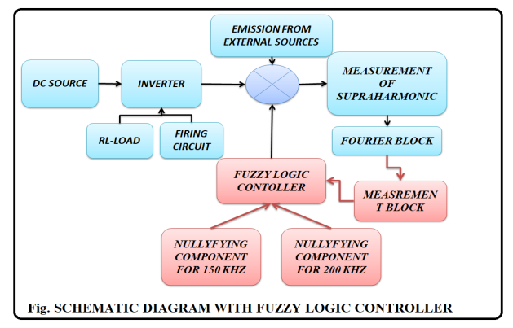
Fig.1 Schematic diagram with fuzzy logic controller

Description of Parts and their Functions

GENERATION OF CFL PROGRAM

The program we are using for this is named as "My 1 Script.m", in which we plot current waveform which is divided into two parts. The first one is the positive cycle which lasts for ten seconds. In this harmonics starts at 3 milliseconds and ends at 6 milliseconds, where t₁= 3ms and t₂=6ms. Similarly, we obtain the negative cycle that too lasts for ten seconds and harmonics are injected at 13 milliseconds and end at 16 milliseconds where t₁₁=13ms and t22=16ms. It is thus a time domain signal and we observe that the waveform is a subtraction of two exponential waveforms i.e. positive and negative.
In the further part of the program we compute FFT and plot the same. This is a Magnitude VS Frequency plot. We here have plotted magnitude FFT of Sine. Here we first increase the harmonics up to a high magnitude then by some means have reduced it to zero, and same is shown in the plot.
POWER ELECTRONIC CIRCUIT
We are giving a DC supply from a DC source which can be either a battery or a rectifier. This supply is given to a three phase Inverter. An inverter is a device that converts DC supply into AC supply. Here we are using a six pulse inverter which consists of IGBT's. IGBT is the acronym for Insulated Gate Bipolar Transistor. Six IGBT's are used numbered as S1 AND S2'1 conducting at one time. Then S2 and S1' and after that S3 and S2' are conducting at same time. It starts conduction after a pulse is given to its gate terminal. Thus, we require a firing circuit to fire a gating pulse. The output of the inverter is fed to an R-L load. The output of the inverter is given to the comparator where we are injecting an emission from an external source of 150kHz to 200kHz.It means we are injecting some harmonic component in the circuit. The waveform is thus observed with harmonics in it and the measurement of supraharmonics is done. To observe the disturbances in the system i.e. to observe the waveform we are using Fourier Block. Then by some means like controllers we are using Controllers.
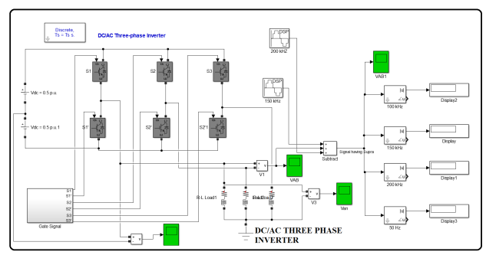
Fig.2 power Electronics Circuit
HARMONICS
We are giving a DC supply from a DC source which can be either a battery or a rectifier. This supply is given to a three phase Inverter. An inverter is a device that converts DC supply into AC supply. Here we are using a six pulse inverter which consists of IGBT's. IGBT is the acronym for Insulated Gate Bipolar Transistor. Thus, we require a firing circuit to fire a gating pulse. The output of the inverter is fed to an R-L load and we observed the current waveform in scope containing harmonics as shown in Fig 3
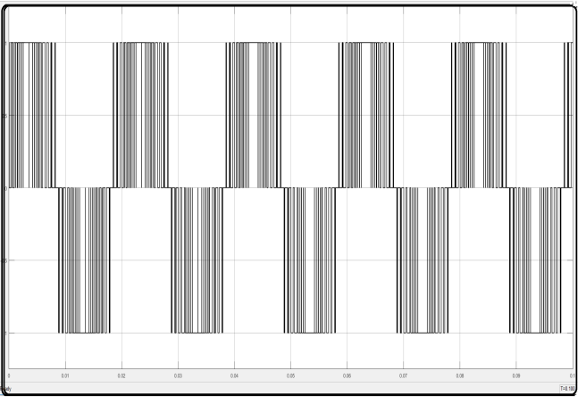Fig 3 Waveform of Harmonics
SUPRHARMONIC
We are giving a DC supply from a DC source which can be either a battery or a rectifier. This supply is given to a three phase Inverter. An inverter is a device that converts DC supply into AC supply. Here we are using a six pulse inverter which consists of IGBT's. IGBT is the acronym for Insulated Gate Bipolar Transistor. Thus, we require a firing circuit to fire a gating pulse. The output of the inverter is fed to an R-L load and we observed the current waveform in scope containing harmonics as shown in Fig 7.1. The output of the inverter is given to the comparator where we are injecting an emission from an external source of 150Khz to 200kHZ. It means we are injecting some harmonic component in the circuit. The waveform is thus observed with harmonics in it and the measurement of supra harmonics is done. To observe the disturbances in the system i.e. to observe the waveform we are using Fourier Block and are as shown in Fig.4
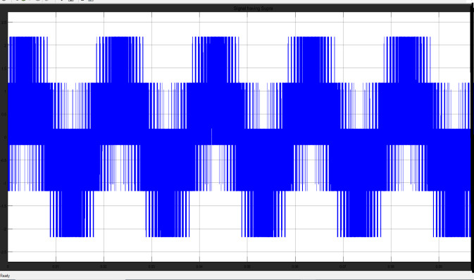Fig 4 Waveform of Suprharmonic
MITIGATION OF CONTROLLER
We are injecting supraharmonics in the gate signals which are of the range of 150 kHz and 200 kHz. To reduce these, we are using controller techniques. Firstly, we try and use Uniform Random Noise in the circuit and observe the current waveforms. But we see that, the method requires a lot of time to execute waveforms and is also a trial and error method. Thus, we didn’t obtain the accurate result. Also, it is a complex method and is difficult while dealing with fixed frequency, which is a disadvantage of this method. To overcome this limitation, we use Fuzzy Controller.
The Uniform Random Number block generates uniformly distributed random numbers over an interval that you specify. To generate normally distributed random numbers, use the Random Number block.
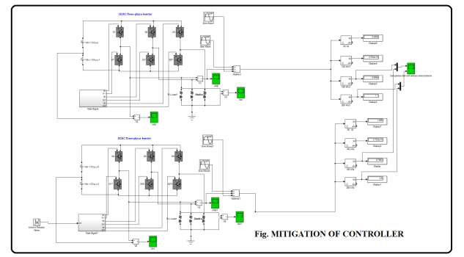
Fig.3 mitigation of controller
The below fig 4 shows the waveform of current for 150 kHz and 200 kHz with and without controller. The yellow line gives the waveform without controller while that with blue depicts the current with controller.
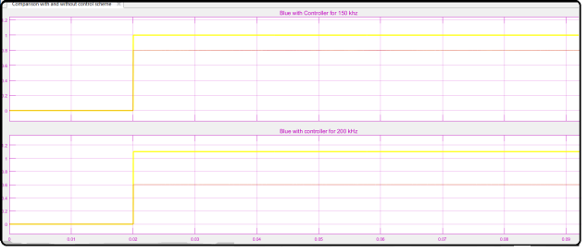Fig.4 Waveform mitigation of controller
MITIGATION OF FUZZY LOGIC CONTROLLER

For the reduction of supraharmonics from the current signal, we are using Uniform Random Noise method. But it is having several disadvantages and the harmonics are not completely reduced. To overcome this limitation, Fuzzy Controllers are used. This method is simple as compared to the former one and can be used for fixed frequencies also. Fuzzy logic works on five basic rules.
In this, we are using Fuzzy Interference System. These are of two types viz. Mandani and Sugeno. Here, we are using Sugeno system. In this type of system, we can give multiple input and also can obtain multiple outputs and is operated at 0 or 1.

The fig 5 below shows the Fuzzy Logic Controller. It output of this is given to the Switch as shown. Also two DSP’s are connected, one of 150 kHz and the other of 200 kHz. As we have seen before, we are injecting a supraharmonic component in the form of sine wave at 180⁰, thus to cancel these here we will in jecting the same harmonics components but at -180⁰ so that both get neutralized and we get the actual waveform. The switch works on the principle that, if the sine value is greater than 0, then the DSP of 150 kHz will come into action and if the value is less than 0, then that of 200 kHz will act. Then the output of this switch is given to the Controlled Voltage Source and it is connected to the sum block.
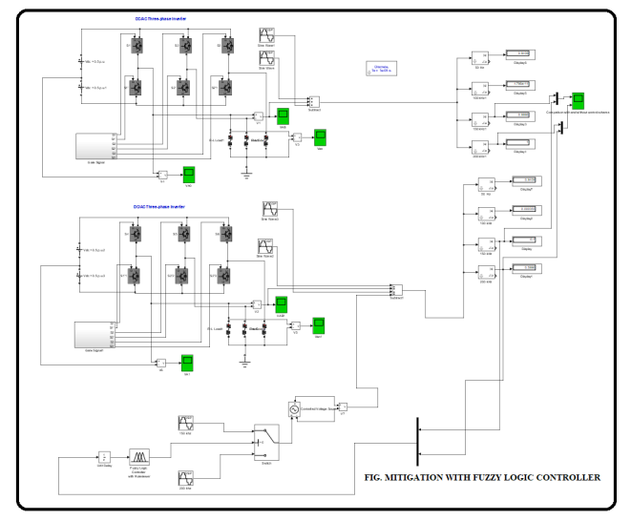Fig.5 Mitigation with Fuzzy Logic Controller

CONCLUSION
Thus we have seen that for the reduction of supraharmonics we use Uniform Random Noise method and then we get fluctuation in power quality, voltage flickering, voltage sag, also which is a complex method, time consuming and it is difficult to fixed frequency systems, Also the results obtained are not accurate. To overcome this, we use Fuzzy Logic Controller which a accurate method which is work on rules that we define and can be used for fixed constant frequency and can easily reduce the supraharmonic components from the signal.
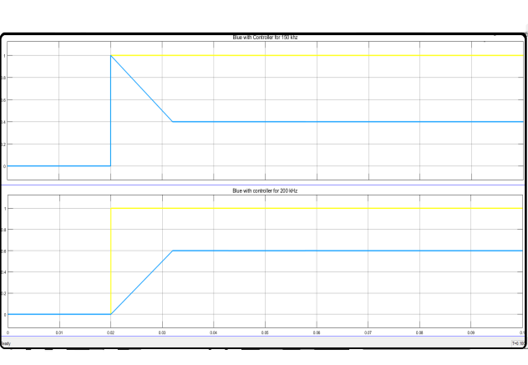Fig.6 Waveform of Mitigation Of Fuzzy Logic Controller
REFERENCES
[1] F. Zavoda et al., CIGRE/CIRED/IEEE working group C4.24 – power
quality in the future grid – progress report.
[2] Sarah Rönnberg, Emission and Interaction from Domestic Installations in the Low Voltage Electricity Network, up to 150 kHz, PhD Thesis, Luleå University of Technology, 2013.
[3] Math Bollen, Magnus Olofsson, Anders Larsson, Sarah Rönnberg and Martin Lundmark, Standards for supraharmonics (2 to 150 kHz), IEEE EMC Magazine, Vol.3 (2014), quarter 1, pp.114-119.
[4] JWG C4/C6.29 Power Quality Aspects of Solar Power– progress report
[5] A. McEachern, "Electric Power Definitions: a Debate, Power Engineering Society General Meeting 2013." .
[6] J. M. Carrasco, L. G. Franquelo, J. T. Bialasiewicz, E. Galvan, R. C. P. Guisado, M. A. M. Prats, J. I. Leon and N. Moreno-Alfonso, "Power-Electronic Systems for the Grid Integration of Renewable Energy Sources: A Survey," Industrial Electronics, IEEE Transactions On, vol. 53, pp. 1002-1016, 2006.
[7] IEC 61727, "Photovoltaic (PV) systems - Characteristics of the utility interface," 2004.
[8] IEC 61000-3-2:2006, "Electromagnetic compatibility (EMC) – Part 3-2: Limits – Limits for harmonic currents emissions (equipment input current up to and 16 A per phase).
[9] S. Rönnberg, "Emission and Interaction from Domestic Installations in the Low Voltage Electricity Network, up to 150 kHz," PhD Thesis, Luleå University of Technology, 2013.
[10] A. Larsson, "High-frequency distortion in power grids due to electronic equipment," Licentiate Thesis, Luleå University of Technology, 2006.
[11] J. Meyer, S. Haehle and P. Schegner, "Impact of higher frequency emission above 2kHz on electronic mass-market equipment," in Electricity Distribution (CIRED 2013), 22nd International Conference and Exhibition on, 2013, .
[12] S. Schöttke, J. Meyer, P. Schegner and S. Bachmann, "Emission in the frequency range of 2 kHz to 150 kHz caused by electrical vehicle charging," in International Symposium on Electromagnetic Compatibility (EMC Europe 2014), Gothenburg, Sweden, 2014,

[13] Dousoky, Gamal M., Masahito Shoyama, and Tamotsu Ninomiya. "FPGA-based spread-spectrum schemes for conducted-noise mitigation in DC–DC power converters: design, implementation, and experimental investigation." Industrial Electronics, IEEE Transactions on 58.2 (2011): 429-435.

[14] Lai, Yen-Sin, Ye-Then Chang, and Bo-Yuan Chen. "Novel random switching PWM technique with constant sampling frequency and constant inductor average current for digitally controlled converter."
Industrial Electronics, IEEE Transactions on 60.8 (2013): 3126-3135.
[14] CIGRE/CIRED JWG C4.29, Power Quality Aspects of Solar Power, final report, in preparation, 2016.

