Infrastructure Quality Assurance Need Of Present Civil Engg. Construction – A Review
Anisha Mire* & Mr.R.C.Singh**
*Asst.Prof. ,Dept of Civil Engg.RSRRCET,Bhilai.
**Asso.Prof. & Head, Dept. of Civil Engg.RSRRCET,Bhilai.

Abstract-: Construction boom is going on in the world at the moment. In India also many residential houses are being constructed, offices and industrial buildings are being built, malls for shopping are being built. As the population is increasing and the space for construction is limited and a fast economic growth rate is taking place in country, with growth in country we expect a scenario to go for higher buildings demolishing the old ones and also to have more roads and over bridges to meet increasing demand of connectivity. But the growth should be sustainable for that its needed to use, optimum use of limited land space and natural resources . Infrastructure development is going on both in public and private sectors. With such increase in activities of construction, there comes the prime question on the quality of materials that are being used for construction and the more professional question comes regarding the factors that really affect the quality in construction. Many constructed earlier old buildings in major cities of India are not resistant to earthquake. Also many bridges also have limited earthquake resistance. Many newly constructed building collapsed recently and also newly bridge constructed collapse have pointed out limitations the quality of finished constructed structures with respect to structure design , method of construction implemented, construction arrangement done, supervision of construction work done, maintenance and use of facilities construction. All these are very important not only to increase the safety but also to increase the life cycle benefits of the structure. Due to all these the customer will get the ultimate benefits when these important issues are properly addressed during execution stage of construction. When a construction time or a post construction disaster strikes, immediately there develops an apprehension regarding quality of the finished structure, we often want to hint at the use of materials of poor quality and supervision. The total extent of quality control, in fact include the (i) Quality of materials in construction used (ii) Finished construction element’s quality (iii) Equipment quality and arrangements used during construction stage,(iv) Quality of construction also depends upon method adopted and its sequence, (v) Quality of safety practice exercised during construction.
- Points Of Considerations In Design
Materials used in engineering construction must use satisfy specified quality and strength. When ever there is disaster like an earthquake, it is important that any building or a bridge or any structure should show its ability as was anticipated in design process. Here plays, a definite role played by material quality used during construction. Earthquake is not only the leading factor to be considered in an engineered design process. A designer initially considers the general stability of the whole structure. Let us take the example of the big disaster that happened in 2001 in Gujarat earthquake, also known as the Bhuj earthquake, occurred on 26 January, India's 51st Republic Day, at 08:46 am IST and lasted for over 2 minutes.
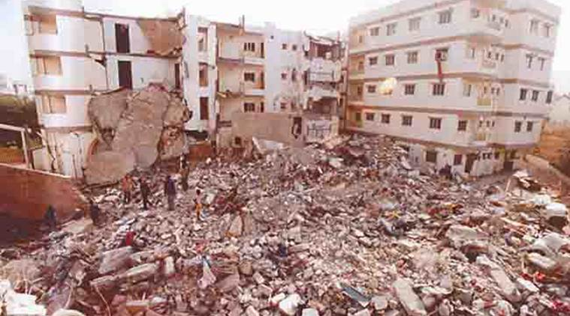
Fig-1 Taluka of Kutch District of Gujarat, India
Its epicenter was about 9 km south-southwest of the village of Chobari in Bhachau. The disaster was not the result of earthquake only. A building or bridge, at first and foremost, must be capable of carrying the gravity load and then also the load of other things that we put on it i.e. the loads coming from its usage type. Next, the designer emphasizes on its resistance against natural calamities like earthquake and severe storm that a structure 'may' experience during its life cycle. Importantly expert supervision and use of materials of better quality may offer additional safety margins against earthquake or other unforeseen natural calamities. Magnitudes of loads coming on the structure from such calamities are often quite unpredictable. Many of the existing old buildings in India especially in Northern region like Delhi are not fit to face a big earthquake, if it really hits. It will cost a lot on life and property.

- Construction perspective
As Indian economy is growing at faster rate, construction and development of infrastructure is also growing, but with the fast pace we cannot compromise with quality of construction. No engineered construction can proceed without having a design from an engineer. The design shall contain geometry of the structure, materials and proportion to be used. The construction method and sequence to be followed will also be mentioned there. Construction should take place under the supervision of engineer who will ensure that designer's expectations are fulfilled at field. It is the responsibility of the owner to appoint able engineer(s) to design and also to supervise. Owner shall also appoint an able contractor who will engage gears, materials and know how to implement the design in the field.
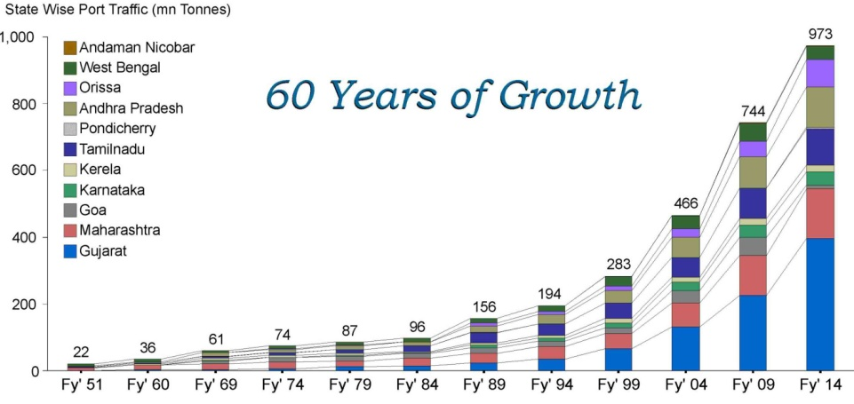
Fig-2 Growth of Indian Economy

Quality of construction equipment and arrangement are important to ensure the quality of the finished product, pace of work and also the safety during construction. The contractor will mobilize these important things. It also includes props, formwork (commonly termed as shutter) and temporary works, including shore piles/ sheet piles/ bracings etc. for earth excavation to construct the basements. These may vary depending on the project and the goal is to satisfy the benchmark requirements.

- Need Of Selection Of Material Quality & Supervision

Most of the companies maintain international standards for example, BIS ( Bureau of Indian Standards ) is the regulatory body in India to specify and enforce the quality to be maintained in any type of construction. But proper use of a material through a good construction practice is very important. Good quality cement doesn’t mean it will form good concrete. For getting good quality concrete you will need good stone, good sand, good workmanship, proper water cement ratio and expert supervision.
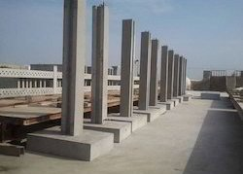

Fig-3 Superior Quality Concrete Columns

Most of our cement companies maintain standard quality in cement manufacturing. Coarse aggregates used are broken lime stones extracted from earth surface. Sands used are as fine aggregates obtained from our river beds are always plenty in India. Hence to offer better durability in construction quality.

- Need Of Ensuring The Quality Of Structure ?
All should be conscious of proper engineered supervision during construction of a building or bridge. If people take advices from any professional engineer, they can minimize cost in many ways. Only a professional engineer knows the proper use of construction materials to get maximum benefits out of it. Columns and foundations should be constructed with care because these elements carry the total load. These are the most critical structural elements. The 2009 Korba chimney collapse occurred in the town of Korba in the Indian state of Chhattisgarh on 23 September 2009. It was under construction under contract for the Bharat Aluminum Co Ltd (BALCO). Construction had reached 240 m (790 ft) when the chimney collapsed on top of more than 100 workers who had been taking shelter from a thunderstorm. At least 45 deaths were recorded Risk of disaster was high in such structural system. But the failure triggered due to weakness in construction supervision. Inadequate design and use of materials of not so good quality increased the risk, leading to a catastrophe. We have ignorance in many works. We take much care in casting a roof and cure it with water but we have carelessness with the construction of columns. Supervision from experts is important.

- Maintenance Of The Constructed Infrastructure
A building or bridge when in use shall also be maintained properly. Repair works shall have to be carried out in a time efficient manner. Vigilance from the owner (and often the user) is important. Like a human being, buildings and bridges also have a life cycle. If not properly used or maintained, today's buildings cannot bear their loads of tomorrow. So the point of maintenance, repair and strengthening comes into picture. We have to build our constructions with products that are economic. In this regard, we have to consider two things: is it economic for now? Or is it economic for a longer life time with minimum maintenance cost to yield the lowest life cycle cost?
- Strengthening Existing Structures - Challenges For Durability
Strengthening is needed when we are in need of using a distressed or unsafe facility for some more time. We can't afford to demolish it for building a new one. In that case, strengthening can be a viable option to avert a disaster. However, strengthening is many times more difficult than constructing a new building. Challenges are in many dimension including technicality, practicability and economy. It is often similar to treating a patient in the Intensive Care Unit. So we, the owners must consult the specialists to design and to supervise the work in field. We cannot even handle a small disaster. We do not have enough equipment or rescue plan. Existing noncompliant buildings must be strengthened. We need a strong enforcement effort from the government in this regard. Many of our construction industries still do not have enough know-how on the materials and techniques used worldwide for strengthening structures. These are imported from abroad. We also need to customize those materials and technologies for use in our local context.

- Steel Or Concrete : Choice Of Materials For Durable Structure ?
Hardinge Bridge, made about 100 years ago, was built by British engineers with steel. It is going to be celebrated 100 years of Hardinge Bridge recently. British India could afford to build it with steel for the intended economic needs of that time. There was no other alternate material available either during that time to go for longer spans to bear heavy rail loads. The popularity of using prestressed concrete for bridge construction in Europe increased significantly around the 1950s and 60s. However, a history of problems has encountered that cast doubt over the long-term durability of such structures. Due to poor workmanship or quality control during construction of prestressed concrete, sometimes the ducts containing the prestressing tendons are not fully filled, leaving voids in the grout where the steel is not protected from corrosion and reduces durability. Which material will be used in construction depends on our affordability and easy availability. The life cycle cost of materials depends on that choice. Life cycle cost of concrete is often costlier than that of steel. We could not afford to build any remarkable bridge with steel in the last 50 years in the country. Any steel structure will ideally be lighter, faster in construction and to last longer, particularly in areas not exposed to salinity or other corrosive environment. Selection of steel structures is suitable where the is not much compressive stress and also there is need of fast assembling and need of fast dismantling if needed, as in case of military operations.

- Salinity Considerations Regarding Concrete & Steel Members
Salinity is the major factor that promotes in an acidic environment. Salinity and reinforcement steel has an inter relation. Acidic environment promotes corrosion. So we need additional protection in this regard. Concrete gives steel an alkaline environment which is opposite to acidic environment. Moisture cannot reach steel in a less permeable concrete. In case of saline environment, clear cover (gap of concrete and steel) should be enhanced. This will require larger concrete sections. Concrete should be dense as well. A salinity zoning map of India i.e parts near coastal areas needs to be developed for use in design.
- Quality Of Bricks For Walls
Bricks are used in making walls and also making concretes of different grades by crushing bricks of the size of coarse aggregates to produce concrete in countries where there is not enough stones such as in Bangladesh. Standard of bricks depends on soil or clay type that we use to produce the bricks. This reduces the quality of our agricultural land from where we harvest clay. Cement based bricks from recycled concrete or sand is an option that is to be studied. The brick wall that is to be constructed that is to be done under proper supervision so that quality of wall is to be maintained and it becomes durable. Also now a days emphasis is given on light weight wall, as wall are only partition between two room spaces, hence replacement of bricks by light weight foam partitions can a suitable choice where there is scarcity of clay.

- Conclusion
All should consult with the proper and educated people before any construction. Concrete is the importance building material its qualities can be maintained in initial stages of mixing, otherwise it not give desired strength if not placed properly. Need of proper compaction with segregation is very important in case concrete so as to get proper cement paste, also curing should also to be done for sufficient number of days, as it will ensure desired concrete strength. Everyone does not need to be an engineer but we have to have basic knowledge of following good construction steps. The definition of literacy should perhaps be redefined.

References
- Quality Management In Concrete Construction , Alok Sarkar , The Indian Concrete Journal October 2007 38-41
- Kamal Rahmani, Abolfazl Shamsai,Bahram Saghafian & Saber Peroti, Effect of Water and Cement Ratio on Compressive Strength and Abrasion of Microsilica Concrete, Middle-East Journal of Scientific Research 12 (8): 1056-1061, 2012, ISSN 1990-9233
- Effects Of Faulty Construction On Building Maintenance , International Journal Of Technology Enhancements And Emerging Engineering Research,Vol-2,Issue 373 ISSN 2347-4289 Copyright © 2014 IJTEEE., Lagos, Nigeria 73-79

- Quality Assurance and Quality Control, Technical Summary-A summary of chapter 9 of the IMCP Manual (reference information on page 4) p.p 241–272

- Abolfazl Shamsai, Kamal Rahmani, Peroti & Loghman Rahemi, The Effect of Water-Cement Ratio in Compressive and Abrasion Strength of the Nano Silica Concretes, World Applied Sciences Journal 17 (4): 540-545, 2012, © IDOSI Publications, 2012, ISSN 1818-4952

- Isaac Akiije, Effects of Using 0.5, 0.55 and 0.6 Water Cement Ratio Separately With a Nigerian Grade 42.5R Portland Cement, International Journal of Science, Technology and Society, ISSN: 2330-7412 (Print); ISSN: 2330-7420 (Online), 2016; 4(6): 80-88

- H.S. Wong1and N.R. Buenfeld, Determining the water-cement ratio, cement content, water content and degree of hydration of hardened cement paste: Method development and validation on paste samples, Concrete Durability Group, Imperial College London, SW7 2AZ, UK, Cement & Concrete Research (2009), 39 (10) 957-965

- Thushara Priyadarshana & Ranjith Dissanayake, Importance of Consistent Cement Quality for a Sustainable Construction, International Journal of Materials, Mechanics and Manufacturing, Vol. 1, No. 4, November 2013 p.p 393-397

- Liana Iureş and Corneliu Bob, The Future Concrete: Self-Compacting Concrete by ,p,p 93-100

- Khaled Marar & Ozgur Eren, Effect of cement content and water/cement ratio on fresh concrete properties, International Journal of the Physical Sciences Vol. 6(24), pp. 5752-5765, 16 October, 2011, DOI: 10.5897/IJPS11.188, ISSN 1992-1950 ©2011 Academic Journals

- Elias B Sayah, Mahadeo S Randive , Gajanan M Sabnis The Effects Of Unskilled Labor On The Quality Of Concrete Construction, 33rd Conference On Our World In Concrete & Structures: 25 – 27 August 2008, Singapore

- Sandra Juradin, Goran Baloevic, Alen Harapin, Impact of Vibrations on the Final Characteristics of Normal and Self-compacting Concrete, Materials Research. 2014; 17(1): 178-185 © 2014

- Tarun R. Naik , Sustainability Of Cement And Concrete Industries, Center for By-Products Utilization Presented and Published at the Global Construction: Ultimate Concrete Opportunities, July 2005, Dundee, Scotland

- Tsung‐Chieh, Furusaka, S. Han,T, Comparative Study on Quality Assurance of Construction Project in Taiwan and Japan, National Yunlin University of Science & Technology, Taiwan, Kyoto University, Japan p.p 308-318

- ASCC Education, Assessing the Impact of “Green” Concrete Mixtures on Building Construction , Research & Development Foundation. December 2013

- Fourth International Conference on Sustainable Construction Materials and Technologies
Vasu Krishna, and Rakesh Kumar, Water to Cement Ratio: A Simple and Effective Approach to Control Plastic and Drying Shrinkage in Concrete

- Nwofor, T.C., Durability of block work: the effect of varying water/cement ratio of mortar joint, Pelagia Research Library, Advances in Applied Science Research, 2012, 3 (3):1848-1853

- Olutoge, F. Adeyemi and Amusan, G. Modupeola, The Effect of Sea Water on Compressive Strength of Concrete, International Journal of Engineering Science Invention, Volume 3 Issue 7 July 2014, PP.23-31, ISSN (Online): 2319 – 6734, ISSN (Print): 2319 – 6726

- Satpute Manesh B., Wakchaure Madhukar R., Patankar Subhash V. Effect of Duration and Temperature of Curing on Compressive Strength of Geopolymer Concrete, International Journal of Engineering and Innovative Technology (IJEIT) Volume 1, Issue 5, May 2012, p.p152- 155

- Hamed Ahmadi Moghadam, Omolbanin Arasteh Khoshbin , Effect of Water- Cement Ratio (W/C) on Mechanical Properties of Self-Compacting Concrete (Case Study), World Academy of Science, Engineering and Technology, International Journal of Civil and Environmental Engineering p.p 317-320

- Francis A. Oluokun, Fly Ash Concrete Mix Design And The Water-Cement Ratio Law, ACI Materials Journal / Julv-Auaust 1994 , p.p 362-371

- Dale P Bentz & Pierre Claude Aitcin, The hidden meaning of water cement ratio , Concrete International , May 2008, p.p 51-54

- R.Savitha, Importance of quality assurance of materials for construction work Building Materials Research and Testing Division, National Building Research Organization

- S. Mahesh , Self Compacting Concrete And Its Properties , Int. Journal of Engineering Research and Applications www.ijera.com ISSN : 2248-9622, Vol. 4, Issue 8( Version 7), August 2014, pp.72-80

- L.Ranjith Kumar, M.Karthikeyan, R.Raghu , Influence of Water-Cement Ratio on Compressive Strength of burnt bricks IOSR Journal of Mechanical and Civil Engineering (IOSR-JMCE) e-ISSN: 2278-1684,p-ISSN: 2320-334X, Volume 14, Issue 2 Ver. II (Mar. - Apr. 2017), pp 91-94

- https://en.wikipedia.org/wiki/2009_Korba_chimney_collapse

