Analysis of Intelligent Transportation System with respect to social, economic and environmental aspect – A Review
K. A. Kulkarni¹, Dr. B.V. Khode² and Dr. S.D. Giripunje³
¹Research Scholar, Transportation Engineering, G.H. Raisoni college of Engineering, Nagpur, Maharashtra, India. Email: kaustubh_kulkarni29@yahoo.com
²Professor, Civil Engineering Department, G.H. Raisoni college of Engineering, Nagpur, Maharashtra, India. Email: bhalchandra.khode@raisoni.net
³Dean PG, Professor, Electronics Engineering Department, G.H. Raisoni College of Engineering, Nagpur, Maharashtra, India. Email: shubhangi.giripunje@raisoni.net

Abstract- Intelligent Transportation systems (ITS) is one of the emerging technologies contributing towards the rapid growth of a country. The problem of growing traffic congestion, growing pollution and increasing fuel consumption and limited land access for the widening of roads can be countered effectively by this technology. Thus many countries are using Intelligent Transportation system to develop a smooth and rapid transportation system for the citizens. This paper presents a review of the effect of Intelligent Transportation systems on social, economy and environmental aspects of a region. A brief study of advantages of ITS is done to understand the efficiency of the technology.
Keywords: Intelligent Transportation System (ITS), congestion, environment, economic, social.

- INTRODUCTION

The increase in population with high growth rate is resulting in increase in number of vehicles on road. And this increasing number of vehicles have started to go beyond the capacity of roadways at many places. As the demand is increasing over the capacity, there is a situation of congestion developed at these places. The studies published on congestion shows how important this problem is for the state or the country. Traffic congestions has bad impact over the development as it affects the economic, environmental and social factors of the society.

Large number of researchers along with various public, private or government organizations are together working to counter the problem of congestion and accidents throughout the world. It is found out that to use the resources at current rates is not feasible. It may lead to the extinction of resources. Thus an idea to develop a sustainable transportation system emerged.

Congestion and reducing level of service of roadways is one of the main concerns of developing urban area and their residents. The local government organizations invest large amount of money on solutions like expansion of roadways or construction of over or under bridge to better the level of service. But it extracts low benefits due to insufficient space for expansion or lack of feasibility of the bridges. Congestion, at the same time also affects an important factor responsible for the existence of human life which is air. It reduces air quality, seen especially in urban areas. The emission of gases like CO, NO_{x}, and other gases is hazardous to human health. Its emission thus make transportation one of the main reason behind the increasing global pollution. Along with these factors as mentioned above, increasing vehicular population have also lead to increase in crashes causing deaths and injuries to millions of people every year.

So a necessity to overcome these effects of increasing on road vehicles causing congestion, pollution and accidents ultimately affecting the social, economic and environmental life of the society emerged. Intelligent transportation System (ITS) is found to be one of the sustainable transportation system. As the various ITS components were deployed, number of researchers evaluated the changes brought about by the implementation. Some of these work is discussed below.

Hui Wang et al. (1) analyzed the impact of Intelligent Transportation System (ITS) technologies on road safety and the challenges of ITS safety evaluation. The main objective was to study the impact of ITS deployment with respect to safety of people. It was achieved by comparing data available from various resources and the results were presented as shown below,

TABLE I
ITS SAFETY BENEFITS
Safety benefits given in terms of percent reduction in accidents
Advanced signal control | 75%~78% | Japan
Adaptive signal control | 18% | United States
Adaptive signal control | 30% | Europe
Ramp metering | 24%~50% | United States
Speed enforcement cameras | 20%~80% | United States
Speed enforcement cameras | 50% | Europe
Controlled motorway | 50% | Europe
Collision warning | 33%~40% | United States
Weather monitoring and VMS | 30%~40% | Europe
Driver monitoring | Up to 41% | Europe
Emergency response | 7%~12% | Europe
Dynamic route guidance | 1% | United States
Incident and emergency management | 15% | United States
Crash avoidance systems | Up to 17% (nationally) | United States

The authors further concluded that fully deployed ITS system reduces the crashes by large percentage and save billions of lives.

LI Jiuxi et al. (2) proposed the use of Intelligent Speed Adaption (ISA) to reduce fuel consumption and emission. ISA was initially used as safety measure. The authors considered a straight forward road section with two different traffic flow: morning peak i.e. am peak and off peak traffic flows. Changes in Total travel time and corresponding fuel consumption along with the emission were studied at different percentage of penetration of ISA applied vehicle in regular flow. The simulation was achieved by a microscopic traffic simulation tool integrated with a modal emission/ fuel consumption model, BDGW which explicitly considers the different driving conditions like acceleration, deceleration.
The results which clearly shows increase in travel time and decrease in fuel consumption with increase in ISA penetration was tabulated as below,

TABLE II
SIMULATION RESULTS OF THE IMPACT OF ISA ON TOTAL TRAVEL TIME AND FUEL CONSUMPTION

ISA  Penetration Rate (%) | Total travel time(vehicle-hours) |  | Fuel consumption(liters)
 | AM peak | Off peak | AM peak | Off peak
0 | 407.2 | 281.7 | 7126 | 4957
10 | 406.7 | 282.2 | 7242 | 4962
20 | 407.3 | 283.6 | 7221 | 4927
30 | 409.6 | 284.6 | 7195 | 4922
40 | 405.8 | 289.1 | 7085 | 4885
50 | 408.2 | 293.2 | 7009 | 4863
60 | 407.6 | 293.3 | 6893 | 4816
70 | 415.2 | 292.3 | 6863 | 4742
80 | 412.7 | 299.2 | 6730 | 4724
90 | 413.3 | 297.8 | 6637 | 4636
100 | 418.1 | 299.8 | 6554 | 4540

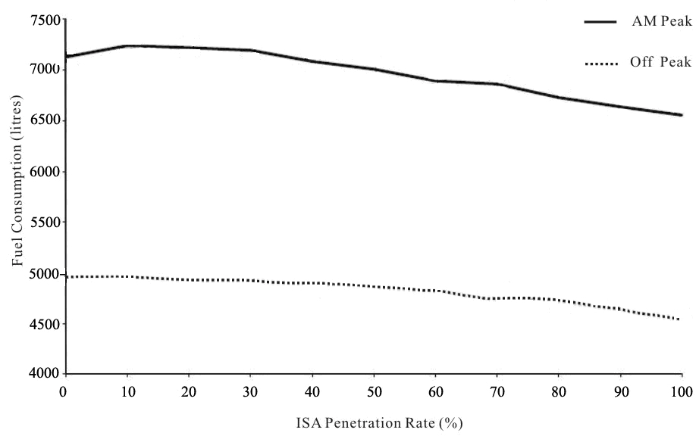
Figure 1. Fuel consumption

Thus it was concluded that ISA may decrease fuel consumption by about 8% if all vehicles in the traffic flow adopts ISA which will ultimately reduce emission as well.

Haiyan GU et al. (3) studied the impact of Intelligent Transportation System on Social Economic development. The increasing migration towards urban cities created a situation of high density of population in these areas and transportation departments which are not ready for to provide service to such a heavy demand comes in trouble. The lack of public transport thus gives rise to vehicle ownership.

Thus the authors on the basis of evidences suggests the use of smart and intelligent transportation system to overcome the traffic problems. The use of ITS will not only give a sustainable solution but also provide a number of job opportunities which will effect into development of economy as well as social life of the citizens.
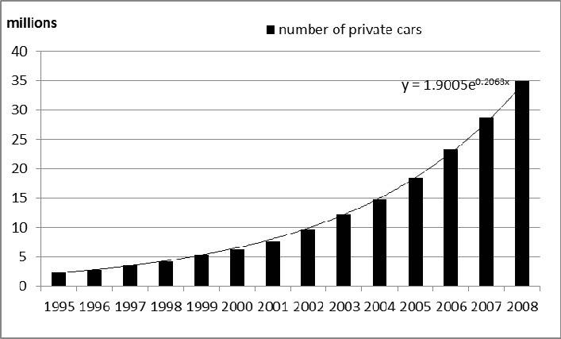
Figure 2. Increasing number of private cars in China.

ITS involves numerous infrastructure and to build and maintain these system, number of skilled and un-skilled labors will be required. Thus ITS have an ability to generate job opportunity if collaborated across industry boundaries, pro-actively with the cities.

Carlos SILVA and Jorge SANTOS (4) evaluated the social acceptability of Intelligent Transportation System (ITS). It is very helpful to know how an user will respond to new technology to determine the success of this technology in future. So the authors conducted a survey to evaluate the social acceptability of ITS by putting the users in a situation and providing them with an ITS solution. Some of the dimensions of ITS adaptability are shown below. (Reference: Vlasenroot et. al. (2010))

- Background Factors Driving
General Indicators
Attitudes
- Knowledge About the problem
- Personal and social Aims
Responsibility Awareness
- Social Norms
- Problem Perception
System Specific Indicators
- Perceived Efficiency
- Perceived Effectiveness
- Perceived usability
- Perceived usefulness
- Satisfaction
- Equity
- Affordability

The situation of fatigue and distraction was put forward to the responders with two different solutions: Only alert; Alert and Control. Only alert solution gave alerts to the driver on dashboards or through voice commands to take rest in case a fatigue is sensed or to reduce speed in case distraction is sensed while the alert and control solution first gave the alert and took over control of the vehicle if the driver don’t respond to the alerts. A valid questionnaire was prepared by the authors and presented to 77 participants (31 females and 46 males). Out of which 49 participants answered Only Alert group questions while 28 answered Alert and Control group questions. The questionnaire was validated by Exploratory Factor Analysis (EFA). The results were presents as shown below.
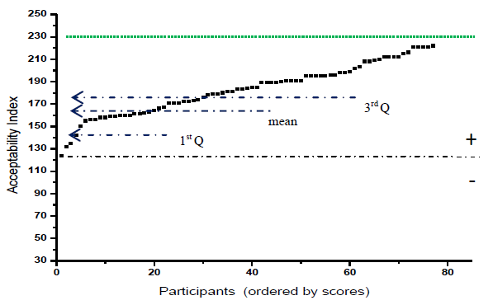
Figure 3. Scores distribution in the AI for all the participants.
The results clearly states that the Acceptability Index of all the participants are in the positive side and maximum of them are above the mean of the scores. Thus most of the people preferred ITS to take over in the situation of fatigue and distraction. Further it was noted that more women tend to accept ITS to take control then men. But overall acceptability for alert only group was found more than the alert and control group. Thus the authors successfully evaluated social acceptability of ITS and formed a valid measurement tool for the same.
Sumit Mallik (5) proposed implementation of various Intelligent Transportation System (ITS) deployments for security, vehicle surveillance combined with other technologies to make the ride safe, economical and causing less harm to the environment. The author rigorously studied the use of ITS in the society and where it can be applied to get maximum output. Three major problems were identified as:
- Lack of Traffic management system.
- Homeland security systems and vehicle operations.
- Vehicle to vehicle co-ordination and implementation of new technologies.

These problems were majorly caused by the growing population of vehicles. On the basis of literature some solutions were suggested as:
- Use of GPS, GIS, Remote sensing applications to manage traffic.
- Implementation of wireless communication by using Bluetooth, WiFi, etc to develop vehicle to vehicle communication.

Some technologies to be implemented for Environmental sustainability were also suggested on the basis of literature. Those technologies are:
- Electronic Road Tolling
- Advanced Driver Assistance system
- Human machine interface on board
- Vehicle to Vehicle communication system

Thus the author concluded that use of ITS is definitely going to better the experience of travelling on road. Use of technology had always been fundamental in providing satisfaction to the user. Thus use of ITS will also encourage more use of public transport system over private vehicle. This will significantly reduce pollution and save large amount of fuel making it available for the future generations. ITS is definitely a technology to look forward to reduce the congestion and pollution and have a safe, smooth, enjoyable travelling experience.
Mostofa Kamal Nasir et al. (6) worked on reduction of fuel consumption and exhaust pollutant using Intelligent Transportation systems (ITS). Through a rigorous literature survey, the paper investigated the ITS technologies to reduce fuel consumption and minimize the rate of exhausting pollutants like Carbon Monoxide (CO), Hydrocarbons, Carbon dioxide, particular matter (PM) and oxides of nitrogen (NO_{x}). It also highlighted environmental impacts of ITS deployments to provide green solution and presented a case study to evaluate the same.
The case study involved a Green navigation method which was based on reduction of fuel consumption. The input of the model included:
- Static street parameters (e.g. Number of stops (ST) )
- Dynamic street parameters (Vehicle mean speed (v))

The Mathematical model:
- Mean Speed,

$$μ(x,t,S)=\frac{1}{\frac{1}{m}\sum_{m}{\frac{1}{v}}}$$

Where, x = location,
t = time interval,
S = section of road,
m = number of vehicles assed through location x,
v = mean speed.

- Total Fuel Consumption (TFC)

$$Total Fuel Consumption TFC= fuel consumed at running + fuel consumed at stop sign.$$

$$Total Fuel Consumption TFC=\sum_{i}^{n}{S_{i}v_{i}+f_{c}}\sum_{j}^{m}{t_{j}}$$
Where,
S_{i} = length of road section i,
v_{i} = mean speed of section S_{i,}
f_{c} = fuel consumption per second for which vehicle is idle,
t_{j}= idle time at point j.

Three different routes between same origin and destination with different traffic condition i.e. free flow, moderate flow and congestion were found out. The total distance travelled, time taken to travel and fuel consumed where presented in results for all 3 routes as given below.
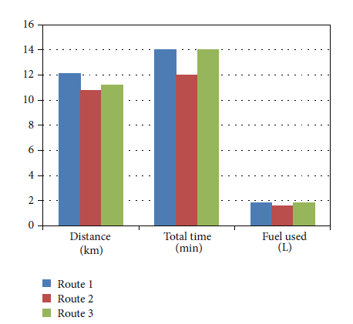
Figure 4. Bar graph for the distance, total travel times, and fuel used in free flow condition.
Thus it was clearly found that green ITS technology significantly reduced energy consumption in road transportation system. Green navigation technology shows little impact when a short distance and single vehicle is considered as seen the results broadcast above but it make a significant difference in terms of fuel consumption if long routes and large number of vehicles are considered.

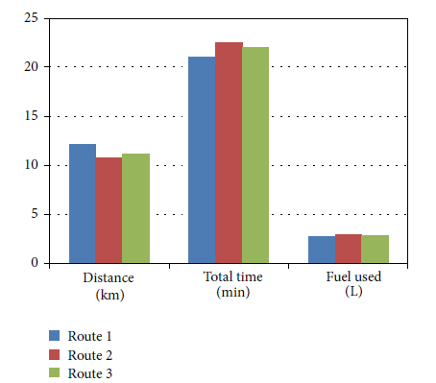
Figure 5. Bar graph for the distance, total travel times, and fuel used in moderate congestion.

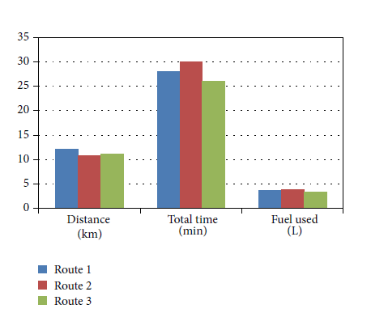
Figure 6. Bar graph for the distance, total travel times, and fuel used in congested condition.

A.B. Nkaro and Y.A. Vershinin (7) studied applications of Intelligent Transport Systems (ITS) on cars and infrastructure which are very important considering the future traffic conditions and vehicle and user sustenance. The present and future trends of ITS applications are discussed considering the enormous literature available on the subject. The ITS applications are majorly divided into two categories to study:
- ITS applications on CARS:

Applications:
- Adaptive Cruise Control (ACC)
- Obstacle Warning
- Lane detection
- Collision notification and avoidance.
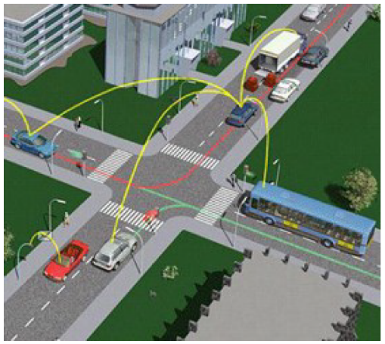
Figure 7. The application of ITS on an intelligent vehicle transmitting information in it’s travelling environment.
Source: (MIRA Ltd. 2014)

- ITS applications on INFRASTRUCTURE:

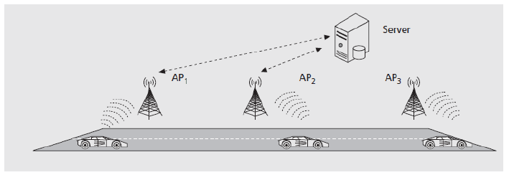
Figure8. The communication between intelligent infrastructure and host vehicle.
Source: (Papadimitratos, P. 2009)

Applications:
- Commercial vehicle administration
- Transit management
- Data management

ITS application on cars is more dependent on increasing and improving driver’s awareness and response of vehicle while on road. According to (McDonald, Mike 2006) Advanced Driver Assistance System were initiated to improve integration of technologies by using sensors and communication devices while applications on infrastructure include transmission of information on three following reasons:
- Receiving information by vehicle from highway infrastructure through sensors, detectors and control systems,
- Receiving information by highway infrastructure from host vehicle,
- Exchange of information between host vehicle and infrastructure for maximizing the benefit.

Future trends of ITS technologies and applications discussed by the author are:
- Global Positioning System (GPS)
- GALILEO
- GLONASS
- WAVE
- Inertia Navigation System (INS)
- COMPASS
- QZSS (Quasis- Zenith Satellite System)
- AutoNet
- VANET (Vehicular applications & inter networking technology)

TABLE III
GLOBAL NAVIGATION SATELLITE SYSTEM (GNSS)
Source: (Batarline 2007)

No. | Acronym of system | The full name of system | Regions of use
1 | GALILEO | European Satellite Navigation System | In Europe since 2008
2 | SBAS | Satellite based Augmentation System | North America, Europe, Asia.
3 | WAAS | Wide area augmentation | North America
4 | ENOS | European Geostationary Navigation Overlay Service | Europe
5 | MSAS | MTSAT Satellite Based Augmentation System | Japan
6 | DGPS | Differential Global Positioning System | In the world
7 | Thales Navigation | Thales Navigation and Thales group | In the world

The aim to deliver immense benefits is achieved by the application of improved and enhanced telematics technology. ITS application will reduce road accidents, improve driver information, improve road capacity and also reduce the expulsion of carbon dioxide which ultimately reduces air pollution. Maximum exploitation of ITS applications is not yet achieved and thus there is reluctance to invest in ITS.

- CONCLUSION

Intelligent transportation system clearly has many positives as proved from the literature and data available from the countries were ITS is implemented. Some of the important conclusions can be stated as:
- ITS deployments can reduce the number of crashes on any transport network and save millions of life and injuries.
- Use of ITS reduces fuel consumption by about 8% ~ 10% which can increases even further on fully deployed ITS network and long routes. This also proves that it reduces exhausting pollutants by almost same amount.
- Use of ITS creates numerous job opportunities which affects the socio-economic growth of the country.

Thus it can be observed that ITS have a positive impact on social, economic and environment of a society and thus it can prove to be an important factor in development of India looking at the current situation of pollution, congestions and fuel consumption.

ITS have only one disadvantage:
- If the complete road network is deployed with ITS applications then the failure of it can stop the complete traffic flow which can lead to a very difficult situation.

While there are benefits ITS, there are opportunities for exploration, research work and application. Some suggested areas for future scope may include research into standardization, to identify most suitable technologies and infrastructure for vehicle to vehicle and vehicle to roadside communications (McDonald, Mike
2006).

REFERENCES

- Hui Wang, Patrick Hasson, Mac Lister, “Intelligent Transportation Systems (ITS) Safety Impact.” , Applications of Advanced Technologies in Transportation (2002)

- LI Jiuxi, WANG Chunshan, LI Qiang, WANG Bin, “Intelligent Speed Adaptation Impact of Fuel Consumption and Emission.” International Conference on Transportation Engineering 2009 (ICTE 2009).
- Haiyan GU, Wei WANG, Yongkai HU, Lili QIAO, Fengping ZHAN, “Study on the Intelligent Transport System and Social Economic Development.” CICTP 2012 © ASCE 2012.
- Carlos Silva, Jorge Santos, “The Social Acceptability of Intelligent Transportation Systems.” ICTIS 2013 © ASCE 2013.
- Sumit Mallik, “Intelligent Transportation System.” International Journal of Civil Engineering Research. ISSN 2278-3652 Volume 5, Number 4 (2014), pp. 367-372
- Mostofa Kamal Nasir, Rafidah Md Noor, M. A. Kalam, and B. M. Masum, “Reduction of Fuel Consumption and Exhaust Pollutant Using Intelligent Transportation Systems” The Scientific World Journal. Volume 2014, Article ID 836375.
- A.B. Nkoro and Y.A. Vershinin, “Current and Future Trends in Applications of Intelligent Transportation Systems on Cars and Infrastructure” 17th International Conference on Intelligent Transportation System (ITSC), October 8-11, 2104. Qingdao, China.

