Design and Fabrication of Human Following Robot

¹Saurabh.S.Purohit, ²Vishal.B.Diwate, ³Umesh.M.Shambharkar, ⁴Swaraj.R.Mohod, ⁵Sharayu.Wasu.
^{1,2,3,4,5}Student, Department of Mechanical Engineering WCEM, Nagpur,India, 440001.
⁵Project Guide-Assistant Professor,WCEM, Nagpur,India. 440001.

Abstract –A robot that can assist us in a variety of ways, such as transporting objects, working with greater accuracy in less time, and performing other tasks. In emergency situations, a robot that can assist us in the hospital or bring medical supplies will be more useful to a doctor. This type of robot has numerous advantages and will be beneficial in the future. This type of robot is quite likely to be near to humans. This useful effort aims to find the proper person or obstacle to follow. Infrared sensors are utilized to move the robot in both directions, while ultrasonic sensors are used to drive the robot forward and backward. As a microcontroller, we used the Arduino Uno. The Arduino Uno microcontroller served as the project's brain.
This robot is powered by four DC motors and is controlled by an ATmega L293d motor driver shield. The primary goal of creating this useful project is to make our lives easier and more luxurious. In this project, a robotic automobile uses an IR sensor to automatically detect humans and follow them around obstacles.
This form of robot will be more useful in the future, and it will be trend.
Humanoid robotics is a new study subject that has gotten a lot of interest in recent years and will play a big part in robotics research and various applications in the twentyfirst century and beyond.
In this fastpaced society, robots like "A Human Following.Robot" are needed to interact and co-exist with humans.
These robots can operate as assistants for people in a variety of scenarios, and they can also obtain or monitor certain information about the human subjectthanks to their human following capabilities. We propose a prototype that incorporates an Arduino Uno and basic sensors such as an ultrasonic and infrared sensor in this paper.
Keywords- Arduino, microcontroller, DC motors, infrared sensors, ultrasonic sensor

INTRODUCTION

A robot must be able to recognize and track humans in this high-tech world. A 'Human Following Robot' is a robot that can recgnise and follow a human or an obstacle within a
certain range.
The image processing performed to visually obtain information about the surroundings is
critical. While performing the processing, keep the following points in mind. The brightness levels should be highly consistent and not fluctuate.
The ranges should be chosen appropriately for the environment in which the tracking will be performed. Because distance affects so much, the object should not be too far away from the
visual sensor. We should avoid using colours that are similar to those of the target surrounding the robot. Otherwise, the robot will become perplexed.

The capability of a robot to track and follow a moving object
can be used for several purposes.
• To help humans.
• To create ease for people.
• Can be used for defense purpose.
In this paper, we presented a method of a human following robot based on tag identification and detection by using sensors. Intelligent tracking of specified target is carried out by the use of different sensors and modules the goal of this research is to locate and track the individual. We have noticed in our daily lives that carrying items in many places will be challenging, so we must implement.
Nowadays, ROBOTS are essential for providing comfort to people.
They are frequently used in large projects, such as social gathering plants and food
processing lines. Humans are following robots have been thoroughly investigated and developed by a variety of organizations and affiliations all over the world, with the goal of maximizing their benefits and applications in our day-to-day lives.
Soon, individual after robots are utilized such that can able and make us much more agreeably and reasonably.
It assists the producer by making it easier to use robots that are programmed to work with
people as well as help themselves.
People nowadays rely on ROBOTS to provide them with comfort.
Large projects, such as social gathering plants and food manufacturing lines, usually employ Themhumans are catching uprobots have been intensively explored and developed by a number of organisations and affiliations around the world in order to maximise their benefits and
applications in our daily lives. Individual after individual, robots are soon to be used in order to make us more agreeable and reasonable. It makes it easier for the producer to use robots that are programmed to work with people as well as help themselves.
DESIGN
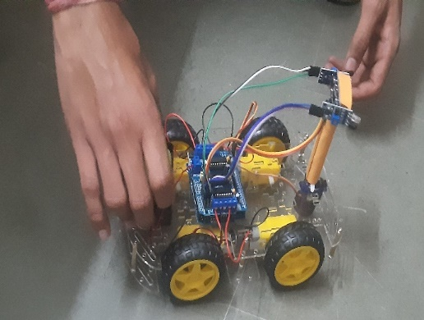
[A]

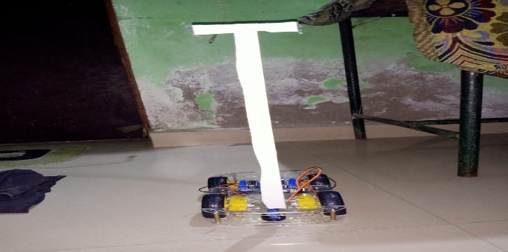
[B]

COMPONENTS

- ARDUINO UNO
The Arduino Uno is an open-source microcontroller board in view of the Microchip ATmega328P microcontroller and created by Arduino.cc. The board is furnished with sets of advanced and simple information/yield (I/O) sticks that might be connected to different development sheets (safeguards) and different circuits.

- MOTOR SHIELD DRIVER
The Arduino Motor Shield depends on the L298 (datasheet), which is a double full-span driver intended to drive inductive loads like transfers, solenoids, DC and venturing engines. It lets you drive two DC engines with your Arduino board, controlling the speed and heading of every one autonomously.

- SERVO MOTOR
A servomotor (or servo engine) is a rotating actuator or
direct actuator that considers exact control of rakish or straight position, speed and acceleration.

- JUMPER WIRES
A leap wire (otherwise called jumper, jumper wire, DuPont wire) is an electrical wire, or gathering of them in a link, with a connector or pin at each end (or in some cases without them - just "tinned"), which is regularly used to interconnect the parts of a breadboard or other model or test circuit, inside or with other gear or parts, without welding.

- ULTRASONIC SENSOR
An ultrasonic sensor is an instrument that actions the distance to an article utilizing ultrasonic sound waves. An ultrasonic sensor utilizes a transducer to send and get ultrasonic heartbeats that hand-off back data about an article's nearness.

- INFRARED SENSORS
The pyroelectric IR sensor utilizes a frequency range from 2 to 14 µm. Infra Tec utilizes unique ingestion layers with the goal that the infrared sensors could function as huge region, long haul stable beneficiaries for UV radiation (for example 193 nm) yet in addition for THz radiation in the scope of 100 µm … 1 mm.

- DC MOTORS
A DC engine is any engine inside a class of electrical machines by which direct flow electrical power is changed over into mechanical power.

METHEDOLOGY
- An efficient exploration philosophy is taken on remembering a definitive objective of a completely utilitarian and independent human following robot.
- A decentralized big picture perspective is utilized for this task. The task is isolated in to five modules. Every module is free from each other. Various stages were done bit by bit, beginning from fundamental sensor testing and continuing towards obstruction aversion, object recognition, object following and information transmission.
- Because of the decentralized methodology, all modules and sensors act freely. Information got by various sensors and modules is on the whole broke down and a shrewd choice based on data got is made that educate the robot to pursue a specific bearing. Two separate units are utilized for example microchip and a regulator. The handling is done by chip and the data acquired by the sensors is constrained by a regulator for example Arduino board. A sequential correspondence among microchip and regulator is laid out to trade the visual detecting data.
- This approach was most reasonable since, in such a case that there is an issue in any of the modules then it wouldn't influence the whole framework. Consequently, this gives the most ideal outcomes by keeping up with exactness.
- Human following, impediment aversion, avoiding the article and laying out a correspondence interface among microchip and regulator are the fundamental parts of this undertaking.
CONCLUSION
This study shows how a person follower robot can be implemented successfully.
This robot not only has detection capabilities, but also tracking and following capabilities. The tracking is based on the detection of the tag, and the human is followed as a result. It was also considered that the robot's "following" capabilities should be as effective as possible. The tests were carried out under various settings in order to identify and correct any errors in thealgorithm.
The various sensors that were integrated with the robot provided an added benefit.
ACKNOWLEDGEMENT
No volume of words is sufficient to offer our thanks towards our aide sir Mr. Tashi Rapden Wangchuk Bhutia, Sr. speaker in the Department of Electrical and Electronics Engineering who has been exceptionally concerned also, directed for every one of the thoughts and settle quires in the readiness of this undertaking. They have been very agreeable and genuine us through to see our persistent effort become productive. We are exceptionally appreciative to Mr. Mukesh Kumar Sharma, project organizer for offering us the chance to convey out this task. Likewise we are especially appreciative to the proprietors of Elcetrozon.in, Sapan Pradhan and Aakash Prajapati for giving the necessary parts at extremely low cost and for giving each detail and working of parts and parts.We additionally need to communicate our gratitude to our folks for giving us the time and cash for this undertaking. Lastly, I might want to offer my thanks towards my colleagues for giving their 100 percent exertion and their hard work to make our task succeed, without them and their help finishing this project was impractical.
REFERENCES
- Kharga Bahadur Kharka, Tashi Rapden Wangchuk Bhutia, Lalita Chettri, Neetes Luitel, Roshan Subba, Eshant Giri, Samuel Lepcha, “Human following robot using Arduino Uno”, IRJMETS Volume:03/Issue:07/July-2021.
- Mano Tejaswini Gandla, “Human following Robot”,
- Muhammad Sarmad Hassan, Mafaz Wali Khan, Ali Fahim Khan, “Student Research Paper Conference Vol-2, No-15, July 2015.
- Dhiren Sati, Sanket Avkirkar, Rishi Pandey, Abhijit Somnathe, “Human following robot”, IJARIIT (Volume 7, Issue 3 - V7I3-1579)

- T. Yoshimi, M. Nishiyama, T. Sonoura, H. Nakamoto, S. Tokura, H. Sato, F. Ozaki, N. Matsuhira, and H Mizoguchi, “Development of a Person Following Robot with Vision Based Target Detection,” in 2006
- IEEE/RSJ International Conference on Intelligent Robots and Systems, 2006, pp. 5286–5291.

- Muhammad Sarmad Hassan, Mafaz Wali Khan, Ali Fahim Khan, “Design and Development of Human Following Robot”, 2015 Student Research Paper Conference,Vol-2, No-15.

- 7.Triebel, R.; Arras, K.; Alami, R.; Beyer, L.; Breuers, S.; Chatila, R.; Chetouani, M.; Cremers, D.; Evers, V.;
- Fiore, M.; et al. Spencer: A Socially Aware Service Robot for Passenger Guidance and Help in Busy Airports; Field
- and Service Robotics; Springer: Berlin, Germany, 2016; pp. 607–622.

