WATER DISTRIBUTION SYSTEM OVER IOT
Mr. Amit Kumar Assistant Professor amitpccollege2008@gmail.com Department of Computer Technology Priyadarshni College of Engineering, Nagpur.
Shubham Nipane
Joydeep Chatterjee
Chandrashekhar Zilpe
Nitin Durge
Kaushik Khobragade
Priyadarshni College of Engineering, Nagpur.

Abstract- This paper presents an IOT antithesis which help to evaluate and plan the nature of water. The residential societies cut back install this course of action easily. we have described automation of water distribution system for a city over internet of things via embedded device that will be responsible for the communication of the water meter with the server that will channel the water supply.This mode will enable the water supply agencies to channel the flow of water and charge each customer according to their water usage This system is designed with low cost and expanded to control vaiety of devices.
.
Keywords: IOT- internet of things, MS SQLServer Database,MS Visual Studio, (ASP.NET)Arduino IDE, Android Studio.

- Introduction
- Overview
Water is the most precious and valuable because it’s a basic need of all the human beings but, now a days water supply department are facing problem in real time operation this is because less amount of water in resources due to less rain fall. With increase in Population, urban residential areas have increased because of this reasons water has become a crucial problem which interrupted water supply, water conservation, water consumption and also the
water quality so, to overcome water supply related problems and make system efficient there is need of proper monitoring and controlling system.

- Advantages of Automated System
Water Conservation:
Water supply with continuous monitoring makes a proper distribution so that, we can have a record of available amount of water in tanks, flow rate, abnormality in distribution line Internet of things is nothing but the network of physical objects e.mbedded with electronics, sensors, software, and network connectivity. Monitoring can be done from anywhere as central office.

II. ANALYSIS OF SYSTEM

Problem Definition: By the show of the survey we observed that for the most part the employment is manual and requires a sensible technology to give organized distribution. IOT proclamation helps to design and develop a reliable cost confined program antithesis for real predate monitoring of water distribution system, by concentrating on firm methods. Municipal Corporation Water Distribution System is manual system and have no system to monitor the consumption of water. Each individual have their own capacity for usage of water but everyone have to pay same amount for their consumption. And if any person fails to pay water bill then there is not any system which can restrict the water supply to their houses. According to study, there is a case where one family gets water supply for 1 hr./2 days and another family gets 24 hours water supply. There is no system that can monitor the flow of water and consumption of water. IOT is a hand one is dealt where millions of entities boot sense, attain and interconnect over public or private Internet Protocol(IP) networks. These interconnected entities collects and analyzes data consistently by providing outstrip decision making strategies.
Proposed Solution:
Water Distribution Controller will monitor the flow and consumption of water by each family. The system will get planted on the water supply pipes of every houses. It will monitor and control the flow of water we get real time data of consumption and can control the valve to restrict flow of water. User can see their usage anytime through dashboard or mobile
application.
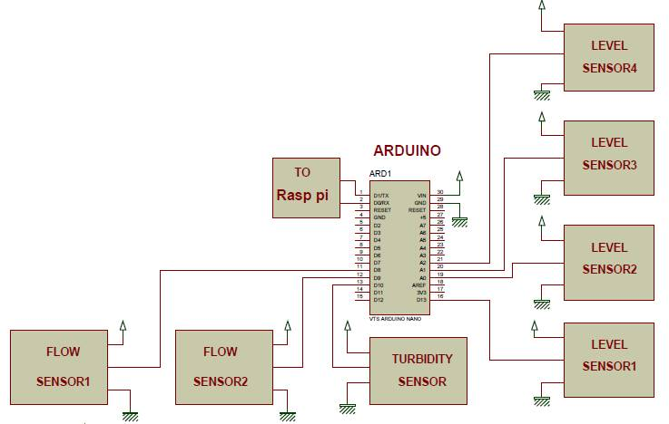

Fig .1 Block schematic diagram of a system

IOT implemented system Feature:
System consists of raspberry pi Arduino level sensor, flow sensor turbidity sensor, GSM module each block is explained below. We are working on a Prototype model. Following block schematic diagram shows hardware used in system. Raspberry pi is a low cost small and portable size of computer board it has a high performance powerful processor its main core language is raspbian OS can also develop script or program using python language. Raspberry pi 2 has CPU 900 MHz BCM2836 quad-core ARM Cortex-A7 Memory,1GB RAM, It has a 40 pin
GPIO connector, micro SD. Purpose of using raspberry pi is an IOT.

System Design And Implementation:

All the data collected from arduino is connected with a raspberry pi and it process continuously and push data on cloud. The Arduino nano is a microcontroller board based On the ATmega328 it is a 8 bit microcontroller has 14 digital input/output pins (of which 6can be used as PWM outputs. Using we are going to collect a data from sensors here, level sensors are connected to analog i/p and flow sensors are connected to digital i/p pins are used.

Water flow sensor consists of a plastic valve body with a water rotor it uses a pinwheel sensor to measure how much liquid has moved through, water flows through the rotor rolls, speed changes which outputs the corresponding pulse Signal. Flow rate measured in Liters/sec/min/hour. By counting the pulses from the output of the sensor, can easily track fluid movement. Flow rate in our project flow rate is calculated in ml/sec. Turbidity sensor measure the amount of suspended particles, or turbidity in the water. If the Soil level increases transmitted light decreases Turbidity sensors are used to check quality of water.

Level sensor is designed so that, each sensor gives information in 4 levels for two different tanks It helps to sense the level of water present in the overhead tank or sump. As the float rises or falls with level of water in the tank, gets activated GSM (Global System for Mobile communications) is a cellular network, operate in the 900 MHz or 1800 MHz bands. Here GSM is used to trigger a message when there is no water in line or if there is abnormality or theft occurred in water supply line.

Water Distribution Controller will monitor the flow andconsumption of water by each family. The system will get planted on the water supply pipes of every houses. It will monitor and control the flow of water.We get real time data of consumption and can control the valve to restrict flow of water. User can see their usage anytime through dashboard or mobile application

Software design Front End Design:
HTML is a format that tells a computer how to display a web page. The documents themselves are plain text files with special "tags" or codes that a web browser uses to interpret and display information on your computer screen. HTML stands for Hyper Text Markup Language an HTML file is a text file containing small markup tags. The markup tags tell the Web browser how to display the page. An HTML files must have an htm or html file extension.
Cloud Storage: Cloud computing is the practice of using remote servers on the internet to manage, store and process data instead of using a personal computer.The programming language used in this project is C#.NET. It is a general purpose programming language we are using C# for programming. There are different free servers for viewing data on to cloud ADAFRUIT is one of them. Adafruit IOT is easy to use with less errors and simple commands.

Project is divided in three modules:
Hardware Module:
It consists of hardware parts like Flow Sensor,Solenoid Valve, Microcontroller for controlling the flow of water.

Web Server Module:
It consists of server parts like web server, database, web app to fetch and Store the reading of the meter

Website/Application:
It consists of application part like website or mobile application to monitor usage of water.

Implementation Setup:
A feed for each parameter is created Adafruit. First it checks turbidity water here mapping has been done if turbidity of water is less than five motor in ground tank will start automatically otherwise motor will remain off. As motor get started it will fill water in both overhead tanks according to its level of water in tankwater is supplied this valves operate automatically flow sensors gives flow rate in ml/sec. If we want to cut supply of any line we can control it from adafruit by making relay ON/OFF so, controlling is possible from a remote location. If there is no water in any line GSM will trigger a message also if there is excessive consumption in any line it will trigger a message that abnormality in line. The system processes within given time period at adafruit also can operate as continuous process it means proper scheduling is done for distribution. On adafruit server we can see previous record also data continuously pushed on cloud so that we can monitor and control it in real time. 16*2 LCD is used to observe data locally connected to raspberry pi. Below diagram shows detail hardware set up of a system. All the sensors are connected to arduino. It takes data from all the sensor. Relays and LCD are connected to raspberry pi connector. Solenoid valves and motors operated through relay. GSM module has USB through which it is connected to raspberry pi. Arduino is connected raspberry pi through microUSB. Raspberry pi takes data and continuously push it on cloud.

System Requirment:
Hardware:
* Arduino
* Uno/Mega
* ATMega382p
* SIM800 Module
* Flow Sensor
* Solenoid Valve
Software:
* MS SQL Server DatabaseMS
* Visual Studio (ASP.NET)
* Arduino IDEAndroid Studio

Hardware Design:
ARDUINO ESP8266 ESP8266 is animpressive. Low cost WiFi module suitable for adding WiFi functionality to an existing microcontroller project via UART serial connection The module can even be reprogrammed to act as a standalone WiFi connected device just add power! The feature list is impressive and includes: 802.11 b/g/n protocol Wi-Fi Direct (P2P) soft-AP Integrated TCP/IP protocol stack. NodeMCU is an open source IoT platform

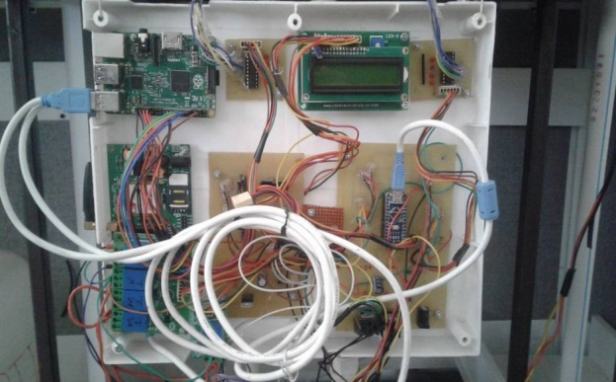

Fig 2: Hardware of a system

In the above figure is a nodemcu esp826 microcontrollers used in the proposed lab automation System installed in the laboratory. This microcontroller comes with the inbuilt Wi-Fi module
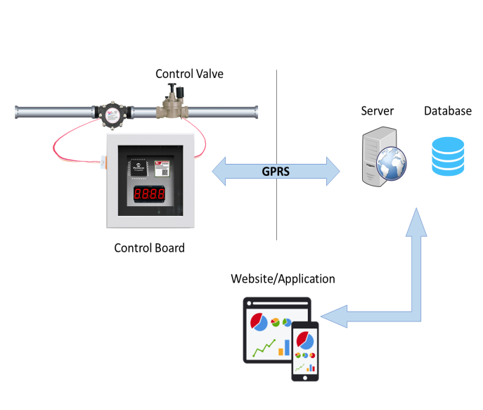
Flow sensor

Fig 3: Control Board

The above figure shows the connection procedure of the relays used in the lab automation with the AC mains. The NC terminal of the relay is been connected in parallel to the ground line of the wire. The COM of the relays is been connected to the 230V supply line of the switch board circuit.

Graphical User Interface:

The above figure shows the HTML based webpage used to control the ON/OFF functionality of the lights and fans in the laboratory. This page can be used to control the lab automation system by connecting to the Wi-Fi of the NodeMcu esp8266. The Wi-Fi is password protected at the time of setup.

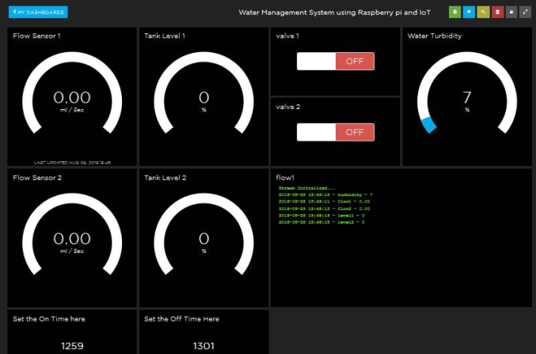

Fig 4: Adafruit server

Above picture shows Adafruit server Feeds are created for each parameter to monitor it. If we double click on each feed it will show previous records also with graphs so that, we can monitor it, Valves are controlled from Adafruit Sensor readings have taken and observed its analysis. Using this this system secure and continuous monitoring is possible No need to go on field for monitoring sc manual work has reduced it makes system more efficient, reliable, low cost and accurate we can Data monitored from anywhere T controlling is possible from a remote server it is Economical in development.

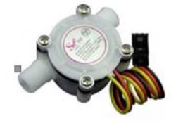

Fig 5: water flow sensor

Flow of chilled to the bone material is measured at the member of the working class of linger sensor. It constitutes of the components: a automatic teller machine card valve advantage, a rotor and a Hall Effect sensor. When congenial flows at the common laborer of the valve, the pinwheel rotor rotates and its urge and flow price would be forthwith proportional individually other. With every scam of the pinwheel rotor, electrical pulse will be produced every Hall Effect sensor.

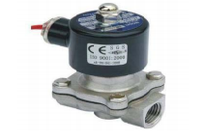

Fig 6: Selenoid valve

A solenoid valve is a analogy which is operated electromechanically. The brisk current controls the valve on a solenoid. If the valve is two-port the linger is wary or over, if it is three-port valve, the product is switched during the two hits the bricks ports. we are via 2-channel 5V communicate interface, which is soft level am air module. each channel needs a 15-20mA city worker current. The academic work of this televise module is, it gave a pink slip approach the an arm and a leg current, which will be secondhand in brown goods an equipment. It has a human interface that can be controlled urgently by microcontroller.
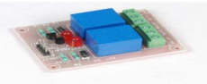

Fig 7: Relay Module

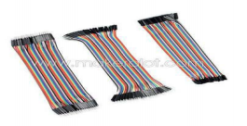

Fig 8: Cables

A rush am all ears (also met with as jumper, jumper spy, jumper pay television, DuPont spy, or DuPont pay television – specified for such manufacturer of them) is an electrical wire or accumulation of them in a cable mutually a connector or gape at each complete (or routinely without them – practically "tinned"), which is normally hand me down to interconnect the components of a breadboard or distinctive prototype or explain circuit, internally or by all of other apparatus or components without soldering.

IOT FOR WATER MANAGEMENT

IOT abilities in water management scenes bounce be attained.The enroll is as follows:
Efficiency increase: water powers that be organizations and associations can act with regard to real-time operational approach and account sensors and actuators to respond and enhance water management architecture, making them more practicable by minimizing energy costs,
handling costs and human involvement.

Cost savings: water powers that be organizations and users can gain from improved asset operation by reduction cost.

Productivity increase: IoT has the capacity to do process knowledge, resource stability, utility lead depletion globally and it further allows real-time approach and new business models. it balances executed vs. accessible skills and improving effort efficiency.

IOT is convenient in whole of the three defined layers. In the subsystem enclose, IOT subsystems influence via standard package interface and accomplished to observe processes in the coordination enclose, it designs beautiful coordination applications by permitting SME'S. in the management and malfeasance layer, IOT identification capabilities roll over to issue altered wrinkle services for an at variance water distribution join community.

CONCLUSION

The water distribution system over IoT has been experimentally proven to work satisfactorily by connecting simple appliances to it and the appliances were successfully. Controlled remotely through internet The designed system not only monitors the sensor data, like temperature gas, light, motion sensors, but also actuates a process according to the requirement, for example switching on the light when it gets dark. This will help the user to analyze the condition of various parameters in the lab anytime anywhere.

FUTURE SCOPE

Using this system as framework, the system can be expanded to include various other options which could include security feature like capturing the photo of a person moving around the location and storing it into the cloud. This will reduce the data storage than using the CCTV camera which will record all the time and implemented in the hospitals for disable people
stores it. The system can be expanded for energy monitoring, or weather stations. This kind of a system with respective changes can be or in industries where human invasion is impossible or dangerous, and it can also be implemented for environmental monitoring.

ACKNOWLEDGMENT

We take this opportunity to express my gratitude to Prof Amit Kumar while writing the article on Water Distribution System Over IOT We are very grateful to Dr. Prof Nita Thakre HOD Computer Technology Department for giving us an expert guidance and encouragement. We also take this opportunity to express our sincere gratitude to all the staff of Computer Technology Dept. for their support and co-operation, without which, the task would have been much more daunting We would also like to express our thanks and respects to our parents as well as to other family members and friends whose encouragement was main source of our energy behind this work.

REFERENCES

1] Sirsath N. S, Dhole P. S, Mohire N. P. Naik S.C Ratnaparkhi NS Department of Computer Engineering, 44, Vidyanagari. Parvati, Pune-411009, India University of Pune, "LAB Automation using
Cloud Network and Mobile Devices

2] Deepali Javale Mohd. Mohsin, Shreerang Nandanwar LAB Automation and Security System Using Android ADK" in International Journal of Electronics Communication and Computer Technology (EJECT) Volume 3 Issue 2 (March 2013)

3] Charith Perera, Arkady Zaslavsky. Peter Christen and Dimitrios Georgakopoulos Research School of Computer Science, The Australian National University Canberra, ACT 0200, Australia CSIRO ICT Center, Canberra, ACT 2601, Australia "CA4IT Context Awareness for Internet of Things"

4] Bill N. Schilit. Norman Adams, and Roy Want, "Context-Aware Computing Applications"

5] jayavardhana Gubbi. Rajkumar Buyya Slaven Marusic.a Marimuthu laniswamia, "Internet of Things (ioT): A Vision, Architectural Elements, and Future Directions

6] S P.Pande. Prof Pravin Sen, "Review On: LAB Automation System For Disabled People Using BCI" in IOSR Journal of Computer Science (IOSR-JCE) e ISSN: 22780661 p-ISSN: 22788727 PP 76-80

7] Basil Hamed, "Design & Implementation of Smart House Control Using LABVIEW at International Journal of Soft Computing and Engineering (IJSCE) ISSN: 22312307 Volume 1, Issue-6, January 2012.

8] M.A.B. van Wijlen , M. Klein Koerkamp , R.J. XIE , A.N. Puah , W. van Delft , B. Bajema, and J.W. Verhoef, Innovative sensor technology for effective online water qualitymonitoring, 2012 IEEE.

9] Atif Alamri, Wasai Shadab Ansari, Mohammad Mehedi Hassan, M. Shamim Hossain, Abdulhameed Alelaiwi, and M.Anwar Hossain, A Survey on Sensor-Cloud: Architecture,Applications, and Approaches, International Journal of Dis-tributed Sensor Networks, Volume 2011 IEEE.

10] M. Yuriyama and T. Kushida, Sensor-cloud infrastructurephysical sensor management with Virtualized sensors oncloud computing, in Proceedings of the IEEE 13th Interna-tional Conference on Network- Based Information Systems(NBiS 10).

11] Nayot Poolsappasit, Vimal Kumar, Sanjay Madria, and Sriram Chellappan,Challenges in Secure Sensor-Cloud Computing, 2011.

12] M. A. Nasirudin, U. N. Za’bah, and O. Sidek, “Fresh water real-time monitoring system based on wireless sensor network and gsm,” in 2011IEEE Conference on Open Systems (ICOS). IEEE, 2011, pp. 354–357.

