Manufacturing Processes Part I: A Brief Review on Forming Technology
Vallabh Bhoyar¹, Swapnil Umredkar²
¹ Student
G.H.Raisoni College of Engineering, Nagpur, India, 440016
² Student
G.H.Raisoni College of Engineering, Nagpur, India, 440016

Abstract: The objective of this paper is to identify and understand the various forming processes, to introduction to various variable in forming, advantages and disadvantages of processes. Forming is the science in which the shaping of metal is done by using the forces. Some important forming terms that are widely used are discussed. A brief description about classification of forming process on the basis of temperature of workpiece (hot, cold and warm forming) and on the basis of types of dies is given. Deformation of material is explained with plasticity of material and theory of plasticity in detail. Also, brief discussion of the material properties and types of forces acted upon workpiece is also explained. In today’s generation formed parts are considered as the better parts than parts produce by casting, and reason is it’s properties (grain flow effect of strain rate on flow stresses). Generation of friction and need of lubrication is also discussed. In this paper, the main concentration is about to introduction briefly about processes in forming as forging, rolling, extrusion, wire and bar drawing, bending operations, deep drawing and shearing process.
Keywords: Forming, Forging, Extrusion, Rolling
- INTRODUCTION:
Forming processes of metal is also known as mechanical working processes. In these processes specific mass of alloys and metals are concentrated by mechanical forces, are also known as primary shaping processes. As a result of mechanical forces, the required size and shape of machine part can be achieved with higher economy in time and material. Material may undergo “plastic deformation” is the requirement of mechanical working during it’s processing. Malleability and ductility are important properties of alloys and metal in case of metal forming. There are both hot and cold metal forming operations because work piece material is not malleable or ductile as per requirement at ordinary room temperature, but can obtain so when heated.
When a single crystal is subjected to an external force, it first undergoes elastic deformation; that is, it returns to its original shape when the force is removed. For example, the behaviour is a helical spring that stretches when loaded and returns to its original shape when the load is removed. If the force on the crystal structure is increased sufficiently, the crystal undergoes plastic deformation or permanent deformation; that is, it does not return to its original shape when the force is removed.
In crystal structures, plastic deformation takes place by two basic mechanisms. First is the slipping of one plane of atoms over an adjacent plane (called the slip plane) under a shear stress. The second and less common mechanism of plastic deformation in crystals is twinning.

- CLASSIFICATION OF MATERIALS

- Elastic material: a material is said to be perfectly elastic when the deformation produced under the action of external loads vanishes completely on the removal of load.
- Plastic material: if a material does not regain its original shape and size on the removal of load and gets permanently deformed, it is called a plastic material. A perfectly plastic material is that in which the material shows a phenomenon of flow with comparatively less load. For example, clay and lead are plastic material.
- Ductile material: if a material can undergo considerable deformation without rupture or can be drawn into wires, it is called a ductile material.
- Brittle material: if a material can not undergo any deformation under the action of external loads and it fails by rupture, it is called a brittle material.

- MECHANICAL PROPERTIES OF MATERIAL
- Strength: the strength of material is its ability to sustain loads without undue distortion, collapse or rupture. The maximum stress that any material will withstand is called ultimate strength or tenacity.
- Elasticity: it is the property of material by virtue of which it regains its original size and shape after deformation, when the loads causing deformation are removed.
- Plasticity: the plasticity of material is the ability to change its shape without destruction under the action of external loads and to regain the shape given to it when forces are removed.
- Ductility: it is the property of a material to undergo a considerable deformation under tension before rupture. A body possessing ductility can be reduced from large sections to thinner and thinner sections i.e. it can be drawn into wires.
- Brittleness: the brittleness of a material property of breaking, fracturing or shattering without prior warning or without much permanent distortion under load.
- Malleability: it is the property of a material by virtue of which it gets permanently deformed by compression without rupture. It is the ability of a material to be rolled or beaten up into thin sheets without cracking by rolling and hammering.
- Impact strength: the amount of shock energy absorbed by a specimen before it fractures is called its impact strength or toughness.
- Hardness: the ability of material to resist wear, abrasion, scratching or indentation by harder bodies is called hardness.
- Fatigue: a material may fail under fluctuating or repeated loads eventhough the maximum applied stress is considerably less than the tensile strength of the material under steady loads. This phenomenon of failure of a material under fluctuating or repeated loading is called fayigue endurance.
- Creep: the continuous deformation with time which the material undergoes due to application of external steady loads is called creep or time yield or plastic flow.
- Stiffness: the ability of a material to resist elastic deformation is called stiffness.

- GENERAL PARAMETERS OF DEFORMATION:
- Material being deformed must be characterized on the basis of;
- Strength or resistance for deformation
- Conditions at different temperatures
- Formability limits
- Reaction to lubricants
- Speed of deformation and speed sensitivity

V- ADVANTAGES AND DISADVANTAGES OF COLD AND HOT WORKING PROCESSES
- Cold working is practically done at room temperature results, no oxidation or tarnishing of surface takes place. There is no scale formation, hence there is no material loss where as in hot working, there is scale formation due to oxidation. Hot working of steel also results in partial decarburization of the work piece surface as carbon gets oxidized as CO2.
- Hot working results in lesser dimensional accuracy, hot rolled steel bars produced by hot rolling process are called black bars (they appear greyish black due to oxidation of surface) while those produced by cold rolling process are therefore called bright bars, results in better dimensional accuracy and a bright surface.
- Heavy work hardening occurs in cold working results in improvement of the strength and hardness of bars, and high forces are required for deformation increasing energy consumption. In hot working this is not so.
- Production of complex shapes is not possible by cold working processes due to limited ductility at room temperature.
- The component manufactured may fail prematurely in service If these stresses are not relieved because several internal stresses are induced in the metal during cold working. In hot working, there are no such residual internal stresses and the mechanically worked structure is better than that produced by cold working.
- At high temperature the strength of materials reduces and Its malleability and ductility improve. This is the reason by which low capacity equipment is required for hot working processes.

VI- COMPARISON OF HOT AND COLD WORKING OF METAL
When plastic deformation of alloy or metal are made to occurs below the recrystallization temperature of that alloy or metal then it is called as cold working. As a result of mechanical working in cold working process the strain hardening occurs, which does not get relived. If the effect of strain hardening is not removed it may cause cracking and failure of material by the forces applied to cause plastic deformation because higher forces for plastic deformation required as the alloys or metal gets progressively strain hardened.
Hot working may be explained as plastic deformation of metals and alloys at such a temperature above recrystallization temperature at which recovery and recrystallization take place simultaneously with the strain hardening.
Recrystallization temperature is not a fixed temperature, but it is a temperature range. Usually it is taken as one third of melting temperature of alloy or metal. It’s value depend upon several factors. Some of the important factors are :
Nature of alloy or metal: It is usually higher for alloys and lower for pure metals. For alloys, recrystallization temperature is roughly half of the melting temperature and for pure metal it is approximately one third of melting point.
Amount of cold work already done: As the amount of strain-hardening done on the work piece increases the recrystallization temperature is decreases.
Strain-rate: Higher the rate of strain hardening, lower is the recrystallization temperature. Considering mild steel 550-650°C may be taken as recrystallization temperature. For the materials having lower melting points like lead zinc and tin may be taken as room temperature. Anneling above the recrystallization temperature can be remove the effects of strain hardening.

VII- ADVANTAGES OF PROCESS MODELLING
- Simulations can be created using finite element modelling
- Models can predict and evaluate the calculations that how a model will respond to fill a forging die, flow through an extrusion die, response of a rolling process or solidify of casting process.
- Simulations of heat treatments.
- Costly developments can be eliminated like trial and error methods.

VIII- VARIABLES IN METAL FORMING THEORY
- Independent variable:

The processes aspects that the engineer or operator has direct control
- Starting material
- Starting geometry of the workpiece
- Tool or die geometry
- Lubrication
- Starting temperature
- Speed of operation
- Amount of deformation

- Dependent variables:
These are those variables that are determined by the independent variable section
- Force or power requirements
- Material properties of the product
- Exit or final temperature
- Surface finish and precision
- Nature of the material flow

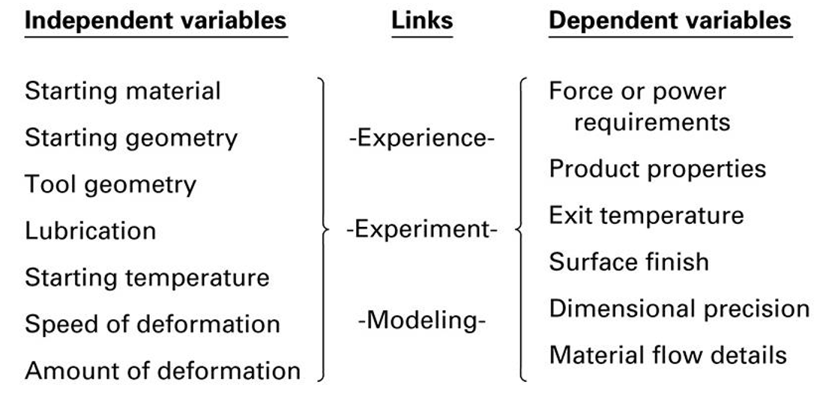
Figure 1: Variables in metal forming theory
IX-TYPES OF METAL FORMING PROCESSES
- Bulk deformation
- Forging process
- Rolling process
- Extrusion process
- Wire and bar drawing
- Sheet metal working or Press working
- Bending operation
- Deep or cut drawing
- Shearing processes
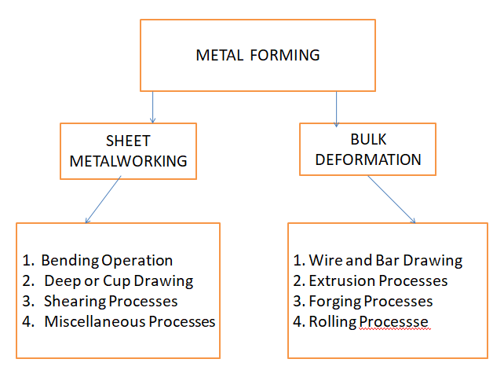
Figure 2: Types of Metal Forming Process
FORGING
Forging maybe defined as a metal forming process of giving required shape to red hot metal with the application of impact force. Forging is the operation where the metal or alloy is heated above its lower critical temperature and then compressive force is applied to get final shape by plastic deformation. It is one of the most important and oldest metalworking operations used to make jewelry, coins, and various implements by hammering metal with tools made of stone. Forged parts now include aircraft and railroads, bolts and rivets, numerous structural components for machinery, large rotors for turbines, hand tools, and a variety of other transportation equipment.
Simple forging operations has been done traditionally by blacksmiths and can be performed with a heavy hammer and an anvil. However, most forgings require a set of dies and such equipment as a press or a powered forging hammer. Forging may be carried out at room temperature (cold forging) or at elevated temperatures (warm or hot forging) depending on the homologous temperature. Cold forging requires higher forces and the work piece material must possess sufficient ductility at room temperature to undergo the necessary deformation without cracking. Cold-forged parts have a good surface finish and dimensional accuracy. the dimensional accuracy and surface finish of the hot forged parts are not as good as in cold forging but Hot forging requires lower forces. Forgings generally are subjected to additional finishing operations, such as heat treating to modify properties and machining to obtain accurate final dimensions and a good surface finish.
The force is applied in two ways (1) Impact force in the form of blow (2) squeeze force by the presses. These parts are referred as forging.
Usually a bar, billet or blank is raw material for forging. Forging is considered as production of heavy parts and the parts which are heated in a closed furnace. The pressure and force is applied by heavy hammers, forging presses and machines. There are four types of forging methods used in practice. Those are :
- Smith or hand forging
- Drop forging
- Press forging
- Machine forging or upset forging
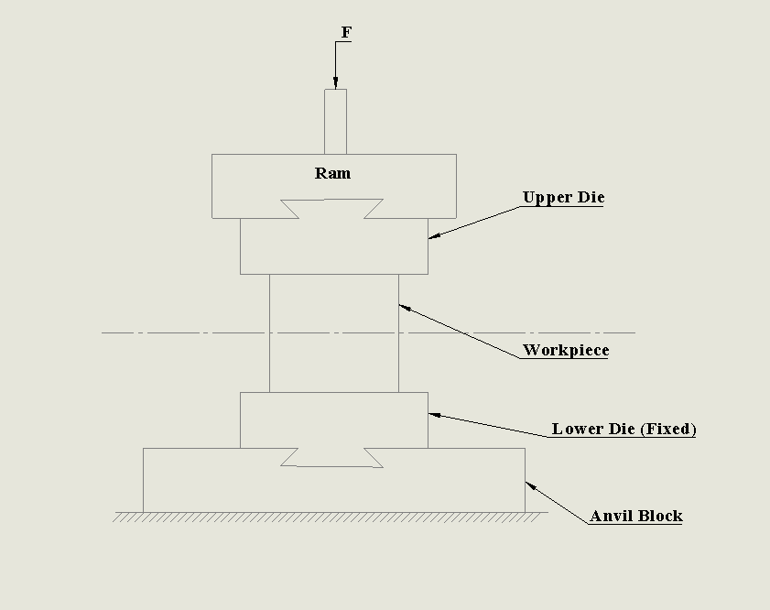
Figure 3: Open Die Forging
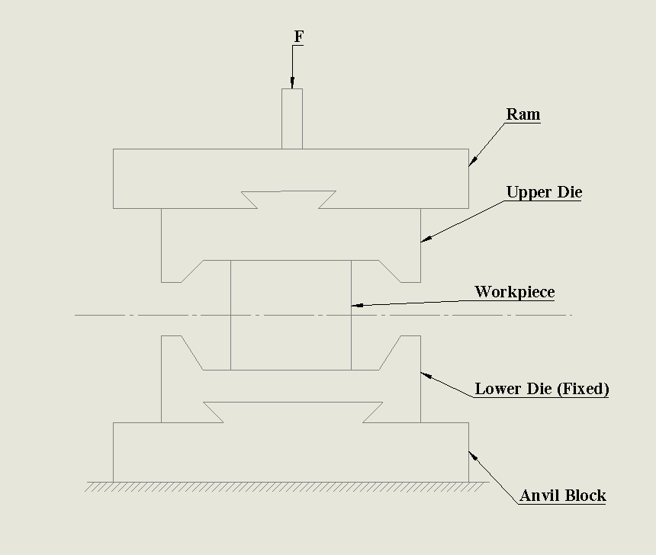
Figure 4: Closed Die Forging
EXTRUSION
Extrusion may be defined as metal working process in which stock of metal subjected to plastic flow by enclosing the metal in a closed chamber in which it is pushed to flow through the opening of die. Extrusion process produces continuous lengths of uniform, non-uniform cross-sections from a metal billet. The cross-section produced are either solid or hollow. The process of extrusion is most commonly used for the manufacture of solid and hollow sections of nonferrous metals and alloys e.g., aluminium, aluminium-magnesium alloys, magnesium and its alloys, copper, brass and bronze etc. An extrusion carried out by extrusion press. It has three major components:
- The container or cylinder
- Die
- Plunger with ram
some steel products are also made by extrusion. Extrusion may be done hot or cold. The cross sections of extruded products vary widely. A heated metal billet is placed in the container and forced out through a die by a ram plunger. The billet coming out of the die takes the shape of the die openings. The pressure is applied either hydraulically or mechanically. The extrusion operation is similar to the squeezing of toothpaste. Mostly non-ferrous alloys are worked in this process. Broadly extrusion process is classified as:
- Direct extrusion
- Indirect extrusion
Pressure required for extrusion depends upon:-
- Strength of material
- The extrusion temperature
- Reduction in cross section required
- The speed of extrusion

X-ADVANTAGES OF EXTRUSION PROCESS
- Cross sections not possible by rolling process can be done using extrusion processes.
- Usually brittle materials can also be easily extruded using these prosses.
- Superfine grain size of extruded parts.
- As compared to rolling cost of setup is less.
- Compared to casting extrusion products are light weight and stronger.
- Superior tolerances can be achieved than rolling processes.

XI-DISADVANTAGES OF EXTRUSION PROCESS
- These can only use for the only those shapes which has constant cross-section.
- As compared to rolling process, scrap and waste after the extrusion process is higher.
XII- APPLICATIONS
- These processes mostly employed on the non-ferrous metals like aluminium, copper magnesium etc.
- Manufacturing of seamless tubes made from special alloy syeels.
- Channel section, I-section, Z-section, T-section, etc.
- Tubes and pipes of complex configurations.

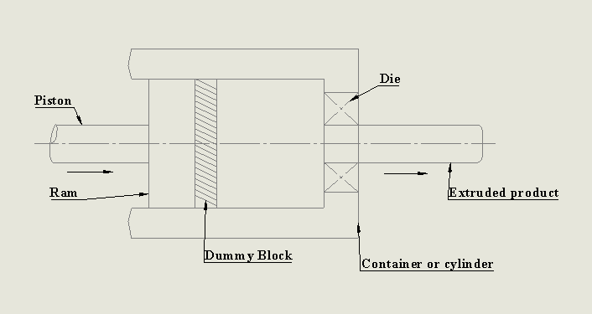
Figure 5: Direct Extrusion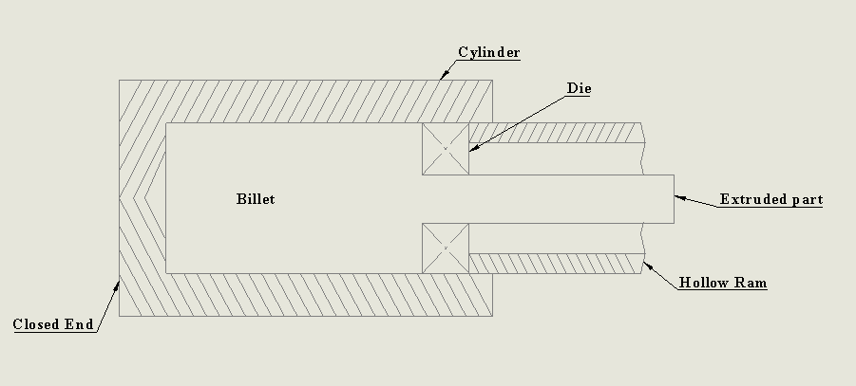
Figure 6: Indirect Extrusion
ROLLING
When requirement of metal is in long length of uniform cross section, the process which is applied for the deformation is known as rolling. Rolling is more economical than forging. In this process, between two rolls which are rotating plastically deformed metals and alloys are being pressed into semifinished or finished product. It is a rapid process of forming metal into desired shape by plastic deformation. Initially, into the space between two rolls metal is pushed, therefore a “bite” once taken by roll of edge of material, by the friction material gets pulled in between the surface of rolls and material. As it is squeezed (and pulled along) by the rolls, the material is subjected to high compressive force. In this method metal is compressed between two rotating rolls to increase in length and reducing its cross-sectional area. Rolling is most widely used mechanical working process used in industry today. Fig. shows rolling of rectangular slab of thickness $t_{1}$, which after rolling is reduced to $t_{2}$. Also, frictional forces between the rolls are responsible for drawing out the metal. Rolling can produce a bar having constant cross-section throughout its length. It can produce many shapes such as I, T , L, C and various channel sections. Rolling is done in both i.e. hot rolling and cold rolling.
TYPES OF ROLLING
The machine in which the rolling operation is performed is known as rolling machine. A set of rolls and the housing in which they are mounted are known as stand. One method to classify the rolling mills is according to number of rolls in the working stand. They are:
- Two high rolling mill
- Three high rolling mill
- Continuous mill
- Four high rolling mill
Several metals are rolled into variety of shapes by hot as well as cold rolling. These metals include aluminium, copper, magnesium and their alloys. Various grades of steel including structural steel are commonly employed to rolling processes. Different types of shapes are formed in rolling processes. Those are I-section, T-section, L-section, C-section as shown in fig.
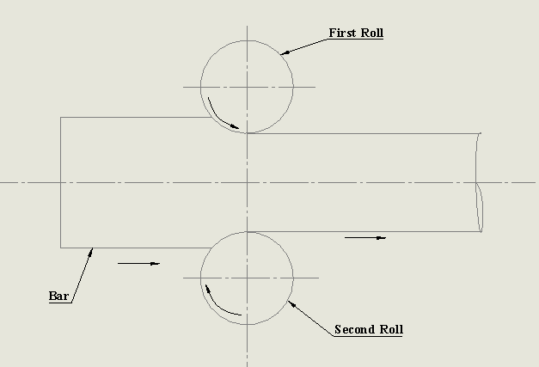
Figure 7: Two high rolling mill
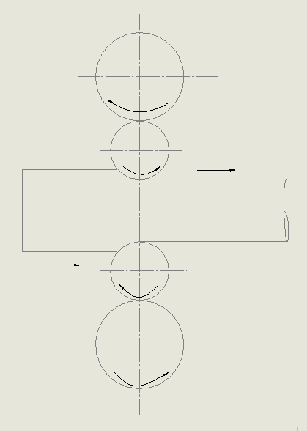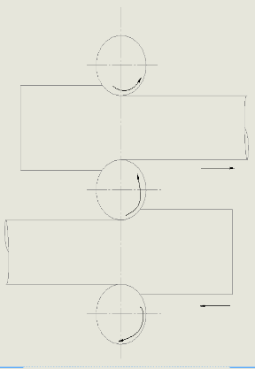
Figure 8: Three high rolling mill & Four high rolling mill
Table no.1: Comparison of Hot and Cold Rolling
Hot rolling | Cold rolling
Metal heated above recrystallization temperature is fed to the rollers. | Metal below the recrystallisation temperature is fed to the rollers.
Poor dimensional accuracy and finish. | Good dimensional accuracy and finish.
Suitable of production of large section. | Deformation is limited to the small section.
Very thin sections cab not be obtained. | Thin sections can be produced.
Roller radius is generally higher in size. | Comparatively roller radius is smaller.
Wide range of shapes like billets, blooms, slabs, sheets, bar, etc. can be produced. | Suitable for production of plates, sheets, foils, etc.

REFERENCES
- Bharti, S. (2017). Advancement in Forging Process: A Review. International Journal of Science and Research (IJSR), 6(12), 465–468. https://doi.org/10.21275/art20178736
- Min, N. L., & Thu, M. P. (2018). Analysis of Forging Processes for Machine Building Industry Modeling. 7(08), 214–217.
- Rathi, M. G., & Jakhade, N. A. (2014). An Overview of Forging Processes with Their Defects. International Journal of Scientific and Research Publications, 4(1), 2250–3153. Retrieved from www.ijsrp.org
- Milutinović, M., Vilotić, D., & Movrin, D. (2008). Precision forging–tool concepts and process design. Journal for Technology of Plasticity, 33(1–2), 73–88.
- Anon. (1978). Cold Forging and Extrusion. Engineering (London), 218(9), 855–859.
- Naresh, P. (2016). Design and Analysis of a Hot Forging Dies. International Journal of Engineering Treends and Advanceed SCiences (IJETAS), (August), 22–32.
- T. Altan & M.Shirgaokar. (2003). Process Design in Impression Die Forging. Handbook of Workability and Process Design, 278–290.
- Tittley, J. (1985). The fundamentals of metal forming. Production Engineer, 64(9), 7. https://doi.org/10.1049/tpe.1985.0215
- Brown, R., & Burns, T. (2005). Lectures Notes on Dermatology. 42, 43, 44, 180.
- Chapter 15 : Fundamentals of Metal Forming. (n.d.).
- Test, T. (n.d.). Chapter 15 : Fundamentals of Metal Forming Engineering Stress-Strain.
- Danchenko, V. N. (2007). NATIONAL METALLURGY ACADEMY of UKRAINE.
- Kwok, T. H. (n.d.). Lecture 4 : Fundamentals of Metal Forming. 1–64.
- Patel, B. V, Thakkar, H. R., & Mehta, P. S. B. (2014). Review of Analysis on Forging Defects for Quality Improvement in Forging Industries. 1(7), 871–876.

