Manufacturing Processes Part II: A Brief Review on Forging
Vallabh Bhoyar¹, Swapnil Umredkar²
¹ Student
G.H.Raisoni College of Engineering, Nagpur, India, 440016
² Student
G.H.Raisoni College of Engineering, Nagpur, India, 440016

Abstract: Forging can be described as the technology of shaping the metal piece into the desired shape. This technology has wide application in the industry for making the well-defined shape of the metal as required. From using the anvil and simple hammer in the 12th century for making a simple shape to making the complex shape in present times forging has witnessed the various advancements in its own domains. In the recent times, there’s much advancement in the processes of forging technology. In this review paper, various forging processes are discussed which bring the revolution in the field of forging technology and it’s application. As new uses for various metals multiplied, and the superior quantities imported to metals by forging came to be more positively recognized, the forging industry accelerated its efforts to produce more and better products at diminishing cost with varied scope and applications. Forging techniques are used for the process design, die design and die manufacturing. When design precision forging process, one has to take into considerations the great number of variables that have to be fulfilled, some important aspects in order to realize the precision forging process to be carried out in proper way.
Keywords: Forging, Advancements in forging, forging technology, forging process
INTRODUCTION
Forming processes of metal is also known as mechanical working processes. In these processes specific mass of alloys and metals are concentrated by mechanical forces, are also known as primary shaping processes. As a result of mechanical forces, the required size and shape of machine part can be achieved with higher economy in time and material. Material may undergo “plastic deformation” is the requirement of mechanical working during it’s processing. Malleability and ductility are important properties of alloys and metal in case of metal forming. There are both hot and cold metal forming operations because work piece material is not malleable or ductile as per requirement at ordinary room temperature, but can obtain so when heated.
When a single crystal is subjected to an external force, it first undergoes elastic deformation; that is, it returns to its original shape when the force is removed. For example, the behavior is a helical spring that stretches when loaded and returns to its original shape when the load is removed. If the force on the crystal structure is increased sufficiently, the crystal undergoes plastic deformation or permanent deformation; that is, it does not return to its original shape when the force is removed.
In crystal structures, plastic deformation takes place by two basic mechanisms. First is the slipping of one plane of atoms over an adjacent plane (called the slip plane) under a shear stress. The second and less common mechanism of plastic deformation in crystals is twinning.
Forging is the science in which the shaping of the metal is done by using the compressive forces. It is of three main types’ i.e. Cold forging, Warm forging and hot forging depending upon the temperature at which they are done. Forging parts are used since the early ages but during the industrial revolution the demand of forged parts increases which result in the development of the new technology to increase the production as well as the quality of the material. In today’s scenario forged parts are considered as the better parts than the parts done through casting because of its properties (grain flow). In this paper, the main concentration is about the advancement in the field of the forging process.
IMPORTANT FORGING TERMS
- Forging die: It may be defined as a complete tool consists of a pair of mating members for producing work by hammer or press. Die pair consists of upper and lower die halves having cavities.
- Billet: A slug cut from rod to be heated and forged.
- Blocker: Preform die or impression, used when part cannot be made in a single operation.
- Cavity: The impression in upper and lower die.
- Draft Angle: The taper on a vertical surface to facilitate the easy removal of the forging from the die or punch. Internal draft angles are larger (70-100), whereas external draft angles are smaller (30-50).
- Fillet: It is a small radius provided at corners of die cavity to ensure proper and smooth flow of material into die cavity. It helps to improve die life by reducing rapid die wear.
- Flash: The excess metal that flows out between the upper and lower dies which is required to accomplish a desired forging shape.
- Gutter: A slight depression surrounding the cavity in the die to relieve pressure and control flash flow.
- Parting Line: The location on the forging where excess material in the form of flash is allowed to exit from the forging during the forging operation.
- Shrinkage: The contraction that occurs when a forging cool.
- Sink: To cut an impression in a die.
- Web: The thin section of metal remaining at bottom of a cavity or depression in a forging. The web may be removed by piercing or machining.
- Die Closure: Refers to the function of closing together the upper and lower members of a forge die during the process of actually producing a forging.
MAJOR REQUIREMENTS IN FORGING
It is understood without specific mention that are excess metal or flash of forgings shall be removed by trimming and that forgings shall be free from injurious defects. Standard specification for forgings is quantity, size, coining or sizing, surface conditions, special requirements, dies, and tolerances. [2]
FORGING DEFECTS
Faults in the original metal, incorrect die design, improper heating, or improper forging operation are some of the reasons for forging defects. Samples of incoming metal should be given a careful metallurgical inspection before the lot is accepted.[2] when shops begin to experience defects in the processes, the necessity is to find the root cause of the problem, corrective actions and procedures should be implemented. A brief description of defects and their causes and remedies is given below:
- Mismatch (die shift): misalignment of forging at flash line.
Cause: misalignments of die halves.
Remedy: Make mistake proofing for proper alignment for eg. provide half notch on upper and lower die so that at the time of alignment notch will match each other. Proper alignment of die halves.

- Flakes: These are basically internal ruptures.
Cause- Improper cooling of forging. The exterior to cool quickly causing internal fractures caused by Rapid cooling.
Remedy- Follow proper cooling practices or methods.
- Incomplete forging penetration: Dendritic ingot structure at the interior of forging is not broken. Actual forging takes place only at the surface. Cause-Use of light rapid hammer blows Remedy-To use forging press for full penetration.
- Surface cracking: Cause-Excessive working on the surface and too low temperature. Remedy-To increase the work temperature
- Cracking at the flash: This crack penetrates into the interior after flash is trimmed off. Cause-Very thin flash Remedy-Increasing flash thickness, relocating the flash to a less critical region of the forging, hot trimming and stress relieving.
- Cold shut (Fold): Two surfaces of metal fold against each other without welding completely. Cause-Sharp corner (less fillet), excessive chilling, and high friction Remedy-Increase fillet radius on the die.
- Unfilled Section (Unfilling/Underfilling): Some section of die cavity not completely filled by the flowing metal. Cause-Improper design of the forging die or using forging techniques, less raw material, poor heating. Remedy-Proper die design, Proper raw material and Proper heating.Fig.7-Shows the fish-bone diagram for root-cause analysis of underfilling defect.
- Scale Pits (Pit marks): Irregular depurations on the surface of forging. Cause-Improper cleaning of the stock used for forging. The oxide and scale gets embedded into the finish forging surface. Remedy-Proper cleaning of the stock prior to forging.Fig.9-Shows the fish-bone diagram for root-cause analysis of Scale Pits defect
- Improper grain flow: Cause-Improper die design, which makes the metal not flowing in final interred direction. Remedy-improper die design.

Residual stresses in forging: Cause-Inhomogeneous deformation and improper cooling (quenching) of forging. Remedy-Slow cooling of the forging in a furnace or under ash cover over a period of time.
FORGING DESIGN:
When the production-design engineer specifies a forging or metalworking process, he is usually trying to design a product with more attractive mechanical characteristics, such as greater strength, or else to economize on the weight of the finished part, thus saving on material cost.[2]
INSPECTION AND ACCEPTANCE OF FORGINGS
All finished forgings are inspected for quality. The aim of quality inspection is to ascertain whether the strength of the forging meets the conditions for which it is designed.[3]
HAMMER FORGING
Heavy machine parts cannot be forged by hand, since the comparatively light blows of a hand or sledge hammer are unable to produce a great degree of deformation in the metal being forged. Moreover, hand forging is a lengthy process and requires repeated heating of the metal. For this reason, hammer forging, sometimes also called power, machine forging, is used for the manufacture of heavy forging.
SMITH FORGING
Smith forging is done by hands on an anvil. It is considered only with the shaping of the small number of lightweight forgings. Some of the principal operations in Smith forging includes Upsetting, drawing down, Bending, Cutting, Punching and drifting, Fullering, setting down, Flatting, Swaging, Forge welding etc.
FORGING OPERATIONS:
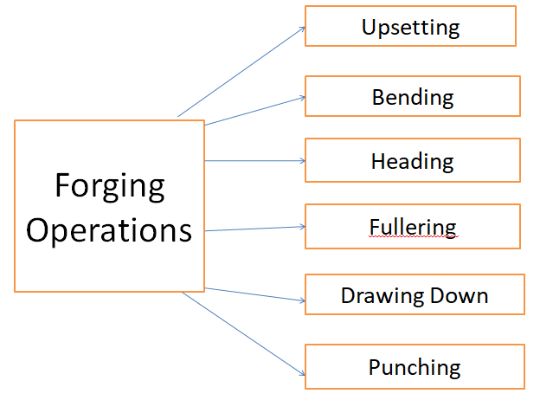
Figure 1: Forging Operations
- Upsetting or Jumping:
This type of smith forging is used to increase the thickness or the bar’s diameter and hence reduce its length. This type of method is used only in some of the cases such as in forming the bolt head etc. In this process, the area which is required to be upset is heated locally and the rest of the area is quenched in water so that the other area doesn’t get affected by the process. This type of process is done very carefully and it is kept in mind that the other part of the material doesn't get bent or deformed.
- Drawing Down:
Drawing process is just the opposite of the upsetting process in which the thickness of the bar is reduced and hence increase its length. It is done by keeping the metal over the horn of the anvil and then hammering it on the face of the anvil.
- Bending:
Bending is a very common process in forging. This type of the operation is used to give the turn to the metal piece. The bending of the piece of metal is done by giving the support to piece of metal on the anvil and then strike its free end with a compressive force e.g. hammer.
- Cutting:
The cutting process is another common process in which the red-hot metal is cut into pieces with the help of chisel and. Now a day’s diamond cutting tools are also used for this process
OPEN DIE FORGING
Open die forging is also called as flat die or hammer forging. In this, the work piece is compressed between ram and anvil or in between two dies. It may be done by hand or by power hammers. Anvil is fixed at bottom and ram is used for motion in both the direction. In open die forging, the working surfaces of both, the anvil and ram are flat and horizontal, where they are forced downwards which results in almost zero/no space for the material flow in lateral direction. In general, the hefty falling weight of the hammer is called the ram and the rigid support is called the anvil block. On the bottom of the ram, upper die is fitted and on the top of the anvil lower die is fitted. According to requirement of the shapes, concave and convex surface dies are also used. Work piece of metal is heated above recrystalline temperature usually ranging from 1900ºC – 2500ºC.
Open die forging is classified in three main types
- Cogging (also called as drawing down):- it is the operation in forging where the stock is thinned at one end by hammering the work piece with flat dies results into reduction in stock thickness and increase in length.
- Edging and fullering: - fullering is a primary forging operation where by using concave and convex shaped dies to elongate bar or workpiece along its length and it decreases the cross section.
- Upsetting: - it is a forging operation where lateral cross section increases in the direction perpendicular to the axis of applied force and length of the workpiece reduces. In upsetting operation barrelling phenomenon is caused due to higher material flow at centre than the material nearer to the dies. This non uniform flow of material with respect to thickness is caused due to friction. There are three types of upsetting in forging, namely: -
- Full upsetting
- Head upsetting
- Central upsetting
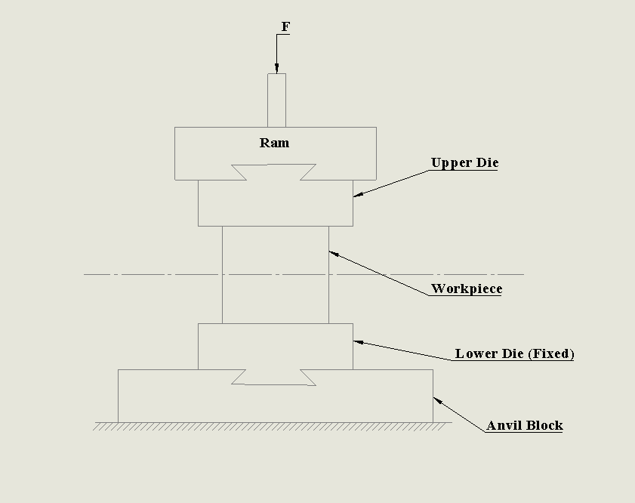
Figure 2: Open Die Forging
ADVANTAGES
- It makes the use of relatively simple tooling.
- Open die forging is relatively inexpensive.
- Large variety in shapes can be produced.
- The shapes mostly forged are bars or slab of circular, rectangular, hexagonal cross sections.
- Mainly used for repair or maintenance work.
DISADVANTAGES
- It produces forgings with lesser accuracy than closed die forging.
- Accuracy depends upon the skill of operator.
- It is suitable for small production lot.
CLOSED DIE FORGING
Closed die forging is also called as impression die forging. In this type of forging, cavities in the form of impressions are cut in the die block. Dies used may be single impression or multi impression depend on the product. The closed dies are carefully machined matching blocks so as to produce forgings of accurate dimensions. The operation consists of placing the piece of heated metal on the lower die block. The metal is forced to take its final shape and dimensions of the die by blow from a machine hammer. Half of the die is called lower die is mounted on the anvil and other half is upper die is on the hammer. During the forging, the cavities in the dies are completely filled. Excess metal is escaped out in the form of thin fin or flash. All forging are performed in the single die block.
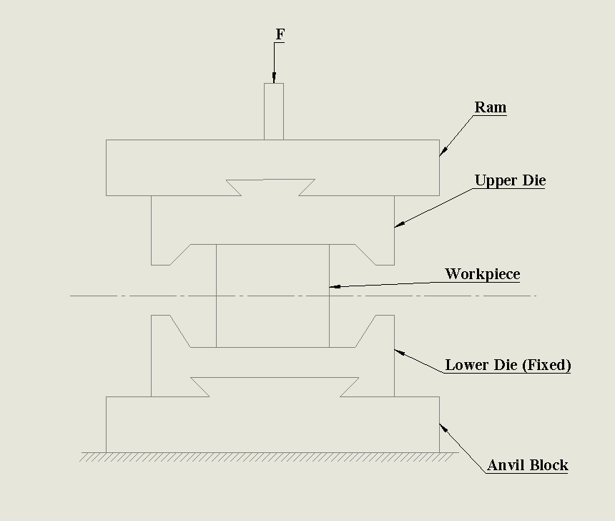
Figure 3: Closed Die Forging
ADVANTAGES
- It is successfully applied to produce complex shapes.
- Large quantities of similar type with greater accuracy can be produced.
- It does not require high skill operator.
- Closed die forging takes less time than open die forging.
- It issuitable for mass production.
DISADVANTAGES
- Tooling cost is high.
- Not economical when quantity of products is small.
- Proper care should be taken determining amount of material to be inserted in the die.
Table no. 1: Comparison of Open Die and Closed Die Forging
Open Die Forging | Closed Die Forging
Solid workpiece is kept between two flat dies and is compressed due to repeated blows by mechanical hammerand shape is manipulated manually. | In this type, the desired configuration is obtained by squeezing the workpiece between two shaped and closed dies.
It can be used for simple shapes only. | It can be used for production of complex shapes.
Dimensional accuracy and surface finish are poor. | Good dimensional accuracy and reproducibility.
Production rate is low. | Production rate is high.
Inexpensive tooling and equipment. | High equipment and tooling cost.
Skilled workers are required. | Do not require highly skilled workers.

Table no. 2: Comparison of Press and Drop Forging
Press Forging | Drop Forging
Press forging is carried out by single continuous slow squeezing action. | Drop forging is carried out by a series of blows by hammer.
Squeezing action is produced by press. | Mechanical hammer is used to produced blow.
It produces less vibrations and shocks due to slow actions. | It produces more vibrations and shocks due to impact blow.
The amount of time the dies are in contact with workpiece is measured in second. | The time in which dies are in contact with workpiece is measured in milliseconds.
It has ability to deform the workpiece completely. | It usually deforms the surface of the workpiece which is in contact with hammer and anvil.
More uniform and dense structure. | Less uniform and dense structure.
The machine structure is not heavy. | The machine structure is heavy and strong.
It is generally used for large and heavy components. | Comparatively smaller size parts are used.

SELECTION OF FORGING MACHINE
Selection of forging machine depends upon force and energy requirements, Material to be forged (soft material- use press, hard material- use hammers), Size-shape and complexity of forging, Strength of the work piece material, Sensitivity of material to rate of deformation, Production rate, Dimensional accuracy, Maintenance, Operating skill level required, Noise level, Cost.
Characteristics of Forging- Usually involves discrete parts, May be done on hot or cold materials, Often requires additional finishing processes such as heat treating, machining, or cleaning, May be done at fast or slow deformation rates, May be used for very small or very large parts, Improves the physical properties of a part by controlling and refining the flow or grain of the material.
Common Applications of Forging- Automotive passenger cars, trucks, buses, trailers, motorcycles and bicycles. Bearings, ball and roller. Electric power generation/transmission. Industrial and commercial machinery and equipments. Hand tools. Industrial tools. Mechanical power transmission equipments. Internal combustion engines. Oil field machinery and equipments. Offhighway, equipment (construction, mining and materials handling). Pipeline fittings. Plumbing fixtures, valves and fittings. Pumps and compressors. Railroad equipments and spikes. Metalworking and special industry machinery. Steam engines and turbines. Steel works, rolling and finishing mills. Ship and boat building and repairs. Aerospace aircraft engines. Guided missiles and space vehicles, etc. Hot forging temperature range for different metals and alloys
Table No. 3: Temperature range for different metals and alloys
Metal or alloy | Temperature reange(°C)
Aluminum alloys | 400- 560
Magnesium alloys | 240-360
Copper alloys | 600-910
Carbon and low alloy steels | 840-1150
Martensitic stainless steel | 1100-1260
Austenitic stainless steel | 1100-1260
Titanium alloys | 700-960
Iron based super alloys | 1040-1180
Cobalt base super alloys | 1180-1260
Tantalum alloys | 1050-1360
Molybdenum alloys | 1150-1360
Nickel-base super alloys | 1060-1200
Tungsten alloys | 1200-1310

FUTURE SCOPE
There are various recent advancements in the field of forging and yet there’s scope for future optimization of the technology. The future relevant technology involves cross-roll forming, reducer-roll forming, etc.
REFERENCES
- Bharti, S. (2017). Advancement in Forging Process: A Review. International Journal of Science and Research (IJSR), 6(12), 465–468. https://doi.org/10.21275/art20178736
- Min, N. L., & Thu, M. P. (2018). Analysis of Forging Processes for Machine Building Industry Modeling. 7(08), 214–217.
- Milutinović, M., Vilotić, D., & Movrin, D. (2008). Precision forging–tool concepts and process design. Journal for Technology of Plasticity, 33(1–2), 73–88.
- Santhosh, T. U. M. A., Babu, R. A., & Vinutha, A. (2016). Analysis of Spline Profile and Its. 17–43.
- Rathi, M. G., & Jakhade, N. A. (2014). An Overview of Forging Processes with Their Defects. International Journal of Scientific and Research Publications, 4(1), 2250–3153. Retrieved from www.ijsrp.org
- Anon. (1978). Cold Forging and Extrusion. Engineering (London), 218(9), 855–859.
- T. Altan & M.Shirgaokar. (2003). Process Design in Impression Die Forging. Handbook of Workability and Process Design, 278–290.
- Naresh, P. (2016). Design and Analysis of a Hot Forging Dies. International Journal of Engineering Treends and Advanceed SCiences (IJETAS), (August), 22–32.
- Chapter 15 : Fundamentals of Metal Forming. (n.d.).
- Elsa, P. M. dos S., & Kongthon, A. (2006). Applied Microbiology and Biotechnology, 85(1), 2071–2079. https://doi.org/10.1016/j.bbapap.2013.06.007
- Brown, R., & Burns, T. (2005). Lectures Notes on Dermatology. 42, 43, 44, 180.
- Patel, B. V, Thakkar, H. R., & Mehta, S. B. (2014). Review of Analysis on Forging Defects for Quality Improvement in Forging Industries. Journal of Emerging Technologies and Innovative Research, 1(7), 871–876.
- Kwok, T. H. (n.d.). Lecture 4 : Fundamentals of Metal Forming. 1–64.
- Danchenko, V. N. (2007). NATIONAL METALLURGY ACADEMY of UKRAINE.
- Test, T. (n.d.). Chapter 15 : Fundamentals of Metal Forming Engineering Stress-Strain.
- Tekkaya, A. E., Homberg, W., & Brosius, A. (2015). 60 Excellent inventions in metal forming. In 60 Excellent Inventions in Metal Forming. https://doi.org/10.1007/978-3-662-46312-3

