AN EXPERIMENTAL STUDY ON USE OF WASTE THERMOCOL AND THINNER WASTE AS AN ADMIXTURE IN CONCRETE
Trushna D. Patle¹, Isha P. Khedikar², Kuldeep R. Dabhekar³
¹PG Student, Department of Civil Engineering, G.H. Raisoni College of Engineering, Nagpur
²Assistant Professor, Department of Civil Engineering, G.H. Raisoni College of Engineering, Nagpur
³Assistant Professor, Department of Civil Engineering, G.H. Raisoni College of Engineering, Nagpur

Abstract :
Present study is aimed to investigate combined effect of thermocol waste and thinner waste[T&T] in concrete. These waste materials that are generated from automobile industrycontainThermocol also. Thermocol waste and thinner waste was mixed with ordinary Portland cement (OPC),sand, aggregate and water to form thermocol-thinner concrete[TTC]. Nine specimen blocks of size 150mm x 150mm x 150mm for each control concrete and TTC for different ratios(1%,2%,3% and 4%) are prepared.The main findings of this investigation reveal that the mixture of waste thermocol and waste solvent as admixture could be used successfully as in concrete composites.The study involvecomparison between control concrete and TTC replacement ratios of 1%,2%,3% and 4% of thermocol-thinner [T&T] in controlconcrete mix at a water-to-binder ratio of 0.40. Initial setting time, final setting time and workability are determined for control concrete and TTC. In addition, cubes of control concrete and TTC were tested after 7,14 and 28 days curing for compressive strengths.
Key Words: Compressive Strength, Environment ,Expanded Polystyrene (EPS), Thermocol waste, Thermocol-Thinner concrete [TTC], Thinner waste, Management of solid waste.
1. INTRODUCTION
Urbanization increase the demand of construction materials which leads to utilize alternative materials for sustainable development [7]. Worldwide annually 15 million metric tonnes of polystyrene are produced [9]. Thermocol is nothing but Expanded Polystyrene (EPS) [10]. Thermocol is cellular plastics material consisting of fine spherical shaped particles of polystyrene [7]. It comprises about 98% air and 2% polystyrene [7].It may be harmful to environment. Thermocol has the characteristics like light in weight, low thermal conductivity, good sound absorbent, etc. [5]. So it have wide usage in the packaging industry, model and craft industry [10]. Now a days, it is also use in the many construction and insulation industrylike in construction of bridge decks, partition wall and wall panels also when bearing capacity of soil is low [1].Use of thermocol in concrete provide faster building rates in construction and lower haulage and handling costs [3]. It is found that thermocol dissolve in different solvents like acetone, alcohol, chloroform, etc [8]. Thinner waste is a by-product from same automobile industry. Hence in the present study attempt is made to prepare admixture for concrete by dissolving thermocol in thinner (solvent).
1.1 Workability
Chandru et al., [2017] studied concrete made with expanded polystyrene (EPS) beads as an aggregate where, they found that EPS concrete have better workability whereas Subhan [2016] experimental study of light weight aggregate concrete founded that concrete mixed with 40% of fly ash and 0.3% of thermocol yields better workability.
1.2 Compression strength
Karthik et al., [2017] did an investigation and evaluated that the mixture of iron fillings and thermocol balls can be used as a partial substitutes of sand in concrete composite also increasing the percentage of thermocol balls in the mixed aggregate up to 10% does not seriously hinder the strength properties of the concrete brick specimens. Selvan et al., [2016] studied lightweight polystyrene sandwich blocks for replacement of bricks which have offered higher compressive strength of 4.12 MPa in 28 day. Subhan [2016] carried out an experimental study of light weight aggregate concrete where concrete was mixed with 40% of fly ash and 0.3% of thermocol and gave higher compressive strength. Pradeepaet al., [2016] studied the use of Reinforced Thermocol Panels as an alternative building material which has given better compressive and flexural strength hence proved that this technology can used for structural purposes. Abd et al., [2016] have studied compressive strength and tensile strength of light weight concrete containing EPS bead which reduces compressive strength and density.
1.3 Other characteristics
Selvan et al., [2016] studied properties of lightweight polystyrene sandwich blocks for replacement of bricks whose density has found 1200 kg/m³.Abd et al., [2016] in their study concluded that increases in EPS content in concrete mixes reduces density of concrete mix. Chandru et al., [2017] studied concrete made where expanded polystyrene (EPS) beads were usedas an aggregate which has found light in weight and with low thermal conductivity. Padmawar et al., [2017] have experimented on light weight fly ash brick using EPS which has found suitable for non-load bearing walls only like partition wall and wall panels and when bearing capacity of soil is low as it helps in reducing dead load of building also it’s a good shock absorbent, good sound absorbent and moisture capacity is high. Selvan et al., [2016] studied lightweight polystyrene sandwich blocks for replacement of bricks and concluded that these lightweight polystyrene sandwich concrete blocks offers reduction in dead load, faster building construction rate and lower haulage and handling costs. Pradeepa et al., [2016] studied use of Reinforced Thermocol Panels as an Alternate Building Material and it has proved good for use in structural purposes also it enables easy, fast and cheap construction. Pawar et al., [2016] has mainly focused on polystyrene (Thermocol / Styrofoam) marine debris with respect to (a) definition and types, (b) sources and distribution (c)environmental impact of on costal and ocean biodiversity, and (d)effective solutions to tackle the polystyrene (Thermocol/styrene) who then suggested that recycling is the solution to over use of thermocol.
2. MATERIALS
2.1 Cement
The cement used was ordinary portland cement of 53 - grade conforming to IS 12269-1987. The cement was check for its freshness and consistency. It was found dry, pure, without any lumps.
2.2 Fine aggregate
Neighborhood clean waterway sand of Zone II, conforming as per IS 383-1970 were used. The sand was sieved with 4.75 mm. It was free from clay, silt and organic impurities. The aggregate was tested for its physical requirements such as gradation, fineness modulus, specific gravity and bulk modulus in accordance with IS: 2386-1963.
2.3 Coarse Aggregate
The course aggregate used in this present study was 20 mm and 10 mm down size locally available crushed stone obtained from local quarries. The physical properties have been determined as per IS: 2386-1963. The specific gravity of coarse aggregate was found to be 2.68. The water absorption was 0.25%.
2.4 Water
Potable water was fit for mixing concrete as well as for curing of concrete. So it was made confirm that the water is covering all the requirements of its purity and use in concrete mix. Mixing water should not contain undesirable organic substances or inorganic constituents in excessive proportions. In this project clean potable water is used and curing as per IS: 456-2000.
2.5 Admixture
Table 2.5 : Properties of T&T solution
Sr. no | Properties | Value | Unit
1 | Flash point | 34 | ˚C
2 | Density | 0.9318 | g/cm^{3.}
3 | Specific gravity | 0.97 | -
4 | Volatile | 80.93 | %
5 | Non volatile | 19.07 | %
6 | pH | 7.1 | -
Admixture was prepared using thermocol and thinner[T&T] solution (10 % of Thermocol in thinner waste) shows in figure 2.5. T&T Solution was mixed with control concrete in different proportions. Admixture had the following properties shown in table 2.5

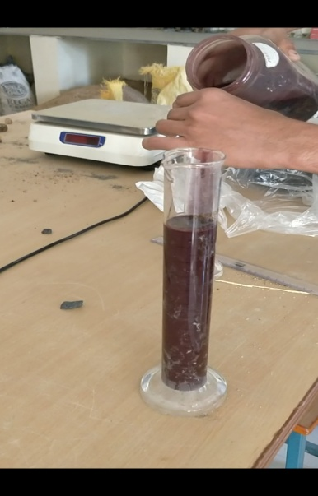
Fig 2.5:Thermocol-Thinner[T&T] Solution

3. MIX PROPORTION

The mix proportion for conventional M 25 grade concrete was derived as per IS 456-2000. Type of cement was OPC of 53 grade conforming to IS 12269.
Table 3.1: Mix proportion
Water content  (w/c)(lit) | Cement  (kg) | Sand  (kg) | Aggregate  (kg)
7.2 | 18 | 18 | 36
0.4 | 1 | 1 | 2

This mix proportion of conventional concrete was taken from IS 456-2000. The proportion of smart material in concrete was decided as follows.
Table 3.2: Mix proportion
Mix | Percentage Addition of T&TSolution (Admixture) | Cement  kg/m³ | Sand  kg/m³ | Aggregate  kg/m³
M1 | 0 | 18 | 18 | 36
M2 | 1 | 18 | 18 | 36
M3 | 2 | 18 | 18 | 36
M4 | 3 | 18 | 18 | 36
M5 | 4 | 18 | 18 | 36

where, M1: control mix, M2: 1% addition of T&T solution,
M3: 2% addition of T&T solution, M4: 3% addition of T&T solution,
M5: 4% addition of T&T solution.

4.PROCEDURE
4.1 Mixing
Concrete mix of M25 grade(1:1:2) was prepared. Concrete cubes were made using steel molds of dimensions 150 x 150 x 150 mm. T&T solution were mixed in control concrete for different proportions. There were total 9 cubes prepared for each mix proportion and that required 18 kg of cement,18 kg of sand and 36 kg of coarse aggregate for each mix proportion. The preparation was done considering all the specifications of mixing and filling.
4.2 Curing
Cubes have been allowed to set for 24 hours. After 24 hours, cubes were cured in the curing tank so as to enable hydration process for gaining strength. Clean potable water was used and curing has done as per IS: 456-2000.
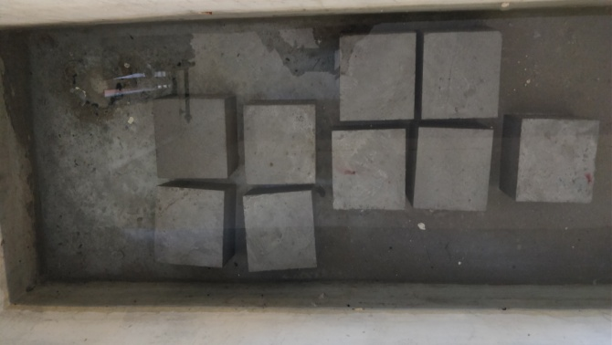
Fig 4.2: Cubes for curing
4.3 Initial and final setting time
IS code used for determining fineness as per IS: 4031 - (part 5) - 1988. By using Vicat apparatus, we have done initial setting time for different percentage of T&T solution in cement.
4.4 Slump cone test
IS code used for determining slump of concrete as per IS: 1199-1959. Compressive test were carried out for addition of admixture in concrete. This test were performed to know the high workability of concrete.
4.5 Compressive strength
IS code used for determining fineness as per IS: 516-1959. Compressive test were carried out for addition of admixture in concrete at different proportions.
Initial setting time, final setting time and slump cone were determined for control concrete and Thermocol-Thinner Concrete [TTC]. Also compressive strength of control concrete and TTC were tested after 7, 14 and 28 days of curing.

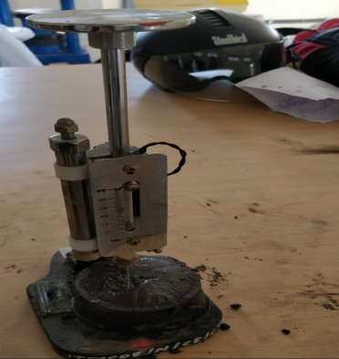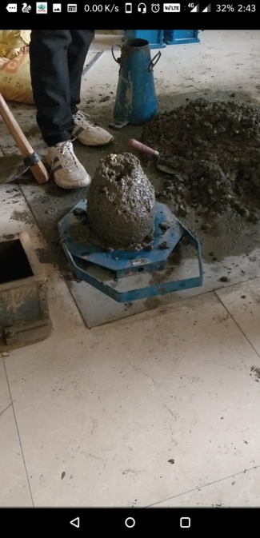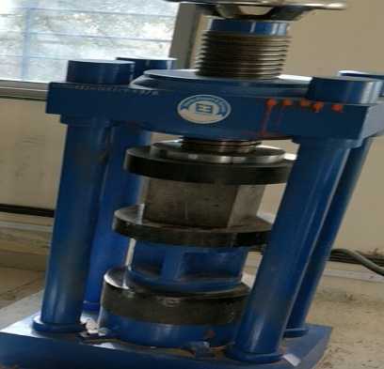
Fig 4.3:Initial and final setting time Fig 4.4:Slump cone test Fig 4.5:Compressive strength test
5. RESULT AND DISCUSSION

5.1 Initial and final setting time
Table 5.1: Initial and Final setting time
Mix | Initial setting time(minutes) | Final setting time(minutes)
M1 | 144 | 256
M2 | 155 | 2733
M3 | 135 | 250
M4 | 110 | 235
M5 | 92 | 208

.

Table 5.1 shows that addition of 1% T&T solution in concrete give maximum value of initial and final setting time but after addition of more T&T solution as admixture in concrete(2%,3%,4%) there is rapid decreasing in initial and final setting time as compare to control mix concrete. So it can be concluded that T&T solution for 2%,3% and 4% has worked as an accelerator in concrete
5.2 Slump cone test
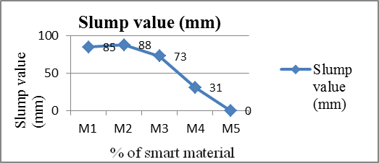
Fig 5.2: slump cone test value
The slump test is the most well-known and widely used test method to characterize the workability of fresh concrete. It was observed that workability of a concrete mix decreases on percentage addition of T&T solution in concrete. Fig 5.2 shows that taking water content proportion 0.4 reduces slump, T&T solution for 1% & 2% has medium workability. While 3% & 4% T&T solution in concrete provide very low workability as compare to control mix concrete , so water content must be increased.
5.3 Compressive Strength

Fig 5.3:Compressive Strength

Strength is an important indicator of quality because strength is directly related to the structure of hardened cement paste.Fig 5.3 shows that for the compressive strength of concrete, 2% addition of admixture was found optimum. Increasing the T&T solution in the concrete mix up to 2% does not seriously hinder the strength properties of the concrete specimens. Addition of admixture in concrete creates lots of voids, which is one of the drawback so concrete mix must be properly tamped or vibrated.

6. CONCLUSIONS
Based on the test results obtained from the investigation programme, the major conclusion has arrived from initial and final setting time, workability, and compressive strength test. The thermocol-thinner waste can be used as an admixture in concrete. Addition of 2%,3% & 4% T&T (thermocol-thinner) solution has worked as an accelerator in concrete. Increasing the T&T solution in the concrete mix upto 2% does not seriously hinder the strength properties of the concrete specimens.
7. REFERENCES
- Chandru.G, Vijay. N, Vignesh.V, SachinKumar.V (2017)." Study on Behaviour of Concrete Blocks with EPS and Partial Replacement of Fly ash and Quarry Dust". International Journal of Advanced Engineering Research and Science (IJAERS) Vol-4, Issue-1.
- KirtiPadmawar, PranaliGajbhiye, AbhishekSahare, Nikeeta B. Dethe(2017)." Light Weight Flyash Brick using Expanded Polystyrene (EPS)". IJSRD - International Journal for Scientific Research & Development| Vol. 5, Issue 1
- T.S.Karthik, Syed Abdul MoeedJaffari, T.Jessy Veronica, Sara Saleem, HoorBanu, Mr. Mohammed Saifuddin(2017)."I.T.Bricks (Iron Fillings and Thermocol Bricks)".SSRG International Journal of Civil Engineering (SSRG-IJCE) , volume 4 Issue 5.
- S.AnandaSelvan, Dr. P.Asha,(2016)," Experimental Study on Lightweight Polystyrene Sandwich Blocks for Replacement of Bricks",International Journal of Engineering Technology, Management and Applied Sciences, Volume 4, Issue No.3, ISSN 2349-4476.
- Md. Subhan,(2016),"Experimental Study of Light Weight Aggregate Concrete", International Journal of Scientific Engineering and Technology Research, Volume.05, Issue No.07, Pages: 1347-1351.
- Pradeepa.S ,Anitha.J ,N.TamilSelvi , Pranav.P , ArpitJaketia,(2016),"A Study on use of Reinforced Thermocol Panels as an Alternate Building Material", International Journal of Research in Advent Technology, Vol.4, Issue No.3, E-ISSN: 2321-9637.
- Suhad M Abd, DhamyaGh.,MaanHattem and Dunya Khalil(2016)." Effective Replacement of Fine Aggregates by Expanded Polystyrene Beads in Concrete". International journal of engineering research and science and technology (IJERST),Vol. 5, No.3, ISSN 2319-5991.
- Narendra B. Selukar, Chaitanya V. Lande, Chetankumar G. Ingole,(2014)"Waste Thermocol to Adhesive for Better Environment",International Journal of Innovative Research in Advanced Engineering, Volume 1, Issue 6, ISSN: 2349-2163.
- Prabhakar R. Pawar,Sanket S. shirgaonkar, RauphunnisaF.Inamdar and Rahul B. Patil,(2016),"Impacts of Thermocol waste on marine life: A Review", International multidisciplinary Research Journal,volume 3, issue 1,ISSN-2395-4744
- Rashi Goel,(2015)"Beauty of Recycling : One Reason Thermocol isn’t Recycled and Many to Start Right Now" thealternative.in. (http://www.thealternative.in/lifestyle/one-reason-thermocol-isnt-recycled-many-start-right-now/)
- Bureau of Indian Standards, IS 456-2000, “Plain and Reinforced Concrete- Code of Practice”, 2000, New Delhi
- Bureau of Indian Standards, IS 4031 - (part 5) - 1988," Methods of Physical Tests for Hydraulic Cement Part 5 determination of initial and final setting times",1988, New Delhi
- Bureau of Indian Standards, IS 1199-1959 ,"Methods of Sampling and Analysis of Concrete",1959, New Delhi
- Bureau of Indian Standards, IS 516-1959, “Method of test for strength of concrete”, 1959, New Delhi

