Spatial Assessment of Wastewater Quality of Nag River
Priti E. Sangode ¹, Dr.A.R.Mhaske², Dr.B.V.Khode³
¹M.Tech Student(Environmental Engineering )
G.H.R.C.E, Nagpur, India, 440036
²Professor & Head(CAS)
Agricultural Engineering Section,Nagpur, India,440012
³Professor(Civil Engineering Dept.)
G.H.R.C.E, Nagpur, India, 440036

Abstract – Spatial and Temporal varieties in surface water assume a vital job in water quality and manageable improvement. Stream water quality in Nagpur is quickly disintegrating due to industrialization and urbanization around the stream banks. Subsequently it is alluring to review the waterway water quality to decide the degree of contamination in the water body. The target of this paper is to survey the occasional water nature of the very dirtied Nag River based on surface water principles. An overview of the surface water of Nag River was performed trying to ponder the ecological effect of anthropogenic exercises and regular exercises on its water quality. Gathered examples were broke down from five vital stations of Nag River for Four months speaking to regular varieties regarding pH, turbidity,EC,BOD,COD,Totalsuspendedsolid(TSS),Total Dissolved Solid(TDS),Sodium Bicarbonates, Colour and total Alkalinity.
Keywords- Nag River;spatio-temporal varieties; water quality.
INTRODUCTION
Nagpur is the second capital city of Maharashtra. Nagpur city is the biggest city in Central India. It is otherwise called the Orange City. Nagpur is likewise the Tiger capital of India. The scope and longitude of Nagpur are 21º 09'N, 79º 05'E/21.15ºN. 79.07'E. Nag River is a stream coursing through the city of Nagpur in Maharashtra, India. The Nag River arranged in Nagpur. The stream is a piece of the Kanhan River System. The stream begins from Ambazari Lake, stretching through the city at long last emptying down into the KanhanRiver. Steady dumping of untreated sewage and industrial effluents has brought about waterway water quality decay and the river has since been developing as a terrible smelling stream. Truth be told the river has now transformed into a running sewage channel. Information published by NEERI obviously expressed that insignificant sewage is streaming in the river. The state of waterway is poor to the point that Nag River lost its Heritage Status in the year 2000. In the year 2013, there was a blast in awareness for revival and reclamation of Nag River. This paper incorporates the investigation of the endeavors as of now taken towards this goal. Contemplating other attempts already embraced in various pieces of India and around the world, this paper will concentrate on understanding different sources and causes of contamination, the present physical and ecological condition of river, advantages of reclamation and how those endeavors can be utilized for the revival and rebuilding of Nag River. Because of increment in populace, there is a steady ascent in the level of sewage in the Nag River. The waste water is investigated for the water quality parameters such as pH, turbidity, conductivity, biochemical oxygen demand (BOD), Chemical oxygen demand (COD), Total suspended solid (TSS), Total Dissolved Solid (TDS), Sodium, Bicarbonates, Colour
And Total Alkalinity broke down solids and temperature. The gushing examples are gathered from five distinct areas.

METHOLOGY
To evaluate the underlying contamination pattern of Municipal Corporation water, the inspecting areas were chosen based on catchment territory at the upstream of the Nag waterway on the grounds that the crisp water provided by the Municipal Corporation getting dirtied because of residential and other use as a dim and dark water and entering to the Nag stream at various areas as proposed by Hamid et al. (2013). At the upstream it is less contaminated and at the downstream, it is getting progressively dirtied by including more contamination load. Thusly, the definite area of inspecting destinations at the STP Maharajbagh, upstream, right tributary and left tributary were chosen to evaluate the spatial and transient examination of Nag waterway coursing through the Nagpur city. The residential sewage profluent of fluctuating quality and other sewage with the exception of the modern enters in the Nag waterway lastly joins the Kanhan stream.

The scope and longitude of inspecting locales were recorded with the assistance of GPS. The dark water and dim water from the family unit and other zone like vehicle washing and dairy release their effluents of changing quality goes into a Nag waterway through open and shut channels. The testing areas from upstream to downstream up to plant delta are appeared in Fig.1
Sampling Procedure
The sampling campaigns were carried out for the period of 4 month from November-2018 to February -2019. The inspecting efforts were done for the time of multi month from November-2018 to February - 2019. Amid this period, sewage water tests were gathered spatially from the referenced point sources. Sewage influent examples were gathered in every long stretch of the period on a fixed day in morning at 9 A.M and evening at 3 P.M. Sampling jugs were absorbed medium-term weakened hydrochloric corrosive before use, and flushed multiple times with test to be gathered before filling. Little amount of Toluene was included as additive in each example. The example bottles were named cautiously according to the areas and time. Separate examples were taken and saved at 4˚ C amid transportation to the research facility. They were quickly broke down for BOD, COD, Turbidity, pH and All the investigation were done according to the standard techniques (APHA 21st Edition).
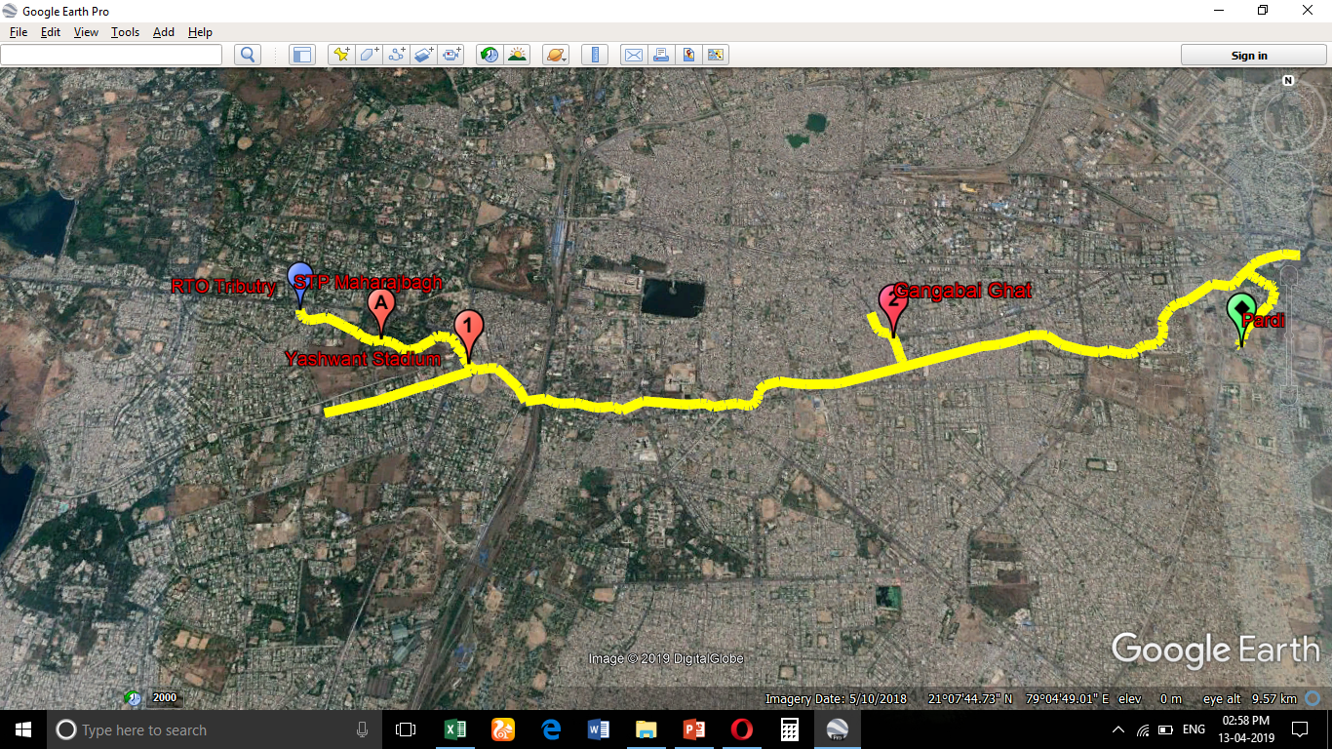
Fig.1.Map showing the location of the sampling sites

Table 1. Instruments/procedures used for the analysis of effluents of the drain
Sr. No | Parameters | Units | Instrument / Procedure
1 | pH | pH units | pH meter
2 | Electrical conductivity | µS/m | Conductometric method
3 | Biological oxygen demand | mg/L | Dilution and Seeding
4 | Chemical oxygen demand | mg/L | Reflux method
5 | Color | ---- | Visual comparison method
5 | Total dissolved solids | mg/L | Gravimetric method
6 | Total suspended solids | mg/L | Gravimetric method
7 | Turbidity | NTU | Turbidity meter
8 | Sodium | mg/L | Titration
9 | Bicarbonates | mg/L | Titration
10 | Total Alkalinity | mg/L | Titration
Source:APHA, 21st edition
RESULTS AND DISCUSSION
1.pH:
Hydrogen ion concentrations an important factor that determines the suitability of water for purposes, including toxicity to animals and plants. pH plays an important role in the biological almost all aquatic organisms. Low pH values indicate acidic water having corrosive properties. High pH values indicate alkaline properties. However, no health-based guideline value has been proposed for pH. The pH in Nag river is varying from 6.54 to 7.98. The average values of 7.55 at RTO tributaries and Gangabaighat respectively. The alkaline water might be due to high domestic effluent in the river and microbial activities. The pH of all the station remained or less constant in all the seasons and was within the permissible limits industrial discharge set by Maharashtra Pollution Control Board, i.e. 6.5 to 8.5.

Fig. 2. Monthly Spatial trend of pH in sewage water

2. Elecrtical conductivity:
The conductivity depends on the concentration of ions and its mineral nutrients status. It also depends on various factors such as low rainfall and high temperature. Conductivity of the water vas carried out to find out the extent of saline water ingress into the estuarine part of the river. The range of conductivity varied from minimum value of 0.234 µS/m to maximum value of 0.982 µS/m. Values of conductivity were highest at Pardi and Gangabaighat. Pardi showed highest conductivity range from 0.6 to 0.982 µS/m. conductance of the samples varied with seasons. The values of conductivity were lowest during November and highest during January and February. High conductivity levels may be due to several other factors including untreated wastewater infiltration, wastewater from sewage treatment plants, wastewater from septic systems and drain field on-site wastewater treatment and disposal systems.

Fig. 3.Monthly Spatial trend of EC in sewage water
3.Turbidity:
Turbidity of the water sample ranged from minimum 48.97 NTU to maximum 71 NTU at the sampling stations. Major variations in turbidity were observed RTO tributaries, Yashwant stadium and STP Maharajbagh.The reason for this could be the discharge of untreated sewage and addition of suspended matter in the form of garbage at STP Maharajbagh and Yashwant Stadium.The values of turbidity, although high were constant at Gangabaighat and Pardi. The values of turbidity in all months are very high as compared to the standards set by Maharashtra Pollution Control Board, i.e., 5 NTU
Fig.4.Monthly Spatial trend of Turbidity in sewage water
4. Total Suspended Solid: The suspended solid is those solid which remain floating in sewage. The Solids in sewage comprise both organic and inorganic solid which of is about 45 and 55 percent of total solid respectively.TSS values were higher (up to 24 mg/l) in the months February. TSS concentration was lowest in the month of November, and intermediate concentration thought out December. The pattern of concentration was likely governed by the ambient temperature. Because of higher temperature in the months of February the evaporation rate was very high, thereby increasing the concentration of the suspended solids in the sewage water. The mean value of TSS in sewage water was higher at Gangabaighat Followed by Pardi, Yashwant Stadium and STP Maharajbagh. No significant difference of TSS was observed in the spatial trend

Fig. 5. Monthly Spatial trend of TSS in sewage water
5. Total Dissolved Solid:
TDS plays an important role in plant growth, crop yield and quality of product (SFWF, 2002). As depicted in Fig.6, it is observed that all the point sources having higher values of TDS at Yashwant Stadium in the month December was up to 382.82mg/L might be due to high evaporation with increasing the ambient temperature. TDS was lower in the month of November due to low ambient temperature. Concentration of TDS was observed more at STP Maharajbagh and Yashwant Stadium. The higher values of concentration of TDS at Yashwant Stadium as compared to other sites might be because of mixing of milk industry water with domestic sewage water, and it is further diluted at Upstream and STP Maharajbagh with addition of domestic sewage water. At RTO site, only domestic sewage water is discharged, hence lowest TDS concentration. The TDS concentration also maximum at Gangabaighat is of 370.86 mg/L.

Fig. 6. Monthly Spatial trend of TDS in sewage water
6. Bicarbonates:
Bicarbonate is the most abundant anion, and ionic species generally stream water, and therefore has a dominating electrical conductivity. Fig.No. 7 represent the spatial trend of nag River of bicarbonates concentrations. The Bicarbonates values linear up to the Nov to Dec. The maximum value is at Pardi is of 400 mg/L is might be because of the industrial loading in that area. The absences of “Photosynthesis” due to highly Turbidity water of Nag River

Fig.7.Monthly Spatial trend of Bicarbonates in sewage water
7.Sodium:Fig. No 8 indicates the sodium values of Nag River Samples.The Values between 23 to 115 mg/L respectively.The valuse are Highiest at Pardi area followed by gangabaighat,Yashwant Stadium Respectively.The Sodium Concentration was Highest at in Nov to Dec and It is lowest to in the month of Feb. Sodium Values have no siginifiacance because of inoraganic matter present in the Nag River.The values of Sodium concentration are not as per MPCB Standards.

Fig. 8 Monthly Spatial trend of Sodium in sewage
Water
8. Chemical Oxygen Demand:COD is another parameter used to determine the organic loading in water. The COD values of the water ranged from minimum of 24.305 mg/lit to a maximum of 145.8 mg/lit.COD values were found to be the highest at sampling stations Gangabaighat and Pardi. It can be argued that the industrial activities around these sampling points are the reason for the high values COD. Although of COD at all the stations were high from January to February as compared to November and December. Periodic tidal flushing another reason for reduction in these values. In general, CÓD values were seen to be tidally influenced as the values were higher during high tide and lower during low tide. Influence of fresh water dilution is also evident. The ratio of BOD: COD gives indication degradable organic compounds in water. The average ratio of BOD: COD at RTO tributaries, STP Maharajbagh, Yashwant Stadium, Ganganaighat and Pardi was near about same i.e is 0.30. A ratio of >=0.5 indicates biodegradable organic compounds. (fig.9)

Fig. 9. Monthly Spatial trend of COD sewage water

9.Biological Oxygen Demand:
The values of BOD varied from minimum of 24.305mg/L to maximum of 145.80mg/L.The average BOD values were High at Pardi(82.65 mg/L) and Gangabaighat(77.79 mg/L)sampling stations as compared to other points due to ingress of organic loading in sewage from human settlements at these stations. The values were lower at Yashwant Stadium (52.89 mg/L) and RTO Tributaries (55.83 mg/L) areas due to industrial activities. It is probably due to the reason that fresh water inflow and river water decreases the organic matter load in the water. Also, the concentration of organic loading was observed to be higher at high tide for almost all stations. When compared to CPCB standards of BOD,ie. 30 mg/l water quality of the river shows non-compliance of BOD values indicating heavy pollution. Those water bodies having BOD more than 6 mg/l are identified as polluted water bodies. (CPCB: Water Quality Assessment, 1.3 Polluted River stretches). The source of organic and microbial pollutants present in the water can be accounted for the presence of severe organic waste and sewage.
Fig.10.Monthly Spatial trend of BOD in sewage water
10. Total Alkalnity:Total alkalnity in waste water is due to presence of dissolved mineral salts including sulphate, carbonates and biocarbonates.High level of alkanity can cause the problems large amounts of scale and sludge, oerheating heat exachangers and pipelines clogs. From the Fig.11 shows spatial variation of alkalnity of Nag river of differnts sampling location. The values minimum at 248.27 mg/L and maximum at 486.9 mg/L at RTO ttibutaries and Pardi Respetively.All the sampling Stations contains High valus of alkalnity of range above 200 mg/L because of industrial waste water dirctly dumped in to the river without treatment.In Pardi and Gangabaighat sampling stations the values of High because of presence of industry namely shree Vaidyanath Ayured Bhavan ,Great Nag Road and Haldiram food international, Bhandara Road near by area.

Fig.11.Monthly Spatial trend of Total Alkalinity in sewage water
11. Color: The sewage has had black grey in all sampling stations.

CONCLUSION
- The as a rule water quality was seen to be inside MPCB standards for present day discharge concerning pH. The pH was around neutral at all stations.
- The turbidity of the water was seen to be exceptionally fluctuating depending after reviewing stations and season. These characteristics were similarly high when stood out from the MPCB standards of 5 NTU.
- The estimations of conductivity demonstrated assortments as shown by looking at stations.
- Organic stacking as BOD and COD was particularly high at all the investigating demonstrates due present day efluent and arrival of sewage. The estimations of BOD and COD were uncommonly high at all testing centers when appeared differently in relation to MPCB benchmarks of 30 mg/L to 250 mg/L.
- The estimations of TSS and TDS was not found inside MPCB models of 20 mg/L and 150 mg/L.
- The estimations of Sodium not as per MPCB rules of 20 mg/L.
- The estimations of Bicarbonates and Total Alkalinity was not found inside MPCB Standards of 200 mg/L.
- The River Flow is to be considered as “Slugeeish” and is not likely to result into “Self-purification “except settling down of suspended matter during the flow causing additional resistance to flow.
REFERANCES
[1] Payal K. Baitule ,Wahid Deshmukh,M. P. Bhorkar(2015). “Investigation of Water Quality Parameters of Nag River in Nagpur Region, MS,India”. International Journal on Recent and Innovation Trends in Computing and Communication Volume: 3 Issue: 2, February 2015
[2] Ashwini V. Padalkar, Satinder Kaur, Rakesh Kumar(2014). “Assessment Of Spatio-Temporal Variations In Physico-Chemicalcharacteristics Of Mithi River Water Quality Of Mumbai, India”. Ressarch Gate, India
[3] A.R. Mhaske, S.M.Tale, Shinde, R.N. Katkar, (2017), “Spatial Assessment of Wastewater Quality of Nag River for Irrigation”, Journal of Agricultural Engineering, Vol. 52 (1): January-March, 2015
[4] Parikshit P. Mudholkar, (2017), “Impact of Urbanization on River and Its Surrounding Structures: Case of Nag River Nagpur”, International Journal of Science and Research (IJSR) ISSN : 2319-7064

