Air Quality Index forecasting using ANN and LSTM Neural Network

Mr.Vinod Kundlik Gajbhiye , Prof. Jayant Adhikari

Tulsiram Gaikwad – Patil College of Engineering & Technology,
Nagpur, India

Received on: 2 Dec,2020 , Revised on: 31 Dec,2020 , Published on: 11 Jan ,2021

Abstract – As the impact of air pollutants is increasing drastically on living beings in recent years, it has become very necessary to address the issue of air pollution control by scientists and environmental lists. To ensure the same, it is important to forecast air quality in terms of parameters that cause air pollution directly or indirectly, which generally affects the living population. Environmental Protection Agency (USEPA) has suggested a method to estimate air quality index in a region which constitutes different concentration of criteria air pollutants such as RSPM, SO2, NO2, and SPM. The motive of our research is to model a predicting model for forecasting daily AQI that can be put to use for local and regional air quality management.

Keywords —AQI, AR, ARIMA.

- INTRODUCTION

It is of great significance to carry out cities' air quality forecasting work for the prevention of the air pollution in urban areas and to the improvement of the living environment of urban residents. The air quality index (AQI) is a dimensionless index that quantitatively describes the state of air quality. Air pollution is a growing threat towards society and various measures are being taken recently to control it. When the weather is cloudy or hot tube then it will be predict by air Quality

index. The problem of concern which remains is the efficient prediction of air pollution.AQI follows a periodic pattern, deep learning models can be used to effectively predict the future AQI values.
The purpose of the forget gate is to forget the historical data that is not signiﬁcant for the next prediction. Algorithm to be used BP neural network, Artificial neural network. This network is trained using the conventional back- propagation method.
The goal of this paper is Time-series data is sampled at discrete time points with a uniform time-interval. Algorithm used BP neural network, genetic algorithm. With the help of web scrapping technology website data could be collect in a format. It can used Machine learning method for collecting data. Then it is used data cleaning and data preprocessing method.
So it will be showing more accuracy for Air Quality index method. The purpose of the forget gate is to forget the historical data that is not signiﬁcant for the next prediction. Algorithm to be used BP neural network, genetic algorithm. This network is trained using the conventional back-propagation method.

II-RELATED WORK
This section provides a literature review for air quality research and its status, as well as the methods to conduct air quality research. Distal used the two-pollutant Cox proportional hazards model to assess mortality associated with exposure to PM2.5 and ozone. The results of the study indicate that exposure to PM2.5 and ozone can have adverse effects, which is most pronounced among ethnic minorities and low-income people. Raaschou-Nielsenetal. 4 estimated the association between the components of a “particular matter” and lung cancer incidence. They suggested that the effect on lung cancer depends on the composition of a particular matter. For example, inhalation of contaminating particles containing Ni and S elements can have a more adverse impact. Inhaled PM may induce adverse cardiovascular reactions through three potential mediators. It is impossible to avoid air pollution altogether, but the current restrictive standards should be guaranteed to reduce the source of potentially polluting air particles.

Inhaled. Suggested that particulate air pollutants have a significant relationship with stroke mortality and environmental health policies that reduce air pollution can reduce the risk of stroke. Concerning the methods to conduct air quality research, AI-based algorithms with big data mining and analysis can excavate valuable data, and further discover related correlation and decision-based knowledge.

Excavation around one city is the most common research. Besides, the use of geographical and meteorological data has been matured during the last two decades. Furthermore, the socioeconomic factors are gradually considered in the mechanism analysis, such as gross domestic product (GDP) and rapid population expansion. The broadest range of research in China is in 87 cities. Kalapanidas. [1] discussed the NEMO prototype that was built to support the short-term forecast of Nitrogen dioxide. They classified pollution level into four levels (a) low, (b) med, (c) high, and (d) alarm by using a lazy learning approach, the case-based reasoning system.

III-PROPOSED RESEARCH METHODOLOGY

Algorithms
ANN- Artificial Neural Network
Artificial neural networks, usually simply called neural networks, are computing systems vaguely inspired by the biological neural networks that constitute animal brains. An ANN is based on a collection of connected units or nodes called artificial neurons, which loosely model the neurons in a biological brain.
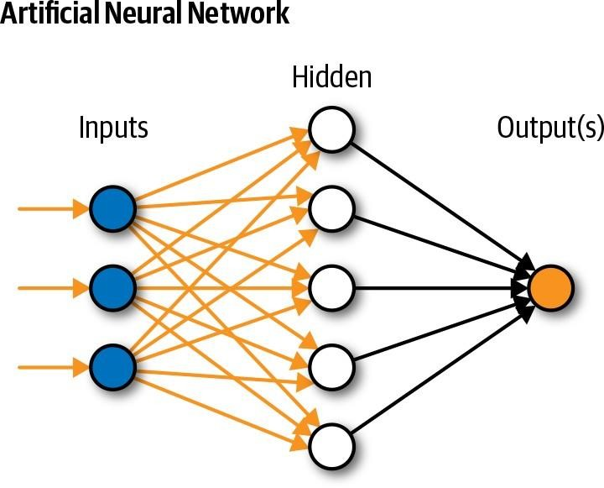
Fig 1 – Artificial Neutral Network

Long Short-Term Memory Neural Network
Long short-term memory (LSTM) is an artificial recurrent neural network (RNN) architecture used in the field of deep learning. Unlike standard feed forward neural networks, LSTM has feedback connections. It can not only process single data points (such as images), but also entire sequences of data (such as speech or video). For example, LSTM is applicable to tasks such as unsegmented, connected handwriting recognition speech recognition and anomaly detection in network traffic or IDSs (intrusion detection systems). A common LSTM unit is composed of a cell, an input gate, an output gate and a forget gate. The cell remembers values over arbitrary time intervals and the three gates regulate the flow of information into and out of the cell. LSTM networks are well-suited to classifying, processing and making predictions based on time series data, since there can be lags of unknown duration between important events in a time series. LSTMs were developed to deal with the vanishing gradient problem that can be encountered when training traditional RNNs. Relative insensitivity to gap length is an advantage of LSTM over RNNs, hidden Markov models and other sequence learning methods in numerous applications.
We will be using advanced data extraction and analysis. The Proper Methodology in the Appendix with full details on data processing, analysis, results and it used to improve the result In our case, the raw data of each attribute has been integrated into a complete data set. It was written into a CSV file to storage. Pandas Library for Python provides perfect data management and abundant analysis methods. We then prepare raw data before computational analysis.

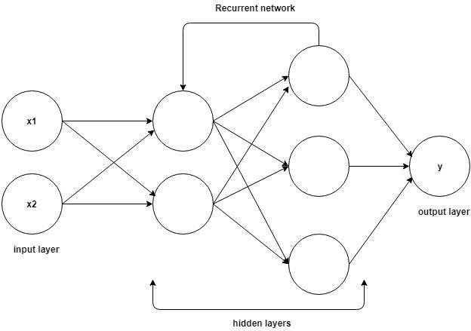

Fig 2- Proposed work models

Features Extraction

Types Preliminaries of ANN

ANN can be considered as an interconnected assembly of simple processing elements (or units/ nodes/neurons). The processing ability of network is stored in the inter-unit connection strengths or weights obtained by a process of learning from a set of training patterns. A typical ANN consists of one input layer, one output layer and hidden layers. Each layer can have several units whose output is a function of weighted sum of their inputs. Input into a node is a weighted sum of outputs from nodes connected to it.
Each unit takes its net input and applies an activation function to it However, it has been shown by Cybenko (1989) that with one hidden layer, an ANN can describe any continuous function (if there are enough hidden units), and that with two hidden layers, it can describe any function. The weights in an ANN, similar to coefficients in a regression model, are adjusted to solve the of these weights.

Two types of learning with ANN are: Supervised and Unsupervised learning. The supervised learning occurs when there is a known target value associated with each input in the training set. Output of ANN is compared with a target value, and this difference is used to train ANN (alter the weights). The unsupervised learning is needed when training data lack target output values corresponding to input patterns.

Multilayered feed forward Artificial Neural Network (MLFANN)

An MLFANN is one in which units in one layer are connected only to units in the next layer, and not to units in a preceding layer or units in the same layer. An MLFANN can have a number of hidden layers with a variable number of hidden units per layer. When counting layers, it is a common practice not to count input layer because it does not perform any computation, but simply passes data onto the next layer. So, an MLFANN with an input layer, one hidden layer, and an output layer is termed as a two layered MLFANN.

The MLFANN is the most popular network architecture. It is the type of network in which units are arranged in a layered feed forward topology. The network thus has a simple interpretation as a form of input-output model, with weights and thresholds (biases) as free parameters of the model. Such networks can model functions of almost arbitrary complexity, with the number of layers, and the number of units in each layer, determining the function complexity.

Learning Algorithms

As the input–output vectors are presented to the network, a learning algorithm adjusts connection weights until the system converges on a function that correctly reproduces the output. Optimal connection weights may be obtained by using gradient descent algorithm or conjugate gradient descent algorithm with a view to minimizing sum of the squared error functions of the network output.

Datasets Description
Our first step is input of data sets. For the feature selection three data set is used to further verify the effectiveness of our method, the datasets are data collection, data processed and data clean are available from Web Scrapping Technology

- Data collection is the process of gathering and measuring information on targeted variables in an established system, which then enables one to answer relevant questions and evaluate outcomes.
- Lasso regression is a type of linear regression that uses shrinkage. Shrinkage is where data values are shrunk towards a central point, like the mean. The lasso procedure encourages simple, sparse models (i.e. models with fewer parameters). This particular type of regression is well- suited for models showing high levels of multi collinearity or when you want to automate certain parts of model selection, like variable selection/parameter elimination.
- A Machine Learning model is defined as a mathematical model with a number of parameters that need to be learned from the data. By training a model with existing data, we are able to fit the model parameters. However, there is another kind of parameters, known as Hyper parameters, that cannot be directly learned from the regular training process. They are usually fixed before the actual training process begins.

Table 1- Dataset Description For Dataset Used In EGFS
Data Sets | No of classes | No of Instance | No of Features
AQI_2013 | 9 | 370 | 8
AQI_2014 | 9 | 420 | 5
AQI_2015 | 9 | 350 | 7

The potential of artificial neural network methodology has been highlighted for successfully tackling the realistic situation in which exact nonlinear functional relationship between response variable and a set of predictors is not known. Although ANNs may not be able to provide the same level of insight as many statistical models do, it is not correct to treat them as “black boxes”. In fact, one active area of research in ANN ‘understands the effect of predictors on response variable’. It is hoped that, in future, research workers would start applying not only MLFANN but also some of the other more advanced ANN models, like ‘Radial basis function neural network’, and ‘Generalized regression neural network’ in their studies.

REFERENCE
- Kula, Maciej. "Metadata embeddings for user and item cold-start recommendations." arXiv preprint arXiv:1507.08439 (2020).
- Sinha, B.B., Dhanalakshmi, R. Evolution of recommender system over the time. Soft Computer 23, 12169–12188 (2019) doi:10.1007/s00500-019-04143-8
- Debnath, Souvik, NiloyGanguly, and PabitraMitra. "Feature weighting in content based recommendation system using social network analysis." Proceedings of the 17th international conference on World Wide Web. ACM, 2019.
- Sahebi, Shaghayegh, and Peter Brusilovsky. "Cross-domain collaborative recommendation in a cold-start context: The impact of user profile size on the quality of recommendation." International Conference on User Modeling, Adaptation, and Personalization. Springer, Berlin, Heidelberg, 2019. Information Reuse and Integration (IRI), Salt Lake City, UT, 2018, pp. 47-54. Publisher: IEEE.
- Paterek, Arkadiusz. "Improving regularized singular value decomposition for collaborative filtering." Proceedings of KDD cup and workshop. Vol. 2019. 2019.
- Wang, Chong, and David M. Blei. "Collaborative topic modeling for recommending scientific articles." Proceedings of the 17th ACM SIGKDD international conference on Knowledge discovery and data mining. ACM, 2019.
- J. Lund and Y. Ng, "Movie Recommendations Using the Deep Learning Approach," 2018 IEEE International Conference on Information Reuse and Integration (IRI), Salt Lake City, UT, 2018, pp. 47-54. Publisher: IEEE.
- M. K. Kharita, A. Kumar and P. Singh, "Item-Based Collaborative Filtering in Movie Recommendation in Real time," 2018 First International Conference on Secure Cyber Computing and Communication (ICSCCC), Jalandhar, India, 2018, pp. 340-342. Publisher: IEEE.
- H. Kunjachan, M. Hareesh and K. Sreedevi, "Recommendation Using Frequent Item set Mining in Big Data," 2018 Second International Conference on Intelligent Computing and Control Systems (ICICCS), Madurai, India, 2018, pp. 561-566. Publisher: IEEE.
- K.Yang and L.Toni,"GRAPH-BASED RECOMMENDATION SYSTEM," 2018 IEEE Global Conference on Signal and Information Processing (GlobalSIP), Anaheim, CA, USA, 2018, pp. 798-802. Publisher: IEEE.
- N. Ifada, E. H. Prasetyo and Mulaab, "Employing Sparsity Removal Approach and Fuzzy C-Means Clustering Technique on a Movie Recommendation System," 2018 International Conference on Computer Engineering, Network and Intelligent Multimedia (CENIM), Surabaya, Indonesia, 2018, pp. 329-334. Publisher: IEEE.
- L. A. Hassanieh, C. A. Jaoudeh, J. B. Abdo and J. Demerjian, "Similarity measures for collaborative filtering recommender systems," 2018 IEEE Middle East and North Africa Communications Conference (MENACOMM), Jounieh, 2018, pp. 1-5. Publisher: IEEE.
- A. Luke, J. Johnson and Y. Ng, "Recommending Long-Tail Items Using Extended Tripartite Graphs," 2018 IEEE International Conference on Big Knowledge (ICBK), Singapore, 2018, pp. 123-130. Publisher: IEEE.
- Y. Wang, J. Wang and L. Li, "Enhancing Long Tail Recommendation Based on User's Experience Evolution," 2018 IEEE 22nd International Conference on Computer Supported Cooperative Work in Design ((CSCWD)), Nanjing, 2018, pp. 25-30. Publisher: IEEE.
- G. Mustafa and I. Frommholz, "Performance comparison of top N recommendation algorithms," 2015 Fourth International Conference on Future Generation Communication Technology (FGCT), Luton, 2015, pp. 1-6. Publisher: IEEE
- A. Kumar, S. Gupta, S. K. Singh and K. K. Shukla, "Comparison of various metrics used in collaborative filtering for recommendation system," 2015 Eighth International Conference on Contemporary. J. Wang and J. Ye, “Two-layer feature reduction for sparse group lasso via decomposition of convex sets,” in NIPS, 2014, pp. 2132–2140 M. Ilhami and Suharjito, "Film recommendation systems using matrix factorization and collaborative filtering," 2014 International Conference on Information Technology Systems and Innovation (ICITSI), Bandung, 2014, pp. 1-6. Publisher: IEEE.
- J. Gupta and J. Gadge, "Performance analysis of recommendation system based on collaborative filtering and demographics," 2015 International Conference on Communication, Information & Computing Technology (ICCICT), Mumbai, 2015, pp. 1-6. Publisher: IEEE.
- Y. Park, "The Adaptive Clustering Method for the Long Tail Problem of Recommender Systems," in IEEE Transactions on Knowledge and Data Engineering, vol. 25, no. 8, pp. 1904-1915, Aug. 2013. Publisher: IEEE.
- Linden, Greg, Brent Smith, and Jeremy York. "Amazon. Com recommendations: Item- to-item collaborative filtering." IEEE Internet computing 7.1 (2003): 76-80.

