Training and Placement Cell Android Application

Mr. Puneshkumar U. Tembhare¹, Anand Khobragade², Rushabh Pachare³, Sanjeev Sharma⁴,Chaitanya Ramteke⁵, Vaibhav Patil ⁶

¹Assistant Professor, Department of Computer Technology, PCE, Nagpur, India - 440016
^{2,3,4,5,6} UG Student, Department of Computer Technology, PCE, Nagpur, India - 440016

Received on: 15 February, 2022 Revised on: 03 March, 2022 Published on: 05 March, 2022

Abstract – T & P project is an informative and management system, which provides the updated details the students. The Training and Placement Application overcomes the difficulty of keeping records of thousands of students and tracking student eligibility based on employment conditions. It facilitates excellent interaction between the Placement Officer and students. Student record keeping, Curriculum Review and retrieval of eligible students based on company criteria.[1]
The purpose of the Training and Placement Application Program is to automate the existing manual system with the help of fully computerized software and software, to meet their needs, so that their important data / information is stored longer and easily accessible. The software is easy to operate. Teaching and Placement Management, as described above, may result in flawless, secure, reliable and fast management system. It can help the user to focus on other tasks instead of focusing on keeping records. So, it will help to plan for better use of resources. An organization can store computer records without unnecessary access. That means you don't have to be distracted by useless information, while being able to access information.

Keywords- Smart Phones, Android Studio, Android Application, up-to-date, Records, Integration, Curriculum, Conditions.

- INTRODUCTION
Everything that is done in the system is done in person keeping records. The management and all the departments that did this work manually make the work difficult and boring in it many times. This difficult task can be made easier by doing a computer program.
The Training and Placement Cell plays an important role in bridging the gap between students and companies in order to meet the current market conditions. It assists companies to recruit students with the necessary skills and knowledge through their on-going training and evaluation process and to hunt for the required talent and skills for the role. The Training and Placement Cell helps students develop their knowledge and skills in their field and showcase their talent and skills in the best possible way. Currently, the College Training and Placement cell follows major categories including the Training and Placement Officer (TPO), Management and Personnel Coordinators, Designated Student Coordinators and finally students participating in the recruitment campaign for a particular year. Currently, the training and placement cell relies on standard programs that include papers and staff. Therefore, maintaining a database as well as analysing it for future use makes it a daunting task when it needs to be done manually.
The various reported cellular management strategies use the traditional method of managing the information system with stand-alone computer systems and storing data in different departmental structures due to lack of infrastructure. The software used does not integrate processes into these networks and cannot communicate on its own. To overcome these problems the Android Application helps. The hiring of a campus is known to be an important issue for both educational institutions and companies. Textbooks indicate that there are differences between student skills and industry standards. There are a number of factors that affect a student's ability to hire a job that the organization offers. Like, the world is headed for android apps; It is difficult to provide the same desktop interface for the user's mobile devices. In this case, the Android app serves as an advantage in the current user market.
The Proposed Program is an online application that can be accessible to the Our project aims to reduce errors in the various categories of institutional positions thus providing an Android-based Application forum for direct communication between the Training and Placement Officer (TPO) and students participating in the recruitment campaign for a particular year. In addition, the application provides security and authentication for anonymous or unauthorized changes to the application portal. Additionally, it provides other important features such as TPO notices for college-visiting companies, hiring tips and hiring instructions and other recent updates. The applications only allow a limited set of performance on different sets of people thus making them more reliable and protected from unwanted malicious activity. It also serves as a useful tool for the T Training Officer to screen and evaluate students enrolled in the recruitment campaign. Therefore, the aim of the project is to build a highly reliable Android app that works well.
The Training and Placement application contains all the details the about students. The system saves everything student’s personal information like, their personal details, aggregated marks, skill sets and technology skills required in the curriculum to be submitted in the company.[1]
- LITERATURE SURVEY
This paper describes a solution to a problem that has occurred in the existing hands-on system. A major problem with the existing hands-on system is finding and updating student data. The proposed system automatically provides for all processes such as registering, updating, and searching student data. This paper explains the view of users and their authority. This makes the application simple and attractive. There are mainly two users: TPO (administrator) and student. Administrator is the primary user. Administrator has a greater number of priorities than other users. The various activities involved are reviewing. The student can register and view / edit his or her profile information.
III – EXISTING SYSTEM
In the existing system, it was kept manually, which leads to more work and it invokes more time. It takes more paperwork for selecting students and the message can be delivered by a time, so it makes a student hope that is an uncomfortable system. It also exceeds the time and difficulty of sending a notification via the mail for a person who sending messages. It makes a more fund for collecting student details and also challenging to coordinate students, companies, and interviews.[3]
Drawbacks:
- Cost-efficient
- No accuracy
- Hard to manage
- No security
IV – PROPOSED SYSTEM
In order to reduce the workload required to manage student knowledge and the knowledge of various employers, a new computerized system is proposed. The proposed system was easily maintained through the recruitment of students in well-known languages. Provides message messaging and reduces operating costs. It is also easy to carry men and equipment. It also provides an easy way to register and view student information for a quiet company and provides information about a selected number of students.[3]
Advantages:
- Time-consuming
- More flexibility
- Easy to manage
- More accuracy
- User Interaction
V - OBJECTIVE
The main objective of this project is to provide information about the candidate to the students and placement officer. The purpose of Training and placement cell app is to guide students to choose right path towards career, knowledge, skill and aptitude. The main role of Training and placement officer as head and departmental Training and placement officer as coordinator is maintaining and regularly updating the database of students, companies and to set up a strategic link for campus recruitments.[3]
VI- MODULE DESCRIPTION
Student Module:
The Student Module contains information about students who are interested in each placement. This information includes both personal and Mark information. With personal information, Students can update details such as Name, Mobile Number, Birth Date and Email-Id. Mark details contain details for 10th, 12th and semester percentages. Additional information includes Number of Arrears. Students can update their relevant information by clicking on personal details or tag details. Students can cut their review details by simply clicking on the Log-out option.[1]
Administrator Module:
Placement Officer has full control over the Android Cell app for placement and training. Sometimes short listing of eligible students leads to erroneous or difficult work. Therefore, in training and placement the android application administrator can retrieve a list of Eligible readers based on company terms in the excel sheet by clicking the shortlist button. After clicking the shortlist button, the administrator must provide details such as semester percentage, fixed arrears, Credit History and Missed or Missed Students. This information is entirely dependent on employers. By providing this information, a list of eligible students is automatically downloaded to the mobile device. The Applicant Officer may have the authority to add to or remove any student from the application.[1]
DATAFLOW DIAGRAM: -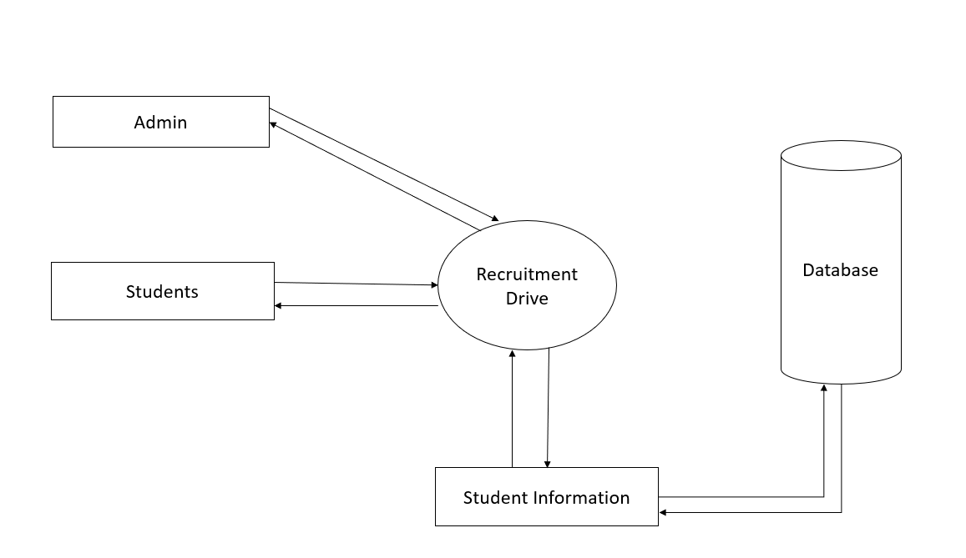Level 0 DFD diagram

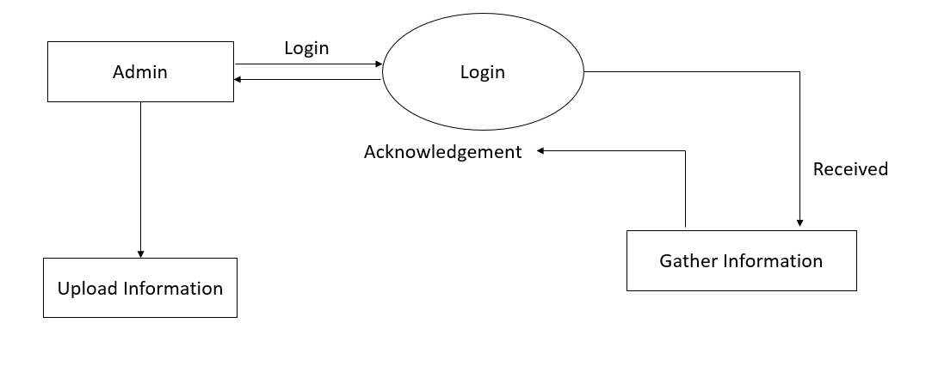Level 1 DFD diagram

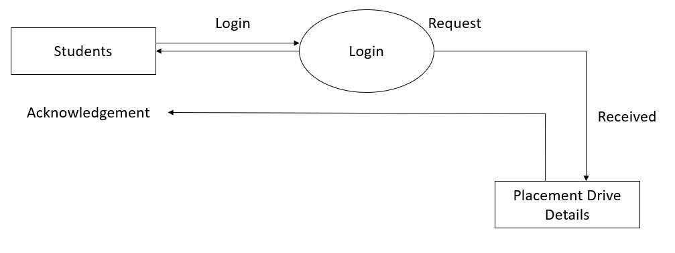
Level 2 DFD diagram
OVERFLOW DIAGRAM:
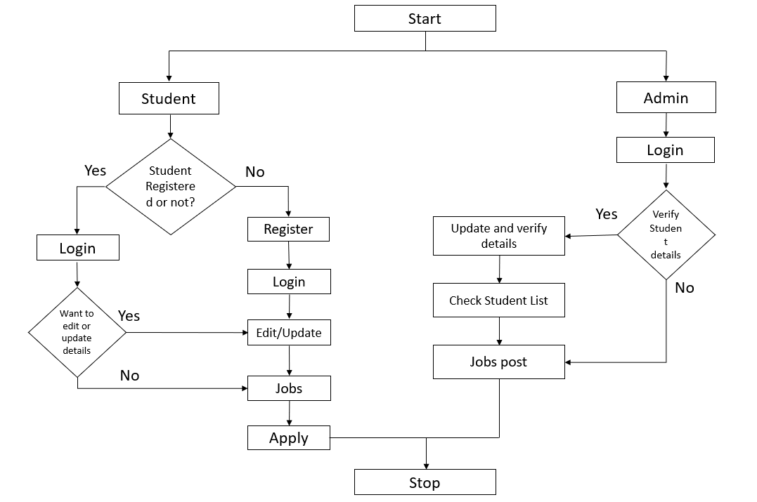
Project over Flow Diagram

VII - CONCLUSION
The placement app has used the Internet to solve the challenges faced by the students and department. Since then, the all-around usage of this application and its potential to solve student document verification and applications appropriately and fairly makes it a crucial constituent of the Internet. The distributed administration of this application is support for inessential details across multiple servers promotes its strong features. The main goal of the T&P project is to minimize the communication gap between T&P officers and aspiring students. Students can upload and update their details with very little effort and without depending on anyone. Also, the students can access the app anywhere at any time. This app minimizes the manual work of the officers. Since most students use phones based on Android OS, this application is developed on Android platforms. This app is very simple and secure to access by all authorized members and students. With an increase in need of comfort, collecting all the information at a place has always been a challenging task for everyone. With the help of this internet-based T & P platform, it makes the lives of administration and students easier by bringing another alternative for the current management.[2]

REFERENCES
- J. Swathi1, K. Priya Tharsini2, S. Suganya Janani3, Asso. Prof Dr.G. Vinoth Chakkaravarthy4, Training and Placement Cell Application, International Research Journal of Engineering and Technology (IRJET), Mar-2018.
- Bhumi Godiwala1, Yash Doshi1, Bhavya Vora1, Anuja Odhekar2, Training and Placement Cell Android Application, Proceedings of the 3rd International Conference on Advances In Science & Technology (Icast) 2020, 3 Apr 2020.
- Mrs. B. Sathyabama1; Mr. S. Mohamed Salahudeen2; Mr. Z. Mohamed Sohail3; Mr. P.S. Mohamed Asarutheen4, App Development for Placement Drive and Recruitment Process, International Journal of Computer Science and Mobile Computing, October 2019.
- Megha Yaligar1, Archana V Korlahalli2, Dixita Mahaveer Patil3, Pavitra P Danappagoudar4, Android Application for Training and Placement Cell, International Research Journal of Engineering and Technology (IRJET), 05 | May 2019.
- Saiteja N1, Shafia Mahedi1, Tarun V Gujjar, Viraj Bhujang Shetty1, Suhas S2, Placement Cell Android Application and Admin Portal, International Journal of Scientific Research in Computer Science, Engineering and Information Technology, June 2021.
- Sandeep S. Chorge1, Ganesh A. Bhabad2, Balaji D. Chate3, Rahul T. Take4, Nitin R. Shinde5, IJARIIE-ISSN(O)-2395-4396, Mar 2017.

