WIFI Module Based Smart Waste Management System

Prof. Monika Ingole ¹, Shital S. Rane ²

^{1,2} Department of Computer Science Engineering, Wainganga College of Engineering and Management, Dongargaon, Wardha Road, Nagpur

monikaingole04@gmail.com

Received on: 15 April, 2022 Revised on: 22 May, 2022, Published on: 24 May, 2022

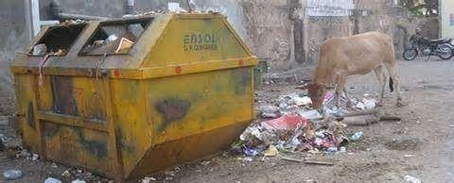
Abstract - Smart Waste Management System which is proposed here is to implement a smarter way of conventional waste management using smart sensors to gather fill-level data, presence of garbage around the dustbin and stinking condition from containers and garbage bins and send it to servers in real time. An authorized phone number which are present in Waste Management Centers gather fill- level and other information sent from multiple containers which are situated throughout a city/locality. The data acquired as above, can be used to systematically plan route-map to collect garbage. The information from the authorized number is sent using communicating modules (GSM/GPRS module). The entire operation is controlled using Atmega328P 8-bit microcontroller. This report showcases a potential design for an IoT gateway that can be used to provide a framework for a smart waste management system.

Keywords: Moisture sensor, Ultrasonic sensor, AT- mega328p microcontroller and GSM/GPRS900A module.

INTRODUCTION

“Cleanliness is next to godliness” is said and believed from the centuries. In this era of environmental concern individuals are outwardly interested in the healthy state of their surroundings. Whether it may a small home of four members or locality cleanliness is of equal importance. India being a huge and highly populated nation, effective waste management is the major concern in maintaining the health and hygiene of the people. Convectional waste management systems which are currently employed in India have static routes and schedules where garbage from containers are collected on fixed schedules, regardless if they are full or not.

Fig 1- Unaddressed filled dustbin with garbage on open streets

This type of situation is often seen where dustbin is not ad- dressed even if it is filled and garbage is spread on open streets. This severely affects the health and hygiene of the people. To promote health and hygiene, the “Govt. Of India” under the leadership of “Prime Minister, Narendra Modi” initiated “Swachh Bharat Campaign” and introduced the concept of “smart cities”
“In the approach of the smart cities mission, the objective is to promote cities that provide core infrastructure and give a decent quality of life to its citizens, a clean and sustainable environment with the application of smart solutions”. Smart cities don’t only mean smart buildings and smart parking areas but “smarter waste management system” is also a major issue to be addressed in developing a smart city. The SMART WASTE MANAGEMENT SYSTEM which is proposed herein uses smart sensors to gather fill-level data from containers and garbage bins and send it to an authorized number in real time. The authorized phone number which is situated in Waste Management Centre gather fill- level information sent from multiple containers which are situated throughout a city/locality. The data acquired as above, can be used to systematically plan route- map as shown in the below figure1.2 and to collect garbage.

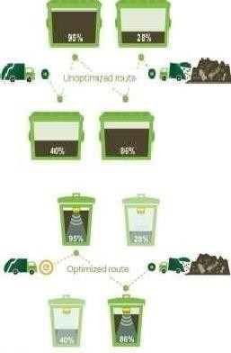

Fig 2-Routing for collection of garbage from filled dustbins.

Secondly most of the times people end-up throwing garbage on open streets, which affect hygiene of city/locality. In order to prevent this dustbin is provided with a sensor and a siren. If the garbage is thrown around the dustbin instead of in the dustbin, the sensor senses it and the siren starts bowling until the garbage is put into the dustbin. This prevents the condition as shown in figure1.1.of not addressing the dustbin.
Many a times, even if the dustbin is not full, it starts stinking resulting in extremely rotten smell. This is mainly due to the wet waste present in the bin. If the bin is not addressed until it is filled, this stinking smell may last for many days and this may severely affect the society. As prevention to this, a Wet sensor is provided in the bin. This sensor collects the information about the wet waste present in the bin and if the value is greater than the threshold level, the message is sent to WMC to address the dustbin. The SWM system pro- posed here, effectively reduces the cost involved in collecting the garbage using conventional methods. It also prevents the spreading of garbage in open streets and stinking of bin which may occur due to the wet waste present in the bin, thus maintaining the hygiene of the city/locality making the life healthy and comfortable which is the main objective of smart city.

II - LITERATURE SURVEY

The following reports show that there is no centralized sys- tem for collection, transport and management of waste. The reports also indicate that, there is no master plan to eradicate the problem. According to report of Central Pollution Control Board On Status Of Compliance By Cpcb With Municipal Solid Wastes (Man- Agement And Handling) Rules, 2000,
- 1, 27,486 TPD (Tons per day) municipal solid wastes are generated in the Country during 2011-12. Out of which, 89,334 TPD (70%) of MSW is collected and 15,881 TPD only (12.45%) is processed or treated.
- House-to-house collection is most critical issue in the entire management of MSW. Municipalities are well equipped with waste transporting vehicles, but many of them are not following the waste transportation norms like –transporting waste under covered conditions so that littering does not occur on the way and it should not be exposed to the public, arrange alternative vehicle while breakdown on the way, etc. According to Solid Waste India Review- 2008, by Mufeed Sharholy, Kafeel Ahmad, Gauhar Mahmood R.C. Trivedi, 90% of MSW is disposed of unscientifically in open dumps and landfills, creating problems to public health and the environment. Stress on Data on quantity variation and generation are useful in planning for collection and disposal systems. With increasing urbanization and changing life styles, Indian cities now generate eight times more MSW than they did in 1947. Presently, about 90 million t of solid waste are generated annually as byproducts of industrial, mining, municipal, agricultural and other processes. The amount of MSW generated per capita is estimated to increase at a rate of 1–1.33% annually (Pappu et al., 2007; Shekdar, 1999; Bhide and Shekdar, 1998).
- Above reports clearly urge for a centralized, scientific and smart collection, transport and disposal of waste and our project proposed concerns on collection and transport in initial stage and further developments on success can address disposal and re- cycling of waste.

Motivation: India with clean households has dirty streets, people find themselves lazy to throw away waste to garbage bins rather dispose waste in open. The county dreaming of smart cities not only has to have concern on electric power management, vehicle traffic and pollution management, water supply and management but also has to have a greater deal on waste collection –segregation – transport – disposal and complete control and management of these.
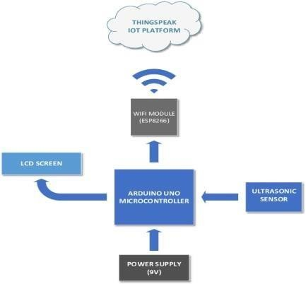
Collection Hence it is highly essential to keep track on fill levels of garbage bins, intelligently plan collection routes, and optimize human and machine numbers and their work efficiency. Data-analysis done on information gathered in servers can be used for proper control, policy making and budget planning for maintenance of the complete system. This can very well be accomplished by the data gathered by the servers sent by smart sensors based on route-maps planned on data gathered, reduces collection costs, vehicle count on task, emissions, road and vehicle wear, noise pollution. It also significantly reduces work hours and human resource assigned, which is a big saving in organization’s budget.
Both solutions which are proposed above in abstract are unique and efficient in complete waste management of a city/locality, which as a whole aids for maintenance of cleanliness and hygiene of city and also in proper waste management.

III –METHODOLOGY

This chapter describes the steps to be followed to implement the proposed system and hardware components required.
In this project of Wifi Module Based Smart Waste Management System, we will be using ultrasonic range sensor to know the amount of garbage collected in garbage containers and this data is sent through GSM/GPRS 900A module to Authorized phone number present at waste management centers [here from called as WMC] and with the help of Wi-Fi module data send to the cloud server. To control this operation, we will be using ATmega328P microcontroller. The Authorized number present at WMCs will receive an SMS which is sent through GSM/GPRS module and show fill- levels of each garbage bin in real-time on server or phone screen. Secondly, the ultra-sonic sensor which is fixed at the dustbin senses if any garbage is thrown on street instead of in dustbin, this information is collected by the microcontroller (here ATmega328).
The siren is then made to ring until the garbage is thrown in the dustbin. Thus, preventing the garbage on open streets. Most of the times even if the dustbin is not filled it may start stinking which may lead to irresistible smell in the locality/city
The main cause for this stinking smell is the wet waste pre- sent in the dustbin, to prevent this moisture sensor is fixed at the dustbin.
This sensor senses the moisture content in the waste, and if the moisture content is more than a particle threshold level, the information is sent to the number in the waste management center.
Once this SMS is received, the dustbin is addressed even if it is not full. Thus, the locality/city is saved from the irresistible smell of the garbage bin.

Block Diagram

Fig.3. (a) Block diagram for smart waste management system.
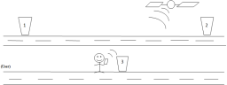
Fig.3. (b). Avoiding garbage on streets and throwing it in dustbin.

Explanation of Block Diagram

Fig 3. (b) shows the different components that are used to implement the smart waste management system. The working of the system may be described in three phases as explained below.

Phase I

- Garbage bins located all-around the city will be fitted with ultrasonic sensor which senses garbage level in the bin and sends it to ATmega328 microcontroller.
- ATmega328 uses the information received from sensor, checks if it’s above upper-threshold level and sends it to authorized number using GSM/GPRS modem.
- The number present at the waste management center receives information from microcontroller and displays it on phone screen.
- If garbage bin is emptied, microcontroller sets itself for continuous monitoring for next information on fill-levels.

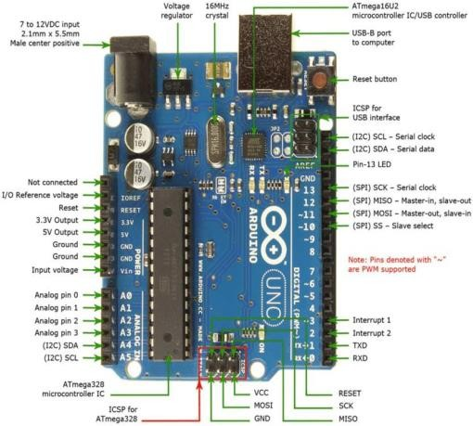
Phase II
- If a person throws the garbage on Open Street (around the dustbin) instead of in the dustbin, the ultrasonic sensor which is fitted outside the dustbin senses it.
- This information is collected and processed by the microcontroller and the siren is activated.
- The siren is made to blow until the garbage is lifted from the street and put in the dustbin. Once the garbage is lifted from the street and there is no garbage around the bin, the siren stops blowing.
- The microcontroller sets itself for continuous monitoring of next information.

Phase III
- Most of the times even if the dustbin is not full, it may start stinking causing highly irresistible smell in the locality/city.
- This is mainly due to the wet waste present in the bin. This issue can be addressed by fitting a moisture sensor.
- The moisture sensor senses the moisture content in the garbage and if the content is more than a threshold level, the SMS is sent to the number pre- sent in the waste management center.
- The dustbin is then addressed even if it is not filled in order to prevent the stinking smell. Once the bin is addressed the microcontroller sets itself for next cycle.

IV -HARDWARE COMPONENTS

Arduino Uno:
The Arduino Uno is a microcontroller board based on the ATmega328 (datasheet). It has 14 digital input/output pins (of which 6 can be used as PWM outputs), 6 analog in- puts, a 16 MHz ceramic resonator, a USB connection, a power jack, an ICSP header, and a reset button. It contains everything needed to support the microcontroller; simply connect it to a computer with a USB cable or power it with a AC-to-DC adapter or battery to get started. An overview of Arduino Uno is shown in figure 4."Uno" means one in Italian and is named to mark the upcoming release of Arduino 1.1. The Arduino Uno can be powered via the USB connection or with an external power supply. The power source is selected automatically.

Fig. 4: An over view of Arduino Uno

Power:

External (non-USB) power can come either from an AC-to- DC adapter (wall-wart) or battery. The adapter can be connected by plugging a 2.1mm center-positive plug into the board's power jack. Leads from a battery can be inserted in the Gnd and Vin pin headers of the POWER connector.
The board can operate on an external supply of 6 to 20 volts. If supplied with less than 7V, however, the 5V pin may supply less than five volts and the board may be un- stable. If using more than 12V, the voltage regulator may overheat and damage the board. The recommended range is 7 to 12 volts.

  - VIN. The input voltage to the Arduino board when it's using an external power source (as opposed to 5 volts from the USB connection or other regulated power source). You can supply voltage through this pin, or, if supplying voltage via the power jack, access it through this pin.
  - 5V. This pin outputs a regulated 5V from the regulator on the board. The board can be supplied with power either from the DC power jack (7 - 12V), the USB connector (5V), or the VIN pin of the board (7-12V). Supplying voltage via the 5V or 3.3V pins bypasses the regulator and can damage your board.
  - 3V3. A 3.3-volt supply generated by the on-board regulator. Maximum current draw is 50 mA.
- GND. Ground pins

Input and Output
Each of the 14 digital pins on the Uno can be used as an in- put or output, using pinMode (), digitalWrite(), and digital Read() functions. They operate at 5 volts. Each pin can pro- vide or receive a maximum of 40 mA and has an internal pull-up resistor (disconnected by default) of 20-50 kilo Ohms. In addition, some pins have specialized functions:

- Serial: 0 (RX) and 1 (TX). Used to receive (RX) and transmit (TX) TTL serial data. These pins are connected to the corresponding pins of the AT- mega8U2 USB-to-TTL Serial chip.

- External Interrupts: 2 and 3. These pins can be configured to trigger an interrupt on a low value, a rising or falling edge, or a change in value. See the attach Interrupt() function for details.
- PWM: 3, 5, 6, 9, 10, and 11. Provide 8-bit PWM output with the analog Write () function

SPI: 10(SS), 11(MOSI), 12(MOSI), 13(SCK).
These pins support SPI communication using the SPI library.
- LED: 13. There is a built-in LED connected to digital pin
- 13. When the pin is HIGH value, the LED is on, when the pin is LOW, it's off.

The Uno has 6 analog inputs, labeled A0 through A5, each of which provide 10 bits of resolution (i.e. 1024 different values). By default, they measure from ground to 5 volts, though is it possible to change the upper end of their range using the AREF pin and the analog Reference () function. Addition- ally, some pins have specialized functionality.

- TWI: A4 or SDA pin and A5 or SCL pin. Support TWI communication using the Wire library.
There are a couple of other pins on the board:

- AREF. Reference voltage for the analog inputs. Used with analog Reference ().
- Reset. Bring this line LOW to reset the microcontroller. Typically used to add a reset button to shields which block the one on the board

COMMUNICATION
The Arduino Uno has a number of facilities for communicating with a computer, another Arduino, or other micro- controllers. The ATmega328 provides UART TTL (5V) serial communication, which is available on digital pins 0 (RX) and 1 (TX). An ATmega16U2 on the board channels this serial communication over USB and appears as a virtual com port to software on the computer. The '16U2 firmware uses the standard USB COM drivers, and no external driver is needed. However, on Windows, file is required. The Arduino software includes a serial monitor which allows simple textual data to be sent to and from the Arduino board. The RX and TX LEDs on the board will flash when data is being transmitted via the USB- to-serial chip and USB connection to the computer (but not for serial communication on pins 0 and 1). A Software Serial library allows for serial communication on any of the Uno's digital pins. The ATmega328 also supports I2C (TWI) and SPI communication. The Arduino software includes a Wire library to simplify use of the I2C bus; see the documentation for details. For SPI communication, use the SPI library.

MICROCONTROLLER AT- MEGA328OVERVIEW

The ATmega328 is a single chip microcontroller created by Atmel in the mega AVR family. Its 8-bit AVR RISC-based microcontroller combines 32kB ISP flash memory with read-while-write capabilities, 1k BEEPROM, 2kB SRAM, 23 general purpose I/O lines,32 general purpose working registers, three flexible timer/counters with compare modes and other features as described below. The device achieves throughout approaching 1MIPS per MHz Figure 4.2 shows the block diagram of ATmega328.

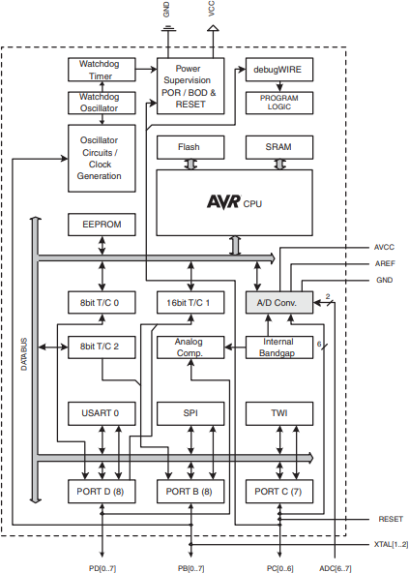

Fig.5. Block diagram of ATmega328 microcontroller.

TheATmega48A/PA/88A/PA/168A/PA/328/P provides the following features:

  - 4K/8Kbytes of In-System Programmable Flash with Read-While-Write capabilities, 256/512/512/1Kbyte EEPROM, 512/1K/1K/2KbytesSRAM,
  - 23 general purpose I/O lines, 32 general purpose working registers, three flexible Timer/Counters with compare modes,
  - internal and external interrupts, a serial programmable USART, a byte-oriented 2-wire Serial Interface,
  - an SPI serial port, a 6-channel 10-bit ADC (8 channels in TQFP and QFN/MLF packages),
  - A programmable Watchdog Timer with internal Oscillator, and five software selectable power saving modes
  - . The Idle mode stops the CPU while allowing the SRAM, Timer/Counters, USART, 2-wire Serial Interface, SPI port, and interrupt system to continue functioning.
  - The ADC Noise Reduction mode stops the CPU and all I/O modules except asynchronous timer and ADC, to minimize switching noise during ADC conversions. In Standby mode, the crystal/resonator Oscillator is running while the rest of the device is sleeping. This allows very fast start-up combined with low power.

GSM/GPRS sim900A module

The GSM shield by Arduino is used to send/ receive messages and make/receive calls just like a mobile phone by using a SIM card by a network provider. We can do this by plugging the GSM shield into the Arduino board and then plugging in a SIM card from an operator that offers GPRS coverage.
This GSM Modem can work with any GSM network opera- tor SIM card just like a mobile phone with its own unique phone number. Advantage of using this modem will be that its RS232 port can be used to communicate and develop embedded applications. Applications like SMS Control, data transfer, remote control and logging can be developed easily using this. It Supports features like Voice, SMS, Data/Fax, GPRS and integrated TCP/IP stack. To be connected to a cellular network, the shield requires a SIM card pro- vided by a network provider. Figure 4.3 shows the different components of a GSM/GPRS module.

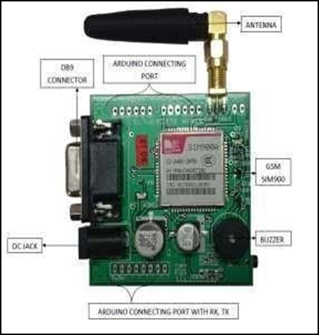
Fig .6.- Front view of a GSM/GPRS sim900A module
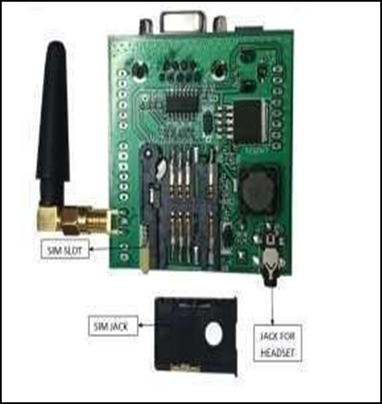
Fig.7. Rear view of GSM/GPRS module

SIM900A: This is an ultra-compact and reliable wireless module. The SIM900A is a complete Dual band GSM/GPRS solution in a SMT module which can be embedded in the customer applications allowing you to benefit from small dimensions and cost-effective solutions.
Featuring an industry-standard interface, the SIM900A delivers GSM/GPRS 900/1800MHz performance for voice, SMS, Data, and Fax in a small form factor and with low power consumption. With a tiny configuration of 24mm x 24mm x 3 mm, SIM900A can fit in almost all the space requirements in your applications, especially for slim and compact demand of design.

Power Requirements
The board should be powered with an external power supply that can provide current between 700mA and 1000mA. Powering an Arduino and the GSM shield from a USB connection is not recommended, as USB cannot provide the required current when the modem is in heavy use. So instead we have to use 12V adapter. The modem can pull up to 2A of current at peak usage, which can occur during data trans- mission.

At Commands for Using The Shield
- checking the operation and connection of GSM shield:
AT Press ENTER this would print OK which signifies of working connection and operation of the GSM shield.

Making a voice call:
ATD+ (country code) mobile number; Press ENTER.

Disconnecting the active call:

ATH Press ENTER.

Receiving the call:
ATA Press ENTER.

Sending a message:
For sending SMS in text Mode: AT+CMGF=1 Press EN- TER AT+CMGS=” mobile number” Press ENTER Once the AT commands is given‟ >‟ prompt will be displayed on the screen. Type the message to be sent via SMS. After this, Press CTRL+Z to send the SMS. If the SMS sending is successful, “OK” will be displayed along with the message number.

Receiving a message:
For reading SMS in the text mode: AT+CMGF = 1 Press ENTER AT+CMGR = num. Number (num.) is the message index number stored in the SIM card. For new SMS, URC will be received on the screen as + CMTI: SM „num‟. After this AT+CMGR=1 Press ENTER this displays the message on the screen along with sender details, number and timing to.
How to Interface the Gsm Module With Arduino Uno
- First, we connect our Arduino Uno to the Computer or Laptop to see which COM port will be used to burn the pro- gram from the computer or laptop. This also provides power to the Arduino Uno
- Next, we supply power to the GSM shield (supply only
12V to the GSM shield from the power jack using the adapter) which is going to be used for our program
- For GSM programs, only 2 pins, RX and TX are to be used mainly. So, we require only these two pins of the Arduino Uno. These pins are pins 0 and 1 of the Arduino Uno

- Next burn the required program in The Arduino Uno using the software

- Then connect the GSM shield to Arduino such that RX, TX of the shield is connected to the TX, RX of the Arduino Uno.

- Your interfacing is completed

ULTRASONIC SENSOR

The human ear can hear sound frequency around 20HZ ~ 20KHZ, and ultrasonic is the sound wave beyond the human ability of 20KHZ. An Ultrasonic ranging module HC - SR04 typically has 4 pins as shown in the figure.7.

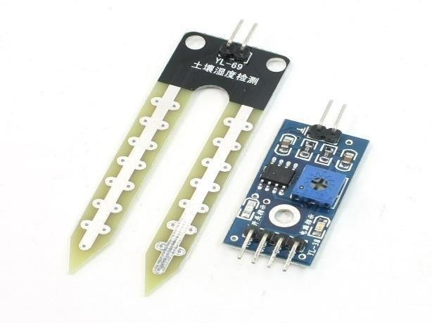
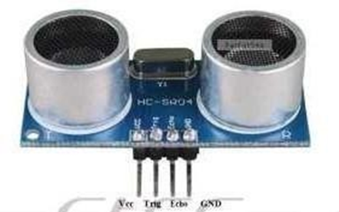
Fig.8. HC-SR04 ultrasonic sensor.

Ultrasonic distance measurement principle
Ultrasonic transmitter emitted an ultrasonic wave in one direction and started timing when it launched. Ultrasonic spread in the air and would return immediately when it en- countered obstacles on the way. At last, the ultrasonic receiver would stop timing when it received the reflected wave. As Ultrasonic spread velocity is 340m / s in the air, based on the timer record t, we can calculate the distance
(s) Between the obstacle and transmitter, namely: s =340t / 2, which is so- called time difference distance measurement principle.
The principle of ultrasonic distance measurement used the already-known air spreading velocity, measuring the time from launch to reflection when it encountered obstacle, and then calculate the distance between the transmitter and the obstacle according to the time and the velocity. Thus, the principle of ultrasonic distance measurement is the same with radar. Distance Measurement formula is expressed as: L = C X T In the formula, L is the measured distance, and C is the ultrasonic spreading velocity in air, T represents time (T is half the time value from transmitting to receiving).
MOISTURE SENSOR

This is an Electrical Resistance Sensor. The sensor is made up of two electrodes. This soil moisture sensor reads the moisture content around it. A current is passed across the electrodes through the soil and the resistance to the current in the soil determines the soil moisture. If the soil has more water resistance will be low and thus more current will pass through. On the other hand, when the soil moisture is low the sensor module outputs a high level of resistance. This sensor has both digital and analogue outputs. Digital output is simple to use but is not as accurate as the analogue output.

Fig 9: YL-69 moisture sensor.

SOFTWARE TOOL
The Arduino software is used for the development and implementation of the entire system proposed in this report. Arduino is an open-source prototyping platform based on easy-to-use hardware and software. Arduino boards are able to read inputs - light on a sensor, a finger on a button, or a Twitter message - and turn it into an output - activating a motor, turning on an LED, publishing something online. You can tell your board what to do by sending a set of instructions to the microcontroller on the board. To do so you use the Arduino programming language (based on Wiring), and the Arduino Software (IDE), based on Processing.

All Arduino boards are completely open-source, empowering users to build them independently and eventually adapt them to their particular needs. The software, too, is open- source. The code used for the implementation of the pro- posed system is given in Appendix A.

RESULT ANALYSIS

Snapshots of output: According to the usage and the in- formation gathered by the sensors the dustbin may display different messages on the screen as shown below.
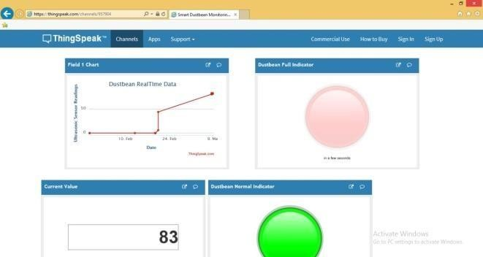
- “DUSTBIN EMPTY” message is displaying in serial monitor, when no waste is found inside dustbin.
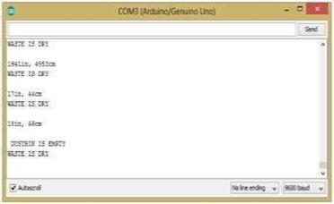
Fig 10 -snapshots of “Dustbin is empty” message are displayed on serial monitor.

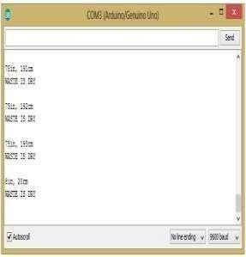
- “WASTE IS DRY” SMS is send and displaying in serial monitor, when waste is dry.

Fig 11. Snapshot of SMS sent when “dry waste” is found.

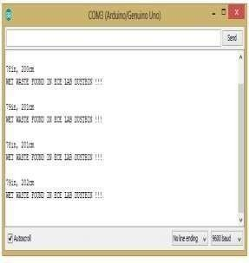
- “WET WASTE FOUND IN ECE LAB DUSTBIN” SMS is sent and displayed on serial monitor, when a wet waste is found in a respective dustbin.

Fig12 - snapshot of SMS sent when “wet waste” is found in dustbin.

- “DUSTBIN IS NOT YET FULL”SMS is sendto waste management center and displayed on serial monitor, when an incorrect garbage level is foun after 2nd check.
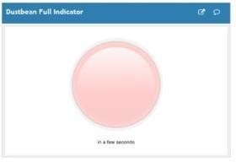
Fig 13. snapshot of SMS sent when there is an “incorrect level of garbage” is found after 2nd check.

- “DUSTBIN IS FULL” SMS is send to waste management center and displays in serial monitor.
Fig 14: snapshot SMS sent when “dustbin is full”.

FINAL RESULTS AND EXPERIMENTAL SETUP
As mentioned in the report, the main objective of the project is to monitor the garbage level, to sense whether the waste is wet or dry and to monitor if any garbage is spread outside the dustbin. All the 3 sensors collect the respective in- formation and fed to the microcontroller (here AT- MEGA328P), the microcontroller processes the information and with the help of GSM/GPRS module, the information is sent to the authorized number present at the waste management center over SMS. The entire experimental setup for the proposed system and the final SMS that is displayed on the phone screen is as shown in below snapshots.
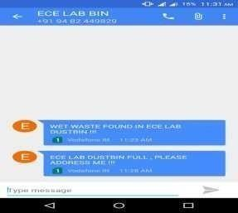
Fig 15- snapshot of message displayed on phone screen.

FUTURE SCOPE
  - Servers can be maintained at the WMC‟s to collect the information from the dustbin instead of a phone number.
  - Each level of the dustbin can be recorded instead of just recording the filled level.
  - Whenever a dustbin is filled, a GPS locator can be used to locate another dustbin which is nearer to the user to make the waste disposal convenient to prevent the waste lying on the open streets.

REFERENCES
- https://components101.com/sensors/ultrasonic- sensor-working-pin out-datasheet
- s.arduino.cc/resources/datasheets/A000066- datasheet.pdf
- https://www.researchgate.net/publication/341870789_ Smart_Waste_Management_System_using_IOT
- Smart Cities Mission, Ministry of urban development, Govt. of India. http://smartcities.gov.in
- “Embedded Systems, a Contemporary Design Tool” by James K. Peckol.
- Fachmin Folianto, Yong Sheng Low, Wai Leong Yeow, “Smartbin: Smart Waste Management System”, April 2015. 4.Mohd Helmy Abd Wahab; Aeslina Abdul Kadir; Mohd Razali Tomari; Mohamad Hairol JabbarMohd Helmy Abd Wahab; Aeslina Abdul Kadir; Mohd Razali Tomari; Mohamad Hairol Jabbar, "Smart Recycle Bin: A Conceptual Approach of Smart Waste Management with Integrated Web Based System”.
- 5.vincenzo Catania; Daniela Ventura “An approach for monitoring and smart planning of urban solid waste management using smart-M3 platform.

