AI_LEEZA: The Virtual Assistant
Sakshi Somkuwar¹, Buddharatna Sahare², Manisha Somkuwar^{3,} Supriya Bhurle ⁴

Department of Computer Science and Engineering,
G.H Raisoni Institute of Engineering and Techology, Nagpur, Shradha Park, B-37/39
Hingna-wadi road,Nagpur,440028
(Professor Priya Khobragade, Department of CSE, GHRIET, Nagpur, 440028)

buddharatna.sahare.cs@ghrietn.raisoni.net

Received on: 11 June ,2022 Revised on: 08 August ,2022, Published on: 10 August,2022

Abstract – There are many virtual assistants’ application like Alexa, ok google, Siri which work on the technology of voice recognition. There is one common thing between the above-mentioned virtual assistants that they all require internet access to be able to function. To overcome this drawback, we have developed an application called AI_LEEZA. Our application can run totally independent of
internet. We have used Unity Engine as our Platform to build our application. It is written in C# language. Windows Speech Library has been used for voice recognition. It can perform various task such as Playing Music, doing simple calculations, Telling us currency conversion rate and so on.

Keywords: Virtual Assistant, Unity Engine, C#, Windows Speech Library.

- INTRODUCTION

Virtual assistants can be very helpful in day-to-day life. For instance, if a user wants to listen a song, all he has to do is give a voice command to the virtual assistant and it will play the song for user, the user does not need to search the song manually.However, there are certain Virtual assistant are application which perform various task when given a voice command. In other words we can say that virtual assistants are combination of automatic speech recognition. drawbacks to the virtual assistants, in order to take commands and till the command is executed the user needs a Internet connection in its device. If the internet

connection is disrupted in between the virtual assistant stops working. In order to overcome this issue, we have developed a virtual assistant called AI_LEEZA. It is completely independent of Internet connection. It takes voice input, recognizes the command and executes the given command without even connecting to internet.
In order to recognize which, we have used the technology of windows speech library which recognizes the user’s voice. The platform which we have used to build this application is UNITY ENGINE.

- LITERATURE SURVEY

- Smart Voice based Virtual Personal assistants with Artificial Intelligence.

In this paper they have described various implementation of a virtual assistant which can perform tasks on desktop.

- Voice Assistants and smart speakers in everyday life and in education.

Usage of voice assistants in everyday life and its potential to be used for educational purposes.

- A Review of Voice Based Personal Assistants.

In this paper, Statistical information about usage of virtual assistant, work done and technologies used till date and future scope of virtual assistant.

- Personal Assistant with Voice Recognition Intelligence.

The implementation of a voice recognition system which has capability to work with or without internet connectivity.

- Voice Controlled Personal Assistant Using Raspberry Pi.

In this paper we have studied the implementation of a voice command system as an intelligent person assistant (IPA) that can perform numerous tasks or services for an Individual.

In this paper we have studied the implementation of end-to-end speech recognition in Virtual assistants.

III -METHODOLOGY

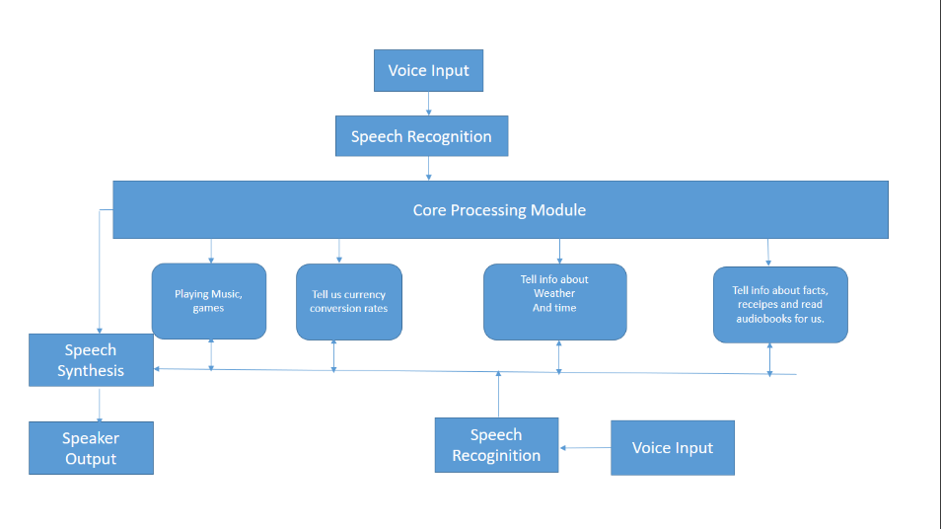
Fig 1: Block Diagram
- In order to recognizes voice, we have used the Windows Speech Library.
- Initially the User gives the voice input.
- The Speech gets recognized.
- If it is a valid command then it will go to Core processing module.
- Core Processing module will select which task has to be executed according to the given voice command.
- According to task, the speech will be synthesized.
- The Output will be given through Speakers as well as will get displayed on the screen as well.
- Our Virtual assistant uses natural language processing (NLP) to match user text or voice input to executable commands.
- Unity exposes three ways to add Voice input to your Unity application, the first two of which are types of Phrase Recognizer:
- The Keyword Recognizer supplies your app with an array of string commands to listen for
- The Grammar Recognizer gives your app an SRGS file defining a specific grammar to listen for
- The Dictation Recognizer lets your app listen for any word and provide the user with a note or other display of their speech

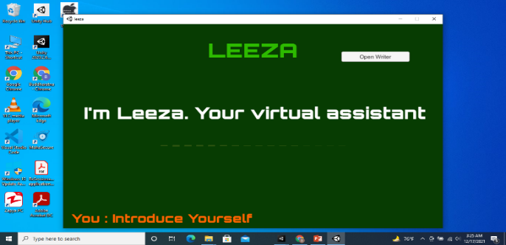
IV-IMPLEMENTATION

Fig 2: Leeza’s response to the given command

- Audio Input is important part of our application. If the audio input is not correct then our application might not work.
- Average Human voice spans from 60 hz to 90 hz. Anything below or above this frequency cannot be considered as valid voice input.
- The Programming language used here is C#.
- Initially we have to take audio input from microphone for that we will create a parent in hierarchy named microphone and add c sharp script Microphone. cs, the sample rate at which the audio will be taken we will be defined in Microphone. cs.
- In order to manage threshold frequency of microphone we will add another c# script named Player Preference Manager. We will define threshold and sensitivity of the microphone in this script.
- For Front End of the application, we will create another parent in hierarchy named canvas.
- In canvas, we will create sub parent named called home. In Home we will add three sub parent object: AI_TITLE, AI_COMMAND, AI_RESPONSE.
- In AI_TITLE, title of the application which will be displayed on the homepage of the application will be added.
- AI_COMMAND, AI_RESPONSE will recognize and give response to the voice commands simultaneously.
- In asset section we will create folder named audio and drop our audio files there which we need our application to play when an appropriate command will be given.
- In order to add different features to our application we will add another cs file named AI HANDLER.
- In AI Handler we will use function of phrase recognizer, which recognize phrase given through voice commands. For example: If give command “Introduce Yourself”, the expected response text will be “I’m Leeza your Virtual Assistant.” And it will play the audio clip assigned to it.
- In order to use audio clips we will use the function called audio clip ac and audio source also in AI Handler.
- Similarly, as any other virtual assistant we can casually talk with our application. If we give voice commands like “Who developed you”, the response
will be “I was created by 4 students og GH RAISONI INSTITUTE OF ENGG. AND TECHNOLOGY”.
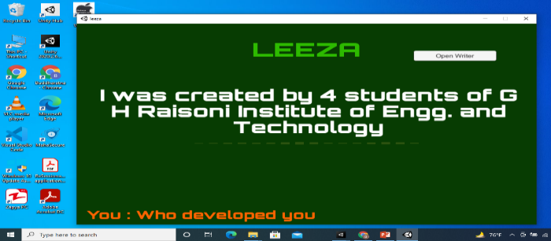
Fig 3: Communication with leeza
- Our application can also tell us time. We will use the function System. Date and Time. Now. To short Time String (). When user will give command of “what is time”, it will display the time which is currently set in the system.
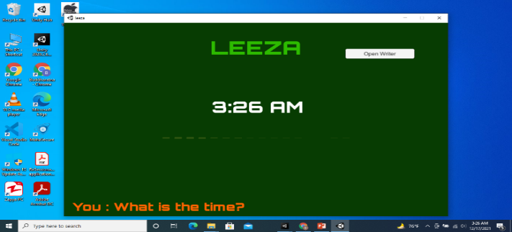
Fig 4: Time
- Our Application can also play music for us. When a user wants to listen a song. It will give command that play a particular song and the application will execute it.
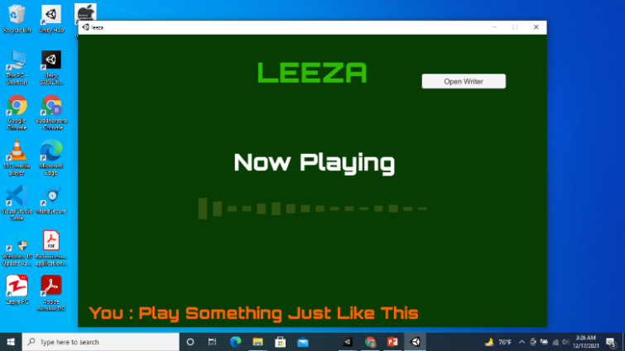

Fig 5: Playing Songs
- Our application also has feature of stopwatch. When user gives the command of stopwatch, our application will execute “Stopwatchmode()” function from AI_Handler.
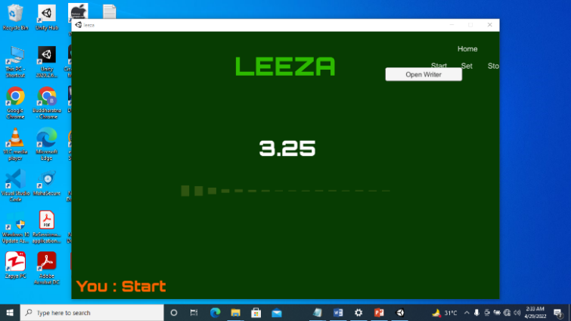

Fig 6: Stopwatch
- When user gives command for currency convertor, it executes Exchange() function from AI_ Handler. It converts Rupees to dollars, Dollars to Euros, Rupees to Euros and vice versa.

- When user gives command of calculator, depending upon the given voice command, the application will execute Calculator Mode () from AI_ Handler. This application is capable of performing four operations in calculator mode addition, subtraction, multiplication and division.
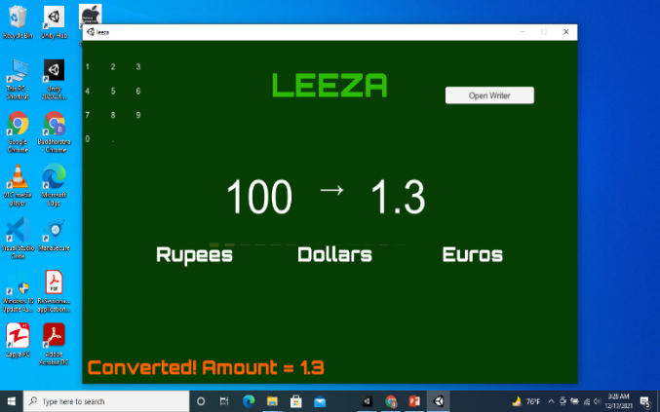
Fig 7: Currency Conversion

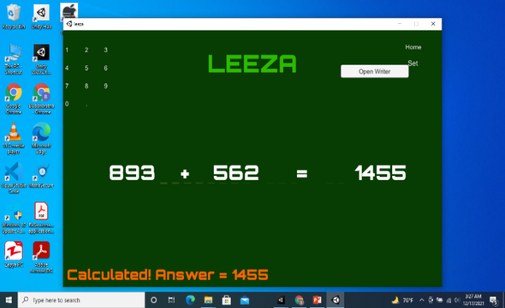

Fig 8: Calculator

- CONCLUSION
In the paper we were able to demonstrate the working of our Virtual Assistant name AI_LEEZA that can recognize our voice. This Application that we have built is capable of recognizing our voice. It not only recognizes our voice but also responds to our recognized voice accordingly. You can perform various tasks by simply giving voice commands. Our Virtual Assistant can Play Music for You. It can also tell you the current time. You can also do simple calculations using our Virtual Assistant. Hence we believe that we were successfully able to develop a Virtual Assistant that can recognize human voice and can perform tasks accordingly and which can work totally independent of Internet connection.

REFERENCES

[1] Sunil Sikka, Priyanka Makkar, ‘‘Smart Voice based Virtual Personal assistants with Artificial Intelligence,’’ june 2020
https://acors.org/ijaco/VOL1_ISSUE3_18

[2] George Terzopoulos, Maya Satratzemi, “Voice Assistants and Smart Speakers in everyday life and in education.”. Information in Education,2020,Vol.19,No.3,473-490,November 2020.

[3] Niko Moritz, Takaaki Hori .
“Triggered Attention for End-to-End Speech Recognition.” IEEE Intl Conference an Acoustics, Speech and Signal Processing (ICASSP) 2019

[4]. R. Manikandan, Vishal Pandita. “A Review of Voice Based Personal Assistants.” International Journal for Research in Applied Science & Engineering Technology (IJRASET) ISSN: 2321-9653; IC Value: 45.98; SJ Impact Factor: 6.887 Volume 6 Issue II, February 2018.

[5]. Dr. Kotrappa Sirbi, Mr. Abhijit Patankar “Personal Assistant with Voice Recognition Intelligence”. Int'l Journal of Engineering Research & Technology ISSN 0974 Vol. 10 2017.

[6]. Prof. Emad S. Othman. “Voice Controlled Personal Assistant Using Raspberry Pi” International Journal of Scientific & Engineering Research Volume 8, Issue 11, November-2017

[7] https://www.smartsheet.com/voice-assistantsartificial-intelligence
[8] https://www.c-sharpcorner.com/blogs/create-a-calculator-using-c-sharp-application

[9] https://github.com/arymangupta/Virtual-Assistant-AR-VR-Unity3D-/projects?type=beta

[10] https://becominghuman.ai/how-to-equip-your-app-with-a-virtual-assistant-d7c2bf0ceff8

