STABILISATION OF SOIL WITH CEMENT

Prof. Harishankar Patel1, Prof. Lokesh Singh2, Pradeep Kumar Dewangan3 Sanjay Kumar Patel 4,Hemant Kumar Prajapati5,Gagan Rathore6 ,
Rahul Rathore7,Kuldeep Sharma 8 Aayush Pal ⁹

3,4,5,6,7,8,9Under Graduate Student

RSR Rungta college of Engineering & Technology, Bhilai Chhattisgarh,India

1,2Assistant Professor

RSR Rungta College of Engineering & Technology, Bhilai Chhattisgarh,India

Abstract– Soil stabilization is the process which improves the physical properties of soil, such as increasing shear strength, bearing capacity etc. which can be done by use of controlled compaction or addition of suitable mixtures like cement, lime and waste materials like cement, fly ash, phosphogypsum, plastic etc. This research work mainly focuses on soil stabilization using cement to improve geotechnical properties such as plasticity, compaction, and unconfined compressive strength of the studied soil.These properties were determined before as well as after the stabilization of soil.In this work it is found that the dry density of soil increased and optimum moisture content decreased by addition of cement in various properties. Also it is observed that at 15% addition of cement, no change is found in dry density as well as in moisture contents.

Keywords- Specific Gravity Test,Water Content Test,Standard Proctor Test,California Bearing Ratio Test,Unconfined Compression Test.

INTRODUCTION

A sustainable transport system must provide mobility and accessibility to all urban residents in a safe and environment friendly mode of transport. This is a complex and difficult task when the needs and demands of people belonging to different income groups are not only different but also often conflicting. For example, if a large proportion of the population cannot afford to use motorized transport - private vehicles or public buses – then they have to either walk or ride bicycles to work .
[1]. Provision of safe infrastructure for bicyclists and pedestrians may need segregation of road space for bicyclists and pedestrian from motorised traffic or reduction in speeds of vehicles. Bothmeasures could result, though not inevitable, in restricting mobility of car users. Similarly, measures to reduce pollution may at times conflict with those needed for reduction in traffic crashes
[2]. For example, increases in average vehicle speeds may reduce emissions but they can result in an increase in accident rates.But most public

discussion and government policy documents dealing with transportation and health focus only on air pollution as the main concern. This is because air pollution is generally visible and its deleterious effects are palpable. It is easy for most people to connect the associations between qualities of motor vehicles, exhaust fumes and increased morbidity due to pollution. However, most individuals are not able to understand the complex interaction of factor associated with road accidents. Health problems due to pollution are seen as worthy of public action whereas those due to injury and death in accidents as due to individual mistakes. Therefore, policy documents dealing with sustainable development for cities always include options for pollution reduction but rarely for road traffic injury control
[3]. In this project we discuss some of the issues concerning public transport, safety and the environment. We illustrate that unless the needs of nonmotorised modes of traffic are met it will be almost impossible to design any sustainable transportation system for urban areas.We show that pedestrians, bicyclists and non-motorisedrickshas are the most critical elements.

GOALS

- Evaluating the soil properties of the area under consideration.
- Deciding the property of soil which needs to be altered to get the design value and choose the effective and economical method for stabilization. 3.Designing the Stabilized soil mix sample and testing it in the lab for intended stability and durability values.

APPLICATION

- Improve the characteristics of the soil.

- Using cement as a stabilizer in (0%, 5%, 10%, 15%) soil sample to increase the strength.

- Test performed specific gravity test, water content test, proctor test, CBR Test, direct shear test, triaxial shear strength test.

- To study about soil cement road.
- To study about construction methods by using soil cement.

- To compare bearing capacity of soil and soil cement.
✓
- To discuss about various properties of soil cement.

- To discuss about advantages and disadvantages of soil cement roads.

METHODOLOGY

The Proctor compaction test is a laboratory method of experimentally determining the optimal moisture content at which a given soil type will become most dense and achieve its maximum dry density. The term Proctor is in honor of R. R. Proctor, who in 1933 showed that the dry density of a soil for a given compactive effort depends on the amount of water the soil contains during soil compaction.
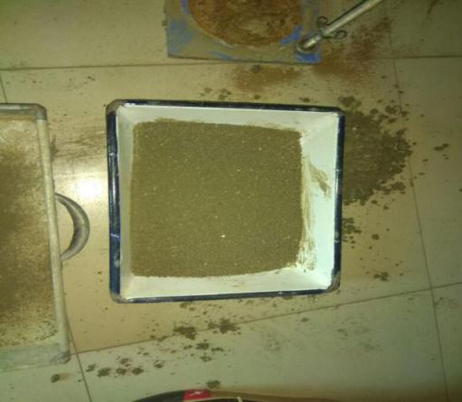
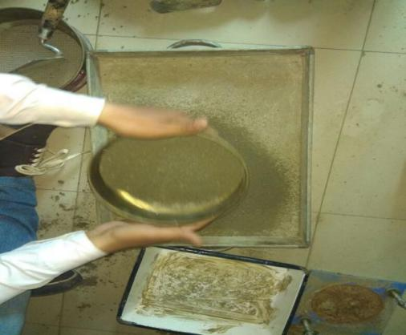

Fig.Collection of soil sample & Sieving

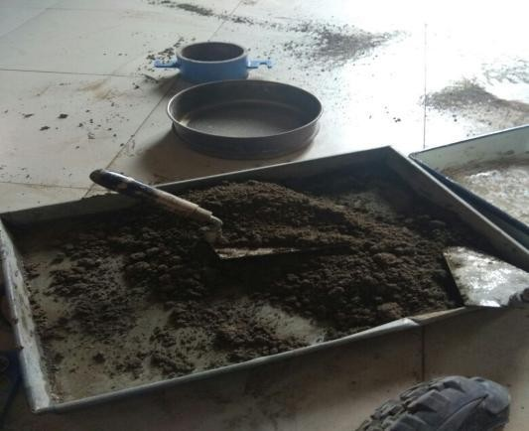

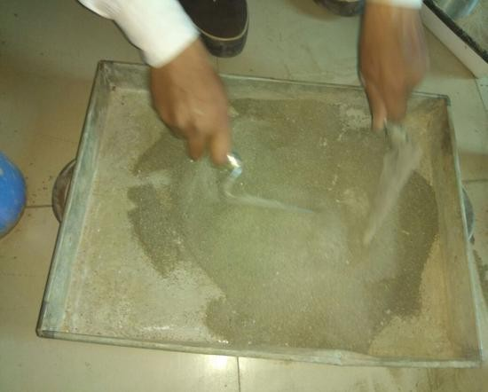
Fig.Addition of cement

The California bearingratio (CBR) is a penetration test for evaluation of the mechanical strength of natural ground, subgrades and basecourses beneath new carriageway construction. It was developed by the California Department of Transportation before World War.

It is the ratio of force per unit area required to penetrate a soil mass with standard circular piston at the rate of 1.25 mm/min. to that required for the corresponding penetration of a standard material. The California Bearing Ratio Test (CBR Test) is a penetration test developed by California State Highway Department (U.S.A.) for evaluating the bearing capacity of subgrade soil for design of flexible pavement.

Unconfined Compression Test

The unconfined compression test is by far the most popular method of soil shear testing because it is one of the fastest and cheapest methods of measuring shear strength. The method is used primarily for saturated, cohesive soils recovered from thin-walled sampling tubes. The unconfined compression test is
inappropriate for dry sands or crumbly clays because the materials would fall apart without some land of lateral confinement..

The unconfined compressive strength (q_{u}) is the load per unit area at which the cylindrical specimen of a cohesive soil falls in compression. q_{u} = P/A
Where P= axial load at failure, A= corrected
area , where is the initial area of

the specimen, = axial strain = change in length/original length.

The undrained shear strength (s) of the soil is equal to the one half of the unconfined compressive strength,
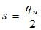

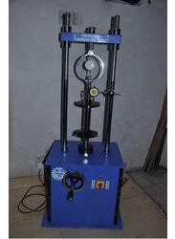

Infrastructure is a major sector that propels overall development of Indian economy. Due to which we are facing various environmental problems. The tests such as liquid limit, plastic limit, standard proctor compaction test, California bearing ratio (CBR) test and unconfined compressive strength (UCS) have been conducted to check the improvement in the properties of black cotton soil. Soil stabilization is very important for any structure and it has to be strong enough to support the entire structure. For foundation to be strong the soil around it plays a very important role. Expansive soils like black cotton soil always create problems in foundation. The problems are swelling, shrinkage and unequal settlement.

Results
Standard Proctor Test(0% CEMENT)

Moisture content(%) | Dry density(g/cc)
15.07 | 13.08
15.19 | 13.6
16.23 | 14.2
19.33 | 13.52

Standard Proctor Test(5% CEMENT) :-Standard Proctor Test(5% CEMENT) :-

Moisture content(%) | Dry Density(g/cc)
15.32 | 14.08
15.22 | 14.6
17.13 | 15.2
19.4 | 13.52

Standard Proctor Test (10% CEMENT)

Moisture content(%) | Dry density(g/cc)
15.2 | 14.07
15.8 | 14.8
17.23 | 15
19.5 | 13.52

FURTHER SCOPE OF WORK

Infrastructure is a major sector that propels overall development of Indian economy. Due to which we are facing various environmental problems. The tests such as liquid limit, plastic limit, standard proctor compaction test, California bearing ratio (CBR) test and unconfined compressive strength (UCS) have been conducted to check the improvement in the properties of black cotton soil. Soil stabilization is very important for any structure and it has to be strong enough to support the entire structure.
For foundation to be strong the soil around it plays a very important role. Expansive soils like black cotton soil always create problems in foundation. The problems are swelling, shrinkage and unequal settlement.

ACKNOWLEDGEMENTS

Special thanks and appreciation is given to our guide Harishankar Patel Sir in accomplishing this work.

CONCLUSIONS

- Addition of CEMENT(PPC) stabilizes soil.
- Addition of Cement in soil up to 5% gives the higher strength to the normal soil.
- Increase the capacity and durability of soil. 4.Soil stabilization with cement passed all the test which are needed for the construction work.
- California bearing ratio (CBR) of stabilized samples increases sharply with increased cement content.
- CBR of sample stabilized with 5% cement and compacted of 5 layers with heavy energy of 55 blows in each layers fulfill the criteria proposed by soil classification.

REFERENCES

- Abu siddique and Bipradasrajbongshi, Mechanical properties of a cement stabilized coastal soil for use in road construction”, Journal of civil engineering The institution of Engineers” Vol. CE 30, NO. 1, 2014

- Anil Misra, DebabrataBiswas and Sushant Upadhyaya (13 Decemeber 2012), “Physio- mechanical behavior of self-cementing mixtures.

- Azm S. Al-Homoud, Taisir Khedaywi and Abdullah M. Al. Ajlouni (2010), “Comparison of effectiveness and economic feasibility of bitumen, lime and cement as stabilizing agents for reduction of swell potential of a clayey soil,” Indian Highways, January 1999, pp.51–58.

- Costas A.Anagnostopoulos (2004), “Physical and Engineering Properties of a cement

stabilized soft soil treated with cement additive.

- Chin, K.G. (2006). Constitutive behavior of cement treated marine clay. Ph.D. Thesis, Department of Civil Engineering, National University of Singapore.

- Cordon, W.A. (1962). “Resistance of soil-cement exposed to sulphates.” Highway Research Board Bulletin, 309, 37-56.

- George, S.Z., Ponniah, D.A. and Little, J.A. (1992). “Effect of temperature on lime-soil stabilization.” Construction and Building Materials, 6(4), 247-252

- Kamruzzaman, A.H.M., Chew, S.H. and Lee,
F.H. (2001). “Behavior of soft Singapore marine clay treated with cement.” Geotechnical Special Publication, ASCE, 113, 472-485.

- Kamruzzaman, A.H.M. (2002). Physico-chemical and engineering behavior of cement treated Singapore marine clay. Ph.D. Thesis, Department of Civil Engineering, National University of Singapore

- Kawasaki, T., Niina, A., Saitoh, S., Suzuki,
Y. and Honjyo, Y. (1981). “Deep mixing method using cement hardening agent.” Proceeding of the 10th International Conference on Soil Mechanics and Foundation Engineering, Stockholm, 721-724.
- Kozan, G.R. (1960). “Soil stabilization: Investigations of a chemically modified cement as a stabilizing material.” U.S Army Engineering Waterways Experiment Station Technology Report, 3, 3-45

- Lambe, T.W. and Moh, Z.C. (1957). “Improvement of strength of soil-cement with additives.” Highway Research Board Bulletin, 183, 38-47.

- Lambe, T.W., Michaels, A.S. and Moh, Z.C. (1960). “Improvement of soil-cement with alkali metal compounds.” Highway Research Record, 241, 67-103.
- Moh, Z.C. (1962). “Soil stabilization with cement and sodium additives.” Journal of the Soil Mechanics and Foundations Division, ASCE, 88, 81-105.

- Nagaraj, T.S., Miura, N., Yaligar, P.P. and Yamadera, A. (1996). “Predicting strength development by cement admixture based on water content.” Proceedings of the 2nd International Conference on Ground Improvement Geosystems, Grouting and Deep Mixing, Tokyo, 431-436.

