Smart Ration Card System Using RFID
Reshma Dhote¹, Ankita Mandawkar², Akhil Dhankute³, Ashwini Barwey⁴, Sanjeev Murmu⁵

¹Dr. S. P. Chhaware, Head of Department
Priyadarshini College of Engineering,
Nagpur, India, 440019

¹Mrs.Priyanka Thakare, Assistant Professor
Priyadarshini College of Engineering,
Nagpur, India, 440019

Abstract –Public Distribution System i.e PDS is the important factor in India which provides the human commodities. . Ration cards are an official documents which is provided by the government of India to poor people who is below the poverty level. All the eligible people having ration cards to purchase the materials from ration shop. But in this existing system, there are some drawbacks occurs that the one is the weight of the material may be inaccurate due to human mistakes and the second is if material is not purchase by customer till the ended of the month shopkeeper will misuse and sell to others or in market without the hint of government and the customer. The proposed system smart ration card system using RFID overcome the drawbacks by using RFID i.e., Radio Frequency Identification which is act as a ration card.
Keywords-RFID Card, RFID Reader, GSM.

INTRODUCTION

Indian food security system of the government of India under ministry of food and public distribution it to distributed food and non food to India’s poor people. This scheme was first launched in Feb 1994. Distributed major commodities include food grains such as wheat, rice, sugar and kerosene .
To avoid the existing systems drawbacks, we proposed the Smart Ration Card System using RFID. We use the RFID i.e. Radio Frequency Identification technology one of its part, a RFID tag holds a Unique Identification Number It issue to all customer. Here RFID tag act as a ration card which includes the detailed information of the customer and about the material and GSM used for the purpose of authentication. This RFID tag distribute to all customers when they are purchasing materials they have to scan the RFID card first. After scanning we use a GSM i.e. Global System for Mobile Communication, it generates a OTP(one time password) and send it to the customers registered Mobile Number. After OTP enters the further procedure will start, open the page of the customer related and material information and distribute the material which are allotted from the government. After evey transaction made by customer, centralized database is immediately updated and he/she will be send a SMS specifying the quantity of commodity bought by customer. There is one webscam that captures and save the picture of customer that the customer can not be refuse.

METHODOLOGY
Main objective of the system is to reduce forgery from ration shops and users will get their grocery in easy way. Also to reduce the manual work.
- GSM MODEM:
GSM stands for Global System for Mobile Communication; it is a mobile communication modem. It is widely used mobile communication system in the world.GSM modem is a device which can be either a mobile phone or a modem device which can be used to make a computer or any other processor communicate over a network. A GSM modem requires a SIM card to be operated. A GSM modem can also be a standard GSM mobile phone with appropriate cable and software driver to connect a serial port or USB port on yourcomputer.
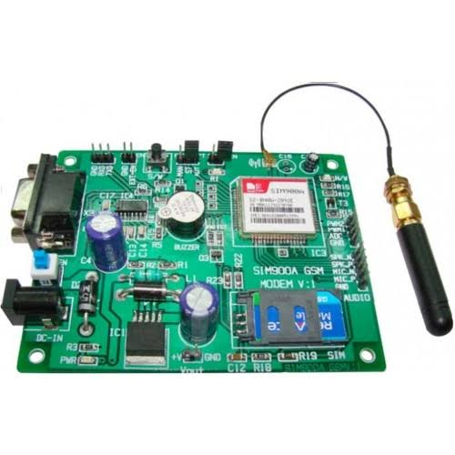
fig. GSM Module

RFID READER:
This module directlyconnects to any UART or through a RS232 converter to PC. It gives UART output. This rfid module works with anyn125KHz RFID tags. So, it can be called as a low frequency RFID reader. It gives out a serial output and has a range of about 8-12cm. there is a built-in antenna and it can be connected to the PC with the help of RS232.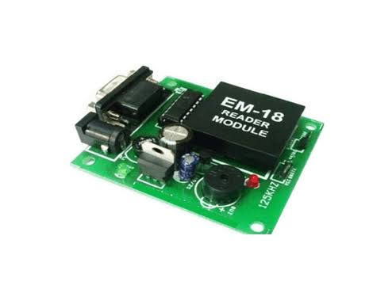
fig. RFID card reader

RFID CARDS:
RFID tags contains the one number which is there inside the card we can’t visible that card number, and it will have one magnetic coil in the card when we place the tag on the reader it will generates a magnetic flux and reads the card number. The RFID have the two types one is active and another one is passive. Passive tags collect energy from a nearby RFID readers interrogating radio waves and active tags have a local power source (such a battery) and may operate hundreads of meters from the RFID reader. This is used for the security purpose in the banks , offices and other security places.

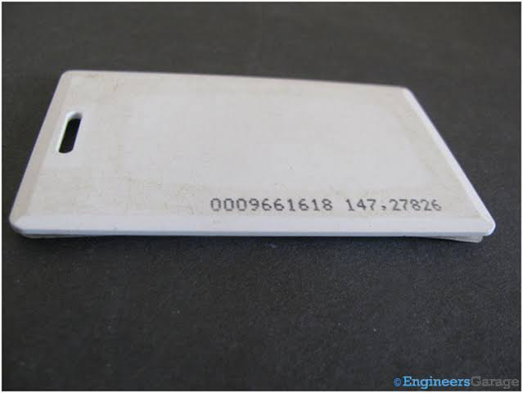
fig. RFID tag
OTP:
OTP(One Time Password) An OTP i.e. One Time Password) is more secure than a static password, especially a user-created password, which is typically weak. OTPs may replace authentication login information or may be used in
addition to it, to add another layer of security.

fig. system module design of Smart Ration Card System using RFID

CONCLUSION
In existing system there are some drawbacks of ration forgery and misuse of ration, to overcome this drawback, in proposed system we are replacing the manual entries in ration bookwith the RFID card which contains the detail information of customer . so that, the proposed system provides the security and transparency to the customers. It reduces the processing speed waiting time and also the material theft. This system is greater scope in future. As there is no manual data stored & all information is stored in database. The higher authority can check the details that the Proper distribution of gains to customer or not.
ACKNOWLEDGMENT
Authors want to acknowledge Principal, Head of department and guide of their project for all the support and help rendered. To express profound feeling of appreciation to their regarded guardians for giving the motivation required to the finishing of paper.

REFERENCES
- International journal of engineering research in computer science and engineering (IJERCSE) vol 3, Issue 12, December 2016, “Review on Public Ration Distribution System By Using Authentication OTP”, (1) Ugale Ashvini G (2) Kute Tejaswini A. (3) Mormare Archana S. (4) Borhade Sham Y computer department Suman Ramesh Tulsiani Technical Campus- Faculty of Engineering, pune, India.
- R. Ramani, S. Selvaraju, S. Valarmathy, P. Niranjan, "Bank Locker security System Based on RFID and GSM Technology", International Journal of Computer Applications (IJCA) (0975-8887) Volume 57-no.18, November 2012.
- Balekar Swati D, Kulkarni Rituja R, “Online Ration Card system by using RFID and Biometrics”, International Journal of Advanced Research in Computer Science and software engineering 2015.
- International journal of informative and futuristic research vol 3, issue 6, February 2016, “RFID based smart ration system” (1) Manish Pawar (2) Aakash Mohite (3) Aditya Marne (4) P. V. Mulmule, Departmenr of Electronics & Telecommunication Engg. Pd. Vasantdada Patil Institute of Technology, Bavdhan, Pune- Maharashtra.

- International journal ofAdvanced Research in Electrical, Electronics and Instrumentation Engineering, vol 6, issue 10, October 2017, “Smart rationing System” (1) Surbhi Surkar, (2) S. B. Somani, (3) Rajkumar D. Komati, Department of Electronics and Telecommunication MAEER’S MIT College of Engineering, Kothrud, Pune (Maharashtra), India.

