**Study on Mechanical Properties of Pervious Concrete Paver Block**

**Pranay Kadam1, Aditya Mankar2, Purushottam Mishra3, Vishnu Nair4, Prof. Swapnil Malipatil5**

*1,2,3,4(UG Students), 5Assistant Professor, Civil Engineering Department, St. John College of Engineering and Management, Palghar, India, 401404*

**Abstract –** Pervious paver concrete is a special type of concrete with high porosity used for concrete flat work applications that allow water from precipitation and other sources to pass directly through, thereby reducing runoff from a site and allowing ground water recharge. This porosity is attained by a highly interconnected void content. Typically pervious concrete has no or very less amount of fine aggregate and had just enough cementing paste to coat coarse aggregate particles while preserving the interconnectivity of the voids. It is a special type of concrete characterized by an interconnected pore structure and high void content / porosity typically in the range of 15 to 35% by volume. The use of pervious concrete may reduce flooding risk, reduce storm-water runoff, reduce noise when in contact with vehicle tires, and prevent glare and skidding during rainy season by allowing water to infiltrate freely through its pores, thus recharge the ground water. A pervious concrete was designed by taking different proportions of fibers like Glass and Polypropylene. A small attempt is made to design the nominal porous paver concrete considering the local road conditions. Compressive Strength test, Void Ratio test, flexural strength, Split tensile strength, permeability test and Infiltration test were carried for the designed Mix proportions.

***Keywords-*** *Pervious Paver Concrete, Precipitation, Glass fiber, Polypropylene fiber.*

1. **INTRODUCTION**

Pervious concrete which is also known as no fines, porous, gap graded and permeable concrete and enhance porosity concrete has been found to be a reliable storm water management tool. By definition, pervious concrete is a mixture of gravel or granite stone, cement, water, little to no sand (fine aggregate). When pervious concrete is used for paving, the open cell structures allow storm water to filter through the pavement and into the underlying soils. In other words, pervious concrete helps in protecting the surface of the pavement and its environment.

Pervious concrete has the same basic constituents as conventional concrete that is 15% - 30% of its volume consists of interconnected void network, which allows water to pass through the concrete. High range water reducer and thickening agent are introduced in the concrete to improve its strength and workability. It can allow the passage of 0.014-0.023 m3 of water per minute through its open cells for each square foot 0.0929 m2 of surface area which is far greater than most rain occurrences. Pervious concrete is rough textured and has a honey-combed surface. Carefully prepared pervious concrete with controlled amount of water and cementitious materials creates a paste. The paste then forms a thick coating around aggregate particles maintains a system of interconnected voids which allow water and air to pass through. The lack of sand in pervious concrete results in a very harsh mix that negatively affects mixing, delivery and placement. Also, due to high void content pervious concrete is light in weight (about 1600 to 1900 kg/m3). Pervious concrete void structure provides pollutant captures which also add significant structural strength as well. It also results in very high permeable concrete that drains quickly.

Pervious concrete can be used in a wide range of applications, although its primary use in pavements which are in: residual roads, alleys and driveways, low volume pavements, low water crossings, sidewalks and pathways, parking areas, tennis courts, slope stabilization, sub-base for conventional concrete pavements, etc. because of its attractive storm water mitigation capabilities, and also in other applications. Pervious concrete pavements have become popular as an effective storm water management tool to reduce the volume of storm water runoff and concentration of pollutants. Apart from this, pervious concrete may be used as a wall concrete in structural applications for light weight or better thermal insulation, surface course for parking lots, tennis courts, zoo areas, stalls etc. and for greenhouse floors to keep the floor free of standing water.Pervious concrete has been increasingly used due to several sustainability-related benefits offered by this material. Pervious concrete includes other environmental benefits such as reduced noise.

* 1. **Goals and Objectives**
* Determination of mechanical properties of pervious concrete.
* Determination of flexural strength.
* Determination of Split tensile strength of pervious concrete
* Permeability (if fabrication of equipment is completed in time) The above results are compared with control concrete.
* The properties such as compressive strength, split tensile strength, flexural strength and permeability are assessed by performing tests.
* To provide more than just a “starting point” to begin mixture proportioning. The level of mixture proportioning depends upon application needs. The resulting mixture proportions can be used with success or iterated for better performance using local conditions and experiences.

**2. METHODOLOGY**

**2.1 Materials Used and Tests**

Cement(PPC) of 53 grade procured from single source confirming to IS:1489-1991 was used. Coarse aggregate (nominal size 12.5 mm for pervious concrete using Glass fiber and 6mm-10mm, 10mm-20mm, 6-10-20mm size aggregate were used for pervious concrete using Polypropylene fiber), small amount of fine aggregate were used in pervious concrete using Glass fiber only and no fines were used in pervious concrete using Polypropylene fiber. Water of pH 7 was used at room temperature. The fibers used were Glass and Polypropylene fiber. The testing was done as per Indian Standards.

**Table 1**- Physical properties of cement

|  |  |  |
| --- | --- | --- |
| **Sr.No.** | **Properties** | **Test results** |
| 1 | Specific Gravity | 3.154 |
| 2 | Normal Consistency | 31% |
| 3 | Initial setting time | 34min. |
| 4 | Final setting time | 435min. |
| 5 | Soundness | 5.5mm |

**Table 2**- Physical properties of coarse aggregate

|  |  |  |
| --- | --- | --- |
| **Sr. No.** | **Properties** | **Basalt Aggregate** |
| 1. | Shape of aggregate | Cubical and angular |
| 2. | Speific Gravity | 2.97 |
| 3. | Unit weight (Kg/m3) | 1591 |
| 4. | Free surface moisture | Nil |
| 5. | Water absorption | 1.19% |

**Table 3-** Physical properties of fine aggregate

|  |  |  |
| --- | --- | --- |
| **Sr.No.** | **Properties** | **Fine aggregate** |
| 1. | Specific Gravity | 2.6 |
| 2. | Fineness Modulus | 2.67 |
| 3. | Water Absorption | 1.21% |
| 4. | Silt Contain | 5.7% |

**Table 4-** Physical Properties of glass fiber:

|  |  |
| --- | --- |
| Properties | Glass fiber |
| Tensile strength | 1200-1700 Mpa |
| Compression strength | 1080 Mpa |
| Specific gravity | 2.7 gm/cm^3 |
| Shape | Irregular pieces |
| Nature | Does not absorb water |
| Source | Industries |

**Table 5-** Physical properties of Polypropylene fiber

|  |  |
| --- | --- |
| **Properties** | **Polypropylene fiber** |
| Specific gravity | 0.90-0.91 gm/cm³ |

**2.2 MIX PROPORTIONS of pervious concrete using Glass fiber**

The aim of proportioning mixture is establishment of excellent balance between paste content, porosity, workability and strength. For producing initial trial batches, ACI522-R10 is used.

3 types of mixes were used to find the properties of pervious concrete:

**Table 6- Mix proportion for various mixes for Pervious concrete using Glass fiber**

|  |  |
| --- | --- |
| **MIX** | **PROPORTION**  **(cement: fine aggregate: coarse aggregate** |
| O% fine aggregate(F0) | 1:0:3 |
| 10% fine aggregate(F10) | 1:0.3:2.7 |
| 20% fine aggregate(F20) | 1:0.6:2.4 |

Where,

F0 = mix with 0% fine aggregate

F10 = mix with 10% fine aggregate

F20 = mix with 20% fine aggregate

Each mix consists of glass fiber with 1.5% replacement of cement by volume.

**2.3 MIX PROPORTIONS of pervious concrete using Polypropylene fiber:**

For adequate workability, void ratio strength and Permeability, pervious concrete mixture the proportion take as : cement content was 375 kg/m3, aggregate content was 1500kg/m3, aggregate ratio 1:4, aggregate sizes 6mm- 10mm-20mm, W/C ratio 0.30,0.35,0.40, polypropylene fiber was 2.54 gm/mould size (150 X 150 X 150 mm3 ).

**Table 7-** Mix proportion for various mixes for Pervious concrete using Polypropylene fiber

|  |  |  |  |  |  |
| --- | --- | --- | --- | --- | --- |
| **Mix name** | **Aggregate sizes** | **W/C ratio** | **Cement content** | **Aggregate content** | **PF content** |
| Mix1 | 10-20mm | 0.3 | 375 kg/m³ | 1500 kg/m³ | 2.54 gm |
| Mix2 | 10-20mm | 0.35 | 375 kg/m³ | 1500 kg/m³ | 2.54 gm |
| Mix3 | 10-20mm | 0.4 | 375 kg/m³ | 1500 kg/m³ | 2.54 gm |
| Mix4 | 6-10mm | 0.3 | 375 kg/m³ | 1500 kg/m³ | 2.54 gm |
| Mix5 | 6-10mm | 0.35 | 375 kg/m³ | 1500 kg/m³ | 2.54 gm |
| Mix6 | 6-10mm | 0.4 | 375 kg/m³ | 1500 kg/m³ | 2.54 gm |
| Mix7 | 6-10-20mm are equal % | 0.3 | 375 kg/m³ | 1500 kg/m³ | 2.54 gm |
| Mix8 | 6-10-20mm are equal % | 0.35 | 375 kg/m³ | 1500 kg/m³ | 2.54 gm |
| Mix9 | 6-10-20mm are equal % | 0.4 | 375 kg/m³ | 1500 kg/m³ | 2.54 gm |

**2.4 EXPERIMENTAL WORK**

The strength development for different percentages of fine aggregate is studied. The entire tests were conducted as per specifications required. For the purpose of testing specimens, various pervious concrete specimens were prepared for different mixes. After thorough mixing, water was added and the mixing was continued until a uniform mix was obtained. The concrete was then placed in to the moulds, which were properly oiled. For cube compression tests on concrete, cube of size150 X 150 X 150 mm3 were employed. All the cubes were tested in saturated condition after wiping out the surface moisture from the specimen. Void content test was conducted in accordance with ASTM C138. Permeability test covers the determination of the field water infiltration rate of in place pervious concrete. Infiltration rate of pervious concrete cube specimens is determined in the laboratory based on the modified version of ASTM C1701. Similar to ASTM C1701 procedure, the test is based on the measurement of the time required for the known volume of water to flow through the specimen. Infiltration rate is calculated based on the equation

I = 4V/D2πt

Where, V is the volume of the infiltrated water

D is the diameter of the specimen and

t is the time required for the designated volume of water to infiltrate through PC

**2.4.1 Experimental work for Pervious concrete using Glass fiber**

The strength related properties such as compressive strength, flexural strength, split tensile strength are studied. Three mix specimens were tested for each test. For the present investigation, cubes were tested by compression testing machine as per IS: 516 – 1959 at an age of 7days, 14 days and 28 days. To determine the flexural strength, beams of size 150mm*150mm *700mm are casted. For splitting tensile strength test, cylinders of size 150mm diameter and 300mm height were casted.

**2.4.2 Experimental work for Pervious concrete using Polypropylene fiber**

The specimens cast were demoulded after 24 hours and kept in normal curing for 7 and 28 days. For determining compressive strength the cubes were tested at an age of 7 days and 28 days. Effect of w/c ratio and density is also determined. The density was determined by ratio of weight of cube to volume of cubes.

D = (weight of cube/volume of cube)

**3. RESULTS AND DISCUSSION**

**3.1 DISCUSSION OF TEST AND RESULTS ON PERVIOUS CONCRETE USING GLASS FIBER**

**Table 8-** Test results on compressive strength

|  |  |  |  |  |
| --- | --- | --- | --- | --- |
| **S.No** | **Type of mix** | **7 days (Mpa)** | **14 days (Mpa)** | **28 days (Mpa)** |
| 1 | F0 | 15.8 | 20.6 | 25.9 |
| 2 | F10 | 17.6 | 22.3 | 27.2 |
| 3 | F20 | 20.4 | 26.4 | 30.1 |

**Table 9-** Test results on flexural strength

|  |  |  |  |  |
| --- | --- | --- | --- | --- |
| **S.No** | **Type of mix** | **7 Days (Mpa)** | **14 Days**  **(Mpa)** | **28 days (Mpa)** |
| 1 | F0 | 0.32 | 0.38 | 0.46 |
| 2 | F10 | 0.35 | 0.43 | 0.52 |
| 3 | F20 | 0.42 | 0.45 | 0.58 |

**Table 10** Test results of void content

|  |  |  |  |  |  |
| --- | --- | --- | --- | --- | --- |
| Sr.no. | Mix | W2 (gms) | W1(gms) | Void content | Average void content |
| 1 | F0 | 6300 | 3680 | 22.37 |  |
| 2 | F0 | 6450 | 3770 | 20.59 | 21.8 |
| 3 | F0 | 6530 | 3830 | 20.00 |  |
| 4 | F10 | 6550 | 4160 | 18.02 |  |
| 5 | F10 | 6740 | 4215 | 19.20 | 18.2 |
| 6 | F10 | 6810 | 4320 | 17.5 |  |
| 7 | F20 | 7120 | 5235 | 16.6 |  |
| 8 | F20 | 7240 | 5320 | 15.94 | 15.6 |
| 9 | F20 | 7310 | 5390 | 16.20 |  |

**Table 11** Test results on split tensile strength

|  |  |  |  |  |
| --- | --- | --- | --- | --- |
| **S.No** | **Type of mix** | **7 days (Mpa)** | **14 days (Mpa)** | **28 days (Mpa)** |
| 1 | F0 | 1.45 | 1.73 | 1.94 |
| 2 | F10 | 1.63 | 2.13 | 2.37 |
| 3 | F20 | 1.84 | 2.31 | 2.64 |

**Table 12** Test results on permeability

|  |  |  |  |
| --- | --- | --- | --- |
| **S.No** | **Type of mix** | **Time in secs** | **Infiltration rate (mm/sec)** |
| 1 | F0 | 25.39 | 6.3 |
| 2 | F10 | 33.33 | 4.8 |
| 3 | F20 | 41.02 | 3.9 |

25 void

**Void content in %**

15.6

18.2

21.8

20

15

10

5

0

F0 F10 F20

**MIX**

**Grap 1** Void content and % of fine aggregate

7Days

15.6

20.6

25.9

17.6

22.3

27.8

20.4

26.4

32.2

35

**Compressive strength in**

**MPa**

30

25

20

15

10

5

0

F0 F10 F20

**MIX**

**Graph 2 Strength Compressive and % of fine aggregate**

7Days

1.56

1.71

1.93

1.75

1.95

2.22

1.89

2.27

2.56

3

7 days

**Flexural Strength in**

**MPa**

2.5

2

1.5

1

0.5

0

F0 F10 F20

**MIX**

**Graph 3** Split Tensile Strength and % of fine aggregate

3

**Split tensile strength in MPa**

7days

14days

28days

28 days

1.45

1.63

1.84

1.73

2.13

2.31

1.94

2.37

2.64

2.5

2

1.5

1

0.5

0

F0 F10 F20

**MIX**

**Graph 4** Flexural Strength and % of fine aggregate

7

**Permeability**



Permeabilityyy

6

5

4

3

2

1

0

F0 F10 F20

**MIX**

**Graph 5** Permeabity and % of fine aggregate

90

**Compressive strength in MPa**

28 days



80

70

60

50

40

30

20

10

0

6.3 4.5 3.9

**Permeability in mm/sec**

**Graph 6** Permeability vs Compressive Strength

**3.2 DISCUSSION OF TEST AND RESULTS ON PERVIOUS CONCRETE USING POLYPROPYLENE FIBER**

**Table 13** The experimental result for pervious concrete with polypropylene fiber at the age of 7 days

|  |  |  |  |  |  |
| --- | --- | --- | --- | --- | --- |
| **Cement (kg/m³)** | **Aggregate** | **W/C ratio** | **Compressive strength (MPa)** | **Void content (%)** | **density (kg/m³)** |
| 375 | 10-20mm | 0.30 | 9.10 | 32.38 | 1710.23 |
| 375 | 10-20mm | 0.35 | 9.25 | 28.73 | 1777.18 |
| 375 | 10-20mm | 0.4 | 9.96 | 25.27 | 1837.92 |
| 375 | 6-10mm | 0.30 | 9.30 | 38.84 | 1546.96 |
| 375 | 6-10mm | 0.35 | 10.43 | 33.31 | 1662.81 |
| 375 | 6-10mm | 0.40 | 12.27 | 30.41 | 1718.22 |
| 375 | 6-10-  20mm | 0.30 | 10.05 | 38.92 | 1544.88 |
| 375 | 6-10-  20mm | 0.35 | 12.32 | 35.10 | 1618.37 |
| 375 | 6-10-  20mm | 0.40 | 12.84 | 30.75 | 1703.11 |

**Table 14** The experimental result for pervious concrete with polypropylene fiber at the age of 28 day

|  |  |  |  |  |  |  |
| --- | --- | --- | --- | --- | --- | --- |
| **Cement (kg/m3**  **)** | **Aggregat e** | **W/C rati o** | **Compressive strength (MPa)** | **Void content (%)** | **Density (kg/m3**  **)** | **permeabilit y ( mm/s)** |
| 375 | 10-20mm | 0.30 | 9.78 | 30.82 | 1749.93 | 24.47 |
| 375 | 10-20mm | 0.35 | 10.94 | 27.49 | 1808.89 | 22.56 |
| 375 | 10-20mm | 0.40 | 10.97 | 24.10 | 1866.96 | 21.71 |
| 375 | 6-10mm | 0.30 | 9.89 | 31.54 | 1731.56 | 19.74 |
| 375 | 6-10mm | 0.35 | 14.29 | 29.05 | 1769.19 | 18.61 |
| 375 | 6-10mm | 0.40 | 16.14 | 26.43 | 1809.48 | 17.90 |
| 375 | 6-10-  20mm are equal % | 0.30 | 10.57 | 36.58 | 1604.14 | 18.33 |
| 375 | 6-10-  20mm are equal % | 0.35 | 12.69 | 32.90 | 1673.18 | 16.95 |
| 375 | 6-10-  20mm are equal % | 0.40 | 15.42 | 29.55 | 1732.74 | 15.89 |

**3.2.1 EFFECT OF W/C RATIO ON COMPRESSIVE STRENGTH OF PERVIOUS CONCRETE (28 DAYS)**

The compressive strength increases with increase in water cement ratio as shown Graph 7. By using 0.40 W/C ratio and aggregate size used mix in grading, we got maximum compressive strength (16.14 MPa) showing in graph 7. The compressive strengths of pervious concrete with polypropylene fiber mixes are given in table no.13 and table no.14

18

16

14

12

10

8

6

4

2

0

0.30

0.35

0.40

**Graph 7**  Effect of W/C ratio on compressive strength

**3.2.2 EFFECT OF W/C RATIO ON VOID CONTENT OF PERVIOUS CONCRETE (28 DAYS)**

The void ratio on pervious concrete with polypropylene fiber discussed in graph 8. We can see void content of pervious concrete reduces with increase in W/C ratio. The void content is large size air void. Graph 8 signify that the aggregate size gives more void ratio (36.58 %). By grading of aggregate and compressive method the void ratio of pervious concrete has been influenced.

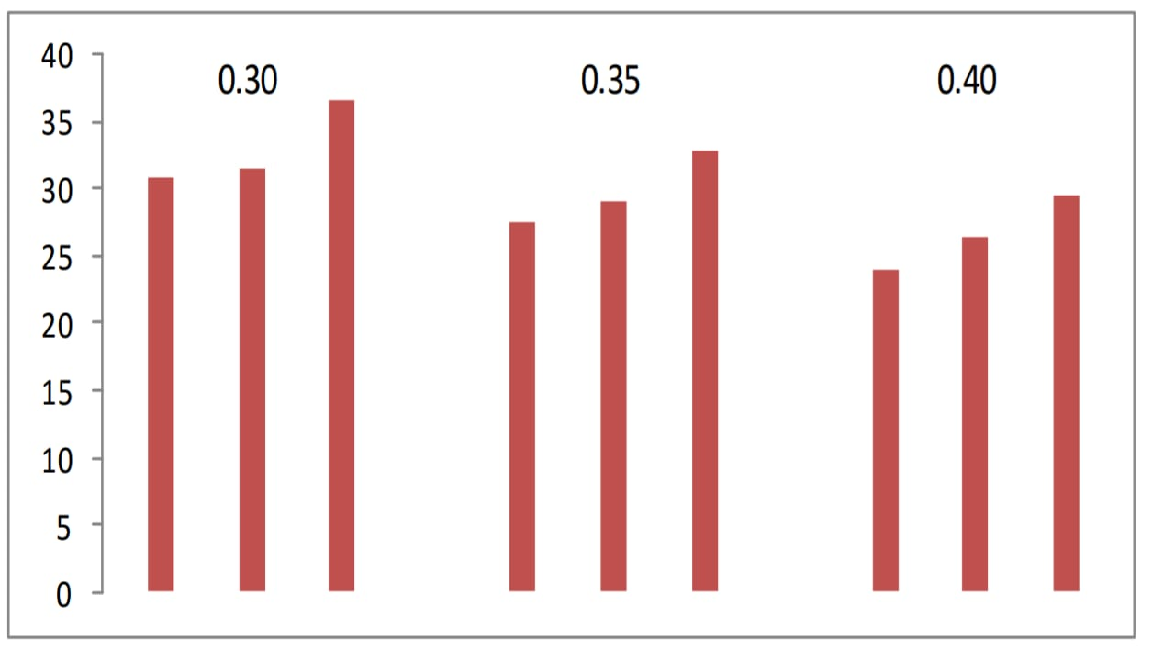

**Graph 8** W/C ratios on void content

**3.2.3 EFFECT OF W/C RATIO ON DENSITY OF PERVIOUS CONCRETE (28 DAYS)**

Density of the pervious concrete with polypropylene fiber was achieved in practical investigation ranges from 1600- 1900 kg/m3. The maximum density values of pervious concrete with polypropylene fiber achieved that is 0.40 W/C ratio shows graph 9. This investigation shows density of pervious concrete increases with increase in W/C ratio. Density of pervious concrete with polypropylene fiber depends on W/C ratio.

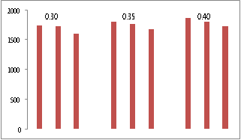

**Graph 9** W/C ratio on density

**3.2.4 EFFECT OF W/C RATIO ON PERMEABILITY FOR PERVIOUS CONCRETE (28 DAYS)**

In Graph 10 the water permeability under 300 mm water head has been summaries. The W/C ratio is increased and water permeability decreased for the pervious concrete shown in Graph 10. Higher values of water permeability have been given by 20 mm to 10mm aggregate size was observed. Water permeability found in range of 15.89 mm/s to 24.47 mm/s. for structure influence water permeability of pervious concrete that also affected by grading and compaction. On adding polypropylene fiber causes increase water permeability.

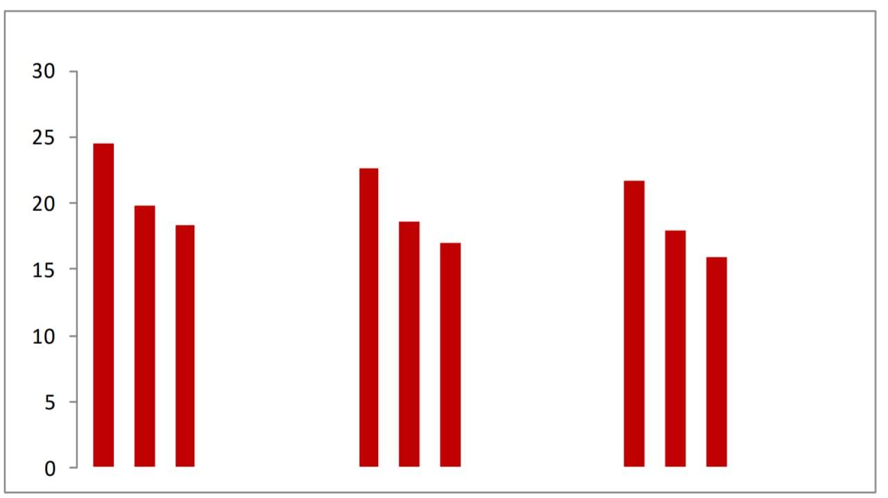

**Water cement ratio**

**Graph 10** Effect of W/C ratio on water permeability

**4. CONCLUSION**

**4.1 General conclusion in both pervious concrete using Glass fiber and Polypropylene fiber are:**

1. It was found that permeability is directly proportional to void content as the void content increases permeability also increases and vice-versa.

2. Void content and compressive strength are inversely proportional.

3. Porous concrete has more voids than conventional concrete thus it has less compressive strength.

4. Use of optimum water content the concrete will reach its strength.

5. More the void ratio, more infiltration take place but as well we have to consider optimum void ratio as it affects the compressive strength.

6. Another conclusion is that compressive strength of pervious concrete reduced by larger size of aggregate. Better compressive strength given by mixing of smaller and bigger size of aggregate instead of single size of aggregate. Gape was filled by smaller aggregate into the bigger aggregate in pervious concrete and may cause the increase in pervious strength.

7. Workability decreases with the addition of fine aggregate. This is normal as the surface area of aggregate is increased more area needs to get wet for paste to coat around.

**4.2 The following conclusions are made from the study on properties of pervious concrete with the replacement of cement by 1.5% of glass fiber and addition of little amount of fine aggregate:**

1. The void content is observed to be in the range of 15% to 22% with average void content.

2. The void content of 10% fine aggregate is decreased by 16.5% and 20% fine aggregate is decreased by 28.4% compared to 0% fine aggregate.

3. The compressive strength of 10% fine aggregate is increased by 7.3% and 20% fine aggregate is increased by 14% compared to 0% fine aggregate and ranges between 25Mpa to 32Mpa for 28 days of curing.

4. The compressive strength of 20% fine aggregate increased by 15% compared to conventional concrete without glass fiber.

5. The compressive strength of concrete with 0% glass fiber is increased by 28% compared to 1.5% of glass fiber.

6. The Split tensile strength increased by 18% for 10% fines and by 26% for 20% fines compared to 0% fines and ranges between 1.9Mpa to 3Mpa for 28 days.

7. The flexural strength increased by 13% for 10% fines and by 21% for 20% fines compared to 0% fines and ranges between 1.8Mpa to 2.6Mpa for 28 days.

8. The permeability of 10% fine aggregate is decreased by 29% for 10% fine aggregate and decreased by 38% for 20% fine aggregate compared to 0% fine aggregate and ranges between 6.3mm/sec to 3.9 mm/sec.

**4.3 Based on the experimental investigation on pervious concrete using Polypropylene fiber following conclusions has been drawn:**

1. With using 0.30 W/C ratio and mix (50%) aggregates for pervious concrete gives better result. Mix void content 36.58 % was found.

2. Increase in compressive strength of pervious concrete leading by increased density that was observed.

3. Another conclusion is that compressive strength of pervious concrete reduced by larger size of aggregate. Better compressive strength given by mixing of smaller and bigger size of aggregate instead of single size of aggregate. Gape was filled by smaller aggregate into the bigger aggregate in pervious concrete and may cause the increase in pervious strength.

4. Polypropylene fiber increases strength of compressive strength and water permeability of pervious concrete.

.

**5. REFERENCES**

1. Savitri s. Karnath *, U. Lohit kumar * and Naveen Danigond * " porous concrete with optimum fine aggregate and fibre for improved strength " advance in concrete construction Vol8. No 4 (2019) 305-309 (Received july 15, Revised sept. 21, 2019, Accepted oct. 19)
2. Porous concrete with optimum fine aggregate and fibre for improved strength Savithri S. Karanth, U. Lohith Kumara and Naveen Danigonda Department of Civil Engineering, Global Academy of Technology, Bangalore, India (Received July 15, 2019, Revised September 21, 2019, Accepted October 11, 2019)
3. EFFECT OF GLASS FIBER ON PROPERTIES OF PERVIOUS CONCRETE

B. Radha Kiranmaye, Assistant Professor, Civil Engineering Department, Mahatma Gandhi Institute of Technology, Hyderabad, India

D. Tarangini, Assistant Professor, Civil Engineering Department, Mahatma Gandhi Institute of Technology, Hyderabad, India

K.V. Ramana Reddy, Professor and Head of the Department, Civil Engineering Department, Mahatma Gandhi Institute of Technology, Hyderabad, India

1. Pervious concrete with glass fiber

Asst. Prof. Mithun Sawant, Daksha Dhande, Shivani Sabde, Rutuja Bhalsing, Praful Yadav, Nilesh Ranjan Department of civil engineering, Dr. D.Y. Patil institute of Engineering, Management and research, Akurdi,Pune

1. DESIGN OF POROUS PAVER CONCRETE BLOCK

R. Veerakumar

Assistant Professor,

Vel Tech Rangarajan Dr.Sagunthala R&D Institute of Science and Technology, Avad;i, Chennai – 600062

1. American Society for Testing and Materials (ASTM) Concrete Committee (C09) 2006, Concrete committee to consider Pervious Activity.
2. A Report on Pervious concrete, American concrete Institute (ACI 522 R10), Analysis of Pervious Concrete Properties by Rama Mahalingam and Assoc. Prof. Shanthi Vaithiyalingam Mahalingam, Government college of Technology, Faculty of Civil Engineering, Tamil Nadu, India, Gradevinar 6/2016, Date of Issue 10.14256/ JCE.14.4.2015.
3. Design of Eco-friendly Pervious concrete by M.Harshavardhana Balaji, M.R.Amarnath, R.A.Kavin, S.Jaya Pradeep Assistant Professor, Knowledge Institute of Technology, International

Journal of Civil Engineering and Technology (IJCIET), Volume 6, Issue 2, Febraury(2015)

1. Effect of paste to voids volume ratio on the performance of the concrete mixtures by Ezgi Yudakul, Peter C.Taylor, Halil Ceyan, IOWA State University, Civil, Construction and Environmental Engineering published in 2013
2. Experimental study on Properties of No-fines concrete By Md. Abid Alam, Shagufta Naz, International Journal of Informative & futuristic Research, Volume 2 Issue 10, June 2015, published on 25/06/2015.
3. Mix proportion of Cementitious Material in Pervious Concrete by Pankaj R Teware and Shrikant. M. Harle, Assistant Professor, Department of Civil Engineering, Prof of Ram Meghe College of Engineering and Management, Badnera, Maharashtra from Journal of Recent Activities in Architectural Sciences, Volume 1. Issue 3
4. Optimal mix designs for Pervious concrete for an Urban area by Stephen A. Arbin, Rezene Madhi Department of civil engineering, Howard University, Washington d.C., United States, IJERT, ISSN: 2278-0181, Volume 3, Issue 12, December 2014
5. Pervious concrete: New Era for Rural Road Pavement” by Darshan s. Shah, Prof. Jayeshkumar Pitroda
6. Preliminary Sudy to Develop Standard Acceptance Tests for Pervious Concrete” by Somayeh Nassiri, Milena Rangelov, Zhao Chen, Department of Civil and Environmental Engineering, Washington State University, published on May 2017.
7. Size effect on flexural strength of Porous concrete by M. Kunieda, T. Yoshida, T. Kannada & K.Rakugo
8. Studies on the Characterization of Pervious Concrete for Pavement Applications by Uma Maguesvari and V.L.Narasimha, 2nd Conference of Transportation Research Group of India (2nd CTRG)
9. Strength Properties of Pervious concrete compared with Conventional concrete by K.Rajashekhar and K.Spandana, Assistant Professor, Krishna Chaitanya Institute of Technology, IOSR Journal of Mechanical and Civil engineering (IOSR-JMCE), Volume 13, Issue 4 ver. III
10. T. Divya Bhavana, S. Koushik, K. Uday Mani Kumar and R. Srinath, Pervious Concrete Pavement, International Journal of Civil Engineering and Technology, 8(4), 2017, pp. 413–421.
11. Bolem Priyanka and Sunil Raiyani. Incorporation of Nano Particles in Pervious Concrete for Water Purification and Strength Improvement. International Journal of Civil Engineering and Technology, 8(4), 2017, pp. 629-63
12. IS: 8112:1989. Specification for 53 grades Portland cement, New Delhi, India: Bureau of Indian Standards.
13. ACI Committee 522 (2006). Pervious concrete, ACI International, Farmington Hills.
14. IS : 383:1970 Specifications for Coarse and fine aggregate from natural sources for concrete, New Delhi, India: Bereau of Indian Standards.
15. IS : 516-1959 Methods of tests for strength of concrete, New Delhi,India: Bureau of Indian Standard.
16. ASTM C 1688 - “Standard Test Methods for Density and Void content of freshly mixed pervious concrete.
17. J.de. Mast, J. Lokkerbol “An analysis of the Six Sigma DMAIC method from the perspective of problem solving” International journal of Production Economics 139 (2012) 604–614
18. M. F. Yilmaz “As a Quality Initiative, Performance Indicator/Improver, Management Strategy” Stockholm 2012