Development of Digital Swiss Gold Glided Sell Web Application

Devyani Madankar, Throvi Thakre, Jaya Nasre, Kiran Likhar

G H Raisoni Institute of Engineering and Technology, Nagpur, India, 440023

devyanimadankar967@gmail.com
Received on: 11 June ,2022 Revised on: 30 July ,2022, Published on: 02 August,2022

Abstract – This review tells us the benefits of investment of gold in various fields under the peril and will profitably give the gold shares. According to the analysis, it gives information about the gold rates and economic variables. Monthly closing share rates of gold mini organizations, gold rate, Companies listed all index, major gold score, and mutual fund index are among the data gathered. When compared to all stock indices, gold ingot research canprovideabnormallyhighreturnsandsubstantiallyhighercapitalgrowth.Whengoldisintroduced to a stock portfolio, it has the ability to minimize sequential. The price of gold is determined by the GDP rate and the dollar exchange rate. Today we all know gold cannot be used as currency but still, it can be used for making money. Not only today, but the value of gold is also from centuries and decades. Buying gold physically is difficult. The main issue indentifying gold is its purity, then comes the problem related to keeping it safe. It is not quite good to go out to a jeweler’s shop or dealer. So, keeping this in mind we have made this project.
.
Keywords- Spring Boot Suite, IntelliJ IDE, Gitbash, Node JS, Admin module, User module

I – INTRODUCTION

Gold is the most well-known and valuable metal. It's utilized in the creation of jewelry. It is a unique metal because of its endurance, the capacity to transfer steam and power, and the fact that it does not rust. Gold has been a core part in electrical production. as a result; it is often done at various levels in silicon wafers and junction boxes. The inflation rate is determined by supply and demand variations on the commodities exchange. Unlike other assets, however, plenty of the metal originally extracted still remains in Wayne such as bullion (gold coins, nuggets, and bricks), junk gold, and ornaments; as a consequence, changes in demand, rather han supply, drive the price of gold down. Annual treasure trove production is just 2,500 tones(approximately1.5percent)of the total above-ground resource.
- What to ask for and how much to charge
- The seeking price is actually under which a valuable is delivered to a purchaser. The cost of acquiring a value from a customer is the cost of the harm. An expansion is measured as the change between a given Request and words.
- Premium
- This price of a bullion product is determined by adding a monetary amount or a percentage to the damage. Banks and precious dealers will charge a premium. Quarters and pieces range in price based on their gold worth and expense, along with other variables. Because bars are not legal money with a face value, they generally have a small premium than coins.
- Types of valuable Investments
- Let's take a look at the most frequent ways to invest in precious metals. Commodity ETFs exist for the most used precious metals: gold, silver, and platinum. They are also known as paper investments. They 'read simple way to purchase and resell physical gold without wanting to collect a bullion currency, circular, or strip. Commodities and unit trust
- Holdings of commodities mining firms are converted to cash in accordance to increase in the level of the hard assets itself. Commodities and investment funds may not be the easiest platform first profitable endeavor if you're not using a thorough understanding of how mining stocks are valued.
- Investing In Gold Has Many Benefits: Unpredictability in the financial and geopolitical spheres When corporations, and thus the monetary system, are deemed unstable, or social cohesion is disputed, gold is usually regarded as a source of value; its prices goup when lose trusting authorities.

- Inflationary or deflationary pressures Gold has historically been a good appreciating asset (an instrument that lowers the cost of other ventures) since its price grows in lockstep with the standards of housing. Furthermore, during instances of hyperinflation (such as the Great Recession), gold's discretionary income grew as mostlimitand reduce.
- Diversification of assets Gold has traditionally risen in worthwhile the price of commodities and other securities has fallen, making it a great option for diversifying an investment account.
- Background As we know we are facing lots of issue due to covid 19 so most of the application need to be online and as we know we are facing lockdown so investment in a major factor, so for investment and to buy gold and to mackerel land.

- To save time and physical efforts of the user.
- To reduce bulk of paper work.
- To provide security to confidential Databases.
- Save time

Objectives of Project
- BuyandSellgold.
- 2.Securityfeaturewithsecure goldlocker.
- 3.Userfriendlywebapp.
- 4.Usercantrackgoldstatus.
- 5.Userwillbeupdate with lice gold price.
Purpose and Scope:
1. Security features were dealing with gold.
2.History
3.Doortodoordeliveryisalsoavailablefor gold.
4.Papergoldisalsothere.

Applicability:
1.ItishelptoaTrackgoldstatus
2.Itwillhelptomaintaintherecordofcustomerandretailer
3.Securityfeatures.

- METHOLOGY

Research type and general goals:This chapter presents data requirements also as methodology employed for the study to realize the objectives and answer esearch Quantitative research, the approach is employed to gather the information for the prevailing system utilized by people within the various fundamental quantity of the year to keep up the steadiness of the system.
- Data Collection:
Monthly trading volume info of Software community major gold firms, gold price,investment companyindex (gold & precious metals), Income, warren charge per unit, solvency ratio, and Bui are among some ofthe help of a survey form. The info is in rands since the goal is to explore gold features for an Africancustomer. A Link, a fiscal and operational database, presented details on gold price, Companies listedmost other index, mineral exploration index, financial services company index, warren currency value,solvency ratio, and GDP. ABSA contains insight for both the New Resource Eta. Stock exchange publishedreportson EconomyandArm or alegcurrency.
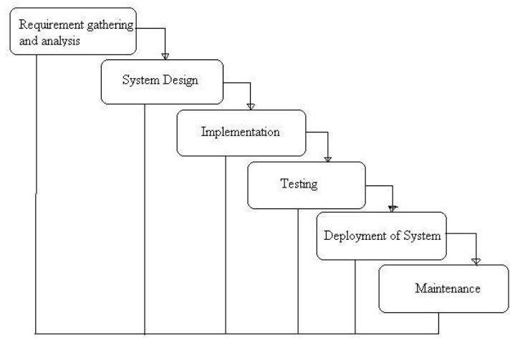
The second gold accord, known as the financial institution Gold Agreement two, was announced in2004. It limited gold sales to 500 tons each year for the next a five-year duration (European financial organization, 2004). In September of 2004, the based on working into operation. Unit Trusts have also been popular since the early 2000s. For example, Physical Gold Solutions (GBS) was set up In march 2004 and has since been feature don the many capital market, and including Kyles, and the South African New Diamond ETF was issued in For the factors outlined above, the quarterly data for this
Approach employed in Development: Water fall Model
The water model is also a comparatively linear serial style approach definitely areas of engineering style. we tend to decide this model as there is no existing system gift, therefore we have got to develop this from the first stage of grouping the info and implementation the aspects. First, we tend to take the survey andgathertheinformationconcerningthecurrentoperatingmethod,wetendtoanalyzetherequirementfromour survey what really need is and what we've to develop in our system, later on, once the analytical survey,wetendtobegincomingupwithoursystem,insidethatwetendtoseethatthesystemshouldbeuser-friendly therefore one and everyone should use the system, coming up with method takes several efforts as a result of it might be a challenge that the system designed ought to be simply graspable to the end-user, later on the implementation method started wherever we tend to develop the system mistreatment numerous tools and package on cetheimplementationmethodtestingshouldbedonetocreatecertainthatthedeveloped system is functioning properly, in take a look acting we tend to elect the unit take a look acting technique wherever we tend to test all the modules singly as a result of the modules are being developed step by step which we should always test each model therefore we tend to elect this testing technique. whereas testing we tend to found several errors and technical issue that is being solved and retested the system, as we tend to tested the module singly whereas developing them, we tend to additionally execute the testing once completion of the project.
- Advantages of Waterfall Module:
- Easy and simple to know and use
- Clearly outlined stages.
- Follow serial Flow.

- DESIGN
- Spring Boot:
Spring Boot is a free and open-source Java-based framework for developing tiny services. Polar Teamcreated it, and it's used to construct comprehensive and production-ready spring applications. This chaptergivesyouan Acein Healthcareoverviewin SpringMVC and showsyou toits keytenets.
Advantages:
- SpringBootbestowsthefollowingbenefitsto itsdevelopers.
- Springappsaresimple tounderstandandcreate.
- Aggregatedemandwas grown.
- Goalsforthe event'sdurationarereduced.
- SpringBootwas createdwith thefollowinginmind.
- Toprevent havingto deal with alot of XMLsettings in Spring.
- Tocreate production-readySpringappsin amoreorganizedmanner.
- Toreducetheeventdurationandruntheapplicationseveraltimes.
- Provideamoreorderlymanner of gettingstartedwith theapplication.
- Thankstotack JavaBeans,XMLsettings,andinformation Transactions,itis quiteflexible.
- IthandlesRESTendpointsandoffers arobustinstructionexecution.

Tools:
- IntelliJ IDE
- Git bash
- NodeJS
- IntelliJIDE
IntelliJ plan has some high productive Java code completion options. Its prognosticative algorithmicprogram will accurately assume what an engineer is trying to sort, and completes it for him, even though he doesn’t recognize the precise name of a specific category, member or the other source.
Pro found Thoughts - IntelliJ plan has a comprehensive understanding of and insight into your code, as well as the framework of the engineer, which distinguishes it from another Sunday.
Finalization of knowledgeable protocols − It primarily enables context-based compiler. It gives a list of the most important symbols that apply to the current situation
Confirmation in a cascade − It's a smart code completion mechanism that shows all suitable symbols in the specific era that may be obtained either algorithm and just go Fulfillment of a structural member − It lets the customer static strategies or integers and adds the necessaryimported phrases manually . Identical detection− It detect sredundantdatatypesontheflyandshowsoradvisesthe’verequested. Rapid and examinations − When Net Beans determines that someone might be about to mess it up, a candlenoticeemerges on thesame column.Theonlinepetitions appears whenyou tap it.
- WhatDoestheDSG_HNW (Gold Transaction) do?
This document specifies the functional specifications for a web application in gold markets that needs to bedeveloped. The document helps the business stakeholders to understand what to expect out of the project &technicalstakeholders tounderstand what to deliver.
- FeaturesoftheSystem:
ThisSystemmaindivided intotwomodules:
- Admin Module
- User Module
Sell and Buy
- Admin Module:
All rights have been given by the admin to the user. The main objective is of this portal to propose a system to make an ease way of dealing gold and transactions. The admin also has to register at this platform. The security has been main aspect we mainly focus that’s why the all the details are confidential and no one can misuse these details. Admin can able to track the activities of the user. The admin would review all the notification regarding deal of property and then give approval to proceed further. When the user wants to sell the gold, they will one request has sent to admin. The approval request will be sent by the admin within 24 hours of the request receive from the user. This makes ease to user to start the dealing without taking lots of days. The admin also has the rights to block the fraud users as we know the many frauds user can do the misleading activities after suspecting this activity the user can report and block that user. AdminhasworkrelatedtoVerification,Validation,Approval,CheckingtheUploadedDocuments,GrantingAccess to Only GenuineUser.
Verification: In this process, the details of seller and land or a gold has been checked through reviews, walkthroughs, inspections and desk-checking.
Validation: The validation is the actual reviewing of the property by visiting at that site. They validation process is carried out after they reification.
Approval: After the completion of above process the approval is given to the user to sell or buy a gold with out approval from the admin, they are not able to sell or buy any gold.
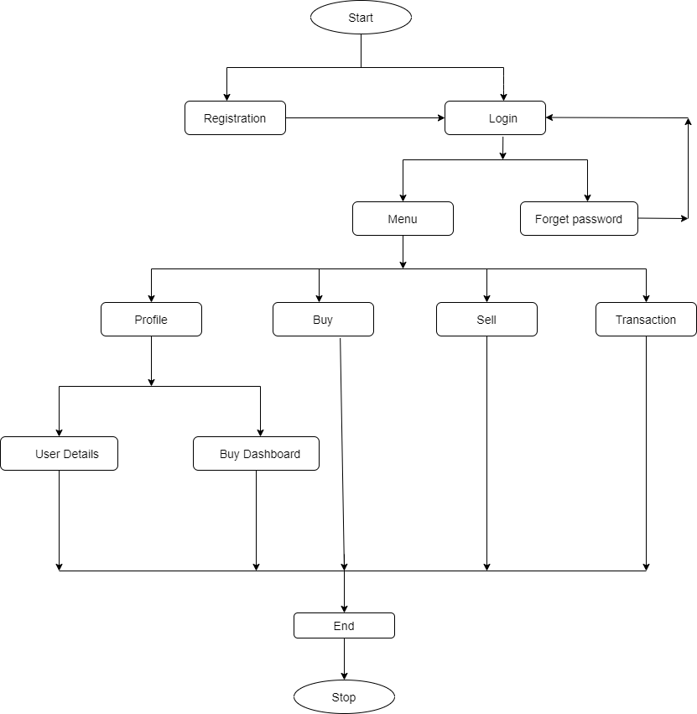
Fig. User Module Flow Diagram

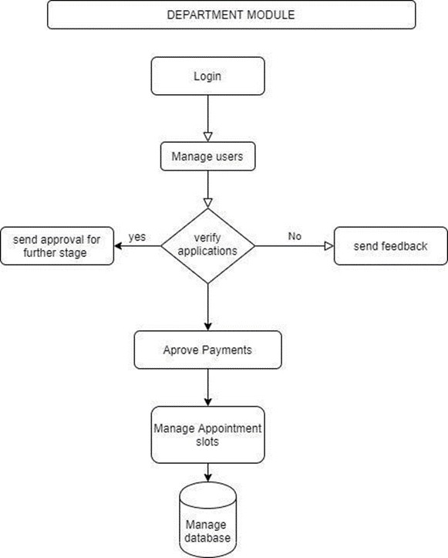
Fig. Admin Working Module
- User Module:
Users will be able to navigate through multiple functionalities for buying, selling gold, delivering gold and adding value to their wealth management. User will receive transparent prices, security, efficiency, free storage as well Users can view all the sell transactions made with some additional facts and figures Users has successfully logged in the web app using registered credentials Users can review and confirm order moving ahead with related details. User have successfully logged in the application. Users will be able to viewdashboard name (top left) - Gilded - Screen. Users will be able to view the currency (top right) and userprofileof theonewho’slogged in.
Sell And Buy
- AccountSummary– PieCharts
- “account# (last4)"
- "Firstname"
- AccountValue
- "Totalgoldweight(kg)"
- totalgoldweight(oz)
- goldmarketvalue(USD)
- accountcashbalance
- accountrenewaldate
- "Livegoldprice"
- "timestamp"
- "transactions"
- Holdings(MiddleRibbon)
Users.
For the first-time user - please display message - Welcome to Gilded! Please select the Buy tab to getstartedonyourgold buyingjourney!
Transactions(MiddleRibbon)
Userscanviewalltransactions madeandrelatedinformation availableintabularformat.
Buy(MiddleRibbon)
Userscanviewvariousparametersfor Buytransactionsand proceedwithreviewandconfirmorder.
Deliver(MiddleRibbon)
Users can view various parameters for Deliver transactions and proceed with review and confirmorder.
Followingparametersarefrombelowribbon–HoldingsTab: -
- AvailableHoldings
Userscanviewholdings.
- SelectedHoldings
Userscanviewholdingsselectedtoreviewandconfirmdeliver order.
- Date
Users can view holdings selected with date in ascending and descending order.datearrowup: sort ascendingdatearrowdown:sortdescending.
FilterBy:-
Userscan filter data bybar typei.e.1kgor 12.5 kg.
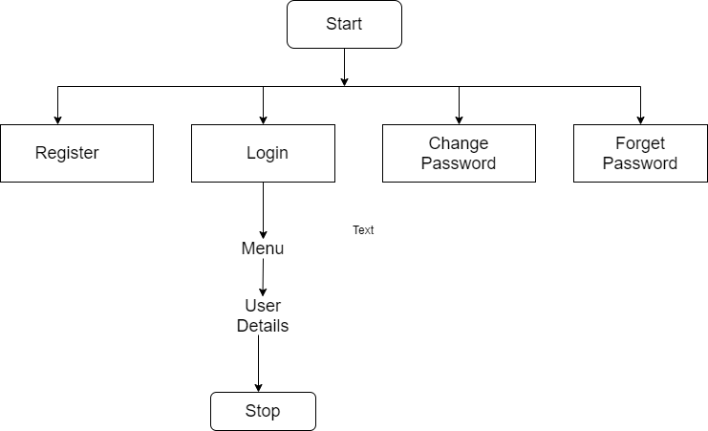
Fig. User Login Module
III -CONCLUSION
- The testing of software is concluded by the accuracy and there fore the efficiency of the software.
- Accuracy defines how near the particular value, whereas precision calculates the share of the relevant results. recall is another important factor for evaluating a network model.
- It Ives the share of the overall applicable results that a model can right classify.
- Efficiency is defined because the difference between the functioning time taken by a median action at lawandthereforetheactual legal action.

REFERENCES
- “e-gold Update: value access” e-gold blog – 14th May 2016
- "OS-Gold", The Gold Economy Magazine, September 2015
- "Why Standard Reserve Failed", The Gold Economy Magazine, May 2013
- "INTGold", The Gold Economy Magazine, September 2018
- ” Bollinger Bands and Single Exponential Smoothing Methods in The Decision System of Selling and Buying Stock “Year: ] 2021, Publisher: IEEE
- Prediction of Gold Price using Deep Learning: Dhanush N,2021, IEEE
- A literature review on gold Predictive techniques, Nurul Asyikin, 2015, IEEE 8. Developing a gold price predictive analysis using Grey Wolf
- Optimizer, ZurianiMustaffa, 2016, IEEE 9. Gold price prediction using radial basis function neural network, Shamsul Faisal Mohd Hussein,2011, IEEE. Sloan, Annie (1996) Decorative Gilding, Collins & Brown, ISBN 978-0-89577-879-6
- Bunker, Emma C. (2002). Nomadic Art of the Eastern Eurasian Steppes: The Eugene V. Thaw and Other Notable New York Collections. Metropolitan Museum of Art. p. 100, item 67.
- Vilfranc, Jenifer M. (1999). Elert, Glenn (ed.). "Thickness of gold leaf". The Physics Factbook. Retrieved 2022-03-05.
- "Gold leaf | art". Encyclopedia Britannica. Retrieved 2017-06-20.
- "Survey of London: Volumes 29 and 30, St James Westminster, Part 1", British History Online, 1960, retrieved 9 April 2015.

