Smart Assistant for Blind Person

Akanksha Raju More¹, Aditi Rajendra Shelke², Sunil Raju More³, Dhananjay Sopan Shelke⁴

¹UG-Student, Amrutvahini college of engineering sangamner,India,422608
²UG-Student, Amrutvahini college of engineering sangamner,India,422608
³UG-Student, Amrutvahini college of engineering sangamner,India,422608
⁴UG-Student, Amrutvahini college of engineering sangamner,India,422608

moreakanksha124@gmail.com

Received on: 03April,2023 Revised on: 28 April,2023 Published on: 30April,2023

Abstract -This paper represents about smart walking stick that alerts blind people over obstacle like vibration of stick and image processing part that detect object through camera and give message to blind person through Bluetooth headset.
Keywords- Node MCU, Bluetooth Headset, Camera, Ultrasonic sensor, Aurduino,buzzer.
- INTRODUCTION

Smart Assistant for blind people is a portable device. This device will make blind and visually impaired people's lives much easier, as it will help them in recognizing object.
There are two main parts of our project image processing and smart stick.
In image processing part we can detect the object in front of blind person through camera like car, tree, bench, table, person and it will give message to blind person through Bluetooth headset.
We use deep learning technique using tensor flow to train the model. In smart stick we use ultrasonic sensor to detect object like stone, wall after detecting object it will gives us reverse signal in the form of vibration using vibrator motor.

II -LITERATURE REVIEW
Table 1: Literature Review
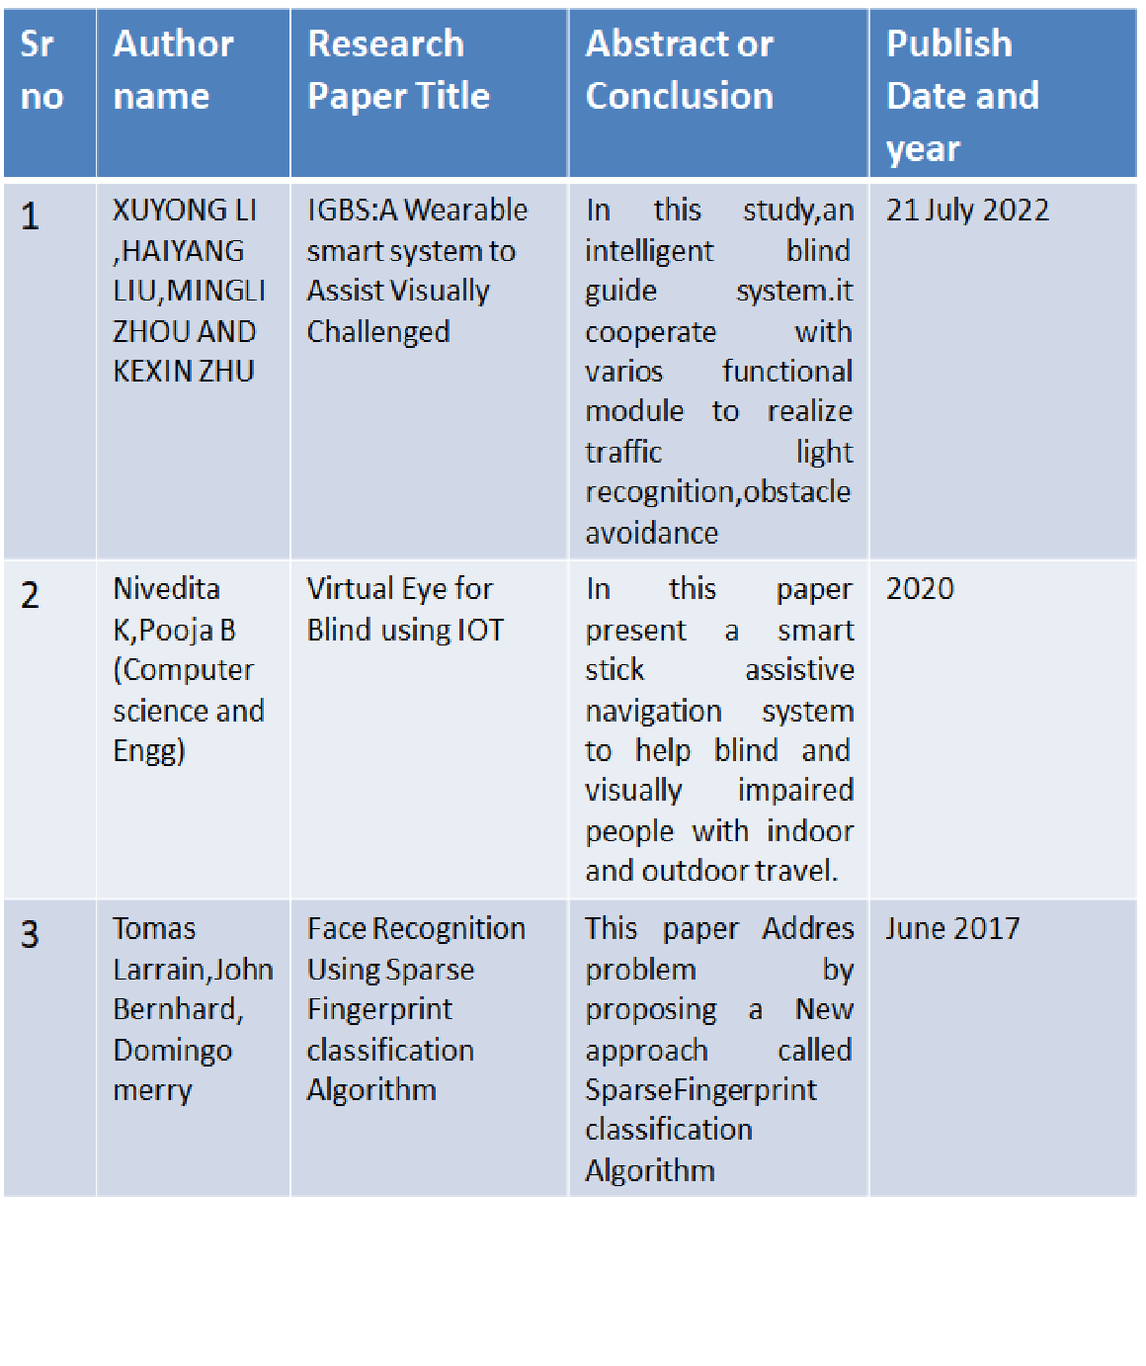

METHOLOGY
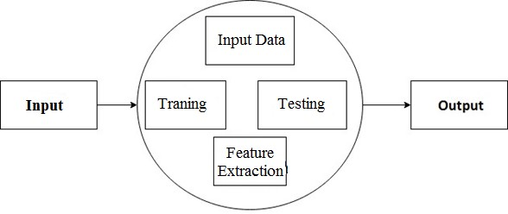
Block Diagram:
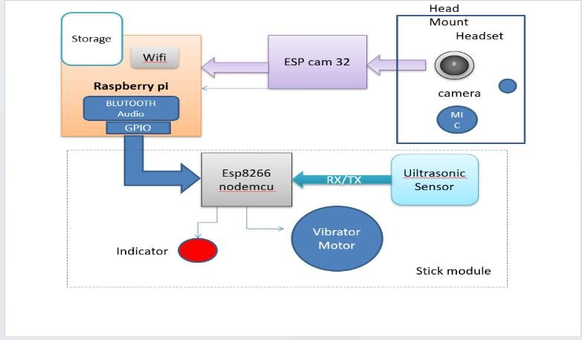
Fig 1 : Block Diagram
Algorithm
- Start
- Create dataset of surrounding image
- Capture image with web cam
- Real time image prediction with AI
- Classification of the image
- Compare capture image with dataset
- If image matched then
- Display Audio signal through Bluetooth
- If image is not matched
- Again capture next image
Fig 2 : Flowchart

System Flow Diagram

Fig 3: System Flow Diagram

Hardware detail

1.Raspberry pi 4:

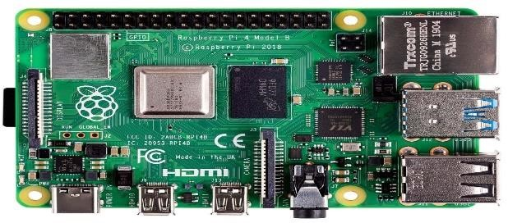

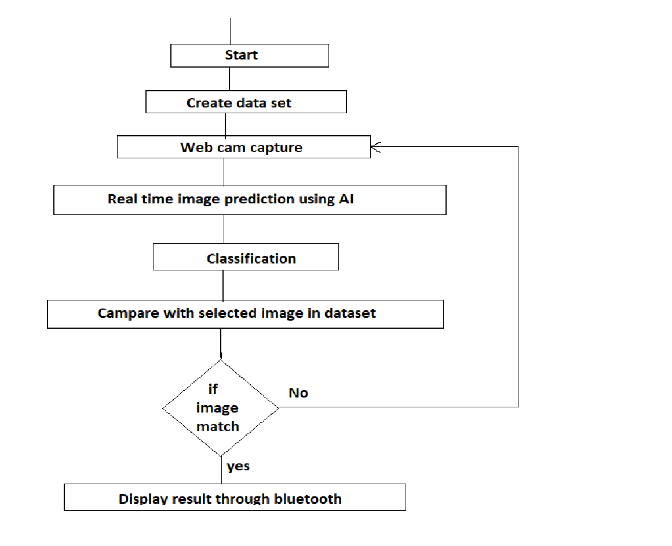
Fig 4: Raspberry pi 4

We use raspberry pi 4 in our project because it has several advantages like image processing, object detection and data storage. An object detection is main part of our project
2.ESP Camera:
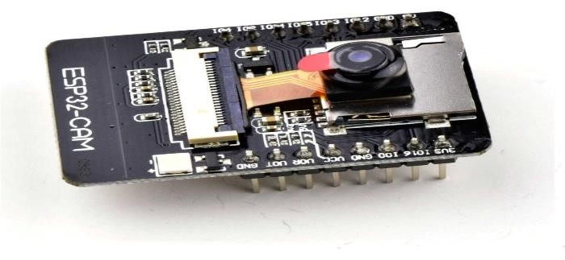

Fig 4: ESP Camera

ESP 32 is small size camera module with wifi support it also have Bluetooth camera with flash 4G for data storage support of wifi image upload etc.
3.Ultrasonic Sensor:
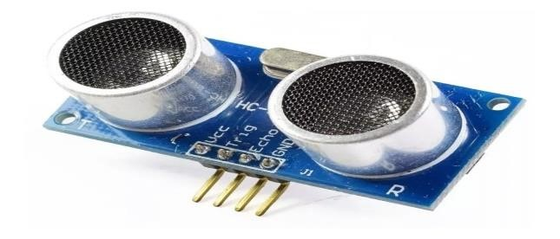
Fig 5 :Ultrasonic Sensor
Ultrasonic sensor is basically used to detect object in specific range and give signal after detecting object.it has range upto 5m. it has two parts transmitter and receiver.
4.Bluetooth Headset:
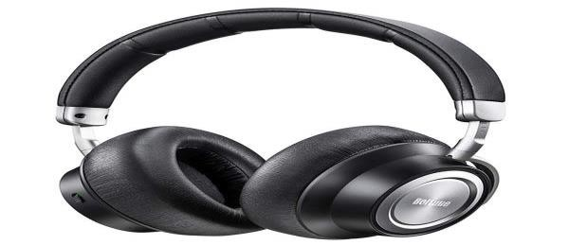
Fig 6 : Bluetooth Headset
Bluetooth headset is wireless headphone used to received audio signal.it has built in rechargeable battery
RESULT & DISCUSSION
There are two main parts of our project image processing and smart stick.In image processing part we can detect the object in front of blind person through camera like car, tree, bench, table, person and it will give message to blind person through Bluetooth headset.

CONCLUSION
It helps to good result in detecting obstacles in the blinds person way over a specific distance .This model provides a low cost and portable, less power consumption. Another feature of our project is it is wireless model.

REFERENCES
- XUEYONG LI, HAIYANG LIU,MINGLI ZHOU,AND KEXIN ZHU from the department of electrical engineering make a device “IGBS:A Wearable Smart System To Assist Visually Challenged “ and published research paper on 21 July 2022.
- Niveditha k,Pooja B,Niveditha p from the department of Computer Science Engg published a device “Virtual Eye For Blind Using IOT” in 2020
- Tomas Larrain,John Bernhard, Domingo mery published a paper Face Recognition Using Sparse Fingerprint classification Algorithm in June 2017.

